Business Intelligence Course Project
Dataset: NYC AirBNB

Group Members:
Ali Khurram (25250), Ali Iqbal (24529)

- Description of Dataset

The following Airbnb activity is included in this New York dataset:
Listings, including full descriptions and average review score Reviews, including unique id for each reviewer and detailed comments Calendar, including listing id and the price and availability for that day

- Data Wrangling Steps:

1. Removed Data:
- Eliminated the 'license' column due to almost empty entries.
- Removed rows with complete empty entries.
- Removed duplicate rows.
- Eliminated rows with identical latitude, longitude, host name, and price, considering them duplicates. This step significantly reduced the dataset from 102,599 to 69,305 entries.

2. Corrected Inaccuracies:
- Adjusted dates in the 'last review' column greater than the year 2022 to the column's median.
- Changed the data type of 'price' and 'service fee' columns from object to float.
- Corrected the spellings of 'Manhattan' and 'Brooklyn' in the 'neighbourhood group' column.

3. Filled Missing Values:
- Imputed the missing values in the 'house_rules', 'name', and 'host name' columns with the word 'blank'.
- Imputed missing dates in the 'last review' column with the earliest date available.
- Used the median to fill missing values in columns such as 'reviews per month', 'availability 365', 'minimum nights', 'review rate number', 'construction year', 'number of reviews', and 'calculated host listings count'.
- Filled missing values in the 'id' column with 0.
- Imputed missing values in the 'host_identity_verified' column with 'unconfirmed'.
- Dropped 'country' and 'country code' columns due to zero variability.
- Filled missing values in the 'neighbourhood' and 'neighbourhood group' columns using latitudes and longitudes.
- Imputed missing values of latitude and longitude using existing data for the same neighborhood.
- Filled missing values in the 'price' and 'service fee' columns with the mean.
- Imputed missing values in the 'instant bookable' column with "true".
- Filled missing values in the 'cancellation policy' column with "moderate".

- Brainstorming:

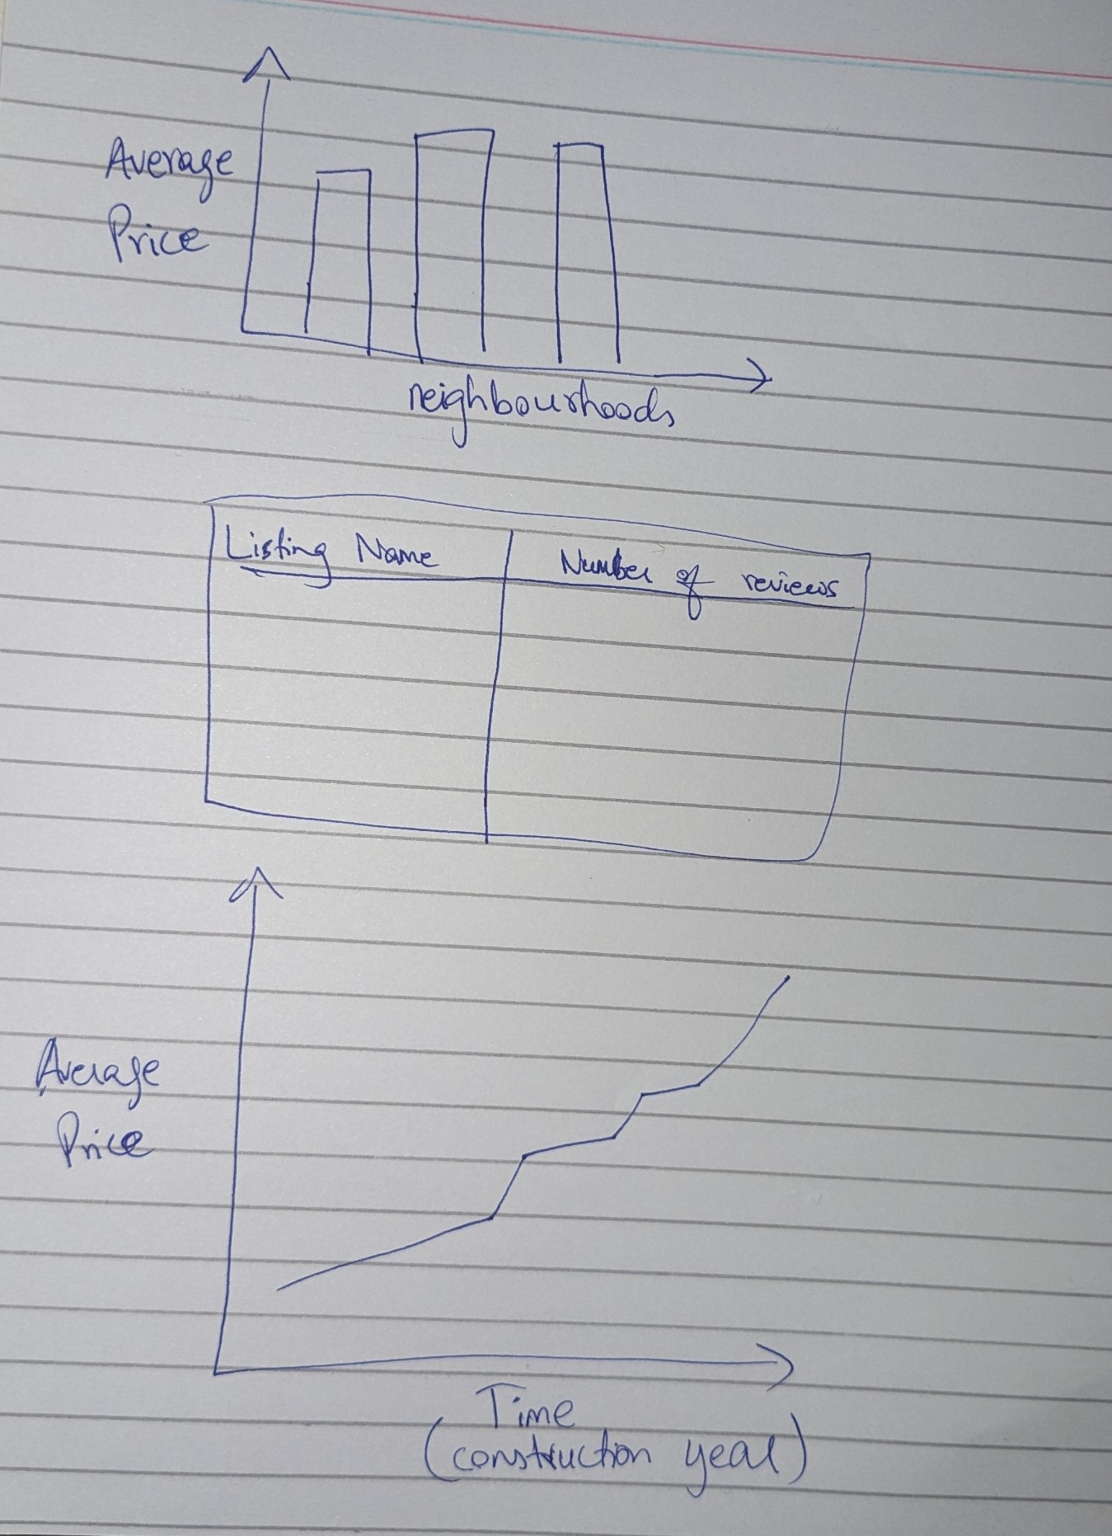
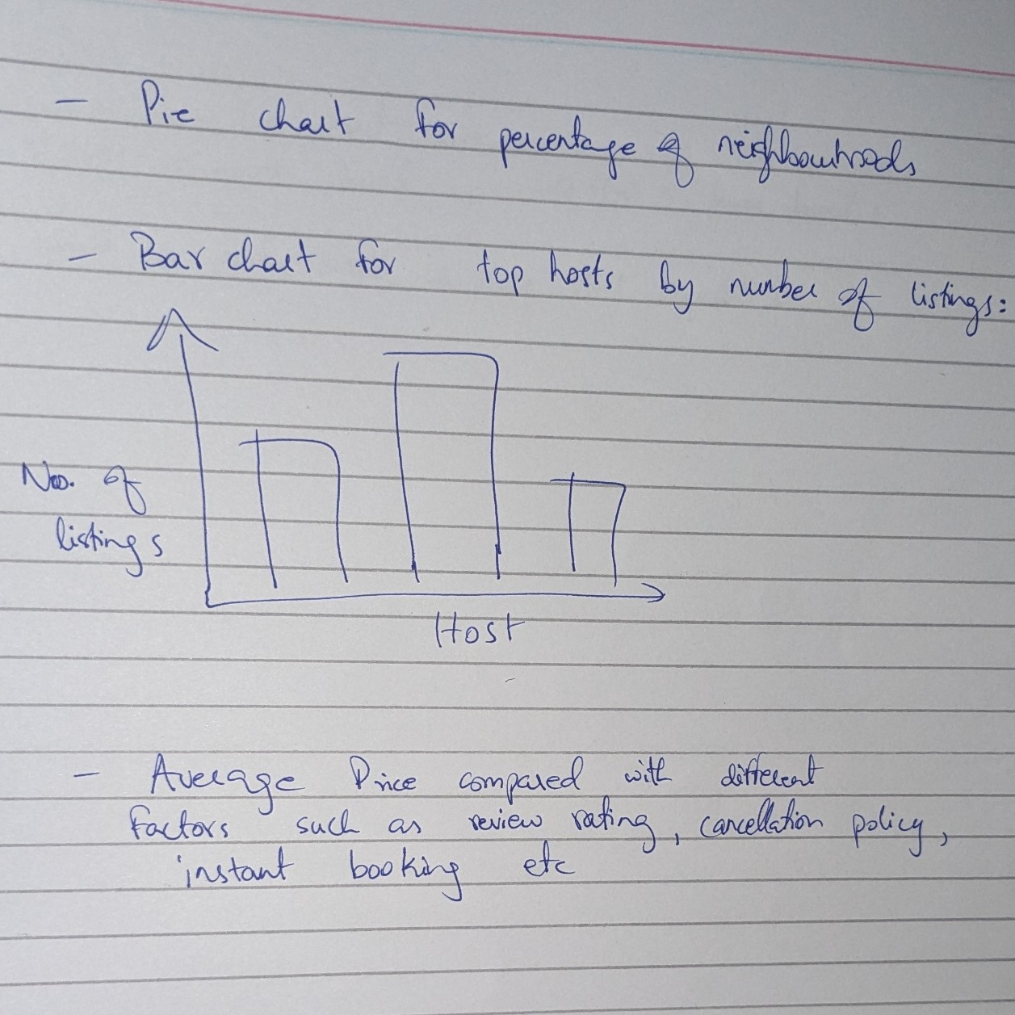

- Charts Made on PowerBI:

Analysis of Price vs Number of reviews for a listing

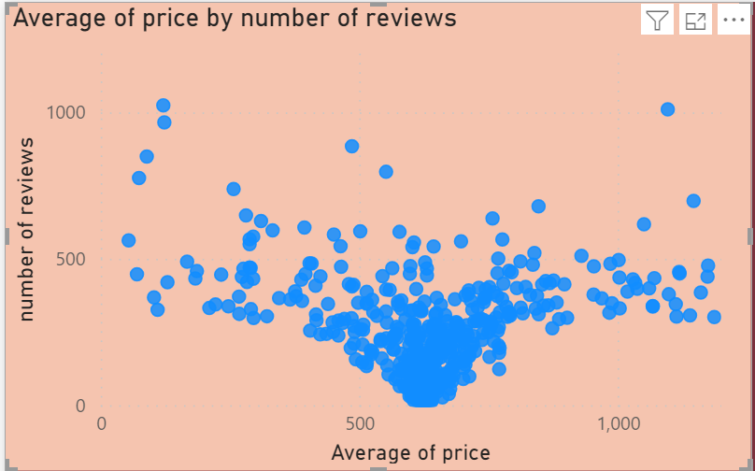

Neighbourhoods ranked by review ratings:
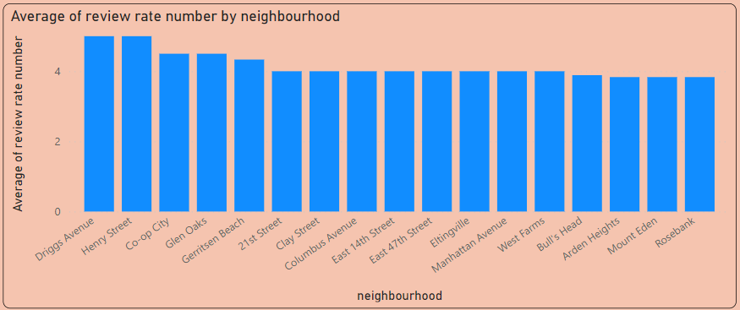

Top 10 hosts according to number of host listings on AirBNB:
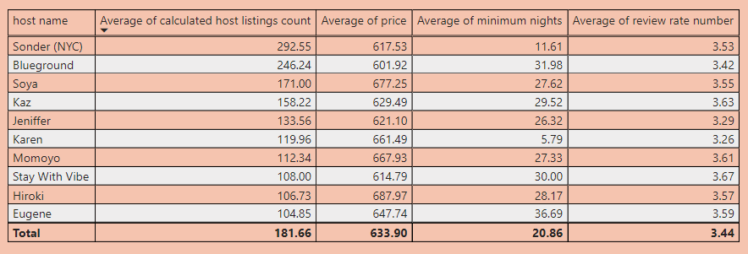

Listings with highest number of reviews, with their rating indicated:
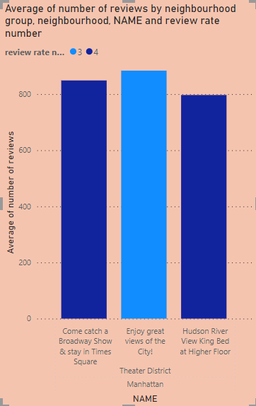

Average of Price vs Average of Service Fee:
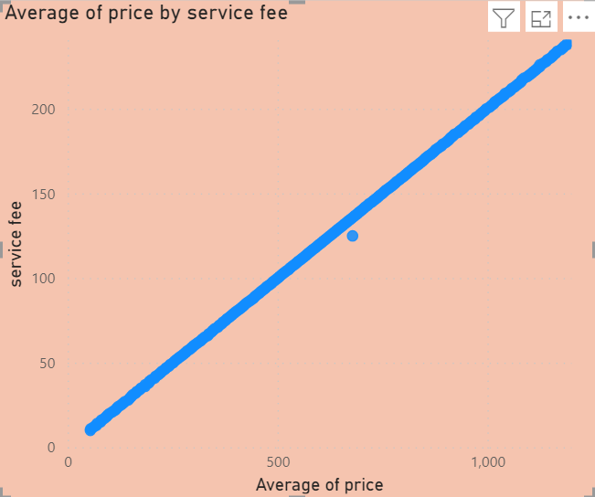

Count of Listings by neighbourhood Group:
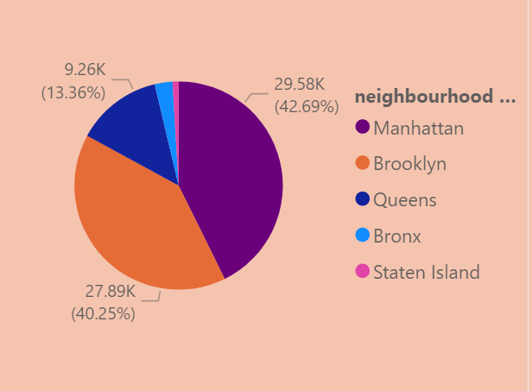

Top 10 Neighbourhoods by Average Price:
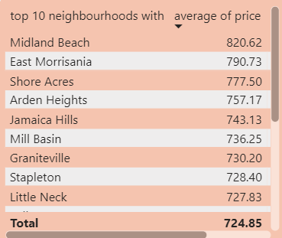

Top 10 Listings by Price:
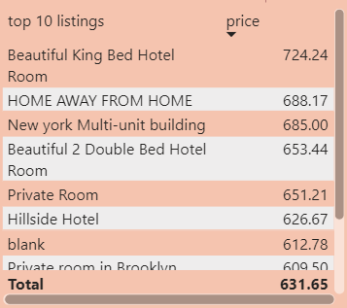

- Dashboards:

Price Analysis Dashboard: Overview of Prices
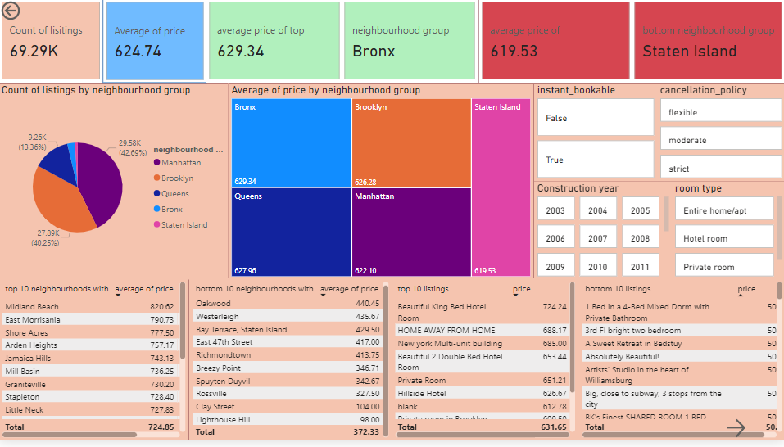

Second Price Analysis Dashboard: Shows comparison of price with different variables such as number of reviews, service fee etc:

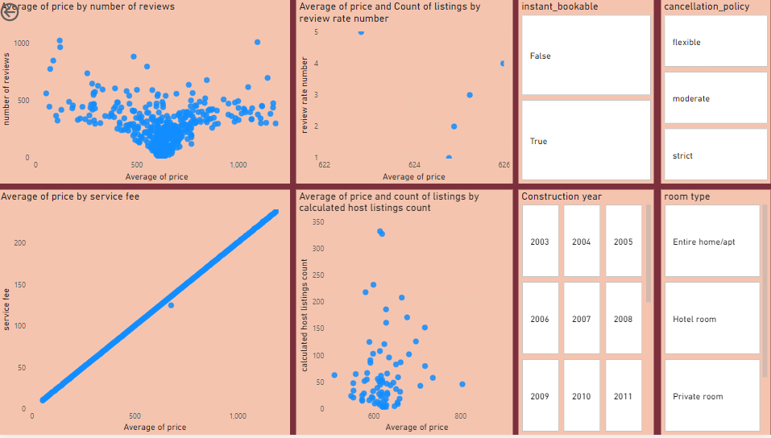
Third Page with additional charts for analysis of top hosts and listings with highest reviews:
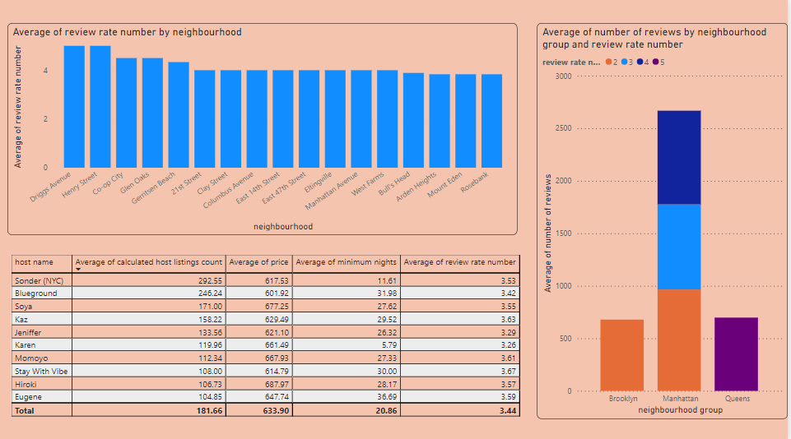

- Team Member Contributions:

Ali Iqbal:
- Made charts on price analysis
- Made the dashboard
- Filled background data knowledge template

Ali Khurram:
- Performed data cleaning
- Made charts on host and reviews analysis
- Made the report

