Assignment for Lecture 5 (this is the end of Project I)
1. (Occurrence of max numbers)
Write a program that reads integers, finds the largest of them, and counts its occurrences. Assume that the input ends with number 0. Suppose that you entered 3 5 2 5 5 5 0; the program finds that the largest is 5 and the occurrence count for 5 is 4.
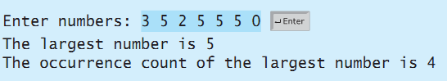
2. Programming Challenges
5.1, 5.2, 5.4 Tony Gaddis Starting out with Java
3. Write a program that uses nested for loops to print a multiplication table inside a dialog as follows:
