Assignment for Lecture 6
1. Implementation of Student Class
a) Write a class Student which models students with their:
ID: string, name, accumulated CPA, prefer courses (an array of String).
b) Write a program that create and display about the following students:
(TROY1231, Bob Walker, 3.21, {"Math", "Philosophy", "Art"})
(TROY1217, Bao Trung, 2.67, {"Computer Science I", "Math")}
(TROY1362, Nina Gigi, 2.99, {"Sing", "Dance", "Physics"})
the find the course that is most prefer by Student.
Don't use constructor, private methods in this exercises.
2. Implementation of TV Class
Consider television sets. Each TV is an object with states (current channel, current volume level, power on or off) and behaviors (change channels, adjust volume, turn on/off). Write a class to model TV sets and demo their usages in a program.
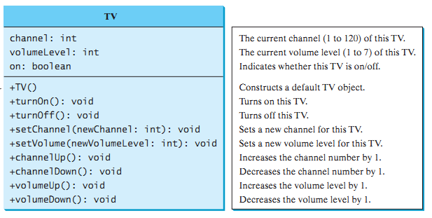
3. Programming Challenges (Array topic)
6.1, 6.2, 6.3, 6.4 Tony Gaddis Java

