CS 360 – PROJECT (Homework 1-6)
GROUP
Members:

Assignment for Lecture 1:

- What are the differences between procedural programming and object oriented programming?
Students: – and –

Aspect | Procedural Programming (POP) | Object-Oriented Programming (OOP)
Encapsulation | Not supported - data and functions are separate. | Supported: builds data + methods into one unit (class/object), uses data hiding and access control (private, public).
Abstraction | Low-level, procedural abstraction (hide the details of the algorithm). | High-level, data abstraction (do not interact directly with raw data, interact through objects that represent real-world entities), hides complex implementation.
Inheritance | Not supported - reuse by calling functions. | Supported - new class inherits attributes and methods from existing ones => promotes code reuse.
Polymorphism | Not supported - each function has a fixed behavior. | Supported - same method name behaves differently for different objects.
Focus | Functions and procedures (doing things) | Objects and data (things + behavior)
Structure | Divided into functions | Divided into objects/classes
Design Approach | Top-down | Bottom-up
Real-world Modeling | Bad at modeling real entities | Copies real-world entities
Data Security | Global data, less secure | Data hiding via access control (private/public/protected)
Modularity | Limited and harder to manage in large systems | High and easier debugging and maintenance
Concepts | Functions, global variables | Encapsulation, inheritance, polymorphism, abstraction
- Find an example in the real world where the Object Technology is applied with success.
Student: –
- Object-oriented techniques are extensively applied in large-scale enterprise systems, including CRM (Customer Relationship Management), ERP (Enterprise Resource Planning), banking, and e-commerce. Objects can interact through methods, just like departments within a business exchange data with one another.
- Setup the environment for compiling and running Java programs. Follows the guide in the section 1.10 Test-Driving a Java Application in the text book Java How to Program 9th edition, run the ATMCaseStudy and take the snapshot of the screen in each step.
Students: – and –
Step 0: Set up the environment and run by PowerShell
Step 1: Enter account information
- Enter the account number: 12345
- Enter the PIN: 54321
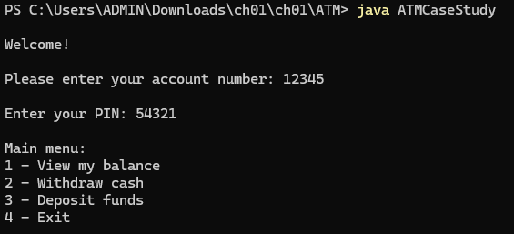
Step 2: View the account balance
- Choose option 1 - View my balance
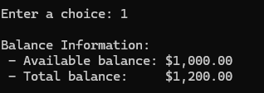
Step 3: Withdraw cash
- Choose option 2 - Withdraw cash
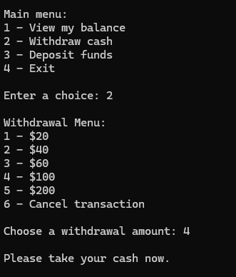
Step 4: Check the updated balance
- Choose option 1 - View my balance again
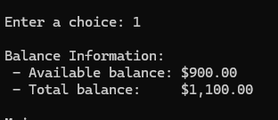
Step 5: Exit the ATM
- Choose option 4 - Exit
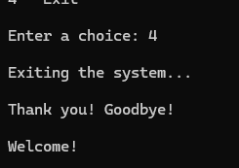

Contribution Table
Problem 1
Problem 1
Problem 2
Problem 3
Problem 3

Assignment for Lecture 2:

- Write a program displaying on the screen two first letters of your name. For example: Thủy -> Display TH:
Students: – and –
- Using command Sytem.out.println() to print each line in the two letter
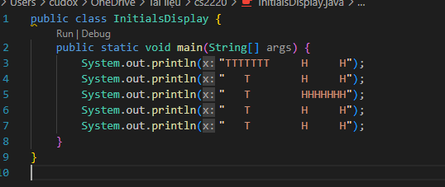

- Result :

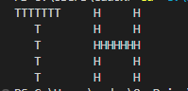

- Programming Challenges
Programming Challenges 17, 18, 19 Chapter 2 Starting Out Java 6ed - p108 - 109 Tony Gaddis Java Textbook.
Students: – and –
17 :
+ This program helps the user adjust ingredient quantities for a cookie recipe.
+ The original recipe makes 48 cookies using specific amounts of sugar, butter, and flour.
+ The program asks the user how many cookies they want to make and then calculates the required amount of each ingredient proportionally.

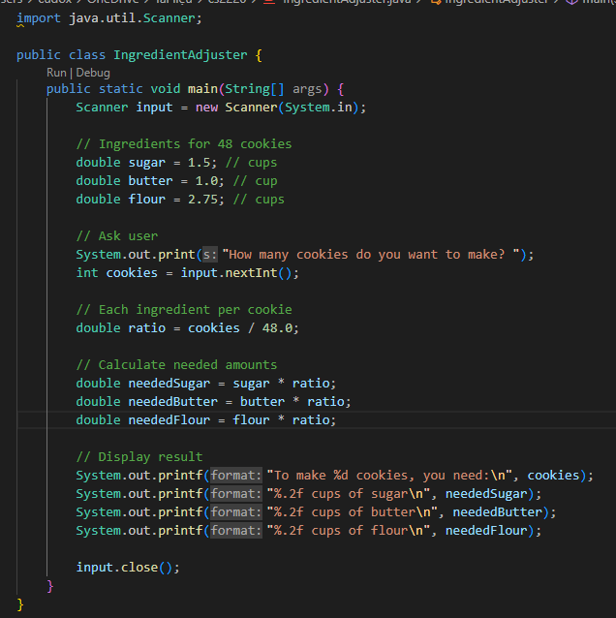

- For example, if you want to make 4 cookies 👍
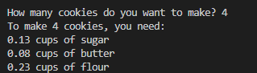

18 :
This program is a simple interactive word game that demonstrates how to use user input to create a personalized story.
When the program runs, it asks the user to type in several pieces of information:
- Their name
- Their age
- The city where they live
- The college they attended
- Their profession
- A type of animal
- The name of a pet
Each of these answers is stored in a variable using the Scanner class.
After collecting all the information, the program combines the user’s input into a pre-written story template.
By inserting the variables into the story, the program generates a unique story every time it runs — based on what the user typed.
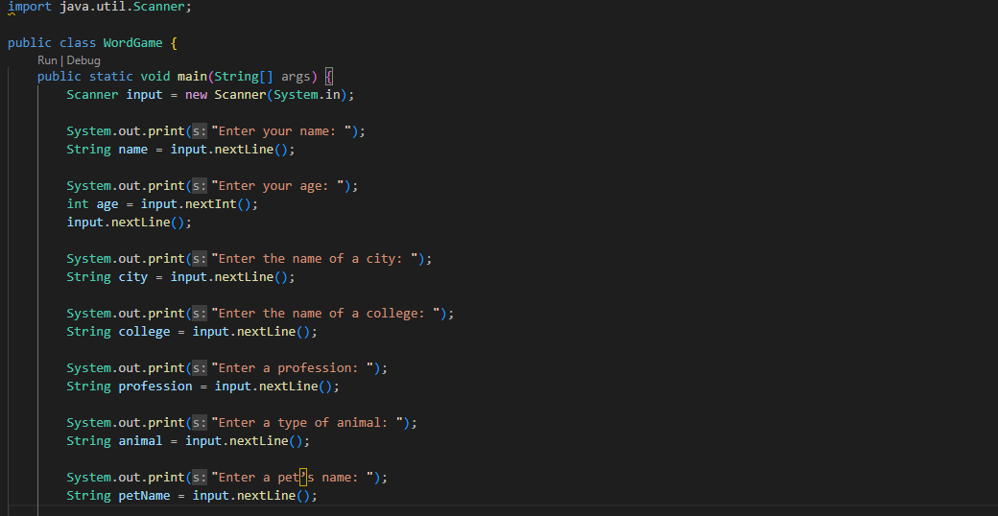
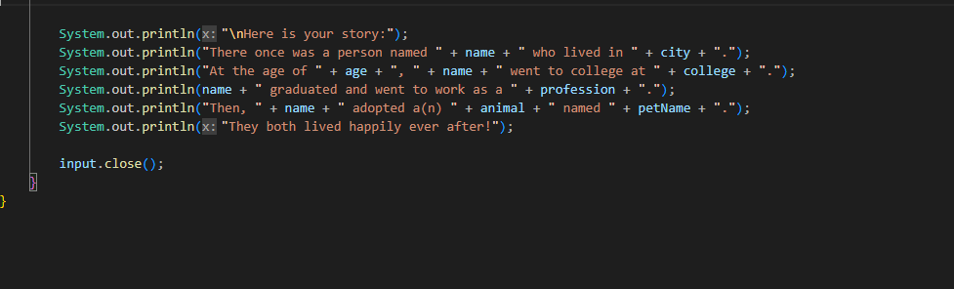

Example Output :
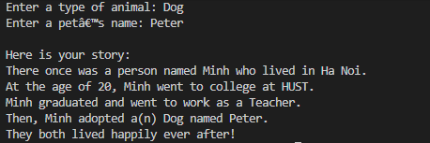

19 :
This problem describes a simple transaction account of a person named Joe. The goal is to write a program to correctly calculate the answer or error from this transaction.

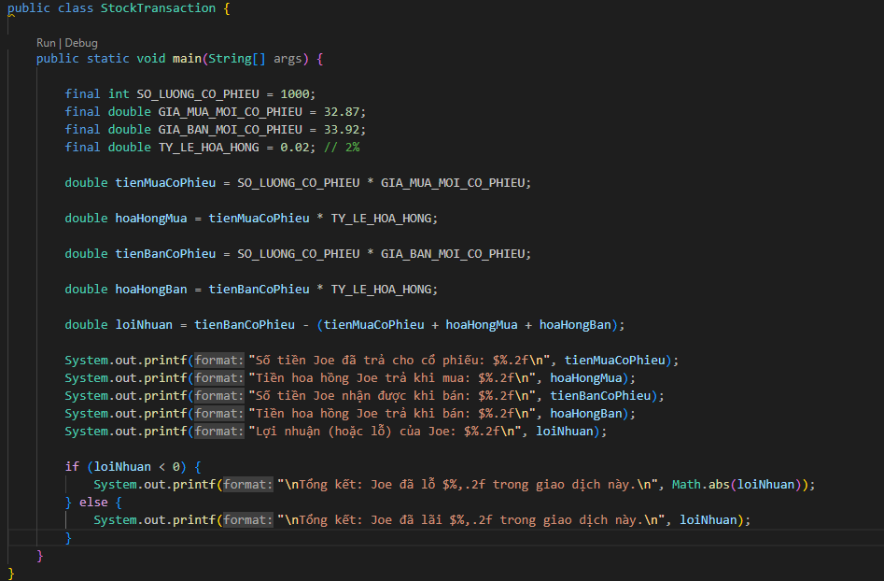
- When you run you will got this :
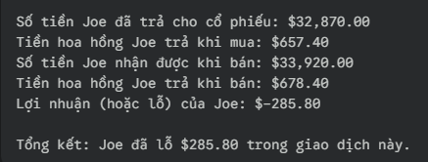
- Write a program that ask for input 2 integer number and display them on dialogs
Student: –
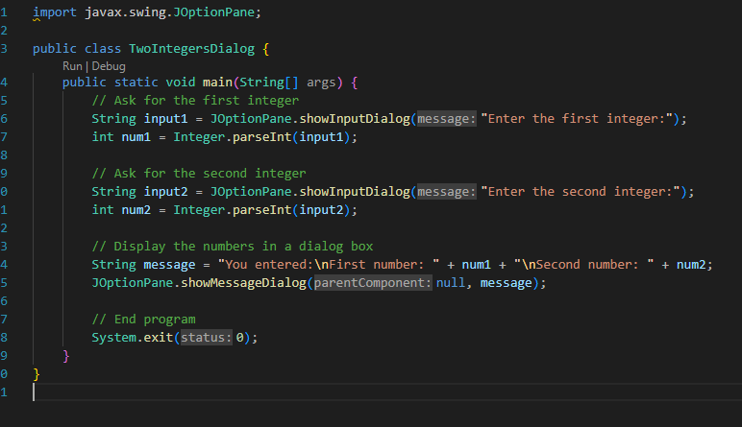
Explanation:
- The program uses the JOptionPane class from javax.swing to show dialog boxes.
- It asks the user to input two integers — one at a time.
- The input from each dialog is a String, so Integer.parseInt() converts it to an int.
- Finally, it displays both numbers together in another dialog box.
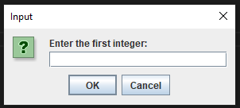
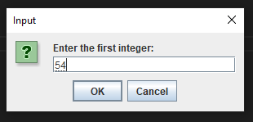
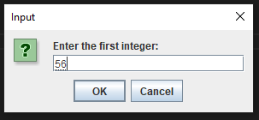
And when i have typed in two numbers its will display this:
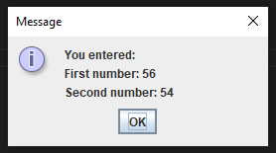

Contribution Table
Problem 1
Problem 1
Problem 2
Problem 2
Problem 3

Assignment for Lecture 3:

- BMI measure
Body Mass Index (BMI) is a measure of health based on height and weight. It can be calculated by taking your weight in kilograms and dividing it by the square of your height in meters. The interpretation of BMI for people 20 years or older is as follow:
} BMI < 18.5 Underweight
} 18.5 ≤ BMI < 25.0 Normal
} 25.0 ≤ BMI < 30.0 Overweight
} 30.0 ≤ BMI Obese
Write a program that prompts the user to enter a weight in pounds and height in inches and displays the BMI. Note that one pound is 0.45359237 kilograms and one inch is 0.0254 meters
Students: – and –
Solution:
Conversion constants:
- 1 pound = 0.45359237 kilograms
- 1 inch = 0.0254 meters
User input:
- The user enter their weight and height
BMI calculation:
- The weight is converted from pounds to kilograms, and the height is converted from inches to meters.
- BMI is then calculated as: BMI = weight (kg) / (height (m)^2).

BMI categories:
- The program determines the category (Underweight, Normal, Overweight, Obese) based on the calculated BMI and outputs the result.
- Declare data variables and use the Scanner function for users to enter BMI indices.
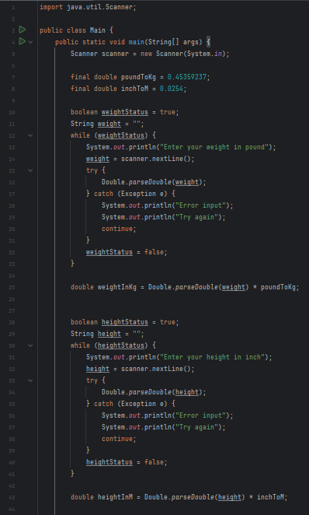
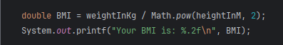
- Use an if statement to compare the index calculated from the data the user enters from the keyboard and the given index.
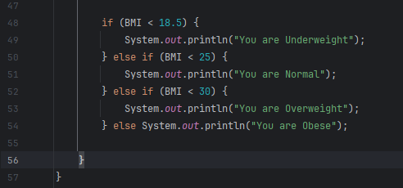
Result:
When entering different indicators, the displayed results will be different. Below are the results of the 4 severe cases mentioned above.
Underweight
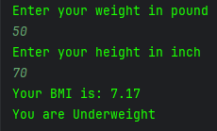
Normal
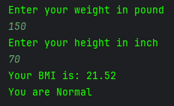

Overweight
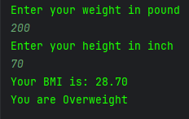
Obese
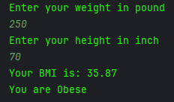
- Programming Challenges
3.7, 3.8, 3.9 Tony Gaddis Java Textbook.
Students: – , – and –
3.7
Write a program that asks the user to enter three names, and then displays the names sorted in ascending order. For example, if the user entered “Charlie”, “Leslie”, and “Andy”, the program would display: Andy Charlie Leslie
Explanation
This program is designed to prompt the user to enter 3 names, then sort in ascending order and display.
The program creates a Scanner object to read user input from the keyboard. The first step is to check if the entered name contains more than one word. If it does, the program should then determine if the first name appears at the beginning or at the end of the full name string.
After prompting the user to enter the names, the program sorts them by comparing them with one another to find the ascending order.
Check the format of the name to determine if it contains more than one word.
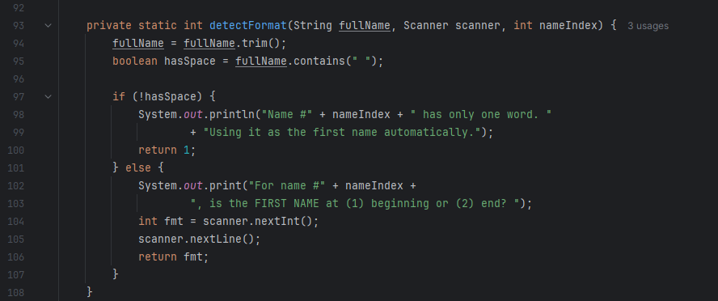
If it contains more than one word, check if the first name appears at the beginning or at the end of the full name string.
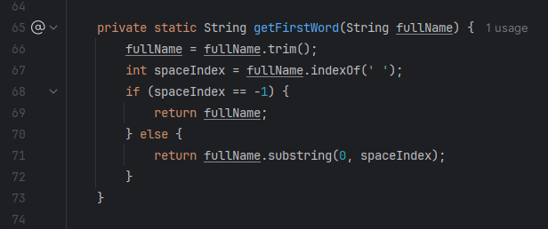
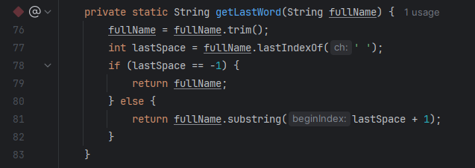

Then, extract the individual names from the user input to prepare them for sorting.
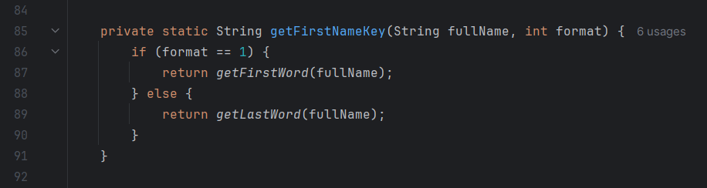
Finally, initiate the sorting sequence to arrange the extracted names in the ascending order.
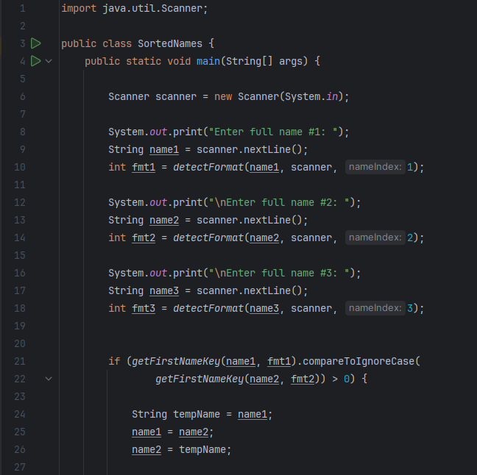
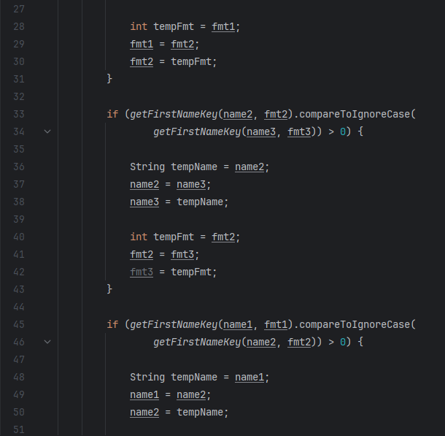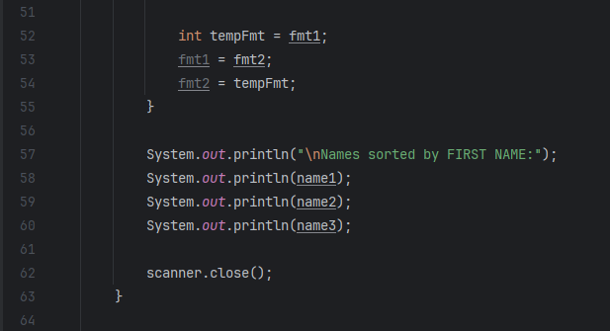
Result:
- 3 names have the first name at the end:
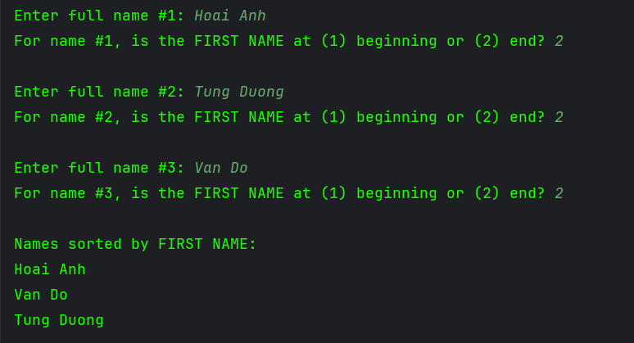
- 3 names have the first name at the beginning:
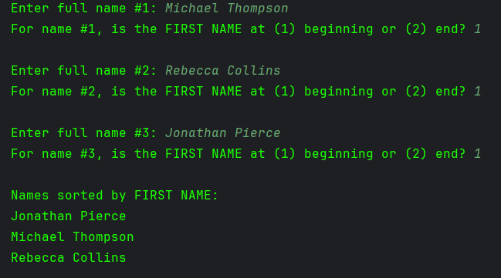

- 3 one-word name:
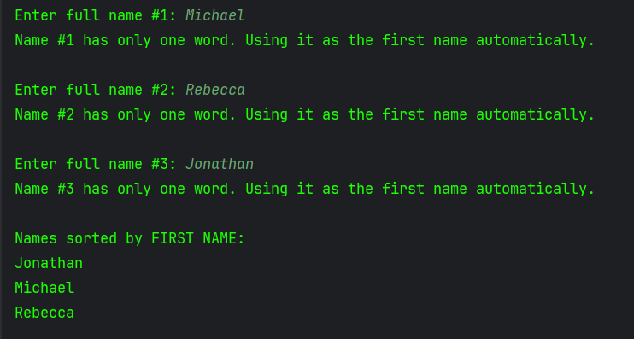
- 3 mixed names (first name at the end or beginning):
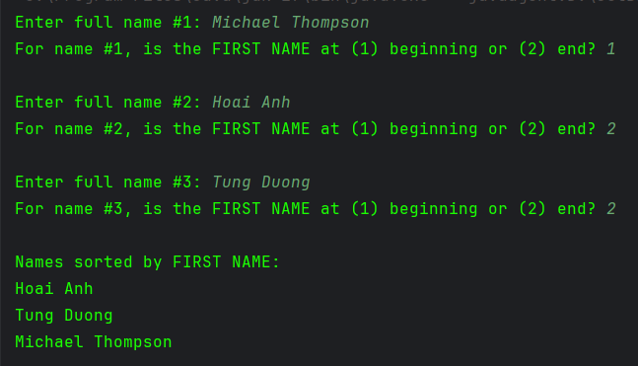

- 3 mixed names (1 or more than 1 word):
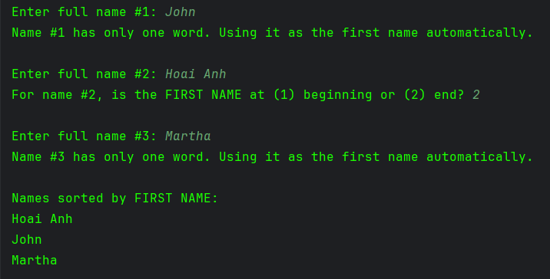
3.8
A software company sells a package that retails for $99. Quantity discounts are given according to the following table:
Quantity | Discount
10–19 | 20%
20–49 | 30%
50–99 | 40%
100 or more | 50%
Write a program that asks the user to enter the number of packages purchased. The program should then display the amount of the discount (if any) and the total amount of the purchase after the discount.
Explanation
This program is designed to prompt the user to enter the number of software packages purchased, then calculate and display the amount of discount (if any) and the total cost after applying the discount.
The program creates a Scanner object to read user input from the keyboard. It initializes the price of a software package at $99 and sets an initial discount rate of 0.0 (indicating no discount).
After prompting the user to enter the number of software packages purchased, the program checks the quantity using an if-else structure to determine the applicable discount rate. If the quantity is 100 or more, a 50% discount is applied. For quantities between 50 and 99, a 40% discount is applied, and so on, down to a 20% discount for quantities between 10 and 19. If fewer than 10 packages are purchased, no discount is applied.
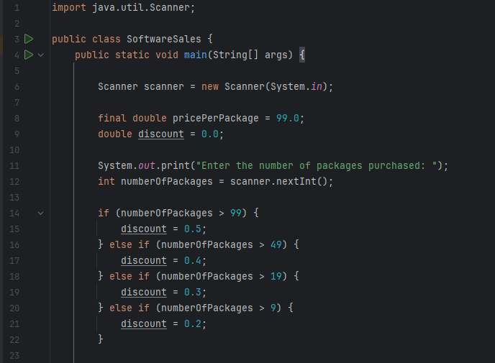
The program calculates the total price of the packages before any discounts and then determines the discount amount. Finally, it computes the total amount payable after the discount has been applied.
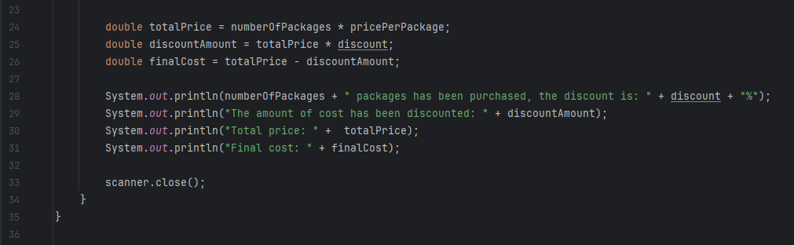
The results, including the discount amount and the total after the discount, are displayed in a formatted manner, ensuring that monetary values are presented with two decimal places.
Result:
- This is the result when entering the number of packages in each discount range.
5 packages ( < 10):
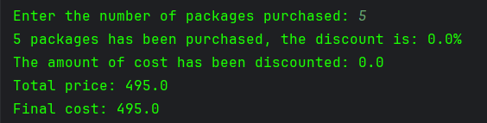
15 packages (10–19):
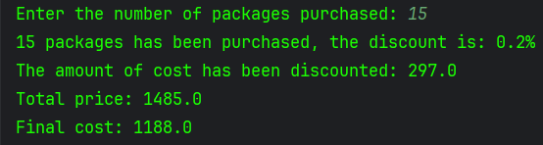
25 packages (20–49):
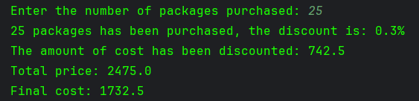
80 packages (50–99):
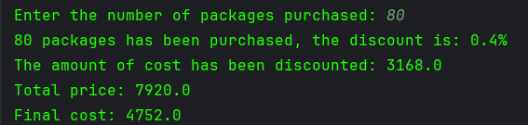

150 packages (100 or more):
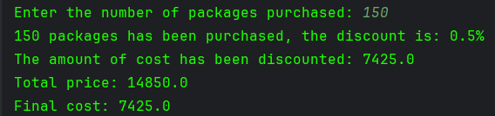
3.9
The Fast Freight Shipping Company charges the following rates:
Weight of Package | Rate per 500 Miles Shipped
2 pounds or less | $1.10
Over 2 pounds but not more than 6 pounds | $2.20
Over 6 pounds but not more than 10 pounds | $3.70
Over 10 pounds | $3.80
The shipping charges per 500 miles are not prorated. For example, if a 2-pound package is shipped 550 miles, the charges would be $2.20. Write a program that asks the user to enter the weight of a package and then displays the shipping charges
Explanation
The Fast Freight Shipping Company has a specific pricing structure for shipping packages based on their weight. This program calculates the shipping charges for a user-entered package weight and displays the cost
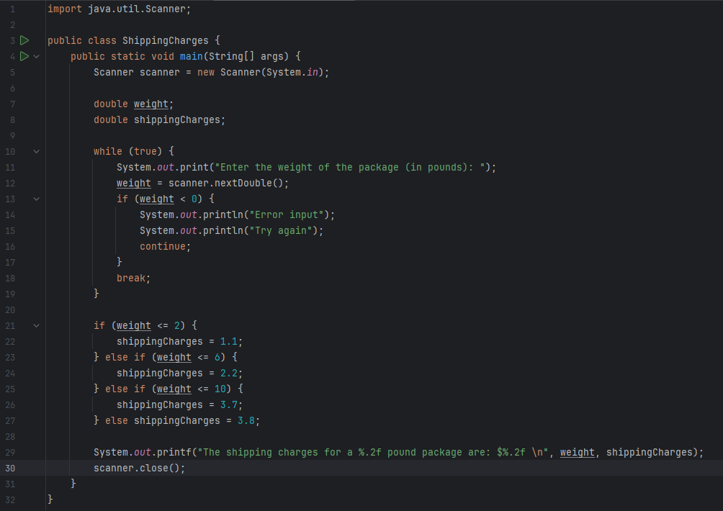
Result:
The program uses a series of if, else if, and else statements to determine the shipping charge based on the weight:
The weight is 2 pounds or less, the shipping charge is $1.10.
The weight is over 2 pounds but not more than 6 pounds, the charge is $2.20.
The weight is over 6 pounds but not more than 10 pounds, the charge is $3.70
The weight is over 10 pounds, the charge is $3.80
Contribution Table
Problem 1
Problem 1
Problem 2
Problem 2
Problem 2

Assignment for Lecture 4:

- Mirror Drawing
Students: – and –
a) Write a program running in Console that asks the user to input the width and the height of the Mirror. They are even numbers.
Draw the mirror.
b) Write an Applet for doing the same thing.
Solution:
This program will ask the user to input the width and height of the mirror. They are even numbers and then draw the mirror accordingly.
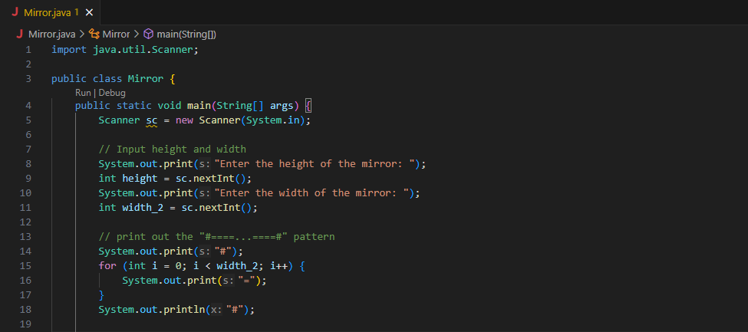
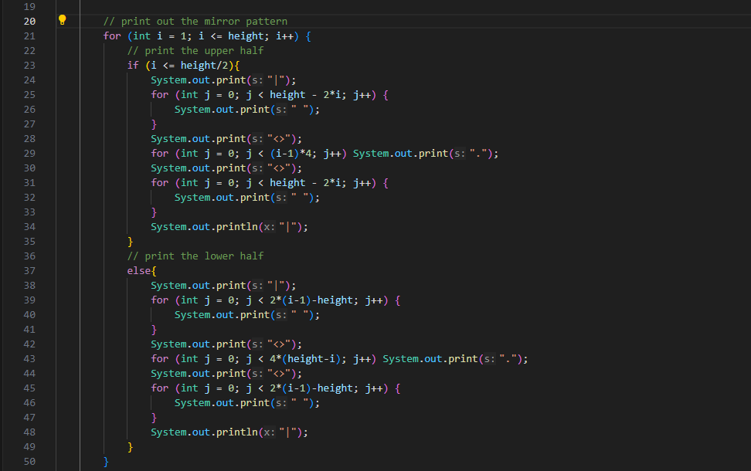
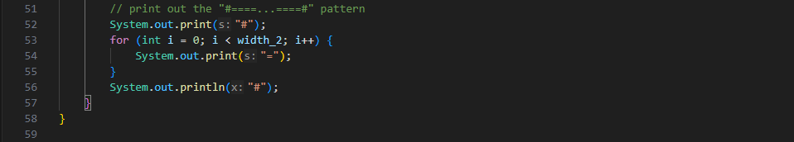
Result in console:
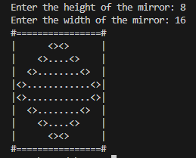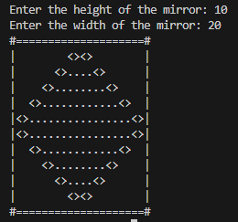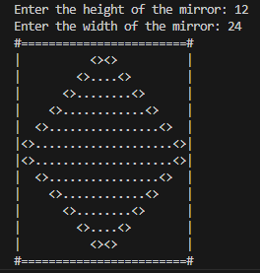
- Programming Challenges
Students: – and –

4.18. Random Number Guessing Game Enhancement.
Enhance the program that you wrote for Programming Challenge 17 so it keeps a count of the number of guesses that the user makes. When the user correctly guesses the random number, the program should display the number of guesses.
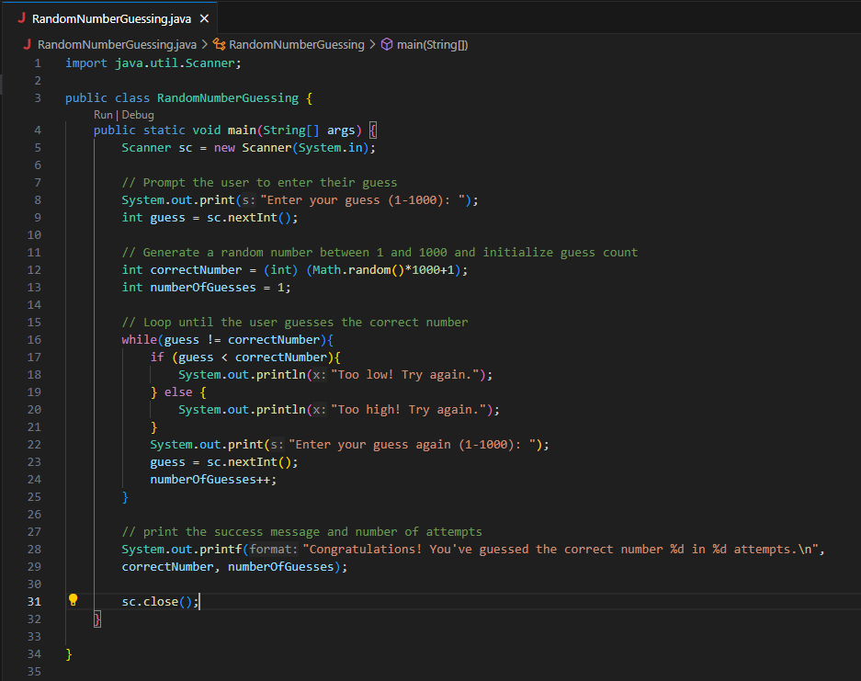Explanation:
1. Imports:
- import java.util.Scanner; allows us to read input from the user.
2. Class Declaration:
- public class RandomNumberGuessing defines the main class of the program.

3. Main Method:
- public static void main(String[] args) is the entry point of the program.
4. Random Number Generation:
- int correctNumber = (int) (Math.random()*100+1); generates a random number between 1 and 1000.
5. Variables:
- int numberOfGuesses = 1; initializes the variable to keep track of the user's guesses.
6. User Interaction:
- The program asks the user to input their guess.
7. Guessing Loop:
- The while loop continues until the user guesses the correct number.
- guess = sc.nextInt(); reads the user's guess from the console.
- numberOfGuesses++; increments the guess count each time the user makes a guess.
- The program provides feedback on whether the guess is too low, too high, or correct.
- When the user guesses correctly, the program displays the random number and the total number of guesses.
8. Closing the Scanner:
- scanner.close(); closes the scanner to avoid resource leaks.
4.19. ESP Game.
Write a program that tests your ESP (extrasensory perception). The program should randomly select the name of a color from the following list of words:
Red, Green, Blue, Orange, Yellow
To select a word, the program can generate a random number. For example, if the number is 0, the selected word is Red, if the number is 1, the selected word is Green, and so forth.
Next, the program should ask the user to enter the color that the computer has selected. After the user has entered his or her guess, the program should display the name of the randomly selected color. The program should repeat this 10 times and then display the number of times the user correctly guessed the selected color.
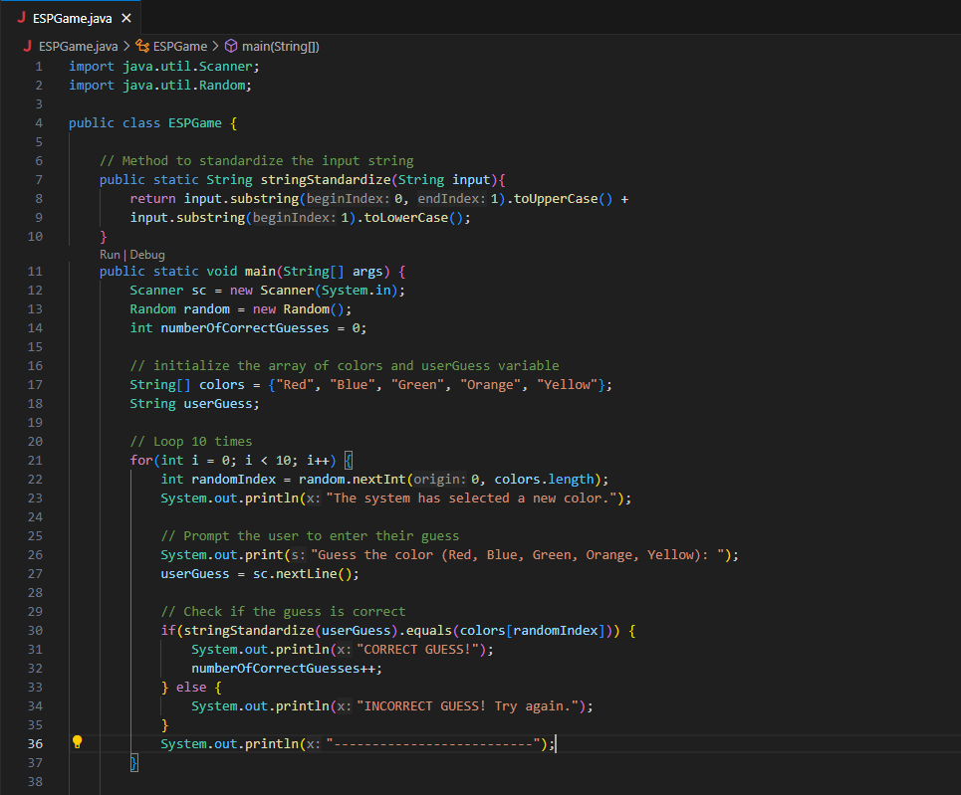
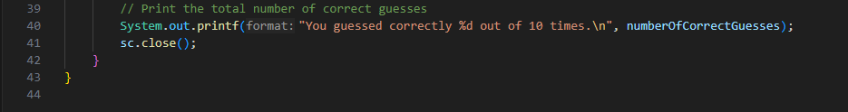

Explanation:
1. Imports:
- import java.util.Random; allows us to generate random numbers.
- import java.util.Scanner; allows us to read input from the user.

2. Class Declaration:
- public class ESPColorGame defines the main class of the program.
- public static String stringStantardize defines the class used for standardizing string input from the user.
3. Main Method:
- public static void main(String[] args) is the entry point of the program.
4. Array of Colors:
- String[] colors = {"Red", "Green", "Blue", "Orange", "Yellow"}; creates an array containing the list of colors.
5. Random Number Generator:
- Random random = new Random(); creates a Random object to generate random indices.
6. Scanner Initialization:
- Scanner scanner = new Scanner(System.in); initializes a scanner to read user input.
7. Correct Guess Counter:
- int numberOfCorrectGuesses = 0; initializes a counter for tracking correct guesses.
8. Guessing Loop:
- The for loop runs 10 times to allow the user to guess the color.
- int randomIndex = random.nextInt(0, colors.length); generates a random index to select a color from the array.
- colors[randomIndex]; retrieves the color corresponding to the random index.
- The program prompts the user to guess the color and reads the input.
9. Display and Check Guess:
- It checks if the user's guess matches the selected color (ignoring case) and increments the correct guess counter if it's correct.
10. Final Output:
- After the loop, the program displays the total number of correct guesses made by the user.
11. Closing the Scanner:
- scanner.close(); closes the scanner to avoid resource leaks.
Result in console:
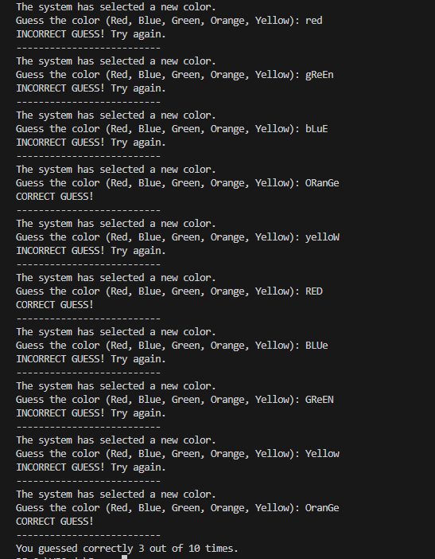
4.21. Dice Game.
Write a program that plays a simple dice game between the computer and the user. When the program runs, a loop should repeat 10 times. Each iteration of the loop should do the following:
- Generate a random integer in the range of 1 through 6. This is the value of the
computer’s die.
- Generate another random integer in the range of 1 through 6. This is the value of the user’s die.
- The die with the highest value wins. (In case of a tie, there is no winner for that particular roll of the dice.)
As the loop iterates, the program should keep count of the number of times the computer wins, and the number of times that the user wins. After the loop performs all of its iterations, the program should display who was the grand winner, the computer or the user.
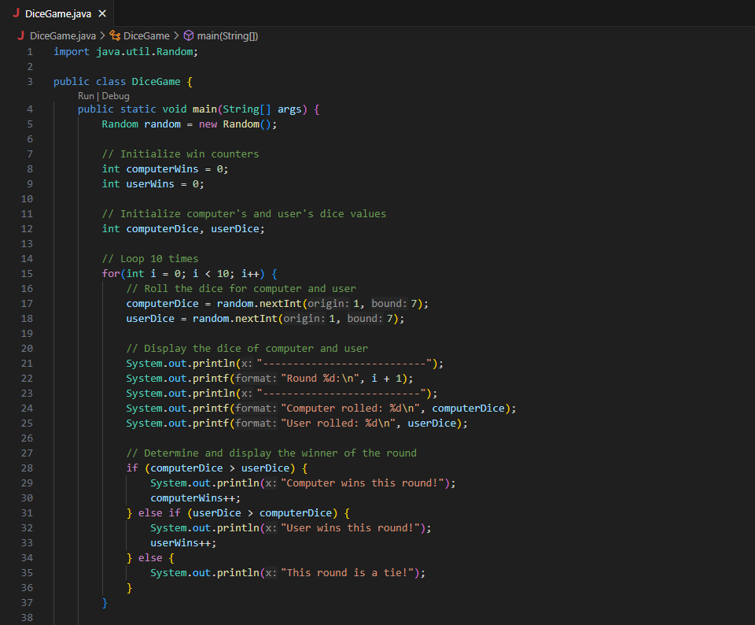
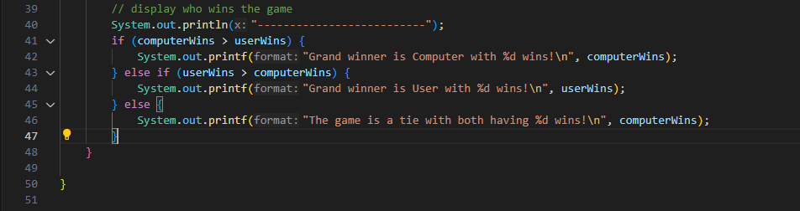Explanation:
1. Imports:
- The program imports the Random class to generate random numbers.
2. Main Method:
- The main method is where the program starts executing.
- counters, computerWins and userWins, are initialized to keep track of the number of wins for each player.
3. Loop for 10 Rounds:
- A for loop runs 10 times, representing each round of the game.
- Inside the loop:
- Random integers are generated using random.nextInt(6) + 1 to simulate dice rolls (values from 1 to 6) for both the computer and the user.
- The results of the rolls are printed.
- comparison is made to determine the winner of each round:
- If the computer's roll is greater, computerWins is incremented.
- If the user's roll is greater, userWins is incremented.
- If both rolls are equal, it results in a tie.
4. Final Results:
- After all rounds are completed, the program prints the total number of wins for both the computer and the user.
- The overall winner is determined and printed based on who has more wins, or if it’s a tie overall.

Result in console:
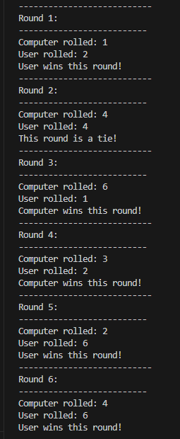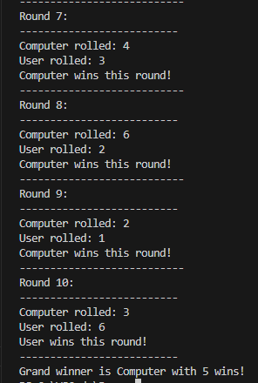

- Write a program that asks the user to enter two numerical values (integers) and then select an operation (addition, subtraction, multiplication and division) then prints the result based on the operation selected. The code below shows examples of the output (text shown in boldface is supposed to be user input).
Student: –
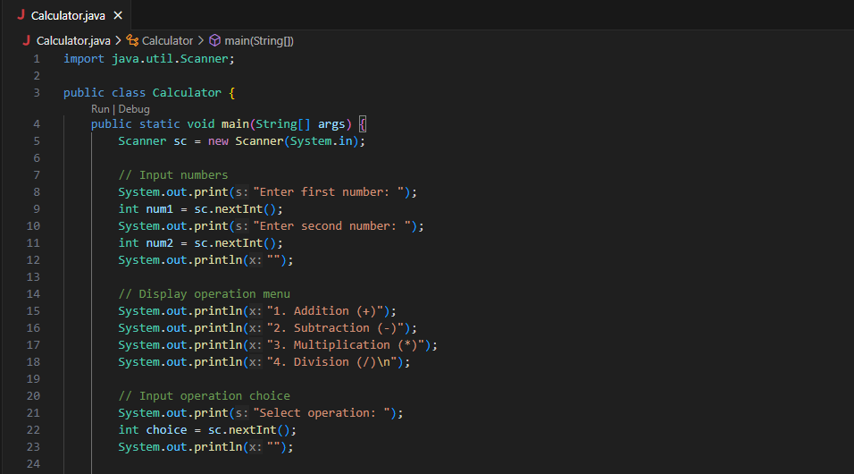
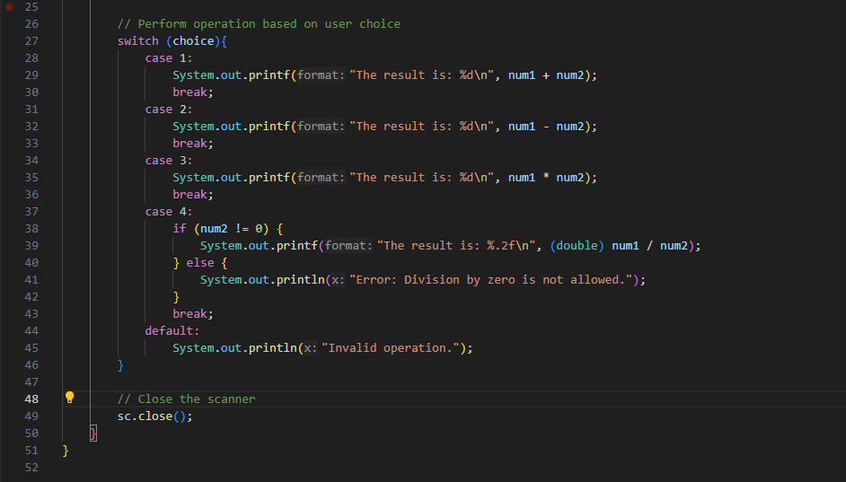
Imports:
- The program imports the Scanner class to read user input.
Main Method:
- The main method is where the program execution begins.
- A Scanner object is created to read input from the console.

User Input:
- The program prompts the user to enter two integers.
- It then asks the user to select an operation from the provided list (addition, subtraction, multiplication, or division).
Use switch cases to let the user enter menu choices:
Operation Selection:
- The program uses a switch statement to determine which operation to perform based on the user's selection.
- For each case (1 to 4):
  - The corresponding operation is performed, and the result is printed.
  - In the case of division, it checks if the second number is zero to avoid division by zero errors.
Result in console:
- Addition(+):
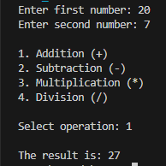

- Subtraction (-):
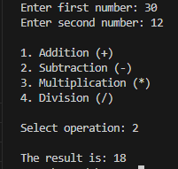

- Multiplication(*):
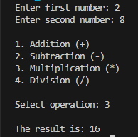

- Division(/):
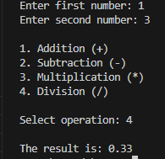

Contribution Table
Problem 1
Problem 1
Problem 2
Problem 2
Problem 3

Assignment for Lecture 5:

Occurrence of max numbers
Write a program that reads integers, finds the largest of them, and counts its occurrences. Assume that the input ends with number 0. Suppose that you entered 3 5 2 5 5 5 0; the program finds that the largest is 5 and the occurrence count for 5 is 4.

DESCRIPTION
- The program reads integers from user input until 0 is entered.
- It keeps track of:
· res → the largest number found.
· cnt → how many times that number appears.
- For each number entered:
· If it’s greater than res, update res and reset cnt = 1.
· If it equals res, increase cnt by 1.
- When input ends, the program prints:
· The largest number.
· The occurrence count of that number.
Student: –

SOLUTION
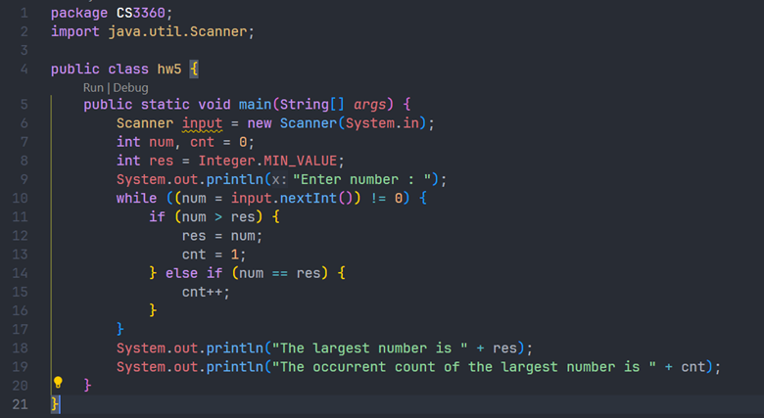

RESULT
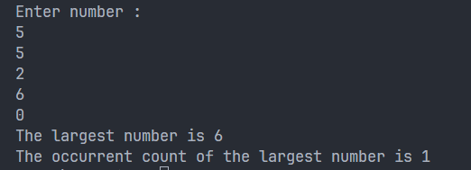
- Programming Challenges
Students: – , – and –
5.1 showChar method
Write a method named showChar. The method should accept two arguments: a reference to a String object and an integer. The integer argument is a character position within the String, with the first character being at position 0. When the method executes, it should display the character at that character position. Here is an example of a call to the method:
showChar("New York", 2);
In this call, the method will display the character w because it is in position Demonstrate the method in a complete program.

DESCRIPTION
- The program defines a method showChar that receives a String and an integer position.
- The method prints the character located at the specified position (index starts from 0).
- The main method asks the user to input a string and an integer index, then calls showChar.
- If the index is within range, the corresponding character is displayed; otherwise, an error message is shown.
SOLUTION
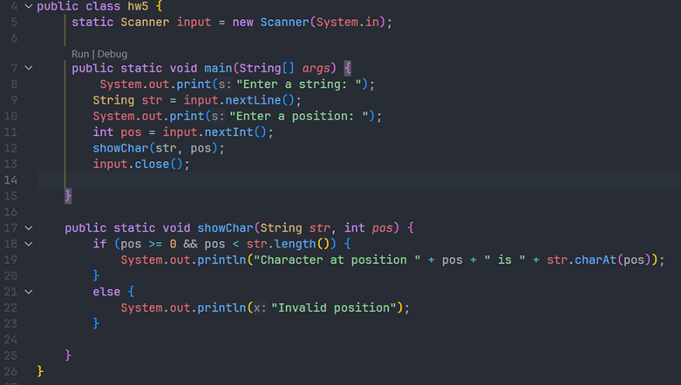

RESULT
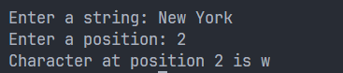
5.2 Retail Price Calculator
Write a program that asks the user to enter an item's wholesale cost and its markup percent- age. It should then display the item's retail price. For example:
If an item's wholesale cost is 5.00 and its markup percentage is 100 percent, then the item's retail price is 10.00.
If an item's wholesale cost is 5.00 and its markup percentage is 50 percent, then the item's retail price is 7.50.
The program should have a method named calculateRetail that receives the wholesale cost and the markup percentage as arguments, and returns the retail price of the item.

DESCRIPTION
-The program asks the user to input two values:
· The wholesale cost of an item
· The markup percentage
-A method named calculateRetail() takes these two values as parameters and returns the retail price.
-The retail price is calculated using the formula:
retail = cost + (cost * percent / 100)
-Finally, the program prints the retail price formatted to two decimal places.

SOLUTION
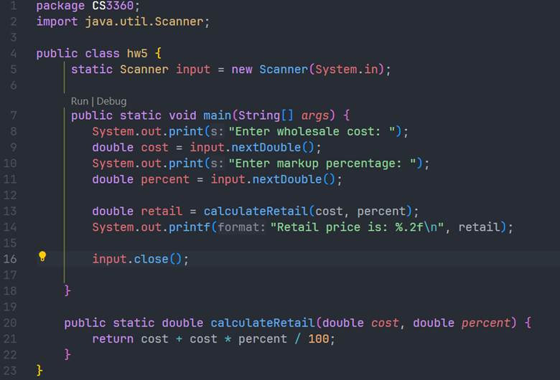

RESULT
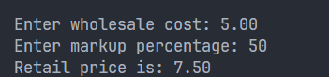
5.4 Paint Job Estimator
A painting company has determined that for every 115 square feet of wall space, one gallon of paint and eight hours of labor will be required. The company charges $18.00 per hour for labor. Write a program that allows the user to enter the number of rooms to be painted and the price of the paint per gallon. It should also ask for the square feet of wall space in each room. The program should have methods that return the following data:
• The number of gallons of paint required
• The hours of labor required
• The cost of the paint
• The labor charges
• The total cost of the paint job
Then it should display the data on the screen.
DESCRIPTION
- The program estimates the total cost of a paint job based on user inputs.
- It prompts the user for:
- The number of rooms to be painted.
- The price of paint per gallon.
- The square feet of wall space in each room.
- Constants used:
- 1 gallon covers 115 sq. ft.
- 1 gallon requires 8 hours of labor
- Labor rate is $18.00 per hour
- Calculations are divided into separate methods for clarity:
- getGallons() → calculates gallons of paint required using total wall area.
- getHours() → calculates total hours of labor.
- getPaintCost() → computes paint cost using number of gallons and price per gallon.
- getLaborCost() → calculates total labor charge.
- getTotalCost() → adds paint cost and labor charge for the final total.
- Results are displayed neatly with two-decimal formatting.

SOLUTION
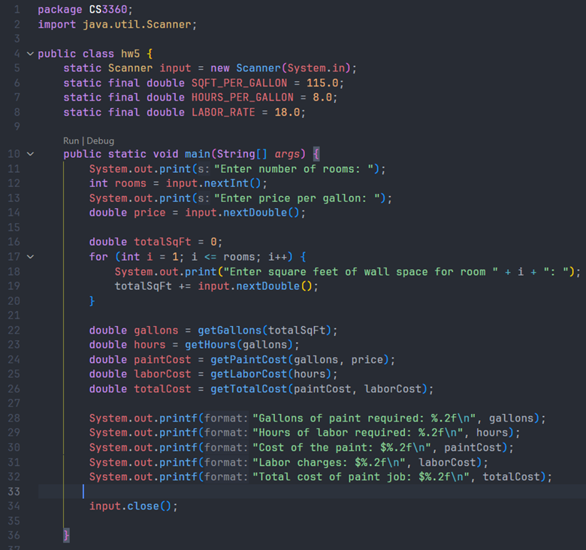
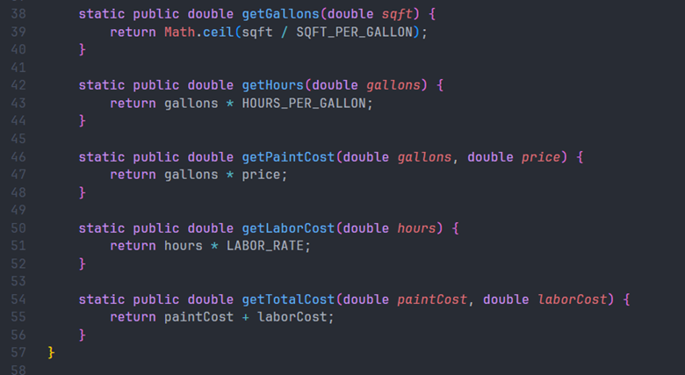

RESULT
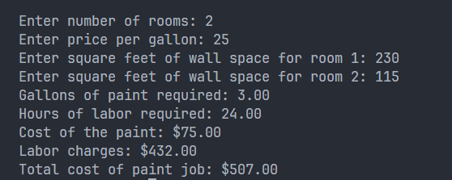
- Muptiplicatin table
Student: –
Write a program that uses nested for loops to print a multiplication table inside a dialog as follows:
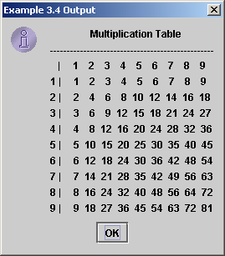

DESCRIPTION
-The program generates and displays a 9×9 multiplication table inside a dialog box using nested for loops.
-A String variable table is used to store the formatted content of the table before displaying.
-The first loop creates the table header showing numbers 1 through 9.
-The nested loops print the row labels and each product (i × j) aligned in columns using String.format("%4d", value) for neat spacing.
-The entire formatted table string is displayed via
JOptionPane.showMessageDialog(null, table, "Multiplication Table", JOptionPane.INFORMATION_MESSAGE);
-The result matches the example output, showing a well-structured multiplication chart inside the dialog.

SOLUTION
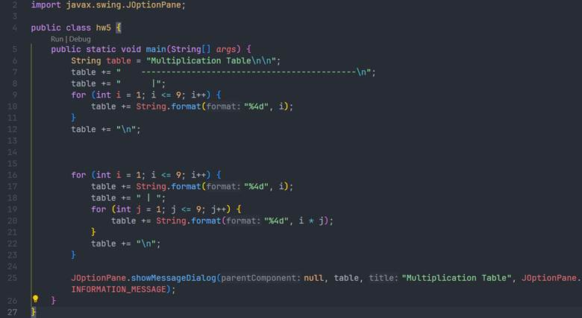

RESULT
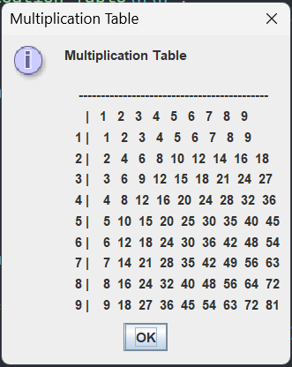

Contribution Table
Problem 1
Problem 2
Problem 2
Problem 2
Problem 3

Assignment for Lecture 6:
- Implementation of Student Class
a) Write a class Student which models students with their:
ID: string, name, accumulated CPA, prefer courses (an array of String).
b) Write a program that create and display about the following students:
(TROY1231, Bob Walker, 3.21, {"Math", "Philosophy", "Art"})
(TROY1217, Bao Trung, 2.67, {"Computer Science I", "Math")}
(TROY1362, Nina Gigi, 2.99, {"Sing", "Dance", "Physics"})
the find the course that is most prefer by Student.
Don't use constructor, private methods in this exercises.
Student: –
ANSWER:
a,
The Studen class models a student with four attributes:
-ID(String)
-name(String)
-CPA(double)
-preferredCourses(String[])
The displayInfo() prints all information about student, include the list of preferred courses.
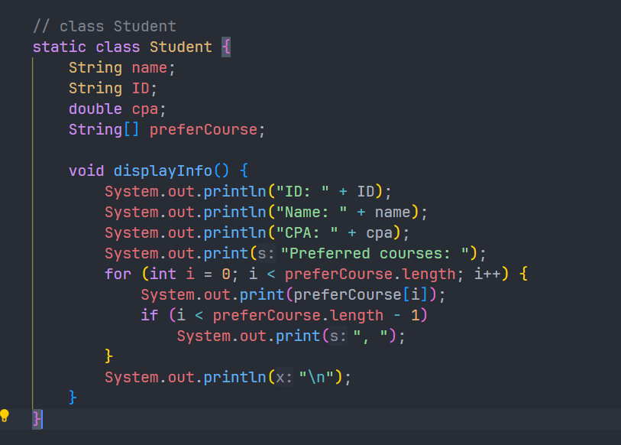
b,
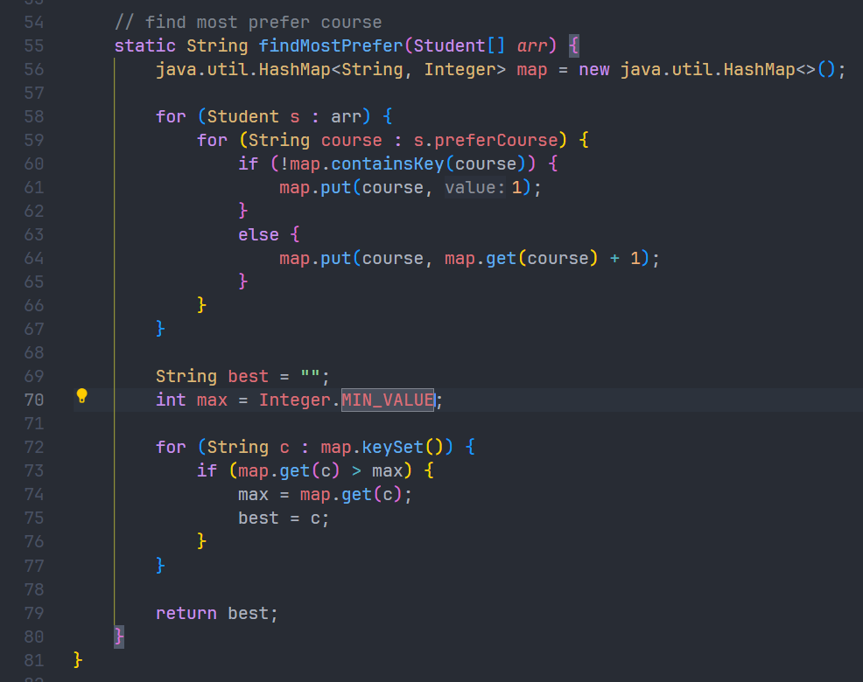
-The method findMostPrefer(Student[] arr) determines which course appears most frequently among all students.
-It uses a HashMap<String, Integer> to count how many times each course is preferred.
-For every student, the method increases the count for each course inside their preferredCourses list.
-After counting, it scans the map to find the course with the highest frequency.
-The method returns the most commonly preferred course.

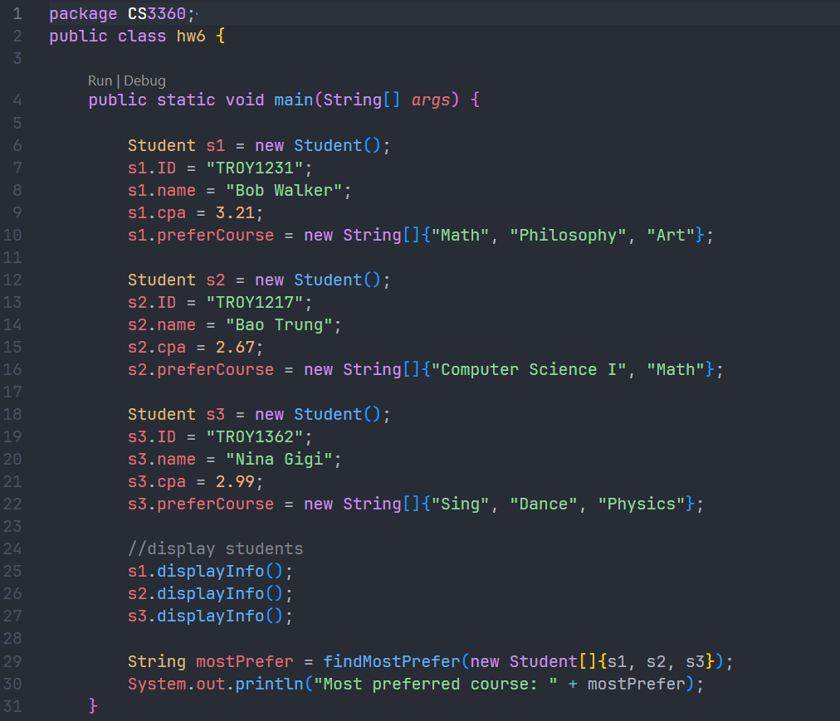

Output
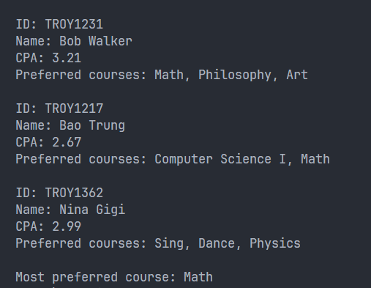
- Implementation of TV class
Consider television sets. Each TV is an object with states (current channel, current volume level, power on or off) and behaviors (change channels, adjust volume, turn on/off). Write a class to model TV sets and demo their usages in a program.
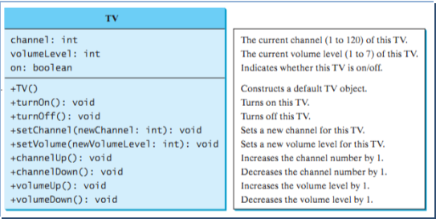

Student: –

Description:
- The class has private fields for channel, volumeLevel, and on (indicating power state).
- The constructor initializes these fields to default values.
- Methods are provided to turn the TV on/off, set channel and volume (within specified limits), and increment/decrement channel and volume.
- The main method demonstrates usage by creating a TV object, turning it on, setting channel and volume, and then performing actions like increasing channel and volume.
Solution:
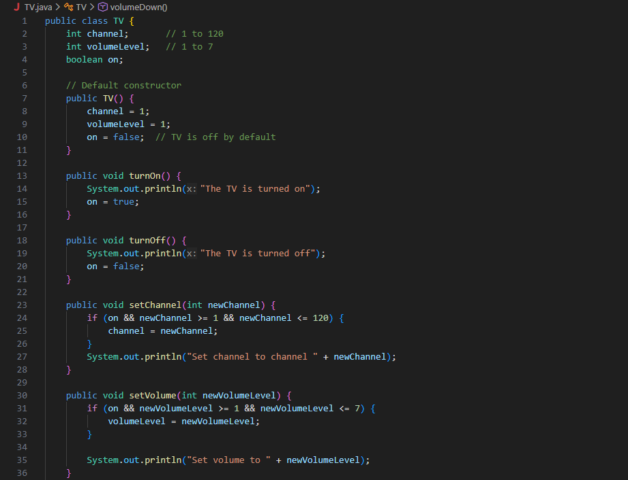
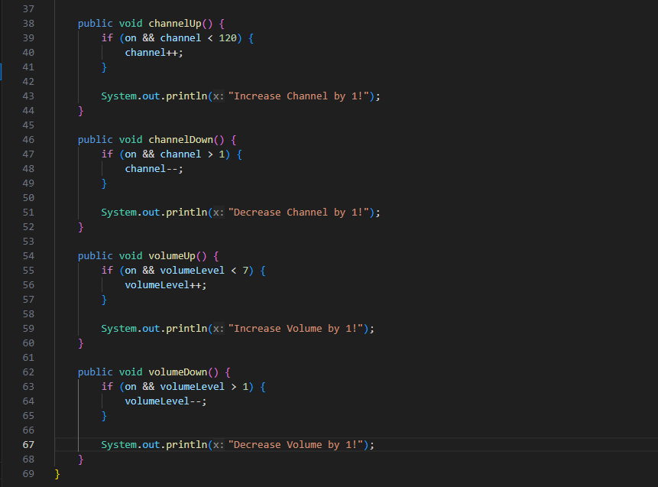
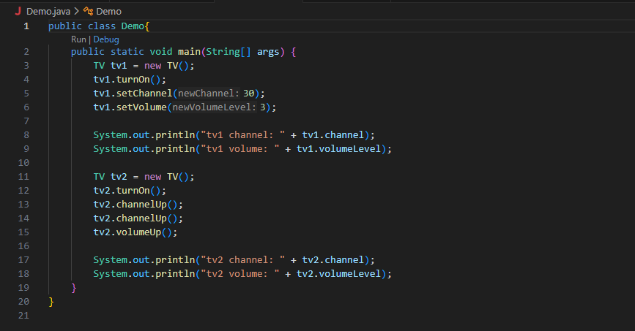

Result:
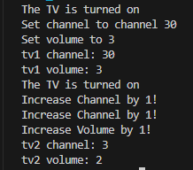

- Programming Challenge

6.1. Employee Class.
Write a class named Employee that has the following fields:
- name. The name field references a String object that holds the employee’s name.
- idNumber. The idNumber is an int variable that holds the employee’s ID number.
- department. The department field references a String object that holds the name of the department where the employee works.
- position. The position field references a String object that holds the employee’s job title.
The class should have the following constructors:
- A constructor that accepts the following values as arguments and assigns them to the appropriate fields: employee’s name, employee’s ID number, department, and position.
- A constructor that accepts the following values as arguments and assigns them to the appropriate fields: employee’s name and ID number. The department and position fields should be assigned an empty string ("").
- A no-arg constructor that assigns empty strings ("") to the name, department, and position fields, and 0 to the idNumber field.
Write appropriate mutator methods that store values in these fields and accessor methods
that return the values in these fields. Once you have written the class, write a separate pro
gram that creates three Employee objects to hold the following data:
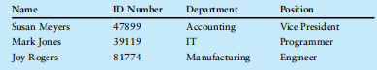
The program should store this data in the three objects and then display the data for each
employee on the screen.
Student: –
Description:
- The Employee class has four private fields: name, idNumber, department, and position.
- It includes three constructors:
o A constructor that initializes all fields.
o A constructor that only initializes name and idNumber, setting department and position to empty strings.
o A no-argument constructor that sets all fields to default values.
- The class also has getter and setter methods for each field.
- The main method creates three Employee objects with the given data, then prints the information in a table format similar to the one in the image.

Solution:

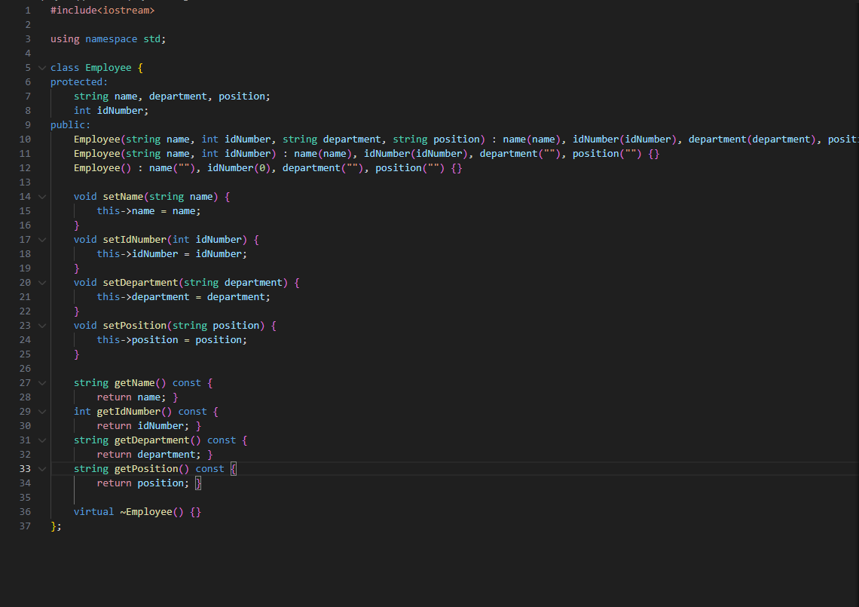
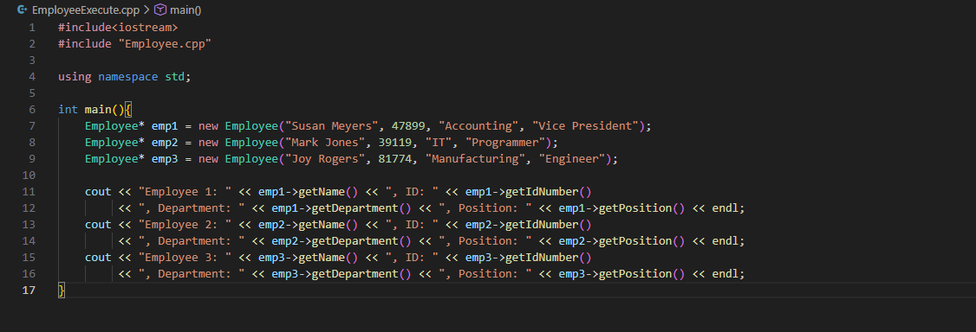

Result:

6.2. Car Class
Write a class named Car that has the following fields:
• yearModel. The yearModel field is an int that holds the car’s year model.
• make. The make field references a String object that holds the make of the car.
• speed. The speed field is an int that holds the car’s current speed.
In addition, the class should have the following constructor and other methods.
• Constructor. The constructor should accept the car’s year model and make as arguments. These values should be assigned to the object’s yearModel and make fields. The constructor should also assign 0 to the speed field.
• Accessors. Appropriate accessor methods should get the values stored in an object’s yearModel, make, and speed fields.
• accelerate. The accelerate method should add 5 to the speed field each time it is called.
• brake. The brake method should subtract 5 from the speed field each time it is called.
Demonstrate the class in a program that creates a Car object, and then calls the accelerate method five times. After each call to the accelerate method, get the current speed of the car and display it. Then call the brake method five times. After each call to the brake method, get the current speed of the car and display it.

Student: –
Description:
● The Car class contains three private fields: yearModel, make, and speed.
● It provides a constructor that initializes the car’s year model and make, while setting the initial speed to 0.
● The class includes accessor methods for all fields, along with two action methods:
• accelerate() increases the speed by 5.
• brake() decreases the speed by 5, ensuring the value does not go below 0.
● The main method creates a Car object and demonstrates its behavior by calling accelerate() five times and printing the speed after each call, then calling brake() five times and printing the updated speed.
Solution:
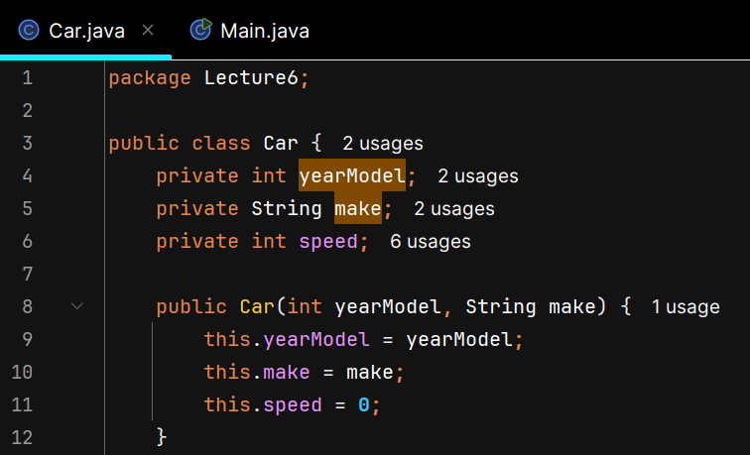
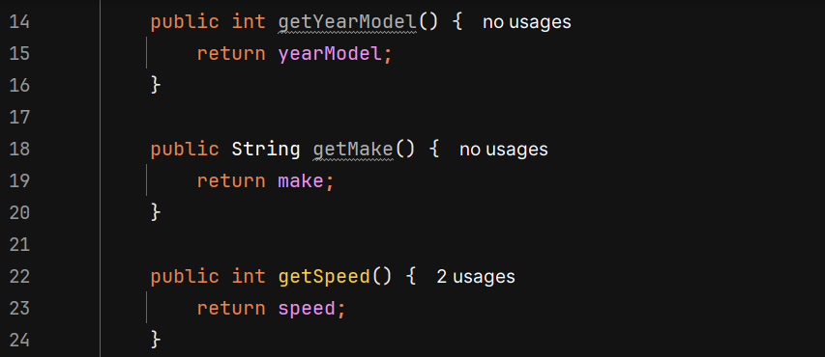
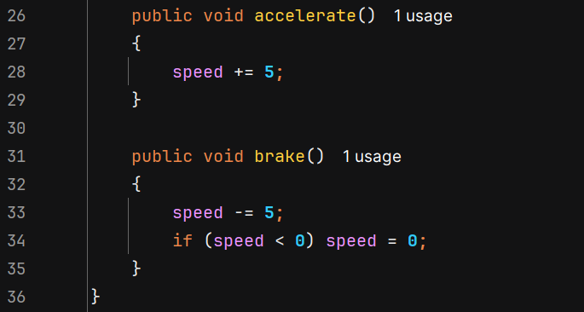
In main():
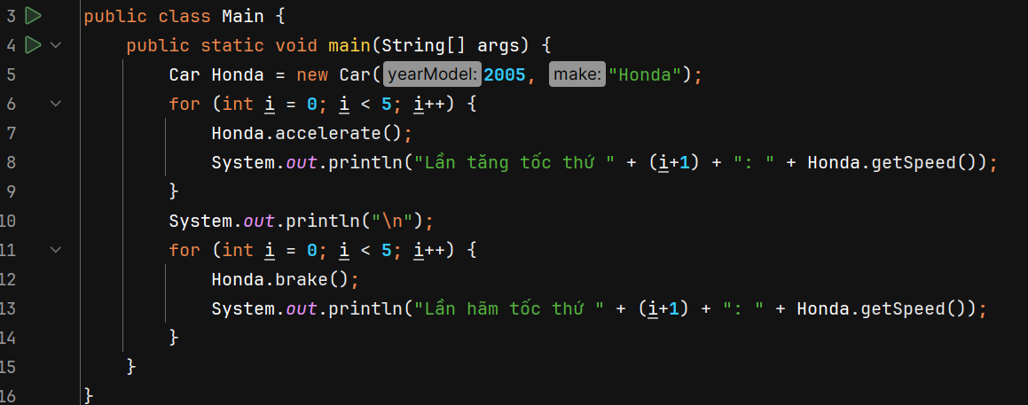

Result:
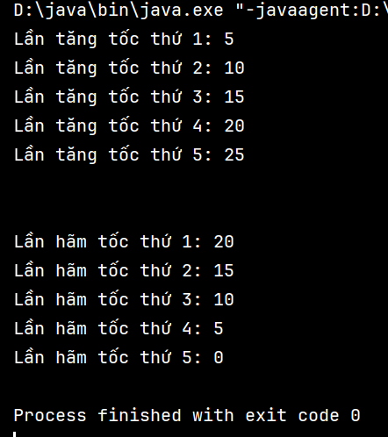
6.3. Personal Information Class
Design a class that holds the following personal data: name, address, age, and phone number. Write appropriate accessor and mutator methods. Demonstrate the class by writing a program that creates three instances of it. One instance should hold your information, and the other two should hold your friends' or family members' information.
Student: –
Description:
- The Personal Info class has four private fields: name, address, age, and phoneNumber.
- The constructor initializes all four fields.
- The class includes getter and setter methods for each field.
- In the main method, three instances of PersonalInfo are created, each representing a different person (yourself, a friend, and a family member).
- The program then displays the information for each person using the getter methods.
Solution:
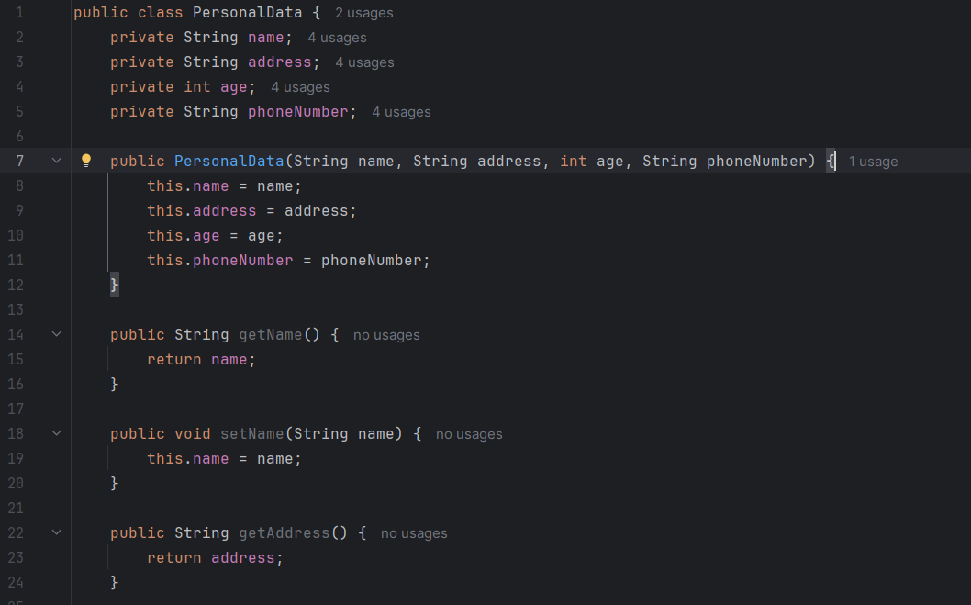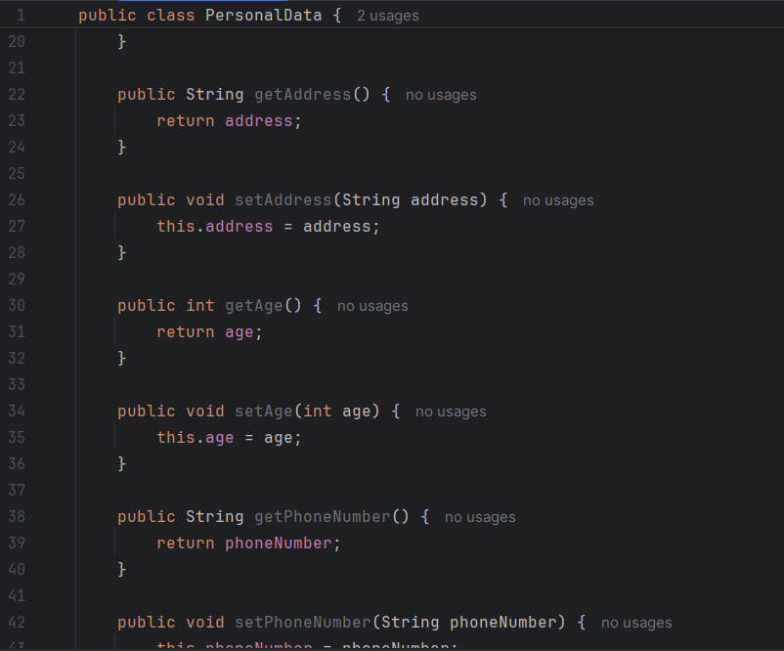
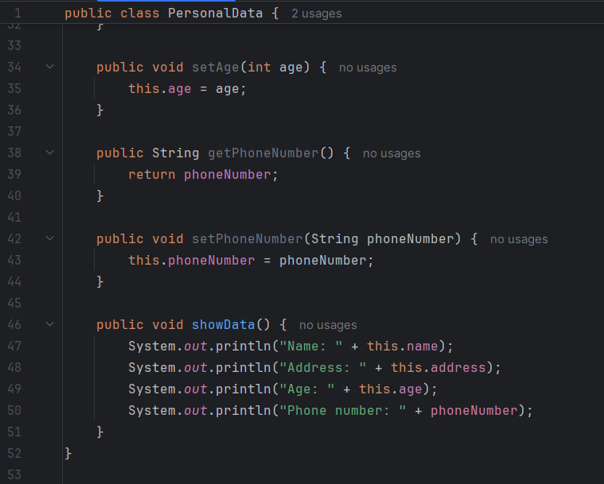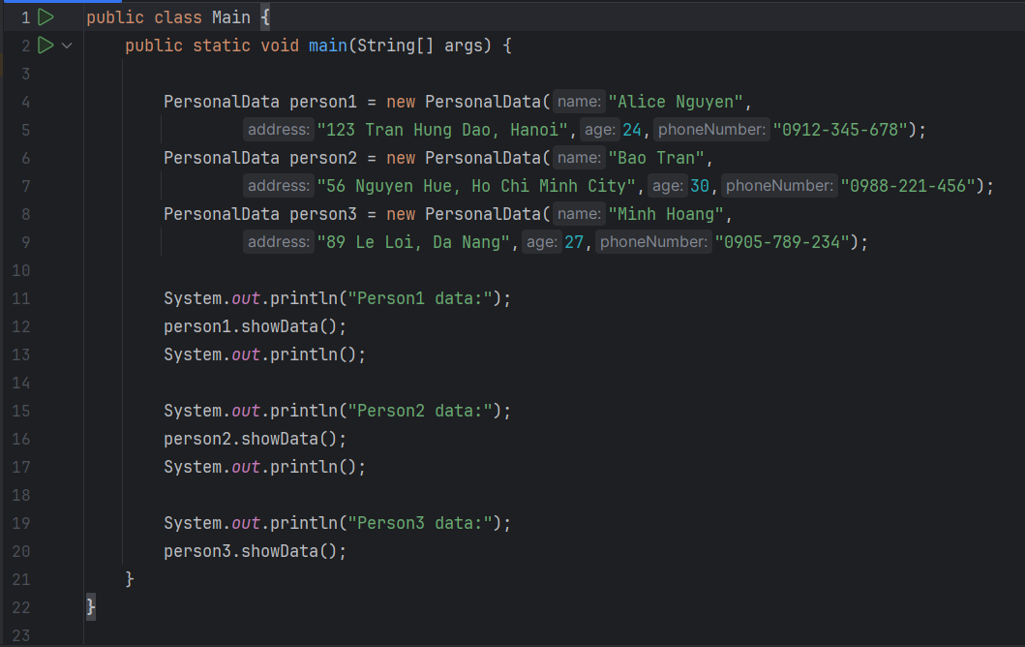

Result:
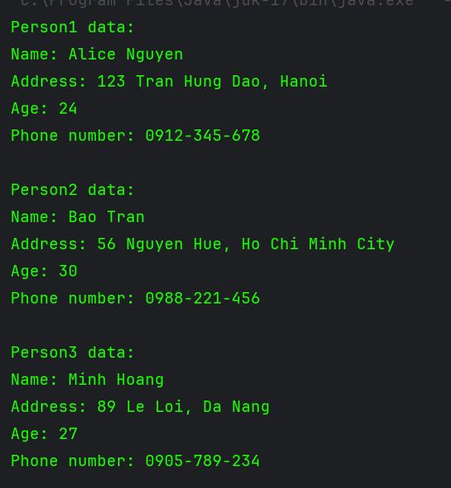
6.4. RetailItem Class
Write a class named RetailItem that holds data about an item in a retail store. The class should have the following fields:
description. The description field references a String object that holds a brief description of the item.
• unitsOnHand. The unitsOnHand field is an int variable that holds the number of units currently in inventory.
price. The price field is a double that holds the item's retail price.
Write a constructor that accepts arguments for each field, appropriate mutator methods that store values in these fields, and accessor methods that return the values in these fields. Once you have written the class, write a separate program that creates three RetailItem objects and stores the following data in them:
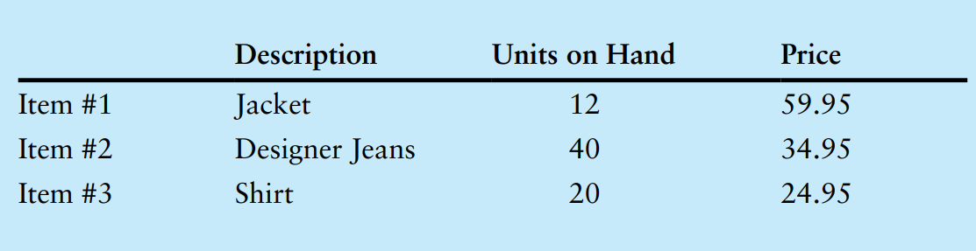
Student: –
Description:
- Definition: The RetailItem class has three fields: description, unitsOnHand, and price.
- Constructor: Initializes each field with the provided arguments.
- Mutator Methods: setDescription, setUnitsOnHand, and setPrice allow setting values to each field.
- Accessor Methods: getDescription, getUnitsOnHand, and getPrice return values of each field.
- Objects Creation: Three RetailItem objects (item1, item2, item3) are created with data from the table and printed.

Solution:
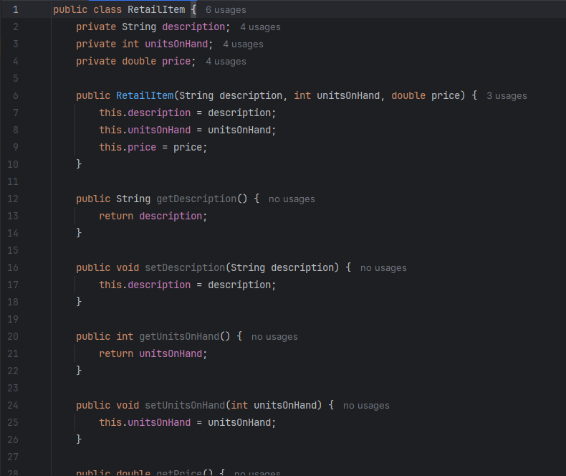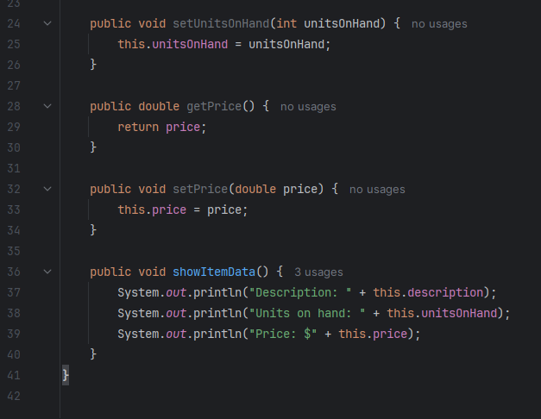

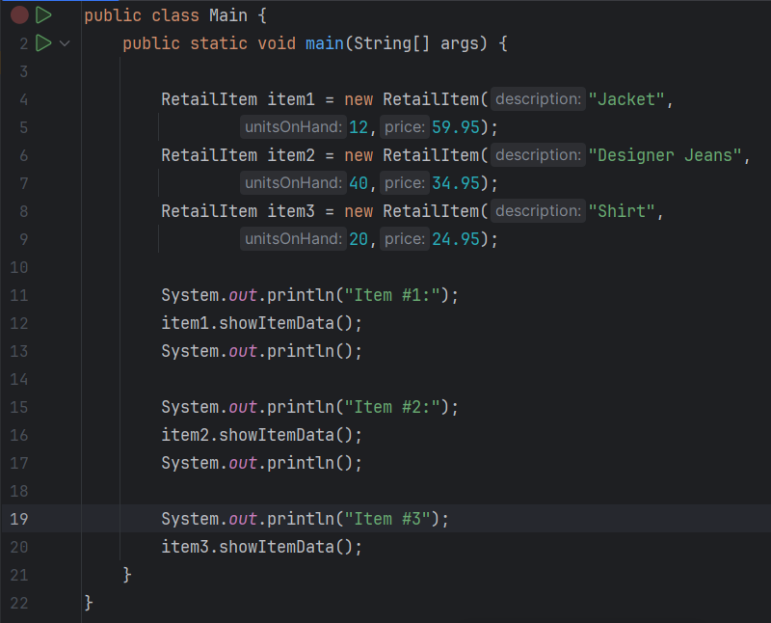
Result:
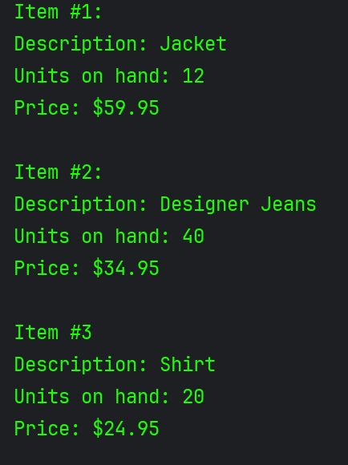
Contribution Table
Problem 1
Problem 2
Problem 3
Problem 3
Problem 3

