CS 360 – PROJECT (Homework 7-12)
GROUP
Members:

Assignment for Lecture 7:

- Employee Class
Create a class called Employee that includes three instance variables—a first name (type String), a last name (type String) and a monthly salary (double). Provide a constructor that initializes the three instance variables. Provide a set and a get method for each instance variable. If the monthly salary is not positive, do not set its value . Write a test application named EmployeeTest that demonstrates class Employee’s capabilities. Create two Employee objects and display each object’s yearly salary. Then give each Employee a 10% raise and display each Employee’s yearly salary again
Students: – and –
Solution:
package Lecture7;
public class Employee {
private String firstName;
private String lastName;
private double salary;
public Employee(String firstName, String lastName, double salary) {
this.firstName = firstName;
this.lastName = lastName;
this.salary = salary;
}
public String getFirstName() {
return firstName;
}
public String getLastName() {
return lastName;
}
public double getSalary() {
return salary;
}
public void setFirstName(String firstName) {
this.firstName = firstName;
}
public void setSalary(double salary) {
if (salary < 0) {
return;
} else {
this.salary = salary;
}
}
public void setLastName(String lastName) {
this.lastName = lastName;
}
}
Result:
package Lecture7;
public class EmployeeTest {
public static void main(String[] args) {
Employee p1 = new Employee("Tam", "Vu", 1000);
Employee p2 = new Employee("Do", "Tran", 2000);
System.out.println("Yearly salary of p1 before raise: " + p1.getSalary()*12);
System.out.println("Yearly salary of p2 before raise: " + p2.getSalary()*12);
p1.setSalary(p1.getSalary()*1.1);
p2.setSalary(p2.getSalary()*1.1);
System.out.println("Yearly salary of p1 after raise: " + p1.getSalary()*12);
System.out.println("Yearly salary of p2 after raise: " + p2.getSalary()*12);
}
}

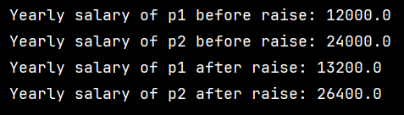

- Programming Challenges
6.5 6.6 6.8 Tony Gaddis Java.
Student: – and –
6.5:
Design a Payroll class that has fields for an employee’s name, ID number, hourly pay rate, and number of hours worked. Write the appropriate accessor and mutator methods and a constructor that accepts the employee’s name and ID number as arguments. The class should also have a method that returns the employee’s gross pay, which is calculated as the number of hours worked multiplied by the hourly pay rate. Write a program that demonstrates the class by creating a Payroll object, then asking the user to enter the data for an employee. The program should display the amount of gross pay earned.
Solution:
package Lecture7;
public class Payroll {
private String name;
private int ID;
private double hourlyPayRate;
private double workingHours;
public Payroll(String name, int ID) {
this.name = name;
this.ID = ID;
}
public String getName() {
return name;
}
public int getID() {
return ID;
}
public double getHourlyPayRate() {
return hourlyPayRate;
}
public double getWorkingHours() {
return workingHours;
}
public void setWorkingHours(double workingHours) {
if (workingHours >= 0) {
this.workingHours = workingHours;
}
}
public void setHourlyPayRate(double hourlyPayRate) {
if (hourlyPayRate >= 0) {
this.hourlyPayRate = hourlyPayRate;
}
}
public void setID(int ID) {
this.ID = ID;
}
public void setName(String name) {
this.name = name;
}
public double grossPay() {
return hourlyPayRate * workingHours;
}
}
Result:
package Lecture7;
import java.util.Scanner;
public class PayrollTest {
public static void main(String[] args) {
Scanner in = new Scanner(System.in);
System.out.print("Please enter name: ");
String name = in.nextLine();
System.out.print("Please enter ID: ");
int ID = in.nextInt();
System.out.print("Please enter hourly pay rate: ");
double hourlyPayRate = in.nextDouble();
System.out.print("Please enter working hours: ");
double workingHours = in.nextDouble();
Payroll p1 = new Payroll(name, ID);
p1.setHourlyPayRate(hourlyPayRate);
p1.setWorkingHours(workingHours);
System.out.println("The amount of gross salary is: " + p1.grossPay());
in.close();
}
}

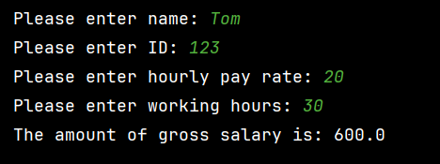

6.6:
Design a TestScores class that has fields to hold three test scores. The class should have a constructor, accessor and mutator methods for the test score fields, and a method that returns the average of the test scores. Demonstrate the class by writing a separate program that creates an instance of the class. The program should ask the user to enter three test scores, which are stored in the TestScores object. Then the program should display the average of the scores, as reported by the TestScores object
Solution:
package Lecture7;
public class TestScores {
private double score1;
private double score2;
private double score3;
public TestScores(double score1, double score2, double score3) {
this.score1 = score1;
this.score2 = score2;
this.score3 = score3;
}
public double getScore1() {
return score1;
}
public double getScore2() {
return score2;
}
public double getScore3() {
return score3;
}
public void setScore1(double score1) {
this.score1 = score1;
}
public void setScore2(double score2) {
this.score2 = score2;
}
public void setScore3(double score3) {
this.score3 = score3;
}
public double getAverage() {
return (score1 + score2 + score3) / 3;
}
}
Result:
package Lecture7;
import java.util.Scanner;
public class TestScoresTest {
public static void main(String[] args) {
Scanner in = new Scanner(System.in);
System.out.print("Please enter test score 1: ");
double s1 = in.nextDouble();
System.out.print("Please enter test score 2: ");
double s2 = in.nextDouble();
System.out.print("Please enter test score 3: ");
double s3 = in.nextDouble();
TestScores scores = new TestScores(s1, s2, s3);
System.out.println("The average score is: " + scores.getAverage());
in.close();
}
}

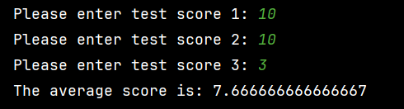

6.8:
Write a class named Temperature that stores a temperature in Fahrenheit and provides methods to retrieve the temperature in Fahrenheit, Celsius, and Kelvin.

1. Data Field
The Temperature class should contain the following field:
- ftemp: a double variable that stores the temperature in Fahrenheit.

2. Methods
The Temperature class must include the following methods:
- Constructor: accepts a Fahrenheit temperature (as a double) and stores it in the ftemp field.
- setFahrenheit(double fahrenheit): sets the value of ftemp to the given Fahrenheit temperature.
- getFahrenheit(): returns the value of ftemp as a Fahrenheit temperature (no conversion required).
- getCelsius(): returns the value of ftemp converted to Celsius.
- getKelvin(): returns the value of ftemp converted to Kelvin.

3. Temperature Conversion Formulas
Use the following formulas for temperature conversion:
- Celsius = (5/9) × (Fahrenheit − 32)
- Kelvin = (5/9) × (Fahrenheit − 32) + 273

4. Demonstration Program
Write a separate program to demonstrate the Temperature class. The program should:
- Prompt the user to enter a temperature in Fahrenheit.
- Create an instance of the Temperature class, passing the user-entered value to the constructor.
- Call the object’s methods to display the equivalent temperatures in Celsius and Kelvin.
Solution:
package Lecture7;
public class Temperature {
private double ftemp;
public Temperature(double ftemp) {
this.ftemp = ftemp;
}
public void setFahrenheit(double ftemp) {
this.ftemp = ftemp;
}
public double getFahrenheit() {
return ftemp;
}
public double getCelsius() {
return (5.0 / 9.0) * (ftemp - 32);
}
public double getKelvin() {
return (5.0 / 9.0) * (ftemp - 32) + 273;
}
}
Result:
package Lecture7;
import java.util.Scanner;
public class TemperatureTest {
public static void main(String[] args) {
Scanner in = new Scanner(System.in);
System.out.print("Please enter a Fahrenheit temperature: ");
double f = in.nextDouble();
Temperature temp = new Temperature(f);
System.out.println("Temperature in Fahrenheit: " + temp.getFahrenheit());
System.out.println("Temperature in Celsius: " + temp.getCelsius());
System.out.println("Temperature in Kelvin: " + temp.getKelvin());
in.close();
}
}

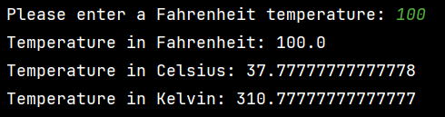
- Modify the CellPhone Project (TextBook page 352) as follows:
Add a field for discount rate (a double value). For example a discount 10% on the price means 0.1.
Add method setDiscountRate that takes a non negative value and set it to the discount rate field of the CellPhone class. This method returns true if it runs successfully and false if the argument is invalid.
Modify the method getRetailPrice so that if the value of discount rate is different to 0, apply the discount on the retail price.
Write the constructor that initialize all fields using parameters.
In the CellPhoneTest class, add a new object phone 2 with a discount rate inputted from keyboard and display all information about this phone.
Students: –
Solution:
package Lecture7;
public class CellPhone {
private String manufact;
private String model;
private double retailPrice;
private double discountRate;
public CellPhone(String man, String mod, double price, double discountRate) {
manufact = man;
model = mod;
retailPrice = price;
this.discountRate = discountRate;
}
public void setManufact(String man) {
manufact = man;
}
public void setModel(String mod) {
model = mod;
}
public void setRetailPrice(double price) {
retailPrice = price;
}
public String getManufact() {
return manufact;
}
public String getModel() {
return model;
}
public double getRetailPrice() {
if (discountRate != 0){
return retailPrice * (1-discountRate);
}
return retailPrice;
}
public double getDiscountRate() {
return discountRate;
}
public boolean setDiscountRate(double discountRate) {
if (discountRate >= 0) {
this.discountRate = discountRate;
return true;
} else {
return false;
}
}
}
Result:
package Lecture7;
import java.util.Scanner;
public class CellPhoneTest {
public static void main(String[] args) {
Scanner keyboard = new Scanner(System.in);
System.out.print("Enter the manufacturer: ");
String testMan = keyboard.nextLine();
System.out.print("Enter the model number: ");
String testMod = keyboard.nextLine();
System.out.print("Enter the retail price: ");
double testPrice = keyboard.nextDouble();
CellPhone phone = new CellPhone(testMan, testMod, testPrice, 0);
System.out.println();
System.out.println("Here is the data for phone 1:");
System.out.println("Manufacturer: " + phone.getManufact());
System.out.println("Model number: " + phone.getModel());
System.out.println("Retail price: " + phone.getRetailPrice());
keyboard.nextLine();
System.out.print("\nEnter the manufacturer for phone 2: ");
String man2 = keyboard.nextLine();
System.out.print("Enter the model number for phone 2: ");
String mod2 = keyboard.nextLine();
System.out.print("Enter the retail price for phone 2: ");
double price2 = keyboard.nextDouble();
System.out.print("Enter the discount rate for phone 2: ");
double discount = keyboard.nextDouble();
CellPhone phone2 = new CellPhone(man2, mod2, price2, discount);
System.out.println();
System.out.println("Here is the data for phone 2:");
System.out.println("Manufacturer: " + phone2.getManufact());
System.out.println("Model number: " + phone2.getModel());
System.out.println("Discount rate: " + phone2.getDiscountRate());
System.out.println("Final price: " + phone2.getRetailPrice());
keyboard.close();
}
}
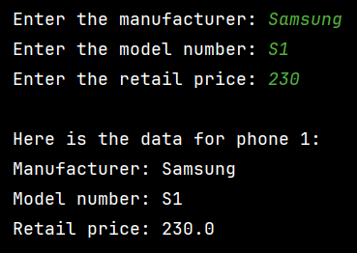
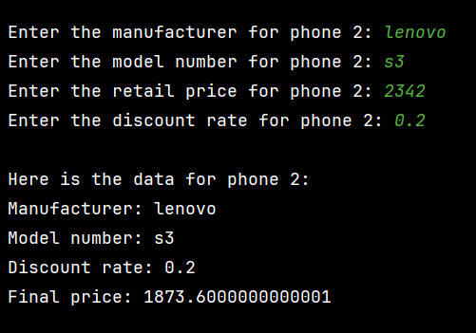

Contribution Table
Problem 1
Problem 1
Problem 2
Problem 2
Problem 3

Assignment for Lecture 8:

- Programming Challenges
7.1, 7.2, 7.3 Tony Gaddis Java.
Students: – and –
7.1:
Write a RainFall class that stores the total rainfall for each of 12 months into an array of doubles. The program should have methods that return the following:
• the total rainfall for the year
• the average monthly rainfall
• the month with the most rain
• the month with the least rain
Demonstrate the class in a complete program.
Input Validation: Do not accept negative numbers for monthly rainfall figures.
Solution:
package Lecture8;
public class Rainfall {
private double[] totalRainfall;
public Rainfall() {
totalRainfall = new double[12];
}
public void setTotalRainfall(double[] totalRainfall) {
for (int i = 0; i < 12; i++) {
if (totalRainfall[i] < 0 ){
System.out.println("Month " + (i+1) + " is not valid!!");
return;
}
}
this.totalRainfall = totalRainfall;
}
public double totalRain(){
double total = 0;
for (int i = 0; i < 12; i++) {
total += totalRainfall[i];
}
return total;
}
public double avgRainfall() {
double total = totalRain();
return total/ 12;
}
public int mostRain() {
int most = 0;
for (int i = 1; i < 12; i++){
if (totalRainfall[i] > totalRainfall[most]){
most = i;
}
}
return most+1;
}
public int leastRain() {
int least = 0;
for (int i = 1; i < 12; i++){
if (totalRainfall[i] < totalRainfall[least]){
least = i;
}
}
return least+1;
}
}
Result:
package Lecture8;
public class TestRainfall {
public static void main(String[] args) {
Rainfall rf = new Rainfall();
double[] data = {
120.5,98.3, 75.0, 60.2,
45.8, 30.1, 25.0, 28.4,
50.6, 80.9, 110.2, 130.0
};
rf.setTotalRainfall(data);
System.out.println("Total rainfall: " + rf.totalRain());
System.out.println("Average rainfall: " + rf.avgRainfall());
System.out.println("Most rainfall month: " + rf.mostRain());
System.out.println("Least rainfall month: " + rf.leastRain());
}
}
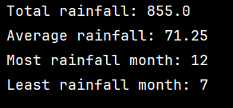
7.2:
Write a Payroll class that uses the following arrays as fields:

• employeeId. An array of seven integers to hold employee identification numbers. The array should be initialized with the following numbers:
5658845 4520125 7895122 8777541 8451277 1302850 7580489

• hours. An array of seven integers to hold the number of hours worked by each
employee
• payRate. An array of seven doubles to hold each employee’s hourly pay rate
• wages. An array of seven doubles to hold each employee’s gross wages

The class should relate the data in each array through the subscripts. For example, the number in element 0 of the hours array should be the number of hours worked by the employee whose identification number is stored in element 0 of the employeeId array. That same employee’s pay rate should be stored in element 0 of the payRate array.

In addition to the appropriate accessor and mutator methods, the class should have a method that accepts an employee’s identification number as an argument and returns the gross pay for that employee.

Demonstrate the class in a complete program that displays each employee number and asks the user to enter that employee’s hours and pay rate. It should then display each employee’s identification number and gross wages.
Input Validation: Do not accept negative values for hours or numbers less than 6.00 for pay rate.
Solution:
package Lecture8;
public class Payroll {
private int[] employeeId = {5658845, 4520125, 7895122, 8777541,8451277, 1302850, 7580489};
private int[] hours= new int[7];
private double[] payRate = new double[7];
private double[] wage= new double[7];
public Payroll(int[] employeeId, int[] hours, double[] payRate, double[] wage) {
this.employeeId = employeeId;
this.hours = hours;
this.payRate = payRate;
this.wage = wage;
}
public int[] getEmployeeId() {
return employeeId;
}
public int[] getHours() {
return hours;
}
public double[] getPayRate() {
return payRate;
}
public double[] getWage() {
return wage;
}
public void setEmployeeId(int[] employeeId) {
this.employeeId = employeeId;
}
public void setHours(int[] hours) {
for (int i = 0; i < 7; i++) {
if (hours[i] < 0 ){
System.out.println("Hours of worker " + (i+1) + " is not valid!!");
return;
}
}
this.hours = hours;
for (int i = 0; i < 7; i++) {
if (payRate[i] != 0)
{
setWage(i);
}
}
}
public void setPayRate(double[] payRate) {
for (int i = 0; i < 7; i++) {
if (payRate[i] < 6 ){
System.out.println("Pay rate of worker " + (i+1) + " is not valid!!");
return;
}
}
this.payRate = payRate;
for (int i = 0; i < 7; i++) {
if (hours[i] != 0)
{
setWage(i);
}
}
}
private void setWage(int i) {
wage[i] = hours[i]*payRate[i];
}
public double grossPay(int ID){
for (int i = 0; i < 7; i++)
{
if (this.employeeId[i] == ID){
return wage[i];
}
}
return -1;
}
}
Result:
package Lecture8;
import java.util.Scanner;
public class TestPayroll {
public static void main(String[] args) {
Scanner sc = new Scanner(System.in);
Payroll payroll = new Payroll(
new int[]{5658845, 4520125, 7895122, 8777541, 8451277, 1302850, 7580489},
new int[7],
new double[7],
new double[7]
);
int[] hours = new int[7];
double[] rates = new double[7];
for (int i = 0; i < 7; i++) {
System.out.println("Employee ID: " + payroll.getEmployeeId()[i]);
System.out.print("Enter hours worked: ");
hours[i] = sc.nextInt();
System.out.print("Enter pay rate: ");
rates[i] = sc.nextDouble();
}
payroll.setHours(hours);
payroll.setPayRate(rates);
System.out.println("\nEmployee Gross Wages");
for (int i = 0; i < 7; i++) {
int id = payroll.getEmployeeId()[i];
System.out.println(id + " : " + payroll.grossPay(id));
}
sc.close();
}
}
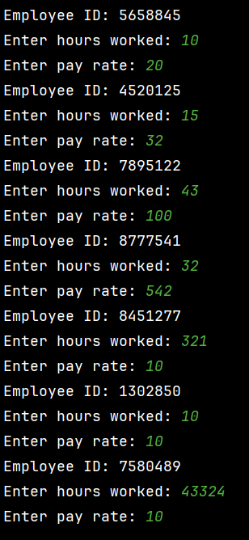
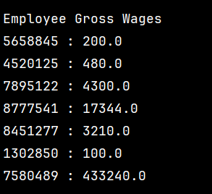
7.3:
Create a class with a method that accepts a charge account number as its argument. The method should determine whether the number is valid by comparing it to the following list of valid charge account numbers:

5658845 4520125 7895122 8777541 8451277 1302850
8080152 4562555 5552012 5050552 7825877 1250255
1005231 6545231 3852085 7576651 7881200 4581002

These numbers should be stored in an array or an ArrayList object. Use a sequential search to locate the number passed as an argument. If the number is in the array, the method should return true, indicating the number is valid. If the number is not in the array, the method should return false, indicating the number is invalid.

Write a program that tests the class by asking the user to enter a charge account number. The program should display a message indicating whether the number is valid or invalid.
Solution:
package Lecture8;
public class ChargeAccount {
private int[] validAccounts = {
5658845, 4520125, 7895122, 8777541, 8451277, 1302850, 8080152, 4562555, 5552012, 5050552, 7825877, 1250255,
1005231, 6545231, 3852085, 7576651, 7881200, 4581002
};
public boolean isValid(int accountNumber) {
for (int i = 0; i < validAccounts.length; i++) {
if (validAccounts[i] == accountNumber) {
return true;
}
}
return false;
}
}
Result:
package Lecture8;
import java.util.Scanner;
public class TestChargeAccount {
public static void main(String[] args) {
Scanner sc = new Scanner(System.in);
ChargeAccount ca = new ChargeAccount();
System.out.print("Enter charge account number: ");
int number = sc.nextInt();
if (ca.isValid(number)) {
System.out.println("The account number is valid.");
} else {
System.out.println("The account number is invalid.");
}
sc.close();
}
}

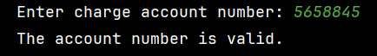

- Write a Circle class that has: its radius as a real number, its color as a string such as “red” “blue”.
The accessors and mutators for these attributes and one new member function getArea to calculate the circle’s area.
Write a program demonstrating the Circle class by asking the user for the circle’s radius, color and creating a Circle object, and then reporting the circle’s area and color.
Student: –
Solution:
package Lecture8;
public class Circle {
private double R;
private String color;
public double getR() {
return R;
}
public String getColor() {
return color;
}
public void setR(double r) {
R = r;
}
public void setColor(String color) {
this.color = color;
}
public double getArea(){
return Math.PI * R * R;
}
}

Result:
package Lecture8;
import java.util.Scanner;
public class TestCircle {
public static void main(String[] args) {
Scanner sc = new Scanner(System.in);
System.out.print("Enter radius: ");
double radius = sc.nextDouble();
sc.nextLine();
System.out.print("Enter color: ");
String color = sc.nextLine();
Circle c = new Circle();
c.setR(radius);
c.setColor(color);
System.out.println("Circle information:");
System.out.println("Radius: " + c.getR());
System.out.println("Color: " + c.getColor());
System.out.println("Area: " + c.getArea());
sc.close();
}
}
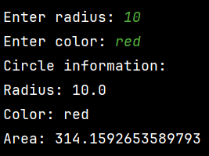

- Create a class called Employee that includes three pieces of information as data members—a first name(type string), a last name (type string)and a monthly salary (type int).
Provide a set and a get function for each data member. If the monthly salary is not positive, set it to 0.Write a test program that demonstrates class Employee’s capabilities.
Create two Employee objects and display each object’s yearly salary. Then give each Employee a 10 percent raise and display each Employee’s yearly salary again.

Student: –
Solution:
package Lecture8;
public class Employee {
private String firstName;
private String lastName;
private int salary;
public Employee(String firstName, String lastName, int salary) {
this.firstName = firstName;
this.lastName = lastName;
if (salary < 0) {
this.salary = 0;
} else {
this.salary = salary;
}
}
public String getFirstName() {
return firstName;
}
public String getLastName() {
return lastName;
}
public int getSalary() {
return salary;
}
public void setFirstName(String firstName) {
this.firstName = firstName;
}
public void setSalary(int salary) {
if (salary < 0) {
this.salary = 0;
} else {
this.salary = salary;
}
}
public void setLastName(String lastName) {
this.lastName = lastName;
}
}
Result:
package Lecture8;
public class EmployeeTest {
public static void main(String[] args) {
Employee p1 = new Employee("Tam", "Vu", 1000);
Employee p2 = new Employee("Do", "Tran", 2000);
System.out.println("Yearly salary of p1 before raise: " + p1.getSalary()*12);
System.out.println("Yearly salary of p2 before raise: " + p2.getSalary()*12);
p1.setSalary((int) (p1.getSalary()*1.1));
p2.setSalary((int) (p2.getSalary()*1.1));
System.out.println("Yearly salary of p1 after raise: " + p1.getSalary()*12);
System.out.println("Yearly salary of p2 after raise: " + p2.getSalary()*12);
}
}
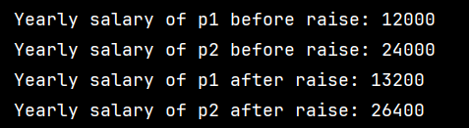
- Create an Account class that a bank might use to represent customers’ bank accounts. Include a data member of type double to represent the account balance and an account number of type string. Provide 4 member functions. Member function credit should add an amount to the current balance. Member function debit should withdraw money from the Account and ensure that the debit amount does not exceed the Account’s balance. If it does the balance should be left unchanged and the function should print a message indicating "Debit amount exceeded account balance." Member function getBalance should return the current balance.
- A pair of get/setAccountNumber should be implemented.
- Write a program that creates two Account objects and tests the member functions of class Account as follows:
  - Account number 122100008121 – credit balance 1.000.050 – then debit 2000.000
  - Account number 122100008121 – credit balance 2.000.050 – then debit 2000.000
- Display information about each account after each transaction.
Student: –
Solution:
package Lecture8;
public class Account {
private double balance;
private String number;
public void credit(double amount) {
balance += amount;
}
public void debit(double amount) {
if (amount > balance) {
System.out.println("Debit amount exceeded account balance.");
} else if (amount < 0) {
return;
} else {
balance -= amount;
}
}
public Account(double balance, String number) {
this.balance = balance;
this.number = number;
}
public double getBalance() {
return balance;
}
public String getNumber() {
return number;
}
public void setNumber(String number) {
this.number = number;
}
}
Result:
package Lecture8;
public class TestAccount {
public static void main(String[] args) {
Account acc1 = new Account(0, "122100008121");
System.out.println("Account number: " + acc1.getNumber());
acc1.credit(1000050);
System.out.println("Balance after credit: " + acc1.getBalance());
acc1.debit(2000);
System.out.println("Balance after debit: " + acc1.getBalance());
System.out.println();
Account acc2 = new Account(0, "122100008121");
System.out.println("Account number: " + acc2.getNumber());
acc2.credit(2000050);
System.out.println("Balance after credit: " + acc2.getBalance());
acc2.debit(2000);
System.out.println("Balance after debit: " + acc2.getBalance());
}
}
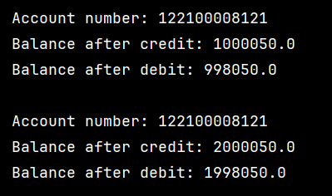

Contribution Table
Problem 1
Problem 1
Problem 2
Problem 3
Problem 4

Assignment for Lecture 10:

- Develop the Complex class as the following specification in C++ and Java:
#ifndef COMPLEX_H
#define COMPLEX_H

class Complex {
private:
double real;
double imag;
public:
Complex(double real = 0.0, double imag = 0.0);
double getReal() const;
void setReal(double real);
double getImag() const;
void setImag(double imag);
void setValue(double real, double imag);
void print() const;
bool isReal() const;
bool isImaginary() const;
// Add the given Complex instance into this instance, and return this instance by reference
Complex & addInto(const Complex & another);
Complex & addInto(double real, double imag);
// Add the given Complex instance and this instance, return the sum in a new instance by value
Complex addReturnNew(const Complex & another) const;
Complex addReturnNew(double real, double imag) const;
};

#endif

Student: – and –
Solution:
In C++:
#ifndef COMPLEX_H
#define COMPLEX_H
class Complex
{
private:
double real;
double imag;
public:
Complex(double real = 0.0, double imag = 0.0);
double getReal() const;
void setReal(double real);
double getImag() const;
void setImag(double imag);
void setValue(double real, double imag);
void print() const;
bool isReal() const;
bool isImaginary() const;
// Add the given Complex instance into this instance, and return this instance by reference
Complex &addInto(const Complex &another);
Complex &addInto(double real, double imag);
// Add the given Complex instance and this instance, return the sum in a new instance by value
Complex addReturnNew(const Complex &another) const;
Complex addReturnNew(double real, double imag) const;
};
#endif

#include "complex.h"
#include <iostream>
#include <cmath>
using namespace std;
Complex::Complex(double real, double imag)
{
this->real = real;
this->imag = imag;
}
double Complex::getReal() const
{
return real;
}
void Complex::setReal(double real)
{
this->real = real;
}
double Complex::getImag() const
{
return imag;
}
void Complex::setImag(double imag)
{
this->imag = imag;
}
void Complex::setValue(double real, double imag)
{
this->real = real;
this->imag = imag;
}
void Complex::print() const
{
cout << "This number = " << real;
if (imag < 0)
cout << " - " << fabs(imag) << "j";
else
cout << " + " << imag << "j";
}
bool Complex::isReal() const
{
if (imag == 0)
{
return true;
}
else
{
return false;
}
}
bool Complex::isImaginary() const
{
if (imag != 0 && real == 0)
{
return true;
}
else
{
return false;
}
}
Complex &Complex::addInto(const Complex &another)
{
setValue(real + another.real, imag + another.imag);
return *this;
}
Complex &Complex::addInto(double real, double imag)
{
setValue(this->real + real, this->imag + imag);
return *this;
}
Complex Complex::addReturnNew(const Complex &another) const
{
Complex temp;
temp.setValue(real + another.real, imag + another.imag);
return temp;
}
Complex Complex::addReturnNew(double real, double imag) const
{
Complex temp;
temp.setValue(this->real + real, this->imag + imag);
return temp;
}

#include <iostream>
#include "Complex.h"
using namespace std;
int main()
{
Complex c1;
Complex c2(3.5, -2.0);
cout << "c1 = ";
c1.print();
cout << endl;
cout << "c2 = ";
c2.print();
cout << endl;
c1.setValue(1.0, 4.0);
cout << "\nAfter setValue, c1 = ";
c1.print();
cout << endl;
cout << "c1 real = " << c1.getReal() << endl;
cout << "c1 imag = " << c1.getImag() << endl;
Complex c3(5.0, 0.0);
Complex c4(0.0, 7.0);
cout << "\nc3 = ";
c3.print();
cout << " -> isReal: " << c3.isReal() << ", isImaginary: " << c3.isImaginary() << endl;
cout << "c4 = ";
c4.print();
cout << " -> isReal: " << c4.isReal() << ", isImaginary: " << c4.isImaginary() << endl;
c1.addInto(c2);
cout << "\nAfter c1.addInto(c2), c1 = ";
c1.print();
cout << endl;
c1.addInto(2.0, 3.0);
cout << "After c1.addInto(2.0, 3.0), c1 = ";
c1.print();
cout << endl;
Complex c5 = c2.addReturnNew(c3);
cout << "\nc5 = c2.addReturnNew(c3) = ";
c5.print();
cout << endl;
Complex c6 = c2.addReturnNew(1.5, 2.5);
cout << "c6 = c2.addReturnNew(1.5, 2.5) = ";
c6.print();
cout << endl;
return 0;
}
In Java:
package Lecture10;
public class Complex {
private double real;
private double imag;
public Complex() {
this(0.0, 0.0);
}
public Complex(double real, double imag) {
this.real = real;
this.imag = imag;
}
public double getReal() {
return real;
}
public void setReal(double real) {
this.real = real;
}
public double getImag() {
return imag;
}
public void setImag(double imag) {
this.imag = imag;
}
public void setValue(double real, double imag) {
this.real = real;
this.imag = imag;
}
public void print() {
System.out.print("This number = " + real);
if (imag < 0)
System.out.print(" - " + Math.abs(imag) + "j");
else
System.out.print(" + " + imag + "j");
}
public boolean isReal() {
return imag == 0.0;
}
public boolean isImaginary() {
return real == 0.0 && imag != 0.0;
}
public Complex addInto(Complex another) {
this.real += another.real;
this.imag += another.imag;
return this;
}
public Complex addInto(double real, double imag) {
this.real += real;
this.imag += imag;
return this;
}
public Complex addReturnNew(Complex another) {
return new Complex(this.real + another.real, this.imag + another.imag);
}
public Complex addReturnNew(double real, double imag) {
return new Complex(this.real + real, this.imag + imag);
}
}

package Lecture10;
public class TestComplex {
public static void main(String[] args) {
Complex c1 = new Complex();
Complex c2 = new Complex(3.5, -2.0);
System.out.print("c1 = ");
c1.print();
System.out.println();
System.out.print("c2 = ");
c2.print();
System.out.println();
c1.setValue(1.0, 4.0);
System.out.print("\nAfter setValue, c1 = ");
c1.print();
System.out.println();
System.out.println("c1 real = " + c1.getReal());
System.out.println("c1 imag = " + c1.getImag());
Complex c3 = new Complex(5.0, 0.0);
Complex c4 = new Complex(0.0, 7.0);
System.out.print("\nc3 = ");
c3.print();
System.out.println(" -> isReal: " + c3.isReal() + ", isImaginary: " + c3.isImaginary());
System.out.print("c4 = ");
c4.print();
System.out.println(" -> isReal: " + c4.isReal() + ", isImaginary: " + c4.isImaginary());
c1.addInto(c2);
System.out.print("\nAfter c1.addInto(c2), c1 = ");
c1.print();
System.out.println();
c1.addInto(2.0, 3.0);
System.out.print("After c1.addInto(2.0, 3.0), c1 = ");
c1.print();
System.out.println();
Complex c5 = c2.addReturnNew(c3);
System.out.print("\nc5 = c2.addReturnNew(c3) = ");
c5.print();
System.out.println();
Complex c6 = c2.addReturnNew(1.5, 2.5);
System.out.print("c6 = c2.addReturnNew(1.5, 2.5) = ");
c6.print();
System.out.println();
}
}
Result:
In C++:
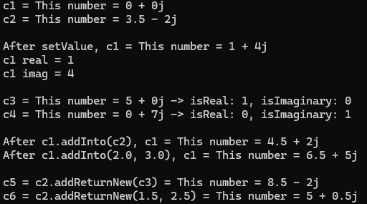
In Java:
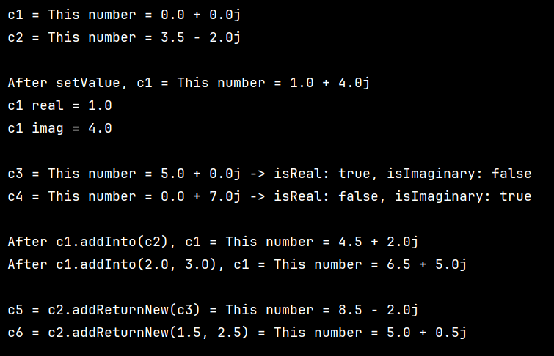
- Implement the class Date in C++ (Date.h, Date.cpp)/Java
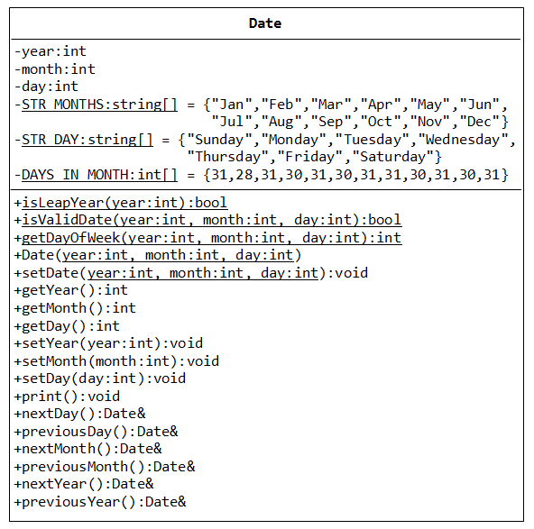

Then test the class (TestDate.cpp) in a program that create the dates Sunday, 1 Jan 2012, Tuesday, 31 Jan 2012, Monday, 31 Dec 2012 then display information about the next day. Display the previous day of 1/1/2012 and the day after one year of 29/02/2012

Student: – and –
Solution:
In C++:
#ifndef DATE_H
#define DATE_H
#include <string>
using namespace std;
class Date {
private:
int year;
int month;
int day;
static const string STR_MONTHS[12];
static const string STR_DAY[7];
static const int DAYS_IN_MONTH[12];
public:
static bool isLeapYear(int year);
static bool isValidDate(int year, int month, int day);
static int getDayOfWeek(int year, int month, int day);
Date(int year, int month, int day);
void setDate(int year, int month, int day);
int getYear() const;
int getMonth() const;
int getDay() const;
void setYear(int year);
void setMonth(int month);
void setDay(int day);
void print() const;
Date& nextDay();
Date& previousDay();
Date& nextMonth();
Date& previousMonth();
Date& nextYear();
Date& previousYear();
};
#endif

#include "Date.h"
#include <iostream>
const string Date::STR_MONTHS[12] = {
"Jan", "Feb", "Mar", "Apr", "May", "Jun",
"Jul", "Aug", "Sep", "Oct", "Nov", "Dec"};
const string Date::STR_DAY[7] = {
"Sunday", "Monday", "Tuesday", "Wednesday",
"Thursday", "Friday", "Saturday"};
const int Date::DAYS_IN_MONTH[12] = {
31, 28, 31, 30, 31, 30, 31, 31, 30, 31, 30, 31};
bool Date::isLeapYear(int year)
{
return (year % 400 == 0) || (year % 4 == 0 && year % 100 != 0);
}
bool Date::isValidDate(int year, int month, int day)
{
if (month < 1 || month > 12)
return false;
int maxDay = DAYS_IN_MONTH[month - 1];
if (month == 2 && isLeapYear(year))
maxDay = 29;
return day >= 1 && day <= maxDay;
}
int Date::getDayOfWeek(int y, int m, int d)
{
if (m < 3)
{
m += 12;
y--;
}
int k = y % 100;
int j = y / 100;
int h = (d + 13 * (m + 1) / 5 + k + k / 4 + j / 4 + 5 * j) % 7;
return (h + 6) % 7;
}
Date::Date(int year, int month, int day)
{
setDate(year, month, day);
}
void Date::setDate(int year, int month, int day)
{
if (isValidDate(year, month, day))
{
this->year = year;
this->month = month;
this->day = day;
}
}
int Date::getYear() const
{
return year;
}
int Date::getMonth() const
{
return month;
}
int Date::getDay() const
{
return day;
}
void Date::setYear(int year)
{
if (isValidDate(year, month, day))
this->year = year;
}
void Date::setMonth(int month)
{
if (isValidDate(year, month, day))
this->month = month;
}
void Date::setDay(int day)
{
if (isValidDate(year, month, day))
this->day = day;
}
void Date::print() const
{
cout << STR_DAY[getDayOfWeek(year, month, day)] << ", "
<< STR_MONTHS[month - 1] << " "
<< day << ", " << year;
}
Date &Date::nextDay()
{
day++;
if (!isValidDate(year, month, day))
{
day = 1;
nextMonth();
}
return *this;
}
Date &Date::previousDay()
{
day--;
if (day < 1)
{
previousMonth();
day = DAYS_IN_MONTH[month - 1];
if (month == 2 && isLeapYear(year))
day = 29;
}
return *this;
}
Date &Date::nextMonth()
{
month++;
if (month > 12)
{
month = 1;
year++;
}
int maxDay = DAYS_IN_MONTH[month - 1];
if (month == 2 && isLeapYear(year))
maxDay = 29;
if (day > maxDay)
day = maxDay;
return *this;
}
Date &Date::previousMonth()
{
month--;
if (month < 1)
{
month = 12;
year--;
}
int maxDay = DAYS_IN_MONTH[month - 1];
if (month == 2 && isLeapYear(year))
maxDay = 29;
if (day > maxDay)
day = maxDay;
return *this;
}
Date &Date::nextYear()
{
year++;
if (month == 2 && day == 29 && !isLeapYear(year))
day = 28;
return *this;
}
Date &Date::previousYear()
{
year--;
if (month == 2 && day == 29 && !isLeapYear(year))
day = 28;
return *this;
}

#include "Date.h"
#include <iostream>
using namespace std;
int main()
{
Date d1(2012, 1, 1);
Date d2(2012, 1, 31);
Date d3(2012, 12, 31);
cout << "Date 1: ";
d1.print();
cout << endl;
cout << "Next day: ";
d1.nextDay().print();
cout << endl << endl;
cout << "Date 2: ";
d2.print();
cout << endl;
cout << "Next day: ";
d2.nextDay().print();
cout << endl << endl;
cout << "Date 3: ";
d3.print();
cout << endl;
cout << "Next day: ";
d3.nextDay().print();
cout << endl << endl;
Date x(2012, 1, 1);
cout << "Previous day of 1/1/2012: ";
x.previousDay().print();
cout << endl << endl;
Date leap(2012, 2, 29);
cout << "Day after one year of 29/02/2012: ";
leap.nextYear().print();
cout << endl;
}
In Java:
package Lecture10;
public class Date {
private int year;
private int month;
private int day;
private String[] STR_MONTHS = {"Jan", "Feb", "Mar", "Apr", "May", "Jun", "Jul", "Aug", "Sep", "Oct", "Nov", "Dec"};
private String[] STR_DAY = {"Sunday", "Monday", "Tuesday", "Wednesday", "Thursday", "Friday", "Saturday"};
private int[] DAYS_IN_MONTH = {31, 28, 31, 30, 31, 30, 31, 31, 30, 31, 30, 31};
public Date(int year, int month, int day) {
setDate(year, month, day);
}
public void setDate(int year, int month, int day) {
if (!isValidDate(year, month, day)) {
this.year = 2026;
this.month = 1;
this.day = 1;
return;
}
this.year = year;
this.month = month;
this.day = day;
}
public int getYear() {
return year;
}
public int getMonth() {
return month;
}
public int getDay() {
return day;
}
public void setYear(int year) {
if (isValidDate(year, this.month, this.day)) this.year = year;
}
public void setMonth(int month) {
if (isValidDate(this.year, month, this.day)) this.month = month;
}
public void setDay(int day) {
if (isValidDate(this.year, this.month, day)) this.day = day;
}
public void print() {
System.out.println(STR_MONTHS[month - 1] + " " + day + ", " + year
+ " (" + STR_DAY[getDayOfWeek(year, month, day)] + ")");
}
public Date nextDay() {
day++;
int dayinM = getDaysInMonth(year, month);
if (day > dayinM) {
day = 1;
month++;
if (month > 12) {
month = 1;
year++;
}
}
return this;
}
public Date previousDay() {
day--;
if (day < 1) {
month--;
if (month < 1) {
month = 12;
year--;
}
day = getDaysInMonth(year, month);
}
return this;
}
public Date nextMonth() {
month++;
if (month > 12) {
month = 1;
year++;
}
int dayinM = getDaysInMonth(year, month);
if (day > dayinM) day = dayinM;
return this;
}
public Date previousMonth() {
month--;
if (month < 1) {
month = 12;
year--;
}
int dayinM = getDaysInMonth(year, month);
if (day > dayinM) day = dayinM;
return this;
}
public Date nextYear() {
year++;
int dayinM = getDaysInMonth(year, month);
if (day > dayinM) day = dayinM;
return this;
}
public Date previousYear() {
year--;
int dayinM = getDaysInMonth(year, month);
if (day > dayinM) day = dayinM;
return this;
}
public boolean isLeapYear(int year) {
if (year % 400 == 0) return true;
if (year % 100 == 0) return false;
return year % 4 == 0;
}
public boolean isValidDate(int year, int month, int day) {
if (year < 1) return false;
if (month < 1 || month > 12) return false;
if (day < 1) return false;
return day <= getDaysInMonth(year, month);
}
public int getDayOfWeek(int year, int month, int day) {
int y = year;
int m = month;
if (m < 3) {
m += 12;
y -= 1;
}
int K = y % 100;
int J = y / 100;
int h = (day + (13 * (m + 1)) / 5 + K + (K / 4) + (J / 4) + 5 * J) % 7;
int dow = (h + 6) % 7;
return dow;
}
private int getDaysInMonth(int year, int month) {
int dayinM = DAYS_IN_MONTH[month - 1];
if (month == 2 && isLeapYear(year)) dayinM = 29;
return dayinM;
}
}

package Lecture10;
public class TestDate {
public static void main(String[] args) {
Date d1 = new Date(2012, 1, 1);
Date d2 = new Date(2012, 1, 31);
Date d3 = new Date(2012, 12, 31);
System.out.print("Date: ");
d1.print();
System.out.print("Next day: ");
new Date(2012, 1, 1).nextDay().print();
System.out.print("Date: ");
d2.print();
System.out.print("Next day: ");
new Date(2012, 1, 31).nextDay().print();
System.out.print("Date: ");
d3.print();
System.out.print("Next day: ");
new Date(2012, 12, 31).nextDay().print();
System.out.print("Previous day of 1/1/2012: ");
new Date(2012, 1, 1).previousDay().print();
System.out.print("Day after one year of 29/02/2012: ");
new Date(2012, 2, 29).nextYear().print();
}
}
Result:
In C++:
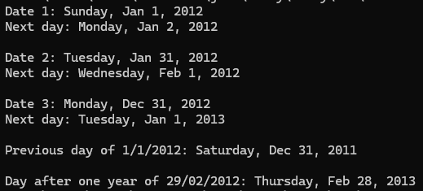
In Java:
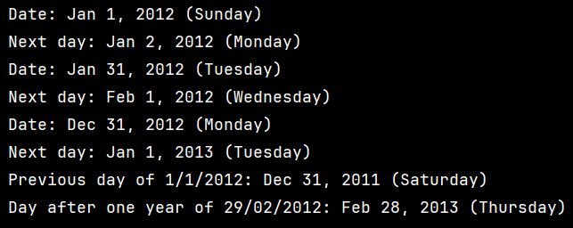

- Programming Challenges
13.13 (Tony Gaddis C++)
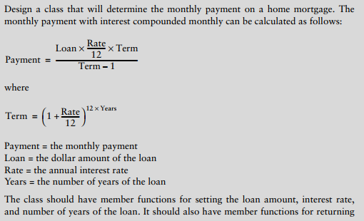
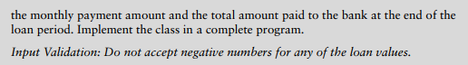
Student: –
Solution:
#ifndef MORTGAGE_H
#define MORTGAGE_H
class Mortgage {
private:
double loan;
double rate;
int years;
public:
Mortgage(double loan = 0, double rate = 0, int years = 0);
void setLoan(double loan);
void setRate(double rate);
void setYears(int years);
double getMonthlyPayment() const;
double getTotalPayment() const;
};
#endif

#include "Mortgage.h"
#include <cmath>
Mortgage::Mortgage(double loan, double rate, int years)
{
setLoan(loan);
setRate(rate);
setYears(years);
}
void Mortgage::setLoan(double loan)
{
if (loan >= 0)
this->loan = loan;
else
this->loan = 0;
}
void Mortgage::setRate(double rate)
{
if (rate >= 0)
this->rate = rate;
else
this->rate = 0;
}
void Mortgage::setYears(int years)
{
if (years >= 0)
this->years = years;
else
this->years = 0;
}
double Mortgage::getMonthlyPayment() const
{
if (loan == 0 || rate == 0 || years == 0)
return 0;
double monthlyRate = rate / 12 / 100;
int term = years * 12;
double payment = loan * monthlyRate * pow(1 + monthlyRate, term) / (pow(1 + monthlyRate, term) - 1);
return payment;
}
double Mortgage::getTotalPayment() const
{
return getMonthlyPayment() * years * 12;
}
Result:
#include <iostream>
#include <iomanip>
#include "Mortgage.h"
using namespace std;
int main()
{
double loan, rate;
int years;
do
{
cout << "Enter loan amount: ";
cin >> loan;
} while (loan < 0);
do
{
cout << "Enter annual interest rate (%): ";
cin >> rate;
} while (rate < 0);
do
{
cout << "Enter number of years: ";
cin >> years;
} while (years < 0);
Mortgage m(loan, rate, years);
cout << fixed << setprecision(2);
cout << "\nMonthly Payment: $" << m.getMonthlyPayment() << endl;
cout << "Total Amount Paid: $" << m.getTotalPayment() << endl;
return 0;
}

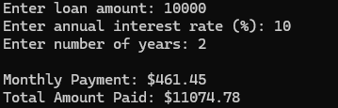

Contribution Table
Problem 1
Problem 1
Problem 2
Problem 2
Problem 3

Assignment for Lecture 11:

- Programming Challenges
Tony Gaddis Java: 8.1, 8.2, 8.3
8.1: Area Class
Write a class that has three overloaded static methods for calculating the areas of the following geometric shapes:
• circles
• rectangles
• cylinders
Here are the formulas for calculating the area of the shapes.
Area of a circle: Area 5 πr2
where π is Math.PI and r is the circle’s radius
Area of a rectangle: Area 5 Width 3 Length
Area of a cylinder: Area 5 πr2h
Where π is Math.PI, r is the radius of the cylinder’s base, and h is the cylinder’s height
Because the three methods are to be overloaded, they should each have the same name, but different parameter lists. Demonstrate the class in a complete program.

Student: –
Solution:
package Lecture11;
public class Area {
static double area(double r){
return Math.PI * r * r;
}
static double area(double w, double l){
return w*l;
}
static double area(double r, double h, boolean isCylinder){
return Math.PI * r * r * h;
}
}

Result:
package Lecture11;
public class TestArea {
public static void main(String[] args) {
System.out.println("Circle area: " + Area.area(5));
System.out.println("Rectangle area: " + Area.area(4, 6));
System.out.println("Cylinder area: " + Area.area(3, 10, true));
}
}
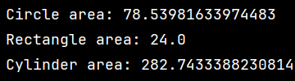
8.2: BankAccount Class Copy Constructor
Add a copy constructor to the BankAccount class. This constructor should accept a BankAccount object as an argument. It should assign to the balance field the value in the argument’s balance field. As a result, the new object will be a copy of the argument object.

Student: –
Solution:
package Lecture11;
public class BankAccount {
private double balance;
public BankAccount() {
balance = 0.0;
}
public BankAccount(double startBalance) {
balance = startBalance;
}
public BankAccount(BankAccount other){
balance = other.getBalance();
}
public BankAccount(String str) {
balance = Double.parseDouble(str);
}
public void deposit(double amount) {
balance += amount;
}
public void deposit(String str) {
balance += Double.parseDouble(str);
}
public void withdraw(double amount) {
balance -= amount;
}
public void withdraw(String str) {
balance -= Double.parseDouble(str);
}
public void setBalance(double b) {
balance = b;
}
public void setBalance(String str) {
balance = Double.parseDouble(str);
}
public double getBalance() {
return balance;
}
}

8.3: Carpet Calculator
The Westfield Carpet Company has asked you to write an application that calculates the price of carpeting for rectangular rooms. To calculate the price, you multiply the area of the floor (width times length) by the price per square foot of carpet. For example, the area of floor that is 12 feet long and 10 feet wide is 120 square feet. To cover that floor with carpet that costs $8 per square foot would cost $960. (12 3 10 3 8 5 960.)

First, you should create a class named RoomDimension that has two fields: one for the length of the room and one for the width. The RoomDimension class should have a method that
returns the area of the room. (The area of the room is the room’s length multiplied by the
room’s width.)
Next you should create a RoomCarpet class that has a RoomDimension object as a field. It
should also have a field for the cost of the carpet per square foot. The RoomCarpet class
should have a method that returns the total cost of the carpet.
Figure 8-21 is a UML diagram that shows possible class designs and the relationships
among the classes. Once you have written these classes, use them in an application that
asks the user to enter the dimensions of a room and the price per square foot of the desired
carpeting. The application should display the total cost of the carpet.
Student: –
Solution:
package Lecture11;
public class RoomDimension {
private double length;
private double width;
public RoomDimension(double len, double w) {
length = len;
width = w;
}
public double getArea() {
return length * width;
}
@Override
public String toString() {
return "Length: " + length + ", Width: " + width + ", Area: " + getArea();
}
}

package Lecture11;
public class RoomCarpet {
private RoomDimension size;
private double carpetCost;
public RoomCarpet(RoomDimension dim, double cost) {
size = dim;
carpetCost = cost;
}
public double getTotalCost() {
return size.getArea() * carpetCost;
}
@Override
public String toString() {
return size.toString() + "\nCost per square foot: " + carpetCost + "\nTotal cost: " + getTotalCost();
}
}
Result:
package Lecture11;
import java.util.Scanner;
public class CarpetCalculator {
public static void main(String[] args) {
Scanner sc = new Scanner(System.in);
System.out.print("Enter room length: ");
double length = sc.nextDouble();
System.out.print("Enter room width: ");
double width = sc.nextDouble();
System.out.print("Enter carpet cost per square foot: ");
double cost = sc.nextDouble();
RoomDimension room = new RoomDimension(length, width);
RoomCarpet carpet = new RoomCarpet(room, cost);
System.out.println("\nRoom information:");
System.out.println(room);
System.out.println("\nCarpet information:");
System.out.println(carpet);
sc.close();
}
}

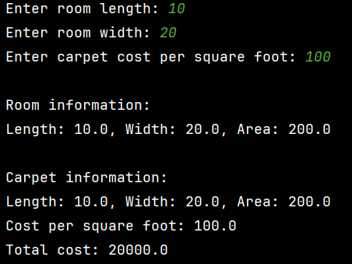
- Tony Gaddis C++: 14.1, 14.2
14.1:
Design a class Numbers that can be used to translate whole dollar amounts in the range 0 through 9999 into an English description of the number. For example, the number 713 would be translated into the string seven hundred thirteen, and 8203 would be translated into eight thousand two hundred three. The class should have a single integer member variable:
int number;
and a static array of strings that specify how to translate key dollar amounts into the desired format. For example, you might use static strings such as
char lessThan20[20][25] = {"zero", "one", …, "eighteen", "nineteen"}; char hundred[] = "hundred";
char thousand[] = "thousand";
The class should have a constructor that accepts a nonnegative integer and uses it to initialize the Numbers object. It should have a member function print() that prints the English description of the Numbers object. Demonstrate the class by writing a main program that asks the user to enter a number in the proper range and then prints out its English description.
Student: –
Solution:
#ifndef NUMBERS_H
#define NUMBERS_H
#include <iostream>
using namespace std;
class Numbers
{
private:
int number;
static const char lessThan20[20][25];
static const char tens[10][25];
static const char hundred[25];
static const char thousand[25];
public:
Numbers(int n);
void print() const;
};
#endif

#include "Numbers.h"
const char Numbers::lessThan20[20][25] = {"zero", "one", "two", "three", "four", "five", "six", "seven", "eight", "nine", "ten", "eleven", "twelve", "thirteen", "fourteen", "fifteen", "sixteen", "seventeen", "eighteen", "nineteen"};
const char Numbers::tens[10][25] = {"", "", "twenty", "thirty", "forty", "fifty", "sixty", "seventy", "eighty", "ninety"};
const char Numbers::hundred[25] = "hundred";
const char Numbers::thousand[25] = "thousand";
Numbers::Numbers(int n)
{
number = n;
}
void Numbers::print() const
{
if (number == 0)
{
cout << lessThan20[0];
return;
}
int n = number;
if (n >= 1000)
{
cout << lessThan20[n / 1000] << " " << thousand;
n %= 1000;
if (n > 0)
cout << " ";
}
if (n >= 100)
{
cout << lessThan20[n / 100] << " " << hundred;
n %= 100;
if (n > 0)
cout << " ";
}
if (n >= 20)
{
cout << tens[n / 10];
if (n % 10 != 0)
cout << " " << lessThan20[n % 10];
}
else if (n > 0)
{
cout << lessThan20[n];
}
}

#include <iostream>
#include "Numbers.h"
using namespace std;
int main()
{
int n;
cout << "Enter a number (0 - 9999): ";
cin >> n;
if (n < 0 || n > 9999)
{
cout << "Invalid input";
return 0;
}
Numbers num(n);
num.print();
return 0;
}
Result:
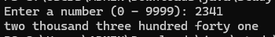
14.2:
Assuming that a year has 365 days, write a class named DayOfYear that takes an integer representing a day of the year and translates it to a string consisting of the month followed by day of the month. For example,
Day 2 would be January 2. Day 32 would be February 1. Day 365 would be December 31.
The constructor for the class should take as parameter an integer representing the day of the year, and the class should have a member function print() that prints the day in the month–day format. The class should have an integer member variable to represent the day, and should have static member variables holding strings that can be used to assist in the translation from the integer format to the month-day format.
Test your class by inputting various integers representing days and printing out their representation in the month–day format.
Student: –
Solution:
#ifndef DAYOFYEAR_H
#define DAYOFYEAR_H
#include <string>
using namespace std;
class DayOfYear
{
private:
int day;
static const string months[12];
static const int daysInMonth[12];
public:
DayOfYear(int d);
void print() const;
};
#endif

#include "DayOfYear.h"
#include <iostream>
using namespace std;
const string DayOfYear::months[12] = {"January", "February", "March", "April", "May", "June", "July", "August", "September", "October", "November", "December"};
const int DayOfYear::daysInMonth[12] = {31, 28, 31, 30, 31, 30, 31, 31, 30, 31, 30, 31};
DayOfYear::DayOfYear(int d)
{
day = d;
}
void DayOfYear::print() const
{
int remaining = day;
int monthIndex = 0;
while (remaining > daysInMonth[monthIndex])
{
remaining -= daysInMonth[monthIndex];
monthIndex++;
}
cout << months[monthIndex] << " " << remaining << endl;
}

#include <iostream>
#include "DayOfYear.h"
using namespace std;
int main()
{
int d;
while (true)
{
cin >> d;
if (d < 1 || d > 365)
break;
DayOfYear day(d);
day.print();
}
return 0;
}
Result:
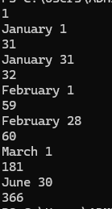

Contribution Table
Problem 8.3
Problem 14.1
Problem 8.2
Problem 8.1
Problem 14.2

Assignment for Lecture 12:

8.3 Carpet calculator
Description:
- The program consists of three classes:
· RoomDimension → stores length and width, calculates room area
· RoomCarpet → holds RoomDimension object and carpet cost per sqft, calculates total cost
· CarpetCalculator → main program that gets user input and displays results
- User enters:
· Room length (feet)
· Room width (feet)
· Carpet cost per square foo
- Calculation:
· Area = length × width
· Total cost = area × cost per square foot
Student: – and –

Solution:
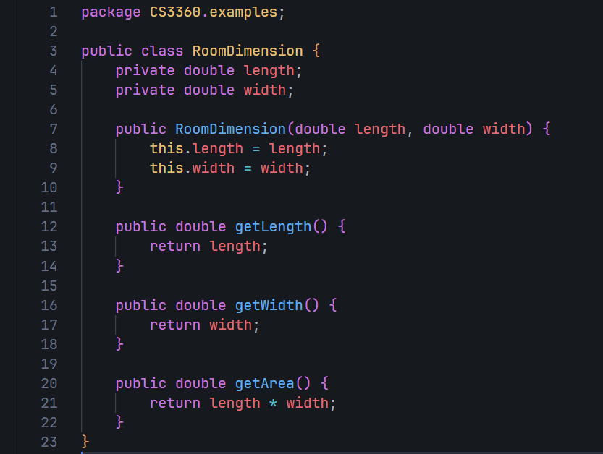
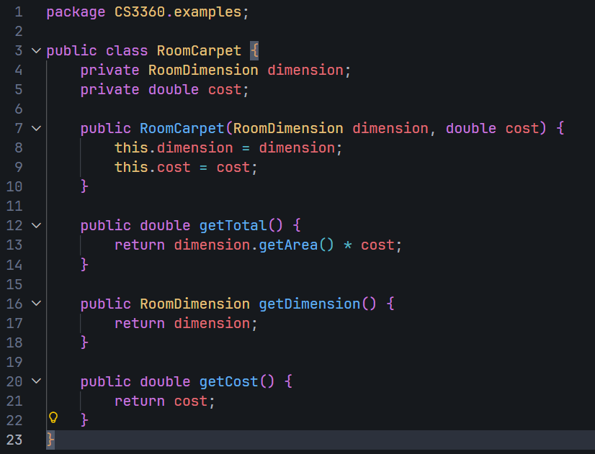
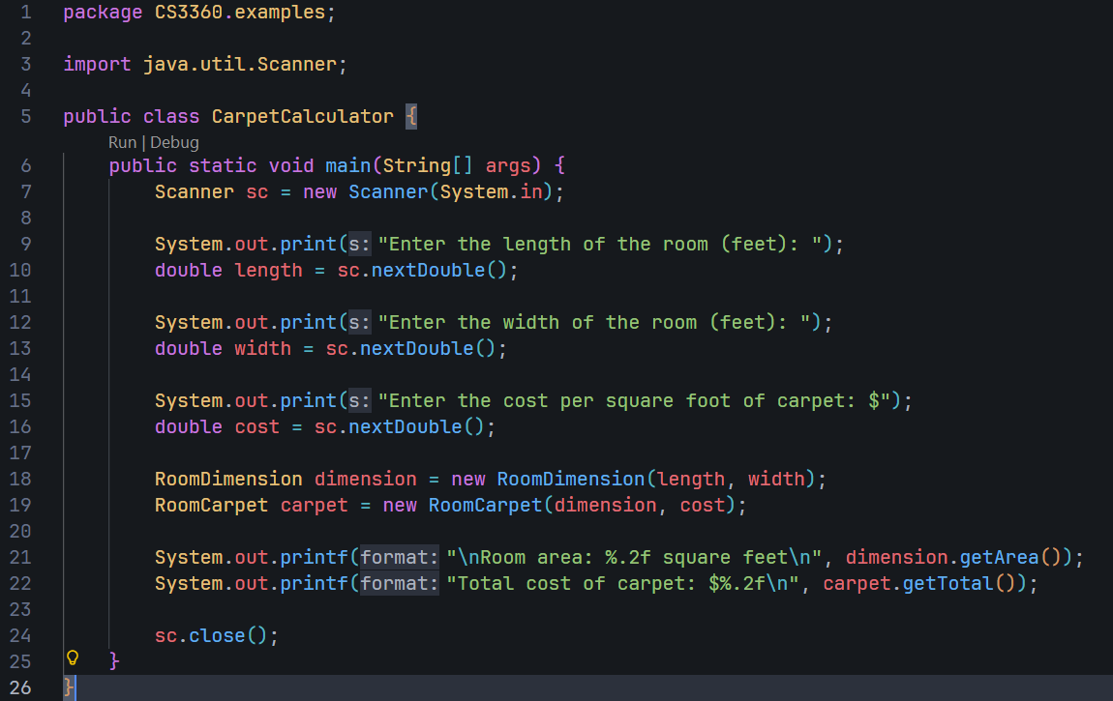
Result:
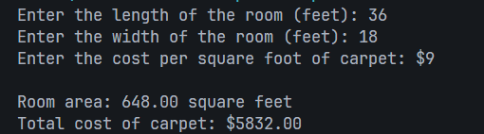

8.8 Parking Ticket Simulator
Description:
- The program consists of five classes:
· ParkedCar → stores car information (make, model, color, license, minutes parked)
· ParkingMeter → stores purchased parking time in minutes
· ParkingTicket → represents a ticket with fine calculation and print method
· PoliceOfficer → inspects cars and issues tickets for violations
· ParkingTicketDemo → demonstrates how classes collaborate

- Police officer inspects parked cars by:
· Comparing car's parked time with meter's purchased time
· Calculating overtime = car minutes - meter minutes
· Issuing a ticket if overtime > 0, otherwise no violation

- Fine calculation:
· Overtime minutes are rounded up to hours
· First hour (or part): $25
· Each additional hour (or part): $10
· Formula: $25 + (hours - 1) × $10
Student: –

Solution:
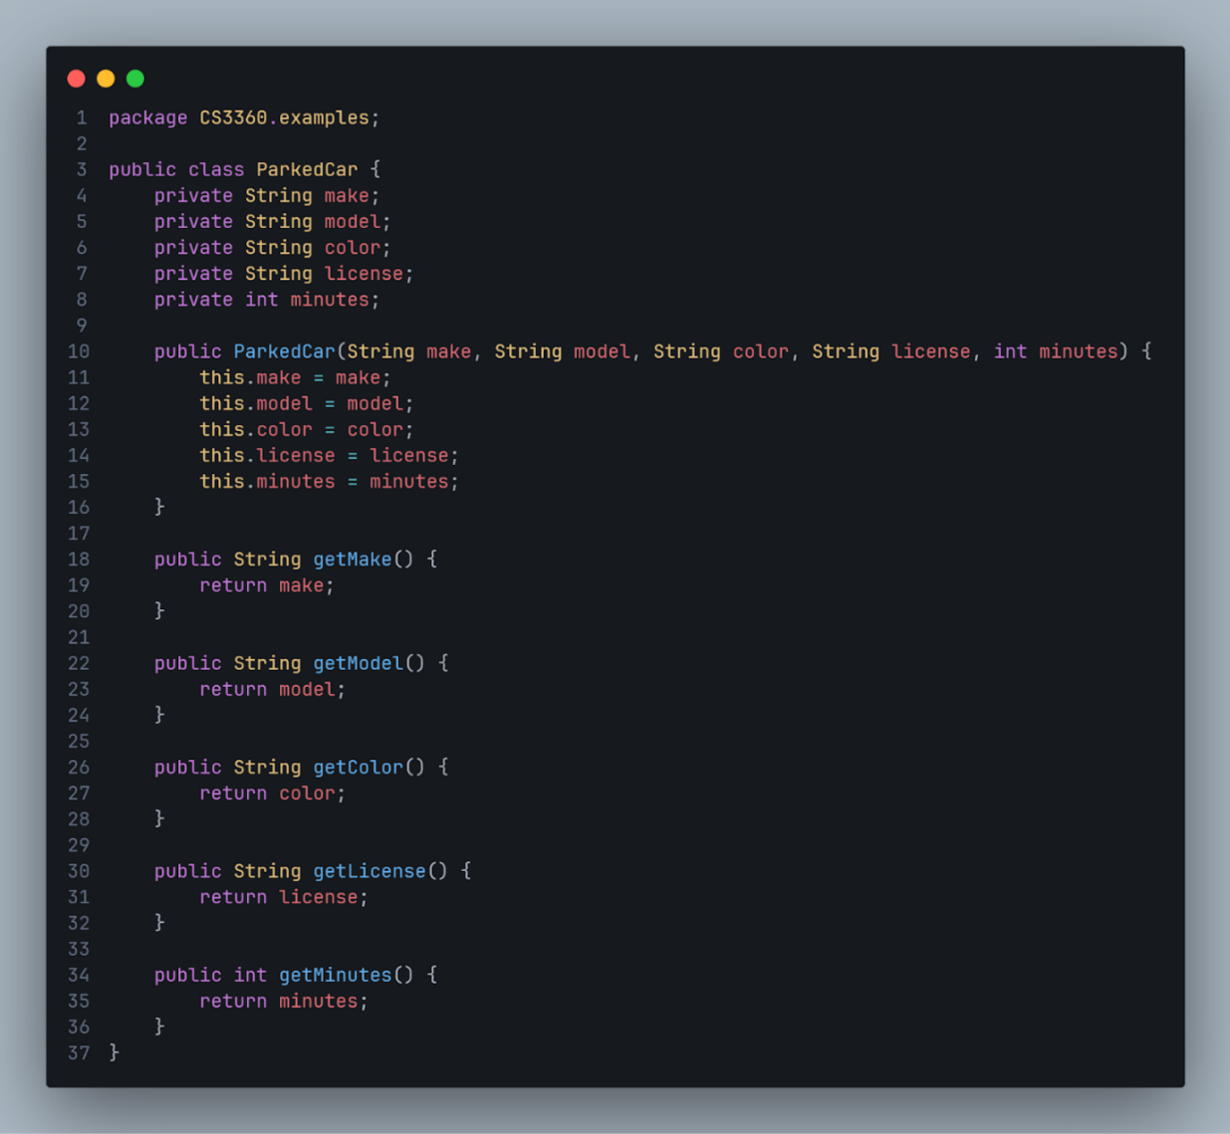
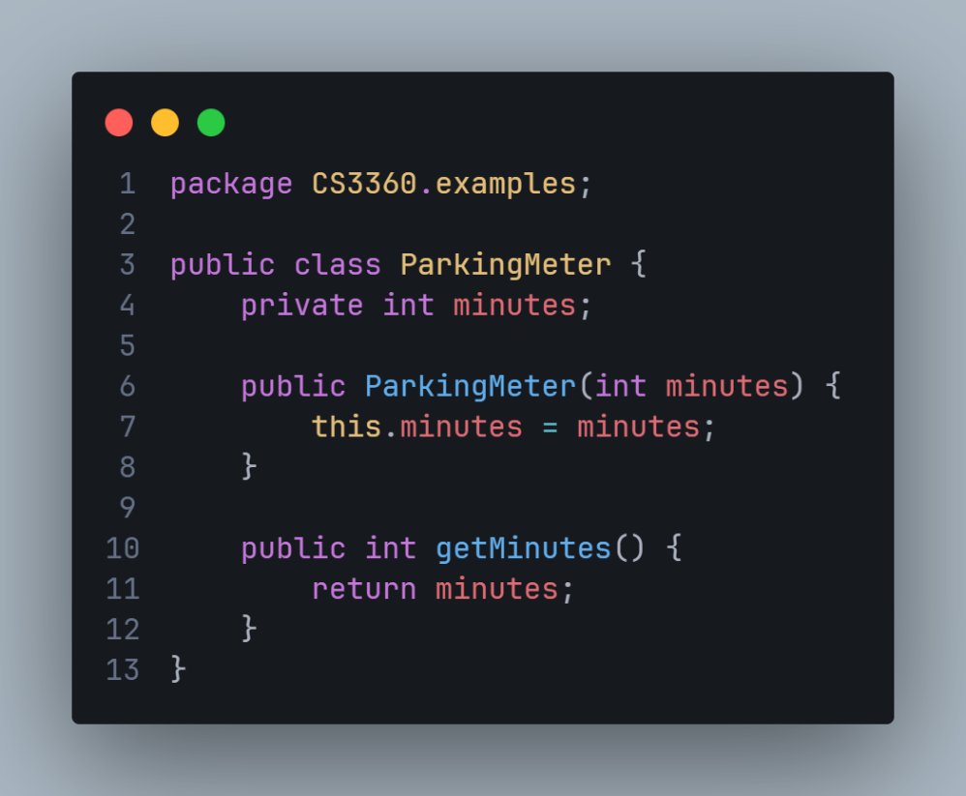
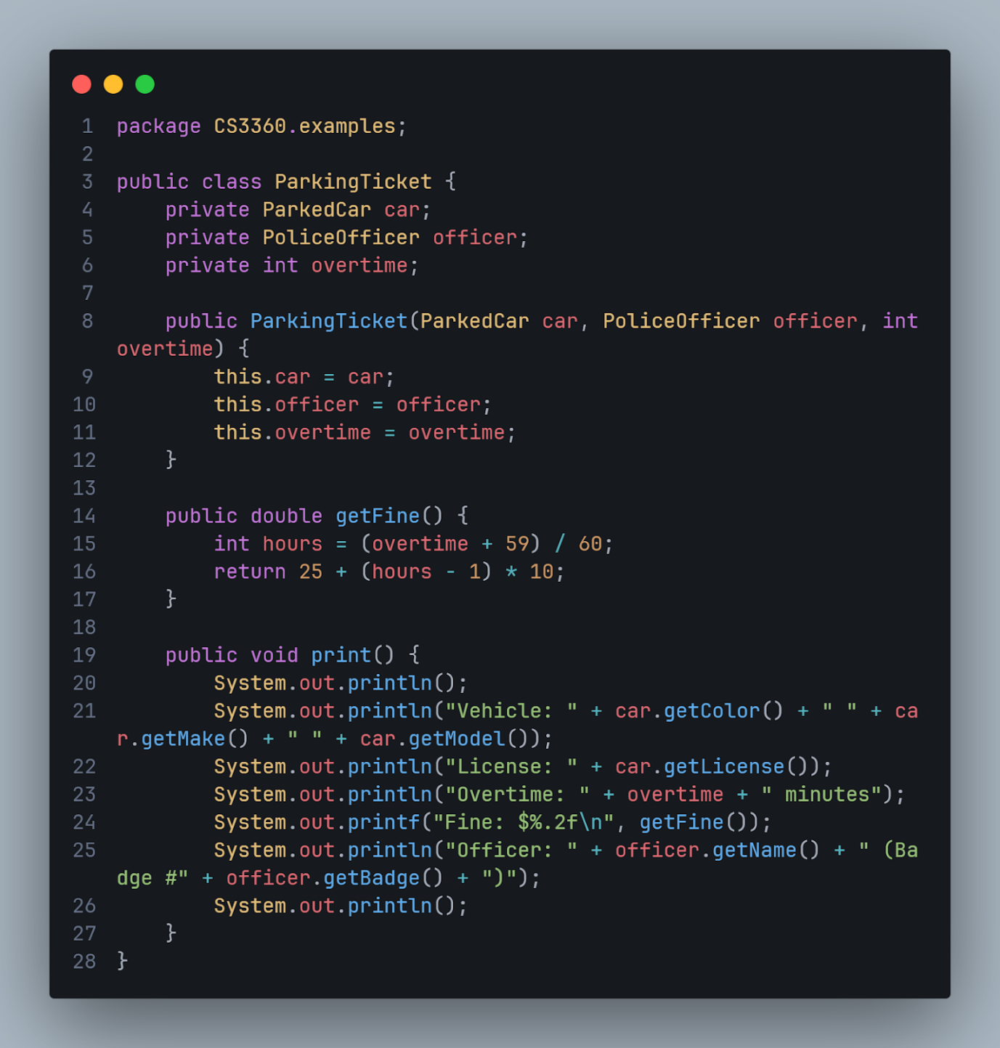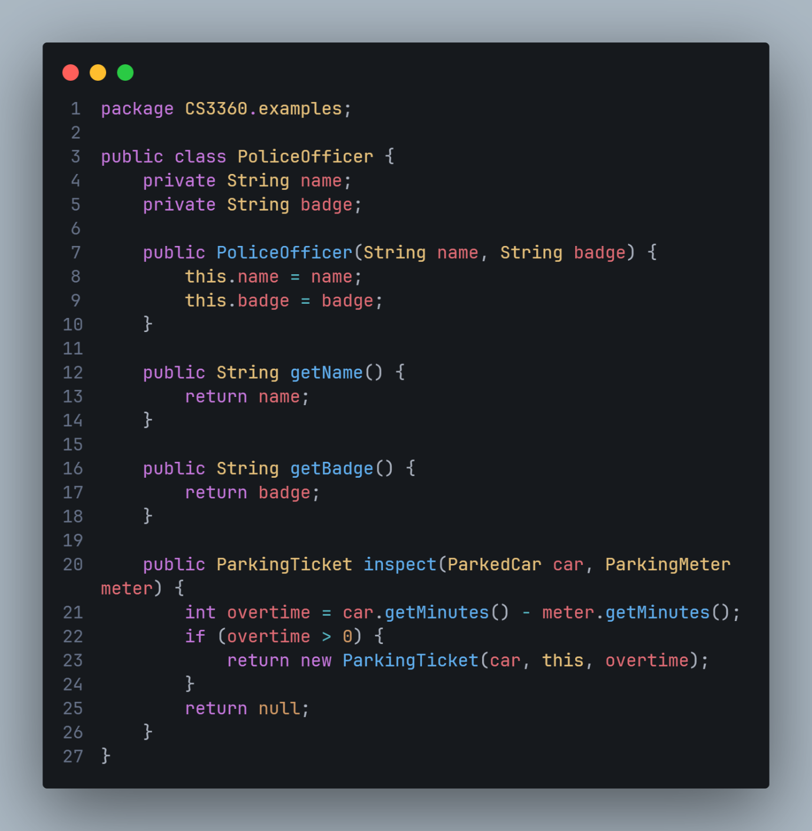
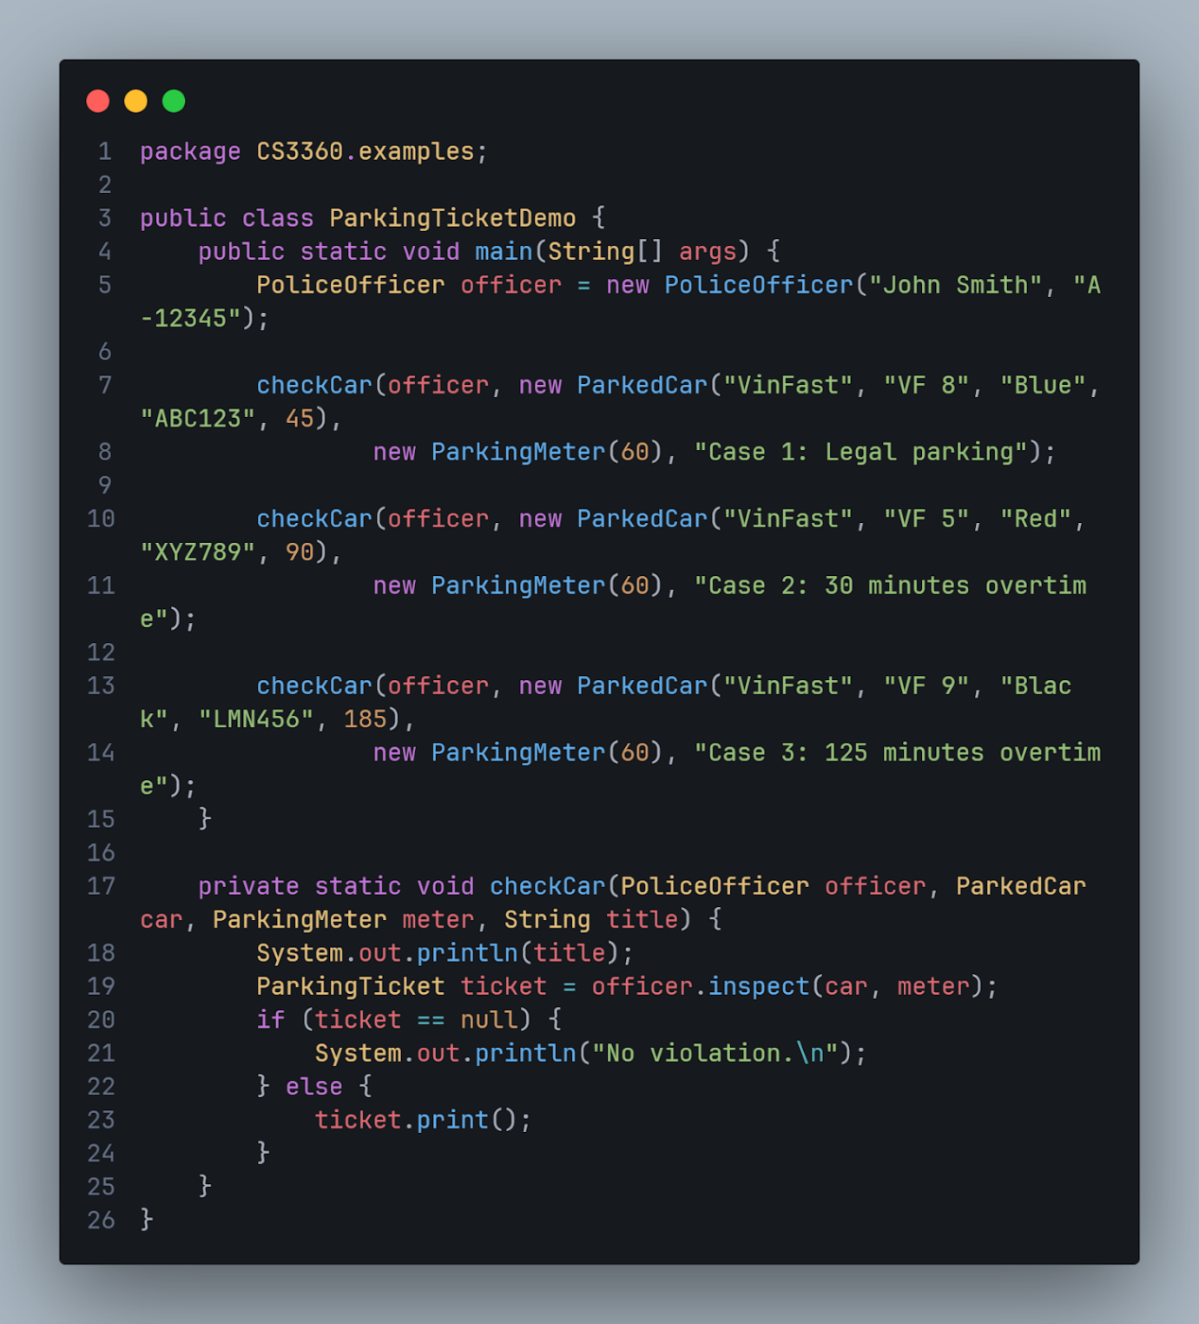

Result:
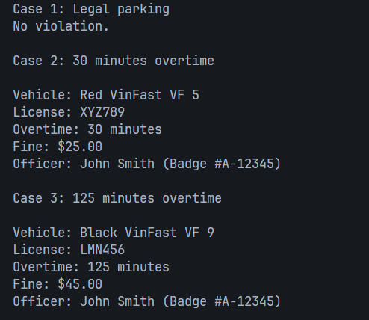
14.13 Carpet Calculator
Description:
- The program consists of three classes:
· FeetInches → stores measurements in feet and inches with copy constructor and multiply() function
· RoomDimension → has two FeetInches objects (length and width), returns area as FeetInches
· RoomCarpet → has RoomDimension and cost per square foot, calculates total cost
- FeetInches class features:
· Automatically simplifies (12 inches = 1 foot)
· Copy constructor for object duplication
· multiply() function to calculate area
· toDecimalFeet() converts to decimal for cost calculation

- User enters:
· Length in feet and inches separately
· Width in feet and inches separately
· Cost per square foot

- Calculation:
· Area = length × width (using FeetInches multiply)
· Total cost = area (in decimal feet) × cost per square foot
Student: –

Solution:
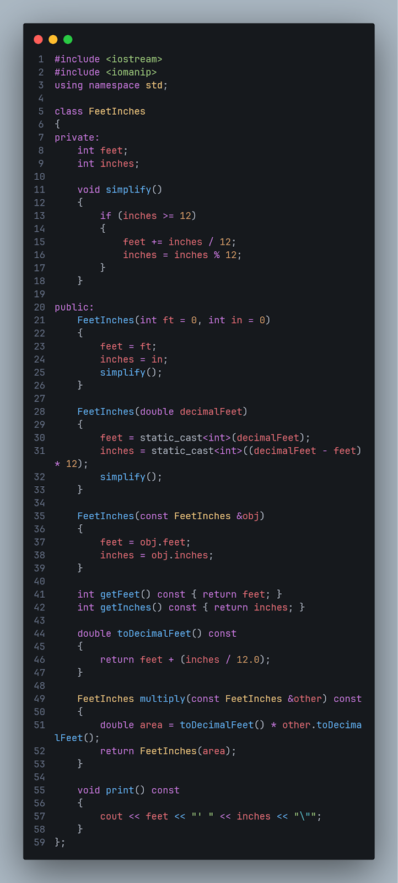
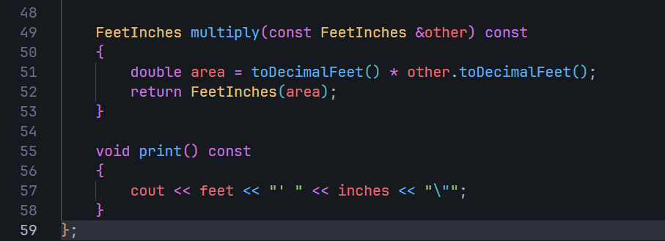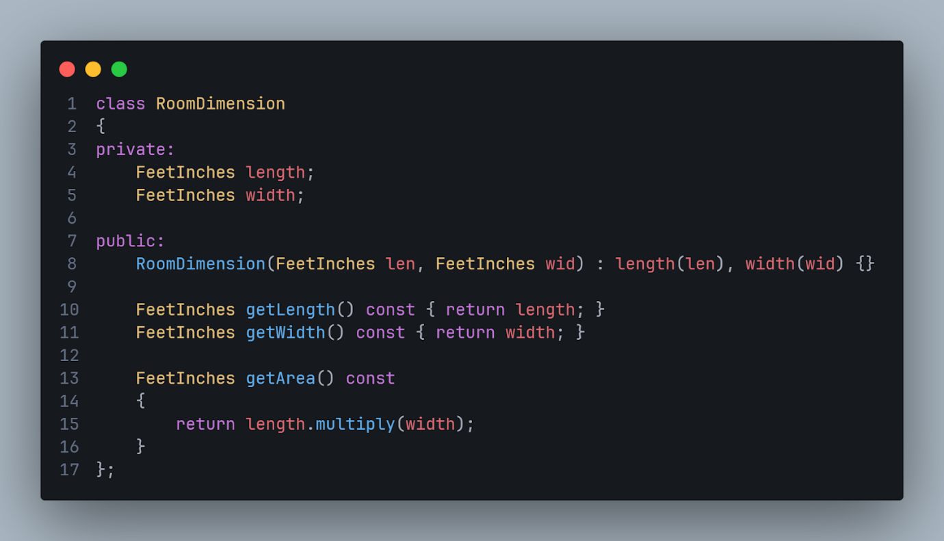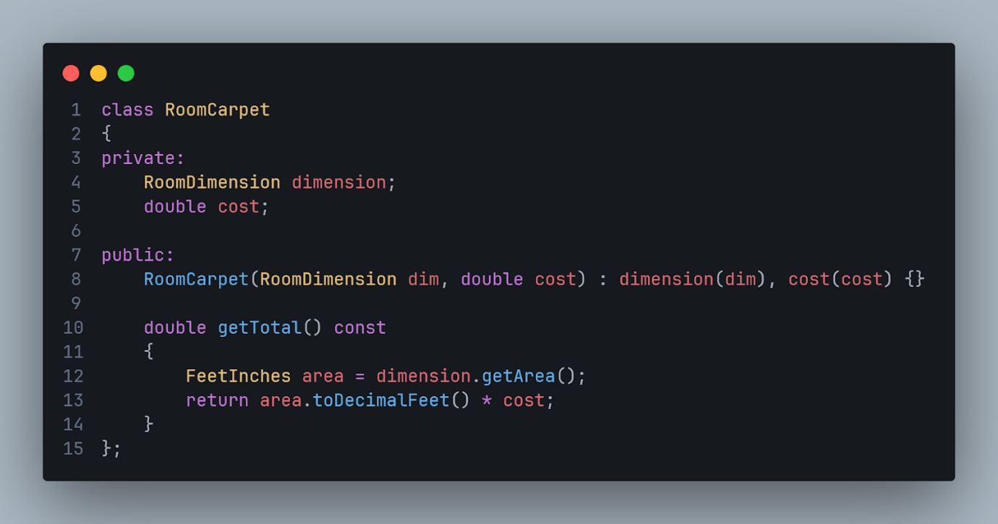
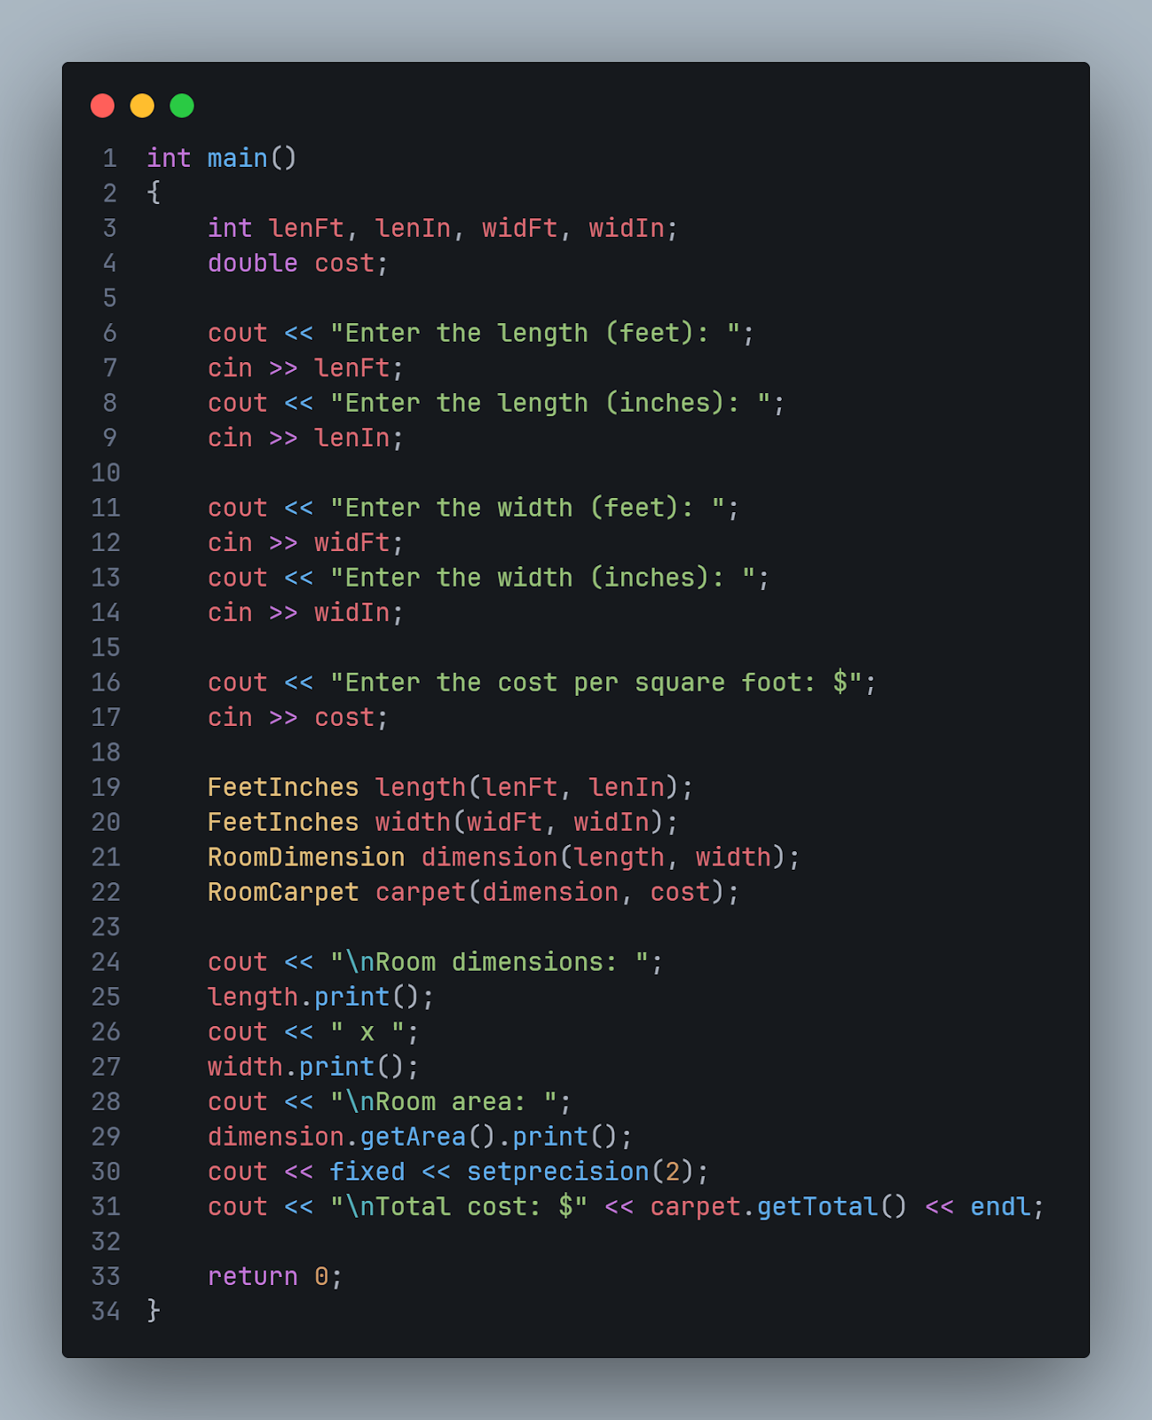

Result:
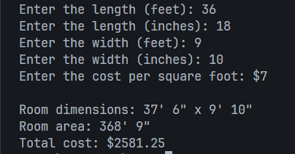
14.14 Parking Ticket Simulator
Description:
- The program consists of five components:
· ParkedCar → stores car info (make, model, color, license, minutes parked)
· ParkingMeter → stores purchased parking time in minutes
· PoliceOfficer → stores officer name and badge number
· ParkingTicket → represents ticket with fine calculation and print method
· Inspection → helper class with static inspect method
- Officer inspects parked cars by:
· Comparing car's parked time with meter's purchased time
· Calculating overtime = car minutes - meter minutes
· Issuing a ticket if overtime > 0, otherwise no violation
- Fine calculation:
· Overtime minutes are rounded up to hours: (overtime + 59) / 60
· First hour (or part): $25
· Each additional hour (or part): $10
· Formula: $25 + (hours - 1) × $10
Student: –
Solution:
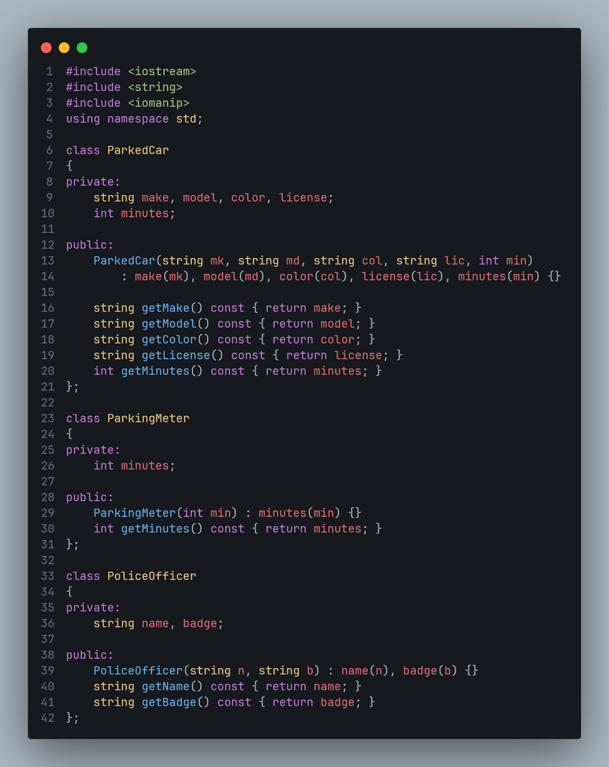

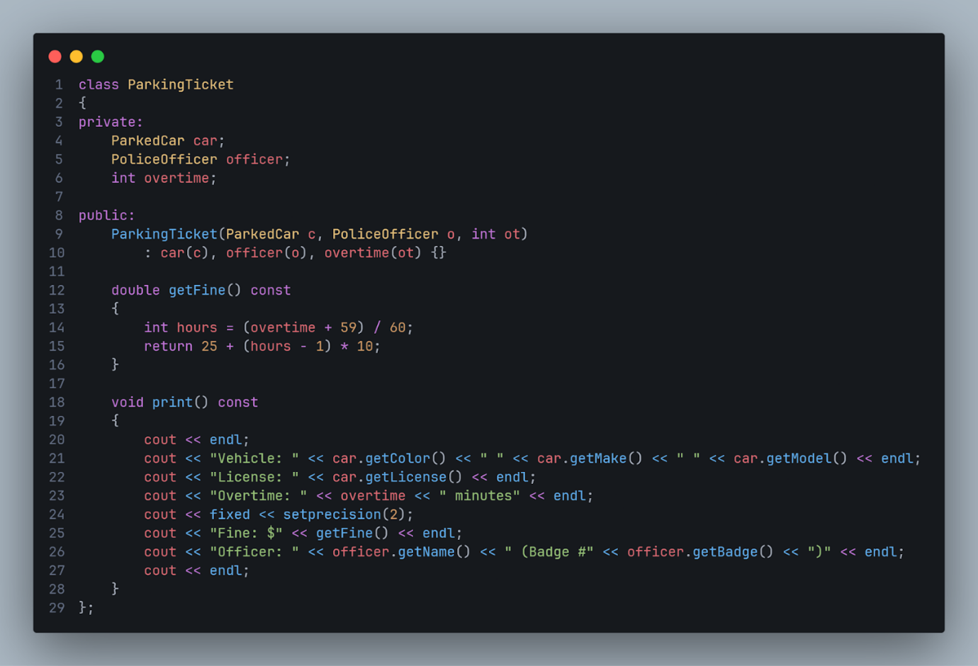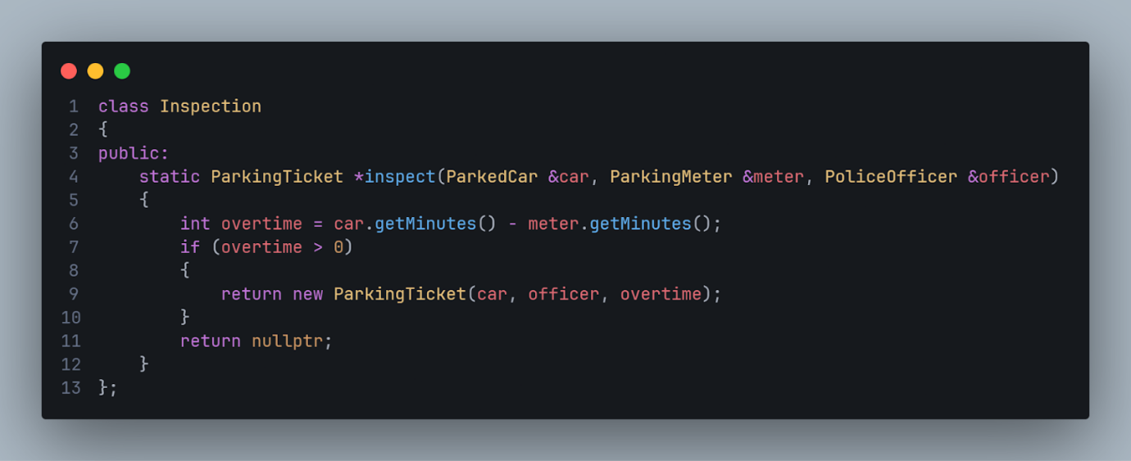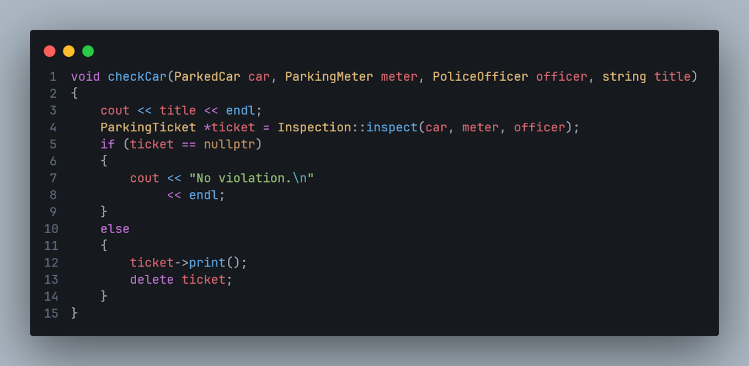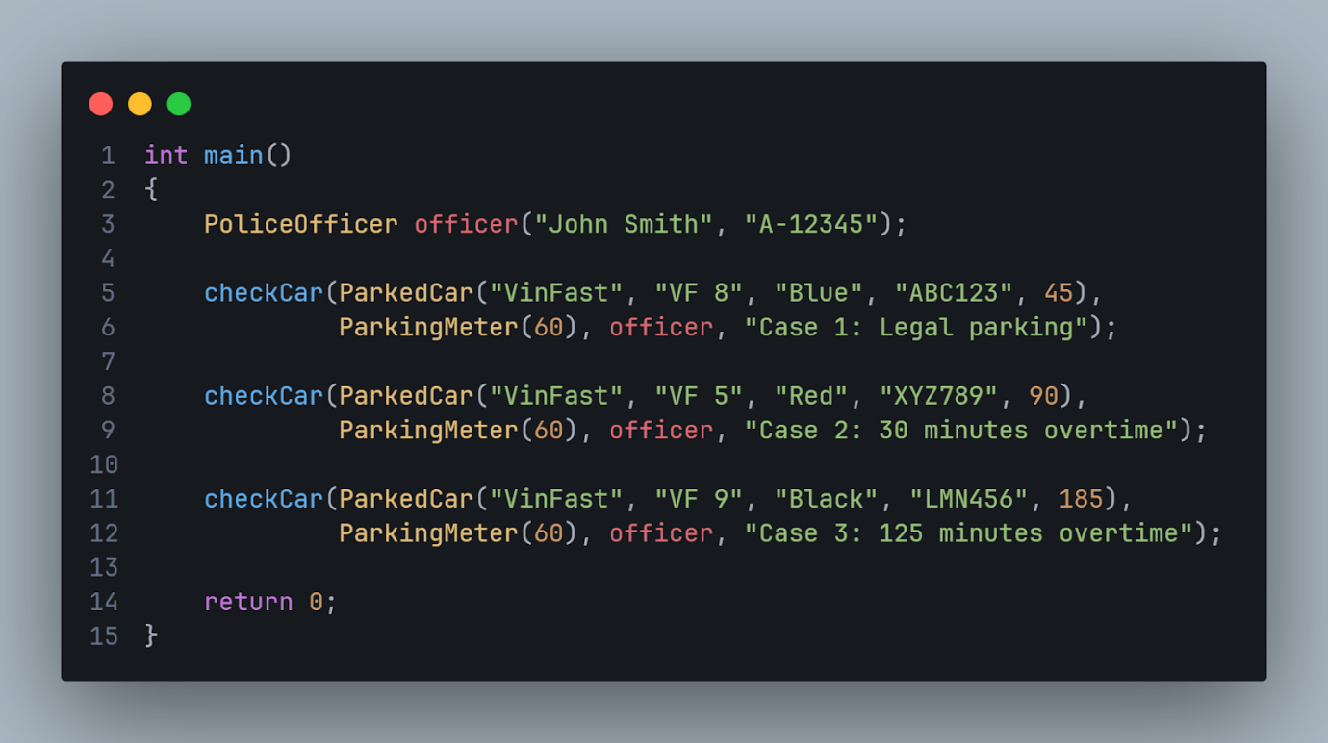

Result:
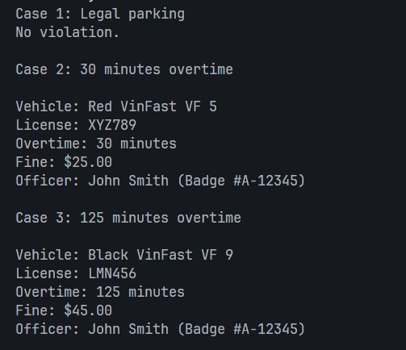

Contribution Table
Problem 8.8
Problem 14.13
Problem 8.3
Problem 8.3
Problem 14.14

