Introduction

FloodLAMP surveillance screening can be run using a variety of physical setups depending on the resources and space that are available and the volume of tests to be run. The following are lists of required aspects and preferred aspects of the test processing space (aka “lab”).

Testing Space Requirements

- Controlled access to testing space:
  - While running assay
  - Whenever certain testing equipment & materials are not stored / secured elsewhere
- Large table (6’)
- Space for dedicated mini-freezer
- Available power sockets/power strip (standard 110V) for:
  - Mini-freezer
  - 5 other plugs

Preferred Testing Space Features

- Dedicated room with access control (i.e., locks)
- Non-carpeted floor
- 3 separate table (smooth plastic for easy cleaning)
- Continuous wifi to enable remote freezer temperature monitoring
- Space for dedicated mini-refrigerator
- Power sockets/strip (standard 110V) additionally for:
  - Mini-refrigerator
  - Temperature monitoring hub
  - Light box

Acceptable Facility Setup
Single table in a room that is dedicated but used for multiple stations

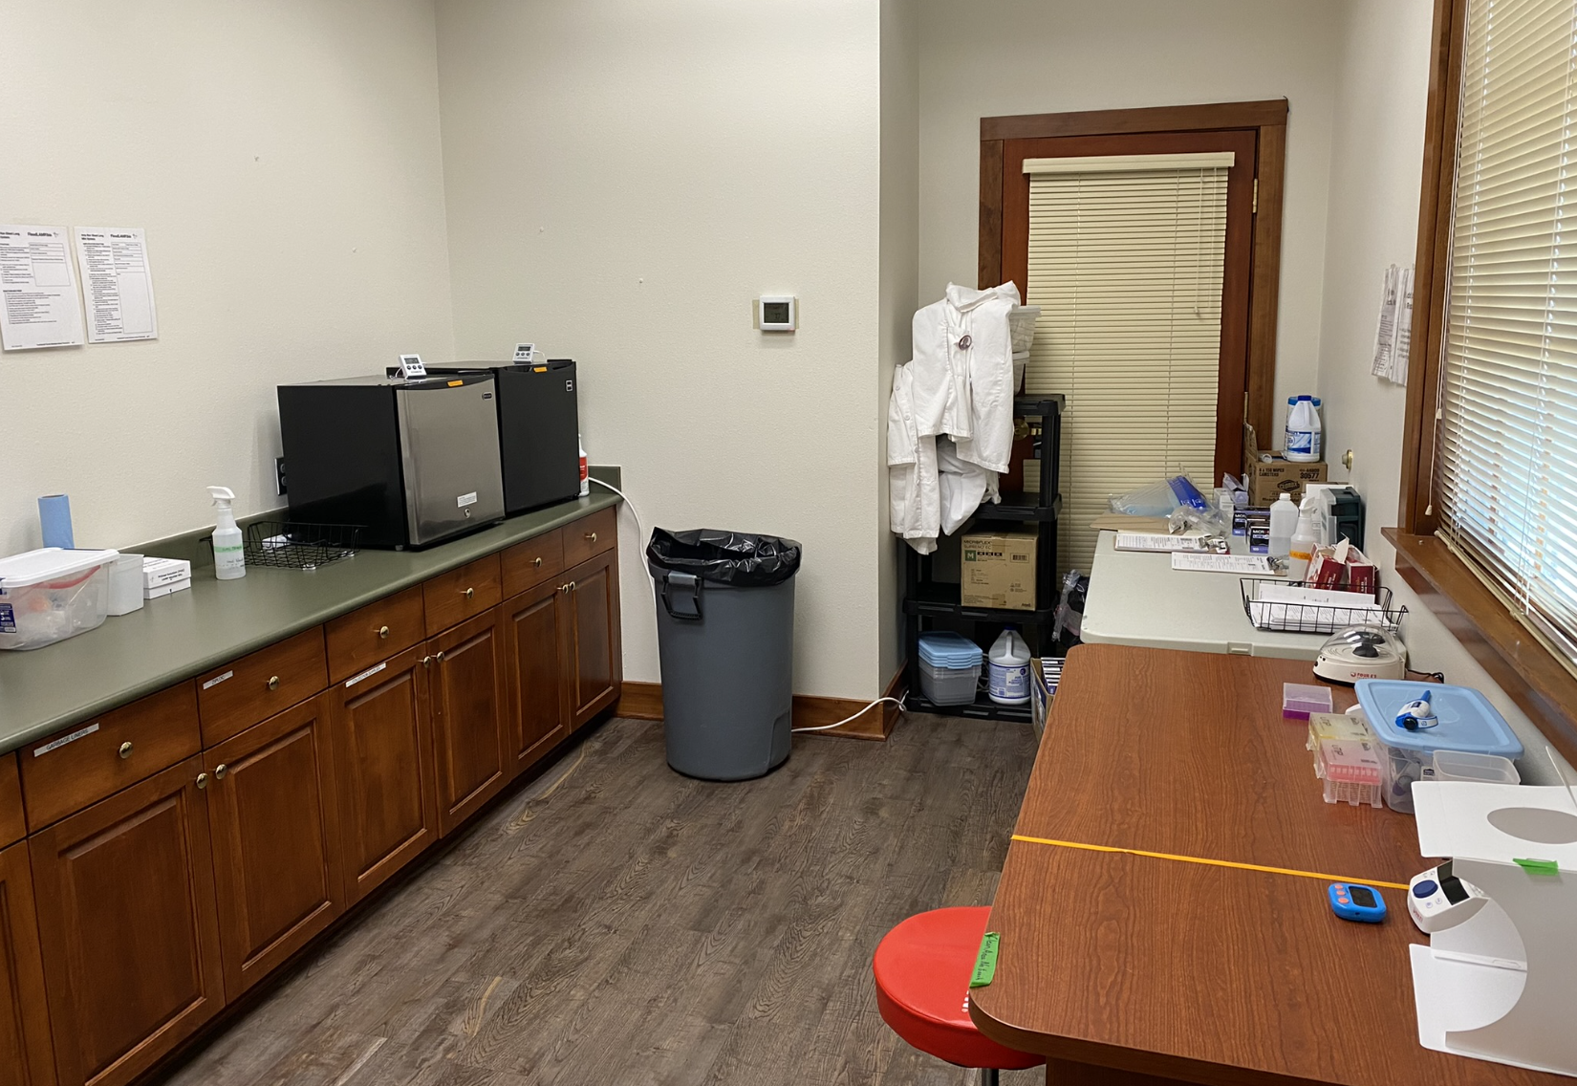
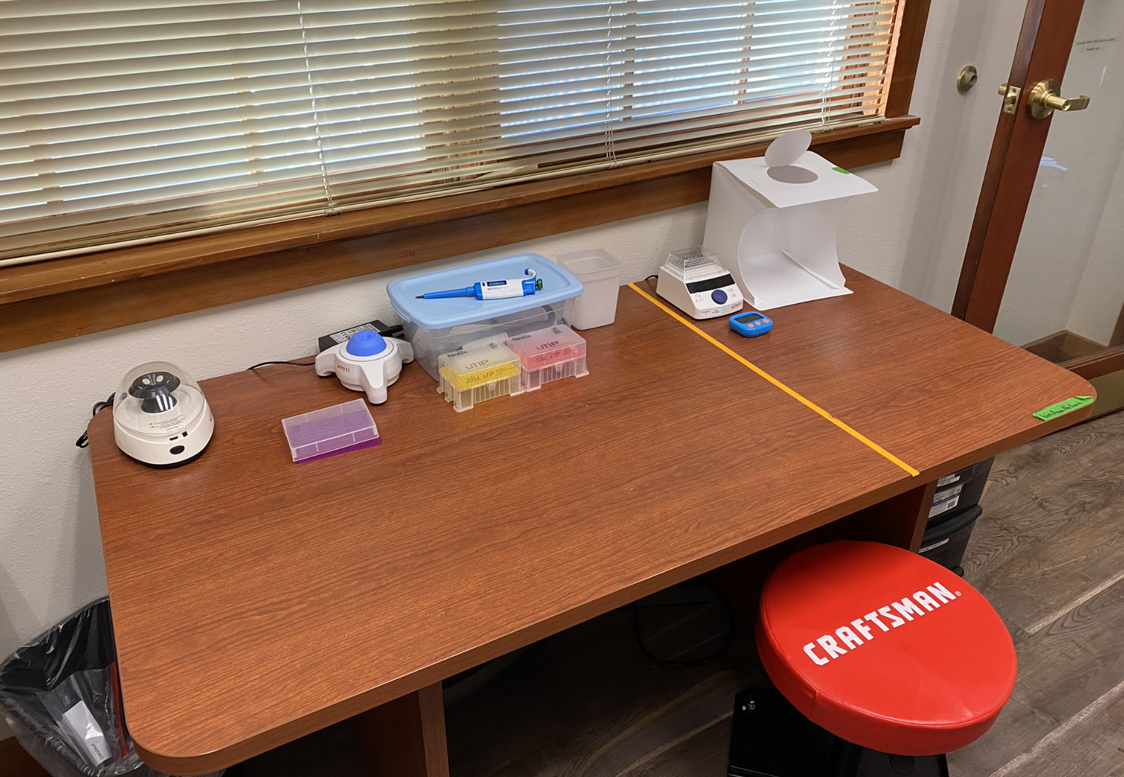

Preferred Facility Setup
Dedicated room, controlled access, dedicated tables for different stations
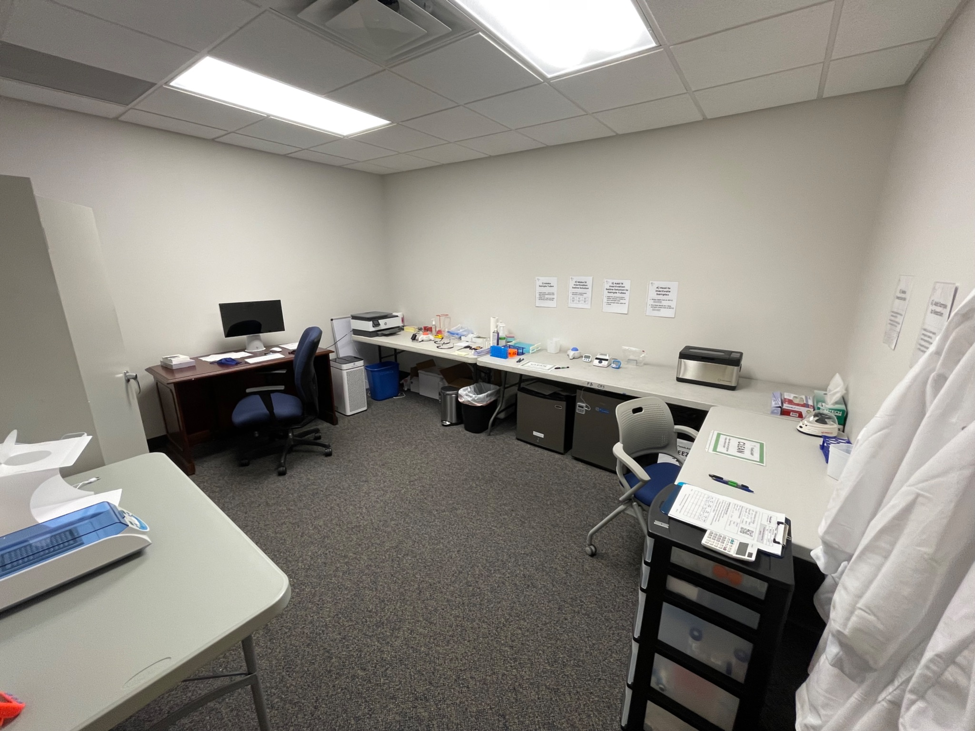

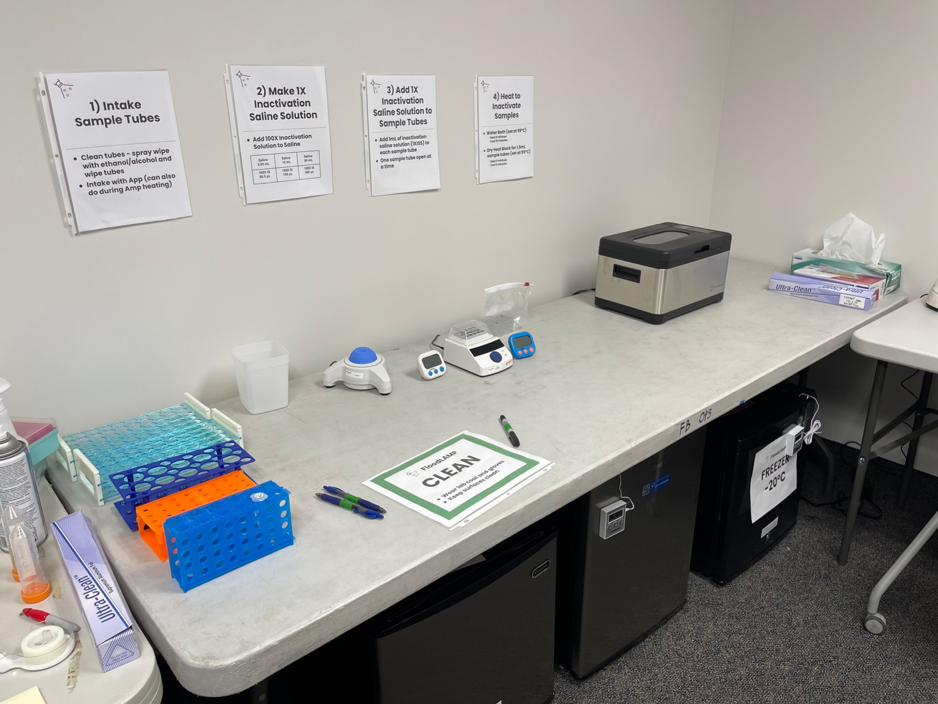

Other Setups
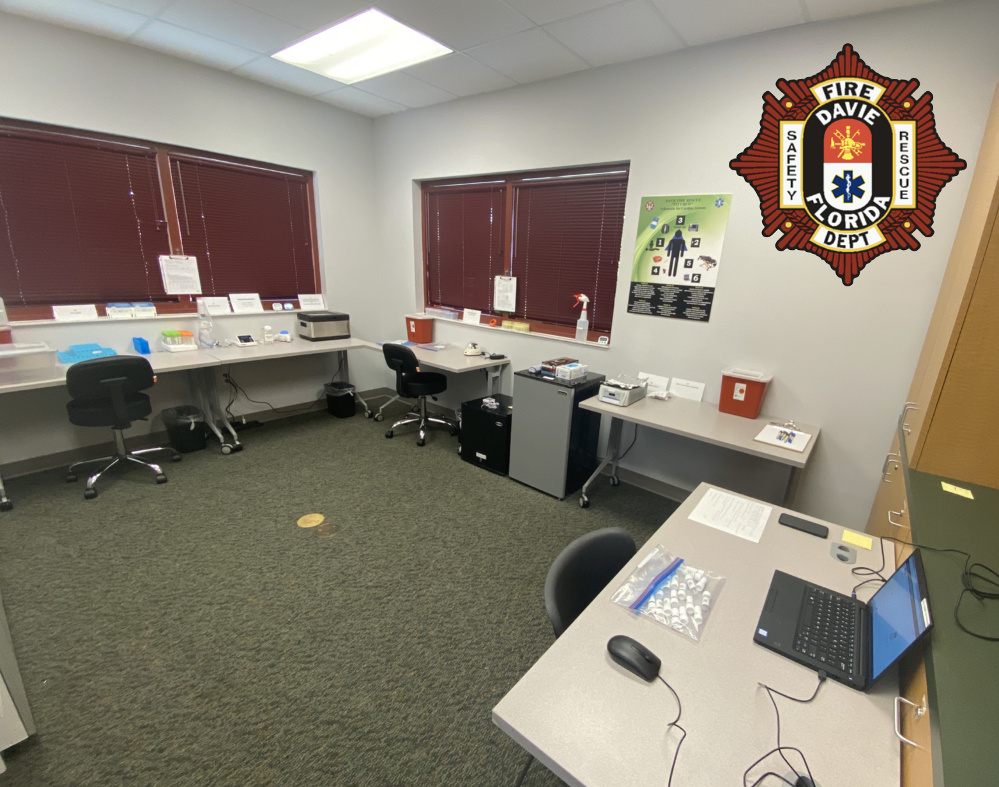

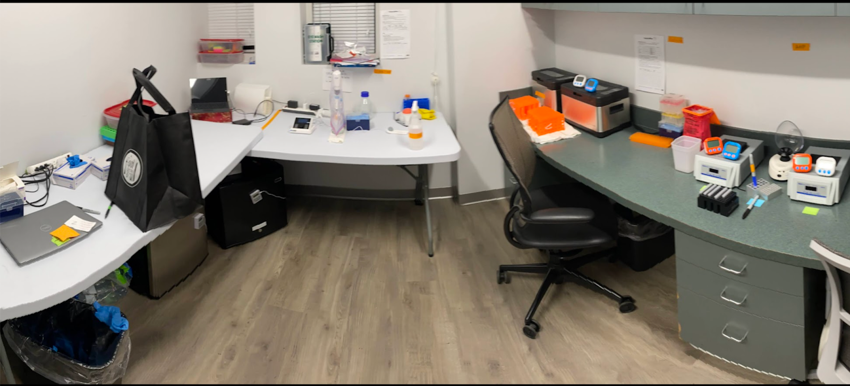

Mobile Operation
