CloudEngine Switches Openflow deployment Guide
Acronyms and Abbreviations | Full Name
LXC | Linux Container
CE | Cloud Engine switch
VRPV8 | Versatile Routing Platform Version 8

introduction
VRP is a network OS incorporating Huawei proprietary intellectual properties and capable of supporting various network systems of Huawei.
Huawei CloudEngine switches support LXC based on Linux OS so as to run customized applications such as OVSDB, Puppet agent, ZTP, Openflow.
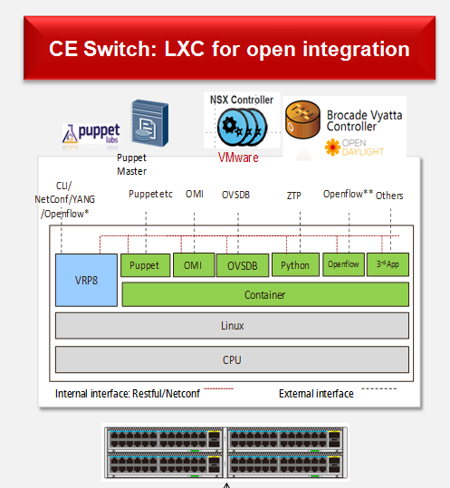

Design guide

Implememtation guide

STEP1: Install container in CloudEngine switch

Install lxc Root filesystem :
<HUAWEI>system-view
Enter system view, return user view with return command.
[~HUAWEI]bash shell rootfs_openflow.sqfs disk-size 100
[*HUAWEI]commit
Committing...........done.
[~HUAWEI]

STEP2: Configure IP connection between container and external network
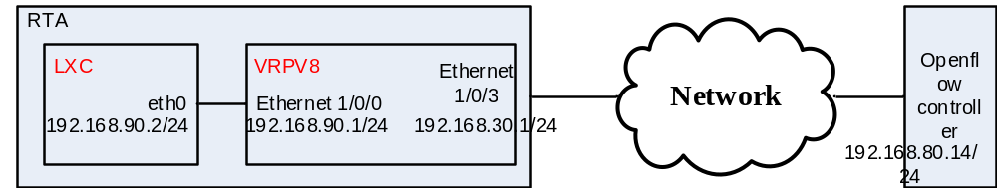

Configure IP address of virtual ethernet port of CE switch
[~HUAWEI] port create virtual-ethernet 1/0/0
[~HUAWEI]interface ethernet 1/0/0
[~HUAWEI-Ethernet1/0/0]ip address 192.168.90.1 24
[~HUAWEI-Ethernet1/0/0]commit
[~HUAWEI-Ethernet1/0/0]

Log in container :
[~HUAWEI]bash
Type <Ctrl+a q> to exit the console, <Ctrl+a Ctrl+a> to enter Ctrl+a itself
Please press Enter to activate this console.
huawei login: root
Password:

Configure IP address of lxc eth0-port (user :root, password :root)
Modify vim /etc/network/interfaces to configure eth0 IP address：
root@huawei:~# vim /etc/network/interfaces
auto eth0
iface eth0 inet static
address 192.168.90.2
netmask 255.255.255.0
gateway 192.168.90.1

Active configure by reboot eth-port：
root@huawei:~# /etc/init.d/networking restart

The router need to be advertised to external network to ensure the IP reachablility between LXC eth0 and openflow controller.
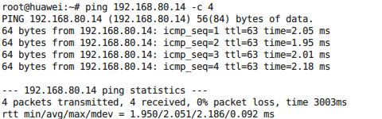

STEP3: VRPV8 configure :

Configure netconf ：
sys
aaa
local-user rootDC password irreversible-cipher Admin@123
local-user rootDC user-group manage-ug
local-user rootDC level 3
local-user rootDC service-type ssh
comm
q
ssh user rootDC
ssh user rootDC authentication-type password
ssh user rootDC service-type all
ssh user rootDC sftp-directory flash:
ssh server cipher aes256_ctr aes128_ctr aes256_cbc aes128_cbc 3des_cbc blowfish_cbc
ssh server hmac sha2_256_96 sha2_256 sha1 sha1_96
commit
stelnet server enable
snetconf server enable
rsa local-key-pair create
commit
netconf
idle-timeout 0
commit
ssh client first-time enable
Note：For security, the following conditions are recommanded for netconf user password :
The password must be at least 8 characters long ;
The password must contain numbers, letters, and special symbols.

Save VRPV8 configures, then the device will not need to re-configure even after rebooted.

STEP4: Install openflow in container:

Log in the container by SSH as root user ;

ftp or scp download openflow-1.3.4.deb.

Install openflow-1.3.4.deb:
dpkg -i openflow-1.3.4.deb

STEP5: Configure and run openflow in container:

Log in the container by SSH as root user ;

Modify configure：
- vim /home/ofdatapath.cfg

- Start ofdatapath：
ofdatapath enable ptcp:6677 -d 000000000020 -I 192.168.90.1 -f /home/ofdatapath.cfg
-d : openflow switch ID ;
-I : IP address of virtual ethernet port of CE switch ;
- Start ofprotocol：
ofprotocol tcp:127.0.0.1:6677 tcp:192.168.80.14:6633
tcp :192.168.80.1 : IP address of openflow controller ;

STEP6: Show openflow flow table:
dpctl tcp:127.0.0.1:6677 stats-flow

