

Executive Summary Report for Pampered Pets' Digitalisation Assessment

Prepared For: Pampered Pets
July 14th 2024



Introduction
Pampered Pets, known for high-quality pet products, is expanding internationally by integrating an international supply chain and establishing automated warehouses. This report evaluates the risks and opportunities of Cathy’s digitalisation plan, focusing on potential impacts on product quality and supply chain security. The Monte Carlo simulation reveals significant risks with a high probability of substantial financial impact due to quality degradation and supply chain disruptions. Key recommendations include implementing advanced monitoring systems, enhancing quality assurance processes, encrypting data, and diversifying suppliers to mitigate these risks.

1: Quantitative Risk Modelling Approach

1.1: Methodology and Justification
A Monte Carlo simulation was conducted to estimate the financial impact of potential risks associated with Pampered Pets' digitalisation and international expansion. This technique models the probability and impact of risk scenarios, offering a range of possible outcomes based on probabilistic inputs. The method is widely used in risk analysis for its ability to incorporate various risk factors and model their interactions comprehensively (Olson & Wu, 2020).

2: Detailed Calculations and Assumptions
To ensure the accuracy, several key assumptions were made based on reliable sources detailed in Table 1:

Assumption | Description | Source
Quality Baseline | Current product quality metrics | Internal company quality reports
Historical Data | Past supply chain disruptions | Historical records, industry benchmarks
Vendor Performance | Performance metrics for new suppliers | Vendor performance records
Table 1: Assumptions

2.1: Monte Carlo Simulation Calculations
The simulation step-by-step process is detailed in Table 2:
Step | Description
Set Parameters | - Quality degradation probability: 15% (Henrich et al. 2022)  - Supply chain disruption probability: 20%. (World Economic Forum, 2022)  - Financial impact ranges:  - Quality degradation: £5,000 - £50,000 (Pattanayak et al. 2019).  - Supply chain disruption: £10,000 - £100,000 (Ramadan et al. 2020).
Define Distributions | Quality degradation: Normal distribution with a mean of 100 and a standard deviation of 20.  Supply chain disruption: Uniform distribution between 50 and 200.
Run Simulations | 1,000 simulation runs to capture a range of possible scenarios and outcomes
Calculate Financial Impacts | Quality Degradation: Multiplier of 250 to convert random values to financial impacts.  Supply Chain Disruption: Multiplier of 500 to convert random values to financial impacts.
Analyse Results | Calculate the average, minimum, maximum, and standard deviation of potential impacts (Olson & Wu, 2020).  Determine the probability of the total impact exceeding significant thresholds (e.g., £50,000) (Furcht et al. 2023).
Table 2: Monte Carlo Simulation

2.2: Summary of Results
The simulation revealed an average total impact of £86,563.51 with a standard deviation of £21,951.00. There is a 97% probability that the total impact will exceed £50,000, indicating significant risks associated with the proposed changes.

2.3: Critical Analysis
The Monte Carlo simulation provides a robust method for assessing risks in Pampered Pets' digitalisation and international expansion. It indicates a high likelihood of substantial financial impacts due to quality degradation and supply chain disruptions. This analysis aligns with concerns from HRH the King and Prince Albert II of Monaco, underscoring the need for strict quality control and supply chain resilience.

2.4: Methodological Strengths and Limitations
Monte Carlo simulations provide a comprehensive range of possible outcomes, crucial for understanding the full spectrum of risks. However, the accuracy of these simulations is highly dependent on the input parameters and assumptions, which can introduce biases if not carefully managed (Lavery et al. 2019). Additionally, these simulations require substantial computational resources and expertise (Olson & Wu, 2020).

3: Risk Analysis

3.1 Potential Risks and Probabilities
The following risks were identified, along with their associated probabilities and potential impacts detailed in Table 3:

Risk Category | Probability | Impact Range | Issues Identified
Quality Risks | 15% | £5,000 - £50,000 | Supplier Quality Variability, Loss of Product Quality
Supply Chain Risks | 20% | £10,000 - £100,000 | Automation Failure, Geopolitical Disruptions, Logistics Disruption
Financial Risks | 20% | £10,000 - £100,000 | Financial loss due to supply chain disruptions and quality issues
Table 3: Risk Results

3.2: Risk Analysis
Following the Monte Carlo simulation, a comprehensive risk analysis was conducted to identify and evaluate the potential threats to Pampered Pets' quality and supply chain. This analysis focuses on the critical risks associated with the digitalisation process, international supply chain integration, and the implementation of automated warehouses.
The Risk Analysis Table below outlines the identified risks, providing a detailed description, the associated mitigation strategies, and the potential impact on the business's main assets. Each risk is assessed based on its probability of occurrence and the severity of its impact, calculated as the product of these two factors. The table also categorises the risks into different tolerance levels to prioritise the necessary actions to mitigate these risks.

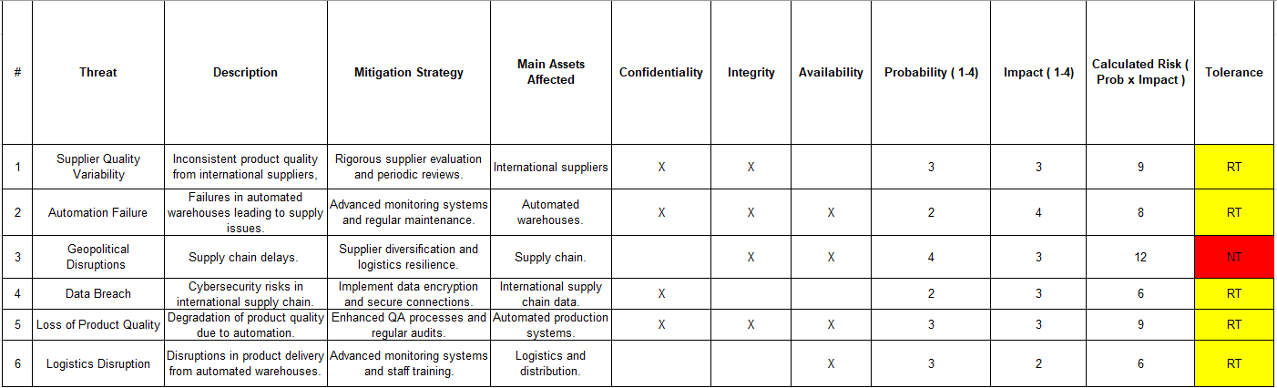
Table 4: Risk Analysis based on ISO31000:2018

3.2: Risk Matrix
The Risk Matrix categorises risks based on their probability of occurrence and potential impact on the business, helping prioritise the risks that need immediate attention and those that require monitoring.
- Impact Ratings:
  - Critical (4): The highest severity level could cause severe damage to the business.
  - Severe (3): Significant severity could cause substantial harm to the business.
  - Medium (2): Moderate severity could cause noticeable disruption or damage.
- Probability Ratings:
  - High (4): Very high likelihood of occurrence.
  - Medium (3): Moderate likelihood of occurrence.
  - Low (2): Lower likelihood of occurrence.

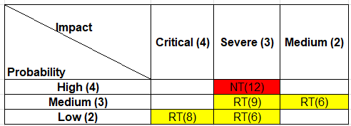
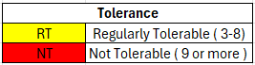
Table 5: Risk Assessment Matrix (ISO 31000, 2018)

4: Recommendations (Prioritised by Business Commercial Needs)

4.1: Similar Industry Digitalisation Examples
Several UK pet food companies have successfully navigated digitalisation, providing helpful case studies for Pampered Pets. For example, Pets at Home leveraged Salesforce's Service Cloud to enhance customer service and satisfaction. By automating workflows and using digital channels, Pets at Home improved its Trustpilot score from 2.7 to 4.2 within four months of implementing live chat. These efforts resulted in significant efficiency gains and improved customer satisfaction (Salesforce, n.d; GlobalPETS, 2020). These examples demonstrate the benefits of adopting advanced digital strategies, such as automated customer service solutions and data-driven insights, to remain competitive and meet customer expectations in the pet care industry.

4.2: Recommendations
Based on the identified risks and their potential impacts, the following strategies are recommended in Table 6:

Priority Level | Recommendation | Action | GDPR Alignment
High | Advanced Monitoring Systems and Regular Maintenance | Prevent automation failures in warehouses, ensuring smooth supply chain operations | Supports data integrity and availability
High | Enhanced QA Processes and Regular Audits | Maintain product quality by implementing stringent QA processes and regular audits. | Ensures high standards of quality and data accuracy
High | Encryption and Secure Connections | Protect against data breaches by encrypting data and ensuring secure connections. | Fully aligns with GDPR requirements for data protection
Medium | Supplier Evaluation and Periodic Reviews | Ensure consistent product quality by evaluating and reviewing international suppliers regularly. | Indirectly supports GDPR through supplier compliance
Medium | Diversified Suppliers and Resilient Logistics Network | Mitigate geopolitical risks by having multiple suppliers and a robust logistics network | Enhances data availability and operational continuity
Medium | Advanced Monitoring Systems and Staff Training | Address logistics disruptions by using advanced monitoring and regular staff training | Supports operational efficiency and readiness
Table 6: Recommendations

4.3: Impacts of Not Following Recommendations
Not implementing the recommended strategies can significantly impact Pampered Pets. Without enhanced QA processes and audits, the risk of quality issues remains high, potentially damaging the brand's reputation and losing customer trust. Additionally, lacking advanced monitoring systems and diversified suppliers can lead to supply chain interruptions, resulting in delayed deliveries and increased operational costs. Failing to implement data encryption and secure connections raises the risk of data breaches, potentially causing legal consequences and financial losses. Furthermore, operational inefficiencies can arise without stringent supplier evaluations and staff training, affecting overall performance and profitability.

5: Business Continuity/Disaster Recovery (DR) Strategy
Pampered Pets has requested that in the event of a disaster affecting the shop premises, the following requirements listed in Table 6 are met to ensure business continuity.
Requirement | Description
High Availability | Cloud-based solutions with automated failover
Data Backup | Regular backups with less than 1-minute data loss tolerance
Recovery Time Objective (RTO) | Less than 1-minute changeover window
Table 6: DR Business Requirements

5.1 System Architecture
The proposed system will utilise an active-active configuration, where two systems will run concurrently in different regions to guarantee immediate failover without any service interruption. This setup is depicted in Figure 1 (University of Essex Online, 2024).

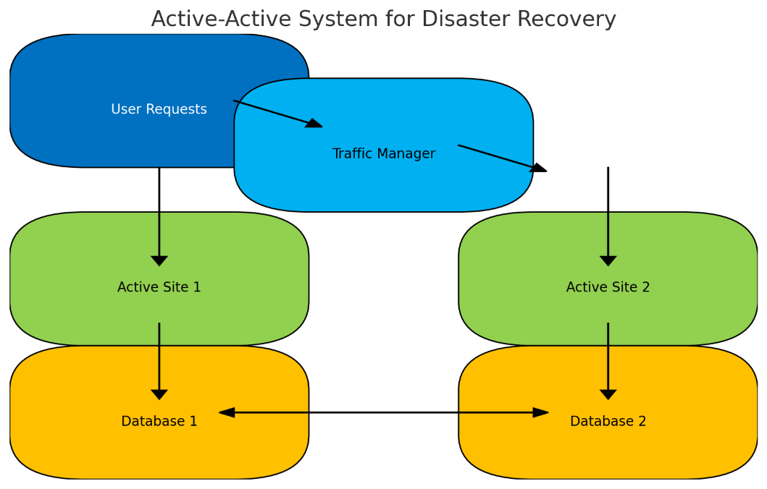

Figure 1: Active-Active System for DR

5.2 Components:
The DR system comprises several essential components. A Traffic Manager (TM) monitors and directs traffic, ensuring a seamless switch to an alternate site if a failure occurs (University of Essex Online, 2024). The configuration will include two active sites—one on-premises and one cloud-based—operating continuously to ensure availability (University of Essex Online, 2024). Databases will employ synchronous replication to maintain data consistency between the sites (University of Essex Online, 2024).

5.3 Benefits:
High availability ensures uninterrupted service (University of Essex Online, 2024). Fast recoverability is achieved through synchronous replication, allowing quick recovery in case of failures (University of Essex Online, 2024). System resilience ensures continued operation despite site failures (University of Essex Online, 2024).

5.4 Considerations:
Effective DR requires addressing data corruption risks, which can be mitigated by slight replication delays (University of Essex Online, 2024). Vendor errors present a significant risk, and employing multi-vendor solutions can reduce the likelihood of widespread outages but will increase system complexity (University of Essex Online, 2024). Furthermore, maintaining dual systems will increase operational expenses (University of Essex Online, 2024).

5.5: Platform Recommendation
Table 8 lists the platform recommendations that meet Pampered Pets requirements.
Recommendation | Description
Cloud Platform | Amazon Web Services (AWS) or Microsoft Azure with cross-region replication.
Vendor Lock-In Mitigation | Employ a multi-cloud strategy and portable technologies like Docker.
Table 8: Platform Recommendations
AWS and Azure offer automated failover and cross-region replication, enhancing resilience and minimising downtime (Malhotra et al. 2023). Automated, frequent backups ensure data integrity and quick restoration (Guo et al. 2020). Quick failover capabilities ensure operations resume immediately after disruption, meeting RTO requirements (Kulkarni et al. 2020).

5.6: ISO 22301:2012
Pampered Pets should consider aligning their plans with ISO 22301:2012 to enhance the business continuity and DR strategy. This standard provides a framework for managing business continuity, ensuring the organisation can continue operations under extreme circumstances. Certification against ISO 22301:2012 will also demonstrate resilience to customers and regulators, strengthening the organisation's reputation and compliance posture (Campbell, 2016).

6: Ethical and Compliance Considerations
To ensure data protection and privacy, the digitalisation will adhere to ethical standards and GDPR compliance. Key measures include data encryption, user consent protocols, and regular audits. Compliance with the PCI-DSS will also be ensured for secure online transactions.

6.1: Legal Considerations for International Expansion
Navigating privacy laws is critical when expanding internationally. Campbell (2016) underscores the need for specialised legal advice to ensure regulatory compliance. Consulting with international legal experts before entering new markets is essential to adhere to local privacy laws (Campbell, 2016). Staying current with privacy regulations in each jurisdiction is vital for ongoing compliance (Campbell, 2016). Stringent data protection measures align with the highest standards and mitigate risks. Addressing these legal considerations is crucial for managing risks and ensuring Pampered Pets' digitalisation strategy remains compliant and effective.
.6.2 Competition Law Considerations
Digitalisation offers significant benefits but also poses competition-related risks. According to Sørensen (2018), digital tools such as algorithms and big data can lead to explicit and implicit collusion. For example, the US Department of Justice prosecuted Topkins for using pricing algorithms to coordinate prices with competitors, illustrating potential anti-competitive practices. Although tacit collusion is not prohibited under Article 101 TFEU, it raises concerns about market fairness and coordinated effects (Sørensen, 2018). Additionally, digital markets characterised by network effects and significant data access can create barriers to entry, impeding competition (Sørensen, 2018).
Pampered Pets should integrate competition law considerations into their digitalisation strategy. Monitoring algorithms regularly can prevent explicit and implicit collusion. Ensuring fair access to market data can avoid creating entry barriers for new competitors. Staying updated on competition law developments is essential for compliance in digitalisation efforts. By implementing these measures, Pampered Pets can manage the competitive challenges of digital markets, ensuring a fair and competitive business environment.

6: Limitations
Despite the comprehensive analysis, there are several limitations to this report. The analysis relies on historical data and assumptions that may only partially capture future uncertainties. Monte Carlo simulations are robust but may not encompass all potential risk scenarios (Olson & Wu 2020). The probability and impact ratings involve subjective judgment, which can introduce bias (AIRMIC, 2010). The rapidly changing business environment can introduce new risks that should be considered in this analysis. Implementing the recommended strategies may be constrained by the available budget and resources, potentially limiting the scope and effectiveness of the mitigation measures.

7: Implementation Timeline
To ensure the effective execution of the recommended strategies, the following timeline in Figure 2 has been developed. This timeline outlines the key activities and their scheduled implementation periods, including the DR strategy to maintain business continuity.

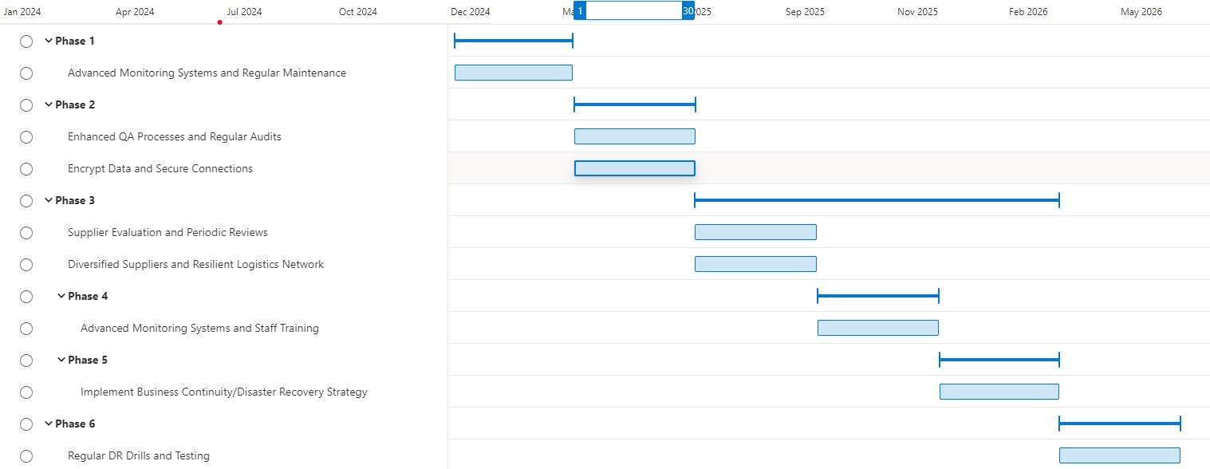

Figure 2: Implementation Timeline Gannt Diagram

Conclusion
Digitalisation presents significant opportunities for growth and efficiency. Pampered Pets can enhance its market position while maintaining product quality and supply chain security by implementing the recommended risk management and DR strategies.

Approval
This report has been submitted for approval to Pampered Pets' management and stakeholders.

References List

AIRMIC. (2010) A structured approach to Enterprise Risk Management (ERM) and the requirements of ISO 31000. Available from: https://www.ferma.eu/app/uploads/2011/10/a-structured-approach-to-erm.pdf [Accessed 11 May 2024].

Campbell, T. (2016) Practical Information Security Management: A Complete Guide to Planning and Implementation.1st ed. ProQuest Ebook Central: Apress. Available from: https://ebookcentral.proquest.com/lib/universityofessex-ebooks/detail.action?docID=4755388 [Accessed 21 June 2024].

Furcht, C., VanSeveren, M., Holstein, M., Feroz, H. & Ghose, S. (2023) Use of Monte Carlo simulations for improved facility fit planning in downstream biomanufacturing and technology transfer. Biotechnology Progress 39(1): 1-10. DOI: https://doi.org/10.1002/btpr.3306

Guo, W., Qin, S., Lu, J., Gao, F., Jin, Z., Wen, Q. & Sgandurra, D. (2020). Improved Proofs Of Retrievability And Replication For Data Availability In Cloud Storage. The Computer Journal 63(8): 1216-1230. https://doi.org/10.1093/comjnl/bxz151.

Henrich, J., Li, J., Mazuera, C. & Perez, F. (2022) Future-proofing the supply chain. Available from: https://www.mckinsey.com/capabilities/operations/our-insights/future-proofing-the-supply-chain [Accessed 22 June 2024].

Kulkarni, S., Liu, G., Ramakrishnan, K., Arumaithurai, M., Wood, T. & Fu, X. (2020) REINFORCE: Achieving Efficient Failure Resiliency for Network Function Virtualization Based Services. IEEE/ACM Transactions on Networking 28(2): 695-708. DOI: https://doi.org/10.1109/TNET.2020.2969961.

Lavery, R.M., Acharya, P., Sivo, A.S. & Xu, L. (2019) Number of predictors and multicollinearity: What are their effects on error and bias in regression? Communications in Statistics – Simulation and Computation 48(1): 27-38. DOI: https://doi.org/10.1080/03610918.2017.1371750

ISO. (2023) ISO31000:2018 Risk Management Guidelines Second Edition. Available from: https://www.iso.org/standard/65694.html [Accessed 14 May 2024].

Malhotra, A., Elsayed, A., Torres, R. & Venkatraman, S. (2023) Evaluate Solutions for Achieving High Availability or Near Zero Downtime for Cloud Native Enterprise Applications. IEEE Access 11: 85384-85394. DOI: https://doi.org/10.1109/ACCESS.2023.3303430

Olson, L.D. & Wu, D. (2020) Enterprise risk management models. 3rd ed. VitalSource: Springer Nature. Available from: https://doi.org/10.1007/978-3-662-60608-7_5 [Accessed 21 June 2024].

Pattanayak, A., Prakash, A. & Mohanty, R. (2019) Risk analysis of estimates for cost of quality in supply chain: a case study. Production Planning & Control 30(4): 299 - 314. DOI: https://doi.org/10.1080/09537287.2018.1541488

Ramadan, H., Gio, P. & Rosmaini, E. (2020) Monte Carlo Simulation Approach to Determine the Optimal Solution of Probabilistic Supply Cost. Journal of Research in Mathematics Trends and Technology 2(1):1-6. DOI: https://doi.org/10.32734/JORMTT.V2I1.3752

Salesforce. (n.d) Pets at Home helps more owners create a happy home for their pets with Salesforce. Available from: https://www.salesforce.com/uk/resources/customer-stories/pets-at-home/ [Accessed 01 July 2024].

Sørensen, T.B. (2018) Digitalisation: An Opportunity or a Risk?. Journal of European Competition Law & Practice 9(6): 349-350.DOI: https://doi.org/10.1093/jeclap/lpy038
ISO. (2023) ISO31000:2018 Risk Management Guidelines Second Edition. Available from: https://www.iso.org/standard/65694.html [Accessed 14 May 2024].

University of Essex Online. (2024) Business Continuity and Disaster Recovery [Lecturecast]. PCOM7E. MSc Cyber Security. University of Essex Online.

World Economic Forum. (2022) The Global Risks Report 17th Edition. Available from: https://www3.weforum.org/docs/WEF_The_Global_Risks_Report_2022.pdf [Accessed 22 June 2024].

Appendices
Appendix A: Monte Carlo Simulation Details.
https://github.com/Kaylie89/kaylie89.github.io/blob/main/Security-and-Risk-Management/artefacts/Unit%2011/Monte%20Carlo%20Simulation.xlsx

