

Risk Identification Report for Pampered Pets' Digital

Transformation Assessment

Prepared For: Pampered Pets
Author: Cyber Risk Rangers

June 6th 2024



Introduction
This report evaluates the risks and opportunities to inform strategic decisions for growth and operational efficiency, focusing on three critical questions:
- Could an online presence grow the business by up to 50%?
- Could changing to an international supply chain reduce costs by up to 24%?
- Could the business lose up to 33% of its existing customers if the business does not provide online features?
This report analyses these questions, assesses impacts, and outlines strategies to manage associated risks.

1: Methodology and Justification
We adopted a hybrid methodology for comprehensive risk management, integrating International Organisation for Standardisation (ISO) 31000, STRIDE, and Factor Analysis of Information Risk (FAIR).

1.1 ISO 31000
It provides a structured approach to risk management, aligning with standards such as ISO 9001 and ISO/IEC 27001 (Barafort et al. 2018). As illustrated in Figure 1, it includes:
- Risk Identification: Pinpointing potential risks.
- Risk Analysis: Evaluating risks based on likelihood and impact.
- Risk Evaluation: Comparing risk analysis results with criteria.
- Risk Treatment: Developing strategies to manage risks.
- Monitoring and Review: Regularly reviewing risks and processes.
- Communication and Consultation: Engaging stakeholders for understanding and management.
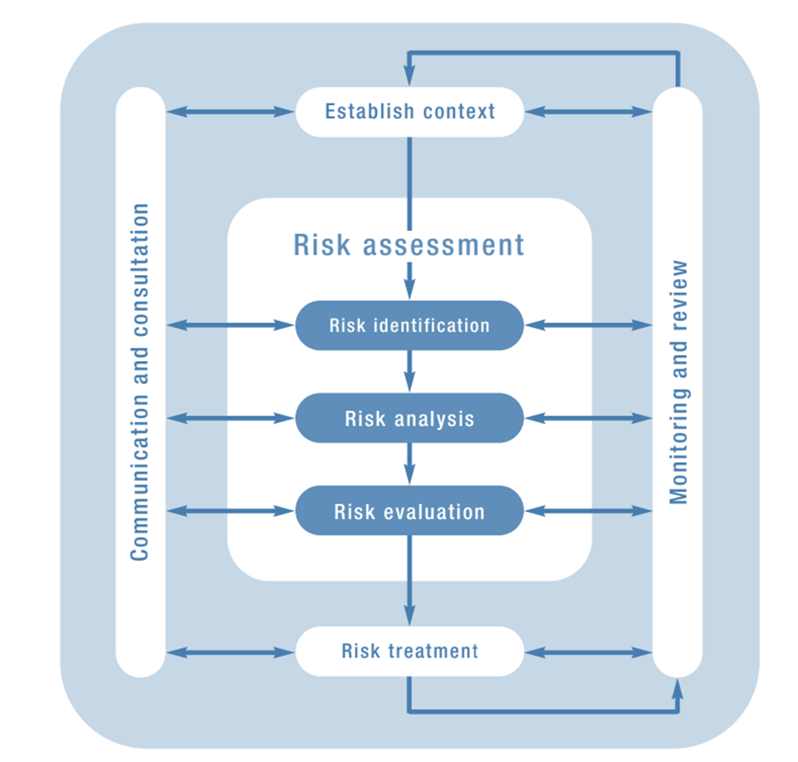

Figure 1: Risk Assessment Process ISO 31000 (AIRMIC, 2010)

1.2 STRIDE
The Stride model Identifies Cybersecurity threats. Shevchenko et al. (2018) specify them in Table 1:
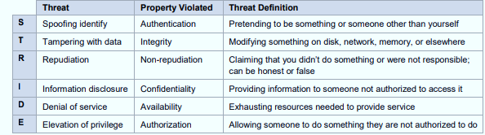
Table 1: Threat Categories

1.3 FAIR
The FAIR model quantifies the financial impact of identified risks using statistical methods and Monte Carlo simulations (Wang et al. 2019).

1.4 Critical Analysis
Combining these methodologies offers a comprehensive, data-driven risk management approach. ISO 31000 provides a structured framework, STRIDE addresses specific Cybersecurity threats essential for digitalisation, and FAIR quantifies risks, translating complex scenarios into clear financial impacts. This integrated approach balances qualitative and quantitative analysis tailored to Pampered Pets' needs.

2: Impact Analysis
The potential impacts are summarised in Table 2:
Impact Area | Description | Estimated Impact | Confidence Level | Basis of Estimate
Business Growth | Expansion through online sales | Up to 50% increase | Medium-High | Market analysis of similar sectors.
Cost Reduction | Efficiency from international supply chain. | Up to 24% reduction | Medium | Supply chain optimisation studies.
Customer Retention | Necessity of online features | Loss of up to 33% | High | Customer feedback and competitor analysis.
Table 2: Impact Analysis

3: Current Risk and Threat Modelling
The primary risks in the current business model are detailed in Table 3:

Risk Level | Risk Category | Description | Mitigation Strategy
High | Physical Store Dependency | Vulnerable to disasters or downturns. | Diversify with e-commerce.
Medium | Manual Data Management | Inefficiencies and data loss. | Implement an ERP system.
Medium | Supply Chain Disruption | Over-dependence on specific suppliers | Develop multiple supplier relationships.
Table 3: Current Business Risks

3.1 Assets Identification per Process for Risk Analysis
The following Turtle diagram provides an overview of the resources, inputs/outputs, and critical criteria related to warehouse inventory and delivery.
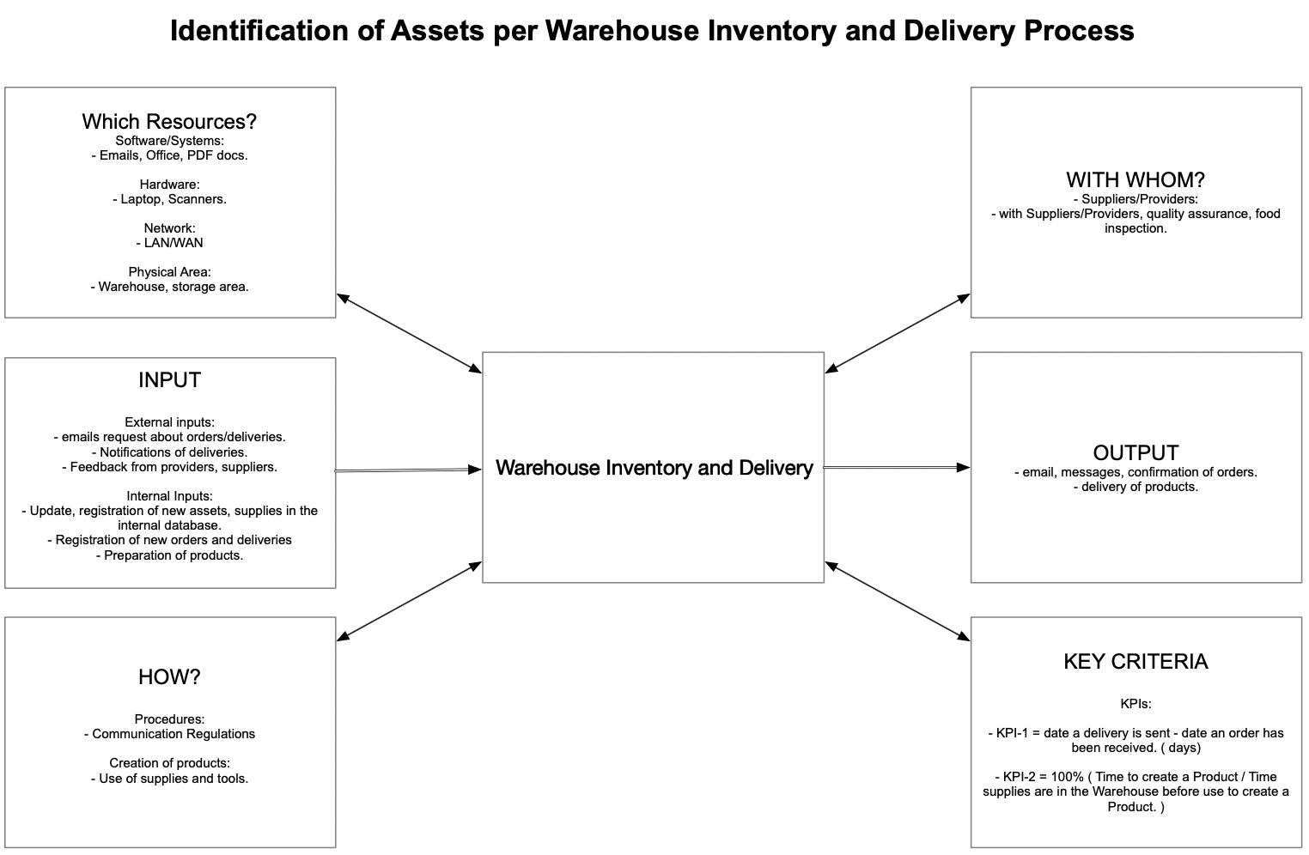
Figure 2: Turtle Diagram for Warehouse Inventory and Delivery process (QUENTIC, 2022)

3.2 Assets Criticality
Following ISO 3100 guidelines, Table 4 defines Assets criticality, Table 5 defines STRIDE

threats definition, vulnerabilities under the current status quo and the proposed

digitalisation process. The analysis indicates that Digitalisation can lead to more tolerable risks.

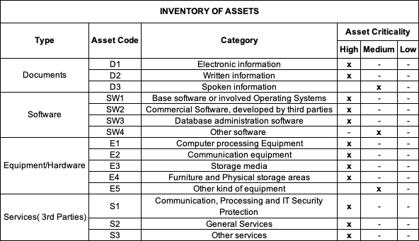
Table 4: Assets Definition (ISO 31000:2018)

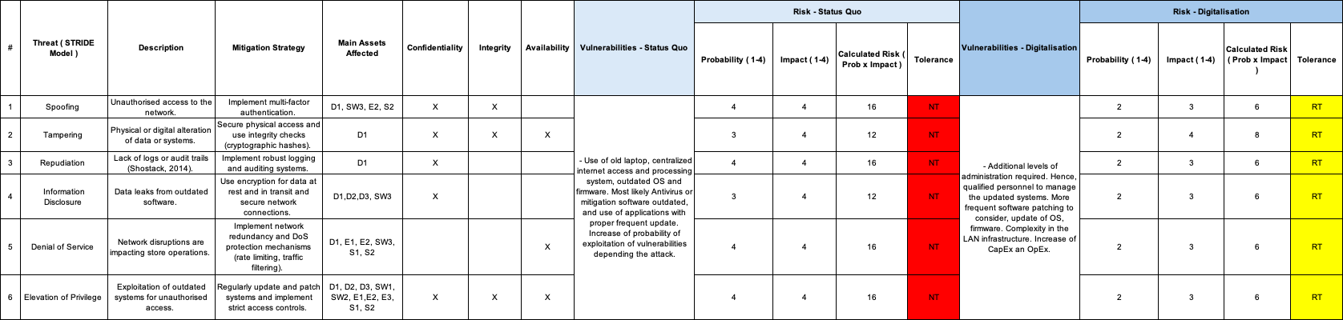
Table 5: Threats, Vulnerabilities, Status Quo vs Digitalisation, Risk Analysis based on ISO31000:2018

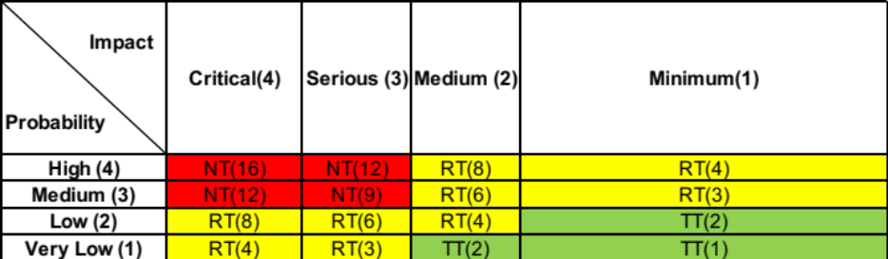

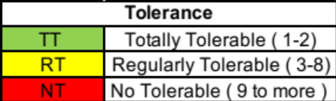

Table 6: Risk Assessment Matrix (ISO 31000, 2018)

3.3 FAIR - Quantitative Risk Analysis
This model estimates the financial impact under the current status quo (Table 7) and proposed digitalisation (Table 8):

Risk | Impact | Probability | Mitigation | Estimated Impact
Cybersecurity breach | Financial loss and reputational damage. | 15% | Basic Cybersecurity measures, periodic audits. | £5,000-£25,000
Table 7: Current Status Quo FAIR Analysis

Risk | Impact | Probability | Mitigation | Estimated Impact
Cybersecurity breach | Financial loss and reputational damage. | 20% | Advanced Cybersecurity measures, regular audits, employee training. | £10,000-£75,000
Table 8: Digitalisation FAIR Analysis

4: Digitalisation Risk Assessment

We propose the following digital initiatives to enhance operational efficiency and customer engagement in Table 9:
Risk Level | Digital Change | Potential Risks | Mitigation Strategy | Specific Technologies
High | E-commerce Portal | Cybersecurity threats, breaches. | Strengthen security measures, regular audits, and training. | Shopify.
High | ERP System | Integration issues, disruptions. | Utilise IT consultancy for phased implementation. | SAP ERP.
Table 9: Digitalisation Proposal

This process flow diagram (Figure 3) outlines the steps to implement the proposed digital

changes, highlighting key phases and decision points to ensure a structured and efficient

transformation.

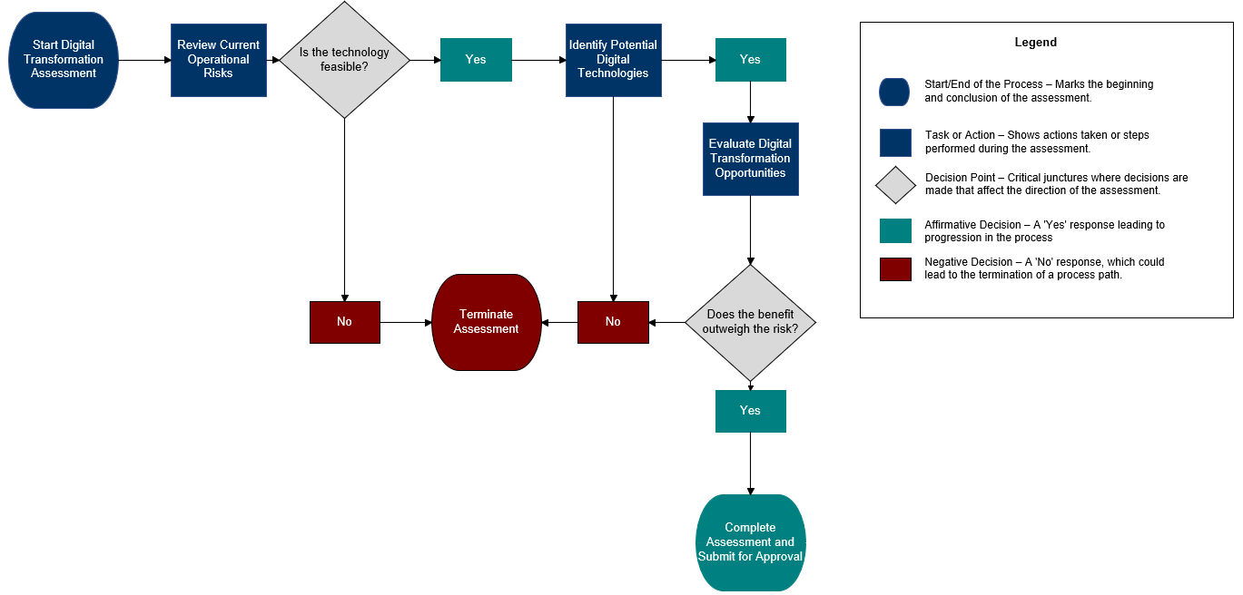
Figure 3: Digitalisation Process Flow

5: Risk Response Treatments and Recommendations
Using risk response treatments (AIRMIC, 2010), we propose the following strategies (Table 10).
- Treat: Measures to minimise the risk.
- Transfer: Move risk to another party (e.g. insurance).
- Tolerate: Accept the risk if mitigation costs outweigh the benefits.
- Terminate: Eliminate the risk by stopping the activity.

Risk Level | Risk Description | Response Treatment | Recommended Action
High | System Failures, Cyber Threats | Treat | Enhance Cybersecurity measures and system redundancies.
High | Physical Store Dependency | Transfer | Obtain business interruption insurance.
Medium | Data Management Inefficiencies | Treat | Implement advanced data management systems.
Low | Logistical Challenges | Tolerate | Regularly monitor supplier performance.
Medium | High Operational Costs | Transfer | Partner with cost-effective suppliers.
Medium | Resistance to Digital Adoption | Terminate | Conduct change management workshops.
Table 10: Risk Mitigation and Recommendations

6: Ethical and Compliance Considerations
The digitalisation will adhere to ethical standards and GDPR compliance to ensure data protection and privacy, including data encryption, user consent protocols, and regular audits.

7: Limitations
The FAIR model’s effectiveness depends on the accuracy of the data used. Thorough data collection and validation are critical for reliable assessments (Barafort et al. 2018). Integrating multiple frameworks can be complex and resource-intensive (Shevchenko et al. 2018). Continuous updates are essential to maintaining relevance and accuracy in meeting evolving Cybersecurity threats (Shostack, 2014).
Human errors and change resistance can impact success, necessitating training and effective change management (Annosi et al. 2021). Moreover, specific risks like natural disasters, which could significantly impact the business, still need to be addressed. A broader risk assessment incorporating this is recommended.

8: Recommendations
The impact analysis supports digitalisation, highlighting growth potential, cost efficiency, customer retention, and improved operations.

9: Implementation Plan
The Gantt Chart in Figure 4 provides the implementation plan timeline for the Digitalisation.

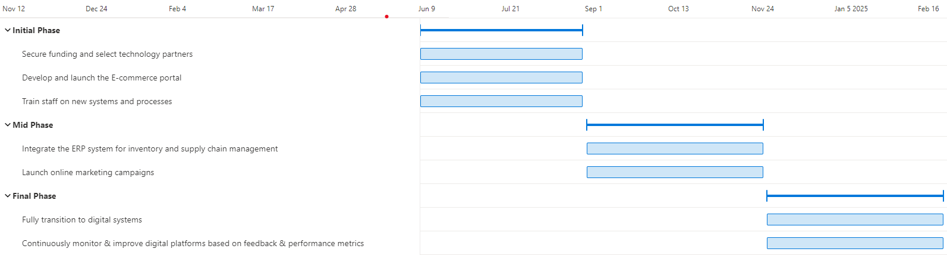

Figure 4: Gantt Diagram

Conclusion
Digitalisation presents substantial growth opportunities, efficiency, and sustainability. Through careful planning, robust risk management, and strategic implementation, Pampered Pets can enhance its market position and customer satisfaction. Moreover, it can foster sustainable practices, operational empowerment, and supply chain collaboration (Rijswijk et al. 2021; Annosi et al. 2021).

Approval
This report has been submitted for approval to Pampered Pets' management and stakeholders.

References List:

AIRMIC. (2010) A structured approach to Enterprise Risk Management (ERM) and the requirements of ISO 31000. Available from: https://www.ferma.eu/app/uploads/2011/10/a-structured-approach-to-erm.pdf [Accessed 11 May 2024].

Annosi, M.C., Brunetta, F., Bimbo, F. & Kostoula, M. (2021) Digitalisation within food supply chains to prevent food waste. Drivers, barriers, and collaboration practices. Industrial Marketing Management, 93: 208-220. DOI: https://doi.org/10.1016/j.indmarman.2021.01.005

Barafort, B., Mesquida, L-A. & Mas, A. (2018) ISO 31000‐based integrated risk management process assessment model for IT organisations. Journal of Software: Evolution and Process.1-15. DOI: https://doi.org/10.1002/smr.1984

ISO. (2023) ISO31000:2018 Risk Management Guidelines Second Edition. Available from: https://www.iso.org/standard/65694.html [Accessed 14 May 2024].

PECB. (2015) ISO31000 Risk Management – Principles and Guidelines. Available from:
https://pecb.com/whitepaper/iso-31000-risk-management--principles-and-guidelines [Accessed 14 May 2024].

QUENTIC. (2022) The Turtle Diagram. How to get process management and analysis. Available from: https://www.quentic.com/articles/the-turtle-diagram/ [ Accessed 25 May 2024].

Rijswijk, K., Klerkx, L., Bacco, M., Bartolini, F., Bulten, E., Debruyne, L., Dessein, J., Scotti, I. & Brunori, G. (2021) Digital transformation of agriculture and rural areas: A socio-cyber-physical system framework to support responsibilisation. Journal of Rural Studies. 85: 79-90. DOI: https://doi.org/10.1016/j.jrurstud.2021.05.003

Shevchenko, N., Chick, T. A., O'Riordan, P., Scanlon, T. P. & Woody, C. (2018) Threat modelling: a summary of available methods. Available from: https://apps.dtic.mil/sti/pdfs/AD1084024.pdf [Accessed 25 May 2024].

Shostack, A. (2014) Threat Modeling: Designing for Security. ProQuest Ebook Central: John Wiley & Sons, Incorporated. Available from: https://ebookcentral.proquest.com/lib/universityofessex-ebooks/detail.action?docID=1629177 [Accessed 25 May 2024].

StandardStores (2024) How to use Turtle Diagrams. Available from: https://16949store.com/articles/how-to-use-turtle-diagrams/ [ Accessed 25 May 2024].

Wang, J., Neil, M. & Fenton, N. (2019) A Bayesian network approach for cybersecurity risk assessment implementing and extending the FAIR model. Computers & Security. 89: 1-20. DOI: https://doi.org/10.1016/j.cose.2019.101659

