When calling patients, you should call the patient using their mobile or home number, calls should be made through Doximity from your phone, see the separate instructions, you should not call using your regular phone, as the patient needs to be able to return calls to the appropriate office, and not to your personal number..
You should create a phone encounter in Epic to track the call, add notes there, and send a secure email to your attending. These instructions are based on Stanford’s Epic implementation but should be similar at other institutions.

Epic

Epic is one electronic health record (EHR) charting software. Check with your attending about if they prefer you to use Epic or to just send them encrypted documents with your notes.
You will need to get access to it first, until you have access, use the word document templates for charting, your attending can copy them into the EHR. Be sure to store them in PHI approved storage.

Getting Access

- Email the appropriate person at your institution
  - Subject: “Need Urgent Epic Access for Remote Wellness Call Volunteering”
  - Content of email: Ask them to give you both Epic access and remote VPN access to Epic, with the ability to make notes.
- Wait for your access, this can take a few days.

Using Epic for Calls

Before starting, make sure you have the appropriate VPN software and the cisco workspace app: https://www.citrix.com/downloads/workspace-app/mac/workspace-app-for-mac-latest.html
https://www.citrix.com/downloads/workspace-app/windows/workspace-app-for-windows-latest.html
- Activate your VPN
- Go to the appropriate site (e.g. https://citrix.stanfordhealthcare.org/Citrix/NonWindowsWeb/ for Stanford)
- Click the Epic icon
- Log into the new window, you may need to pick a department, which should be your attending’s department generally. Be careful, in Epic different departments have different Epic setups and some may not be able to create phone calls.
- Open the patient station:
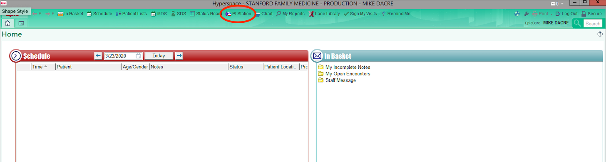
- Enter the name/MRN given to you by your attending, and verify that it is the correct patient
- Go to Encounters->Telephone:
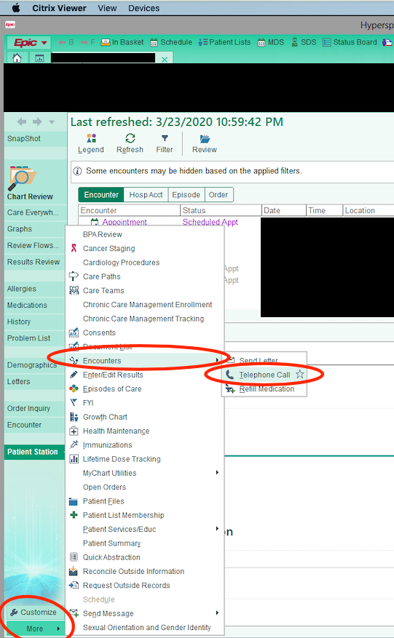
- A box will pop up and you will create a new encounter. Note: once you click this you cannot delete the encounter, you now have to call and record the details.
- The details screen looks like this:
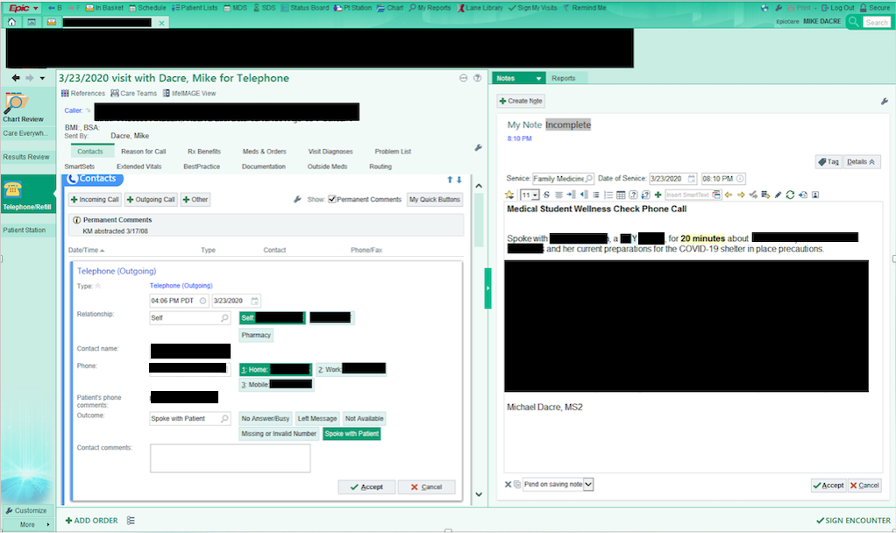
- In the split screen view, you can see your new note on the right and call details on the left.
- For the call details, make sure you put the correct time in. For relationship choose ‘Self’, ie. the patient. For the number, put the mobile usually. This is the number you will call with Doximity. You can try multiple numbers and save the one that connected.
- Add the outcome, hopefully it will be “Spoke with Patient”:
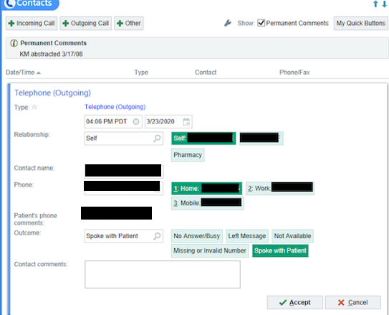
- Next, put in the reason for the call, which should be the next box down.
  - The reason is “Wellness Check”
  - The comment should be “Called to check on wellness, anxiety, and preparation given current COVID-19 restriction”
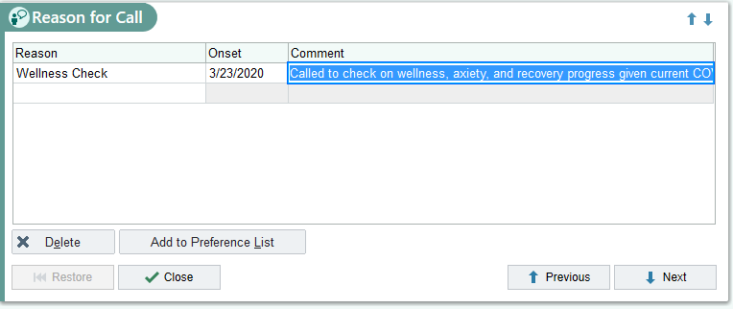
- When you are done with your note and all information is accurate, save it and sign the encounter.
- Next, send the note to your attending.
- Once you have saved and signed your note, find it again in chart review and click “Route”:
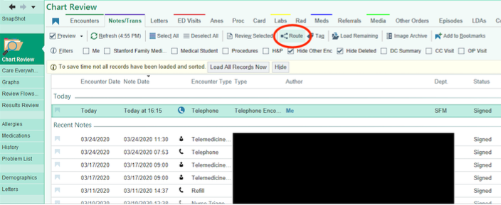
- You will get a dialog to pick who to send to, pick PCP or search your attending manually if needed:
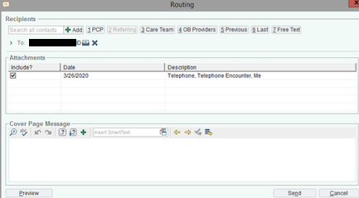
- After this, send an Epic email to your attending with additional information. In the message, you can add any outstanding todos or questions that you need the attending to work on.
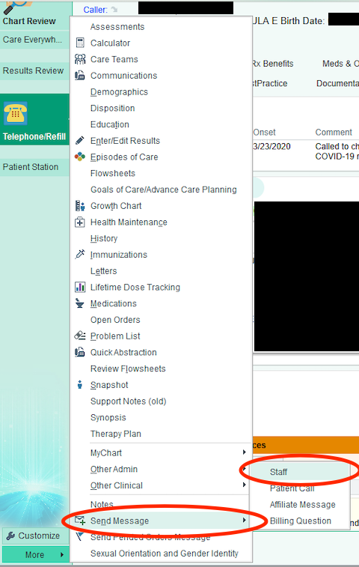
- The next screen uses a basic email format, just enter your attending’s name to find them.
- Note: you will not be notified of their replies, you must log into Epic to check.
  - There is a mobile version of Epic (called Haiku), your hospital will need to give you the configuration for it. It will allow you to get push notifications for messages.

Note: it is much easier if you use a template for the notes, see the template that came with these instructions.

