Operator/Operand Expression Card Sets

Operator/Operand Expression sets can be printed and cut from regular printer paper, or you can write them out on construction paper, creating color-coded sets (recommended to prevent cheating and to reinforce memory cues).

Set A Question Card:
Build expressions that evaluate to the following:
7
0
2
11
8
17
18

SET A Cards:
15
8
3
%
+

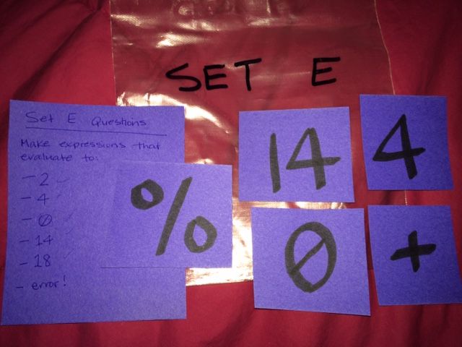

An example of the finished product.

Set B Question Card:
Build expressions that evaluate to the following:
2
36
0
1
45
4
11

Set B Cards:
9
5
4
*
/

Set D Question Card:
Build expressions that evaluate to the following:
0
5
7
20
21
13
18

Set D Cards:
18
3
7
/
+
Set C Question Card:
Build expressions that evaluate to the following:
-1
0
9
1
2
-9
-3

Set C Cards:
10
2
3
%
-

Set E Question Card:
Build expressions that evaluate to the following:
2
4
0
14
18
error!

Set E Cards:
0
4
14
%
+

