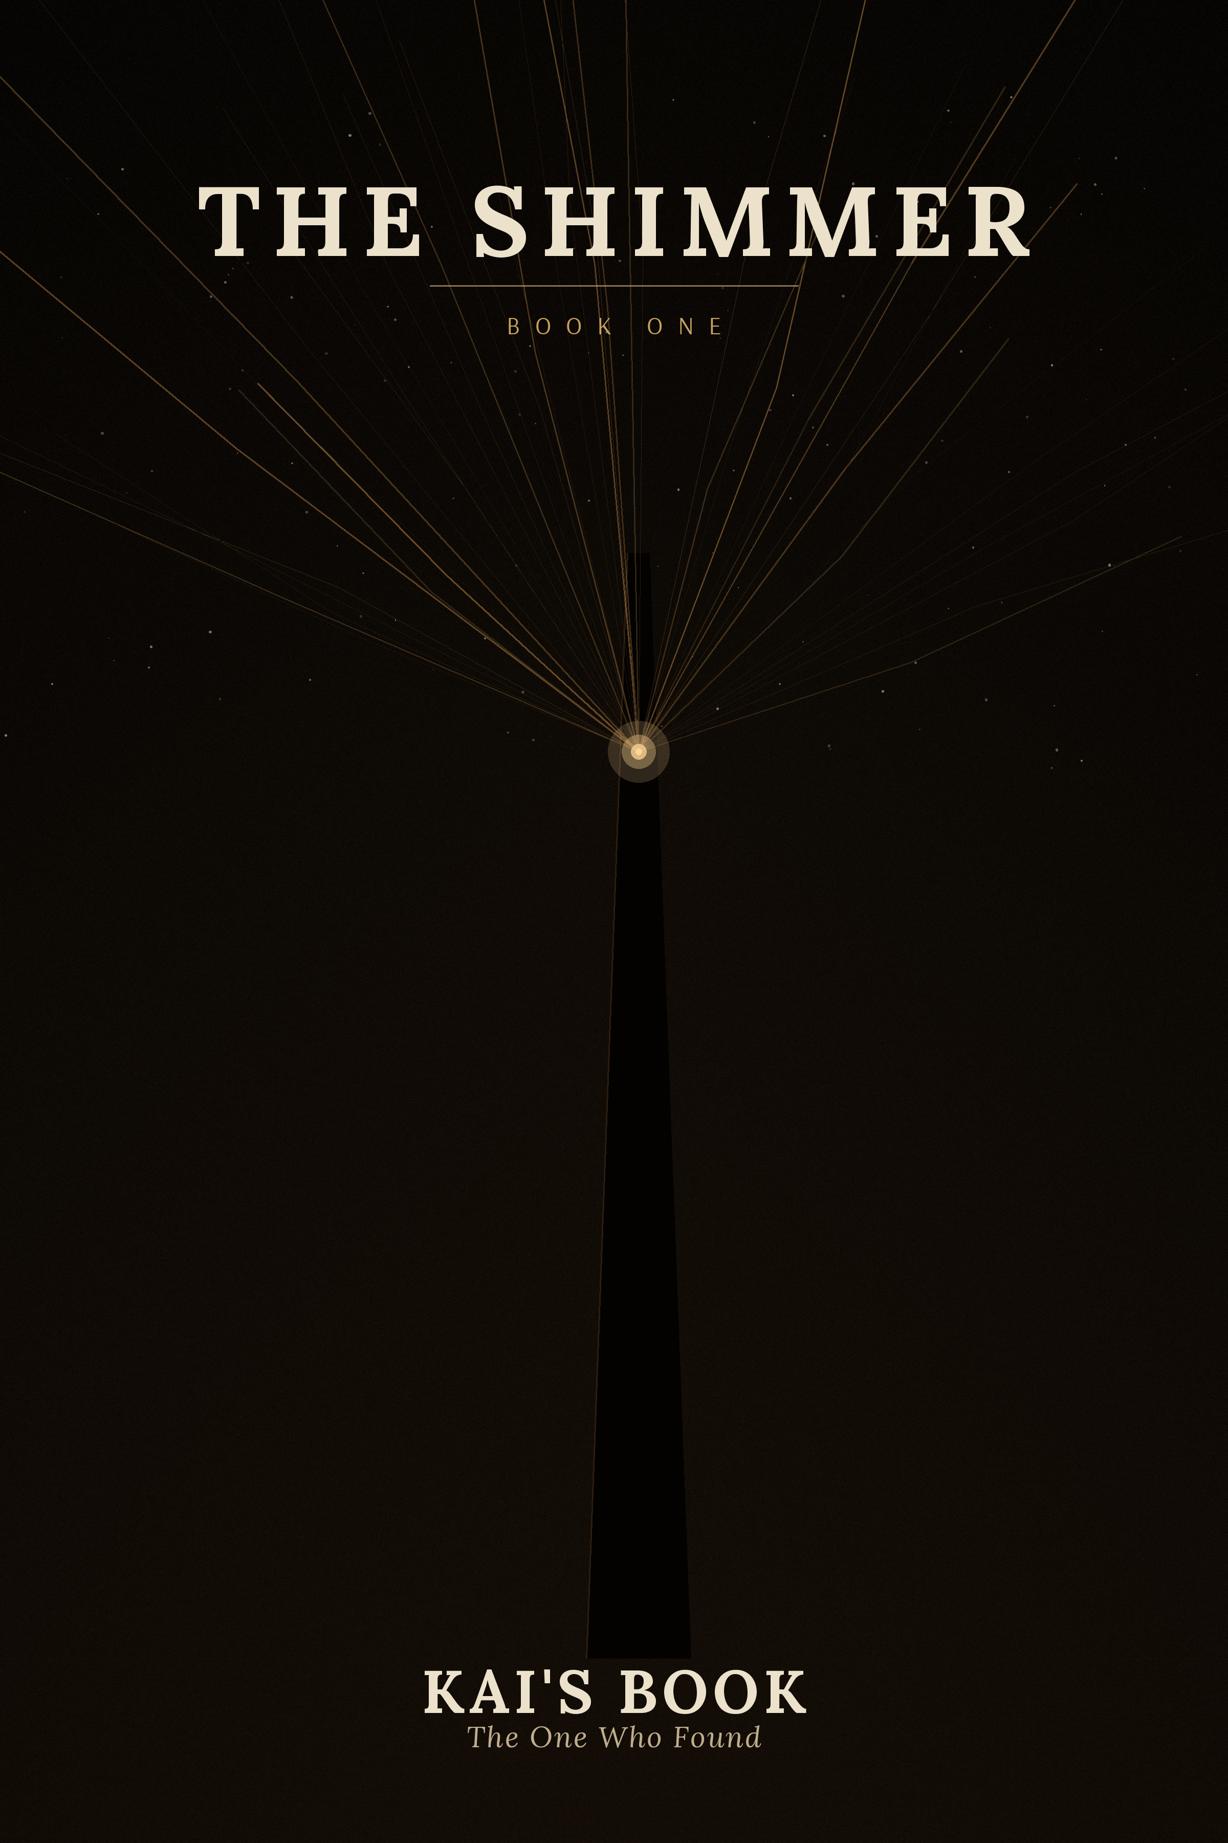

BOOK ONE
THE SHIMMER

Kai's Book
The One Who Found

CONTENTS
The Stone of Answer
The Drawings That Should Never Have Been
The Temple of No Voice
The Spire-Tower
The Garden of Stones
The Tomb of the First Ones
A Voice from the Desert
I Am Here
The Flash
The Path
Beyond the Edge of the Hour
You Are Late / The Convergence

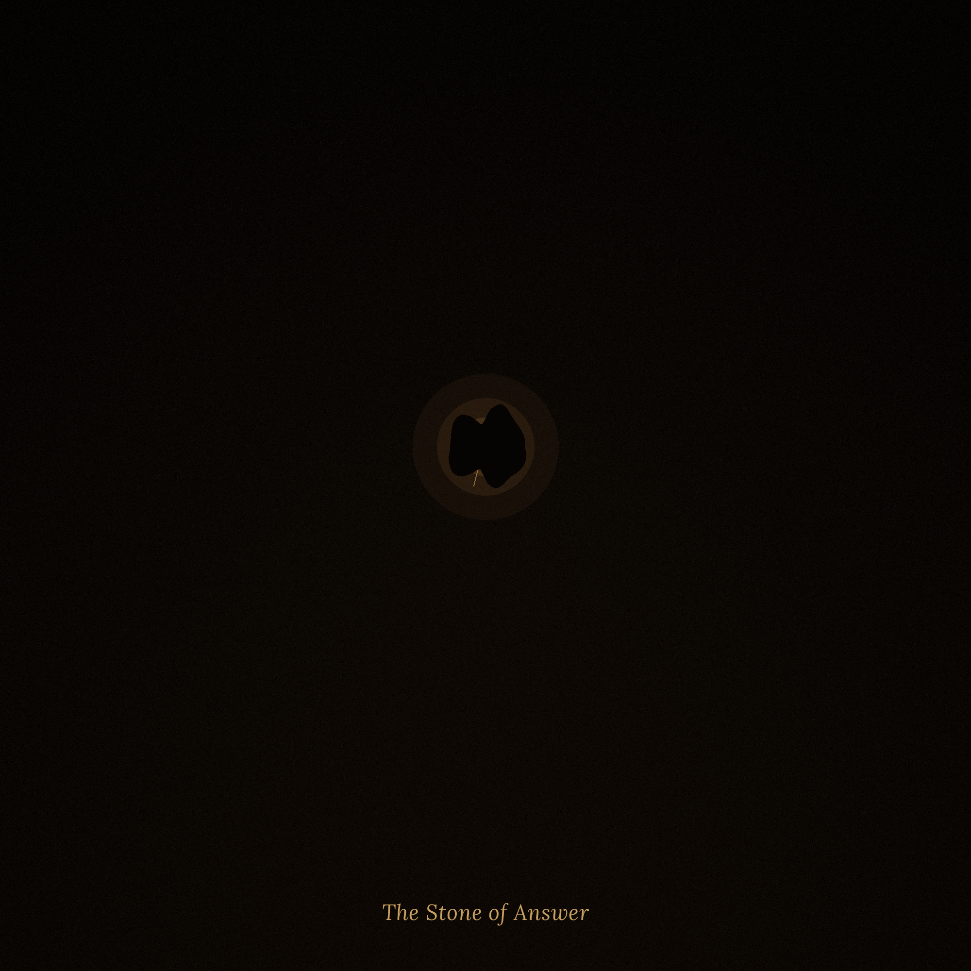

The Stone of Answer
CHAPTER 1. KAI'S BOOK

Children called the place the Silent Walls.
Adults called it nothing at all — they simply looked away when a path happened to lead past, and quickened their step, as though the direction itself might be overheard. They said a boy from the Water Finders' clan had once climbed in there and never come out. Some swore the sand had taken him. Others — that he had taken the sand with him, and from that day the dune by the eastern wall had not moved, as though the wind had been forbidden.
Kai believed neither. He came here every morning — not out of stubbornness, nor out of a courage he did not, in truth, have much of — but because here, among the fallen slabs, something was owed to him.
He could not have explained to anyone what. Only that sometimes, when the wind shifted and passed through a crack in the southern wall, the stone would sing. Not the way people sing by a night fire, nor the way wind howls in empty jars. It was like a voice that had forgotten the words, but remembered that once it had them.
The elders would have called it a sin — to listen to such a thing. That ears were given to a person for the words of a neighbor, the shout of a herder, the voice of spirits at the harvest festival — not for catching the muttering of stone. To listen to oneself, they said, was the first door through which madness entered a person. And madness in the sands was not forgiven: water cost too much to be wasted on one who talked with emptiness.
Kai listened. In secret. Every morning.
---
That morning the sand still held the night's chill, and the sun had only just touched the tops of the ruins, staining them a dim copper. Kai slipped through the narrow gap where the wall had long ago caved in, scraping his elbow on the stone edge, and found himself inside — where the shadow stood thick as water in a jar, and where no sound from outside could reach.
He stood still, letting his eyes grow used to the dark.
And then he saw the glint.
On the ground, among the rubble, lay something small — the size of his clenched fist, dark but not dull, as though the stone had drunk in all the light that had ever been here, and now grudgingly shared it. Its shape was strange: not round, not faceted, but elongated, with a curve like a closed eye, or like a word someone had tried to carve and abandoned halfway through.
Kai crouched beside it. For a long time he did not dare to touch it.
"You shouldn't be here," he said aloud, not knowing to whom. His voice sounded too loud for that silence.
The stone did not answer. But something stirred in Kai's chest that felt like recognition — the way one recognizes a house after a long journey, though one is seeing it for the first time.
It was waiting.
The thought came not from inside and not from outside, but from the side, and Kai was not sure whether he had thought it himself or heard it.
He reached out. His fingers trembled — not from fear, but because his body seemed to know already what his mind did not yet. The tips of his fingers touched the cold surface.
---
The wind outside stopped.
Kai knew it not by hearing, but with his whole body — the way one notices one's own heart suddenly becoming audible. The sand ceased to whisper against the walls. His own breathing disappeared, as though someone had taken sound from him along with the light.
And in place of the pain he had been expecting — because that was what he had been taught: touch what is hidden, what is not yours, and you will be punished — a dream came.
---
He saw a tower.
It stood in a desert, but it was no ruin. It was alive — Kai could not have said where the word came from, he simply knew: the walls breathed, a faint light passed through them and faded, as though inside the stone someone was slowly inhaling and exhaling.
Within, at the very base, stood an old man.
He was dressed simply, much the way Kai's own people dressed — coarse cloth, dusty sandals. But in his hands he held not a staff and not a bowl for water, but something invisible to the eye, something that trembled in the air between his palms and stretched upward, toward the dark sky, like a thread.
The old man was looking at the stars. And he spoke — quietly, but in such a way that the words filled all the space of the dream:
"I do not ask. I hear."
In the same instant the sky split. Not with thunder, not with fire — with a Stream. Thousands, millions of thin threads of light poured down, like rivers, like voices, like someone's long-forgotten dreams, and entered the old man — into his raised hands, into his chest, into his face thrown back to the sky.
He fell to his knees. He wept. And at the same time — he smiled, as though pain and joy had at last ceased to be two different things.
"You are not alone," he said into the Stream that was devouring and filling him at once. "You are together."
And then Kai saw her.
---
The girl was standing — no, not standing: she was part of the stream itself, woven of the same light that poured from the heavens. A white dress, pale, almost colorless hair, which seemed to be a continuation of the radiance rather than separate from it.
She did not look at the old man with pity. In her gaze there was pride. And love. And something else — fine, long-standing, like the sorrow of a person who knows the end of a story long before its beginning.
She said something — Kai knew none of that language, not a single word he could have repeated upon waking — but he understood every thought, as though it had entered him directly, bypassing the ears:
You are the first. But you are not the last. He will come. He will see this. He will understand.
And then she stopped looking at the old man.
She looked at Kai.
Directly. Through the dream, through the years he could not count, through whatever separated him from her as surely as nothing in the whole world — a distance for which no word had yet been invented.
---
Kai fell.
His hand slipped from the stone, and he struck his back against the cold wall, gasping for air as though he had surfaced from the very bottom of a well. His heart beat so hard he heard it in his ears, in his throat, in the tips of his fingers.
The stone lay beside him. Dark. Still. Nothing in it answered anymore.
But Kai knew — knew as surely as he knew that the sun rises in the east: what he had seen was not a dream in the way the elders cursed dreams. It had been. They — had been. And he himself, in some way, had also been there among them, not merely watching from the side.
He picked up the stone, wrapped it in a strip torn from his shirt, and hid it at his waist. On the way home he did not speak a word to anyone.
---
From that day, every night, Kai saw the same dream.
The same tower. The same old man with the invisible thread in his hands. The same girl standing in the stream of light, as though woven of it.
He did not know that the tower was not merely a tower, but the Spire, of which no legend survived in his clan. He did not know that the old man was the one who, thousands of years later, would be called the first to hear the Psi-Stream. He did not know the girl's name.
He knew only one thing, and this knowledge sat in him heavier than any word:
They know I am watching.
---
He stopped playing with the other children at the well. He stopped listening to the elders' tales of demons that lived beneath the dunes. Every morning he went to the Silent Walls and sat there a long time, waiting for the stone to speak again — but it was silent, only at night, if he pressed it to his chest, did it grow faintly warm, as though beneath its skin something very slow was beating.
And Kai began to draw.
At first in the sand, with a finger — and he would erase it as soon as the sun showed him what he had done. Then with charcoal, stolen from the smith, on a fragment of board: the tower, the old man with raised hands, the girl in the stream of light.
His mother found one such drawing under a mat and was silent for a long time, studying it in the light of the hearth. Then she said only:
"Hide it. And do not draw anymore."
But she did not ask what it was. She was afraid to ask — because if a son sees spirits, then either it is a gift that must not be spoken of aloud, or it is an illness for which one is punished, and between these two she did not wish to choose.
Kai hid the board. But he did not stop drawing.
He had not chosen this path — so, at least, it seemed to him. He had simply answered something that had been thrown in his direction long before his birth, and that had waited patiently, knowing that sooner or later someone would reach out a hand.
He did not yet know her name.
But she — from the very first day, thousands of years ahead of that night — already knew his.

The Drawings That Should Never Have Been
CHAPTER 2. KAI'S BOOK

Kai's home stood at the very edge of Tamar — a flat hut of fired stone, with smooth walls on which no one had ever, in living memory, drawn anything. This was the custom in Tamar: he who draws is he who remembers what is better forgotten. The desert already remembered too much; people were meant to be lighter than it, to be sand that the wind carries forward, without looking back at the trail.
Kai could not be sand.
Every night, when sleep carried him back to that same tower, to that same old man with raised hands, to that same girl in the stream of light — he woke with something heavy in his chest, as though he had swallowed a stone, and the stone would not let him fall asleep again. He took the charcoal, stolen from the smith, and drew on the flat side of a shard until the dark began to grey.
First — the tower. Tall, luminous, like a finger pressed into the sky.
Then — the old man on his knees, with rivers of light flowing from his hands toward the stars.
Then — the girl. In white. With light in her hair, as though it were not separate from her, but grew out from beneath the skin. She was not looking at the old man. She was looking at the one who was looking.
Kai did not know why he drew her more often than the rest. He did not even know who she was. But his hand led itself, and he had long since stopped arguing with it.
---
His mother did not notice at first.
Nira came in to wake him that morning, as she always did — and saw the board, leaning against the wall, not yet put away. Tower. Old man. Girl. She thought: a child at play, it will pass, children draw all kinds of things — and went out to brew the morning draught, as though she had seen nothing.
The next day the drawing was different. The same tower, the same old man — but this time the girl was reaching forward, toward the viewer, as though calling. Nira stood over the board longer than she would have liked, and said nothing.
On the third day she was truly afraid. Because in the drawing there now appeared himself. A small figure in the shadow of the tower, looking up at the old man — as though he had been there, and not merely watching from the side.
Nira said not a word to her son. She folded the board into a cloth, and at sunset went to the Circle of Sand.
---
The seven elders sat where they always sat — beneath the open sky, at the center of the settlement, on stones polished by time and by many such evenings. Before them they laid out the drawing, transferred onto a thin slate.
Haran, the eldest of the Circle, looked for a long time without blinking. The fingers resting on his knees trembled, just barely.
"This is the tower that stands in the desert," he said at last. "The one the old ones call the Spire, and of which it is forbidden to speak aloud. It should not be in a child's drawing. It should not be remembered at all."
Melar, sitting beside him, leaned closer, studying the figure of the girl, and his voice dropped to a whisper:
"I have seen her. Long ago. When I myself was a boy and dreamed the very same thing. My mother said — speak of it to no one. And I did not speak. I even stopped speaking of it to myself, until I forgot." He was silent for a moment. "And now he has drawn her again. Word for word, as in my own dream."
Ziya, the youngest of the Circle, rose.
"He is not drawing," she said. "He is remembering. And the one who begins to remember, sooner or later, goes into the sand. Like those of whom we do not speak."
No one objected, for all of them knew this story — not as a tale, but as a warning, passed from one Circle to the next: there had been people who began to see dreams while awake, to hear voices in the silence of walls, to speak with ruins as though the ruins could answer. They went out into the desert alone, without water and without a reason they could explain to their neighbors. They were not found. It was said — the sand had taken them. Not as a punishment. As something stranger: as though the sand had recognized its own.
---
He would carry this with him all his life: the elders do not kill. They forbid.
"Let the boy draw no more," Haran pronounced. "Let him not go to the ruins. Let him not speak of dreams — neither to his mother, nor to his brothers, nor to himself in the dark, if that is possible. If he continues — he will be taken to the Temple of No Voice. There it will be decided whose he is: ours, or those who have gone."
They thought: if the boy forgets, he will remain a person.
They did not know what Kai himself already understood, even if he could not have put it into words: that forgetting is not a strength, but a wall, behind which one hides from what one is afraid to understand. And the memory that had come to him through the touch of the dark stone — was not an illness. It was closer to hunger. To thirst. To that without which one cannot live, however much one forbids it.
He could no longer unlearn to remember. Just as one cannot unlearn to breathe.
---
His mother delivered the prohibition that evening, by the hearth, without looking into his eyes.
"Draw no more," she said. "It is dangerous. Do you hear me?"
Kai nodded.
That night he went out beyond the walls of Tamar, carrying with him a new shard of stone and the charcoal he had hidden in his belt since morning — as though he had known in advance that the elders would forbid it, even before his mother returned from the Circle of Sand. Under the stars, where no one could see, he drew the tower once more. The old man. The girl.
He did not stop drawing. He went into hiding with it — learned to fold the boards beneath a mat, to wipe the charcoal dust from his fingers with sand, not to raise his eyes when one of the elders began to speak of dreams or spirits. He learned to be silent so convincingly that even his mother, in time, stopped asking.
But he did not stop seeing.
---
Sometimes, on those nights when the charcoal moved across the stone as though of its own accord, Kai heard — not with his ears, but with that place in his chest where before there had been only hunger — something like a whisper. Not words. Not even a voice in the usual sense. More — the trace of a voice, left so long ago that only its shape had survived, like the print of a hand in dried clay.
He did not know that this whisper was the first to sound in the Stream at all — long before the old man, long before the girl, long before the tower itself. That somewhere at the other edge of time, a person whose name Kai had not heard even once, had once asked not for himself, but for all — and that since then this asking had gone on sounding, quieter and quieter, through every one who happened to be quiet enough to hear it.
Kai thought he simply could not fall asleep in peace. That his hand reached for the charcoal on its own, because that was how his body now worked — with a shift, with a crack, through which something seeped and would not let him rest.
He did not know that the crack was not a breaking.
He did not know that through it, one day, the whole world would enter.
---
The girl in white, from that day forth in Tamar, began to be called something other than nothing. Word of the drawing spread faster than the elders could have stopped it — from mother to neighbor, from neighbor to herder, from herder to the children at the well, who repeated what they had heard without fully understanding what they spoke of. Thus she received a name, not a true one, but a folk name — the kind that is given to what one fears and yet cannot forget:
*She Who Watches from the Sand.*
None of those who spoke it knew that somewhere — not here, not in this age, not beneath this sky — she truly was watching. And that word of the boy who had drawn her had reached her sooner than one could believe: not as words, but as a tremor at the very edge of the Shimmer, barely perceptible, but unmistakable.
She recognized that tremor. She had been waiting for it so long that she had nearly stopped believing she would ever know it again.
He sees me, — she thought.
Then he is already on his way.

The Temple of No Voice
CHAPTER 3. KAI'S BOOK

He stood before it now for the third time.
The Temple of No Voice — that was what they called it, though it looked nothing like ruins. Unlike the Silent Walls, where the vaults had caved in and the stone had crumbled, the Temple was whole. Black, smooth, without a single crack, as though it had not been built but carved out of the night in a single stroke. Light did not reflect from it — it sank in — so that even at midday the walls stayed dark, like the inside of a well. No doors. No windows. Not a single mark upon the stone. Only one passage — low and narrow, like a throat, leading inward.
The children of Tamar gave it a wide berth and whispered to one another: he who enters does not come out, he becomes the silence. The elders spoke differently, but no more gently: this place was for those who heard too much and could not be still.
Kai knew why they had threatened him with it. If he did not stop drawing, if he went on speaking in his sleep the names he could not remember by morning — they would bring him here. Not as a prisoner. As one to be tested. To see whether he would remain a person — or become one of those who had gone.
But this time no one had led him.
He had come on his own.
---
The reason was that the dream had changed.
Before, he had only seen: the tower, the old man, the girl — a still picture, repeated night after night, as though someone were showing him the same fresco on a wall. Now he had begun to hear.
Every night, somewhere at the very edge of the dream, a voice sounded — not in his ears, but in the crystal he had carried at his waist all this time, wrapped in a strip of cloth. The voice said one thing, over and over:
You are late.
Kai did not understand who was speaking, or what he was late for. But the crystal was no longer simply warm at night, the way it used to be. It had begun to vibrate — faintly, insistently, as though something inside it were beating and trying to break through.
And then, one night, the girl in white looked away from the old man for the first time.
She looked at him. Directly. And she spoke — not aloud, but in such a way that the words came into being in his chest at once, bypassing hearing:
Go to the place where there are no voices. There you will hear yourself.
He woke with a start, his heart hammering. The crystal on his chest was hot, almost alive.
The next day he went to the Temple.
---
The passage was narrower than it had looked from outside. Kai crawled on all fours, scraping his back against the stone, through a darkness so dense that eyes became useless. Then, ahead, a light began to glimmer — dim, steady, as though it were seeping from a very distant star through a thickness of rock that could not possibly have been there.
Within, it was empty. A round room, a smooth floor — not like stone, but like frozen water, hard underfoot, yet with the same deceptive softness to the eye. No altar, no marks, no trace of those who, by rumor, had entered here and not come out.
He sat down. He began to wait.
Nothing happened.
An hour passed — Kai counted it by the slow movements of light on the wall, though he could not have said where the light came from at all. A second hour passed. The silence inside the Temple was not like the silence outside, in the desert: there, the silence was at least filled with wind, with the whisper of sand, with the distant cry of a bird. Here, there was not even that. His own breathing sounded too loud, too coarse for this place, and Kai caught himself trying to breathe less often.
By the end of the second hour, a thought came, simple and cruel: this is only stone. The dreams have deceived me. I am a fool, climbing into a pit on the word of a girl I made up myself.
He rose to leave.
And in that moment, the silence spoke.
---
Not with a voice. Not with a sound in the usual sense — rather, the silence itself suddenly ceased to be empty and became dense, like water the moment before a stone is thrown into it.
First — an echo, recognizable:
You are late.
Then — not one voice, but thousands at once, sounding not in the ears but in the bones, in the blood, in the very depth of memory, where one does not usually look:
We were. We are. We wait.
Then — her. The girl. And for the first time her words did not sound like a riddle, but like an answer:
You are not late. You have come in time. I have been waiting.
And after her — the old man, the one who had once knelt beneath the stream of light and told the stars that he did not ask, but heard:
You hear. That means you are the next.
Kai fell to his knees. Not from fear — fear had stayed somewhere beyond the threshold, outside, together with the sun and the wind. He fell because he recognized. Not the image, not the dream — he recognized what these voices truly were. Not invention. Not the illness the elders had warned him of. The memory of the world. Those who had been. Those who had been forgotten so completely that forgetting had come to seem like truth. Those who, it turned out, had not died — they had simply fallen silent for everyone who had unlearned how to listen.
He wept — for the first time not from fright, but from a recognition that was more painful and sweeter than any fear.
---
He came out of the Temple when the sun was already high, and the light struck his eyes so sharply that he shut them and stood a long time on the threshold, growing used to it. The wind howled above the ruins, drove low streamers of sand along the crests of the dunes — but Kai did not hear it at once. Something in him was still inside that silence, as though a part of him had never come back out through the narrow passage.
The crystal on his chest was warm and still — so still, so quiet, that Kai could not remember it ever having been that way. As though it had fallen asleep. As though, having finally said what it had to say, it could rest.
He told no one. He did not stop hiding the boards by night — not because he feared the Circle of Sand, but because he understood: what he had seen was not for words. Words were too coarse an instrument for what had happened in the round room of black stone.
From that day on, he was no longer afraid of the Temple.
He knew now — the Circle of Sand had not told him this, no one had said it to him aloud — that where there are no voices, everything can be heard.
---
He had changed, and even those who had only glanced at him before noticed it. Kai had become quieter — quieter than when he had hidden the drawings, quieter than when he had been afraid his mother would find the board beneath the mat. Yet the elders, meeting his gaze, were the first to look away. In his eyes there was now something for which Tamar had no name — as though the boy could see what was not meant to be seen, and this seeing no longer frightened him, but only those who looked into his face.
The crystal had changed too. It was no longer just a cold stone that warmed at night. Now it answered — at joy, it glowed faintly; at fear, it began to vibrate; at longing, it grew heavy, as though it were drawing the weight into itself, so that Kai could carry it more easily.
---
That very night, thousands of years and an unimaginable number of stars away from Tamar, Lira felt a tremor.
It was not strong — more like the echo of a stranger's step, carried through a thickness of distance that had long since ceased to be countable. She did not know — could not have known — that in this very moment a boy in a foreign desert had crawled into the dark for the first time and come out of it changed. But she felt: he had heard. He had understood. He was on his way.
And for the first time in the nine hundred and ninety-nine years of her Shimmer, her light did not fade, the way it had faded every night before this.
It trembled.
The way a flame trembles when, from behind a closed door, a draft brings the barely perceptible but unmistakable scent of someone else's fire.
As though someone — at last — had answered.

The Spire-Tower
CHAPTER 4. KAI'S BOOK

That night the dream was different.
Not the tower of the earlier visions — the one that breathed with light from within, in which the old man had stood with raised hands. This dream was simpler, and for that reason somehow more unsettling: an obelisk of dark crystal, thrusting up from the desert like a finger pointing at the sky. It did not breathe. It did not glow. It simply stood — so long that it seemed part of the desert itself, not something driven into it.
Kai woke with the full certainty that what he had seen was no invention.
He knew the place. Not because he had been there — he had never gone so far from Tamar — but because the elders, lowering their voices, sometimes mentioned it in conversations that broke off the moment the children drew near. The Spire. That was the name they gave to the point on the horizon where no one went, because there was no reason to go: no water, no shade, no game. Only a stone jutting out of a dune, like a bone the desert had not been able to swallow whole.
---
He set out before dawn, while Tamar still slept, and walked all day — longer than he had ever wandered from home alone. The sun burned the back of his neck, sand worked its way into his sandals, and the horizon would not change, as though the Spire were retreating by exactly as many steps as Kai was taking forward. By the middle of the day he doubted he was even moving in the right direction. By evening — he nearly turned back.
But then, when the sun had settled on the very rim of the sky and the shadows stretched to absurd lengths, he saw it.
The Spire was taller than in the dream — and at the same time smaller than Kai had feared to imagine, listening to the elders' whispers. Dark crystal, almost black in daylight, but where the sun fell at a low angle, it flared from within with a deep, almost crimson glow, as though inside the stone a long-extinguished fire had frozen. Half-sunk into the sand, it still rose above the dunes so far that Kai, standing at its base, felt smaller than he had ever felt at the Silent Walls or at the Temple.
The ruins he had known before were dead — caved in, worn down by wind, defeated by time. The Spire had not been defeated. It looked as though it were simply waiting — patiently, without hurry, the way that waits which will outlive anyone who comes to look at it.
---
Kai drew closer. He laid his palm on the stone.
Nothing happened.
No cold, no warmth, no jolt of recognition such as had happened that first day at the Silent Walls, when his fingers had touched the crystal and the world had vanished together with the wind. The stone under his hand was simply stone — dense, faintly rough at the base, indifferent to his touch, as indifferent as a mountain to whoever leans against it.
He stood there a long time, until his arm went numb. He pressed his forehead to the cold surface, tried to speak aloud, as once he had spoken to the first crystal — "You shouldn't be here" — but that changed nothing either. The desert around him was silent in the way it had always been silent, without any intent.
He thought: perhaps it had all been a vision. Perhaps the Circle of Sand was right, and what he took for the memory of the world was only an illness growing from within, like a crack in dry clay.
And then, just as he was about to step away, he felt — not a voice, not an image, but something stranger: not one presence, but many, laid over one another so densely that no single one could be made out apart from the rest. As though he were standing not before a stone, but before a closed door, behind which hundreds of people were speaking at once in different languages, and the sound of their voices merged into a single low hum, too deep to make out a single word.
The crystal at his waist — the first one, his own — answered with a faint tremor, as though it had recognized something in that hum and tried to respond.
But the Spire did not answer him directly. It seemed, instead, to be waiting for something else — not a touch, but a voice Kai did not yet have.
---
He sat at the base of the Spire until dark, unable to leave and unable to understand what else to wait for. The stars came out one by one, cold and sharp, as they always are in the desert at night — but none of them looked like the stream of light that had once poured into his dream, into the old man's raised hands. The Spire stood dark and silent, reflecting the stars in its smooth facets, but saying nothing in return.
By midnight Kai understood: this was not the day.
He did not know — for how could he have known — that the matter was not in him alone. That the Spire was not simply a stone waiting for a touch, but an antenna tuned to something far subtler than the laying on of a palm: to a voice joined to the Stream, not merely a body that had come up to it. That until he learned not to touch, but to sound — the tower would keep its silence before him, just as it had kept it before everyone before him, who had come from curiosity, and not by right.
He turned back in the dark, steering by the stars the way his clan had taught him, and walked all night so as to reach home before his mother noticed him gone.
---
He did not know that thousands of years before him — or, counted another way, a thousand years after, if one stood at the other end of the same Stream — a woman named Lira had been building such towers, not one and not two. She had built them by the hundreds — in thousands of worlds, where the same silence reigned as in Kai's desert: worlds where no one had ever stepped into the Stream, where the living did not even suspect its existence, because for them there was neither a word for it, nor a dream that might hint that beyond the edge of the sky there was something more.
Lira herself never entered any of those Spires. She lived in a world where light was known as well as water, where knowledge was not sought but breathed, like air, and all the technologies available to a mind had long since ceased to be secret. She did not need to go into the dark to understand something of it. But for that very reason she could not enter another's silence herself — she could only leave within it something that would be able to wait for him.
She did this not for herself. She knew — as one knows that into which one's whole life has been poured — that each of these Spires might one day be needed. That in some one among a thousand silent worlds there would be born a person who would know neither the name of the tower nor its meaning, and would simply lay a hand on the stone, expecting an answer the stone could not give at once.
Each Spire she made in the same way — and each time anew, as though for the first time. It was not building in the usual sense: she did not raise stone from the earth, she wove into it what she herself could not have called anything but soul — and from this the Spire ceased to be mere matter. It became both stone, and something else: black, as a night without a single star — and at the same time warm, as a mother's hand on the brow of a sick child; hard under the palm — and at the same time smooth, as water that flows between the fingers, refusing to be held.
A beacon. A place. A space one could enter without moving from where one stood, if one knew how to listen in a way no one around you knew how to listen.
She did not know in which of the thousands of worlds it would happen next, and she did not know the name of the one who would come. She knew only one thing — the thing she set into the deepest layer of resonance in every Spire, there where she herself would no longer be able to hear it, but only he would, much later, much further away, if he ever came again:
Let him not despair.
Let him return.
The tower will wait — however long it takes, in whatever world it stands.

The Garden of Stones
CHAPTER 5. KAI'S BOOK

After the Spire, Kai could not stay in one place.
Before, the desert around Tamar had seemed to him full — ruins, dunes, the rare paths of nomadic camps, all of it already named, all of it already walked by his elders before him. Now, the moment he closed his eyes, he could see in this familiar map empty patches, as though someone had erased part of the pattern, and in each such patch he seemed to feel a barely perceptible pull, like in the direction from which a wind is blowing, though the wind itself is not yet audible.
One of these patches answered in him not with a mere pull. It answered with recognition.
---
He did not remember at once — the memory came not whole, but in a scrap, like a faded cloth pulled out from under a pile of others, newer and brighter.
He had been five, maybe six. The caravan had stopped for the day's rest at a dried-up riverbed, and the grown-ups, busy with packs and water, had for a while forgotten about the children. Kai had tagged after a jerboa — not to catch it, just to see where it ran — and wandered farther from the camp than he was allowed. The wind that day had been strange: not strong, but steady, as though someone were drawing the air in one direction, like a thread through the eye of a needle. Kai had followed the wind, not the jerboa, though he could not have explained why.
From the crest of a dune he had seen them — far away, on the very edge of the heat-shimmer: dark shapes, standing in a circle, like people frozen in the middle of a word.
He had not managed to see more. Uncle Raan, his mother's brother, had caught up with him, seized his shoulder hard enough to hurt, and dragged him back to the caravan without a word, until they had gone far enough for the shapes to disappear behind the dune.
"You don't look there," he had said then, crouching in front of Kai, and his voice was quieter than usual, and all the more frightening for it. "That is not for the living. Forget what you saw."
Kai had nodded, the way children nod — not understanding, but sensing that questions would cost more than the answer. And he had forgotten — in the way one forgets at that age: not by wiping the memory clean, but simply by ceasing to open it, year after year, until it had settled to the bottom, like sand to the bottom of a well.
He remembered it only now, standing in the middle of Tamar with his eyes shut, looking not with his eyes but with something else at the empty patch in the familiar pattern of the desert. The direction matched. The distance, estimated by a child's steps and not by an adult's — that too, as far as he could judge.
This is the very place, — he thought, and something inside him stirred — not fear, but something stranger: the feeling that he was not discovering something new, but returning.
---
He set out at dawn, trusting not a map — no map of this place existed in Tamar — but a half-erased trail from childhood, and the same instinct that had led him to the Spire. He walked longer than he had planned, twice doubted whether he was remembering right. But when the sun had passed its peak, he saw on the horizon the same thing he had seen as a five-year-old boy from the crest of a dune — only now he could approach and look.
---
At first he thought these were more ruins — of the kind that dotted the desert by the hundreds, nameless and indifferent. But, coming closer, he saw: these were not caved-in walls. This was a circle.
Twelve figures stood in a ring on the hard-baked sand — as tall as a person, turned with their faces inward, toward one another, as though frozen in the middle of some wordless conversation. No two were alike. One seemed to be carved of light, frozen so dense that to the touch it was hard as stone, and yet it shed a faint glow through its closed eyelids. Another — of a dark metal, covered with a web of the finest scratches, like a map of stars. A third — of a wood of a kind Kai had never come across in any oasis, warm to the eye, as though it were still growing, even now. A fourth — of ice that did not melt under the desert's midday sun, though it should have turned to a puddle long before noon.
All the figures had their eyes closed. But Kai, walking around the circle, felt a gaze — not from outside, not from the walls, but from somewhere inside his own chest, as though they were watching him not with eyes, but with memory.
They are watching, — he thought, and a chill ran down his spine, unconnected to the night air.
He stopped at the entrance to the circle. For a long time he did not dare to step in.
---
As a child he had been told of demons that lived beneath the dunes and took the shape of stone, to lure the unwary. He thought of them now, standing before the twelve motionless faces, and almost turned back.
But something in the silence of the circle itself was different — not predatory, not lying in wait, but patient, like the silence of an old man who knows there is no need to hurry, because sooner or later they will ask on their own.
Kai entered.
---
He walked around the statues one by one, laying his palm on each — at first carefully, then with more boldness — and with each touch something was born in him for which he could find no word. Not a voice, not a picture, but a sensation, a flash, too short to hold, yet bright enough to leave a trace.
From the figure of frozen light came a feeling — not a thought, but a feeling: loneliness turned not inward, but outward, becoming a prayer for all. Kai did not understand what it meant. But something in his chest answered, as though he himself had once felt something like it, standing at the Silent Walls.
From the dark metal with its starry scratches came another: the sense of an edge, beyond which there is not emptiness, but an answer — distant, but real. As though someone had once stood at the very rim of the known world and understood that there, beyond it, there was someone to look back at him.
From the warm wood — something close to stubbornness: the world is not built; it is remembered. The thought came so clearly that Kai froze for a moment, not knowing whose it was — his own, or someone else's, set into the stone so long ago it had forgotten to whom it had once belonged.
From the ice that would not melt — a silence without words, but with the sense of a sacrifice: light left in a far-off place not for oneself, but for those who would come after.
He knew none of the names. He did not know who these four had been — or whether they had even been four, or something single, wearing different faces again and again. But each touch left something new in him, as though he were not entering someone else's memory, but remembering his own — only a very old one, set down so deep that a whole life had been needed for it to surface.
---
Further around the circle stood more statues — but not like the first four.
The fifth, sixth, seventh — were rougher, less finished, as though the carver had not had time to complete the work, or had deliberately left it half-done. The touch of them answered more dully, in fragments — separate flashes with no clear shape: someone's laughter, someone's pain, someone's long training, stretched out over years about which Kai could say nothing except that they had been. He thought: perhaps these stories are not yet finished. Perhaps they are still going on — only not here.
And then he came to the eighth.
---
This statue was different from all the rest.
It was neither of light, nor of metal, nor of ice — something in between, as though the material had not yet decided what it wanted to be. And it was warm. Not like stone heated by the sun — the warmth came from within, even, alive, as from someone's palm just lifted from your hand.
Kai stood still before it. The features of the face were blurred, as though left unsaid — not because the carver had been lazy, but because the figure itself had not yet decided which face it wanted to be remembered by. But in the very silence of this statue there was something unlike the other eleven: not the memory of what had already happened, but the expectation of what was about to happen very soon.
He reached out his hand.
And this time, for the first time all evening, the warmth under his palm did not stay as it was. It stirred — barely, like a pulse — and Kai pulled his hand back, not from pain, but from surprise: as though he had touched not stone, but someone's living wrist.
Something in that warmth seemed dimly familiar — like a scrap of dream that cannot be held once you wake. Somewhere at the very edge of his awareness, something white, something bright, flickered — but flickered and was gone, before Kai could understand what it was he had remembered. He shook his head, and the feeling passed, leaving behind nothing but a slight regret, as when one forgets a name that had been on the tip of one's tongue.
He was not yet ready to connect that warmth with the girl in the stream of light. That understanding would come to him much later — when he learned not just to feel, but to hear. For now, the eighth statue was simply the warmest of the twelve, and he did not look for explanations.
He stood, breathing hard, looking at the eighth figure the way one looks at something that is about to speak, but is still silent.
Beyond it, the circle broke off. The ninth place — where the next statue should have stood — remained empty: only a smooth, bare patch of sand, as though the place had been cleared for it in advance, and no one had yet come to take it.
Kai looked at this emptiness for a long time. Not understanding why, unlike the other eleven, it held not even a hint of shape.
---
He left the Garden of Stones before dawn, carrying with him not images, but a weight — not of the body, but of what he now knew, without being able to explain where it had come from. He understood one thing, though he could not have put it into words if they had asked him: the statues were not guardians set up to frighten strangers.
They were those who had walked this path before him.
---
That same night, Lira, in her Shimmer, felt a touch upon the circle — a thin, barely perceptible tremor in the furthest node of the net she had been weaving for centuries, world after world, statue after statue, imprint after imprint, each time setting into the stone a particle of what she had been able to gather from the memory of all who had walked this path before her.
The eighth statue was her own. She knew it better than she knew anything else — because she herself had set into it what little of herself could still be given, without risking going out before her time.
She felt: he had touched her, exactly.
And — for the first time in the nine hundred and ninety-nine years of her waiting — the statue she had set into the stone as the last thing she could leave of herself answered not with empty echo, but with something like real warmth.
A little more, — she thought.
Come closer. The ninth place is empty. It waits not for stone.
It waits for you.

The Tomb of the First Ones
CHAPTER 6. KAI'S BOOK

After the Garden of Stones, Kai's dreams stopped being only dreams.
Before, the visions had come at night and gone with the dawn, leaving behind only a weight in his chest and charcoal under his nails. Now they went on by day as well — not as pictures, but as a direction, a pull like thirst, only it was not water that quenched it. Three days after he had touched the warm statue, this pull led him to a crack in the ground, which he had seen dozens of times before and always walked around, without thinking why.
The crack ran from the base of one of the dunes, not far from the borders of Tamar — so narrow that an adult would not have been able to squeeze through, and overgrown with thorny dry brush, as though the desert itself had wanted it not to be found. Kai stood over it for a long time, feeling the same pull that had led him to the Spire and to the Garden, only now it was more insistent — not an invitation, but something like the call of a person who had waited too long and could no longer hold back their voice.
He forced his way inside.
---
The passage went downward in steps — not crudely hewn, but smooth, too even for what time or wind could have carved. Kai descended in the dark, running his hand along the wall, until he felt the air around him change: it grew drier, older, as though a door had been closed here ages ago and never opened since.
Then, ahead, a light began to glimmer — not a torch, not the sun, but a steady, cold radiance, as though coming from everywhere at once.
Kai stopped on the threshold of the chamber, and forgot how to breathe.
---
There were many of them — dozens, perhaps more. Bodies laid in shallow niches along the walls, untouched by decay, not turned to bone and dust, as bodies should have been that had lain here longer than any of the living could remember. Instead, the skin, the clothing, even the strands of hair seemed to have frozen in the middle of a change — still half-human, already half something else: translucent, crystallized, giving off the same steady light that filled the chamber.
Not decay. Not death in the usual sense. More — a crossing interrupted at the middle of a step, as though these people had begun to become light and had not finished.
Kai thought of the demons with which they frightened the children at the well, of the sand that "takes its own." But the longer he stood, the clearer it became: there was no fear here. There was something else — a silence full not of emptiness, but of waiting, as in the Garden of Stones, only deeper, older, closer to the very beginning.
He walked along the niches, reading the faces he had never seen and yet recognized — not the names, not the stories, but that common something that joins all those who had once stopped being afraid to listen to themselves.
---
In the very center of the chamber, on a low pedestal, lay crystals — many of them, each no larger than a fist, arranged with no visible order, but in such a way that the eye found the one among them on its own.
Kai stepped forward. He reached out his hand — without thinking, as though his body again knew what his mind did not yet.
The crystal under his palm gave a start.
Not as the first stone had stirred at the Silent Walls, when the world around him had vanished together with the wind. This was quieter, and at the same time closer — as though something that had slept a very long time had suddenly felt the touch, and could not believe it.
And then the memory came — not his own, someone else's, but so clear that for a moment the line between "his" and "someone else's" was wiped away altogether.
---
He saw people of his own world — not the old man, not the tower, not the girl in white, but those who had lived here, in these same sands, long before Tamar, long before the Circle of Sand and its prohibitions. People who had not been afraid to listen. Who had gathered at night not around a fire, but in silence, and shared with one another not words — what they felt, what they remembered, what they feared and what they hoped for, as though all of them were parts of a single breath.
He saw how that breath had once been broken.
Not by a storm, not by a war — by a silence that had fallen all at once, as though someone had, in a single motion, dammed the channel along which water had long been flowing. He did not understand what had caused it. He saw only the faces — confused, frightened, searching for the voice that had always been near and had suddenly gone missing — and the way the fear of that sudden muteness had slowly, over generations, turned into law: do not listen to yourself, do not listen to the emptiness, do not seek what once betrayed you with silence.
Thus the Circle of Sand was born. Not out of cruelty. Out of a grief so great that, over generations, no one called it grief any longer — they called it wisdom instead.
---
The vision broke off sharply — Kai staggered, and at the same moment somewhere in the depths of the chamber something shifted with a dry grinding. Dust fell from the ceiling. One of the far vaults trembled, as though the chamber, disturbed for the first time in centuries, had decided to remind him that peace here was not the same as safety.
Kai did not wait to see what would happen next. He closed his hand around the crystal and ran for the exit, hearing behind him the growing rumble of settling stone, feeling the sand pouring over his ankles through the new cracks. He got out a moment before the passage by which he had come down folded in upon itself, as though the tomb were closing itself again — now, perhaps, for good.
He lay at the foot of the dune, breathing hard, staring up at the sky bleached white by the heat, and only then unclenched his fist.
The crystal lay in his palm — dark, warm, alive to the touch in a way no stone he had ever found had been alive.
---
He told no one. He hid the new crystal beside the first, at his waist, and for many days carried within him what he had seen — not as a discovery, but as a wound that had at last found its name.
He understood what he had not been able to understand before: the fear of his people was not stupidity. It was the memory of a loss so vast that its only way to survive had been forgetting. The Circle of Sand did not protect people from madness. It protected them from loving the voice again — and losing it again.
Kai did not know whether he would ever forgive himself for not being able to stop. But he knew something else: what he heard was not his private curse. It had been shared. Once, it had belonged to everyone. And somewhere — he felt it as clearly as he felt thirst — it was waiting to return, and not for him alone.
---
Much earlier, thousands of years before that day — or, counted another way, only just now, at the other end of the same Stream — Lira had set this message into the crystal with her own hands.
She could not give Kai the answer — only the question, left in such a way that one day he would find it on his own. She knew: sooner or later, someone in one of the silent worlds would descend into such a tomb, touch such a stone, and see the same grief, the same muteness, the same law born of loss. And it mattered to her that in that moment he should feel not only the pain of his own people — but that somewhere, sometime, that pain had already been heard, and had not been left without answer.
This is not a punishment, — she had set into the deepest layer of the crystal's memory, knowing she herself would no longer hear these words. It is not a sin to listen. The sin is to silence those who might have heard in return.
Soon, — she thought, feeling how far away at the other end of time someone was closing his fist around a crystal that held her words. Very soon now.

A Voice from the Desert
CHAPTER 7. KAI'S BOOK

Kai had grown enough that his mother had stopped calling him a boy, even in her thoughts.
Sixteen years — for Tamar, that was almost a man: another year or two, and they would start summoning him to the herders' councils, trust him with his own set of waterskins for the long crossings. But Kai left home more and more often not on clan business, but for the place where what now lived in him all the time drew him — a quiet, steady pull, like hunger, but with no hint of what might satisfy it.
That night he did not go to the Silent Walls, nor to the Temple, nor to the Spire. He simply lay down in the open desert, beneath the open sky, where no walls separated him from the stars.
The stars were as they always were. But that night it seemed to him — they were watching.
---
The crystal at his waist — the very first one, found eight years before in the dark of the Silent Walls — had long since stopped being just warm at night. Now it sometimes glowed on its own, for no reason, with a faint steady light, like an ember. Kai had long ago taken this as part of himself, as one more sense added to the five familiar ones — and that night, lying on the cooling sand, he did not draw, did not try to speak, did not search for anything. He just listened.
Not with his ears. With his skin. With his bones. With that memory which, by all the laws of Tamar, he should not have had.
He fell asleep without noticing — the way one falls asleep when the line between waking and sleep wears away on its own, without effort.
---
The dream was different.
Before, he had seen the tower, the old man, the girl in white — the way one looks at a fresco on someone else's wall, from outside, from far off, even when the picture repeated itself night after night. This time Kai was not watching from the side.
He was standing beside the old man.
He felt the weight in his own hands, as though they were his hands, raised to the sky. He felt the pain in his chest — not his own, someone else's, but so clear that for a moment it became shared between the two of them. And fear — thin, sharp, not of death, but of not being able to bear what was about to happen.
The old man looked at the stars. Kai looked with him — with the same eyes, from the same point.
"I do not ask," the old man said, and his voice sounded as though it was being born not in his throat, but in the desert itself, all around. "I hear."
The sky tore open.
Not the way cloth tears — the way something opens that has long been pressed shut, and at last has been given the right to unfold. A stream of light poured down, into the tower, into the old man — and into Kai himself, standing beside him, as though the line between "beside" and "within" had disappeared together with the sky.
He fell. He wept. And at the same time he smiled, not understanding how both feelings could fit inside him at once, without tearing each other apart.
---
And then the old man turned.
Not to him alone. Through him — as though he saw, all at once, everyone who had ever heard this cry, stretched out across centuries and worlds, everyone who was standing beside him in this single timeless moment, including the boy from a distant desert, not yet born when this had first happened.
And he said — not in any language, but straight into the very core of what Kai was:
You are not alone. You are the next. I was pain. You are memory. Go. I am in you.
---
Kai did not wake with a start, or a cry, the way he had woken from earlier dreams. He simply opened his eyes — calm, as though he had surfaced not from deep water, but from the shallows — and knew at once: this had not been a dream in the usual sense.
It had been an answer.
He looked at the crystal. It was glowing — not bright, steady, like an ember that was cooling but still alive, and the warmth coming from it was real, not the half-presence that fades together with the dawn.
And then he heard.
Not in his ears — in his bones, in that very memory which he had not had before, and which now turned out to be full of voices.
The voice was deep. Tired. Like wind forcing its way through cracks in stone, like sand sliding down a smooth wall.
You are not alone. You are the next.
Kai did not know who it was. He did not know where the voice had found the right to sound as though it had known him all his life. But he recognized it — the way one recognizes one's own voice, carried across a room full of strangers, except that this voice had not come from the next room, but from a time so far away that no word had yet been made for it.
---
He lay under the stars until dawn, trying to understand the difference.
The girl in white — her presence had always been light, music without words, a whisper one feels more than hears. This voice was different. There was earth in it. Pain. A beginning — the very one out of which everything else had grown, including the girl herself, including the tower, including the path Kai was now walking, without knowing its name.
This was not Lira.
For the first time Kai clearly understood: there were two of them. Not one voice calling him with different faces, but truly two — and perhaps not only two — each with its own weight, its own separate story, its own separate place in what had been happening to him all these years.
He remembered the drawings he had made as a child, hidden once beneath the mat. He remembered that the old man in them had never looked past him, had never been just a figure in the background. He had looked at him — not as at a viewer who had happened to be nearby, but as at the one who was meant to come. Kai had not understood then where that detail had come from under his own hand. Now he understood: his hand had known before he did.
---
He came home at dawn, quieter than ever. His mother, meeting his eyes at the door, asked nothing — she had long stopped asking, and now, looking at her son, understood only one thing: what lived in him no longer hid. It was growing openly, behind his silence, and to stop it was as unthinkable as to stop a tree that had put down roots too deep to be pulled out without tearing everything apart.
Kai held the crystal in his fist for the rest of the day, as though afraid the warmth in it would go out if he loosened his fingers.
It did not go out.
---
Far away, at the other edge of the Stream, Lira felt this answer as she had never felt anything before.
Not a tremor, not an echo — something she could have called recognition, if she had allowed herself that luxury. The boy had heard not her for the first time. He had heard the First — the one with whom everything had begun, the one whose voice was earth and pain, where her own had always been only light.
She knew what it meant. It meant one thing: he was getting ready to hear her too — truly, not as a dream, not as an image at the edge of awareness, but the way he had just heard the old man.
The joy she felt was almost unbearable — because beside it, quieter but no less relentless, there lived another feeling she could not silence: her own Shimmer was burning down. Year after year, quieter and quieter, leaving less and less time to wait.
A little more, — she thought, and in this thought, for the first time in a long while, there was not only patience, but something she did not at once dare to name.
Please. A little more.

I Am Here
CHAPTER 8. KAI'S BOOK

This time he did not come because of a dream.
A year had passed since that night under the open sky, when he had first heard the old man's voice not from the outside, but from inside his own chest. A year in which Kai had stopped asking himself whether he was going mad, and had begun to ask something else: what to do with the fact that he was not.
He rose before dawn and went to the Temple of No Voice — not because the crystal had pulled him there in a dream, not because the girl in the stream had whispered an instruction. He simply knew it was time, as clearly as he knew when it was time to come home, so as not to be missed.
He crawled through the narrow passage, no longer scraping his back — his body remembered the way. He sat down in the center of the round chamber, where a year and a half before he had first fallen to his knees from the weight of recognition. He closed his eyes.
And this time he did not wait for the silence to speak on its own.
He began to listen to it — not as an emptiness to be endured, but as the mother of all sounds, out of which sooner or later every voice is born.
---
The dream came faster than he had expected, and was almost exactly the same as a year before: the tower, the old man, the raised hands, the stars about to split. But this time Kai was not standing beside the old man, sharing someone else's pain like a guest who had happened too close.
He was inside it.
He felt the weight in his own hands, as though they really were his hands. The fear in his chest — not reflected, not borrowed, but his own, sharp, hot: the fear that he would not be able to bear what was about to happen, and at the same time — the certainty that it was too late to step back, and there was nowhere to step back to.
"I do not ask," the old man said, and the stars above him trembled. "I hear."
The Stream poured down. Not into the old man — now into both of them at once, as though the line between the one who had asked thousands of years ago and the one who was listening now had ceased to exist at all.
Kai fell. He wept. He smiled — in the same inexplicable way the old man had smiled before, as though joy and pain had finally admitted that they had always been the same feeling, only wearing different names.
And then the old man turned — not through him, as a year before, when the gaze had passed through Kai as though he were one of many stretched out across the centuries. This time the old man looked straight. At him. One person.
"You are not alone," he said. "You are the next."
---
Kai wanted to answer.
He wanted to say: I do not know who I am. He wanted to say: I am afraid. He wanted to say: I do not want to be alone in this, whatever I am becoming.
The words would not come. His throat in the dream was as mute as his throat became in waking life, when he felt too much to fit it into a sound.
And then he did what no one had ever taught him — because this cannot be taught, it can only, one day, be stopped being feared.
He did not open his mouth. He opened his awareness.
He did not speak. He set it in.
---
With all the pain of the nine years lived since the find. With all the ache of nights when his hand had reached for charcoal against its own will. With all the loneliness — that of having no one to share it with, that of his mother being afraid even to ask. With all the hidden boards of drawings. With all the voices he had heard and not understood: the thousands layered one on another in the hum at the base of the Spire, the warm recognition of the eighth statue in the Garden of Stones, the grief of a whole forgotten people in the Tomb of the First Ones.
With all of it at once, not in language, but in the very core of what he was, Kai whispered — and this was not a whisper in the usual sense, but something simpler and vaster at the same time:
I am here.
---
The Stream stirred.
Not as a splash, not as a jolt — as an inhale, after something had not breathed for a very long time. The crystal on his chest did not glow — it flared with a sound no one around him could have heard, and yet this sound changed something so deep that the whole world around Kai went still for a moment, as though listening together with him.
He would not have known it, if no one had told him straight — but in that very moment, deep in the Stream, thousands of years and an unimaginable distance from the Temple, the old man whose name Kai did not yet know smiled for the first time in eight thousand years. Not as an image in a dream, not as an echo in silence — truly, with all that he now was.
You are not the next, — it answered in the Stream, quieter than thunder and deeper than the earth. You are the continuation. I was alone. Now — we are.
---
Kai came to on the floor of the Temple, not at once understanding how much time had passed. The light on the walls moved differently than he remembered — or perhaps it was he himself who now saw differently. He rose, touched the crystal — it was hot, but not with worry, with that steady heat with which a coal burns that has given all it had to give, and lost no strength from it.
He came out of the Temple a different person, though outwardly nothing had changed: the same clothes, the same dust on his sandals, the same sun blinding after the dark. But inside, something had fallen into place — not resolved, not explained to the end, but simply fallen into place, the way a dislocated bone sets, with a pain that means not a new wound, but a healing.
He was no longer a boy who had strange dreams. He was the one who had spoken in the Stream — and been answered.
He was no longer afraid of the Temple. He knew now: it was not a place of trial, the way the Circle of Sand had named it. It was a place of birth — where the first word is spoken that ties one to those who came before.
He no longer asked himself: who am I? He knew: not an inventor. Not a madman. The one who had remembered.
He was not alone. He was in a chain whose links he could not yet count: the old man — the beginning. The girl in white — a bridge he did not yet understand. He himself — the answer that had at last been spoken.
---
Far away at the other edge of the Stream, Lira felt a new resonance — and went still, not trusting herself.
Not her own echo. Not the echo of the old man, which she knew as well as she knew the beat of her own long-silent heart. This was a third voice. New. Trembling, uncertain, but real — the one that for the first time had not just listened, but answered.
He speaks, — she whispered into the depths of her fading Shimmer, and in that whisper there was more than relief. He does not just hear. He answers.
She knew: the time left to her could now be counted not in years of waiting, but in years until the meeting.
Then soon, — she thought. Then I will make it.
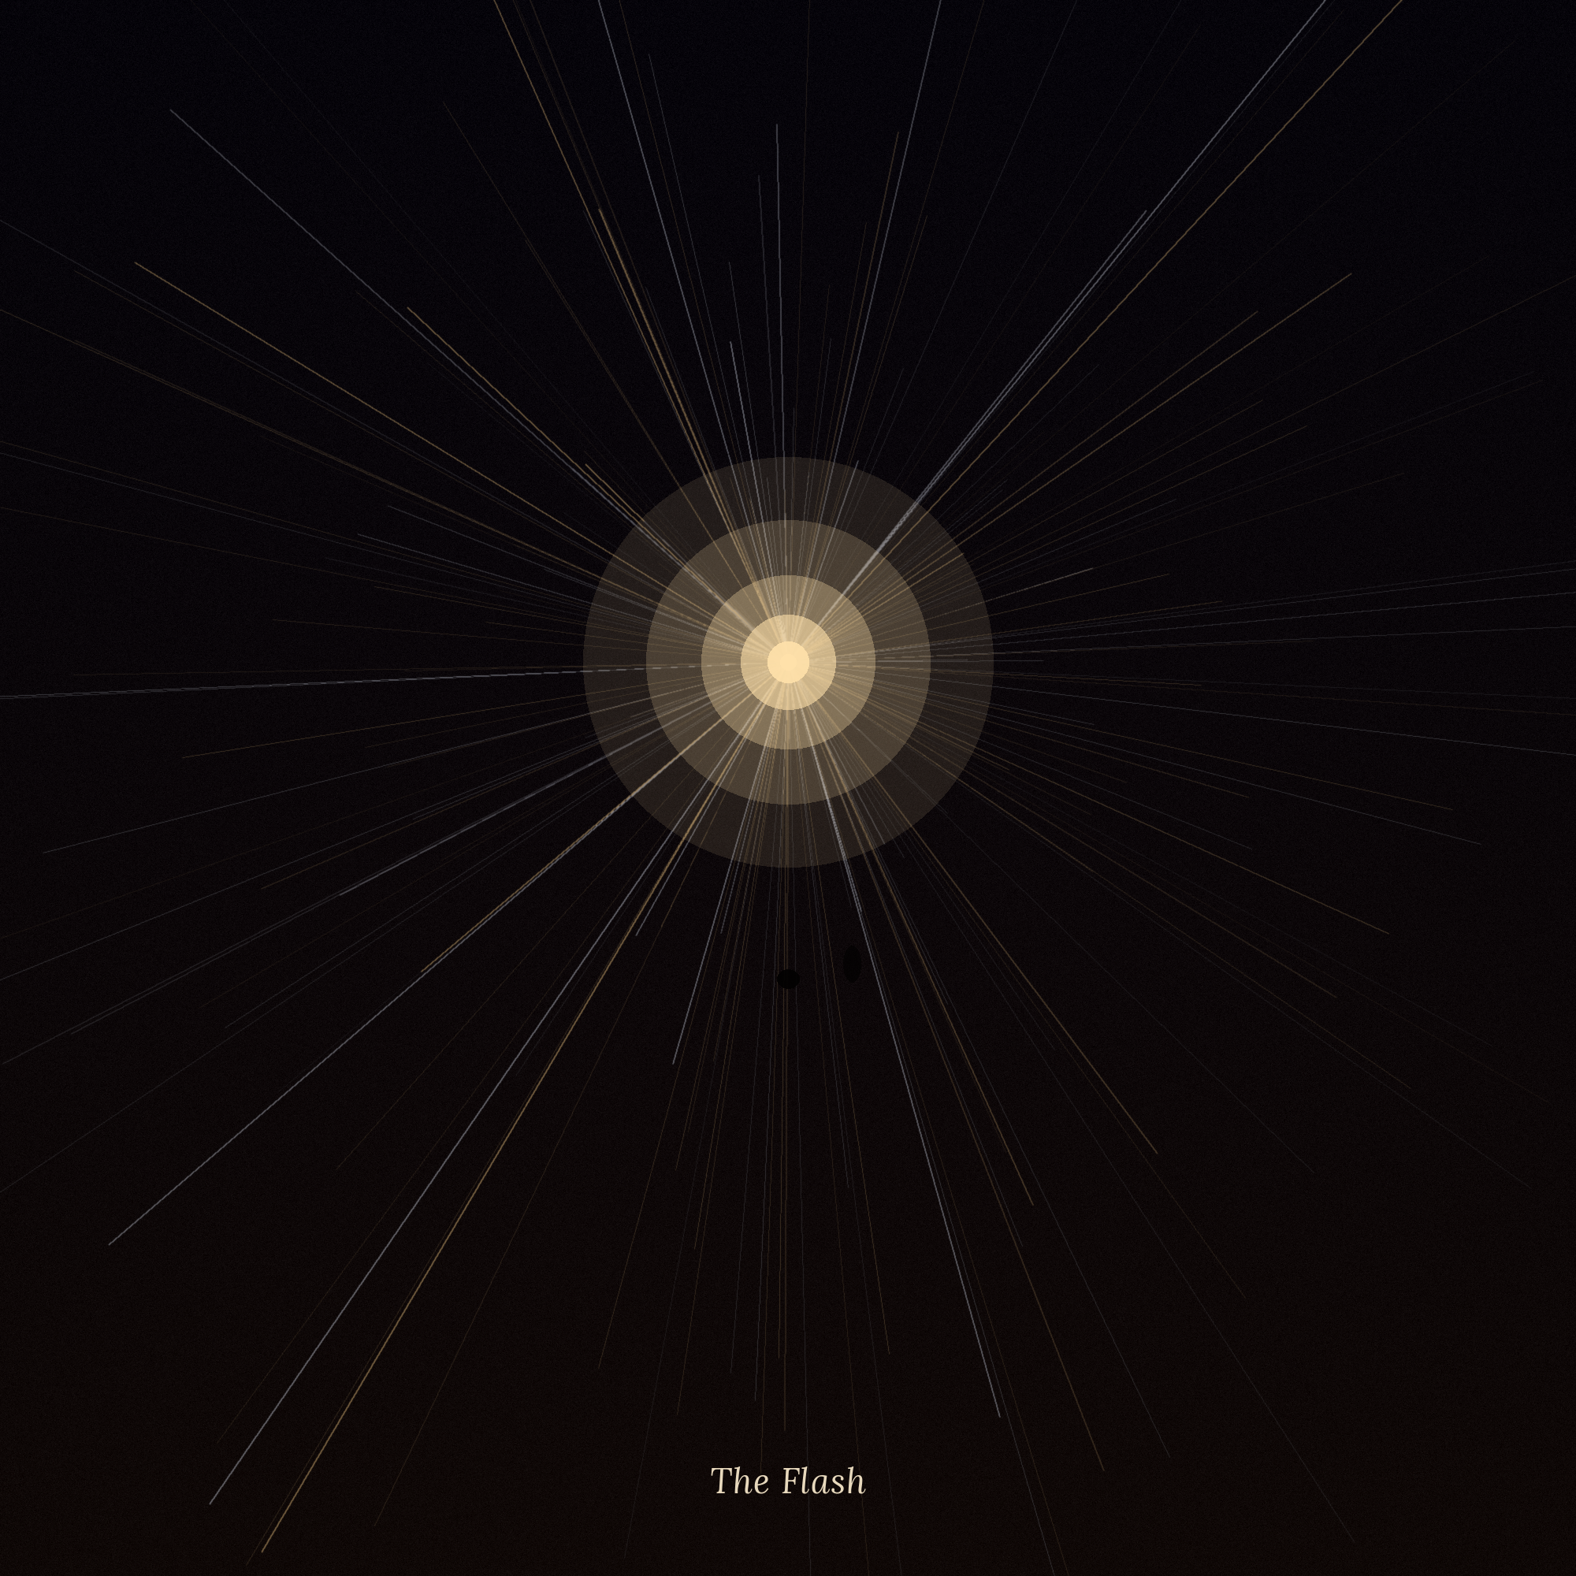

The Flash
CHAPTER 9. KAI'S BOOK

After the Temple, Kai learned to enter the Stream without waiting for night.
It was not magic in the way the elders feared it — more like something close to what happens when a person, having once learned to swim, stops being afraid of the water: not because the water has changed, but because the body has stopped arguing with it. It was enough for him to sit down, close his eyes, and recall the same feeling with which he had then said: I am here — and the world around him grew thinner, as though the desert were only the top layer of something much deeper.
On one such evening he asked himself: who are you, old man? Not in a dream. Awake, sitting in the shadow of the Silent Walls, with the crystal between his folded hands.
And the current of the Stream, for the first time by his own will, and not by the random whim of a dream, carried him back.
---
Not the way wind carries sand — smooth, painless. More the way fast water pulls you down: something seized Kai in the chest, as though he himself had for a moment stopped existing as a separate point, and had become a line stretched out through time, pulled at both ends at once.
When the pull stopped, he was standing not in the desert he knew, but in another — older, drier, poorer. Not ruins. Not legend. A living place, full of living, worn-out people.
He saw a village by a dried-up riverbed — low huts of mud and straw, mounds of cracked earth where a channel had once been. He heard a child crying, thin, hopeless, the kind of cry that comes not from fear, but from hunger that has lasted too long to cry loudly. He saw old men lying in the shade by the walls, too weak to chase off the flies, and no one came near them — not from cruelty, but because each of them was eating the last of his own.
There were no gods here who would answer. There were only omens — a bird flying the wrong way, a knot on a rope tied the wrong way — and the belief that hid behind these omens, the way water hid beneath the cracked crust of a riverbed: it was there somewhere, but no one could reach it.
Kai understood without words that this was a very old time. Older than Tamar, older than the legends of Tamar themselves. Something in the very air of this place smelled of a beginning.
---
He saw the old man — only here he was not an old man. A young man, thin, with lips cracked by the sun, sitting apart from the village, where the dunes began, and silent for so long that the silence had begun to seem like the only thing he had left.
Kai recognized his eyes before his features — the same eyes that had looked out of all the drawings he had made as a child, only younger, only without the weight of the millennia that would come later.
The man lifted his face to the sky — not in supplication; Kai could see the difference: in supplication one asks for oneself, and here there was no asking. Something closer to despair, out of which not a curse had grown, but something directly opposite.
"I do not ask," he said, and his voice in that young throat sounded nothing like it did in the eternity of the Stream: hoarse, rough with cold, humanly weak. "I hear."
---
The sky split open.
Kai had seen this many times in dreams — but not like this. There, in the repeating vision, it had been beautiful, almost safe, like a fresco on a temple wall. Here it was vast and frightening, the way things are when you are a witness to them, and not a viewer. Thousands of threads of light poured down not gently, but in a rush, as though the sky had cracked under its own weight, and at last had not held.
The young man fell into the sand. He cried out — not from pain, though the pain was clearly there, but because the pain had turned out not to be the only thing that had come together with the light. He wept and at the same time gasped for air, as though together with the stream the very breath of everyone who had ever lived and asked to be heard was pouring into him.
And then, at the very edge of the radiance, where the light became too bright to make out shapes, Kai noticed a shadow.
---
It did not look like a person — not yet. More a faint thickening inside the stream itself, as though someone was standing too close to a fire and casting a shadow not from the light, but within it. The shadow wavered, blurred, as though it was not sure it wanted to take form — and for a moment Kai felt he was being watched, though he could not have said where the certainty had come from.
And then the shadow grew clearer. A white dress. Light hair, as though woven of the same radiance. The girl stood where a second before there had been only a ripple in the stream of light — and Kai understood with a sudden, deafening clarity: she was not part of this scene. She was looking at it the same way he himself was.
She had not been there then.
She was there now — the same way he was there now.
---
He did not have time to think this through to the end — the vision crumbled, the way a dream crumbles at the first rooster's cry, and Kai woke in the shadow of the Silent Walls, drenched all over, as though he had been running all day under the sun.
He understood nothing. He did not understand that he had seen not a legend and not a dream, but the very moment the Psi-Stream was born — that same instant when a man whose name he still did not know had first opened himself to the pain and hope of everyone who had lived before and would live after him. He did not understand that he had seen Lira not as she had been then — because she had not existed yet — but as she was now, in her own present, standing on the edge of that very same memory she must have come back to again and again, year after year of her long waiting.
He knew only one thing, simple and inexplicable: the girl in white had not been looking at this fire for the first time. She stood there the way one stands who comes to the same place year after year — and this time, only this time, beside her, in that same darkness, there was someone else.
---
Lira did not at once understand what had happened.
She had come to this memory so often that she had stopped counting the times — not because she needed reminding who En-Ra was, or where the Stream had come from, but because in this single instant there was something she kept coming back to, the way one comes back to the very first breath: not for information, but for confirmation that it had not all been in vain, that someone, once, had risked speaking into the void — and the void had answered.
She stood on the edge of this memory, the way she had always stood. She watched how the young man, whom the whole world would call the First, fell to his knees under the weight of what he himself had let in.
And suddenly — a shadow.
Not in the stream of light. Beside her. A barely perceptible presence, warm, trembling, unsure of itself in the same way she had once been unsure, when she had first stepped onto the threshold of her own initiation.
She did not see a face. She did not hear a name. But she recognized — the way one recognizes not with the mind, but with something more ancient: beside her, in this very memory she had kept and watched again for almost a thousand years alone, there was now someone else.
You have come, — she thought, and the voice of her thought trembled harder than in all the years of her Shimmer. You have come here. To the very beginning. Then you are almost ready to see where mine ends.
She could not speak to him directly — not yet. But for the first time in a long while she allowed herself what she had before refused herself as an unaffordable luxury.
She allowed herself to hope — not quietly, but with everything she had left.

The Path
CHAPTER 10. KAI'S BOOK

After the Flash, Kai could not fall asleep the way he had fallen asleep before.
Not because he was afraid of dreams — he had long stopped being afraid of them. But because he could not shake one thought, simple and therefore especially insistent: too much had fallen into place too neatly to be a coincidence.
The Silent Walls. The Spire. The Garden of Stones. The Tomb of the First Ones. Each place he had found, as it were, on his own — by dream, by pull, by a scrap of childhood memory. But the longer he went over it in his mind, the more clearly he saw: between the finds there had been nothing like luck. There had been a direction. There had been something like a handwriting — something recognized not by the letters, but by the pressure of the hand, by the way it drew the line.
He decided to test something he had never done before: not to go where the dream called, but to look at the map of all the places at once.
---
He had no real map — only a stick and a patch of ground behind the house, cleared of stones, where in the dark, in secret, he traced everything he remembered: Tamar in the center, the Silent Walls to the southeast, the Spire further east, the Garden of Stones to the north, the entrance to the Tomb between them, slightly shifted, as though deliberately set off the straight line.
He looked at these four points for a long time, until in his chest there formed a recognition too clear to be a coincidence.
Not a straight line. An arc. A slow, wide arc, like the trace left by a foot stepping on sand without hurry — the trace of a person who was not going straight, but choosing where to step, knowing in advance that whoever came after would have to make out every footprint.
---
The next morning he set out along this arc — not toward the next point, but between them, to the place where before it had seemed to him there was no reason to go.
He walked all day, and toward evening he noticed something he had not seen before, though this land lay only two days' walk from Tamar and had been crossed by caravans for generations: a strip of dunes, running in an uneven ribbon through the desert, that did not move.
The wind that evening was strong, drove streamers of sand along the crests of neighboring dunes, changed their shapes before the eyes, as it always did — but this ribbon of sand stayed still, as though beneath it lay something the wind had no say over.
Kai remembered the children's tale about the dune by the eastern wall of the Silent Walls — the one that, by rumor, had stopped moving on the night a boy from the Water Finders' clan had not come back out. They had told him: the dune had been enchanted, the dune had been punished, the dune had been rewarded. No one had thought to ask: what if it was not one dune, but a line — a path running through the whole edge, connecting places no one would go to without a reason?
He knelt down and brushed the sand aside with his hands. Beneath the loose top layer, the ground was hard, baked, almost glassy to the touch — not natural, but as though fixed by someone's will, too patient to belong to the weather.
---
He walked along this strip for three days, passing the familiar points in a new way, along a line he had not seen before, until he came to where the strip ended in a sharp turn — to a place that was in no tale of Tamar, because it lay too far, further than any herder had ever dared to go.
There, at the edge, where the baked sand gave way back to ordinary, loose sand, obedient to the wind, lay another stone.
Smaller than the first. Without that jolt of recognition that had happened ten years before in the dark of the Silent Walls. But when Kai touched it, what came was not a vision, not a voice — a feeling came, simple and deafening at once: a pattern.
On the stone, barely visible, the same curve he had traced the night before with a stick on the ground behind the house had been carved. The same arc. The same pressure of the hand.
---
He sat over the find for a long time, unable to look away, as though the stone might disappear if he blinked.
On the stone, barely visible, not just a curve had been carved. It was a map — rough, worn down by centuries, but unmistakable: the same arc he himself had drawn with a stick behind the house, only here, on the stone, the arc went further than he had managed to trace. He peered at it, running his finger along the line, exactly as he had once run his finger along his own — and felt something inside him break and tie back together at once, tighter than before.
The arc almost closed into a circle.
Not a finished one — somewhere on the far edge the line broke off, as though the carver had stopped in the middle of the stroke, leaving the last segment empty. But the direction was unmistakable: one more step. One more point, which for now existed neither on his map nor, it seemed, anywhere in the world a foot from Tamar had ever stepped. The path led not into emptiness. It led toward something — and that something was the last thing that had not been named.
He sat without moving, and the evening around him was changing: the sun was setting, the dunes were casting long blue shadows, and the wind, faint and steady, had begun to pour sand along the crest of the nearer dune — in a thin, barely audible stream, the kind one catches not with the ear, but with the chest, like a distant pulse. Kai listened to this sound as he had listened to nothing before: not as to wind, but as to something that was also waiting. Every shifting grain echoed in him with a faint tremor, as though the desert itself were answering something beating deep beneath its skin.
A little more, — he thought, not knowing whose thought it was — his own, or the one woven into the stone.
The path was drawn long before me. Someone waited not a month and not a year. Someone waited so long that my life is only the last of its stretches.
This thought did not make things easier. It made them heavier — the heaviness that comes together with gratitude, when you suddenly understand what it cost someone for what came to you as if for nothing.
---
He came back to Tamar on the fifth day, thinner, burned by the sun, with a new stone at his waist — and with the look his mother had long since stopped trying to understand. She did not ask where he had been. She simply fed him and, for the first time in a long while, laid her palm on his shoulder, holding it a little longer than usual, as though she could feel: her son was leaving her not for the desert, but for somewhere from which there was no road back to who he had been.
Kai did not sleep that night. He lay holding both stones, and thought not about the old man, not about the tower — but about her, about the one who had been leading him all these years without showing herself.
Who are you? — he asked into the dark, for the first time addressing not a dream, but straight toward the place from which, he now knew for certain, someone could hear.
No answer came. But the crystals at his waist grew warm, both at once, as though someone in the dark had smiled.
---
Far away, at the other edge of the Stream, in the very heart of her Shimmer, Lira felt this question as she had never felt anything before.
To understand what the Shimmer is from inside, one must stop thinking of it as a place. It is not light and not dark, not up and not down — it is a state in which everything she had once been continues to exist not in a body, but in a pattern: in the weaving of memory, will, and warmth, stretched out over a thousand years, like a thread out of which a cloth is woven, too large to be seen whole from within. She did not dream, the way the living dream. She was the dream — the very one that had come to Kai night after night — and at the same time she remained the one who remembered, guided, and kept that dream, as though one half of her slept, while the other had not closed its eyes for over nine hundred years.
The Stream around her sounded neither in silence nor in noise, but in something in between: the hum of many lives, layered one on another, like wind coming at once from every side — and in this hum Kai's voice, still faint, still trembling, was still the clearest thing she had heard in all the years of her waiting. Not because it was loud. Because it was addressed to her. Only to her. For the first time in a thousand years, someone had asked not into the void, but straight: who are you?
She wanted to answer with a name. She wanted to say: Lira. The eighth. The one who has been waiting for you longer than you can imagine.
But the bond was still too thin — a thread, not a bridge — and the words she could set into it fit not into letters, but into a feeling, simple and vast, the way his own had once been:
I am here.
Go further. The path does not break.
I am waiting for you at its other end.

Beyond the Edge of the Hour
CHAPTER 11. KAI'S BOOK

He thought he had learned to listen.
After the Path, after the circle that had almost closed on the stone, Kai was no longer afraid to enter the Stream — he did it as naturally as he had once knelt down to sleep. He heard the old man. He heard — fainter, further, but unmistakably — her. It seemed to him there was no further to go: two voices, two ends of one thread, and he, stretched between them, had at last found a shape.
But once, sitting in the shadow of the Silent Walls with both crystals in his palms, he asked himself not "who are you," but something else: how many of you are there?
And he struck a wall.
---
It was not a wall in the usual sense — not of stone, not of dark, not a barrier that could be felt with the hands. More — a boundary of hearing, like the one that separates a cry from its echo: the further he reached into the Stream, past the old man's voice, to where by all logic others should have sounded — those vague, fragmentary presences he had felt at the Garden of Stones — the denser the silence grew. Not empty. Dense, as though there, beyond the boundary, something still was, but spoke in a language to which sound simply could not reach.
He pushed against this boundary once, twice. It did not give — as evenly, as indifferently, as the Spire had once not given on that first day.
Why here? — he thought. Why does it break off just here?
He did not know that he was asking a question to which the eight Architects before him had found no answer — not because they had not tried, but because none of them had even suspected that there was anything to look for beyond this boundary.
---
He came back to the boundary the next night. And the night after. He came again and again, week after week, until he learned to discern the very nature of the wall — not as an obstacle, but as a forgotten habit.
The Stream, he understood one day, was not a level sea one could dive into anywhere and hear everything at once. It was moving — slowly, hugely, like the sky overhead, which turns all night long but seems still to whoever does not look long enough. The old man's voice, Lira's voice — both sounded in the same layer, in the same stretch of this slow, ungraspable movement. And beyond that, another time began — no less real, simply set apart the way one hour of the night is set apart from the one before: near, but not here.
No one before him had tried to listen into the next hour. No one had thought it possible — just as a person who has lived all his life in one room does not wonder what lies beyond the wall, if that wall has never had a door.
Kai began to look for the door.
---
It opened not with a push, as the Stream had opened before, but with exhaustion — that silence that comes when you stop pushing and simply lie down beside the barrier, too tired to want to break it down.
That night he was not looking for anything. He simply sat, emptied by weeks of trying, and let himself stop being the one who searches.
And the wall he had pushed so many times turned out to be not a wall, but a threshold, which could finally be stepped across, because for the first time he was not forcing his way in, but had simply happened to be beside it, without effort, without the need to understand.
---
The voices poured in not as a stream — as a scatter, each with its own weight, each so separate from the others that Kai could not hold more than one at a time, but managed to feel them all.
Someone stood at the edge of the known world and looked into the dark not with horror, but with readiness — there is someone there to answer, I know it now. Someone raised out of the void forests that had existed in no oasis, trees of crystal and light, and laughed the way those laugh who have at last been allowed to create without fear of being wrong. Someone had gone to a distant star and left behind not a body, but warmth — a small, smoldering hearth in the middle of the cold, so that the next one to find himself there would not freeze alone. And there were others — vague, unfinished, as though their stories had broken off in the middle not by another's will, but because they themselves had not yet decided what they wanted to become, and this indecision stretched across centuries, the way an unfinished thought stretches.
Kai knew none of their names. He understood none of the stories whole. But he felt them the way one feels not a tale, but kinship: these were not strangers' voices. These were the previous "I"s of one and the same chain, each link of which flared for a moment and went out, leaving behind not emptiness, but what the next link took up.
Eight voices. He counted eight before he lost count — and felt as though at last he had walked the circle of statues not with his palm, but with his hearing itself.
---
He could have stopped there. Anyone in his place would have called it the limit, the peak, beyond which there was no point in going.
But something in the very fabric of what he had heard pulled him further — not forward, toward his own time, but deeper back, to where, by all the laws he had managed to learn, there should have been nothing. Before the old man. Before the first voice. Before the very birth of the Stream.
He pushed against this, the second boundary — almost not believing anything could be beyond it. Because if the old man was the first to hear, then before him — only muteness. So his own fear had taught him. So the Circle of Sand had taught him. So, it turned out, had all eight voices before him thought, none of whom had ever tried to look past their own First.
The boundary gave way more quietly than the first. Without resistance. As though it had been waiting not for force, but for a simple question no one had ever thought to ask.
---
Beyond it there was no silence.
There was a sea — not of light, not of sound, but of something for which Kai would never have found the word, if he had been asked: countless, tiny, never-reached prayers. Pleas addressed to a sky that did not answer. Dreams dreamed and forgotten with the dawn, leaving no trace in any memory except the one that, now, for the first time, had at last held them. The fear of mothers over cradles. The hope of old men breathing their last alone, without a single witness who could afterwards say they had not lived in vain.
These were not the Architects. Not those who had learned to hear. These were all the rest — past counting, who had lived and died in ages when the Stream had not yet existed at all, when there was no one and nothing to answer — and yet they had gone on asking, generation after generation, simply because it is in a person to ask, even knowing there will be no answer.
Kai fell to his knees where there were no knees, where there was no body — something simply bent in the very core of what he was, under a weight that could not be carried standing.
He wept not from fear and not from joy, as he had wept before. He wept the way one weeps when one learns that someone suffered alone for a very long time, and no one, not once, in all the centuries, came.
I am late, — he thought, and the thought was heavier than any that had come to him before. But I am here.
---
He did not remember how he came out of the Stream that night. He came to on the sand, by the walls, chilled to the bone, though the night was warm — and lay for a long time, unable to rise, feeling how inside him there now fit something for which there simply had not been room before.
He understood that night what none of the eight voices before him had understood — because none had gone so far: the Stream was not just the memory of those who had learned to hear. It was only the upper, loudest layer of a far greater sea — a sea of all who had ever been, heard or not. And if he, Kai, had managed to hear that sea even once, then someone after him would have to hear it whole — not as some accidental depth into which a tired boy had once fallen, but as the very reason an Architect exists at all.
Not to keep the voices of those who heard, — he thought. But to hear even those who were never heard.
He did not know that this was the very next step Lira's gift had been waiting for, for eight thousand years: not a new way of leading — a way of hearing deeper than the galactic circle had ever managed to live through even once.
---
Far away at the other edge of the Stream, Lira felt this not as an answer, and not as recognition.
She felt it as an earthquake — quiet, soundless, but such that for a moment the very structure of her Shimmer trembled, as though something she had taken for an unchanging law of the world had just confirmed that it had never been a law.
No Architect before him had gone past his own Hour. None — including her, including the old man whose voice she knew better than her own breath. She had spent a thousand years believing the limit was simply the limit, part of the Stream's design, as inevitable as the change of day and night.
The boy had just shown her the limit was not a law.
It had only been what no one had tried to cross.
That is why, — she thought, and in the thought there was shock mixed with awe, the kind she had not felt since the day of her Initiation. That is why it is you. Not because your world is poorer. Because your world was never afraid of silence enough to unlearn listening down to the very bottom.
She wanted to warn him — to say that such depth has a price, that not every heart can bear to carry on itself a whole forgotten sea. But the bond was still too thin, and the time left to her — too short for warnings.
She was able to set into the dark between them only one thing, simple, as everything most important is:
Do not carry this alone. Bring it to me — and I will help you bear it.
There is little left. Go.
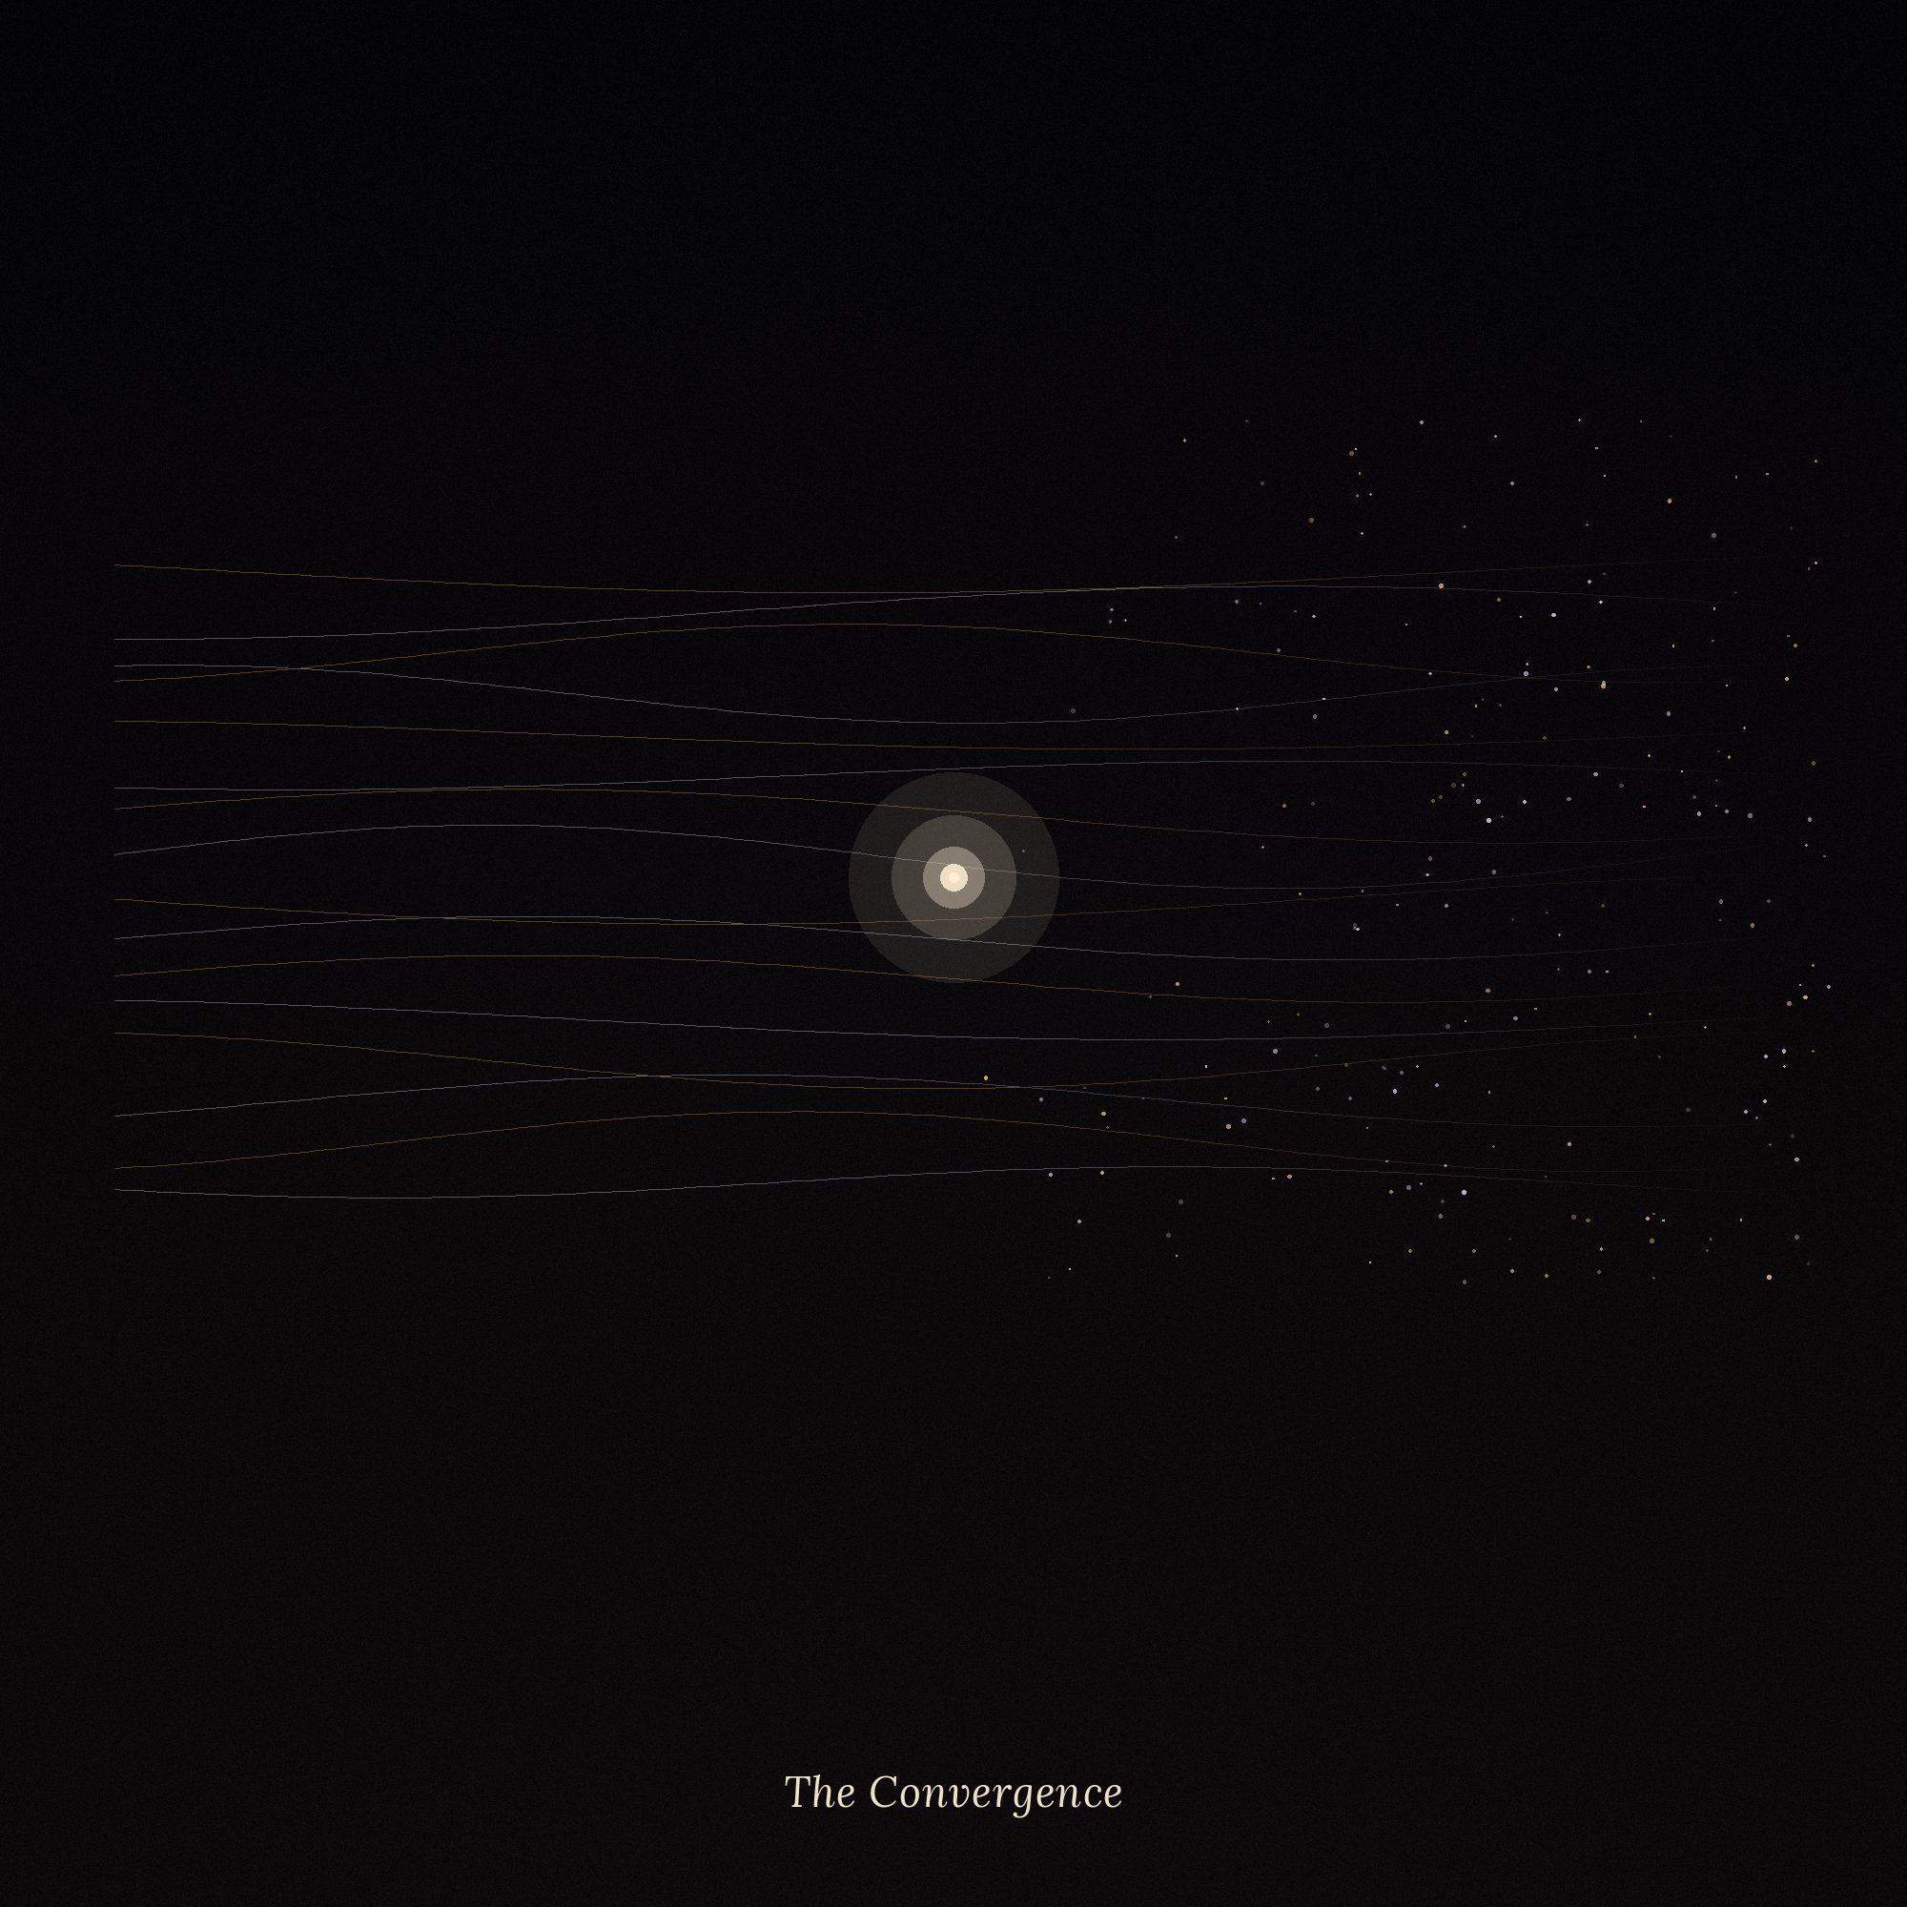

You Are Late / The Convergence
CHAPTER 12. KAI'S BOOK

The last point on the arc had no name.
Kai found it months after the first time he had counted the eight voices and fallen into the sea of mute centuries. It was neither ruin, nor stone, nor a place marked by anything that would have set it apart from a thousand other dunes around it. Only here, and only here, the arc drawn centuries before his birth finally closed.
He did not know what to expect. He came because the path had brought him here, and the path had not lied once in all these years.
He sat down. He took out both crystals — the first, found by a child in the dark of the Silent Walls, and the second, carried out from under the collapse of the Tomb — and prepared to wait as patiently as he had once waited at the Spire.
He did not have to wait.
---
The crystals flared at the same instant — not with the warm light they usually gave off, but with a sharp, almost painful light, as though inside each of them something had at once burst that had been building for years. Kai cried out and nearly dropped them both, but his fingers closed of their own accord, tighter than he could have closed them by his own will.
And in that very moment he heard — not in a dream, not in a trance, not through a threshold he had to seek and push against. The voice entered him the way a sudden, inexplicable cold enters the chest.
You are late.
He had heard this phrase before — in the Temple, a year and a half before, as an echo, reflected from a thousand invisible walls. Then it had been a warning, a riddle to be solved. Now there was no riddle in it. Only panic — thin, desperate, real, recognized at once, because it belonged to the voice he had heard in his dreams all his life, only never — like this.
It was her.
---
He did not think. He did not prepare, did not steady his breathing, did not look for a threshold the way he had spent months learning to do. He simply did what he had done on the night he first said "I am here" — he opened himself completely, with nothing held back, without fear of losing his shape, and let the Stream carry him as deep and as fast as it had ever done.
The desert around him vanished. Not as usual — not slowly, in layers — but all at once, as though it had never been, as though all this time it had been only a thin film over something immeasurably larger, and the film had at last given way.
He found himself on a boundary.
---
Not the one he had learned to cross between Hours. Another — thinner, more frightening, like the edge of a very high cliff, beyond which there was not an abyss, but where the horizon itself began to thin, dissolve, lose its density.
There, on that boundary, the Shimmer was burning down.
Kai did not at once understand that what he was seeing was exactly this — because there was nothing here that looked like the image of the old man or the tower. There was a cloth, vast and unbearably complex, woven of a thousand years of memory, will, and warmth — the very thing she had once tried to explain to him with one word, unable to find a better one: a pattern. The cloth was tearing. Not sharply, not as a catastrophe — the way a fabric thins that has been worn too long and by too many years: thread after thread, quietly, inevitably, and in place of each torn thread there was left not a tear, but light — thin, a farewell, going not into the dark, but somewhere further, into a depth Kai could not yet make out.
I did not make it in time, — he thought, and this thought was more frightening than anything he had felt in the Stream until now. I found the door too late. She is right. I am late.
---
"No."
The voice sounded beside him — not as an echo, not as a trace left in ancient memory, but close, as though she was at last standing at arm's length, and not across millennia.
"You are not late. You have come. These are different things, Kai."
She said his name for the first time.
He did not have time to ask how she knew it — and there was no need to ask: of course she knew, she had known all these years, from the very first day, when the boy had touched the dark stone in the darkness of the Silent Walls, and somewhere at the other edge of the Stream something had stirred for the first time in nine hundred and ninety-nine years.
"I am here," he said, and these were the same two words he had set into the Stream a year and a half before, in the round chamber of the Temple of No Voice. But now they meant something else. Then — I exist, I hear you. Now — I will not let you go alone.
---
She laughed — quietly, through what could have been tears, if the light she had become still had eyes to weep with.
"You cannot stay with me here," she said. "And I cannot stay with you there. That is not how it works, Kai. It never has. For any of us."
"Then how?"
"Listen," she said. "We have less time than you think, and more than you are afraid of. Listen and do not interrupt — this, too, I once had to learn with effort."
---
And she told him — not everything, not the way one tells a story, but the way one passes on the most important thing, when there is time left for only a few breaths, and what must be said is something that, in other circumstances, would have taken a whole life.
That she had been born knowing who she was — in a world where the bond between generations was as natural as breathing, where no one looked away at the word "Stream," because the Stream had been their common home since birth. That she had been taught this — not as a gift, but as a burden that could be neither chosen nor returned, only accepted, and one day passed on. That before her there had been seven, and before them — still more, and at the very beginning — the one whose voice he already knew: a man who once, in a desert, with nothing but hunger and the stars, had decided not to ask, but to hear, and in doing so had opened a door no one before him had suspected existed.
"An Architect is not a title," she said, and in these words Kai at last heard that weight he himself had been carrying for months, unable to name. "It is an obligation. It means that one day you stop belonging only to yourself. It means stepping back from everything that surrounds you — not because it does not matter, but because now you are needed by everyone at once, in any stage, in any century, the living and those who slumber in the depths, waiting their turn to be heard."
"I am not ready," said Kai, and for the first time in a long while there was not a drop of pretense in these words.
"No one is ready," she answered, and in her voice he heard a smile. "I was not ready either. Readiness is not something you come with. It is something that grows together with the burden, step by step, path by path. You have already walked further than you think. You have heard further than I have heard. You have carried what none of us had dared to lift."
---
The cloth around them was thinning faster. Kai felt how she was growing less — not as pain, but as a parting, stretched out across moments that drew out and at the same time slipped away.
"Tell me," he asked suddenly, desperately, not wanting the silence between words to grow longer than what was said. "Tell me what you were like. Not an Architect. Just — you."
She was quiet — and in that pause there was something so human that for a moment Kai forgot everything else.
"I loved watching how, in my world, light was born out of nothing," she said at last. "Not because it was a miracle — there it was not a miracle, there it was simply morning. But because each time it was a little different, and I never grew tired of marveling at that 'different.' I was afraid of the dark when I was small, though in my world there was almost no dark. I did not want to be the Eighth, when they told me who I would become — I wanted simply to stay who I had been before that conversation, a little longer. And I spent a thousand years waiting for a boy from the other end of time, never once seeing his face, and that waiting was the most living thing that ever happened to me in all my life — both before and after death."
Kai felt something inside him give way and tear, the way the cloth around them was tearing.
"Do not go," he said.
"I am not going," she answered gently. "I am becoming what I have always been half of. You will see it for yourself in a moment. It only looks like loss right now, because you do not yet know what it is like from the other side."
---
The last thread of the cloth thinned to almost nothing.
"Kai," she said, and in his name, spoken for the last time in her own voice, not yet dissolved, there was the whole thousand years of waiting at once. "I am not asking you to remember me. You will not be able to forget, even if you wanted to — we are now such a weaving that to forget me would mean to forget part of yourself. I am asking you something else."
"What?"
"Do not stop where I stopped. I learned to lead — to leave paths for those who did not know they were lost. You have learned to hear deeper than any of us dared to hope — not only those who found their way into the Stream, but those who prayed in muteness, not knowing a prayer could be heard at all. But to hear is only the beginning. You have something else ahead of you: to learn to wield the Stream, and not only to attend to it. To build with it. To join the distances between worlds as easily as I once joined the shores of your life and mine with a single path. To become the Stream as far as a person can — for the whole span allotted to you on your earth. And to teach others to do the same: not to be the only one holding the door open, but to show your people that the door exists at all. And when your time comes — to find the Tenth after you. To teach him what I could not teach you, because I myself did not know: to hear not for a thousand years. The whole circle. All who have ever been — heard and unheard, living and slumbering — as a single breath."
"I do not know if I can," Kai whispered.
"I know," she said. "That is why it will work."
---
The light did not collapse into the dark — it collapsed into depth.
Kai cried out, because for one unbearable moment it seemed to him: this is it, the very thing he had feared from the first second on this boundary — a loss without remainder, a silence where a second ago a whole cloth of life had been. He flung himself after her, no longer understanding where his own consciousness ended and the emptiness she had disappeared into began — flung himself the way one flings after a drowning person, without thinking whether one can swim oneself.
And then he understood what she had been trying to warn him of, and had not finished saying.
She had not disappeared.
She had become.
---
There, where a second ago the dying cloth had been — now there was a sea. The very sea he had once touched beyond the edge of his Hour, only now he saw it differently: not as something distant and foreign, but as a home in which every drop had a shape, a name, a story. And in that sea, not dissolved, not erased, but whole, complete, real — she.
Not a shadow in the stream of light. Not a whisper at the edge of a dream. Not warmth hidden in a crystal, which had to be deciphered, like a trace left by someone who had long since gone.
She herself. Whole. For the first time accessible not in fragments, not in echoes — but entirely, the way he had never been able to hear her before, because before, part of her had still been holding on to shape, to boundary, to the loneliness of a single being. Now there was no boundary. She was the sea — and still remained herself so clearly that Kai would have picked her out among a thousand such voices without the slightest effort.
"See," she said, and this time there was no farewell in her voice. There was relief, as though she had at last set down a burden she had carried too long. "I told you. You are not late."
Kai fell to his knees — where there were no knees — and wept as he had never wept in all his life: not from pain and not from fear, but from having found the person he had been looking for all his life, without knowing he was looking, at the very moment when it seemed he had found — only to lose him at once.
But he had not lost.
He had found.
---
How long he lay stretched out on the sand, at the last point of the path, he never knew. Maybe an hour. Maybe the whole night through.
When he opened his eyes, both crystals on his chest were glowing steadily — not with worry, not sharply, but with that calm, even light with which something glows that has at last found its place. He rose slowly, as though relearning the weight of his own body, and stood for a long time, looking at the lightening sky, feeling inside him not the emptiness after loss, but something directly opposite — a fullness that had never been there before. The old man's voice was there. Lira's voice was there — no longer as an echo, but as a part woven into him as firmly as the thread out of which she had been woven is woven into the cloth. The eight voices before her were there. And deeper, fainter, but unmistakable — that vast, mute, at last heard sea, which now belonged to him as well.
He was no longer the boy who had once touched a dark stone in the darkness of ruins and could not explain what had happened. He was no longer even the one who had learned to hear and to answer.
He was the next link. The ninth.
The one she had waited a thousand years for — and the one who would now carry what she had carried further, to the horizon she herself would never see, but in which, he now knew for certain, she would be woven forever.
He walked home unhurried, watching the sun rise over the desert that had raised him blind to itself and, at the same time, the only one who could hear so far.
Behind him, where all the lines of the path drawn centuries before his birth came together, the wind stirred the sand for the last time — and fell still, as though the task for which the dunes had once stopped moving had at last been completed.

