Binary Beasts


Contents
1.About us 2
2.Idea of the project 2
3.Stages of working 2
4.Used technologies 2
5. Block diagram 3
6. Functions 4

1.About us
Name | Role | Grade
Miroslav Iliev | Scrum trainer | 9B
Iordan Raynov | Front-End Developer | 9B
Dimitar Nyagalov | Back-End Developer | 9B
Ivan Trifanov | Back-End Developer | 9A

2.Idea of the project
The Sports Score Manager application is a modern and efficient platform designed to manage live sports events, track scores, and organize teams and tournaments. It is useful for coaches, players, referees, tournament organizers, and sports fans who want quick access to match information and statistics.
The application’s interface was developed using the extbf{Raylib} graphics library. Raylib allows the application to run smoothly while providing responsive controls and a clean visual design. The layout is simple and easy to navigate, making it suitable for both beginners and experienced users.
The design is responsive and works well on desktop and mobile devices. Live score updates are clearly displayed, helping users follow matches in real time.

3.Stages of working
№ | Stages
First Week | We created the idea and the working environment.
Second Week | We created the Main Menu, Login/Register and also the menus of the app.
Third Week | In the third week we made the presentation and documentation and now the project is ready to be presented.

4.Used technologies
- C++ - for creating the app.
- Github – for the synchronization.
- Raylib – for the User Interface.
- MS PowerPoint – for creating presentation.
- MS Word – for creating documentation.
- MS Teams – for communication in the team.
- 5. Visual Studio 2022 – for writing the code.

5. Block diagram
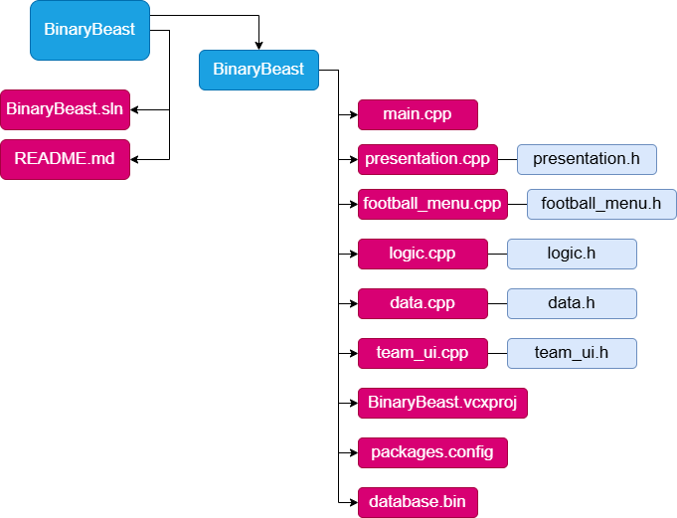

6. Functions
Type | Name
void | mainMenu()
void | renderApp()
void | renderLoginScreen()
void | renderRegisterScreen()
void | renderDashboard()
void | renderHeader()
void | renderExpenseTable()
void | renderFormPanel()
void | renderSearchPanel()
void | renderStatsPanel()
void | renderBudgetPanel()
void | renderSettingsWindow()
void | renderNotifCenter()
void | renderStatusBar()
void | renderDeleteModal()
void | addNotification()
void | checkBudgetNotifications()
void | refreshExpenses()
bool | registerUser()
bool | loginUser()
bool | usernameExists()
bool | changePassword()
void | bubbleSortByAmount()
void | quickSortByDate()
void | bubbleSortByCategory()
int | binarySearch()
double | recursiveTotal()
double | recursiveMonthlyTotal()
int | recursiveCountByCategory()
bool | addExpense()
bool | editExpense()
bool | removeExpense()
bool | toggleCompleted()
double | totalExpenses()
double | avgExpense()
double | maxExpense()
double | minExpense()
void | categoryTotals()
bool | setBudget()
double | getBudget()
double | getBudgetUsed()
bool | isValidDate()
bool | isValidAmount()
bool | isValidUsername()
bool | isValidPassword()
bool | isValidEmail()
int | loadExpenses()
bool | saveExpenses()
bool | appendExpense()
bool | updateExpense()
bool | deleteExpense()
int | nextExpenseId()
int | loadUsers()
bool | saveUsers()
int | loadBudgets()
bool | saveBudgets()

