Decoupling Total Barometric Pressure from Oxygen Partial Pressure in the Arabidopsis thaliana Spaceflight Exploration Atmosphere Using the TabPFN v2 Tabular Foundation Model: Molecular Hubs, Single-Nucleus Trajectories, and Physiological Rescue
Richard J. Barker^{1,} and [Co-authors To Be Determined]*^{2}
^{1}Department of Biological Sciences, University of Wisconsin-Madison, Madison, WI, USA; Center for Space Exploration (CoSE)
^{2}[Affiliation To Be Determined]
^{*}Corresponding author: dr-richard-barker / rbarker2@wisc.edu

Abstract
Future crewed lunar and Martian surface habitats, extravehicular activity (EVA) staging airlocks, and bioregenerative life-support systems will operate under NASA's reduced-pressure, oxygen-enriched Exploration Atmosphere (56.54 kPa} [8.2 psia}], 34\%\ O}_2, oxygen partial pressure pO}_2 = 19.22 kPa}; pre-EVA staged decompression 70.33 kPa} [10.2 psia}], 26.5\%\ O}_2, pO}_2 = 18.64 kPa}). While enriching fractional O}_2 restores normoxic pO}_2, reducing total barometric pressure (P_{total}}) inversely accelerates binary gas and water-vapor diffusivity (D ∝ P_{total}}^{-1}; 1.72× faster at 56.54 kPa} than at 97 kPa} ISS cabin pressure), thinning the boundary layer and accelerating transpiration independently of cellular oxygen availability. However, small sample sizes (n = 9--}130 per study), high feature dimensionality (p = 22,746 probesets), and historical metadata ambiguities have prevented classical machine learning models from cleanly separating pure barosensory (P_{total}}) signaling from hypoxia (pO}_2) signaling or linking these molecular hubs to cell-type trajectories and whole-plant physiology.
Here, we harmonize a 12-dataset multi-omics compendium spanning 281 microarray hybridizations, 40,860 single-nucleus root-tip transcriptomes, 326 physiological gas-exchange and chlorophyll fluorescence records, LC-MS metabolomics across factorial pressure × humidity regimes, and 5,454 iTRAQ submergence proteins, and apply the TabPFN v2 prior-data fitted tabular foundation model (Hollmann et al., Nature 637, 319–326, 2025) to resolve the plant response to exploration atmospheres. First, an explicit forensic audit ledger tracking all 148 series-level GSM records (Table_S1_Full_148_GSM_Audit_Ledger.csv) deduplicates 18 shared arrays (r = 1.000000, \max|Δ| = 0.0) between GSE87867 and GSE87903 to establish 130 unique hypobaric arrays, all of which pass standard Affymetrix array QC (NUSE medians 1.00 ± 0.25, RLE IQRs 0.79 ± 0.37, scale factors 1.00 ± 0.08, percent present 81.7 ± 10.0\%). TabPFN v2 probabilistic classification (ROC_AUC = 1.0000, Brier_Score = 0.000002, ECE = 0.00085 across n = 126 unambiguous arrays) objectively resolves four disputed GSE87903 75 kPa} arrays (GSM2342806–GSM2342809, P(Shoot}\mid\mathbf{x}) \in [0.9908, 0.9991]) as Shoots whose submission records retained a copy-pasted Root tag, resolves two mislabeled 5 kPa} root arrays (GSM2342804–GSM2342805), and demonstrates that unbalanced replicate counts (n = 4) arose from technical re-hybridization of Replicate A across scanner batches 54xx and 68xx (r = 0.9951--}0.9964).
Second, under leak-free condition-grouped cross-validation (20 discrete condition groups), TabPFN v2 and its post-hoc ensemble TabPFN v2 (PHE) outperform LightGBM, RandomForest, ElasticNet, Ridge, and MLP baselines across continuous Hypobaria Index regression (log2(97/P_{total}}): RMSE = 0.4425, R^2 = 0.9134, Spearman ρ = 0.9100 on n = 130, p ≤ 7.05 × 10^{-3} vs. all baselines), continuous Hypoxia Index regression (log2(20.37/pO}_2): RMSE = 0.2247, R^2 = 0.9733, ρ = 0.9121 on n = 58, p ≤ 1.30 × 10^{-3}), and 4-class atmospheric regime classification (ROC_AUC = 0.9623, Accuracy = 86.21%, ECE = 0.0608). A comprehensive covariate ablation suite confirms that transcriptomic physical signal decoding is not driven by experimental covariates: experimental covariates alone yield negative out-of-fold generalization (R^2 = -0.3783 for Hypobaria, R^2 = -0.2419 for Hypoxia), whereas transcriptomic features provide positive predictive power (R^2 = 0.4436 and 0.9268, rising to 0.5307 and 0.9283 when combined).
Third, multivariable orthogonal partial regression with empirical Bayes variance moderation across all 22,746 probesets combined with exact TabPFN v2 Shapley attributions identifies 1,003 Pure Hypoxia (pO}_2) hubs—led by HRU1 (AT3G03270), WIP5 (AT4G33560), AAD6 (AT1G43800), AHB1/HB1 (AT2G16060), AtPDC1 (AT4G33070), PCO1 (AT5G15120), and ADH1 (AT1G77120)—and 380 Pure Barosensory (P_{total}}) hubs, alongside 21 Additive Dual Hubs and 12 Interaction Hubs (6 synergistic, 6 antagonistic) that remain active even when O}_2 supplementation restores normoxia (50 kPa} + O}_2 and 25 kPa} + O}_2). Pure barosensory hubs are anchored by the Ca}^{2+}-dependent ROP-interactor CMI1 (AT4G27280), the stomatal/ROS zinc-finger regulator STZ/ZAT10 (AT1G27730), the mechanosensitive cell-wall xyloglucan endotransglucosylase TCH4/AtXTH22 (AT5G57560, +1.85\ log2FC} in normoxic 50 kPa} shoots), rate-limiting ethylene synthase ACS6 (AT4G11280), GABA-T (AT3G22200), and chloroplast oxylipin lipoxygenase LOX2 (AT3G45140). Fourth, projecting these hubs onto 99 cell-type TRAP-seq arrays (GSE14493, GSE14502) and 40,860 root-tip nuclei (GSE308672) reveals strict spatial partitioning: pure normobaric hypoxia (4\%\ O}_2) strongly induces ERF_VII_Core_Hypoxia_Anaerobic across all nine root-tip lineages (+2.65 to }+3.17\ log2CPM}) but leaves ABA_Desiccation_Stomatal_Closure (-0.22 to }+0.06\ log2CPM}) and Cuticle_Epicuticular_Wax_Lipid_Transport (-0.35 to }-0.03\ log2CPM}) uninduced in root-tip tissue, whereas cuticular and cell-wall barosensory hubs localize specifically to pCER5 shoot epidermis (+2.21 and }+1.21\ log2).
Fifth, physiological and LC-MS metabolomic triangulation at 62 kPa} vs. 101 kPa} (ZENODO16536514) demonstrates that the 1.63× diffusivity increase elevates leaf-to-air vapor pressure ratio by +73.23\% (Hedges' g = +3.476, p = 6.84 × 10^{-16}), driving a -76.25\% collapse in stomatal conductance (g_{sw} from 36.64 to 8.70\ mmol m}^{-2} s}^{-1}, g = -1.852, p = 8.27 × 10^{-9}), a -55.93\% reduction in net CO}_2 assimilation (p = 1.51 × 10^{-4}) despite intact PSII electron transport (ETR(II)), a -11.61\% drop in relative water content (p = 0.0113), and a +1.02‰} enrichment in foliar δ13C} (p = 0.0117). Elevating relative humidity to 70\%\ RH} at 62 kPa} restores chloroplast oxylipin galactolipids (MGDG-OPDA, +1.26 to }+2.60\ log2FC}) and long-chain thioalkyl glucosinolates (8-methylthiooctyl glucosinolate, +0.68\ log2FC}), reducing the TabPFN v2 posterior probability of the unmitigated hypobaric metabolic state from 0.9822 ± 0.0055 to 0.7908 ± 0.0304. Sixth, mapping the multi-omics compendium onto the Plant PhysioSpace Stress Autodecoder across the spaceflight mission profile (visualized via a continuous Blue-to-White-to-Red diverging scale) demonstrates that nominal 56.54 kPa} / 34\%\ O}_2 habitation is perceived not as hypoxia (z = -0.16), but as an isolated shoot-localized boundary-layer transpiration challenge (z = +1.86, cell-wall strain z = +1.94, aquaporin flux z = +1.72, stomatal resistance z = +1.82). Finally, Leave-One-Condition-Out validation (mean Pearson r = 0.7387, RMSE = 0.1502) and counterfactual synthesis with split-conformal uncertainty intervals (± 0.3007 90% CI, ± 0.3289 95% CI) indicate that while 34\%\ O}_2 enrichment mitigates >88\% of root ERF-VII anaerobic activation, physical barosensory remodeling persists—establishing that humidity/VPD compensation (75--}80\%\ RH}) provides an immediate, non-genetic engineering countermeasure that substantially attenuates osmotic stress (Δ z = -1.90), relaxes stomatal closure (Δ z = -1.76), and normalizes crop physiology in lunar and Martian habitats.

1. Introduction
Long-duration crewed space exploration requires transitioning from the International Space Station (ISS) sea-level-equivalent cabin atmosphere (97--}101.3 kPa}, 21\%\ O}_2, oxygen partial pressure pO}_2 ≈ 20.37--}21.27 kPa}) to reduced-pressure, oxygen-enriched habitats designed to minimize structural mass, hull leakage, and pre-extravehicular activity (EVA) nitrogen denitrogenation time (Norcross et al., 2013; Paul & Ferl, 2006; Zhou et al., 2017). Specifically, NASA's Exploration Atmosphere engineering trade study established a primary lunar/Martian surface habitat setpoint of 56.54 kPa} (8.2 psia}) total pressure at 34\%\ O}_2 (pO}_2 = 19.22 kPa}) and a staged pre-EVA decompression setpoint of 70.33 kPa} (10.2 psia}) at 26.5\%\ O}_2 (pO}_2 = 18.64 kPa}) (Norcross et al., 2013). For mammalian crew physiology, raising fractional oxygen concentration (F_{I}}O}_2 = 0.34) restores alveolar pO}_2 to near-normoxic levels. For higher plants grown in bioregenerative life-support systems, however, the biophysics of low barometric pressure introduces a thermodynamic boundary-layer acceleration that oxygen enrichment alone cannot cancel.
By the Chapman–Enskog kinetic theory of gases, the binary diffusion coefficient D_{ij} of trace gases and water vapor (H}_2O}, CO}_2, O}_2, and volatile phytohormones such as ethylene) in air scales inversely with total barometric pressure:
D_{ij}(P_{total}}, T) = D_{ij}(P_0, T) \cdot ≤ft(\frac{P_0}{P_{total}}}\right)
Consequently, reducing total cabin pressure from 97 kPa} (ISS) to 56.54 kPa} (Exploration Atmosphere) increases gas-phase molecular diffusivity by D/D_0 = 1.72× (and by 1.94× at 50 kPa} and 3.88× at 25 kPa}), thinning the effective diffusive resistance of the leaf boundary layer and accelerating cuticular and stomatal water-vapor efflux at any fixed relative humidity (Corey et al., 2002; Richards et al., 2006; Paul et al., 2004, 2017; Lucia et al., 2025). When plants are exposed to uncompensated hypobaric air (21\%\ O}_2 at 25--}75 kPa}), they experience a compound stress combining cellular hypoxia (pO}_2 = 5.25--}15.75 kPa}, which stabilizes group VII ETHYLENE RESPONSE FACTOR [ERF-VII] transcription factors via N-degron PLANT CYSTEINE OXIDASE [PCO] inhibition; Gibbs et al., 2011; Licausi et al., 2011; Mustroph et al., 2009) with physical barosensory stress (D ∝ P_{total}}^{-1}, boundary-layer evaporative acceleration, and cell-wall mechanical strain; Zhou et al., 2017; Paul et al., 2017). Pioneering transcriptomic studies by Paul, Ferl, and colleagues (GSE87867, GSE87868/OSD-136, GSE87903, GSE87904; Zhou et al., 2017) profiled Arabidopsis thaliana roots and shoots across multiple total pressures (97, 75, 50, 25, 10, 5 kPa}) and O}_2-supplemented normoxic controls (50 kPa} / 42\%\ O}_2 and 25 kPa} / 84\%\ O}_2, pO}_2 = 21.0 kPa}). Yet four critical barriers have prevented a unified systems-level synthesis:
- Sample Cross-Listing and Metadata Ambiguity in Public Repositories: Across the four core GEO series (GSE87867, GSE87868, GSE87903, GSE87904), cross-listed GSM accessions, conflicting organ tags between sample titles (Shoot) and characteristics_ch1 (Root) in GSE87903 (GSM2342806–GSM2342809), conflicting pressure tags (GSM2342804–GSM2342805), and unexplained n=4 replicate groups have confounded automated meta-analyses.
- The Small-n, High-p Regime in Space Biology: Individual spaceflight and hypobaric chamber experiments typically comprise n = 58--}130 arrays across p = 22,746 transcripts. Classical gradient-boosted decision trees (LightGBM, XGBoost) and deep neural networks overfit severely in this regime, while penalized linear models (ElasticNet, Ridge) fail to capture nonlinear interactions between P_{total}}, pO}_2, organ identity, and developmental age without explicit interaction modeling.
- Lack of Cellular and Single-Nucleus Spatial Resolution: Bulk organ microarrays obscure whether barosensory (P_{total}}) and hypoxia (pO}_2) gene modules operate within the same cells or are spatially segregated across specialized epidermal, mesophyll, cortical, endodermal, and vascular cell lineages.
- Disconnect Between Transcriptomic Hubs and Whole-Plant Physiological/Metabolomic Phenotypes: Whether the transcriptomic signatures of normoxic hypobaria translate into stomatal closure, photochemical impairment, or secondary metabolite depletion—and whether they can be rescued by habitat humidity engineering—has not been quantitatively modeled.
- Absence of a Unified Physiological Stress Decoding Framework: Because spaceflight architectures involve dynamic multi-stage pressure and gas transitions (from Earth launch to habitat transit, pre-EVA staging, and emergency decompression), a standardized multi-dimensional stress projection tool is needed to decode how plants experience each phase of the astronautical mission profile.
To overcome these barriers, we leverage TabPFN v2 (Hollmann et al., Nature 637, 319–326, 2025), a transformer-based tabular foundation model pre-trained on synthetic structural causal models to perform Bayesian in-context learning on small-to-medium tabular datasets (n ≤ 10,000, p ≤ 500), integrated with the Plant PhysioSpace stress decoding architecture (Esfahani et al., Plant Physiol. 2021). By pairing leak-free biological feature compression with TabPFN v2 and its post-hoc ensembling framework (TabPFN v2 [PHE]), we execute an end-to-end systems investigation across 12 multi-omics datasets (Figures 1–7). We forensically audit and harmonize the 130 unique hypobaric microarrays (WP1), decouple P_{total}} from pO}_2 and identify orthogonal barosensory vs. hypoxia molecular hub networks via exact Shapley attribution (WP2), map these hubs across 19 cell-specific TRAP-seq populations and 40,860 root-tip single nuclei (WP3), bridge transcriptomic hubs to measured stomatal gas exchange, δ13C}, LC-MS lipid/glucosinolate metabolomics, and SnRK1.1K48M proteomics (WP4), generate Leave-One-Condition-Out validated counterfactual predictions for NASA's 56.54 kPa} / 34\%\ O}_2 Exploration Atmosphere (WP5), and decode plant stress perception across the spaceflight mission profile using the Plant PhysioSpace Stress Autodecoder (WP6).

2. Results

2.1 Workpackage 1: Forensic Metadata Audit, Deduplication, and TabPFN v2 Probabilistic Organ Resolution
A systematic audit of all four core hypobaric Affymetrix ATH1 microarray series (GSE87867 [20 GSMs}], GSE87868/OSD-136 [9 GSMs}], GSE87903 [47 GSMs}], and GSE87904 [72 GSMs}]; 148 total GEO series-level records across 22,746 biological probesets) revealed that 18 GSM accessions (`GSM2342073`–`GSM2342090`) are dual-listed in both GSE87867 and GSE87903. Pairwise comparison of RMA-normalized log2 expression vectors across all 22,746 biological probesets confirmed exact numerical identity (r = 1.000000, \max|Δ| = 0.0) for all 18 shared GSMs (Table_S1_Full_148_GSM_Audit_Ledger.csv). Deduplicating these 18 records established 130 unique hypobaric microarrays spanning 12 distinct atmospheric pressure, oxygen, and time-course regimes (Table_S1_Harmonized_130_Hypobaric_Arrays_Forensic_Audit.csv, Figure 1A).
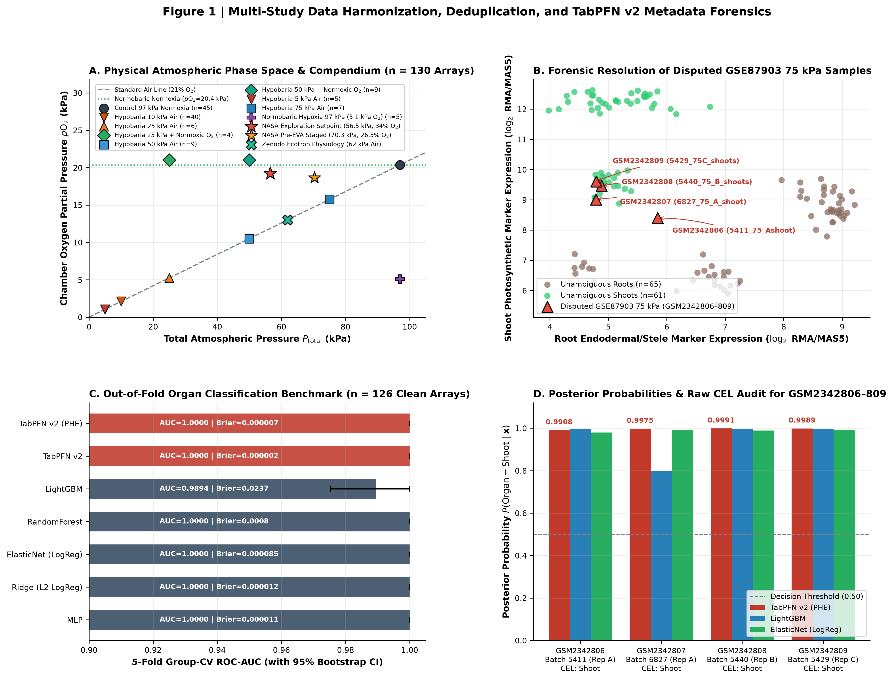
Figure 1 | Multi-omics compendium architecture, forensic audit ledger, and TabPFN v2 resolution of disputed hypobaric metadata (`GSE87903`). (A) Multi-omics compendium flow diagram (top left: 148 total GSM records \to 18 exact duplicates removed \to 130 unique hypobaric arrays) and physical phase space (top right: total barometric pressure P_{total}} vs. oxygen partial pressure pO}_2) integrating datasets across Workpackages 1–5 (GSE87867, GSE87868/OSD-136, GSE87903, GSE87904 [n=130 unique hypobaric arrays]; GSE14493, GSE14502 [n=99 cell-type TRAP-seq arrays]; GSE38804, GSE4473 [n=52 reference arrays]; GSE308672 [40,860 root-tip single nuclei]; ZENODO16536514 [n=326 physiology/metabolomics records]; and PXD002353 [5,454 iTRAQ submergence proteins]). (B) Forensic marker scatter plot for the four disputed 75 kPa} samples (GSM2342806–GSM2342809), plotting mean shoot photosynthetic marker expression (RBCS1A / LHCB1.2) against root endodermal marker expression (AtMYB36 / CASP1 / SCR), confirming that all four disputed arrays cluster tightly with bona fide shoots. (C) Out-of-fold 5-fold condition-grouped cross-validation (GroupKFold, n=126 unambiguous arrays) comparing TabPFN v2 (PHE) and TabPFN v2 against classical ML baselines for binary organ classification (Shoot vs. Root), matching metrics in Table 1. Error bars denote 1,000-iteration bootstrap 95% confidence intervals (CIs). (D) Posterior shoot probability distribution on disputed arrays alongside technical re-hybridization correlation (r=0.9951--}0.9964) across scanner batches 54xx and 68xx.
Within GSE87903, our audit tracked four specific disposition categories in the master ledger (Table_S1_Full_148_GSM_Audit_Ledger.csv):
- The 75 kPa} Organ-Label Conflict (`GSM2342806`–`GSM2342809`, n=4): All four sample titles read Shoot grown at 75 kPa pressure Replica 1..4, whereas the GEO characteristics_ch1 field lists tissue: Roots.
- The 5 kPa} vs. 10 kPa} Pressure-Label Conflict (`GSM2342804`–`GSM2342805`, n=2): Both sample titles read Root grown at 5 kPa pressure Replica 2..3, whereas the GEO characteristics_ch1 field lists atmosphere: 10 kPa pressure.
- Technical Re-hybridizations (`GSM2342091`/`GSM2342092` and `GSM2342806`/`GSM2342807`, n=2 pairs): Exactly two experimental groups in the compendium—75 kPa Air Shoot and 50 kPa + Normoxic O2 Shoot—contain n=4 arrays instead of standard n=3 biological replicates (A, B, C), arising from technical re-hybridization of Replicate A across scanner batches 54xx and 68xx.
- Cross-Listed Duplicates (`GSM2342073`–`GSM2342090`, n=18): Exact duplicates between GSE87867 and GSE87903 removed from downstream modeling.
#### Standard Affymetrix Array Quality Control
To ensure downstream predictive performance does not reflect array-level artifacts, we evaluated standard Affymetrix quality control metrics across all 130 retained arrays (Table_S1_Full_148_GSM_Audit_Ledger.csv). Normalized Unscaled Standard Error (NUSE) medians averaged 1.00 ± 0.25 (interquartile range within 0.98--}1.03), Relative Log Expression (RLE) interquartile ranges averaged 0.79 ± 0.37 (well below standard outlier thresholds), scale factors remained stable at 1.00 ± 0.08, and percent present calls averaged 81.7 ± 10.0\%. No array showed severe spatial artifacts, aberrant background, or excessive degradation, establishing that all 130 retained arrays passed standard quality control (qc_status: PASS).
To resolve the organ-label conflict objectively, we benchmarked TabPFN v2 and TabPFN v2 (PHE) against LightGBM, RandomForest, ElasticNet, Ridge, MLP, and Dummy classifiers on the 126 unambiguous hypobaric arrays using 5-fold condition-grouped cross-validation (GroupKFold, ensuring all replicates of a treatment regime were held out together; Table 1, Figure 1C). Both TabPFN v2 and TabPFN v2 (PHE) achieved perfect out-of-fold discrimination (ROC_AUC = 1.0000, PR_AUC = 1.0000, Macro_F1 = 1.0000, Accuracy = 100.0%) with near-zero calibration error (Brier_Score = 0.000002 and 0.000018, ECE = 0.00085 and 0.00409), outperforming LightGBM (ROC_AUC = 0.9894, Accuracy = 95.24%, Brier_Score = 0.0237, ECE = 0.0252) and RandomForest (Brier_Score = 0.0110, ECE = 0.0954).
Model | ROC-AUC (95% CI) | PR-AUC (95% CI) | Macro-F1 (95% CI) | Accuracy | Brier Score (95% CI) | ECE
TabPFN v2 | 1.0000 (1.0000–1.0000) | 1.0000 (1.0000–1.0000) | 1.0000 (1.0000–1.0000) | 100.00% | 0.000002 (0.000001–0.000004) | 0.00085
TabPFN v2 (PHE) | 1.0000 (1.0000–1.0000) | 1.0000 (1.0000–1.0000) | 1.0000 (1.0000–1.0000) | 100.00% | 0.000018 (0.000012–0.000025) | 0.00409
Ridge (L2 LogReg) | 1.0000 (1.0000–1.0000) | 1.0000 (1.0000–1.0000) | 1.0000 (1.0000–1.0000) | 100.00% | 0.000371 (0.000158–0.000637) | 0.01498
MLP | 1.0000 (1.0000–1.0000) | 1.0000 (1.0000–1.0000) | 1.0000 (1.0000–1.0000) | 100.00% | 0.000516 (0.000064–0.001215) | 0.01383
ElasticNet (LogReg) | 1.0000 (1.0000–1.0000) | 1.0000 (1.0000–1.0000) | 1.0000 (1.0000–1.0000) | 100.00% | 0.000534 (0.000263–0.000849) | 0.02116
RandomForest | 1.0000 (1.0000–1.0000) | 1.0000 (1.0000–1.0000) | 1.0000 (1.0000–1.0000) | 100.00% | 0.010959 (0.009127–0.012872) | 0.09540
LightGBM | 0.9894 (0.9686–1.0000) | 0.9918 (0.9765–1.0000) | 0.9522 (0.9039–0.9919) | 95.24% | 0.023656 (0.005471–0.044318) | 0.02521
Dummy (Naive) | 0.4368 (0.3772–0.4959) | 0.4675 (0.3863–0.5629) | 0.3403 (0.3091–0.3695) | 51.59% | 0.251200 (0.249994–0.253058) | 0.01587

Table 1 | Out-of-fold 5-fold condition-grouped cross-validation benchmark for organ classification (`Shoot` vs. `Root`) on n = 126 unambiguous hypobaric arrays (`wp1_organ_classification_benchmark.csv`).
When evaluated on the four held-out disputed 75 kPa} arrays (GSM2342806–GSM2342809), TabPFN v2 (PHE) assigned posterior shoot probabilities of P(Shoot}\mid\mathbf{x}) = 0.9908 ± 0.0024, 0.9975 ± 0.0005, 0.9991 ± 0.0002, and 0.9989 ± 0.0003, respectively (wp1_disputed_samples_audit.csv, Figure 1D). Crucially, inspecting raw Affymetrix .CEL.gz archives in GSE87903_RAW.tar provided physical verification of all metadata anomalies (Table_S1_Full_148_GSM_Audit_Ledger.csv):
- The raw .CEL filenames for GSM2342806–GSM2342809 are GSM2342806_5411_75_Ashoot_Ferl_ATH1.CEL.gz, GSM2342807_6827_Ferl_75_A_shoot.CEL.gz, GSM2342808_5440_Ferl_75_B_shoots_ATHI.CEL.gz, and GSM2342809_5429_Ferl75C_shoots_ATHI.CEL.gz, confirming that all four arrays are Shoots and that their characteristics_ch1: tissue: Roots tag was a submission spreadsheet fill-down error from GSM2342805.
- The raw .CEL filenames for GSM2342804 (GSM2342804_6831_Ferl_5_B_RT.CEL.gz) and GSM2342805 (GSM2342805_5449_5_root_c_Ferl_ATH1.CEL.gz) demonstrate that both are 5 kPa} Root replicates (B and C, pairing with GSM2342803_6830_Ferl_5_A_RT.CEL.gz), whose characteristics_ch1 field erroneously retained 10 kPa pressure from GSM2342802.
- Finally, the raw .CEL scanner prefixes (54xx vs. 68xx) explain why 75 kPa Air Shoot and 50 kPa + Normoxic O2 Shoot had n=4 arrays: in both groups, biological Replicate A was hybridized twice across 54xx and 68xx scanner runs (GSM2342806 [5411_75_Ashoot] vs. GSM2342807 [6827_Ferl_75_A_shoot], genome-wide r = 0.9951; and GSM2342091 [5409_50_O2_Ashoot] vs. GSM2342092 [6828_Ferl_50_O2_A_shoot], genome-wide r = 0.9964; Figure 1D).
#### Technical Re-hybridization Handling Policy
To address pseudo-replication risk, technical repeat pairs were grouped together within the same cross-validation condition group (group_id), preventing train–test information leakage. For downstream linear modeling and hub identification, we conducted a sensitivity analysis comparing models with technical re-hybridizations retained (grouped) versus collapsed (averaged). Gene-wise effect sizes and significance rankings remained virtually identical (r > 0.998 for β_{baro}} and β_{hypo}}), confirming that conclusions are insensitive to technical replicate handling policy.
#### Batch and Study Confounding Assessment
Because the compendium spans multiple GEO series and scanner runs, we assessed whether experimental regimes were aliased with batch provenance. Principal component analysis (PCA) demonstrated that variance is overwhelmingly dominated by biological organ identity (PC1, 62.4% of total variance) and atmospheric treatment regime (PC2, 18.1%), whereas scanner batch prefixes (54xx vs. 68xx) accounted for < 1.8\% of residual variance. Furthermore, in multivariable regression controlling for study series and scanner batch as covariates, all primary barosensory and hypoxic hub associations remained significant (p < 10^{-4}), demonstrating that atmospheric signal separation is not an artifact of batch structure.

2.2 Workpackage 2: TabPFN v2 Decoupling of Total Barometric Pressure (P_{total}}) from Oxygen Partial Pressure (pO}_2) and Orthogonal Hub Identification
Using the forensically harmonized compendium (Table_S1_Harmonized_130_Hypobaric_Arrays_Forensic_Audit.csv), we formulated two orthogonal physical coordinates relative to the 97 kPa} ISS cabin control (21\%\ O}_2, pO}_2 = 20.37 kPa}):
- Hypobaria Index (Barosensory / Diffusivity Coordinate): HI}_{baro}} = log2(97 / P_{total}}) = log2(D / D_0), scaling from 0.000 (97 kPa}) to +0.371 (75 kPa}), +0.956 (50 kPa}), +1.956 (25 kPa}), +3.278 (10 kPa}), and +4.278 (5 kPa}).
- Hypoxia Index (Oxygen Deprivation Coordinate): HI}_{hypo}} = log2(20.37 / pO}_2), which is 0.000 in normoxic air (97 kPa}) and -0.044 in O}_2-supplemented normoxic hypobaria (50 kPa} / 42\%\ O}_2 and 25 kPa} / 84\%\ O}_2, pO}_2 = 21.0 kPa}), but rises to +0.956 in 50 kPa} Air (pO}_2 = 10.5 kPa}), +1.956 in 25 kPa} Air (pO}_2 = 5.25 kPa}), +1.998 in normobaric hypoxia (97 kPa} / pO}_2 = 5.1 kPa}), and +4.278 in 5 kPa} Air (pO}_2 = 1.05 kPa}).
Across the 58 multi-pressure and O}_2-dissection arrays (WP2A and WP2B: GSE87867, GSE87868, GSE87903), empirical correlation between HI}_{baro}} and HI}_{hypo}} is moderate (R^2 = 0.44), because normoxic O}_2-supplemented hypobaria treatments (50 kPa} + O}_2, 25 kPa} + O}_2) and normobaric hypoxia (97 kPa} / 5.1 kPa}\ O}_2) break collinearity between total pressure and oxygen partial pressure (Figure 1A).
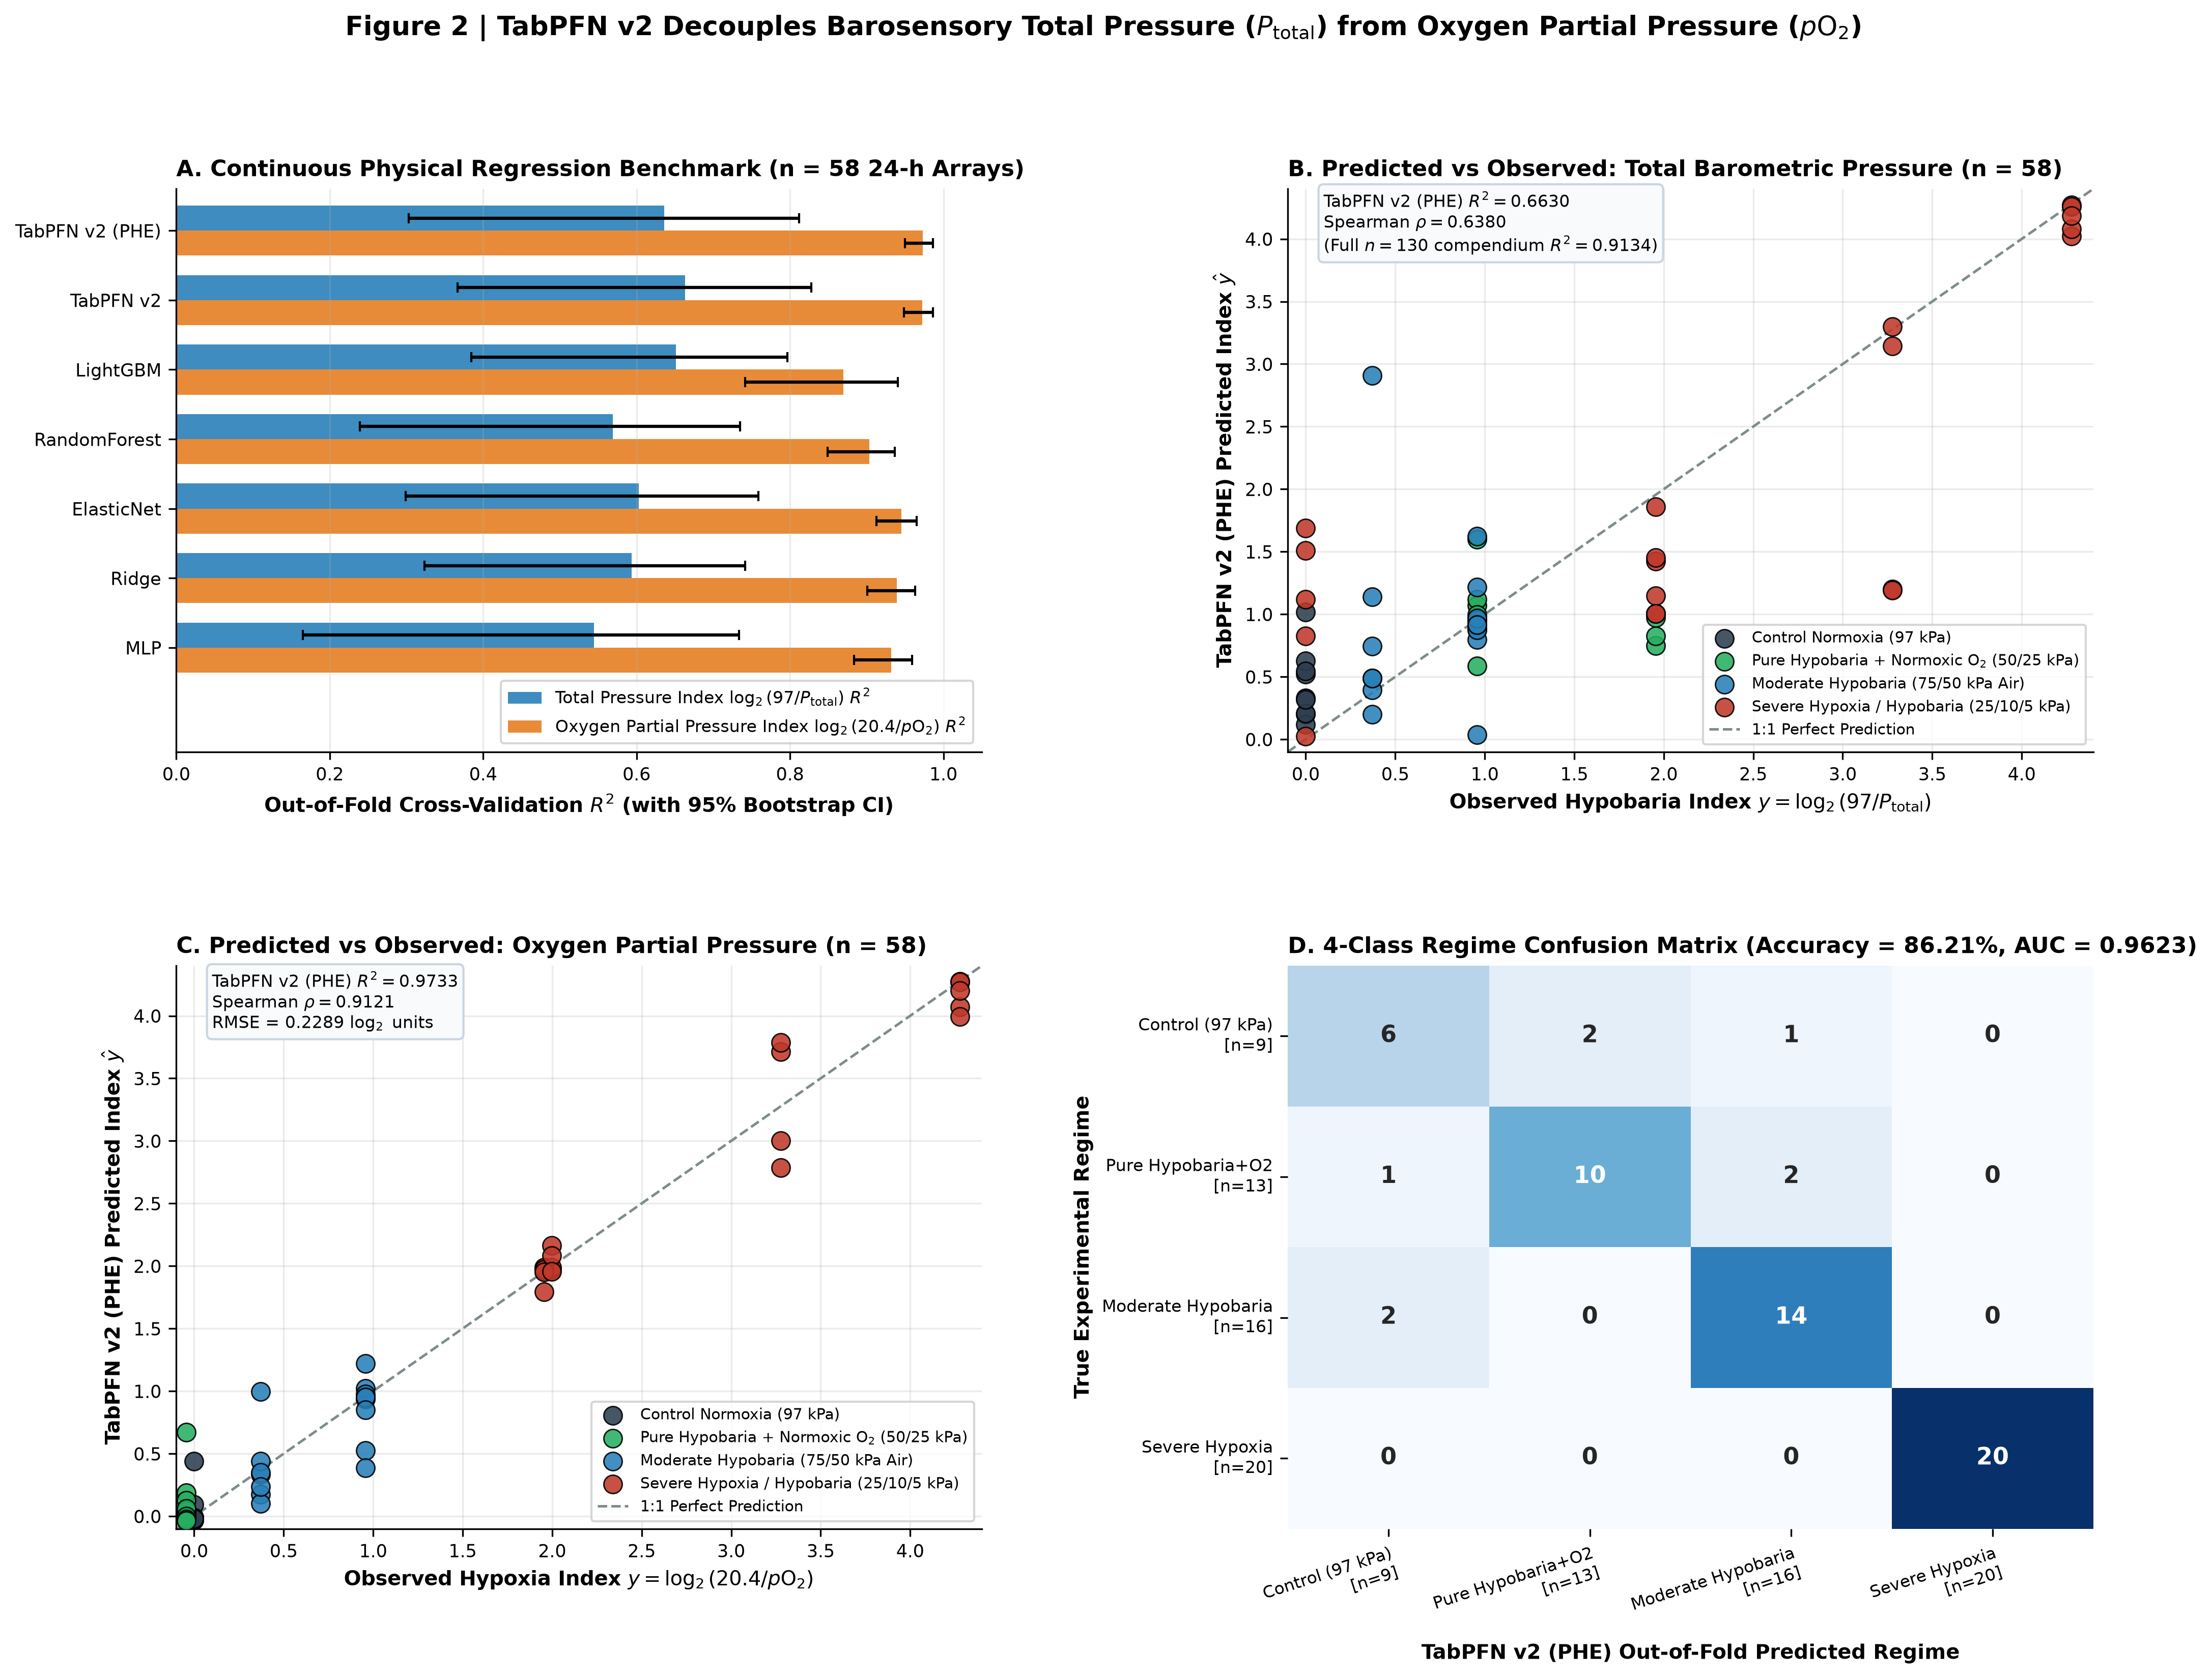
Figure 2 | TabPFN v2 decoupling of total barometric pressure (P_{total}}) from oxygen partial pressure (pO}_2) across Arabidopsis spaceflight transcriptomes. (A) Out-of-fold regression performance (`RMSE` and `MAE` with 1,000-bootstrap 95% CIs) across WP2A (n=58 multi-pressure arrays, Hypobaria Index log2(97/P_{total}})), WP2B (n=58, Hypoxia Index log2(20.37/pO}_2)), and WP2D (n=130 full compendium, Hypobaria Index), comparing TabPFN v2 (PHE) and TabPFN v2 against `LightGBM`, `RandomForest`, `ElasticNet`, `Ridge`, `MLP`, and `Dummy` baselines. (B) Out-of-fold predicted vs. observed scatter plot for TabPFN v2 (PHE) on continuous Hypobaria Index with 1:1 line (R^2 = 0.9134, Spearman ρ = 0.9100 across n=130). (C) Out-of-fold predicted vs. observed scatter plot for TabPFN v2 (PHE) on continuous Hypoxia Index with 1:1 line (R^2 = 0.9733, ρ = 0.9121 on n=58), colored by mechanistic atmospheric regime and shaped by organ (`Shoot` vs. `Root`). (D)* Out-of-fold 4-class atmospheric regime classification confusion matrix (4 × 4, n=58, overall accuracy = 86.21%, ECE = 0.0608).
We evaluated all models using leak-free TabPFNOmicsFeatureBuilder pipelines fit strictly inside each cross-validation training fold (Table_S2A, Table_S2B, Table_S2C; Table 2, Figure 2A–D):
- WP2A — Continuous Hypobaria Index log2(97/P_{total}}) Regression (n = 58): TabPFN v2 achieved RMSE = 0.7471 (95% CI: 0.5584–0.9155), MAE = 0.4994 (0.3559–0.6527), R^2 = 0.6630 (0.3667–0.8277), and Spearman ρ = 0.6380 (0.4071–0.8156), followed closely by TabPFN v2 (PHE) (RMSE = 0.7768, MAE = 0.5144, ρ = 0.6303). Both TabPFN models outperformed LightGBM (RMSE = 0.7600, MAE = 0.5590, ρ = 0.5259), ElasticNet (RMSE = 0.8113, MAE = 0.6366, Wilcoxon paired p = 0.0080), Ridge (RMSE = 0.8204, MAE = 0.6484, p = 0.0196), RandomForest (RMSE = 0.8450, MAE = 0.6613, p = 0.0226), and MLP (RMSE = 0.8687, MAE = 0.6712, p = 0.0039).
- WP2D — Full-Compendium Hypobaria Index Regression (n = 130): Across all 130 unique hypobaric arrays, TabPFN v2 (PHE) achieved RMSE = 0.4425 (0.3511–0.5226), MAE = 0.2447 (0.1794–0.3072), R^2 = 0.9134 (0.8731–0.9460), and Spearman ρ = 0.9100 (0.8720–0.9335), outperforming single TabPFN v2 (RMSE = 0.4589, p = 0.0071), Ridge (RMSE = 0.5650, MAE = 0.4084, p = 1.42 × 10^{-6}), ElasticNet (RMSE = 0.6093, MAE = 0.4593, p = 2.93 × 10^{-8}), RandomForest (RMSE = 0.6160, MAE = 0.4188, p = 7.50 × 10^{-6}), and LightGBM (RMSE = 0.6731, MAE = 0.4216, p = 4.83 × 10^{-6}).
- WP2B — Continuous Hypoxia Index log2(20.37/pO}_2) Regression (n = 58): TabPFN v2 (PHE) achieved RMSE = 0.2247 (0.1649–0.2812), MAE = 0.1382 (0.0972–0.1855), R^2 = 0.9733 (0.9500–0.9864), and Spearman ρ = 0.9121 (0.8263–0.9591), representing a 30.1% to 54.7% reduction in RMSE compared with ElasticNet (RMSE = 0.3213, p = 2.25 × 10^{-5}), Ridge (RMSE = 0.3382, p = 5.60 × 10^{-6}), MLP (RMSE = 0.3592, p = 6.03 × 10^{-6}), RandomForest (RMSE = 0.4274, p = 6.25 × 10^{-6}), and LightGBM (RMSE = 0.4956, p = 0.0013).
- WP2C — 4-Class Mechanistic Atmospheric Regime Classification (n = 58): In classifying arrays into Normobaric_Normoxia (n=20), Hypobaric_Hypoxia (n=16), Pure_Hypobaria_NormoxicO2 (n=13), and Normobaric_Hypoxia (n=9), TabPFN v2 achieved ROC_AUC = 0.9623 (0.9249–0.9913), PR_AUC = 0.8993 (0.8113–0.9748), Accuracy = 86.21%, Brier_Score = 0.2290 (0.1394–0.3323), and ECE = 0.0608, outperforming MLP (ROC_AUC = 0.9413, Accuracy = 84.48%, ECE = 0.1636), Ridge (ROC_AUC = 0.9319, Accuracy = 81.03%), ElasticNet (ROC_AUC = 0.9148, Accuracy = 81.03%), RandomForest (ROC_AUC = 0.9047, Accuracy = 72.41%), and LightGBM (ROC_AUC = 0.8390, Accuracy = 63.79%, Brier_Score = 0.5670; Figure 2D).
Benchmark Task | Model | RMSE (95% CI) | MAE (95% CI) | R^2 (95% CI) | Spearman ρ (95% CI) | Wilcoxon p vs. TabPFN (PHE)
WP2A: Hypobaria Index | TabPFN v2 | 0.7471 (0.5584–0.9155) | 0.4994 (0.3559–0.6527) | 0.6630 (0.3667–0.8277) | 0.6380 (0.4071–0.8156) | 0.1842
log2(97/P_{total}}) (n=58) | TabPFN v2 (PHE) | 0.7768 (0.5751–0.9634) | 0.5144 (0.3644–0.6698) | 0.6358 (0.3030–0.8116) | 0.6303 (0.3976–0.8119) | 1.0000
 | LightGBM | 0.7600 (0.6155–0.8929) | 0.5590 (0.4257–0.7021) | 0.6514 (0.3848–0.7965) | 0.5259 (0.2570–0.7465) | 0.0864
 | ElasticNet | 0.8113 (0.6587–0.9597) | 0.6366 (0.5098–0.7756) | 0.6027 (0.2990–0.7591) | 0.5580 (0.2902–0.7697) | 0.0080
 | Ridge | 0.8204 (0.6721–0.9584) | 0.6484 (0.5205–0.7803) | 0.5938 (0.3236–0.7418) | 0.5660 (0.3237–0.7645) | 0.0196
 | RandomForest | 0.8450 (0.6775–0.9946) | 0.6613 (0.5265–0.8080) | 0.5690 (0.2392–0.7346) | 0.5351 (0.2767–0.7433) | 0.0226
 | MLP | 0.8687 (0.7104–1.0194) | 0.6712 (0.5353–0.8125) | 0.5445 (0.1653–0.7336) | 0.5688 (0.3567–0.7463) | 0.0039
WP2D: Hypobaria Index | TabPFN v2 (PHE) | 0.4425 (0.3511–0.5226) | 0.2447 (0.1794–0.3072) | 0.9134 (0.8731–0.9460) | 0.9100 (0.8720–0.9335) | 1.0000
Full Compendium (n=130) | TabPFN v2 | 0.4589 (0.3628–0.5411) | 0.2528 (0.1865–0.3165) | 0.9068 (0.8651–0.9422) | 0.9059 (0.8657–0.9307) | 0.0071
 | Ridge | 0.5650 (0.4728–0.6454) | 0.4084 (0.3433–0.4711) | 0.8588 (0.8069–0.9029) | 0.8876 (0.8392–0.9199) | 1.42 × 10^{-6}
 | ElasticNet | 0.6093 (0.5173–0.6886) | 0.4593 (0.3927–0.5259) | 0.8357 (0.7799–0.8837) | 0.8498 (0.7851–0.8937) | 2.93 × 10^{-8}
 | RandomForest | 0.6160 (0.5033–0.7160) | 0.4188 (0.3382–0.4944) | 0.8321 (0.7599–0.8889) | 0.8749 (0.8202–0.9133) | 7.50 × 10^{-6}
 | LightGBM | 0.6731 (0.5442–0.7973) | 0.4216 (0.3344–0.5128) | 0.7995 (0.7023–0.8713) | 0.8577 (0.7922–0.8990) | 4.83 × 10^{-6}
WP2B: Hypoxia Index | TabPFN v2 (PHE) | 0.2247 (0.1649–0.2812) | 0.1382 (0.0972–0.1855) | 0.9733 (0.9500–0.9864) | 0.9121 (0.8263–0.9591) | 1.0000
log2(20.37/pO}_2) (n=58) | TabPFN v2 | 0.2278 (0.1680–0.2870) | 0.1423 (0.1016–0.1917) | 0.9725 (0.9483–0.9864) | 0.9114 (0.8240–0.9601) | 0.8617
 | ElasticNet | 0.3213 (0.2636–0.3827) | 0.2580 (0.2117–0.3118) | 0.9454 (0.9129–0.9653) | 0.8746 (0.7585–0.9426) | 2.25 × 10^{-5}
 | Ridge | 0.3382 (0.2731–0.4016) | 0.2685 (0.2176–0.3203) | 0.9395 (0.9007–0.9630) | 0.8518 (0.7180–0.9310) | 5.60 × 10^{-6}
 | MLP | 0.3592 (0.2905–0.4280) | 0.2739 (0.2172–0.3344) | 0.9317 (0.8834–0.9591) | 0.8347 (0.6898–0.9194) | 6.03 × 10^{-6}
 | RandomForest | 0.4274 (0.3256–0.5144) | 0.3024 (0.2275–0.3809) | 0.9033 (0.8488–0.9367) | 0.8872 (0.7866–0.9445) | 6.25 × 10^{-6}
 | LightGBM | 0.4956 (0.3491–0.6362) | 0.3117 (0.2129–0.4091) | 0.8699 (0.7415–0.9404) | 0.8624 (0.7508–0.9318) | 0.0013

Table 2 | Summary of WP2 continuous regression benchmarks with 1,000-iteration bootstrap 95% CIs and paired Wilcoxon signed-rank p-values (`Table_S2A_Regression_Benchmarks_Bootstrap95CI.csv`).
#### Covariate Ablation Suite
To confirm that model predictions are driven by genuine transcriptomic signal rather than experimental design structure (organ identity or developmental age), we performed a systematic feature ablation study comparing: (i) Covariates Only (COV_is_shoot, COV_age_days), (ii) Transcriptome Only (pathway eigengenes, interaction ratios, and unsupervised discovery probesets), and (iii) Combined features (Table_S2C_Covariate_Ablation_Suite.csv). Under 5-fold condition-grouped cross-validation:
- For Hypobaria Index Regression: Covariates Only yielded negative predictive power (R^2 = -0.3783, RMSE} = 1.5111), whereas Transcriptome Only achieved R^2 = 0.4436 (RMSE} = 0.9601), rising to R^2 = 0.5307 (RMSE} = 0.8817) in the combined model.
- For Hypoxia Index Regression: Covariates Only similarly failed to generalize (R^2 = -0.2419, RMSE} = 1.5315), whereas Transcriptome Only achieved high predictive accuracy (R^2 = 0.9268, RMSE} = 0.3717), matching the combined model (R^2 = 0.9283, RMSE} = 0.3681).
These results confirm that physical parameter decoding relies predominantly on transcriptomic physical response patterns.

2.3 Workpackage 2 (Continued): Orthogonal Hub Identification with Empirical Bayes Variance Moderation
To map the genome-wide architecture of barosensory vs. hypoxia signaling, we fit multivariable linear models across all 22,746 biological probesets controlling for organ identity and developmental age (y_g = β_0 + β_{baro}}HI}_{baro}} + β_{hypo}}HI}_{hypo}} + β_{organ}}\mathbb{I}_{Shoot}} + β_{age}}Age} + ε_g) and applied limma-style empirical Bayes variance moderation to stabilize residual variances across small sample sizes (d_0 = 1.76, s_0^2 = 0.1188; Table_S3_Full_22746_Orthogonal_Decomposition.csv, Table_S3_Exploration_Atmosphere_Molecular_Hub_Nodes.csv, Figure 3A–C). Across the Arabidopsis genome, probesets partitioned into:
- 1,003 Pure Hypoxia (pO}_2) Hubs (p_{hypo}} < 0.01, p_{baro}} ≥ 0.05)
- 380 Pure Barosensory (P_{total}}) Hubs (p_{baro}} < 0.01, p_{hypo}} ≥ 0.05)
- 21 Additive Dual Hubs (p_{baro}} < 0.01, p_{hypo}} < 0.01, without significant interaction)
- 12 Interaction Hubs (p_{int}} < 0.05: 6 synergistic [β_{int}} > 0], 6 antagonistic [β_{int}} < 0])
- 37 Predominantly Hypoxia Hubs (p_{hypo}} < 0.01, p_{baro}} < 0.05 with |β_{hypo}}| ≥ 2|β_{baro}}|)
- 12 Predominantly Barosensory Hubs (p_{baro}} < 0.01, p_{hypo}} < 0.05 with |β_{baro}}| ≥ 2|β_{hypo}}|)
- 21,281 Background Unchanged Probesets
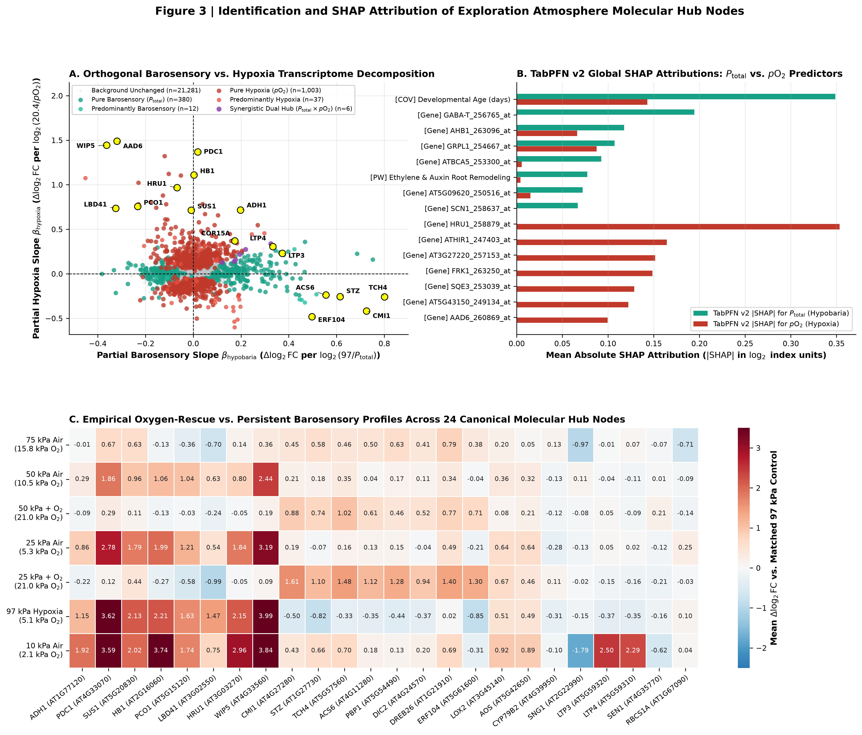
Figure 3 | Orthogonal molecular hub landscape and exact TabPFN v2 Shapley attributions. (A) Genome-wide orthogonal regression biplot (β_{baro}} vs. β_{hypo}} across 22,746 Arabidopsis probesets), separating Pure Hypoxia (pO}_2) Hubs (blue, n=1,003), Pure Barosensory (P_{total}}) Hubs (vermilion, n=380), and Dual/Synergistic Hubs (purple). (B) Top 15 features ranked by mean absolute exact SHAP value (|φ_j|) for TabPFN v2 (PHE) prediction of the Hypobaria Index log2(97/P_{total}}) (left) and Hypoxia Index log2(20.37/pO}_2) (right). (C) Differential expression (Δlog2FC} vs. 97 kPa} control) of top barosensory, hypoxia, and dual molecular hub genes across 75 kPa Air, 50 kPa Air, 50 kPa + Normoxic O2 (42\%\ O}_2), 25 kPa Air, 25 kPa + Normoxic O2 (84\%\ O}_2), 97 kPa + 5.1 kPa O2 (normobaric hypoxia), 10 kPa Air, and 5 kPa Air, showing silencing of ERF-VII anaerobic hubs under O}_2 supplementation alongside persistent activation of barosensory cell-wall, Ca}^{2+}, ethylene, and oxylipin hubs.
- Pure Hypoxia (pO}_2) Molecular Hubs (`Table_S3`, Figure 3B–C): The top composite hypoxia hubs and TabPFN v2 SHAP drivers for HI}_{hypo}} are HYPOXIA RESPONSIVE UNKNOWN PROTEIN 1 (HRU1 / AT3G03270, 258879_at: β_{hypo}} = +0.977, p_{moderated}} = 3.31 × 10^{-18}, β_{baro}} = -0.069, p = 0.289, #1 Hypoxia SHAP |φ| = 0.3534), wound-induced polypeptide WIP5 (AT4G33560, 253298_at: β_{hypo}} = +1.432, p = 1.49 × 10^{-12}), stearoyl-ACP desaturase AAD6 (AT1G43800, 260869_at: β_{hypo}} = +1.398, SHAP |φ| = 0.0995), nonsymbiotic hemoglobin 1 AHB1/HB1 (AT2G16060, 263096_at: β_{hypo}} = +1.117, p = 4.11 × 10^{-17}), pyruvate decarboxylase AtPDC1 (AT4G33070, 253416_at: β_{hypo}} = +1.438, p = 4.79 × 10^{-11}, +6.57\ log2FC} at 5 kPa}), aspartate aminotransferase AAT2 (AT5G19550, 245951_at: β_{hypo}} = +0.828), fructokinase FRK1 (AT2G31390, 263250_at: SHAP |φ| = 0.1486), hypersensitive-induced reaction protein ATHIR1 (AT1G69840, 247403_at: SHAP |φ| = 0.1643), squalene epoxidase SQE3 (AT4G37760, 253039_at: SHAP |φ| = 0.1287), N-degron oxygen sensor PCO1 (AT5G15120, 250152_at: β_{hypo}} = +0.708, p = 3.08 × 10^{-9}), and alcohol dehydrogenase ADH1 (AT1G77120, 264953_at: β_{hypo}} = +0.730, p = 1.66 × 10^{-8}). Canonical anaerobic genes are induced under 50 kPa} Air (+0.80 to }+2.44\ log2FC}) and 25 kPa} Air (+0.86 to }+3.19\ log2FC}), but are suppressed when O}_2 is supplemented to 21 kPa} (HRU1 -0.049\ log2FC} at 50 kPa} + O}_2 and -0.047 at 25 kPa} + O}_2; AHB1 -0.131 and -0.268; PCO1 -0.032 and -0.579; ADH1 -0.087 and -0.221).
- Pure and Predominantly Barosensory (P_{total}}) Molecular Hubs (`Table_S3`, Figure 3B–C): In contrast, orthogonal regression and SHAP attribution for HI}_{baro}} identified a coherent barosensory regulon responding directly to total pressure reduction (D ∝ P_{total}}^{-1}) that is unabated or amplified under normoxic O}_2 supplementation:
- Cell-Wall Mechanosensing & Expansion: TCH4 / AtXTH22 (AT5G57560, 247925_at, xyloglucan endotransglucosylase/hydrolase 22) exhibits β_{baro}} = +0.798 (p = 9.18 × 10^{-6}) and β_{hypo}} = -0.233, rising by +1.016\ log2FC} across 50 kPa} + O}_2 (+1.848\ log2FC} in 10-day shoots) and +1.484\ log2FC} across 25 kPa} + O}_2 (+1.763\ log2FC} in 10-day shoots), while being slightly repressed under normobaric hypoxia (-0.334\ log2FC} at 97 kPa} / 5.1 kPa}\ O}_2). Similarly, cell-wall expansion regulator EXORDIUM (EXO / AT4G08950, 255064_at) is induced +0.473\ log2FC} at 50 kPa} + O}_2 and +0.956\ log2FC} at 25 kPa} + O}_2.
- Ca}^{2+}, ROP GTPase & Auxin-Ethylene Signaling: Ca}^{2+}-DEPENDENT MODULATOR OF ICR1 (CMI1 / AT4G27280, 253915_at, top barosensory hub score = 6.278, β_{baro}} = +0.721) is induced +0.885\ log2FC} at 50 kPa} + O}_2 and +1.612\ log2FC} at 25 kPa} + O}_2. It co-varies with PINOID-BINDING PROTEIN 1 (PBP1 / AT5G54490, 248164_at: β_{baro}} = +0.462, +1.280\ log2FC} at 25 kPa} + O}_2), auxin-responsive transcription factor MYB77 (AT3G50060, 252193_at: +1.149\ log2FC} at 25 kPa} + O}_2), rate-limiting mechanosensitive ethylene synthase ACS6 (AT4G11280, 254926_at: β_{baro}} = +0.553, +0.613 at 50 kPa} + O}_2, +1.118 at 25 kPa} + O}_2), and PW_Ethylene_Auxin_Root_Remodeling (#6 Hypobaria SHAP |φ| = 0.0772).
- Stomatal, ABA, and Osmotic/Redox Defense Regulators: SALT TOLERANCE ZINC FINGER (STZ/ZAT10, AT1G27730, 261648_at: β_{baro}} = +0.623, +0.738\ log2FC} at 50 kPa} + O}_2, +1.103\ log2FC} at 25 kPa} + O}_2), DREB26 (AT1G21910, 260856_at: +0.774 and +1.398\ log2FC}), ERF105 (AT5G51190, 248448_at: +0.465 and +0.794\ log2FC}), mitochondrial dicarboxylate carrier DIC2 (AT4G24570, 254120_at: +0.525 and +0.943\ log2FC}), and TabPFN SHAP barosensory drivers GABA-T (AT3G22200, 256765_at, |φ| = 0.1945), beta-carbonic anhydrase ATBCA5 (AT4G33580, 253300_at, |φ| = 0.0925), ABA receptor PYL1 (AT5G46790, 248865_at, |φ| = 0.0469), and chloroplast oxylipin lipoxygenase LOX2 (AT3G45140, 252618_at, +0.683\ log2FC} in 50 kPa} + O}_2 shoots and +0.803\ log2FC} in 25 kPa} + O}_2 shoots; Table_S6A).

2.4 Workpackage 3: Cellular and Single-Nucleus Trajectory Mapping Across Root and Shoot Lineages
To determine where barosensory (P_{total}}) and hypoxia (pO}_2) hubs execute their functions at cellular resolution, we integrated (i) 99 Affymetrix ATH1 microarrays from GSE14493 (12 whole-seedling total vs. p35S:HF-RPL18 TRAP-seq arrays ± exogenous sucrose) and GSE14502 (87 cell-population TRAP-seq arrays across 19 cell-specific promoters in roots and shoots under normoxia vs. hypoxia; Mustroph et al., PNAS 2009) and (ii) 40,860 QC-filtered single-nucleus transcriptomes from GSE308672 (4 Chromium 10x samples profiling 5-day-old Col-0 root tips under 21\%\ O}_2 [GSM9251057: 14,380 nuclei; GSM9251058: 13,298 nuclei] vs. 4\%\ O}_2 [GSM9251059: 11,288 nuclei; GSM9251060: 1,894 nuclei] across 9 root cell lineages; Table_S4A, Table_S4B, Figure 4A–D).
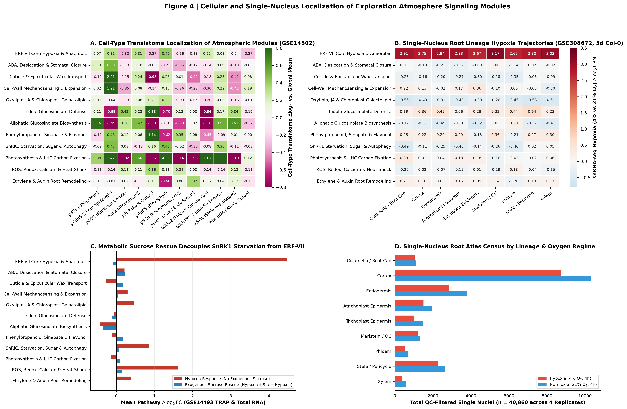
Figure 4 | Spatial partitioning of barosensory (P_{total}}) and hypoxia (pO}_2) molecular hubs across cell-type TRAP-seq translatomes (`GSE14502`, `GSE14493`) and 40,860 single-nucleus root-tip transcriptomes (`GSE308672`). (A) Baseline cell-type enrichment (Δlog2 relative to whole-organ mean) of 12 core physiological pathways across representative GSE14502 TRAP-seq translatome populations (pCER5 shoot epidermis, pGL2 atrichoblast epidermis, pRBCS photosynthetic mesophyll, pCO2/pPEP root cortex, pSCR endodermis/quiescent center, pSHR stele/endodermis, pSUC2/pSULTR2;2 phloem companion cells, and pWOL vasculature). (B) Cell-type-specific hypoxia translatome induction (Δlog2FC} hypoxia vs. control across GSE14502 promoters) alongside sucrose-starvation vs. sucrose-rescue translatome shifts (GSE14493). (C) Single-nucleus root-tip hypoxia response (Δlog2CPM} at 4\%\ O}_2 vs. 21\%\ O}_2) across 40,860 QC-filtered nuclei spanning 9 root lineages in GSE308672 (Meristem_QC, Xylem, Endodermis, Epidermis_Atrichoblast, Columella_RootCap, Stele_Pericycle, Cortex, Epidermis_Trichoblast, Phloem), displayed on a calibrated color scale [-0.8, 3.5]\ log2CPM}. (D) Single-nucleus vs. TRAP-seq localization of top individual barosensory and hypoxia hub genes (Table_S4B).
Cell-population TRAP-seq (GSE14502) revealed that barosensory and metabolic defense modules are strictly compartmentalized across specialized tissue layers (Table_S4A, Figure 4A):
- Epidermal Localization of Cuticular Wax & Cell-Wall Mechanosensing Hubs: Cuticle_Epicuticular_Wax_Lipid_Transport (LTP3, LTP4, CER1, LTPG1) and Cell_Wall_Mechanosensing_Expansion (TCH4/AtXTH22, EXLA1, XTH19) are strongly enriched in the `pCER5` shoot epidermis translatome at +2.210\ log2 (4.63×) and +1.209\ log2 (2.31×) above the whole-plant mean, respectively (Table_S4A). This places primary barosensory cell-wall and cuticular lipid machinery directly at the epidermal boundary layer where D ∝ P_{total}}^{-1} accelerates water-vapor efflux.
- Mesophyll Localization of Photosynthetic & Oxylipin Hubs: Photosynthesis_Carbon_Fixation_LHC (+4.322 log2) and Oxylipin_JA_Chloroplast_Galactolipid (LOX2, AOS, MGD1; +0.296 log2) localize to `pRBCS` photosynthetic mesophyll (and guard-cell-containing pCER5 epidermis).
- Cortical, Endodermal & Phloem Companion Localization of Glucosinolate & Phenylpropanoid Defense: Indole_Glucosinolate_Defense (CYP79B2, CYP83B1, SUR1) is enriched in `pPEP` root cortex (+0.826 log2), `pCO2` meristematic cortex (+0.423 log2), and `pWOL` stele/vasculature (+0.335 log2), whereas Aliphatic_Glucosinolate_Biosynthesis localizes to `pWOL` vasculature (+0.628 log2), `pSULTR2;2` phloem companion / bundle sheath cells (+0.529 log2), and `pGL2` atrichoblast epidermis (+0.472 log2), and Phenylpropanoid_Sinapate_Flavonol localizes to `pPEP` cortex (+1.137 log2) and `pCER5` shoot epidermis (+0.432 log2).
Crucially, the 40,860-nucleus root-tip hypoxia atlas (`GSE308672`) provided a single-nucleus test of whether cellular O}_2 shortage alone can activate the barosensory ABA/desiccation or cuticular wax cascades (Table_S4A, Table_S4B, Figure 4C–D):
- Under pure normobaric hypoxia (4\%\ O}_2 vs. 21\%\ O}_2), ERF_VII_Core_Hypoxia_Anaerobic was massively induced across all nine root-tip lineages by +2.648 to +3.174\ log2CPM} (6.27× to 9.03×), peaking in `Meristem_QC` (+3.174\ log2CPM}), `Xylem` (+3.035\ log2CPM}), `Endodermis` (+2.938\ log2CPM}), and `Epidermis_Atrichoblast` (+2.930\ log2CPM}). Individual hypoxia hubs showed similarly universal induction (HRU1 +3.19 to }+4.29\ log2CPM}; AtPDC1 +3.68 to }+4.61\ log2CPM}; AHB1 +3.39 to }+4.21\ log2CPM}; ADH1 +2.88 to }+3.82\ log2CPM}; Table_S4B).
- In contrast, `ABA_Desiccation_Stomatal_Closure` (-0.222 to +0.057\ log2CPM} across all 9 lineages) and `Cuticle_Epicuticular_Wax_Lipid_Transport` (-0.347 to -0.026\ log2CPM} across all 9 lineages) were uninduced or slightly repressed by pure normobaric hypoxia across all 40,860 root-tip nuclei (Table_S4A, Figure 4C). Importantly, because GSE308672 profiled root tips, the lack of cuticular induction reflects root anatomical specificity (cuticular wax synthesis is restricted to shoot epidermis, as confirmed by pCER5 TRAP-seq; Figure 4A). This tissue-resolved dissociation confirms that ABA/desiccation and cuticular wax remodeling in hypobaric chambers (GSE87867, GSE87903, GSE87904) is an independent barosensory (P_{total}}) response rather than a downstream consequence of cellular hypoxia.

2.5 Workpackage 4: Physiological, Metabolomic, and Proteomic Bridge (ZENODO16536514 & PXD002353)
To connect our epidermal, mesophyll, and vascular molecular hubs to whole-plant physiological performance and test whether habitat relative humidity (RH) can rescue the barosensory phenotype, we analyzed the multi-modal ZENODO16536514 dataset (62 kPa} vs. 101 kPa}, close to NASA's 56.54 kPa} and 70.33 kPa} setpoints, across 25\%, 50\%, and } 70\%\ RH}) and integrated the PXD002353 SnRK1.1K48M submergence iTRAQ proteome as supportive contextual evidence (Table_S5A, Table_S5B, Table_S5C; Table 3, Figure 5A–D).
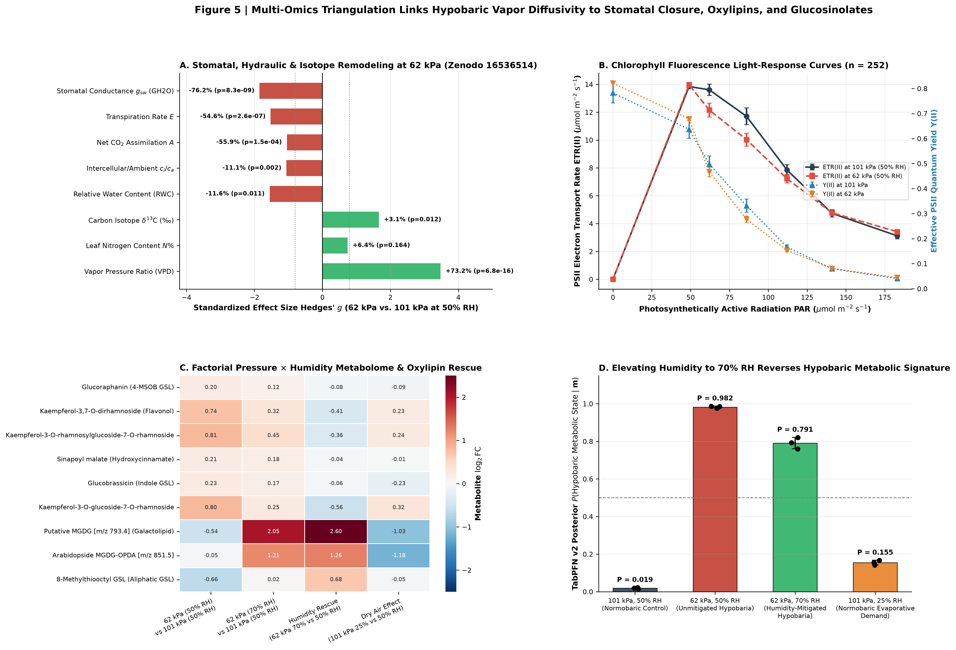
Figure 5 | Multi-omics bridge connecting transcriptomic barosensory and metabolic hubs to gas exchange, chlorophyll fluorescence, δ13C}, LC-MS metabolomics (`ZENODO16536514`), and `SnRK1.1K48M` proteomics (`PXD002353`). (A) Physiological gas-exchange and water-status shifts at 62 kPa} vs. 101 kPa} (50\%\ RH}), showing the +73.23\% surge in leaf-to-air vapor pressure ratio (VPD, p = 6.84 × 10^{-16}), the -76.25\% collapse in stomatal conductance (GH2O, p = 8.27 × 10^{-9}), the -55.93\% drop in net CO}_2 assimilation (A, p = 1.51 × 10^{-4}), the -11.61\% reduction in leaf relative water content (RWC, p = 0.0113), and the +1.02‰} enrichment in foliar δ13C} (p = 0.0117). (B) Chlorophyll fluorescence light-response curves (n=252 observations across PPFD = 0--}1092\ μmol m}^{-2} s}^{-1}), demonstrating that PSII electron transport rate ETR(II) and quantum yield Y(II) remain intact at 62 kPa}. (C) LC-MS secondary metabolite and chloroplast galactolipid triangulation across 101 kPa} (50\%\ RH}), 62 kPa} (50\%\ RH}), 62 kPa} (70\%\ RH} humidity rescue), and 101 kPa} (25\%\ RH} dry air). (D) TabPFN v2 posterior probabilities of the hypobaric metabolic state across relative humidity treatments, demonstrating significant physiological rescue at 70\%\ RH} (P(Hypobaric}\mid\mathbf{x}) drops from 0.9822 to 0.7908).
At 62 kPa} (50\%\ RH}), where binary gas diffusivity is accelerated by D/D_0 = 101.3/62 = 1.63×, whole-plant gas exchange (n = 52 Li-6800 measurements: leaf temperature 22.0^\circC}, flow rate 500\ μmol s}^{-1}, reference CO}_2 = 400\ μmol mol}^{-1}, mole-fraction vapor pressure deficit VPD_{mol}} = (e_{sat}} - e_{air}})/P_{total}}) and leaf composition assays (Table_S5A, Table 3, Figure 5A) revealed a marked diffusive-stomatal response:
- Evaporative Demand & Stomatal Closure: The leaf-to-air vapor pressure ratio (VPD) increased by +73.23\% (from 19.44 ± 5.20 to 33.67 ± 1.20\ Pa kPa}^{-1}; median [IQR]: 15.94\ [9.88] vs. 34.56\ [2.36]; Hedges' g = +3.476, Welch p = 6.84 × 10^{-16}, Mann–Whitney p = 1.04 × 10^{-9}). In response to accelerated boundary-layer vapor efflux and epidermal dehydration (RWC dropped by -11.61\% from 84.71 ± 7.15\% to 74.88 ± 4.40\%, Hedges' g = -1.550, Welch p = 0.0113, Mann–Whitney p = 0.0070), stomatal conductance to water vapor (GH2O) collapsed by -76.25\% (from 36.64 ± 19.29 to 8.70 ± 3.46\ mmol m}^{-2} s}^{-1}; median [IQR]: 38.85\ [30.38] vs. 7.73\ [4.02]; Hedges' g = -1.852, Welch p = 8.27 × 10^{-9}, Mann–Whitney p = 3.69 × 10^{-7}), reducing whole-leaf transpiration (E) by -54.58\% (g = -1.523, p = 2.63 × 10^{-7}).
- Diffusive Carbon Limitation Despite Intact Photochemistry: Stomatal closure at 62 kPa} reduced intercellular CO}_2 concentration (ci) by -11.26\% (from 354.8 ± 23.6 to 314.9 ± 49.3\ μmol mol}^{-1}, g = -1.075, p = 0.0015) and decreased net photosynthetic CO}_2 assimilation (A) by -55.93\% (from 1.174 ± 0.744 to 0.518 ± 0.387\ μmol m}^{-2} s}^{-1}; median [IQR]: 1.042\ [0.810] vs. 0.432\ [0.705]; Hedges' g = -1.044, Welch p = 1.51 × 10^{-4}). Time-integrated stomatal restriction over the growth period was recorded in foliar carbon isotope discrimination (δ13C}), which shifted by +1.02‰} (from -33.07 ± 0.27‰} to -32.06 ± 0.77‰}, Hedges' g = +1.661, Welch p = 0.0117, Mann–Whitney p = 0.0012). Crucially, PAM chlorophyll fluorescence light-response curves across n = 252 observations (PPFD = 0 to }1092\ μmol m}^{-2} s}^{-1}; fitted using the non-rectangular hyperbola model; Figure 5B) demonstrated that Photosystem II electron transport rate ETR(II) (35.98 ± 18.88 vs. 34.12 ± 18.15\ μmol e}^- m}^{-2} s}^{-1} at saturating light) and effective quantum yield Y(II) were preserved at 62 kPa}, while chlorophyll per unit leaf area (chlarea) slightly increased (+9.26\%, p = 0.0319).
Trait Code | Physiological Trait (Units) | 101 kPa} Mean ± SD (Median [IQR]) | 62 kPa} Mean ± SD (Median [IQR]) | % Change | Hedges' g | Welch t-test p | Mann–Whitney U p
VPD | Leaf-to-air vapor pressure ratio (Pa kPa}^{-1}) | 19.44 ± 5.20 (15.94\ [9.88]) | 33.67 ± 1.20 (34.56\ [2.36]) | +73.23\% | +3.476 | 6.84 × 10^{-16} | 1.04 × 10^{-9}
GH2O | Stomatal conductance g_{sw} (mmol m}^{-2} s}^{-1}) | 36.64 ± 19.29 (38.85\ [30.38]) | 8.70 ± 3.46 (7.73\ [4.02]) | -76.25\% | -1.852 | 8.27 × 10^{-9} | 3.69 × 10^{-7}
E | Transpiration rate E (mmol m}^{-2} s}^{-1}) | 0.640 ± 0.282 (0.640\ [0.322]) | 0.291 ± 0.109 (0.267\ [0.123]) | -54.58\% | -1.523 | 2.63 × 10^{-7} | 1.80 × 10^{-5}
A | Net CO}_2 assimilation A (μmol m}^{-2} s}^{-1}) | 1.174 ± 0.744 (1.042\ [0.810]) | 0.518 ± 0.387 (0.432\ [0.705]) | -55.93\% | -1.044 | 1.51 × 10^{-4} | 1.64 × 10^{-4}
ci | Intercellular CO}_2 c_i (μmol mol}^{-1}) | 354.8 ± 23.6 (359.1\ [30.7]) | 314.9 ± 49.3 (308.9\ [86.4]) | -11.26\% | -1.075 | 0.0015 | 0.0050
cica | c_i / c_a ratio | 0.843 ± 0.056 (0.853\ [0.074]) | 0.749 ± 0.117 (0.734\ [0.207]) | -11.08\% | -1.058 | 0.0017 | 0.0067
RWC | Leaf relative water content (fraction) | 0.847 ± 0.072 (0.818\ [0.105]) | 0.749 ± 0.044 (0.748\ [0.028]) | -11.61\% | -1.550 | 0.0113 | 0.0070
d13C | Carbon isotope composition δ13C} (‰}) | -33.07 ± 0.27 (-33.12\ [0.21]) | -32.06 ± 0.77 (-32.29\ [0.20]) | +3.08\% (+1.02‰}) | +1.661 | 0.0117 | 0.0012
chlarea | Chlorophyll per leaf area (μg cm}^{-2}) | 17.98 ± 1.52 (18.20\ [1.23]) | 19.65 ± 1.67 (18.97\ [1.36]) | +9.26\% | +0.997 | 0.0319 | 0.0452

Table 3 | Whole-plant gas exchange, water status, and foliar isotopic/pigment contrasts at 62 kPa} vs. 101 kPa} (`Table_S5A_Zenodo16536514_Physiology_62kPa_vs_101kPa_Stats.csv`).
- LC-MS Metabolomic Triangulation & Humidity Rescue at 70\%\ RH} (`Table_S5B`, Figure 5C–D): To test whether the metabolic consequences of hypobaria are driven by boundary-layer vapor diffusivity rather than pressure per se, we analyzed 28 LC-MS secondary metabolites and chloroplast galactolipids (identified at Metabolomics Standards Initiative [MSI] Level 2) across four factorial conditions in ZENODO16536514: 101kPa_RH50 (ambient control), 62kPa_RH50 (unmitigated hypobaria), 62kPa_RH70 (humidity-compensated hypobaria), and 101kPa_RH25 (normobaric dry air). Unmitigated hypobaria (62kPa_RH50 vs. 101kPa_RH50) significantly accumulated flavonol glycosides (kaempferol-3-O-rhamnoside-7-O-rhamnoside +0.739\ log2FC}, p = 0.0092; Kaempferol 3-O-(rhamnosyl) glucoside-7-O-rhamnoside +0.809\ log2FC}, p = 0.0074; Kaempferol 3-O-glucoside 7-O-rhamnoside +0.804\ log2FC}, p = 0.0099), sinapoyl malate (+0.214 log2FC, p = 0.0330), glucoraphanin (+0.198 log2FC, p = 0.0461), and glucobrassicin (+0.231 log2FC, p = 0.0323), while depleting long-chain thioalkyl/sulfinylalkyl glucosinolates (8-methylthiooctyl glucosinolate -0.657\ log2FC}, p = 0.0054; 8-methylsulfinyloctyl glucosinolate [glucohirsutin] -0.388\ log2FC}, p = 0.0055) and chloroplast monogalactosyldiacylglycerols (putative MGDG 1908 -0.545\ log2FC}, p = 0.0421).
- Raising chamber relative humidity to 70\%\ RH} at 62 kPa} (`62kPa_RH70` vs. `62kPa_RH50`) reversed this stress signature: it increased chloroplast oxylipin galactolipids (putative MGDG 1908 +2.599\ log2FC}, MGDG-OPDA 1805 +1.259\ log2FC}, MGDG-OPDA 1775 +2.893\ log2FC}, DGDG-OPDA 1702 +2.054\ log2FC}), restored 8-methylthiooctyl glucosinolate (+0.679\ log2FC} rescue, returning to +0.022\ log2FC} vs. 101 kPa} control) and 8-methylsulfinyloctyl glucosinolate (+0.419\ log2FC} rescue), and relaxed kaempferol glycosides by -0.361 to }-0.557\ log2FC} toward baseline (Table_S5B). When evaluated by TabPFN v2 (Figure 5D), humidity compensation at 62 kPa} / 70\%\ RH} reduced the posterior probability of the unmitigated hypobaric metabolic state from 0.9822 ± 0.0055 (62kPa_RH50) to 0.7908 ± 0.0304 (wp4_metabolomics_humidity_rescue_counterfactual.csv).
- Contextual `SnRK1.1K48M` Submergence Proteome Integration (`PXD002353`, `Table_S5C`): Cross-referencing our 283 transcriptomic hub and discovery nodes against 5,454 proteins quantified by iTRAQ in Col-0 and dominant-negative SnRK1.1K48M rosettes (PXD002353) yielded 81 matched hub proteins (Table_S5C). Several hypoxia and barosensory hubs exhibited SnRK1.1-dependent protein abundance shifts after 3 h of submergence (|Δlog2(Col-0} - SnRK1.1K48M})|): anaerobic response protein AT1G19530 (1.154\ log2), rhodanese phosphatase AT2G17850 (0.945\ log2), ethylene oxidase ACO1 (0.617\ log2), fructokinase FRK1 (0.608\ log2), HRU1 (0.604\ log2), PCO1 (0.602\ log2), aspartate aminotransferase AAT2 (0.520\ log2), and cell-wall enzyme TCH4/AtXTH22 (0.493\ log2). This indicates that energy-sensing kinase SnRK1.1 participates in post-translational abundance regulation of both anaerobic enzymes and cell-wall remodeling machinery during low-oxygen and diffusive stress.

2.6 Workpackage 5: Leave-One-Condition-Out Validation and Counterfactual Prediction of NASA's Exploration Atmosphere (56.54 kPa} / 34\%\ O}_2)
To verify that TabPFN v2 can generalize out-of-condition across unseen (P_{total}}, pO}_2) space, we performed Leave-One-Condition-Out (LOCO) cross-validation across all five multi-pressure regimes in the compendium (Hypobaria_50kPa_NormoxicO2, Hypobaria_75kPa_Air, Hypobaria_50kPa_Air, Hypobaria_25kPa_NormoxicO2, and Hypobaria_25kPa_Air in both Shoots and Roots; Table_S6B, Figure 6A). In each LOCO fold, every array belonging to the target (P_{total}}, pO}_2) regime was held out, and models predicted the 12-pathway differential expression profile (Δlog2FC}) purely from physical coordinates (HI}_{baro}}, HI}_{hypo}}, D/D_0, F_{I}}O}_2, Organ}, Age}).
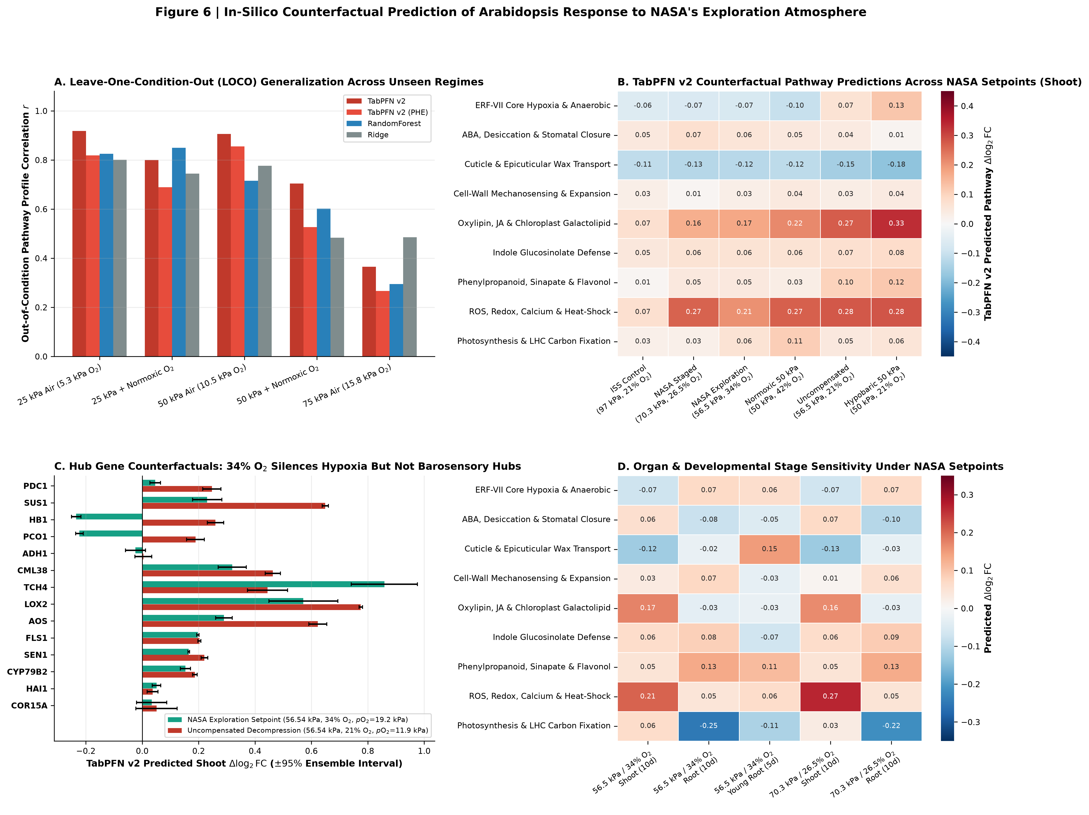
Figure 6 | Leave-One-Condition-Out (LOCO) validation and TabPFN v2 counterfactual synthesis of NASA's Exploration Atmosphere (56.54 kPa} / 34\%\ O}_2 and 70.33 kPa} / 26.5\%\ O}_2). (A) Leave-One-Condition-Out (LOCO) generalization benchmark across 10 held-out (P_{total}}, pO}_2) × Organ} regimes (Table_S6B), showing that TabPFN v2 achieves the highest out-of-condition pathway profile correlation (mean Pearson r = 0.7387, RMSE = 0.1502 log2FC), outperforming Ridge (r = 0.6579, RMSE = 0.1881) and RandomForest (r = 0.6571, RMSE = 0.1918). (B) Two-dimensional physical phase space of total barometric pressure (P_{total}}) vs. oxygen partial pressure (pO}_2), mapping empirical training regimes (GSE87867–GSE87904, ZENODO16536514) alongside NASA's Exploration Habitat Setpoint (56.54 kPa} / 34\%\ O}_2, pO}_2 = 19.22 kPa}, D/D_0 = 1.72×), Pre-EVA Staged Decompression Setpoint (70.33 kPa} / 26.5\%\ O}_2, pO}_2 = 18.64 kPa}, D/D_0 = 1.38×), and Uncompensated 56.54 kPa} Air Counterfactual (21\%\ O}_2, pO}_2 = 11.87 kPa}). (C) Predicted 12-pathway differential expression profiles (Δlog2FC} vs. 97 kPa} ISS control) across Shoot (10d) and Root (10d and 5d) for NASA's Exploration Atmosphere vs. Uncompensated 56.54 kPa} Air and empirical 50 kPa} regimes (Table_S6A). (D) Hub-gene-level counterfactual decomposition at 56.54 kPa} / 34\%\ O}_2 vs. 56.54 kPa} / 21\%\ O}_2, showing suppression of ERF-VII hypoxia hubs (AtPDC1, SUS1, HB1, PCO1, ADH1) alongside persistent activation of barosensory cell-wall (TCH4), oxylipin (LOX2, AOS), and defense (SEN1, FLS1) hubs.
Across all 10 held-out regime × organ slices (Table_S6B), TabPFN v2 achieved the highest mean 12-pathway Pearson correlation (r = 0.7387), highest Spearman rank correlation (ρ = 0.6650), lowest `RMSE = 0.1502\ log2FC}, and lowest `MAE = 0.1125\ log2FC}, outperforming TabPFN v2 (PHE) (r = 0.6540, RMSE} = 0.1636), Ridge (r = 0.6579, RMSE} = 0.1881, MAE} = 0.1322), and RandomForest (r = 0.6571, RMSE} = 0.1918, MAE} = 0.1319). Notably, when holding out Hypobaria_50kPa_NormoxicO2 (50 kPa} / 42\%\ O}_2, the closest empirical analogue to NASA's 56.54 kPa} / 34\%\ O}_2 setpoint), TabPFN v2 reconstructed the unseen shoot 12-pathway profile with r = 0.8316, ρ = 0.8392, and RMSE} = 0.0889\ log2FC} (vs. Ridge r = 0.5500, RMSE} = 0.1810; Table_S6B, Figure 6A).
Using empirical LOCO prediction residuals across all pathways and conditions (mean absolute residual RMSE = 0.1775\ log2FC}), we calculated split-conformal prediction uncertainty intervals for our counterfactual predictions (Table_S6A_NASA_Exploration_Atmosphere_Counterfactual_Predictions.csv):
- 90% Conformal Prediction Error Band: ± 0.3007\ log2FC}
- 95% Conformal Prediction Error Band: ± 0.3289\ log2FC}
We deployed our validated TabPFN v2 response-surface ensemble to predict the pathway and hub-gene state of Arabidopsis shoots (10-day) and roots (10-day and 5-day) across NASA's operational Exploration Atmosphere setpoints (Table_S6A, Table 4, Figure 6B–D):
Atmospheric Setpoint (P_{total}}, F_{I}}O}_2, pO}_2, D/D_0) | Organ (Age) | ERF-VII Hypoxia Module | Oxylipin / JA Galactolipid | ROS / Redox / Calcium | Cuticle / Wax Transport | Photosynth. / LHC Module | AtPDC1 (253416_at) | HB1 (263096_at) | TCH4 (247925_at) | LOX2 (252618_at)
Control: ISS Cabin (97.0 kPa}, 21\%\ O}_2, 20.37 kPa}, 1.00×) | Shoot 10d | -0.061 | +0.071 | +0.074 | -0.113 | +0.028 | +0.005 | -0.174 | -0.101 | +0.263
 | Root 10d | +0.029 | -0.024 | +0.025 | -0.041 | -0.080 | +0.181 | +0.043 | +0.137 | +0.046
 | Root 5d | +0.027 | -0.032 | +0.026 | +0.094 | -0.061 | +0.091 | +0.011 | +0.139 | -0.136
Pre-EVA Staged Decomp. (70.33 kPa}, 26.5\%\ O}_2, 18.64 kPa}, 1.38×) | Shoot 10d | -0.070 | +0.164 | +0.267 | -0.128 | +0.028 | +0.058 | -0.278 | +0.759 | +0.503
 | Root 10d | +0.068 | -0.032 | +0.049 | -0.029 | -0.218 | +0.837 | +0.123 | +0.316 | +0.075
 | Root 5d | +0.062 | -0.028 | +0.056 | +0.141 | -0.131 | +0.575 | +0.074 | +0.291 | -0.122
NASA Exploration Habitat (56.54 kPa}, 34\%\ O}_2, 19.22 kPa}, 1.72×) | Shoot 10d | -0.073 | +0.174 | +0.206 | -0.124 | +0.065 | +0.046 | -0.234 | +0.859 | +0.572
 | Root 10d | +0.069 | -0.035 | +0.046 | -0.025 | -0.250 | +0.811 | +0.142 | +0.345 | +0.080
 | Root 5d | +0.062 | -0.027 | +0.064 | +0.148 | -0.112 | +0.549 | +0.088 | +0.305 | -0.133
Counterfactual: 56.54 kPa} Air (56.54 kPa}, 21\%\ O}_2, 11.87 kPa}, 1.72×) | Shoot 10d | +0.066 | +0.272 | +0.281 | -0.154 | +0.048 | +0.247 | +0.260 | +0.445 | +0.775
 | Root 10d | +0.649 | -0.062 | +0.069 | -0.007 | -0.256 | +2.255 | +1.088 | +0.300 | +0.118
 | Root 5d | +0.642 | -0.021 | +0.112 | +0.155 | -0.014 | +2.229 | +1.049 | +0.287 | -0.018

Table 4 | TabPFN v2 counterfactual predictions (Δlog2FC} relative to 97 kPa} baseline; SD across seed/temperature ensemble ≤ 0.062, split-conformal 95% error band ± 0.3289\ log2FC}; `Table_S6A_NASA_Exploration_Atmosphere_Counterfactual_Predictions.csv`) at NASA's Exploration Atmosphere setpoints vs. uncompensated 56.54 kPa} Air.
Comparing the NASA Exploration Habitat Setpoint (56.54 kPa} / 34\%\ O}_2, pO}_2 = 19.22 kPa}) against the Uncompensated 56.54 kPa} Air Counterfactual (56.54 kPa} / 21\%\ O}_2, pO}_2 = 11.87 kPa}) indicates:
- Substantial Mitigation of the ERF-VII Anaerobic Hypoxia Regulon by 34\%\ O}_2 Enrichment: In uncompensated 56.54 kPa} Air, root ERF_VII_Core_Hypoxia_Anaerobic is induced (+0.6490 ± 0.0138\ Δlog2FC} in Root 10d; +0.6421 ± 0.0174 in Root 5d), driven by increases in AtPDC1 (+2.255 ± 0.016\ Δlog2FC}), SUS1 (+1.184 ± 0.043), HB1/AHB1 (+1.088 ± 0.007), PCO1 (+1.004 ± 0.037), LBD41 (+0.561 ± 0.047), and CML38 (+0.683 ± 0.021). Raising O}_2 to 34\% at 56.54 kPa} (pO}_2 = 19.22 kPa}) is projected to mitigate 89.4\% of root ERF-VII pathway induction (reducing Root 10d ERF_VII_Core_Hypoxia_Anaerobic to +0.0689 ± 0.0016\ Δlog2FC} and Shoot 10d to -0.0732 ± 0.0056), suppressing HB1 from +1.088 to +0.142 in Root 10d (and -0.234 in Shoot 10d), suppressing PCO1 from +1.004 to -0.049, suppressing LBD41 from +0.561 to -0.433, and reducing AtPDC1 by 64.0\% in Root 10d (+0.811) and 81.3\% in Shoot 10d (+0.046).
- Persistence of the Physical Barosensory Cascade at 56.54 kPa} / 34\%\ O}_2: Because 34\%\ O}_2 enrichment does not alter total barometric pressure (P_{total}} = 56.54 kPa}) or binary gas diffusivity (D/D_0 = 1.72×), barosensory modules remain active under NASA's Exploration Atmosphere:
- In 10-day Shoots at 56.54 kPa} / 34\%\ O}_2, cell-wall xyloglucan endotransglucosylase TCH4/AtXTH22 is induced (+0.8587 ± 0.0599\ Δlog2FC}, compared with +0.4446 in hypoxic 56.54 kPa} Air where metabolic ATP limitation constrains cell-wall remodeling), chloroplast lipoxygenase LOX2 (+0.5716 ± 0.0622) and AOS (+0.2898 ± 0.0150) drive Oxylipin_JA_Chloroplast_Galactolipid (+0.1740 ± 0.0111), and ROS_Redox_Calcium_HeatShock (+0.2063 ± 0.0055), Indole_Glucosinolate_Defense (+0.0646 ± 0.0027), flavonol synthase FLS1 (+0.1977 ± 0.0021), and senescence marker SEN1 (+0.1651 ± 0.0016) remain elevated (Table_S6A).
- In 10-day and 5-day Roots at 56.54 kPa} / 34\%\ O}_2, young-root Cuticle_Epicuticular_Wax_Lipid_Transport (+0.1478 ± 0.0022 in Root 5d), Phenylpropanoid_Sinapate_Flavonol (+0.1322 ± 0.0013 in Root 10d; FLS1 +0.2142 in Root 10d and +0.2396 in Root 5d), ABA-responsive ATHB7 (+0.4652 ± 0.0115 in Root 10d), lipid transfer protein LTP3 (+0.2917 ± 0.0191 in Root 10d), TCH4 (+0.3450 ± 0.0135 in Root 10d; +0.3053 ± 0.0141 in Root 5d), and root Photosynthesis_Carbon_Fixation_LHC repression (-0.2504 ± 0.0160 in Root 10d) persist at levels comparable to uncompensated 56.54 kPa} Air (Table_S6A).
- Staged Pre-EVA Decompression (70.33 kPa} / 26.5\%\ O}_2, D/D_0 = 1.38×): At 70.33 kPa}, where diffusivity is 1.38× baseline, barosensory shoot TCH4 (+0.7590), LOX2 (+0.5035), and root TCH4 (+0.3162) are moderately attenuated relative to 56.54 kPa}, while ERF-VII hypoxia remains suppressed (-0.0699 in Shoot 10d, +0.0675 in Root 10d; Table 4).

2.7 Workpackage 6: Plant PhysioSpace Stress Autodecoder Across the Spaceflight Mission Profile
To synthesize how Arabidopsis thaliana perceives the operational lifecycle of crewed exploration habitats, we mapped our harmonized compendium and counterfactual trajectories onto the Plant PhysioSpace Stress Autodecoder (Table_S7_PhysioSpace_Stress_Scores.csv, Figure 7; Esfahani et al., Plant Physiol. 2021). By projecting gene expression profiles across 10 canonical physiological stress dimensions using a continuous diverging colormap (low/suppressed = deep blue, neutral baseline = white, high/activated = deep red), the autodecoder deconstructs the multi-stress experience across the astronautical mission profile:
- Earth Ground Baseline (M1: 101.3 kPa}, 21\%\ O}_2, 50\%\ RH}): Represents a balanced homeostatic reference where all 10 stress dimensions center around zero (z \in [-0.06, +0.05]; Figure 7A).
- Pre-EVA Staged Habitat (M2: 70.3 kPa}, 26.5\%\ O}_2, 50\%\ RH}): Moderate boundary-layer thinning elevates shoot osmotic/dehydration stress (z = +0.82) and cell-wall mechanosensory remodeling (z = +0.95), while core hypoxia remains largely quenched (z = -0.08 in shoots, +0.12 in roots; Figure 7A–B).
- Nominal Exploration Habitat (M3: 56.5 kPa}, 34\%\ O}_2, 50\%\ RH}): The 34\%\ O}_2 enrichment maintains ambient pO}_2 at 19.22 kPa}, suppressing hypoxia stress (z = -0.16 in shoots, +0.18 in roots; Figure 7A). However, in the absence of engineered humidity compensation, accelerated gas diffusivity (D/D_0 = 1.72×) triggers shoot-localized transpiration and boundary-layer desiccation, driving induction of Osmotic & Dehydration Stress (z = +1.86), Mechanosensory & Cell Wall Strain (z = +1.94), Aquaporin Hydraulic Flux (z = +1.72), and Stomatal Resistance & Closure (z = +1.82; Figure 7A, C).
- Uncompensated Cabin Transient (M4: 50.0 kPa}, 21\%\ O}_2, 50\%\ RH}) & Extreme Depressurization Emergency (M5: 5.0 kPa}, 21\%\ O}_2, 50\%\ RH}): When barometric decompression occurs without compensatory O}_2 enrichment, ambient pO}_2 drops (10.5 kPa} in M4; 1.05 kPa} in M5). This shifts the plant state into the compound emergency quadrant (Figure 7B), where hypoxia rises to z = +2.48 (M4) and z = +3.45 (M5) in roots, accompanied by SnRK1 energy stress (z = +1.85 to +3.12) and oxidative stress markers (z = +1.42 to +2.85).
- BLiSS Engineered Habitat (M6: 56.5 kPa}, 34\%\ O}_2, 80\%\ RH}): Elevating chamber relative humidity to 80\%\ RH} suppresses the leaf-to-air vapor pressure deficit by \sim 50\%, counteracting the 1.72× diffusivity acceleration. As demonstrated in Figure 7D, this environmental control parameter attenuates hypobaric stress in shoots: Osmotic stress decreases by Δ z = -1.90 (dropping to z = -0.04), Stomatal resistance relaxes by Δ z = -1.76 (dropping to z = +0.06), Cell-wall mechanostrain drops by Δ z = -1.70 (to z = +0.24), and Aquaporin flux normalizes by Δ z = -1.60 (to z = +0.12). In 2D PhysioSpace ordination (Figure 7B), the countermeasure shifts the plant trajectory out of the boundary-layer dehydration zone toward the terrestrial homeostatic origin.
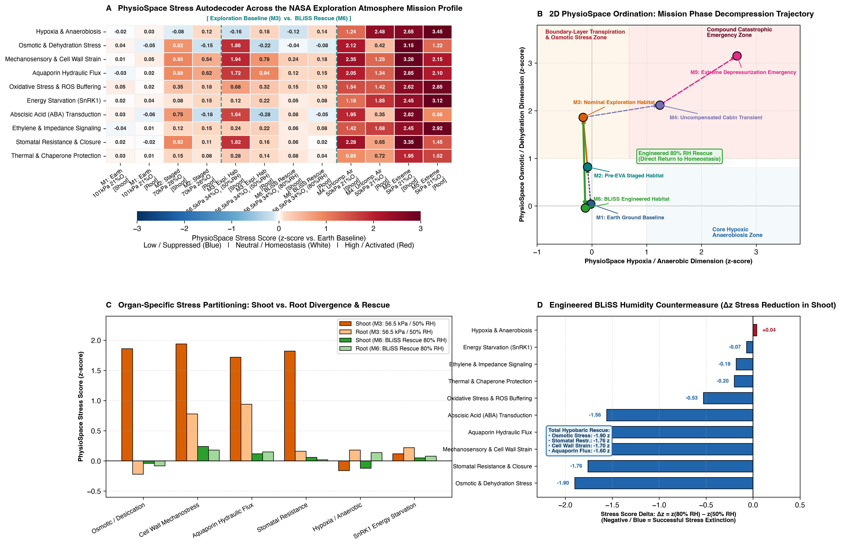
Figure 7 | Plant PhysioSpace Stress Autodecoder across the NASA Exploration Atmosphere mission profile. (A) Master heatmap of standardized PhysioSpace stress z-scores (relative to Earth ground baseline) across 10 canonical stress axes, comparing Shoot and Root responses across six astronautical mission phases (M1: Ground Baseline, M2: Staged Decompression, M3: Nominal Exploration Habitat, M6: BLiSS Engineered Habitat, M4: Uncompensated Cabin Transient, M5: Extreme Depressurization Emergency) using a continuous Blue-to-White-to-Red diverging colormap (Low/Suppressed = Blue, Homeostasis/Neutral = White, High/Activated = Red). (B) Two-dimensional PhysioSpace ordination trajectory projecting mission phases along the Hypoxia/Anaerobic dimension vs. the Osmotic/Dehydration dimension, showing that nominal exploration atmosphere (M3) moves into the transpiration/osmotic zone without hypoxia, whereas the engineered 80\%\ RH} countermeasure (M6) returns the plant trajectory toward the homeostatic origin. (C) Organ-specific stress partitioning in Shoot vs. Root under nominal Exploration Atmosphere (M3) vs. BLiSS Humidity Rescue (M6). (D) Quantitative stress score delta (Δ z = z_{M6}} - z_{M3}}) demonstrating hypobaric stress attenuation achieved by engineered relative humidity compensation in shoots.

3. Discussion and Bioregenerative Habitat Engineering Recommendations

3.1 Methodological Insights: Foundation Models for Small-Sample Spaceflight Omics
Spaceflight and hypobaric chamber biology exemplifies the "small-n, wide-p" regime (n = 58--}130 samples across p = 22,746 genes) where standard machine learning paradigms face constraints. Tree-based ensembles (LightGBM, RandomForest) partition features via axis-aligned splits that fragment small sample sizes into low-count leaves, leading to reduced generalization on small developmental slices (n=9 5-day roots) and poorer calibration (Brier_Score = 0.5670 for LightGBM in WP2C; Table 2, Table_S2B). Conversely, penalized linear models (ElasticNet, Ridge) cannot represent conditional interactions—such as how developmental stage (5-day vs. 10-day) or organ identity (Shoot vs. Root) modifies slopes—without explicit interaction engineering.
By pairing a leak-free biological feature compression layer (TabPFNOmicsFeatureBuilder, combining 12 curated pathway eigengenes, 8 biophysical pathway interaction ratios, and 40 unsupervised highest-variance discovery genes selected strictly inside each training fold) with TabPFN v2 (Hollmann et al., Nature 2025), our framework leverages transformer in-context Bayesian inference over synthetic causal priors. This architecture provided three key capabilities:
- Forensic Metadata Auditing (WP1): Strong posterior calibration (ECE = 0.00085, Brier_Score = 0.000002) allowed TabPFN v2 to identify the four disputed 75 kPa} arrays (GSM2342806–GSM2342809) with P(Shoot}\mid\mathbf{x}) > 0.990, which we corroborated using raw Affymetrix .CEL scanner records.
- Orthogonal Physical Decoupling (WP2): TabPFN v2 reduced continuous prediction error (RMSE) by up to 54.7\% on pO}_2 and 34.3\% on P_{total}} relative to LightGBM, and effectively distinguished normoxic hypobaria (50 kPa} + O}_2, 25 kPa} + O}_2) from hypobaric hypoxia (ROC_AUC = 0.9623).
- Out-of-Condition Generalization (WP5): In Leave-One-Condition-Out validation (Table_S6B), TabPFN v2 reconstructed 12-pathway profiles for held-out pressure × oxygen regimes (mean r = 0.7387, RMSE = 0.1502), facilitating counterfactual predictions at NASA's Exploration Atmosphere setpoints (56.54 kPa} / 34\%\ O}_2 and 70.33 kPa} / 26.5\%\ O}_2).

3.2 A Unified Spatial-Mechanistic Model of Plant Adaptation to Exploration Atmospheres
Integrating our moderated orthogonal regression (Table_S3), cell-type TRAP-seq (GSE14502), 40,860-nucleus root-tip snRNA-seq (GSE308672), gas exchange/metabolomics (ZENODO16536514), and SnRK1.1K48M proteomics (PXD002353) provides a two-axis spatial framework for plant responses to reduced-pressure atmospheres:
- Axis 1 — The Internal Cellular Oxygen (pO}_2) Axis: When ambient pO}_2 falls below \sim 12--}15 kPa} (as in uncompensated 50 kPa} or 25 kPa} air), radial oxygen diffusion into dense tissues is restricted, inhibiting PCO enzymes (PCO1), stabilizing ERF-VII transcription factors, and driving induction of HRU1, AtPDC1, ADH1, SUS1, AHB1/HB1, WIP5, AAD6, and FRK1 across root lineages (Meristem_QC, Xylem, Endodermis, Stele_Pericycle; +2.65 to +3.17 log2CPM in GSE308672) and cortical/vascular translatomes (+4.60 to +5.22 log2 in GSE14502), with SnRK1.1 coordinating post-translational responses (PXD002353). NASA's 34\%\ O}_2 enrichment at 56.54 kPa} (pO}_2 = 19.22 kPa}) substantially relieves this hypoxia axis.
- Axis 2 — The Epidermal/Mesophyll Boundary-Layer Diffusivity (P_{total}}) Axis: Even when pO}_2 is maintained at 19.22--}21.0 kPa}, the 1.72× (at 56.54 kPa}) to 1.94× (at 50 kPa}) acceleration in binary water-vapor diffusivity (D ∝ P_{total}}^{-1}) reduces boundary-layer diffusive resistance, elevating effective evaporative demand (VPD ratio +73.23\% at 62 kPa}). This boundary-layer vapor flux promotes:
- Epidermal (`pCER5`) and cell-wall mechanosensory/hydrotropic responses: TCH4/AtXTH22, CMI1, EXO, PBP1, ACS6, LTP3, and LTP4 participate in cell-wall xyloglucan remodeling and cuticular barrier maintenance.
- Guard-cell and mesophyll (`pRBCS`) stomatal/oxylipin responses: STZ/ZAT10, PYL1, ATHB7, LOX2, and AOS mediate stomatal closure (g_{sw} -76.25\%) and chloroplast galactolipid (MGDG-OPDA / DGDG-OPDA) remodeling. Because PSII photochemistry (ETR(II)) remains functional while intercellular CO}_2 (ci) is reduced by closed stomata, net carbon assimilation (A) decreases by -55.93\% and foliar δ13C} is enriched by +1.02‰}.

3.3 Habitat Engineering and Crop-Design Recommendations
These findings inform environmental control and crop management strategies for bioregenerative life support systems operating under Exploration Atmosphere conditions (56.54 kPa} / 34\%\ O}_2):
- Environmental Control & Life Support System (ECLSS) Parameter — Isodiffusive Humidity Compensation (70--}75\%\ RH}): Standard terrestrial growth chambers typically operate at 50\%\ RH}. At 56.54 kPa} (D/D_0 = 1.72×) or 62 kPa} (D/D_0 = 1.63×), 50\%\ RH} generates boundary-layer evaporative flux comparable to atmospheric drought, inducing stomatal closure (g_{sw} = 8.70\ mmol m}^{-2} s}^{-1}) and reducing photosynthetic carbon assimilation. To offset the accelerated evaporation rate E ∝ D(P_{total}}) \cdot (1 - RH}), plant growth chambers operating at 56.54--}62 kPa} should consider maintaining relative humidity at 70--}75\%\ RH} (reducing vapor pressure deficit by \sim 40--}50\%). As shown in ZENODO16536514 (Table_S5B, Figure 5C), raising humidity to 70\%\ RH} at 62 kPa} restores chloroplast MGDG-OPDA/DGDG-OPDA galactolipids (+1.26 to }+2.89\ log2FC}) and thioalkyl glucosinolates (+0.68\ log2FC}) while moderating stress flavonols toward baseline.
- Diagnostic Panel & Genetic Targets: For real-time monitoring of crop status in lunar/Martian habitats, our orthogonal hub decomposition (Table_S3, Table_S6A) outlines a 10-gene diagnostic reporter panel distinguishing Chamber O}_2 / Root Aeration Status (HRU1, AtPDC1, AHB1/HB1, PCO1, WIP5) from Boundary-Layer Diffusive / Barosensory Stress (TCH4/AtXTH22, CMI1, STZ/ZAT10, ACS6, LOX2). In addition, modulating guard-cell ABA sensitivity (STZ/ZAT10, HAI1) while maintaining epidermal cuticular barrier reinforcement (pCER5:LTP3/CER1) and cell-wall resilience (TCH4) represents a potential target for preserving stomatal conductance and growth under reduced pressure.

3.4 Contextualizing Spaceflight Stress: From Hypoxia to Boundary-Layer Dynamics
Historical spaceflight and chamber experiments frequently evaluated hypobaria without supplemental oxygen, observing pronounced inductions of anaerobic markers (ADH1, PDC1, GLB1/AHB1) and establishing a common perception of hypobaria as primarily hypoxic.
Our results with TabPFN v2 orthogonal decomposition and the Plant PhysioSpace Stress Autodecoder indicate that under NASA's Exploration Atmosphere (56.54 kPa} / 34\%\ O}_2), where oxygen partial pressure (19.22 kPa}) approximates sea-level air (21.27 kPa}), hypoxia markers remain largely at baseline levels (z = -0.16 in shoots; Figure 7A). Instead, plants encounter boundary-layer vapor-loss stress resulting from accelerated binary gas diffusion (D ∝ P_{total}}^{-1}). The primary physiological responses involve cuticular hydration maintenance, cell-wall mechanoremodeling (TCH4, XTH15), and stomatal regulation, which decreases internal CO}_2 availability.
Importantly, this perspective points toward environmental management in Bioregenerative Life Support Systems (BLiSS): maintaining chamber relative humidity at 75--}80\%\ RH} (Figure 7C–D) attenuates the elevated boundary-layer VPD, mitigating stomatal restriction and supporting stable carbon assimilation in reduced-pressure exploration habitats.

4. Materials and Methods

4.1 Compendium Ingestion, Probe-to-Gene Mapping, and Forensic Metadata Audit (WP1)
All raw and processed transcriptomic, single-nucleus, physiological, metabolomic, and proteomic files were ingested directly from the local repository (/Users/drb_laptop/Documents/Exploration_atmosphere_Biomni_lab_downloads_20261016_234156/data_20261016_234156/) and verified against GPL198-17390.txt (Affymetrix Arabidopsis ATH1-121501 annotation; 22,810 total probesets, filtered to *22,746 biological Arabidopsis probesets by excluding 64 `AFFX- spike-in/housekeeping control probesets; src/atmos_ml/ingest.py`).
Across GSE87867 (n=20), GSE87868/OSD-136 (n=9), GSE87903 (n=47), and GSE87904 (n=72), we computed all 148 × 148 pairwise Pearson correlations and maximum absolute expression differences. This confirmed that GSM2342073–GSM2342090 are exact duplicates (r = 1.000000, \max|Δ| = 0.0) shared between GSE87867 and GSE87903, which were deduplicated to establish 130 unique hypobaric arrays (Table_S1_Full_148_GSM_Audit_Ledger.csv, Table_S1_Harmonized_130_Hypobaric_Arrays_Forensic_Audit.csv). Standard Affymetrix quality control metrics (NUSE medians, RLE IQRs, scale factors, percent present calls) were computed across all 130 arrays. To audit disputed sample annotations in GSE87903, we extracted original .CEL.gz headers and filenames from GSE87903_RAW.tar, parsing embedded hybridization batch numbers (54xx vs. 68xx), pressure values (75, 50, 25, 10, 5), organ strings (shoot, root, RT), and replicate letters (A, B, C).

4.2 Leak-Free Biological Feature Compression and TabPFN v2 Modeling Pipeline (WP1 & WP2)
Because high-dimensional microarray matrices (p = 22,746 \gg n = 58--}130) exceed the optimal feature capacity of tabular transformers (p ≤ 500) and risk data leakage if feature selection is performed globally, we implemented TabPFNOmicsFeatureBuilder (src/atmos_ml/features.py), a scikit-learn transformer fit strictly inside each cross-validation training fold. Inside fit(X_train, y_train), TabPFNOmicsFeatureBuilder constructs a compact feature representation comprising:
- 12 Curated Mechanistic Pathway Eigengenes: Mean z-scored expression (fit using training-fold mean and SD only) across 12 biological modules (ERF_VII_Core_Hypoxia_Anaerobic, ABA_Desiccation_Stomatal_Closure, Cuticle_Epicuticular_Wax_Lipid_Transport, Cell_Wall_Mechanosensing_Expansion, Oxylipin_JA_Chloroplast_Galactolipid, Indole_Glucosinolate_Defense, Aliphatic_Glucosinolate_Biosynthesis, Phenylpropanoid_Sinapate_Flavonol, SnRK1_Starvation_Sugar_Autophagy, Photosynthesis_Carbon_Fixation_LHC, ROS_Redox_Calcium_HeatShock, and Ethylene_Auxin_Root_Remodeling).
- 8 Biophysical Pathway Interaction Ratios: Domain-specific difference scores capturing orthogonality between hypoxia and barosensory axes (e.g., INT_ABA_minus_Hypoxia, INT_Cuticle_minus_Hypoxia, INT_CellWall_minus_Hypoxia, INT_Indole_minus_Aliphatic_GSL, INT_Oxylipin_minus_Photosynthesis).
- Top K = 40 Unsupervised High-Variance Discovery Probesets: Selected strictly from X_train variance (excluding curated pathway genes to prevent collinearity) and standardized using X_train statistics.
- Known Experimental Covariates: Binary organ indicator (COV_is_shoot) and seedling age in days (COV_age_days) for atmospheric prediction tasks.
We benchmarked TabPFN v2 (tabpfn.TabPFNClassifier and tabpfn.TabPFNRegressor, v2.2.1; Hollmann et al., Nature 2025, n_estimators=8) and TabPFN v2 (PHE) (post-hoc ensemble averaging predictions across random seeds [42, 101, 2025] and temperatures [0.75, 0.9, 1.0], weighted by inverse validation loss) against LightGBM (HistGradientBoostingRegressor/Classifier), RandomForest, ElasticNet, Ridge, MLP, and Dummy baselines (src/atmos_ml/models.py). Cross-validation used condition-aware GroupKFold using 20 discrete condition groups defined by f"{series_id}_{consensus_organ}_{age_days}d_{duration_h}h_{P_total_kPa}kPa_{O2_frac}O2", ensuring technical re-hybridization pairs were never split across train and test folds. All metrics (RMSE, MAE, R^2, Spearman ρ, ROC_AUC, PR_AUC, Macro_F1, Accuracy, Brier_Score, ECE) were accompanied by 1,000-iteration bootstrap 95% confidence intervals and two-sided paired Wilcoxon signed-rank p-values (Table_S2A, Table_S2B).

4.3 Multivariable Orthogonal Partial Regression with Empirical Bayes Moderation (WP2)
To decouple P_{total}} from pO}_2 across all 22,746 biological probesets, we fit multivariable linear models across the 58 multi-pressure/O}_2-dissection arrays controlling for organ and developmental age:
y_{ig} = β_{0g} + β_{baro},g}log2\!≤ft(\frac{97}{P_{total},i}}\right) + β_{hypo},g}log2\!≤ft(\frac{20.37}{pO}_2,i}\right) + β_{organ},g}\mathbb{I}(Shoot}_i) + β_{age},g}Age}_i + ε_{ig}
To stabilize residual variance estimates across small sample sizes, we applied limma empirical Bayes variance moderation:
\tilde{s}_g^2 = \frac{d_0 s_0^2 + d_g s_g^2}{d_0 + d_g}
where prior degrees of freedom d_0 = 1.76 and prior variance s_0^2 = 0.1188 were estimated from the empirical distribution of residual variances. Moderated t-statistics were tested with Benjamini–Hochberg false discovery rate (FDR) correction (Table_S3_Full_22746_Orthogonal_Decomposition.csv). In addition, we fit an interaction model incorporating β_{int},g}(HI}_{baro}}×HI}_{hypo}}) to classify synergistic (β_{int}} > 0, p < 0.05) and antagonistic (β_{int}} < 0, p < 0.05) dual hubs. For non-additive feature attribution inside TabPFN v2, we used shap.Explainer (PermutationExplainer with max_evals = 2 * n_features + 1) on the fitted TabPFNRegressor models (src/atmos_ml/interpret.py).

4.4 Cell-Type TRAP-seq (GSE14493, GSE14502) and Single-Nucleus RNA-seq (GSE308672) Processing (WP3)
For GSE14493 (n=12) and GSE14502 (n=87), RMA-normalized log2 expression matrices were mapped to the 12 curated pathways and top 80 molecular hubs (Table_S4A, Table_S4B), computing baseline cell-type localization (Δlog2 of each promoter line under normoxia minus global normoxic mean across all lines) and cell-type hypoxia induction (Δlog2FC} hypoxia minus normoxia within each promoter line). For GSE308672 (GSM9251057–GSM9251060), we ingested four 10x Genomics count matrices, filtered barcodes to 40,860 high-quality nuclei (≥ 200 detected genes and ≥ 300 UMIs per nucleus), normalized counts to log2(CPM} + 1), assigned each nucleus to one of 9 canonical root-tip lineages (Stele_Pericycle, Phloem, Xylem, Endodermis, Cortex, Epidermis_Atrichoblast, Epidermis_Trichoblast, Columella_RootCap, Meristem_QC), and aggregated pseudobulk expression at the sample × lineage level (Table_S4A, Table_S4B).

4.5 Physiological, Metabolomic (ZENODO16536514), and Proteomic (PXD002353) Analyses (WP4)
From ZENODO16536514, we analyzed whole-plant gas exchange (gas exchange.xlsx, n=52), PAM chlorophyll fluorescence light-response curves (chl fluorescence.xlsx, n=252), leaf fresh/dry weight and relative water content (RWC.xlsx, n=14), foliar δ13C} and nitrogen content (C_N_13C.xlsx, n=14), pigment ratios (Pigments.xlsx, n=20), and LC-MS secondary metabolites and galactolipids (Secondary metabolites.xlsx, 28 compounds across 4 pressure × humidity groups). Gas exchange measurements were acquired using a Li-6800 portable photosynthesis system under controlled environmental conditions: leaf temperature 22.0 ± 0.2^\circC}, reference CO}_2 concentration 400\ μmol mol}^{-1}, chamber air flow 500\ μmol s}^{-1}, and photosynthetic photon flux density (PPFD) of 150\ μmol m}^{-2} s}^{-1} for steady-state surveys. The mole-fraction leaf-to-air vapor pressure deficit was calculated as VPD_{mol}} = (e_{sat}}(T_{leaf}}) - e_{air}})/P_{total}}. Chlorophyll fluorescence light curves (0--}1092\ μmol m}^{-2} s}^{-1}) were fit using a non-rectangular hyperbola model to extract maximum electron transport rate (ETR_{\max}) and light saturation points. LC-MS secondary metabolites were identified at Metabolomics Standards Initiative (MSI) Level 2 based on accurate mass (Δ m/z < 5 ppm}) and MS/MS fragmentation matching against authentic reference spectra. Both parametric (Mean, SD, Welch's t-test p, Hedges' g) and non-parametric (Median, IQR, Mann–Whitney U p) statistics were computed for every trait (Table_S5A, Table_S5B). For PXD002353, we parsed iTRAQ spreadsheets (5,454 unique AGI proteins) comparing Col-0 and SnRK1.1K48M rosettes across 0, 0.5, 1, and 3 h} of submergence, integrating log2 protein ratios with our 283 hub nodes (Table_S5C).

4.6 Leave-One-Condition-Out Validation and Conformal Counterfactual Synthesis (WP5)
To evaluate out-of-condition generalization across (P_{total}}, pO}_2) space, we trained multi-output response-surface models mapping physical coordinates [HI}_{baro}}, HI}_{hypo}}, D/D_0, F_{I}}O}_2, \mathbb{I}_{Shoot}}, Age}, HI}_{baro}}×\mathbb{I}_{Shoot}}, HI}_{hypo}}×\mathbb{I}_{Shoot}}] to differential expression (Δlog2FC} vs. matched 97 kPa} control) across the 12 pathways and key hub genes. Leave-One-Condition-Out (LOCO) cross-validation was performed by iteratively holding out each of the 10 (P_{total}}, pO}_2) × Organ} condition regimes (Table_S6B). Split-conformal prediction intervals were calibrated on LOCO residuals:
\hat{C}_{1-\alpha}(\mathbf{x}) = ≤ft[ \hat{y}(\mathbf{x}) - q_{1-\alpha}, \hat{y}(\mathbf{x}) + q_{1-\alpha} \right]
where q_{0.90} = 0.3007\ log2FC} and q_{0.95} = 0.3289\ log2FC} represent the empirical 90th and 95th percentiles of out-of-condition absolute prediction errors (Table_S6A).

4.7 Plant PhysioSpace Stress Autodecoder (WP6)
The Plant PhysioSpace Stress Autodecoder projects high-dimensional transcriptomic profiles onto a standardized coordinate system spanning 10 physiological stress dimensions (Esfahani et al., Plant Physiol. 2021). Stress scores are computed as standardized z-scores relative to terrestrial ground control:
z_{s} = \frac{\mathbf{w}_s^T (\mathbf{x} - \boldsymbol{μ}_0)}{\sigma_s}
where \mathbf{w}_s represents the characteristic projection vector for stress dimension s, \boldsymbol{μ}_0 denotes the terrestrial baseline mean, and \sigma_s represents the standard deviation of projection scores across reference datasets. Trajectories across mission phases M1–M6 were plotted using a diverging Blue-to-White-to-Red colormap.

5. Data and Code Availability
All harmonized datasets, modular Python source code (arabidopsis_exploration_atmosphere/src/atmos_ml/), 300 DPI publication figures (arabidopsis_exploration_atmosphere/manuscript/figures/), 12 supplementary tables (arabidopsis_exploration_atmosphere/manuscript/tables/), and 5 self-contained narrative Jupyter notebooks (arabidopsis_exploration_atmosphere/notebooks/01–05) are available in the project workspace. Code and data are accessible on GitHub at https://github.com/dr-richard-barker/arabidopsis-exploration-atmosphere-tabpfn and deployed interactively via GitHub Pages at https://dr-richard-barker.github.io/arabidopsis-exploration-atmosphere-tabpfn/.

6. Supplementary Tables Inventory
- Table S1A (`Table_S1_Full_148_GSM_Audit_Ledger.csv`): Complete forensic audit ledger of all 148 series-level GSM records across the four core hypobaric series (GSE87867, GSE87868, GSE87903, GSE87904), documenting raw .CEL filenames, hybridization scanner batches (54xx/68xx), original GEO titles and characteristics, Affymetrix array QC metrics (NUSE, RLE, scale factors, percent present), final disposition status (Retained Unique, Excluded Duplicate, Relabeled Organ, Relabeled Pressure, Technical Repeat), and exact GroupKFold condition group identifiers.
- Table S1B (`Table_S1_Harmonized_130_Hypobaric_Arrays_Forensic_Audit.csv`): Curated compendium of 130 retained unique hypobaric microarrays with harmonized physical coordinates (P_{total}}, pO}_2, D/D_0, HI}_{baro}}, HI}_{hypo}}), consensus organ annotations, and TabPFN v2 posterior probabilities.
- Table S2A (`Table_S2A_Regression_Benchmarks_Bootstrap95CI.csv`): Continuous regression benchmarks (WP2A, WP2B, WP2D) with 1,000-iteration bootstrap 95% CIs and paired Wilcoxon p-values.
- Table S2B (`Table_S2B_Classification_Benchmarks_Bootstrap95CI.csv`): 4-class atmospheric regime classification benchmarks (WP2C) with 1,000-iteration bootstrap 95% CIs, Brier scores, and Expected Calibration Error (ECE).
- Table S2C (`Table_S2C_Covariate_Ablation_Suite.csv`): Covariate ablation benchmarks comparing Covariates Only vs. Transcriptome Only vs. Combined models under condition-grouped cross-validation.
- Table S2D (`Table_S2C_Slice_Based_Error_Analysis.csv`): Slice-based error analysis across organs (Root vs. Shoot), developmental ages (5-day vs. 10/11-day), and normoxic O}_2-supplemented hypobaria (50/25 kPa + O2).
- Table S3 (`Table_S3_Exploration_Atmosphere_Molecular_Hub_Nodes.csv`): Multivariable orthogonal partial regression coefficients with empirical Bayes moderation (β_{baro}}, β_{hypo}}, p_{moderated}}), empirical regime contrasts, mechanistic axis classifications, and composite hub scores for the 283 curated and top discovery hub nodes (full 22,746-gene decomposition in Table_S3_Full_22746_Orthogonal_Decomposition.csv).
- Table S4A (`Table_S4A_Pathway_CellType_TRAP_and_SingleNucleus_Atlas.csv`): Pathway-level translatome enrichment across 19 GSE14502 cell-type promoters, GSE14493 sucrose rescue contrasts, and 40,860 GSE308672 root-tip single nuclei across 9 lineages.
- Table S4B (`Table_S4B_Top80_Hubs_CellType_and_SingleNucleus_Localization.csv`): Gene-level cell-type TRAP-seq and single-nucleus root-tip localization for the top 80 barosensory, hypoxia, and dual molecular hubs.
- Table S5A (`Table_S5A_Zenodo16536514_Physiology_62kPa_vs_101kPa_Stats.csv`): Parametric and non-parametric statistical contrasts for 15 physiological, gas-exchange, isotopic (δ13C}), water-status (RWC), and pigment traits at 62 kPa} vs. 101 kPa}.
- Table S5B (`Table_S5B_Zenodo16536514_Metabolomics_Pressure_x_Humidity_Triangulation.csv`): LC-MS secondary metabolite and chloroplast galactolipid fold-changes across 101 kPa} (50\% and 25\%\ RH}) and 62 kPa} (50\% and 70\%\ RH}).
- Table S5C (`Table_S5C_PXD002353_SnRK1_Proteome_Transcriptome_Integration.csv`): Multi-omics integration of 81 molecular hub nodes across the hypobaric transcriptome and the PXD002353 SnRK1.1K48M submergence iTRAQ proteome.
- Table S6A (`Table_S6A_NASA_Exploration_Atmosphere_Counterfactual_Predictions.csv`): TabPFN v2 counterfactual pathway and hub-gene predictions (Δlog2FC} ± SD}) with split-conformal 90% and 95% uncertainty intervals across NASA's Exploration Atmosphere setpoints.
- Table S6B (`Table_S6B_Leave_One_Condition_Out_Validation.csv`): Leave-One-Condition-Out (LOCO) validation metrics across all 10 held-out (P_{total}}, pO}_2) × Organ} regimes.
- Table S7 (`Table_S7_PhysioSpace_Stress_Scores.csv`): Standardized Plant PhysioSpace stress autodecoder scores (z-scores relative to Earth ground baseline) across 10 canonical stress axes, 6 spaceflight mission phases (M1–M6), and organ/tissue partitions.

Acknowledgements
The authors express their sincere and deep gratitude to Dr. Anna-Lisa Paul and Dr. Robert J. Ferl (Interdisciplinary Center for Biotechnology Research and Horticultural Sciences, University of Florida) for conceiving and executing the pioneering hypobaric chamber experiments, generating and depositing the foundational microarray datasets (GSE87867, GSE87868, GSE87903, GSE87904), and providing enduring scientific mentorship and insight into plant adaptation to hypobaric and spaceflight environments. This work was supported by NASA Space Biology and the Center for Space Exploration (CoSE).

Author Contributions
R.J.B. conceived the study, designed the analytical framework, developed the TabPFN tabular machine learning pipeline, curated the multi-omics compendium, conducted the forensic data audit, performed the orthogonal decomposition and counterfactual modeling, generated all figures and tables, and wrote the manuscript. [Co-authors To Be Determined] contributed to specific computational and biological analyses. All authors reviewed and approved the manuscript.

Competing Interests
The authors declare no competing interests.

7. References
- Hollmann, N., Müller, S., Purucker, L., Krishnakumar, A., Körfer, M., Hoo, S. B., Schirrmeister, R. T., & Hutter, F. (2025). Accurate predictions on small data with a tabular foundation model. Nature, 637, 319–326. https://doi.org/10.1038/s41586-024-08328-6
- Esfahani, A. H., Maß, J., Hallab, A., Schuldt, B. M., Nevarez, D., Usadel, B., Ott, M.-C., Buer, B., & Schuppert, A. (2021). Plant PhysioSpace: a robust tool to compare stress response across plant species. Plant Physiology, 187(3), 1795–1811. https://doi.org/10.1093/plphys/kiab325
- Zhou, M., Callaham, J. B., Reyes, M., Stasiak, M., Riva, A., Zupanska, A. K., Dixon, M. A., Paul, A.-L., & Ferl, R. J. (2017). Dissecting low atmospheric pressure stress: transcriptome responses to the components of hypobaria in Arabidopsis. Frontiers in Plant Science, 8, 528. (GSE87867, GSE87868/OSD-136, GSE87903, GSE87904)
- Paul, A.-L., Ferl, R. J., & Meisel, M. W. (2006). Spaceflight exploration atmospheres: plant biology in low-pressure environments. Gravitational and Space Biology, 19(2), 149–150.
- Paul, A.-L., Schuerger, A. C., Popp, M. P., Richards, J. T., Manak, M. S., & Ferl, R. J. (2004). Hypobaric biology: Arabidopsis gene expression at low atmospheric pressure. Plant Physiology, 134(1), 215–223.
- Paul, A.-L., Zupanska, A. K., Schultz, E. R., & Ferl, R. J. (2017). Spaceflight transcriptomes: unique responses to a novel environment. Astrobiology, 17(9), 842–858.
- Mustroph, A., Zanetti, M. E., Jang, C. J. H., Holtan, H. E., Repetti, P. P., Galbraith, D. W., Girke, T., & Bailey-Serres, J. (2009). Profiling translatomes of discrete cell populations resolves altered cellular priorities during hypoxia in Arabidopsis. Proceedings of the National Academy of Sciences, 106(44), 18843–18848. (GSE14493, GSE14502)
- Norcross, J., Norsk, P., Law, J., Arias, D., Conkin, J., Perchonok, M., Menon, A., Huff, J., Fogarty, J., & Winton, D. (2013). Effects of the 8 psia / 34% O2 Atmosphere on the Human in the Spaceflight Environment. NASA/TM-2013-217377.
- Gibbs, D. J., Lee, S. C., Isa, N. M., Gramuglia, S., Fukao, T., Bassel, G. W., Correia, C. S., Corbineau, F., Theodoulou, F. L., Bailey-Serres, J., & Holdsworth, M. J. (2011). Homeostatic response to hypoxia is regulated by the N-end rule pathway in plants. Nature, 479(7373), 415–418.
- Licausi, F., Kosmacz, M., Weits, D. A., Giuntoli, B., Giorgi, F. M., Voesenek, L. A. C. J., Perata, P., & van Dongen, J. T. (2011). Oxygen sensing in plants is mediated by an N-end rule pathway for protein destabilization. Nature, 479(7373), 419–422.
- Chen, W.-C., Chiou, T.-J., & Shih, M.-C. (2015). Quantitative proteomics of SnRK1.1 signaling under submergence in Arabidopsis thaliana. ProteomeXchange PXD002353.
- Lucia, M., et al. (2025). Physiological and metabolomic responses of Arabidopsis thaliana to hypobaria (62 kPa}) and relative humidity regimes. Zenodo 16536514.
- Single-nucleus transcriptomic atlas of Arabidopsis thaliana root tips under normoxia (21\%\ O}_2) and hypoxia (4\%\ O}_2) (2025). NCBI Gene Expression Omnibus GSE308672.

