Knowledge Agent Instructions
- Download files from https://github.com/kevmcdonk/SCS25-SharePoint-AI-Workshop/tree/main/Sample%20Documents
- New Document libraries for each subfolder i.e. Aviation Incident Report will need to be created. Then the corresponding files uploaded.

The instructions below focus on the Aviation Incident Reports and files so will prompts/instructions need to be adapted if other files are used.

Create a New Document Library
- Go to the home page of your site and from the new menu click New Document Library
- Name the Document library i.e. Aviation Incident Reports
- Upload corresponding files in Document Library
- Give it a 1-2 mins to cook (Docs to be indexed!)

Create Columns Using Knowledge Agent
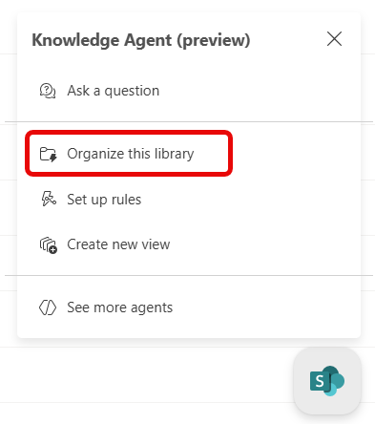
- Navigate to your library and then click on the floating SharePoint Knowledge Agent logo
- Click Organize this library
- Review suggested prompts on right hand side menu
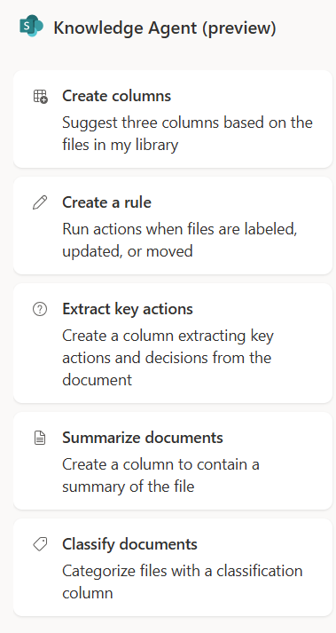
- You may select these suggested prompts, which will then populate the message box, allowing for further modification as needed.
- The Knowledge Agent will automatically suggest “3 Suggested Columns” it has identified from your content.
- You can keep these columns or even modify them i.e. change prompt or delete.
- Create columns using the following prompts
  - “Add a column “Airline” identify the main airline in the report?”
  - “Extract the last number from the filename i.e. Aviation Incident Report - WZ-647 - 21062021.docx would be 21062021”
- To add further suggested columns click on the in the Top Right-hand corner of the Knowledge Agent -it will then suggest three further columns it could create using Autofill.
- Click Save Changes
- View Library

Create Views Using Knowledge Agent

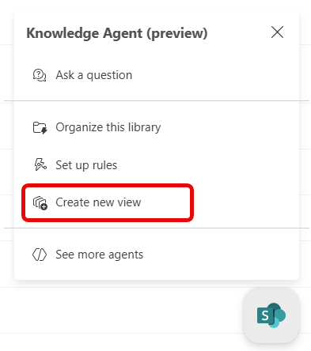
- Navigate to your library and then click on the floating SharePoint Knowledge Agent logo
- Click Create new view
- Review suggested prompts on right hand side menu
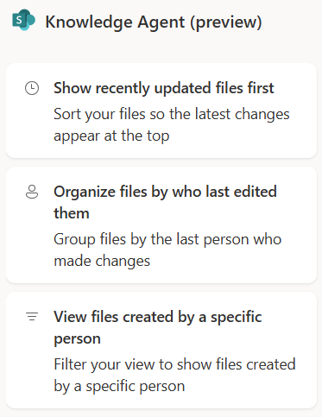
- You may select these suggested prompts, which will then populate the message box, allowing for further modification as needed.
- Create a view grouping the reports by Airline
  - Suggested Prompt: “Group Files by column Airline”
- Experiment with views i.e.
  - !Sort by Incident date descending”
  - “Filter by Airline = British Airways”
  - “Group by Airline”
- Save Changes
- View files in library in the document library views created.

Ask a Question Regarding Files in your Library
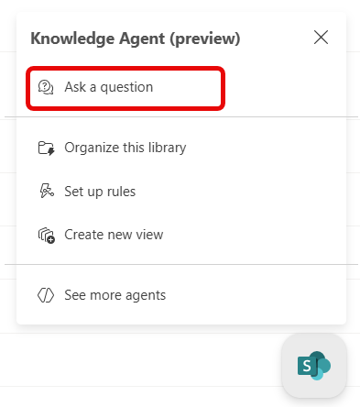
- Navigate to your library and then click on the floating SharePoint Knowledge Agent logo
- Click Ask a question
- Type a question i.e. how many incidents involve British Airways?
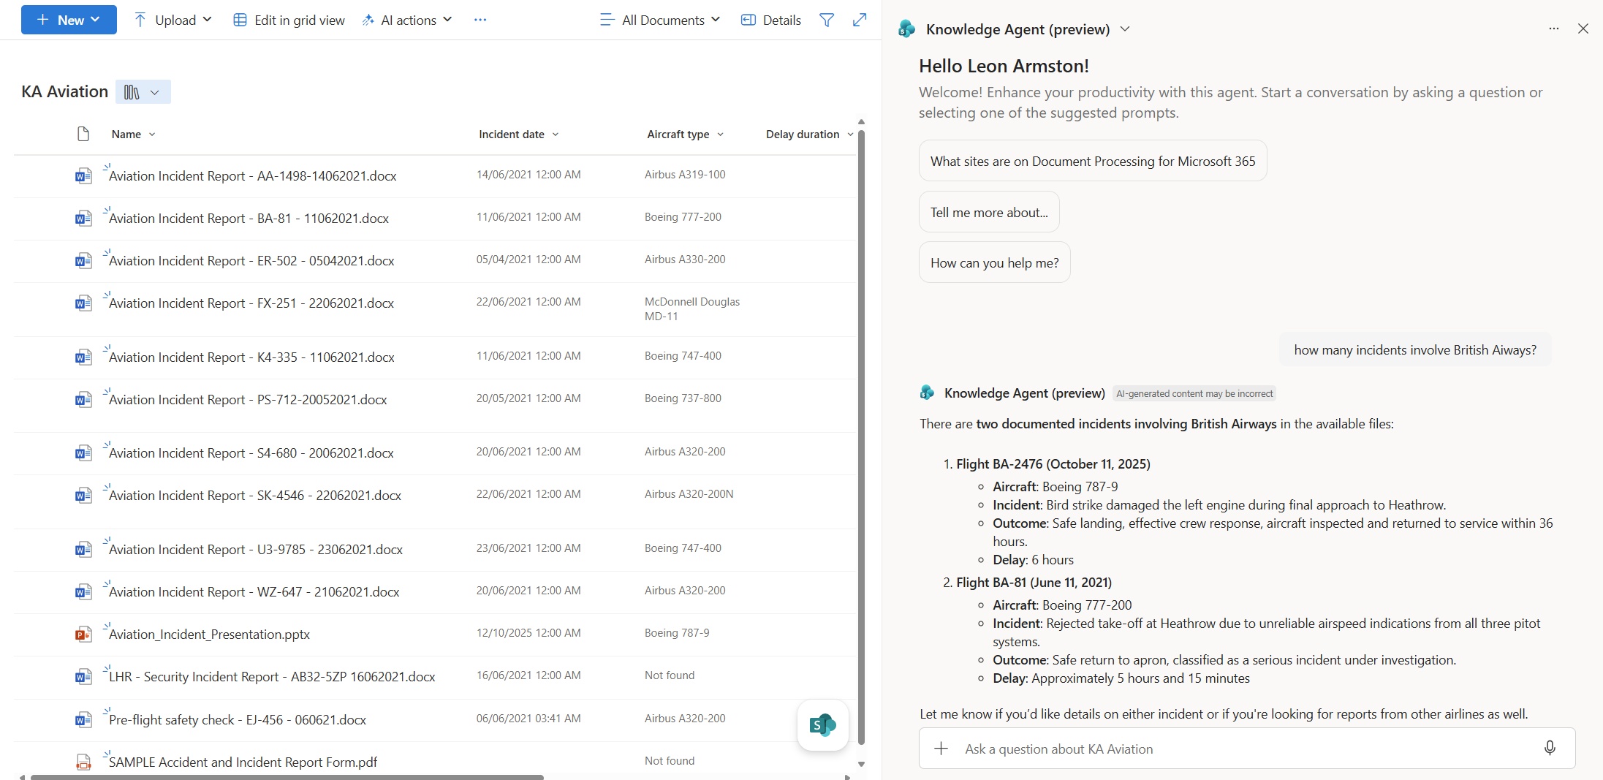
- Ask other questions about the documents.

Set up rules in the Document Library

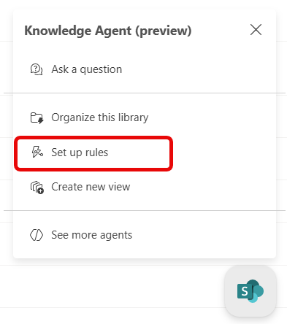
- Navigate to your library and then click on the floating SharePoint Knowledge Agent logo
- Click Create new view
- Review suggested prompts on right hand side menu
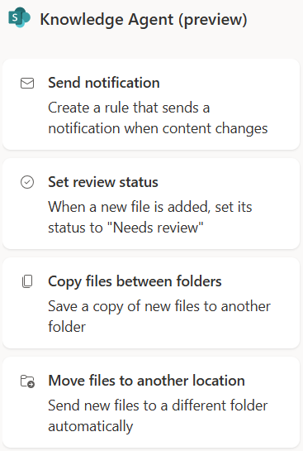
- You may select these suggested prompts, which will then populate the message box, allowing for further modification as needed.
- Click on the suggested prompt “Send Notification”
- This then enters the prompt “When a new file is added, send me an email.”
- Review this prompt and then submit the prompt.
- Experiment with further rules.

Use AI Actions on individual files
- Navigate to your library
- Select one file and ensure the checkbox beside is selected.
- Select AI actions from the document library toolbar
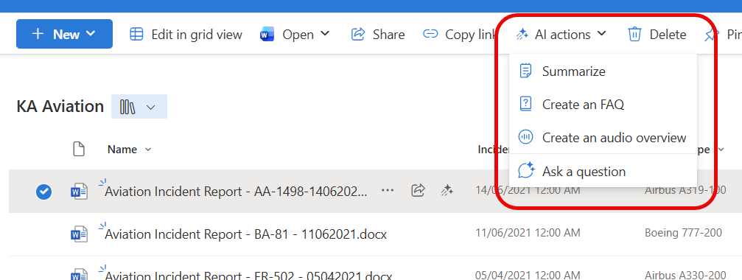

- Experiment by clicking Summarize, Create an FAQ then Create an audio overview.
- Along with asking a question grounded on just the selected document.

Use AI Actions on (upto 5) files together
- Navigate to your library
- Select at least two files and a maximum of 5 files.
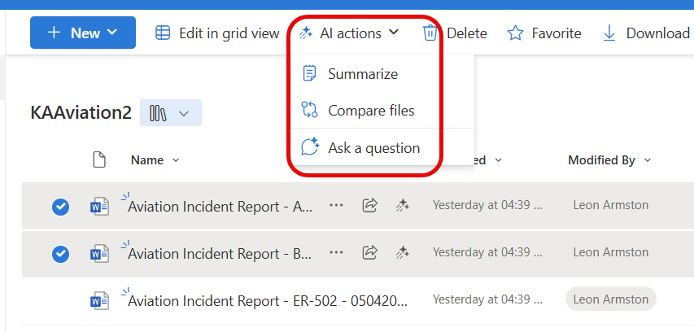
- AI actions can then be used to review the files and
  - Summarize them together.
  - Compare the differences

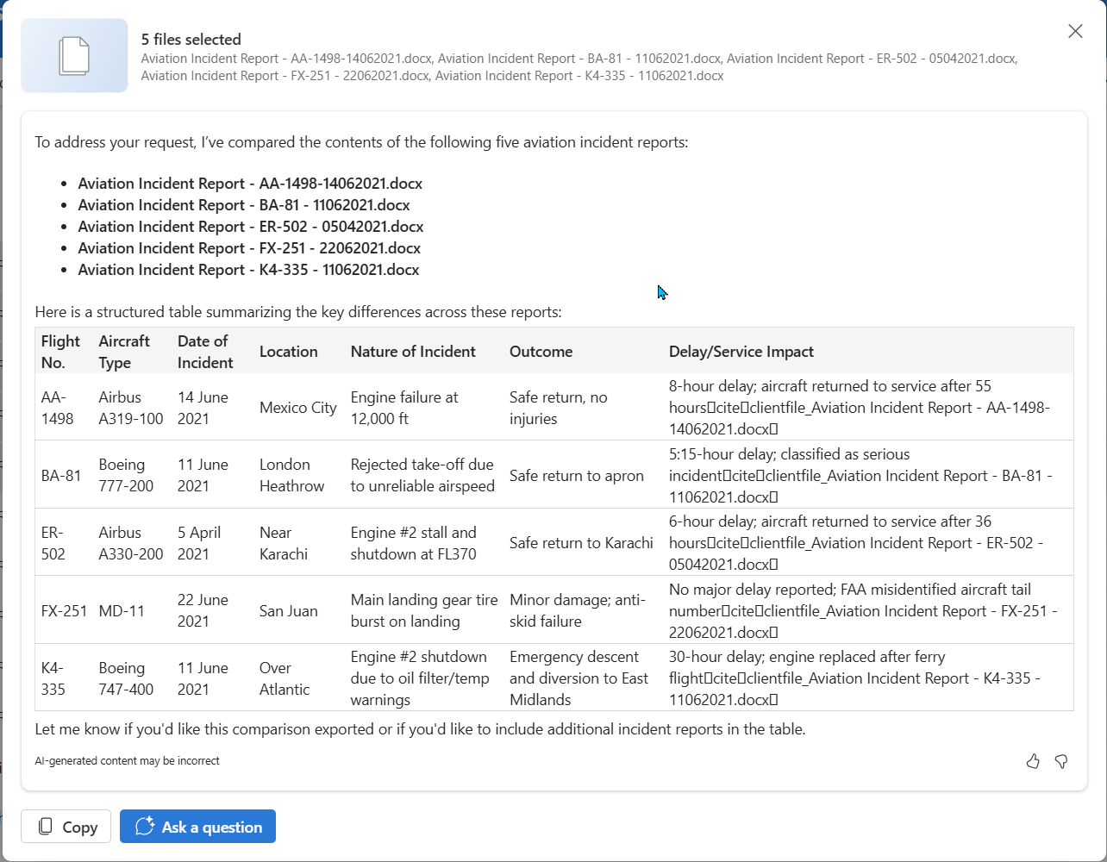

Further Suggestions
- Create Other libraries i.e. Purchase Orders and run the Knowledge Agent on them.
- Experiment with adding Autofill columns to a library
Create an autofill column | Microsoft Learn
- Experiment with Document Translation
Overview of document translation | Microsoft Learn

