
ServiceNow Integration
  - Runbook for deploying application

Copyright 2018 Nutanix, Inc.
Nutanix, Inc.
1740 Technology Drive, Suite 150
San Jose, CA 95110
All rights reserved. This product is protected by U.S. and international copyright and intellectual property laws.
Nutanix is a trademark of Nutanix, Inc. in the United States and/or other jurisdictions. All other marks and names mentioned herein may be trademarks of their respective companies.

Contents
Executive Summary 5
Introduction 6
Audience 6
Purpose 6
About Nutanix 6
Prerequisities 7
ServiceNow 7
Nutanix AHV 7
ServiceNow – Setting up the MID server 8
ServiceNow – Setting E-Mail notifications 8
ServiceNow – Populate the CMDB 8
Service Now – Configuring LDAP 9
Service Now – Environment Configuration 12
Plugins 14
Plugin activation 14
Plugin Configuration 16
Importing the ServiceNow Application 17
Nutanix Configuration Tables 18
Operating Systems 18
Cluster Types 18
Credential Types 19
Authentication Types 19
Authentication Methods 19
Authentication 20
Guest Customization Types 20
Guest Customizations 21
API Specifications 23
Credentials 24
Cluster Configurations 25
Catalog Items 25
Catalog Items Credentials 26
VM Sizes 26
Final Configurations 27
Service Catalog 27
Adjust Discovery Settings for CMDB 29
Assign Roles 29
APPENDIX A – FAQ 30

Executive Summary
This document contains the steps to install and configure our ServiceNow integration with a Nutanix AHV Cluster and SSP.

Introduction

Audience
This document is intended for IT administrators and architects.

Purpose
Our integration is contained inside a ServiceNow application, which can be imported directly from one of our Dev instances or imported as an update set XML. This document will show you how to import our application and make the necessary configuration changes to start provisioning AHV VM’s from your ServiceNow instance.

About Nutanix
Nutanix makes infrastructure invisible, elevating IT to focus on the applications and services that power their business. The Nutanix enterprise cloud platform leverages web-scale engineering and consumer-grade design to natively converge compute, virtualization, and storage into a resilient, software-defined solution with rich machine intelligence. The result is predictable performance, cloud-like infrastructure consumption, robust security, and seamless application mobility for a broad range of enterprise applications. Learn more at www.nutanix.com or follow up on Twitter @nutanix.

Prerequisities

ServiceNow
- ServiceNow should be version Istanbul or higher.
- Recommended to load and test in a development instance before pushing to a production instance
- The ServiceNow MID server needs to be installed and already configured
- MID server should have access to PRISM API
- Instance should be configured with Active Directory Integration
- Manager hierarchy should be in place to utilize approvals
- Administrator Access to instance is required
- CMDB Environments should be configured – Options to populate the CMDB are described in the ServiceNow documentation
- E-mail Setup should be completed – for instructions on how to setup E-Mail notifications see the ServiceNow documentation

Nutanix AHV
- Requires AOS 5.5.0.4
- Nutanix Cluster deployed and configured
- SSP deployed and configured
- Projects and Networks created
- Enable IP address management with an IP address pool configured for the networks to be used.
- Images uploaded to Prism Central
(verify image service has automatically uploaded to registered clusters)
- Linux image(s) have cloud-init package installed
- Windows Images should have been sysprep sealed
(sysprep /generalize /shutdown /oobe)
- API user with admin access created

ServiceNow – Setting up the MID server
The MID server (Management, Instrumentation, and Discovery) is a Java application that runs as a Windows service or UNIX daemon on a server in your local network. The MID Server facilitates communication and the movement of data between a ServiceNow instance and external applications, data sources, and services.
If you have no MID server running in your environment, please follow the ServiceNow documentation which can be found here.
Specific installation instructions for Windows and Linux systems:
Install the MID server on a Linux host
Install the MID server on a Windows host
After completing the MID server installation it is important to test the MID server connection to the ServiceNow instance as well as validating the MID server to ensure that it is trusted to access credentials by the ServiceNow instance for automations.

ServiceNow – Setting E-Mail notifications
Notifications keep users informed of events that concern them. ServiceNow can notify users by email, SMS text message, or push notification. Details on how to set up E-Mail notification can be found here.

ServiceNow – Populate the CMDB
The Configuration Management data base (CMDB) creates and maintains the logical configurations your network infrastructure needs to support a ServiceNow service.
You can populate the CMDB by using Discovery, by importing information from another source, by integrating with an existing external CMDB, or by manually creating a CI.
Detailed information about the Options to populate the CMDB can be found at the ServiceNow documentation following this link.

Service Now – Configuring LDAP
- Navigate to System LDAP > Create New Server
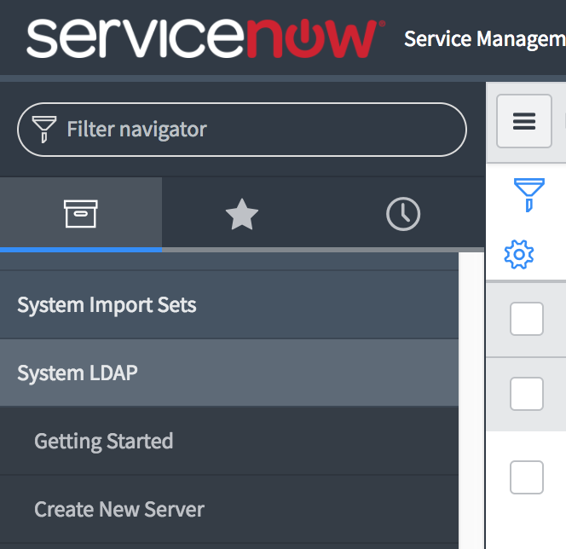
- Enter your LDAP details in the form and click submit. You will be redirected to the newly created LDAP Server configuration page
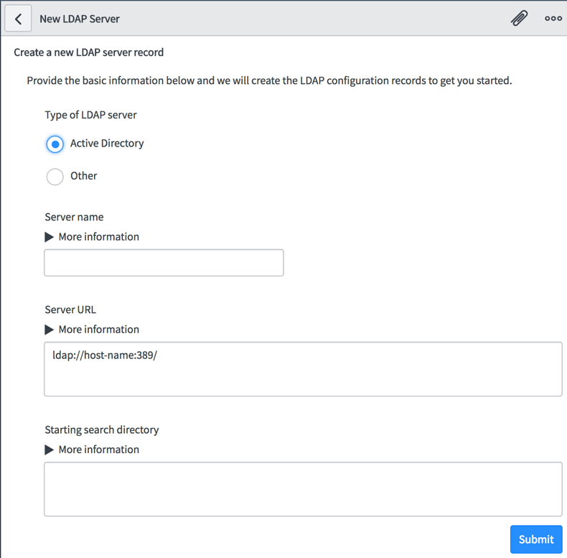
- Before making changes to the LDAP configuration, make sure you scroll down to the Related Links section and select Stop Listener
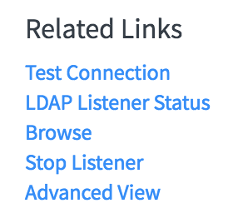
- Once the page has refreshed, enter your LDAP details like login name and password, as well as the search directory string. Specify your MID server in this step as well.
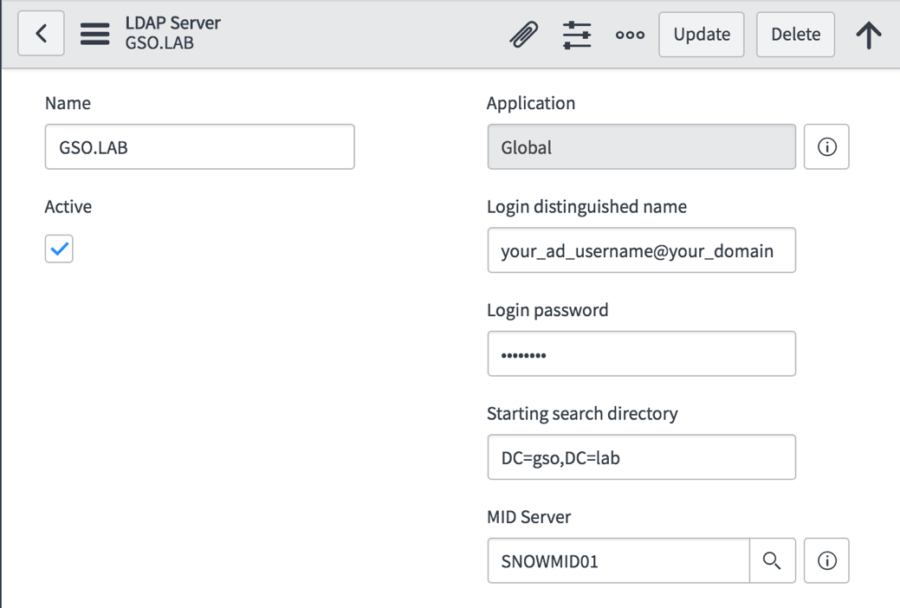
- Scroll down the the Related Links section again and select Test Connection
- If the connection test was successful make sure to start the Listener again via Related Links > Start Listener
- Navigate to System LDAP > Scheduled Loads
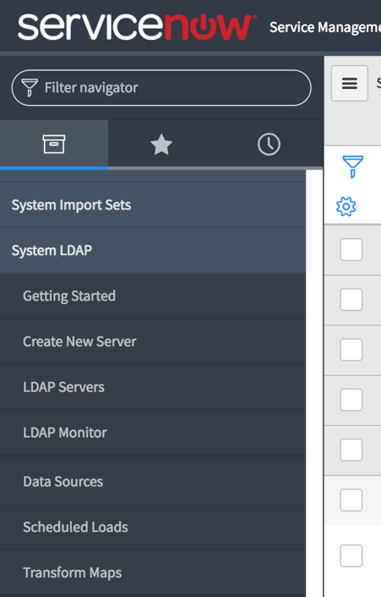
- In the table, select your DOMAIN/Users Import.
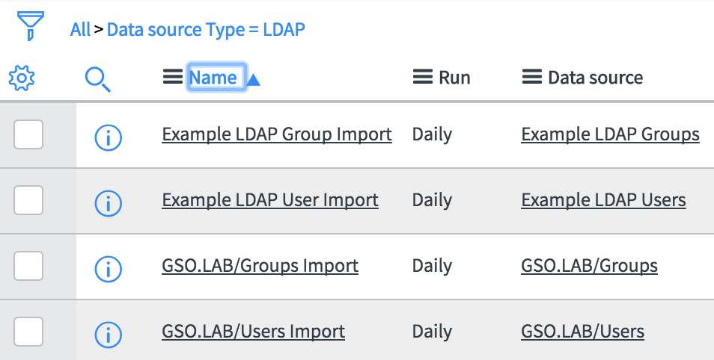
- On the next screen select Execute Now to run the User Import immediately without waiting for the next scheduled load.
- Repeat step 8 and 9 for the Group Import

Service Now – Environment Configuration
If you have not yet set up your environment or standing up a new developer instance, please follow these steps to configure your environment.
- Navigate to System Definition > Tables
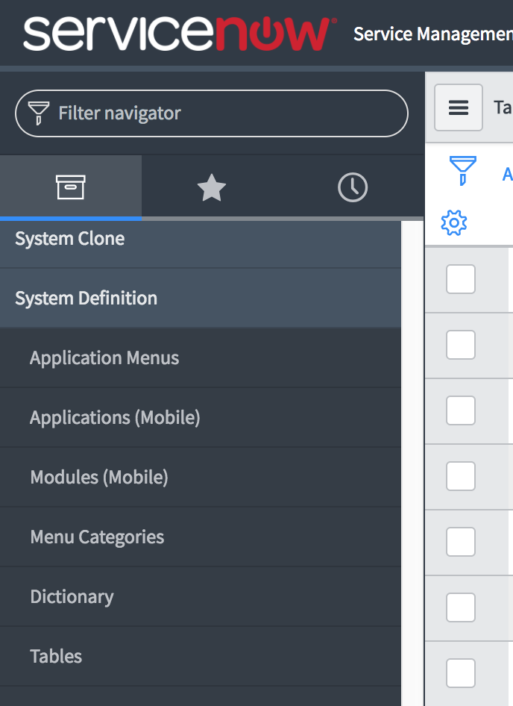
- In the top menu search for cmdb_ci_environment
(make sure you’re searching for Name and not Label)
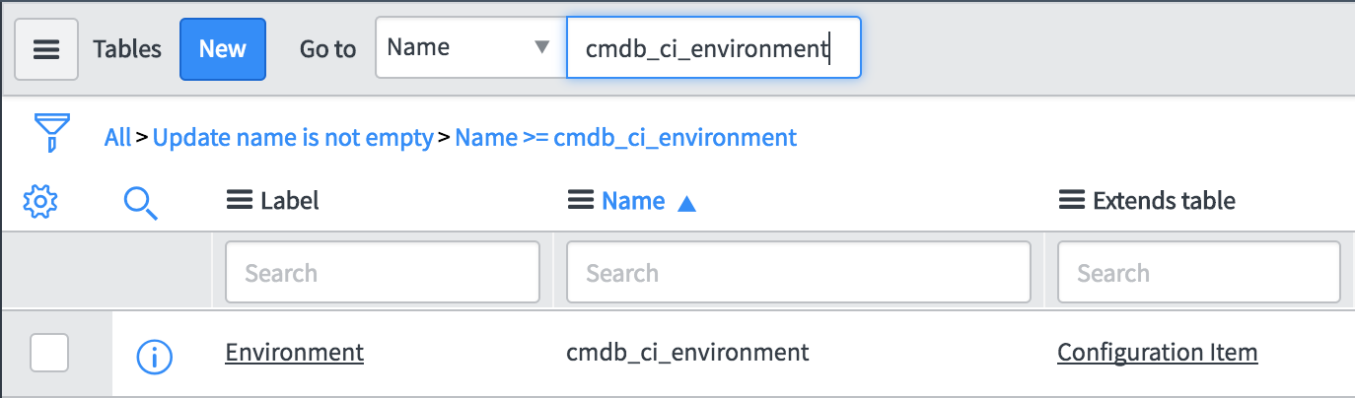
- Select Environment from the returned search results
- Scroll down to the Related Links section and select Show List
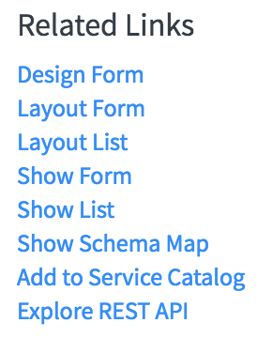
- Click New at the top menu and create your environment
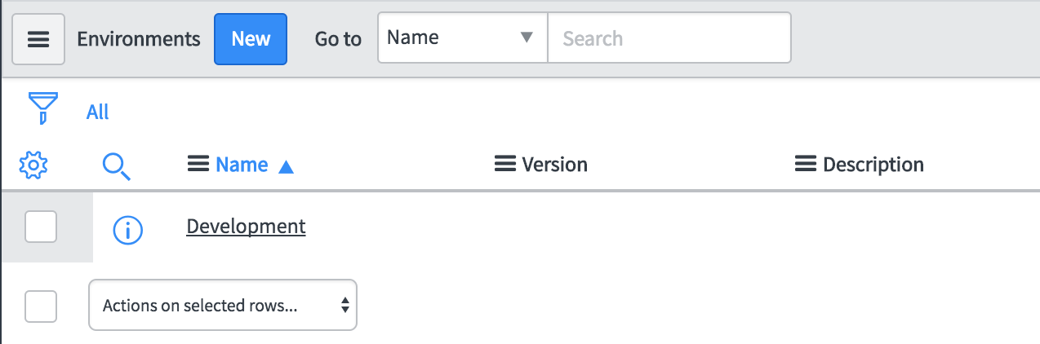
- Fill out the details and Submit the changes
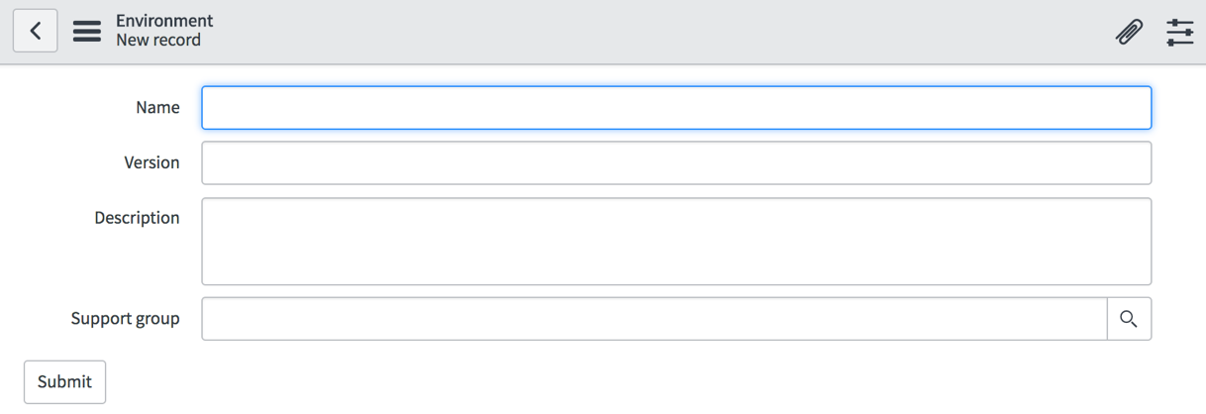

Plugins

Plugin activation
- Navigate to System Definitions > Plugins
- In the search box enter the substring of the plugin name to be searched for
  - In this example we are using encrypt to search for the Encryption Support plugin
- Right click on the plugin and select Activate/Upgrade
- Once complete the list will refresh and the plugin status will change from Inactive to Active
- Repeat steps 1 through 4 for the following list of plugins that need to be activated
  - Encryption Support
  - Configuration Management for Scoped Apps (CMDB)
  - Performance Analytics – Content Pack – Discovery
  - Performance Analytics – Content Pack – Configuration Management (CMDB)
    - This plugin should be activated with the previous plugin activation, but if it hasn't been activated, please activate it.

Plugin Configuration
To configure the Discovery Plugin, navigate to the Discovery > Credentials module
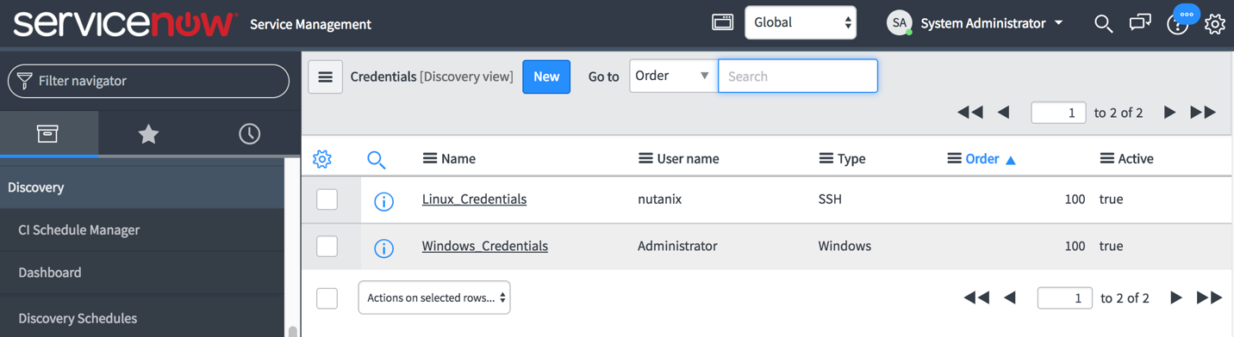
- Click New on the Credentials list
- Enter the required credentials for Linux and/or Windows access

Importing the ServiceNow Application
This section describes how to Import the Completed Update Set from XML.
- On the target instance, navigate to System Update Sets > Retrieved Update Sets
- Under Related Links, choose Import Update Set from XML
- Choose XML file provided by Nutanix Services for the NutanixSSP Utilities and click Upload
- Once uploaded click on NutanixSSP Utilities and then click Preview Update Set
The file you are looking for is called ‘ServiceNow_NutanixSSP-Utilities.xml’
  - There should not be any errors
  - Click Commit Update Set
- Go back to Related Links, choose Import Update Set from XML and perform the same steps for the NutanixSSP XML import.
The file you are looking for is called ‘ServiceNow_NutanixSSP-Core.xml’
- After Update Set NutanixSSP is loaded, click Click on NutanixSSP to bring up the Retrieved Update Set
- Click on Preview Update Set
  - There should not be any errors
    - If there are any errors, there should only be a couple (between 7 to 9). Skip those errors by selecting them at the bottom of the page and running Skip from the drop-down menu.
    - If you find that you are missing tables such as ldap_import, please verify that the LDAP server configuration is correct and that you have run the group and user imports under System LDAP > Scheduled Loads.
  - Click Commit Update Set

Nutanix Configuration Tables
There are several tables that will need to have new records created. The procedure to insert new records into the tables is as follows:
- Navigate to Nutanix SSP > Module (This will be the table to insert new records into).
- Select New
- Enter the information as recorded below.
- Click Submit
Please enter records into the following tables in the following order. (Table modules are in the appropriate order on the NutanixSSP menu)
Note: Types are required to be entered exactly as below. Operating Systems, Customization Specs, Credentials, Cluster Configurations and Catalog Items are tailored to match environment. Records listed below for these tables are examples of how the records are entered.

Operating Systems
Enter the OS information as follows:
OS | Price | Recurring Price
Windows |  | 50.00
Linux

Cluster Types
Enter the following type into the table:
- Default
Additional types can and should be entered based on customer input. Examples of types can be: SQL, Oracle, All Flash, Tier-1, Tier-2 and so on.

Credential Types
Enter the following types into the table:
- Windows Admin
- Linux Admin
- Nutanix Cluster
- Domain Join
- Windows Auto Logon

Authentication Types
Enter the authentication types as follows:
Type | User Label
SSH | Login
Login | User
HTTP | User Name

Authentication Methods
Enter the authentication methods as follows:
Method | Hidden | Password Label | Form Field
Password | Unchecked | Password
Basic Auth | Unchecked | Password
Token | Unchecked | Token
Publickey | Checked | SSH Key Passphrase | ssh_private_key

Authentication
Enter the authentication records as follows:
Authentication Name | Authentication Types | Authentication Methods
Basic Auth | HTTP | Basic Auth
SSH Key | SSH | Publickey
Token | HTTP | Token
Default Login | Login | Password
SSH Login | SSH | Password

Guest Customization Types
Add the following customization types as follows:
Name | Description
cloud_init | Linux Customization Type
sysprep | Windows Customization Type

Guest Customizations
Enter the cloud-init or unattend.xml data into this table. Demo data is as follows:
Note: Specs are to be customized per environment, OS and server deployment required. The specs included below are strictly listed as examples. The product keys and private keys have been altered and are not usable.

Name | Type | Description | Spec
Cloud-Init | cloud_init | Generic Cloud-Init | #cloud-config  fqdn: ${vm_name}  manage_etc_hosts: true
Server 2012R2  or Server 2016 | sysprep | Windows Server 2012R2 or 2016 with minor customizations | (BELOW IS AN EXAMPLE)  <?xml version="1.0" encoding="utf-8"?>  <unattend xmlns="urn:schemas-microsoft-com:unattend">  <settings pass="oobeSystem">  <component name="Microsoft-Windows-Shell-Setup" processorArchitecture="amd64" publicKeyToken="<public token goes here>" language="neutral" versionScope="nonSxS" xmlns:wcm="http://schemas.microsoft.com/WMIConfig/2002/State" xmlns:xsi="http://www.w3.org/2001/XMLSchema-instance">  <OOBE>  <HideEULAPage>true</HideEULAPage>  </OOBE>  <UserAccounts>  <AdministratorPassword>  <Value>${windows_admin_password}</Value>  <PlainText>true</PlainText>  </AdministratorPassword>  </UserAccounts>  </component>  <component name="Microsoft-Windows-International-Core" processorArchitecture="amd64" publicKeyToken="public token goes here" language="neutral" versionScope="nonSxS" xmlns:wcm="http://schemas.microsoft.com/WMIConfig/2002/State" xmlns:xsi="http://www.w3.org/2001/XMLSchema-instance">  <InputLocale>en-US</InputLocale>  <SystemLocale>en-US</SystemLocale>  <UILanguage>en-US</UILanguage>  <UserLocale>en-US</UserLocale>  </component>  </settings>  <settings pass="specialize">  <component name="Microsoft-Windows-Shell-Setup" processorArchitecture="amd64" publicKeyToken="="<public token goes here>" language="neutral" versionScope="nonSxS" xmlns:wcm="http://schemas.microsoft.com/WMIConfig/2002/State" xmlns:xsi="http://www.w3.org/2001/XMLSchema-instance">  <ComputerName>${vm_name}</ComputerName>  <RegisteredOrganization>”Org goes here”</RegisteredOrganization>  <RegisteredOwner>="owner goes here”</RegisteredOwner>  <TimeZone>Pacific Standard Time</TimeZone>  <ProductKey>XXXXX-XXXXX-XXXXX-YYYYY-ZZZZZ</ProductKey>  </component>  <component name="Microsoft-Windows-UnattendedJoin" processorArchitecture="amd64" publicKeyToken="="public token goes here"  language="neutral" versionScope="nonSxS" xmlns:wcm="http://schemas.microsoft.com/WMIConfig/2002/State"  xmlns:xsi="http://www.w3.org/2001/XMLSchema-instance">  <Identification>  <UnsecureJoin>false</UnsecureJoin>  <Credentials>  <Domain>”Domain goes here”</Domain>  <Password>${domain_user_password}</Password>  <Username>${domain_user}</Username>  </Credentials>  <JoinDomain>”Domain goes here“</JoinDomain>  </Identification>  </component>  </settings>  </unattend>

API Specifications
Enter the API Spec for a intentful VM build. Provided is an example for a single disk Linux VM. Please reference developer.nutanix.com v3 API guide for guidelines on what is available for VM intentful Spec.
The following parameters are available and updated by default upon VM request:
- vm_name
- vm_num_vcpus
- vm_memory_mb
- vm_network_uuid
- project_uuid
- vm_user

Name | Description | Spec
linux1disk | API Spec for Single Disk VM - 60GB | {"spec":{"name":"${vm_name}","resources":{"power_state":"ON","num_vcpus_per_socket":1,"num_sockets":${vm_num_vcpus},"memory_size_mib":${vm_memory_mb},"power_state_mechanism":{"mechanism":"HARD"},"disk_list":[{"disk_size_mib":61440,"device_properties":{"device_type":"DISK","disk_address":{"adapter_type":"SCSI","device_index":0}},"data_source_reference":{"kind":"image","uuid":""}}],"guest_customization":{"cloud_init":{"user_data":""}},"nic_list":[{"subnet_reference":{"uuid":"${vm_network_uuid}","kind":"subnet"}}]}},"metadata":{"project_reference":{"uuid":"${project_uuid}","kind":"project"},"kind":"vm","owner_reference":{"kind":"user","uuid":"${vm_user}"},"categories":{}},"api_version":"3.0.0"}
windows1disk | API Spec for Single Disk VM – 50GB | {"spec":{"name":"${vm_name}","resources":{"power_state":"ON","num_vcpus_per_socket":1,"num_sockets":${vm_num_vcpus},"memory_size_mib":${vm_memory_mb},"power_state_mechanism":{"mechanism":"HARD"},"disk_list":[{"disk_size_mib":50000,"device_properties":{"device_type":"DISK","disk_address":{"adapter_type":"SCSI","device_index":0}},"data_source_reference":{"kind":"image","uuid":""}}],"guest_customization":{"sysprep":{"unattend_xml":""}},"nic_list":[{"subnet_reference":{"uuid":"${vm_network_uuid}","kind":"subnet"}}]}},"metadata":{"project_reference":{"uuid":"${project_uuid}","kind":"project"},"kind":"vm","owner_reference":{"kind":"user","uuid":"${vm_user}"},"categories":{}},"api_version":"3.0.0"}

Credentials_SSP
Enter the credential records as follows:

Name | Credential Type | User | Password | Authentication | SSH Private Key  (Hidden unless SSH Key is selected for Authentication) | User Variable Name | Password Variable Name
Enter cluster name here | Nutanix Cluster | Enter cluster user account for access here | Enter password for user | Basic Auth |  | nutanix_cluster_user | nutanix_cluster_password
Enter Domain name ere | Domain Join | Enter User name with access to join Windows servers to the Domain | Enter domain user password | Default Login |  | domain_user | domain_user_password
Enter Name for Linux account | Linux Admin | Enter Linux Admin user name here | Enter password for linux admin here | SSH Login |  | linux_admin_user | linux_admin_password
Windows Admin | Windows Admin | administrator | Enter adimistrator password here | Default Login |  | windows_admin_user | windows_admin_password
Windows Adminstrator Auto Logon Account | Windows Auto Logon | administrator | Enter Auto logon account password here | Default Login |  | windows_auto_logon_user | windows_auto_logon_password

Cluster Configurations
Enter the credential records as follows for your Prism Central instance

Name | FQDN | IP | Uuid | Environment | Type | Location | Credentials | Description
PC 5.5 name is entered here | PC 5.5 FQDN is entered here | PC 5.5 IP is entered here | not needed | Select Environment  (this is pulled from the CMDB environment entries) | Default | Select Location  (This is pulled from the Location table for the ServiceNow instance. | Select the cluster credentials that were setup in the previous step | Enter a description

Catalog Items
Create an entry for each disk image you would like for your catalog. To get the Disk Image UUID, follow these instructions:
- SSH to Prism Element and login with nutanix
- type acli image.list
- This will show all images and their UUID

Name | UUID | OS Type | Cluster Name | Description | API Specification | Customization Spec
Enter a name for the Catalog Item here | Disk Image UUID is entered here | Select the appropriate OS type | Select the cluster that the template resides on | Enter a description here | Select the appropriate API specification. | Select the appropriate customization spec.

Catalog Items Credentials
Enter the catalog item and credential information as follows:
Catalog Item | Credential
Catalog item to link with credential  e.g. Below | Credential to link with catalog item  e.g. Below
Windows Server 2012R2 | Name of Windows Admin type
Windows Server 2012R2 | Name of Domain Join type
Windows Server 2012R2 | Name of Windows Auto Logon type

VM Sizes
To enable t-shirt sizing of your catalog items, fill out the following table:
Size | Number CPU | Memory in MB | Price | Recurring Price | Description
Enter Size  (small,large,etc) | Enter Number of CPU Sockets | Enter Memory in MB | Enter Price for this size

Final Configurations

Service Catalog
- Navigate to Self Service > Service Catalog
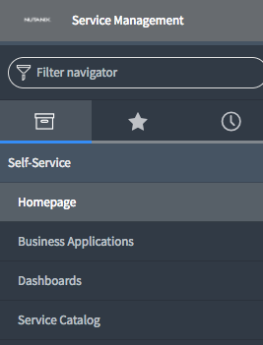
- Select the + sign at the top right of the Service Catalog view
- Add Nutanix Services to the desired position of your Service Catalog

Adjust Discovery Settings for CMDB
- As a System Administrator, go to Discovery Definition > Probes
- Make sure you are in the Global Context, not the NutanixSSP before proceeding
- Search for Probe Name Shazzam
- Click on Shazzam in results to edit
- Add or modify the following probe parameter: BannerTCP_waitForConnectMS with a value of 120000

Assign Roles
Assign additional roles to the user or group that will be requesting items via the catalog.
- Navigate to User Administrator > Users (or Groups) and select the correct user or group you want to modify.
- At the bottom of the page select the Edit… button within the Roles table
- Assign the following roles:
  - x_72900_nutanixssp_ssp_users_user
  - x_72900_nutanixssp.security_context_user
  - x_72900_nutanixssp.operating_systems_user
  - x_72900_nutanixssp.cluster_configurations_user
  - x_72900_nutanixssp.vm_sizes_user

APPENDIX A – FAQ

ServiceNow Development Instance modifications
When working in a ServiceNow development instance, make sure you remove the instance demo data before starting to work on the instance. To remove the demo data, login to your ServiceNow developer account and navigate to Manage > My Instance. Make sure you select the correct instance and then go to Action > Remove demo data.
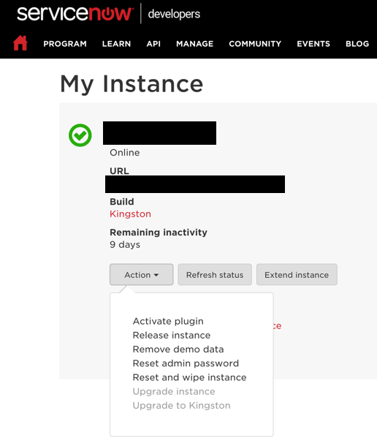

Service Catalog
(optional step if Nutanix Services is not showing in the Self-Service section)
- Add catalog item Nutanix Services to your service catalog
- Navigate to System Applications > Studio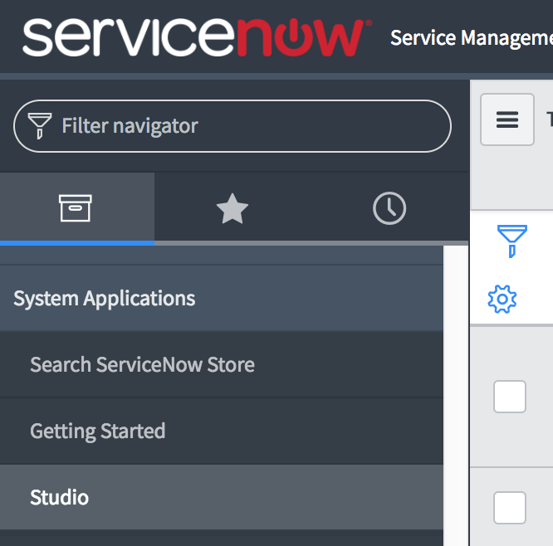
- You will be presented with the Load Application view, select NutanixSSPv5
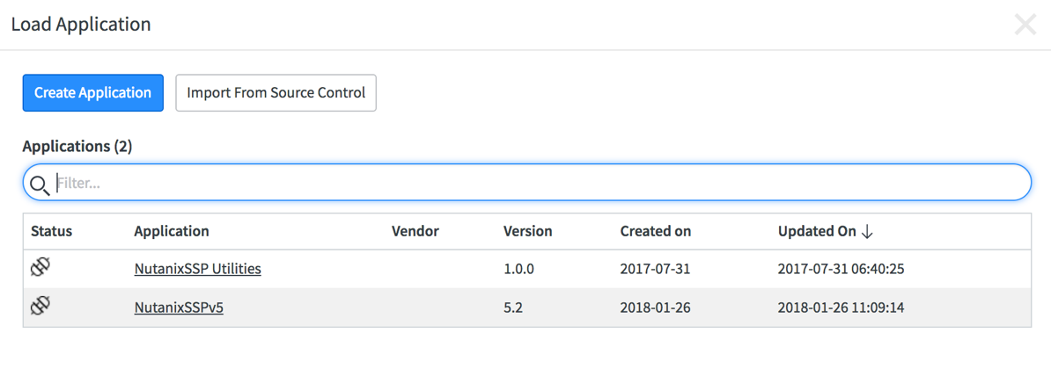
- Within the Studio Editor navigate to
Service Catalog > Catalog Items> AHV Choose OS
- In the Catalog Item view, select the appropriate Catalog for your environment
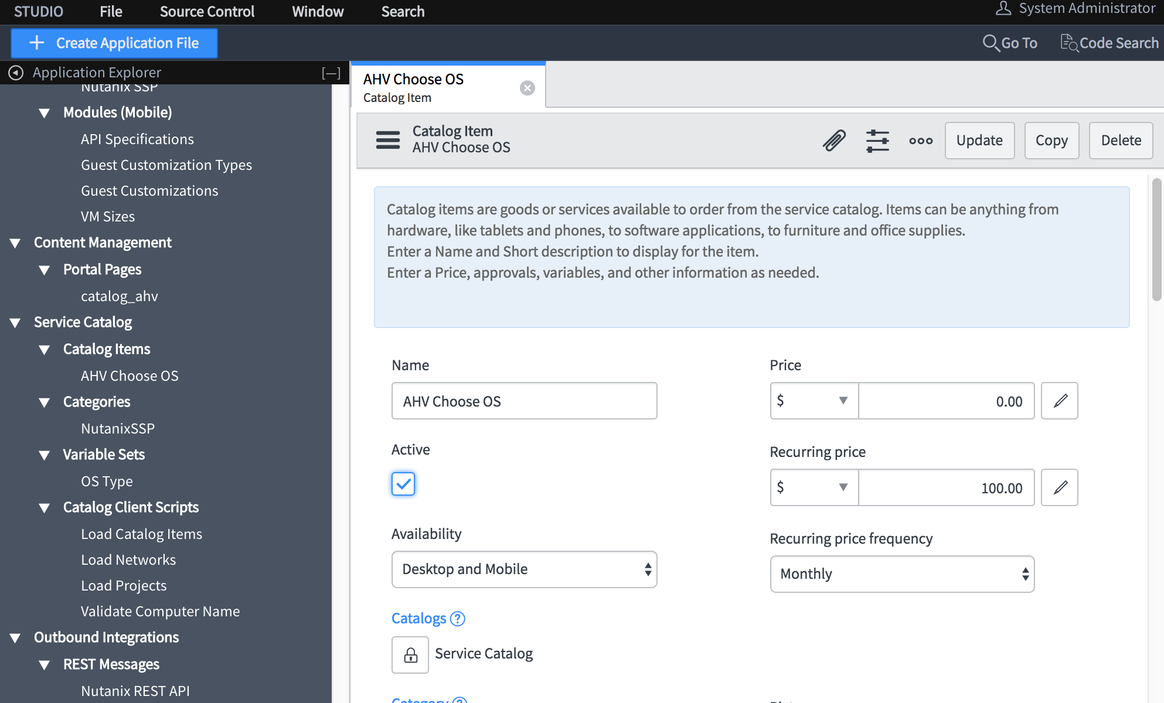
- Login with your user or use the Impersonate User function by selecting the System Administrator account at the top right of the ServiceNow screen
- Navigate to Service Catalog and you’ll be presented with your Service Catalog items which should now include AHV Choose OS
Note: if AHV Choose OS is not showing up, try using the search function at the top right of the Service Catalog screen.

