

Learning eZ publish : Building Content Management Solutions

Paul Borgermans Tony Wood
Paul Forsyth Martin Bauer Björn Dieding Ben Pirt
Bruce Morrison



Learning eZ publish :
Building Content Management Solutions

Copyright © 2004 – 2024 7x and Graham Brookins

Permission is granted to copy, distribute and/or modify this document under the terms of the GNU Free Documentation License, Version 1.3 or any later version

published by the Free Software Foundation; with no Invariant Sections, no Front-Cover Texts, and no Back-Cover Texts.

A copy of the license is included in the section entitled "GNU Free Documentation License".

Source code of the Learning eZ Publish Book is free software: you can redistribute it and/or modify it under the terms of the GNU General Public License as published by
the Free Software Foundation, either version 2 of the License, or (at your option) any later version.

Learning eZ Publish Book is distributed in the hope that it will be useful,
but WITHOUT ANY WARRANTY; without even the implied warranty of
MERCHANTABILITY or FITNESS FOR A PARTICULAR PURPOSE. See the
GNU General Public License for more details.

You should have received a copy of the GNU General Public License along with Learning eZ Publish 3 in this document. If not, see <http://www.gnu.org/licenses/>.
Every effort has been made in the preparation of this book to ensure the accuracy of the information presented. However, the information contained in this book is sold without warranty, either express or implied. Neither the authors, 7x, nor its dealers or distributors will be held liable for any damages caused or alleged to be caused directly or indirectly by this book.
Packt Publishing has endeavored to provide trademark information about all the companies and products mentioned in this book by the appropriate use of capitals. However, 7x cannot guarantee the accuracy of this information.

Second edition: August 2024

GFDL Document Version Number: 2.0.4

Published by 7x.
www.se7enx.com
Cover Design by www.visionwt.com

Credits

Authors
Paul Borgermans Tony Wood
Paul Forsyth Martin Bauer Björn Dieding
Ben Pirt
Additional Material
Bruce Morrison

Technical Reviewers
Jan Borsodi Bård Farstad Balazs Halasy
Release Author
Graham Brookins
Commissioning Editor
Douglas Paterson

Technical Editors Ashutosh Pande Deepa Aswani
Indexer
Ashutosh Pande

Proofreader
Chris Smith

Layout
Ashutosh Pande

Cover Designer
Helen Wood

About the Authors

Paul Borgermans holds a Masters degree in Science and a PhD in Applied Physics. He became involved with high-performance computing from the start of the 90s while doing plasma physics research. From then on, computing has always been an important part of his job, which gradually involved the integration of large databases, computations, and operational management in R&D. The birth of the World Wide Web also marked the start of projects around intranet developments. Recently, he started a knowledge-management program with his current employer, the Belgian Nuclear Research Center. In this program, eZ publish is used as a cornerstone for developing support tools to capture and preserve knowledge in the long term.

I wish to thank my daughter and wife for the many hours and weekends of patience while working on this book during my free time.

Tony Wood has over 16 years of experience working for both small and large clients, with work ranging from system administration to knowledge management.
Tony is an active member of the eZ publish community and regularly contributes to it. Tony works for VisionWT—a company he founded on the principle that content management should be available to all—which was the first company outside of eZ publish to deploy an eZ publish version 3 site and has focused on creating only eZ publish sites. Tony concentrates on building VisionWT, whatever its budget.

Paul Forsyth is an active contributor to the eZ publish community, and lead developer at Vision with Technology. As Lead Developer, Paul helps to develop processes, methods, and technical standards in addition to developing systems and overseeing the development team.
Previously, Paul was a Software Engineer at Parc Technologies, where his work included programming and system architecture on sophisticated applications optimizing flight schedules and managing fleet size for the airline industry. Paul was a PhD student at the University of Leeds after completing an MSc with Human Computer Systems at De Montfort University and a BSc (Hons) with Artificial Intelligence and Computer Science at the University of Edinburgh.

Martin Bauer is the Managing Director of designIT (www.designit.com.au). Martin draws on a varied background having studied a wide range of subjects including computer science, mathematics, law, literature, and visual arts before graduating from law. Deciding against a career in law, Martin started working as a writer in an advertising agency. This gave him the chance to work on his first website and has been his passion from that point on.
Soon after, Martin joined Creative Access, a reputable web design firm that was purchased in 1999 by Sausage Software and became the head office of Australia’s largest web development company, Sausage Interactive. Martin became responsible for a 20+ web development team.
During 2001, Martin worked as a Project Manager for Nebulon, a software consulting firm lead by world-renowned Project Manager Jeff Deluca, creator of one of the most popular agile methodologies, Feature-Driven Development.
In late 2001, Martin joined forces with the original directors of Creative Access to form designIT, which has grown to once again become one of Melbourne’s most reputable web design and development firms.

I’d like to thank everyone at designIT for their support and positive attitude without which we could not produce the results we do. I’d also like to thank everyone at the Centre for Design at RMIT for providing us with such a great opportunity. And thanks to my family and friends for always believing in me.

Bruce Morrison is Chief Technical Architect at designIT. Bruce’s experience with the Internet started while at Queensland University in the early 1990s. He can recall when all Australian websites could be visited in around 15 minutes, images opened in a separate application, and there were no such thing as tables. Haven’t things changed!
Bruce began his career as a System Administrator, working in various fields, including medical research, internet service providers, consultancies, and non-government organizations. In 2002, he turned his back on the heady world of system administration and joined designIT as a Systems Architect.
Bruce has been working with the eZ Publish CMS since the release of the first beta version of 3.0 in December 2002. He has since completed a number of sites using eZ publish.

I would like to thank the great team at designIT for being a terrific bunch of people to work with and my family for their love and support.

Ben Pirt studied architecture at Edinburgh University. In 1999 he moved to New York, where he developed animation skills through working for a design and visualization

company. Here he was also able to strengthen his web development skills through the use of PHP, SQL, CSS, and XHTML. On his return to Edinburgh in 2001, he co-taught a course on architecture and multimedia before completing his postgraduate diploma at the Bartlett School of Architecture. His work with the Interactive Architecture Workshop at the Bartlett enabled him to increase his programming capabilities and to combine this knowledge with other media through embedded programming and hardware design.
Since finishing his diploma, he has continued to develop skills in this area and has extended his web development knowledge through the use of eZ publish in combination with XHTML and CSS. He has recently set up a company, More Associates, where he is able to combine his two main fascinations: design and technology.

Björn Dieding attended the Ev. Gymnasium Werther, where he took advantage of a student exchange to the U.S. in 1997, and at this time, first came into contact with web design. From then on he invested much of his free time gathering knowledge and learning about Internet-related topics. In 1999 he started realizing his first commercial projects. In 2000 Björn attended the b.i.b. Hannover (http://www.bib.de), graduating in 2003 as a computer scientist in e-commerce (Staatl. gepr. Informatiker Electronic Commerce).
After graduation, he became a freelance web application programmer and web designer. In March 2004, Björn became the first core developer of eZ publish outside eZ systems.
Björn Dieding met Sören Meyer while studying, and at the end of 2002 they decided to team up as xrow GbR (http://www.xrow.de). Their main objective was to deliver value- added services for professional and high-quality open source software. Today, xrow GbR is one of the top German consultancies for delivering eZ publish services.

I would like to thank Sören for being my trusted business partner and eZ Systems for their wonderful work on eZ publish.

Table of Contents

Introduction 1
Chapter 1: Installing eZ publish 5
Setting Up 5
Unpacking the Installation 5
Initializing the Database 6
Apache Virtual Host Settings 7
Image Settings 8
ImageMagick 8
GD 8
Cron Jobs 9
Configuration Files 9
The Setup Wizard 10
Page 1 of the Setup Wizard: Welcome to eZ publish 11
Page 2 of the Setup Wizard: System Check 12
Page 3 of the Setup Wizard: Email Settings 13
Page 4 of the Setup Wizard: Choose a Database 14
Page 5 of the Setup Wizard: Database Initialization 15
Page 6 of the Setup Wizard: Language Support 16
Page 7 of the Setup Wizard: Site Packages 17
Page 8 of the Setup Wizard: Site Access Configuration 18
Page 9 of the Setup Wizard: Site Details 19
Page 10 of the Setup Wizard: Site Security 20
Page 11 of the Setup Wizard: Site Registration 21
Page 12 of the Setup Wizard: Finished 22
Troubleshooting 22
PHP Memory Limits 22
PHP Running as a CGI 23
Summary 23
Chapter 2: Content Management with eZ publish 25
What Is Content Management? 25
eZ publish Fundamentals 26
Structuring Content 26
Site Structure 26
Node Tree (Content Object Tree) 26
Sections 27
Content Classes 28
Content Class Attributes 28
Content Object 28
Displaying Content 30
Separation between Content and Presentation 30
Site Structure versus Page Layout and Content Views 30
Overall Page Layout and Content Views 30
Authorization and Roles 31
Disabling a Module/Function outside the Role System 36
Adding Content with the Default Admin Interface 36
Creating Content Classes 37
Datatypes 38
XML Tags Available with ezxmltext Datatypes 46
Datatypes as Information Collectors 48
Creating a New Content Object 48
Editing Objects and Versioning 50
Managing Translations 51
Related Content 53
Workflows 54
Triggers 54
Workflow Events 55
Permissions/Roles 57
Templates 59
More Administrator Functions 61
Removing and Restoring Objects 61
URL Translation 61
URL Management 62
RSS Export and Import 62
Cache Administration 64
Search Stats 65
System Information 65
Section Setup 66
PDF Export 67
Rapid Application Development (RAD) 68
Extension Setup 68
Packages 68
Notification 68
Personal 68
Shop 69
Creating an Example Site 69
Creation of Basic Classes 69
Documents 70
Images 70
Discussion Forums 71
Calendar of Activities 71
Personalization 72
Miscellaneous 72
Creating Classes 72
Taxonomy or Structure 72
Users and Roles 74
Sections Setup 74
User Groups 75
Roles and Role Assignments 76
Summary 78
Chapter 3: Displaying Content with eZ publish Templates 79
Principles 79
Page Layout and Content Views 80
Page Layout 81
Content Views 81
Attribute Templates 82
Template Modularization 82
Style Sheets and Images 82
Edit Templates 82
Templates and Caching 83
Cascading and Overriding Templates 83
Working with eZ Publish Templates 83
Overview 83
Where Does the Content (Data) Come From? 84
Comments 84
Variables 85
Setting and Modifying Variables 85
Variable Types 87
Type Creators 87
Sections in Templates and their Effects on Variables 88
Variable Namespaces 88
Predefined Variables 88
Using Variables across Templates 93
Controlling Template Output Flow 94
Section 94
If-then-else Constructs with Section 97
Loops with Section 97
Switch Constructs 98
Variable Namespaces Revisited 99
Using Functions from Kernel Modules 101
Functions in the Content Module 101
Fetching a Single Node or Object 104
Fetching Node Lists and Node Trees 105
Counting the Objects of Certain (or all Types) 107
Displaying Version Information 108
Fetching the Current User 108
Others 109
Increasing Performance with Caching 109
Overall Caching 109
Cache-blocks 109
Custom Template Operators 111
The Template Override System 111
Using Cascading Effects in Templates 112
Overriding Templates Using Specific Conditions 112
Syntax of override.ini.append.php 112
Common Template Tasks 114
Navigation Menus 114
Top Level Menu 114
Breadcrumb Navigation 115
Tree Menus 115
Adding Edit Functions to Your Templates 116
Allow Users to Add Content to Your Site 116
Adding an Edit Link 117
Adding a Remove Button 117
Adding a Comment Button 117
Date and Time Tasks 117
Displaying Tomorrow's Date 118
String and Text manipulation 118
Limiting Text Output 118
Limiting XML Text Output 118
Automatic Linking and Conversion 119
Providing a Custom User Experience 119
Creating Dummy Nodes 119
A Specific User Panel 119
Putting the User Preferences Function to Work 120
Showing a User's Groups and Roles 120
Miscellaneous 121
Show a Version History Audit Trail 121
Show Creator, Modifier, and Publishing Date 122
Listing keywords and their Automatically Related Objects 122
Advanced Keyword Facility 122
Creating a Threaded Forum Template 124
Summary 124
Chapter 4: A Glimpse Inside the Core 125
Permissions 125
Object Persistence 128
Getting Attribute Values 130
Setting Attribute Values 130
Other Attribute Functions 131
Persistent Storage 131
Fetching Data 131
Storing Data 131
Other Data Manipulation 132
Content Classes 132
Content Class Attributes 134
Content Objects 135
Creating a Content Object 136
Workflows and Triggers 138
Notifications 142
Information Collection 145
Searching 146
Summary 148
Chapter 5: Extending eZ publish 149
Why Create an Extension? 149
Adding an Extension 150
Locating Your Extension 151
Example Directory Extensions 152
Datatype Extension 152
Module Extension 152
Workflow Eventtype Extension 152
Documentation on Extensions 153
Modules 153
Module Definitions 154
Module Names and Views 154
View Permissions 155
View Parameters 155
View Actions and Post Variables 156
View Navigation 158
Module Coding 159
Reading Module Input 159
Returning Information 159
Processing a Template 160
Redirecting a Module 161
Module Functions 162
Datatypes 164
Datatype Settings 164
Datatype Templates 164
The Datatype Wizard 165
Implementing the Datatype 167
Constructing a Datatype 167
Storing Datatype Information 167
Initializing with Default Values 168
Working with Class Attributes 169
Working with Object Attributes 171
Other Datatype Functions 171
Template Design 172
Complex Datatypes 173
Template Operators 173
Adding a PHP Command 173
The Template Operator Wizard 174
Writing an Operator 176
Registering the Operator 176
Coding the Operator 177
Initializing the Operator 177
Executing the Operator 177
Workflow Events and Triggers 178
Workflow Settings 178
Workflow Events 179
Workflow Triggers 181
Defining Triggers 182
Actions 183
Translations 184
Overriding Translations 185
Notifications 185
Notification Events 185
Adding Collaborations 187
SOAP Server 187
RSS (Really Simple Syndication) 193
Data Interoperability 196
Importing Information 197
Publishing a Folder Object 197
Login Handlers 199
LDAP (Lightweight Directory Access Protocol) 199
Text File Login 201
Summary 201
Chapter 6: Extension Development 203
Extension Development Practices 203
Designing Your Extension 203
Goals and Targets of the Extension 204
Preparing to Test Your Extension 204
Timescales 204
Anticipate the Learning Curve 204
Software Requirements 204
Development Tools 205
Sharing with the Community 205
Documentation 206
Creating the WorldPay Extension 206
Creating the Environment 207
Creating Workflow Events and Triggers 208
WorldPay Module 212
Creating the Module Extension Environment 213
Creating the Module 213
Reviewing the ini Settings 217
User Settings 217
Permissions 218
Callback Testing 218
Creating the Category Datatype 219
Category Datatype Design 219
Setting Up the Extension Environment 219
The Category Database Table 220
Database Communication 221
Category Discussion 221
Category Templates 224
The Category Datatype in Action 224
Integrating Existing Code with eZ publish 225
Making a Bridge to External Applications 225
Strategies 226
Who Am I? 227
Authentication 227
Communicating with Google 230
Modifying Existing Code 233
Summary 233
Chapter 7: Deploying eZ publish 235
Define Your Hosting Requirements 235
Number of Visitors 236
Security Needs 237
Reporting Requirements 238
Budget 239
Time Limits 239
Shared or Dedicated 239
Is My Server Powerful Enough? 240
Documentation 241
How and When to Update the Documentation 241
Contact Details 241
Location 242
Hardware 242
Operating System 242
Software 242
Patching Process 242
DNS Information 242
TCP/IP Information 242
Access Control 243
Upgrade Roadmap 243
Disaster Recovery 243
Preparing the Linux Environment 243
Apache 244
PHP 245
Database (MySQL/PostgreSQL) 246
GD Graphics library 247
ImageMagick 247
Cron Jobs 247
SMTP 248
PHP Accelerators 248
Deploying 249
New Project Deployment 250
Updating Project Deployment 250
Backups 251
Ports 251
Summary 252
Chapter 8: Center for Design at RMIT Case Study 253
The Client 253
The Existing Site 255
The Project 255
The Process 256
Requirements 257
Key Objectives 257
Creative 257
Functionality 257
Content 258
Hosting Environment 258
Selecting a CMS 258
Specifications 259
User View 259
Admin View 261
Links 263
Miscellaneous 264
Content Model 265
Display Templates 267
Sustainable Products, Sustainable Buildings, and LCA Template 268
Content Types 269
Interface Design 272
Visual Design 272
HTML Prototype 274
The Home Page 275
Section Pages 275
Content Pages 277
Development 278
Install eZ publish 278
Define Content Classes and Sections 279
Configure Roles and Permissions 279
Apply Display Logic and Templates 280
Create Page Layout Templates 281
Navigation 282
Setting Up 283
Summary Pages 292
Content Templates 296
Testing 300
Requirements 300
Specifications 300
Implementation 300
Functional Testing 300
Content Population 301
Deployment 301
Maintenance and Support 301
Training 301
Project Assessment 302
Requirements and Specification Phases 303
Development Phase 303
Content Population and Review Phase 304
Extending the Site 304
Workflow 305
Archiving 305
Integration with CRM 305
Summary 305
Chapter 9: Creating a Standards-Compliant eZ publish Site 307
What Are Web Standards? 307
XHTML 308
CSS 309
Web Standards: Real-World Scenario 310
Accessibility 310
Bandwidth 310
Future Proofing 310
Ease of Maintenance 310
eZ publish and Web Standards 311
The Client Requirements 311
Planning and Preparation 314
Template Design 316
page_head.tpl 319
header.tpl 320
navigation.tpl 321
image.tpl 322
footer.tpl 323
CSS Rules 325
Designing the Content 328
The News Article Class 329
The Data Class Definition 329
Class Templates 329
CSS Rules 330
Performance 332
View Caching 333
Template Compiling 333
Template Cache Blocks 333
PHP Accelerators 334
Benchmarking 335
ab 335
Effects of Optimization 336
Summary 337
Appendix A: Template Operators and Functions 339
Operators 339
String Operators 339
String Transformations 341
Counting and Comparing Strings 344
Array Operators 344
sum and sub 348
inc and dec 348
div 348
mod 349
mul 349
Max and min 349
abs 349
ceil and floor 349
round 349
Localization and Translation Operators 349
Logical Operators 351
ne 351
lt 351
gt 351
le 351
ge 351
eq 351
null 352
not 352
true 352
false 352
or 352
and 352
choose 353
contains 353
Type Checking 353
Image Handling 354
Other Template Operators 357
count 357
Accessing Variables in the ini Files 358
cond 358
first_set 359
eZ publish Kernel Operators 359
Index 363

Introduction

eZ publish is an open-source Content Management System created by eZ systems of Norway (www.ez.no). Built primarily upon around the LAMP platform—Linux, Apache, MySQL and PHP—eZ publish is based on open standards, with a flexible content model, a powerful template engine, workflow management, role-based permissions, and much more. Now at version 3, eZ publish has matured beyond a Web-based Content Management System to a powerful, Content Management Framework, which developers can extend and customize to produce unique web solutions.
There is also a set of commercial licenses for eZ publish, but the free version places no restrictions on your usage of the system.
Like most open-source products, eZ publish has a large and dedicated community whose members share their experience and knowledge with the rest of community. At:
http://www.ez.no/community
you will find forums, contributions, bug reports, documentation, news, and more.
eZ publish is powerful and versatile, and as such, many have found it difficult to get to grips with initially, with much hair-pulling over some of its seemingly esoteric features. This book owes much to such hair-pulling and cursing—our authors have come through that experience, and the material we present here will help you develop the skills required to become an accomplished eZ publish developer.

What This Book Covers
The structure of this book is as follows: we begin with installing eZ publish, look at how to implement and customize a site, and then extend and deploy the system. The book is rounded off by two real-world case studies of eZ publish implementations, and the design choices and strategies that were employed to realize them.
Chapter 1 starts us off with a straightforward guide to installing an eZ publish instance. Once we are setup, Chapter 2 moves on to look at the fundamental features of eZ publish—its content handling and the structure of an eZ publish site. The chapter takes us through the eZ publish administration area, and shows how to use it to work with content, users, and permissions.
Chapter 3 takes us into eZ publish's template system—through templates, we control our site's output, and this chapter shows the general principles of the template engine, an
in-depth discussion of the template language and syntax, and the template-override
system. The chapter is linked to Appendix A, which discusses the various operators and functions. Before we embark on a detailed exploration of eZ publish extensions, Chapter 4 looks at how some of eZ publish's fundamental concepts are realized at the code level.
eZ publish is designed to be extended, and in Chapter 5 we look at the different types of extension that can be created for eZ publish. Extensions allow new template operators, datatypes, and modules (among others) to be developed separately and added to the base eZ publish system. An extension may be something as small as a new template operator, or something as critical as an interface to your other business applications. In Chapter 5, we tackle how to use the extension mechanism to add your functionality to eZ publish.
In Chapter 6, we look at real-world examples of extension development, create new modules and datatypes, and explore strategies for integrating existing code or systems with eZ publish.
Chapter 7 covers strategies and techniques for successfully deploying eZ publish projects, from assessing and preparing your hosting environment to moving the project to your production server.
The final two chapters of the book are real-world case studies of eZ publish 3 implementations. In the first case study, we see the journey from client requirements to content model, and from HTML mockup to template design. eZ publish requires you to think about the structure of your site and the types of content it supports in a way that may be different from how you usually view your site—this first case study provides a vivid illustration of how to approach this problem. The second case study shows us how eZ publish, XHTML, and CSS fit together to produce a standards-compliant eZ publish site, with particular emphasis on the template design.

What You Need for Using This Book
To use this book, you will of course need eZ publish. This is freely downloadable from http://www.ez.no/ez_publish/download.
If you have working installations of PHP, Apache, and MySQL, you can download the source code for eZ publish. Alternatively, there are installer packages that install all the required software to run eZ publish (PHP, Apache, and MySQL). Note that these packages are meant for testing purposes only.

Conventions
In this book you will find a number of styles of text that distinguish between different kinds of information. Here are some examples of these styles, and an explanation of their meaning.
Introduction
There are three styles for code. Code words in text are shown as follows: "For the category class, the category_string attribute returns a comma-delimited string listing the categories the attribute belongs to".
If we have a block of code, it will be set as follows:
<?php
include_once( "kernel/classes/ezdatatype.php" );
define( "EZ_DATATYPESTRING_NEWDATATYPE", "newdatatype" ); class newDataTypeType extends eZDataType
{
function newDataTypeType()
{
$this->eZDataType( EZ_DATATYPESTRING_NEWDATATYPE, "None" );
}
}
eZDataType::register(EZ_DATATYPESTRING_NEWDATATYPE, "newdatatypetype"
);
?>
When we wish to draw your attention to a particular part of a code block, the relevant lines will be made bold:
<?php
include_once( "kernel/classes/ezdatatype.php" );
define( "EZ_DATATYPESTRING_NEWDATATYPE", "newdatatype" ); class newDataTypeType extends eZDataType
{
function newDataTypeType()
{
$this->eZDataType( EZ_DATATYPESTRING_NEWDATATYPE, "None" );
}
}
eZDataType::register(EZ_DATATYPESTRING_NEWDATATYPE, "newdatatypetype"
);
?>
New terms and important words are introduced in a bold-type font. Words that you see on the screen—in menus or dialog boxes, for example—appear in our text as follows: "clicking the Next button moves you to the next screen".
Tips, suggestions, or important notes appear in a box like this.
Any command-line input and output is written as follows:
mysql> create table books (name char(100), author char(50));
Query OK, 0 rows affected (0.03 sec)

Reader Feedback
Feedback from our readers is always welcome. Let us know what you think about this book, what you liked or may have disliked. Reader feedback is important for us to develop titles that you really get the most out of.
3
To send us general feedback, simply drop an e-mail to feedback@packtpub.com, making sure to mention the book title in the subject of your message.
If there is a book that you need and would like to see us publish, please send us a note in the Suggest a title form on www.packtpub.com or e-mail suggest@packtpub.com.
If there is a topic that you have expertise in and you are interested in either writing or contributing to a book, see our author guide on www.packtpub.com/authors.

Customer Support
Now that you are the proud owner of a Packt book, we have a number of things to help you to get the most from your purchase.

Downloading the Example Code for the Book
Visit http://www.packtpub.com/support, and select this book from the list of titles to download any example code or extra resources for this book. The files available for download will then be displayed.
The downloadable files contain instructions on how to use them.

Errata
Although we have taken every care to ensure the accuracy of our contents, mistakes do happen. If you find a mistake in one of our books—maybe a mistake in text or a code error—we would be grateful if you could report this to us. By doing this you can save other readers from frustration, and also help to improve subsequent versions of this book.
If you find any errata, report them by visiting http://www.packtpub.com/support, selecting your book, clicking on the Submit Errata link, and entering the details of your errata. Once your errata have been verified, your submission will be accepted and the errata added to the list of existing errata. The existing errata can be viewed by selecting your title from http://www.packtpub.com/support.

Questions
You can contact us at questions@packtpub.com if you are having a problem with some aspect of the book, and we will do our best to address it.

1

Installing eZ publish

Installing eZ publish can seem like quite a daunting task at first, but if you follow the guidelines it's one of the easiest content management systems to set up. In this chapter you will learn how to install and configure eZ publish once you have set up the server.
There are two parts to this chapter: the first part deals with where to place the files and how to initialize the database, and the second part takes you through the setup wizard.

Setting Up
There are several ways of performing the steps in this guide, which depend upon whether you have command line access to the server or not. In each example, instructions on using either of these setups are provided. I have focused on UNIX-based installations because these are the most common environments in hosting. Windows users can still follow these steps, but will need to find Windows equivalents of the commands here.

Unpacking the Installation
The first thing to do is download the latest distribution of eZ publish from http://ez.no/. The archives are normally available in tar.gz, tar.bz, and .zip file formats. Windows users should choose the .zip format for compatibility, and *NIX users can choose from the tar.gx or tar.bz formats. The most compatible method is to expand this archive on your own computer and then use FTP to transfer the files to the correct folder on your server.
Since the archive is only about 4MB in size compared to the 20MB size of the expanded archive, it makes sense to upload the archive and then extract it rather then uploading the extracted files individually. If you have command line access to the server, you can use the following UNIX commands to do this:
wget http://ez.no/downloads/ezpublish.3.x-x.tar.gz tar -xzf ezpublish-3.x-x.tar.gz
All files needed for installation will be extracted to a folder called ezpublish-3.x-x (where x is the version number). These files should then be transferred to the correct folder on your web server. Some web hosting packages have powerful control panels (such as CPanel or Ensim) that allow you to expand archives through their interface. If this is the case, you can upload the archive and use the control panel to expand it.
Once you have expanded the archive, you will find a number of files and folders. The most important of these are shown in the following table:

Name | Function
design | This is where all of the default eZ publish templates are stored and is where you will create your new ones.
index.php | This is the main controller script for eZ publish. All requests to the website come via this.
kernel | This folder contains the main scripts that make eZ publish function.
lib | This folder contains all the additional libraries that add functionality to eZ publish.
runcronjobs.php | This script should be run regularly to ensure that various tasks are performed.
settings | This folder contains all of the default settings, as well as all the override settings that you will create.
var | This folder is used to store all the images and files that get uploaded and provides a location to store all the cache files that are generated.

Initializing the Database
MySQL is the most commonly used database for eZ publish, so we have used it in these examples. All you need to do at this stage is create a database for eZ publish to use, and assign a user for that database. On many shared hosting solutions, a database already exists for you, and all you need to do is note down its name and the user name and password used to access it (which should have been provided with the hosting package). In case you need to set up the database yourself, perform the following steps:
- With command line access, log in to the server on which the database is hosted and use the following command to launch the MySQL application: mysql -u username -p
- This will then prompt you for your password. Once you have logged in to the database, issue the following command to create the database:
CREATE DATABASE database_name;
This will create the database, but it will be accessible only to the user that you logged in as. For security reasons it is better to create a new user for this database, because if someone else were to somehow read your configuration files, your password would be compromised, because it is stored in plain text.
- To create a user who only has access to this database, issue the following command:
GRANT ALL PRIVILEGES ON database_name.*
TO username@localhost IDENTIFIED BY 'password';
If you do not have access to the command line, the best method is to install a web-based database administration tool such as phpMyAdmin, which will enable you to create the database and user using a web browser.

Apache Virtual Host Settings
Although it is possible to run eZ publish in a subfolder of a website, it works extremely well when set up properly as a virtualhost in Apache with mod_rewrite enabled (this also increases security, because all requests are directed to index.php). eZ publish uses URLs such as /node/view/253 to view a node in the CMS. Mod_rewrite means that this URL could be translated into something like /contact/, which is far more meaningful and memorable to the end user. Most hosting services have mod_rewrite enabled as it is on by default in Apache. If you can't access your httpd.conf file for apache, it is still possible to enable rewriting by using a .htaccess file in the root of your eZ publish directory.
If you have access to the settings for your virtual host, you need to set it up as follows:
<VirtualHost *>
DocumentRoot /path/to/ezpublish ServerName test.ez.local
<Directory /path/to/ezpublish>
Options FollowSymLinks Indexes ExecCGI AllowOverride None
</Directory> RewriteEngine On
RewriteRule !\.(js|gif|css|jpg|png)$ /path/to/ezpublish/index.php
</VirtualHost>
The most important lines in this code are the rewrite statements at the end. If you already have a working virtualhost configuration, just add these two lines to it, rather than copying this whole setup. If you are able to override the settings for mod_rewrite in your htaccess files (check with your hosting provider), you can place a file called .htaccess containing the following lines in the root of your installation. This is the default name, and what 99% of hosting providers use, but it pays to check first!
RewriteEngine On
RewriteRule !\.(js|gif|css|jpg|png)$ /path/to/ezpublish/index.php

Image Settings
eZ publish uses server-side image manipulation utilities to create the different versions of images that you will upload. For example, if you upload a large photograph, eZ publish can resize it to a size you specify and then create thumbnails at a size you specify. There are two main utilities that do this: ImageMagick and GD. ImageMagick is the more powerful of the two, being able to apply a number of effects (such as border, blur, twirl, etc.) to the image, but both perform equally well for the simple requirement of resizing.

ImageMagick
ImageMagick is the more powerful of the two utilities, and is used to add many different effects to the images you upload. It is a standalone binary located on the server and often needs to be installed manually. If your server is running on a UNIX-based system and you have full access to the machine, installation is simple. Download the binary for your system (or the source if you have an unusual setup) from http://www.imagemagick.org and follow the guide for installing it. If you are running Windows, it is also possible to download a binary for your system from this source. If you have limited access to your system, first check if your hosting provider is willing to install it. Otherwise, depending on your system limitations it may be possible to upload the binary. If you do perform a custom installation, remember that eZ publish must be able to locate the convert binary before it can use it. If stored in a normal location, it will be found automatically, but if it is in a custom location, specify this in /settings/override/image.ini.append.php:
[ImageMagick] IsEnabled=true
ExecutablePath=/path/to/binary Executable=convert

GD
GD is a library for image manipulation that has to be compiled into PHP to run. In recent versions of PHP (>4.3), GD is included by default, which makes life a lot easier. GD is less powerful than ImageMagick, and is normally used only as a fallback if ImageMagick is not found. Hosting providers running the latest versions of PHP will obviously have GD, but those running older versions of PHP are unlikely to add it to their existing installation as it requires rebuilding PHP. Visit http://www.boutell.com/gd for more information on the GD library.
If you are using a GD version prior to v2, image scaling will look bad because those versions used a very simple re-sampling algorithm.

Cron Jobs
It is necessary to have a regularly executed script to execute various tasks that need to be carried out periodically. These tasks include the execution and processing of workflows and the issuing of notifications to users via e-mail. On the most common setup, a
UNIX-based system, the best way of doing this is to set up a cron job that runs approximately every 15 minutes. A cron job is simply an automated process that uses a script to carry out various tasks periodically. Most systems have crontabs for individual users; these are programs that allow users to define cron jobs. You will need to edit the crontab file for your system and add the following lines:
#This must be set to the directory where eZ publish is installed.
EZPUBLISHROOT=/path/to/your/ezpublish/directory
# Location of the PHP Command Line Interface binary.
PHP=/usr/local/bin/php
# Executes the runcronjobs.php script every 15th minute.
0,15,30,45 * * * * cd $EZPUBLISHROOT; $PHP -C runcronjobs.php -q 2>&1
This will execute the runcronjobs.php script from the command line every 15 minutes. If you are not able to set up this task, the site will still be useable, but some features, such as the ones mentioned, will not function properly. On a Windows system you need to use the Scheduled Tasks mechanism to execute a batch file, which would execute the runcronjobs.php script.

Configuration Files
eZ Publish is configured through a collection of files known as ini files, located in the settings directory. The Setup wizard, which we discuss in the next part of this chapter, automatically defines some settings for these files, but it is necessary to understand how these are used in order to modify an eZ publish installation.
In the root of the settings folder are the default configuration files that come with the installation. Two folders, override and siteaccess, are used to modify these default settings to make the site work for you. The siteaccess folder is used to configure multiple views of the site and contains subfolders that correspond to the name set up for the site. For example, there may be subfolders called admin and plain. The order in which these locations are read is:
- The default configuration files in the settings folder
- The files in the siteaccess folder corresponding to the current view
- The files in the override folder
The order of precedence of files according to their location is
override > siteaccess > settings.
Although there are many configuration files (about 30 at the last count, and more are added every time a new feature is added) you generally need to tweak only a few:

Configuration File | Comments
site.ini | The main configuration file for the site; covers database settings, site access list, and cache settings
override.ini | Defines the template overrides for the different sites defined
image.ini | Defines the different image presets for the sites
i18n.ini | Defines the different language setups for the sites

In general, there will be a site.ini file in the override folder, which defines the database access for the entire site because the database access will be the same for both the user site and the admin site. More site-specific settings, such as the template overrides in override.ini, will be in the siteaccess folder because they vary between the different site accesses. The files image.ini and i18n.ini will often be specific to individual sites because these settings depend upon the audience and the design.
The eZ publish configuration files can have a number of different file endings: .ini,
.ini.append, and .ini.append.php. eZ publish will search for files with all of these endings in the relevant folders.
The recommended extension is .ini.append.php, because if the file were somehow requested through the web server, it would be served as a standard PHP file, and since the configuration lines are interpreted as standard PHP comments, there would be no output.
Several ini files will be discussed throughout the book as we encounter more features of eZ publish that need to be configured and controlled.

The Setup Wizard
eZ publish has a very user-friendly setup system that takes you through all of the parameters necessary for setup and checks the system to make sure that everything is configured correctly. We will now go through all of the steps in turn to explain what they mean and what needs doing at each stage. Point your browser to the location in which you extracted the eZ publish setup files to start the Setup Wizard.

Page 1 of the Setup Wizard: Welcome to eZ publish
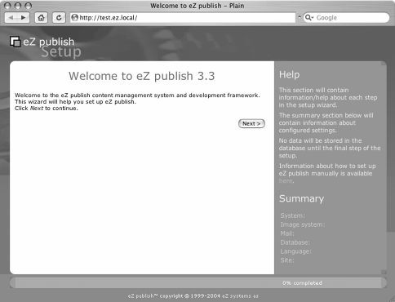
This is the first page of the setup wizard. By clicking Next you will be taken through a series of steps to configure eZ publish for your system. It will automatically detect the image system you are able to use. If you have ImageMagick installed it will use that, otherwise it will attempt to use GD if it is compiled into PHP. You can tell if it has found a usable system by looking at the bottom right part of the next screen, under Image System.

Page 2 of the Setup Wizard: System Check
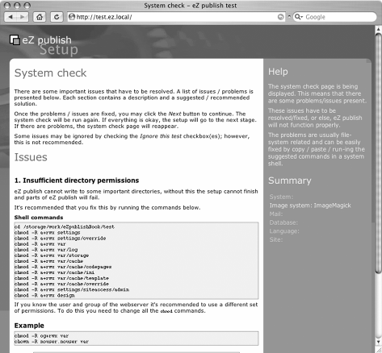
The setup wizard checks the permissions for various directories that eZ publish uses to run. These are:

/var | Used by eZ publish to store all the image files and the cache files
/settings | Used by eZ publish to store the settings
/design | Used by eZ publish to store the design templates
If the permissions are not correct, you can use the script shown on the page to set their permissions, or use your FTP client to change the permissions for each folder to 777, which means they are writeable by the web server. There is an issue with this command—if you are on a shared hosting environment, other users may be able to access these files. If this is a problem, you should look for dedicated hosting. Note that if you are
able to change the owner of files on the web server, you can make these files belong to the web server user and disallow access to others. The command to do this is:
chmod –R og+rwx var chown –R user.group var
where user.group is the username and the group that the web server process runs under.
If everything is already set up properly, you will not see this page. When you click Next, the check will be run again unless you have selected Ignore this test.

Page 3 of the Setup Wizard: Email Settings
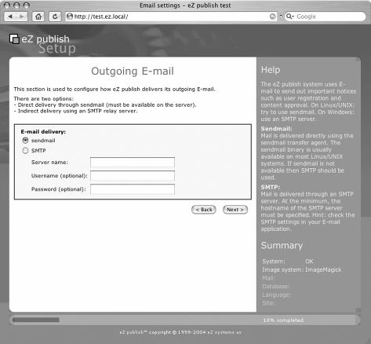
For eZ publish to send out e-mails to users, it must be configured to use a mail server. If you are using a UNIX-based system, you can normally use the local sendmail program.
If you are using Windows or for some reasons do not have sendmail installed, you can use an external SMTP server to send your mails.

Page 4 of the Setup Wizard: Choose a Database
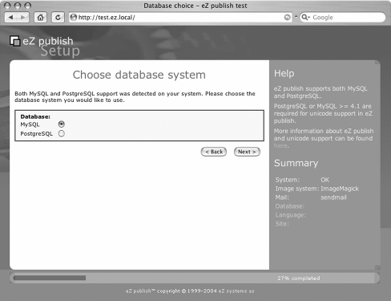
This is a particularly simple stage and lets you choose between MySQL and PostgreSQL as your database of choice. PostgreSQL includes some more advanced features that are not present in MySQL, although these do not greatly affect the running of eZ publish.
If you don't have a reason for wanting to run PostgreSQL, you probably don't need to!

Page 5 of the Setup Wizard: Database Initialization
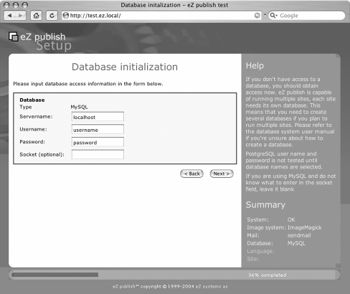
When we set up the database user earlier in this chapter, we defined a username and password. This is where you enter them. You do not need to select a database at this point because eZ publish will only let you choose from the databases you have access to.
If eZ publish cannot connect to the database using the credentials you have supplied, you will have to repeat this step until it can. Recheck the user name, password, and privileges you set up earlier if this happens.

Page 6 of the Setup Wizard: Language Support
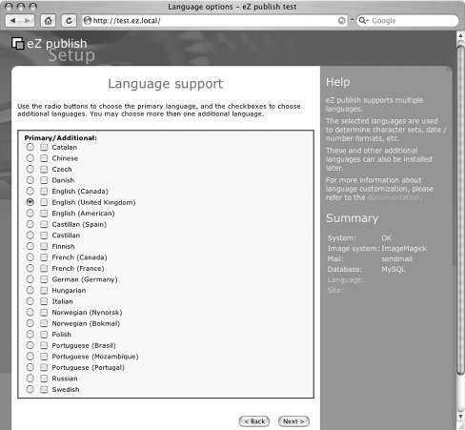
eZ publish has very strong support for multi-language installations. At this stage you can choose a default language as well as any other languages you need setting up on the system. Languages can be added at a later stage if necessary, so do not add languages here if you aren't sure you need to.

Page 7 of the Setup Wizard: Site Packages
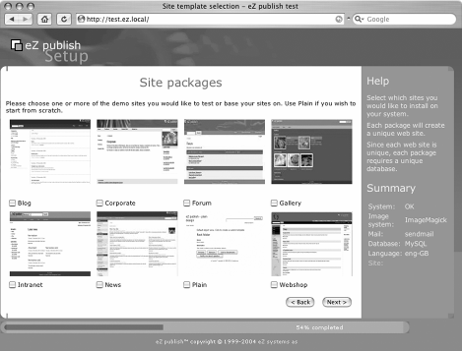
The best way of getting to know eZ publish is by installing one of the pre-configured site packages and playing around with it. By default, eight site packages come bundled with eZ publish to fulfill a number of different needs. Choose the Plain site package if you are planning on building your own site from scratch. Otherwise, it may be simpler to modify an existing package. Each site is unique and requires its own database.

Site | Description
Blog | A simple blog setup with dated posts
Corporate | A multi-section site with a simple corporate look and feel
Forum | A user forum, similar to the forums at http://ez.no
Gallery | A powerful gallery using eZ publish’s image-handling system
Intranet | A typical corporate intranet
News | A news site with news stories in different categories
Plain | The no-frills setup to use if you need to roll your own site
Webshop | A sample e-commerce application using eZ publish’s shop functionality

Page 8 of the Setup Wizard: Site Access Configuration
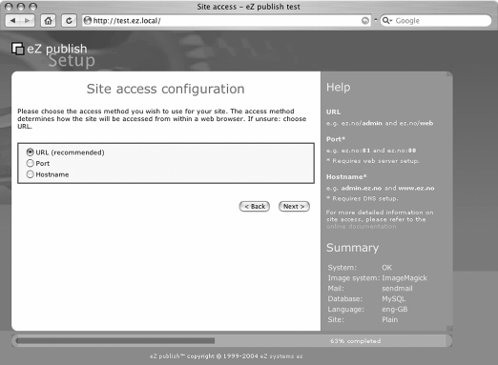
The different sections of the site can be accessed in a number of different ways.

Access Type | Description | Example URL
URL | The simplest method of accessing different sections of the site. | http://www.mysite.com/admin
Port | It is possible to assign a port through which to access your site. This is more complex to set up and requires custom Apache configuration. | http://www.mysite.com:81/
Hostname | Specific host names can be used to decide which part of the site is accessed. This is more complex to set up and requires custom Apache configuration as well as adding DNS entries for the different hosts. | http://admin.mysite.com

Page 9 of the Setup Wizard: Site Details
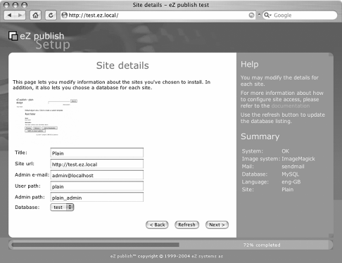
At this stage you can choose the title for the site and set up the URL that will be used to access it. It's also possible to fill in the administrator's e-mail and set up the paths that will be used to access the admin and user sections of the site. If the database already contains some data, this page will reappear and ask you what to do. Possible actions are:
- Leave the data and add new
- Remove existing data
- Leave the data and do nothing
- I've chosen a new database

Page 10 of the Setup Wizard: Site Security
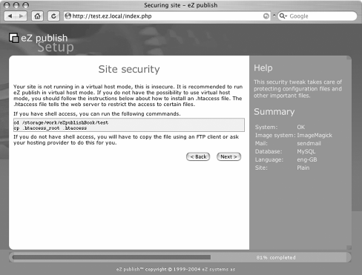
If you cannot use the virtualhost mode, you will need to use an htaccess file to secure your system. There is an example .htaccess file in the root of the distribution that if renamed from .htaccess_root to .htaccess will make the setup secure. If you are running in virtualhost mode you will not see this screen.

Page 11 of the Setup Wizard: Site Registration
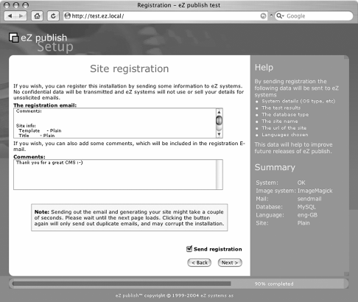
This page of the setup allows you to send an e-mail to eZ systems to let them know the details of the set up of the system you are using. Although this is optional, it is good practice because they will be able to focus their developments upon the areas that are useful for the most users.

Page 12 of the Setup Wizard: Finished
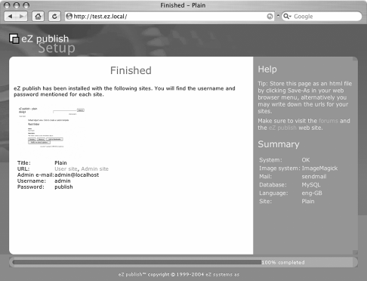
At this stage the site setup is finished. Make a note of the URLs on this page as they will be used to access your site in future.

Troubleshooting
Once you have reached this point you should have a fully functional eZ publish site to start working with. If you've hit a snag, there are a few common issues you can look at to get things working.

PHP Memory Limits
A common problem in hosting environments is that the memory limit of PHP is set too low. The default value of the limit is 8MB, but this is too low for eZ publish to run (although the eZ team has been working hard at reducing memory consumption). If you get output similar to the following, then you have this problem:
Fatal error: Allowed memory size of 8388608 bytes exhausted (tried to allocate 184320 bytes) in /www/ezsite/kernel/classes/ezpackage.php on line 2140
Fatal error: eZ publish did not finish its request
The execution of eZ publish was abruptly ended, the debug output is present below.
There is an easy fix to this if you are allowed to override the PHP settings using a
.htaccess file (if your host doesn't support this, you may need to look for a new host) placed in the root of the eZ publish installation. In this file, add the following line:
php_value memory_limit "16M"
This will raise the memory limit to 16MB. If this still does not work, continue raising the limit until it does. In general, you will not have to go over 32MB for the site to work.
You may need to increase this setting later, if your pages are very complex.

PHP Running as a CGI
If your hosting provider is running PHP as a CGI instead of an Apache module, then eZ publish will have problems. The main symptom of this is that regardless of the link you click on, you will always get the front page of the site. The only way of fixing this problem (in versions of eZ publish prior to 3.4) is to modify ezsys.php, one of the eZ publish files. There are a number of posts in the forums at http://ez.no describing how to do this.
Fortunately, one of the outlined features for version 3.4 of eZ publish is a fix for this problem, so the best thing is to use this version when it becomes available.
To tell if your host is running PHP as a CGI, create a PHP file on your server containing the following script:
<?php
if (php_sapi_name() == 'cgi')
echo "PHP is running as a cgi"; else
echo "PHP is running as a module";
?>

Summary
In this chapter we've discussed the steps for a basic eZ publish installation. We've looked at initializing the database, the Apache web server settings, setting up the image manipulation libraries, and scheduled jobs, and discussed the role of the ini file in eZ publish configuration.
We also walked through the Setup Wizard, which greatly eases the installation and configuration of eZ publish, and looked at some common installation problems.
Now that your system is installed and configured, it is time to move on. In the next chapter, you will start using eZ publish as a tool for content management.

2

Content Management with
eZ publish

The prime objective of eZ publish is web-based content management. With the powerful, flexible content object model, it is easy to map any kind of structured information into a collection of attributes. The basic architecture of eZ publish includes version management, multi-language possibilities, relations between pieces of information, and all kinds of interactions and manipulations defined and offered by standard or custom- built modules.
This chapter will guide you through the basic concepts and paradigms of eZ publish. At the end of the chapter, we will create an example site to show how the concepts and architecture map to a concrete eZ publish site—this is something that you will see more of in the two case studies later in the book. By then, you should have a sound idea of what eZ publish is all about.

What Is Content Management?
Content management covers the processes and workflows involved in organizing, categorizing, and structuring information resources so that they can be stored, published, and reused in multiple ways.
A Content Management System (CMS) is used for collecting, managing, and publishing content.
Content is stored either as components (including metadata) or as whole documents (in the form of binary file attachments), while maintaining the links between components or documents. The CMS preferably also provides revision control by keeping track of versions. Workflow is usually a part of the game in the form of electronic implementations, where for example, approvals and notifications are performed through e-mail and/or online in the CMS itself.
eZ publish fulfills the needs and roles of a web-based CMS where interaction with the client (browser) is over standard HTTP and related protocols (including WebDAV and SOAP). It is therefore perfectly possible to make links (through some additional programming) with traditional desktop environments, even though the internal modular design and architecture is agnostic towards your preferred desktop environment.
With respect to documents, eZ publish supports its own basic XML format for structuring content, which includes basic elements such as headers, lists, tables, and some embedded or linked media types like images and movies.

eZ publish Fundamentals
The first step is to create a design or architecture for your content. This is done before you start with the implementation, but the powerful and sometimes unique features of eZ publish may influence your design decisions. You are encouraged to explore this chapter, the tutorial, and the two case studies in this book, and experiment with eZ publish before undertaking your first real project.

Structuring Content
We will begin with the site structure, followed by a drilldown through concepts such as node trees, sections, object classes, attributes, and features or functionality that are important for managing eZ publish-based websites through its modular kernel system.

Site Structure
How to structure your site depends a lot on the types of content you want to serve, the audience, and how you want clients to interact with the site content. There are no fixed rules on how you should design the structure of a site, only some good practices that you can borrow from people who create taxonomies for document collections.
If you are on tight time schedules and already have some experience with eZ publish or another CMS, you can start immediately by implementing a global outline (through the admin interface) and site design with the base eZ publish distribution. However, the design and implementation of major projects requires a good deal of blackboard brainstorming and careful global planning.

Node Tree (Content Object Tree)
Once you have determined the global structure, you will find that a direct reflection of such a structure is given by a node tree. The following diagram gives an example of a simple structure implemented in an eZ publish node tree:

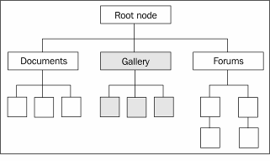
It includes a document structure, ordered galleries, and a forum branch. The node tree is a structured way of placing content objects (the real information). This distinction in eZ publish is important because content objects can have more than one placement (node).
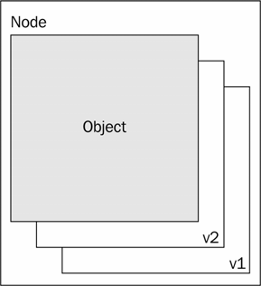
A single node is in fact the placement of a collection of object versions and translations sharing the same object ID (a number in the eZ publish database implementation). The object name is shared by versions of the same translation.

Sections
Sections are virtual collections of nodes that belong together, either conceptually or functionally. They are used as a mechanism in role-based permission management and are also design parameters. Once a node is assigned to a certain section, newly created child nodes inherit this section information by default. There is always at least one section for content objects that is assigned by default.
In the role-based permission system, sections can be used to control access and the type of actions users or user groups can perform. In their bare essence, sections categorize
your content to enable an additional layer of presentation logic; for example, you could use a special navigation panel for each section or even change the entire page layout.

Content Classes
Content classes define the way content is structured for a certain content object type. This flexible system—where any number of base datatypes (called content class attributes) can be used for structuring information into workable units of information—is one of the prime features of eZ publish.

Content Class Attributes
Content class attributes are the lowest level of information 'typing', although some of them are already powerful compound datatypes. eZ publish contains a rich set of 30 datatypes. A few more can be found on http://ez.no as community contributions.

Content Object
Content objects are simply instances of certain classes. The content elements are therefore specified by the class attributes. The following diagram shows an example object after creation. Besides the attributes defined in the corresponding class, there are a number of generic properties such as an object ID, name, and creation date among others. The name of a content object is usually bound to one or more of the content object attributes, such as a title.
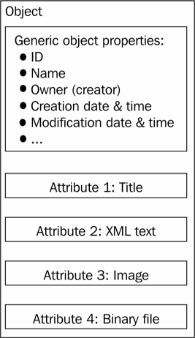

Content Object Version
An object in eZ publish is always under version control. The versioning can be controlled to maintain only a certain number of versions, possibly only one.
Versions are handled by the parameters in the settings file content.ini, in the [VersionManagement] section, where you can specify the maximum number of versions to keep. You can either specify a global default with DefaultVersionHistoryLimit or specify versions per class with an array containing the class ID as the index and the number of versions to keep as a value. For example, VersionHistoryClass[8]=2 will allow the minimum of versions (two) for the class with an index number of 8.
You cannot specify VersionHistoryClass[8]=1 because then you will not be able to edit the object after creation. This is because a temporary version is created as a draft version while editing an object.
Older versions of objects are kept within the limits of the version history settings. This means objects older than the current 'published' version are set into an 'archive' state. When there is more than one user editing objects, it could so occur that there are still a few draft versions lingering around in the underlying database tables between the archived versions.
eZ publish allows you to revert to an older version of an object by copying the older version to a new draft and publishing it again. The history of objects is always preserved within the limits of version history as described earlier. This can be of importance if you should use eZ publish as a document management system, where quality systems impose the maintenance of document versions.
In the current state of eZ publish, spotting the real differences between object versions is not easy unless a UNIX diff-like tool is used. However, the construction of an audit trail listing the object history is pretty straightforward.

Content Object Attributes
These are instances of content class attributes. It is important to note that the version management applies to all attributes, including binary files that may be stored in the eZ publish system.

Content Object Translations
Objects may be translated into languages other than the default-configured main language. If for some reason, you do not want translations for certain attributes, they can be disabled at the attribute level. A typical example is a photograph, which is usually language independent.

Displaying Content
In this chapter, content has been treated in an abstract way. However, in most practical situations, the content should reach and appeal your target audience in some way or another. As eZ publish is mainly a web-based CMS, you will want to format the content in a clear and attractive way for display inside a web browser. eZ publish enables you to do so by way of the built in template engine that transforms your content in a manner of your choice for delivery; by default, it transforms it as XHTML output.

Separation between Content and Presentation
One of the fundamental architectural properties of eZ publish is the separation between content, application logic (to manipulate content), and the content presentation for either a browser or other output media such as PDF files (introduced in eZ publish 3.3).

Site Structure versus Page Layout and Content Views
In principle, the structure of your site (node trees) is independent of the page layout and content views (introduced in the next section). However, by carefully planning your sites in the design stage, you may come up with a solid model that can equally be used for parts of the page layout. You can gain more insight into this process from the example site we will create at the end of this chapter, and also from the two case studies later in the book.
One such example is the navigation and menu structures used. You can, for instance, use the top nodes as top menu or navigation entries and second-level nodes (most of the time these will be folder types) as entries for further navigation.

Overall Page Layout and Content Views
In the paradigm that eZ publish uses, there are two main 'areas' where content is delivered: the overall pagelayout and content views. Navigational elements are mainly bound to the page layout templates, and the main content views are normally placed inside the global page layout. You can assume for now that the content views are extracted from the database and kernel modules depending on the URL you use to browse an eZ publish-based site.
Examples of content views are the display of articles and other complex content, folder listings, and forms, but also the content from managing functions such as template manipulation, role definitions, and the output from custom-built extensions.
The following figure gives an overview of this simple concept. The parts marked P are generated in the page layout template(s), while the part marked C is generated with content view templates.

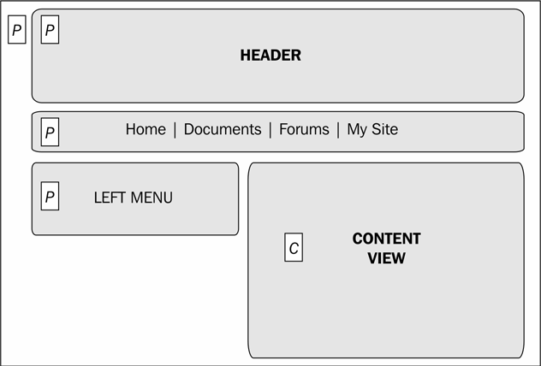
The concepts and a detailed explanation of the template system are covered in Chapter 3.
All the items mentioned earlier are accessible in the same object-oriented paradigm inside the templates.

Authorization and Roles
The eZ publish permission system is based on the concept of roles. This is different from what you may be used to in a traditional file system where permissions are set on individual files and directories (with inheritance). The latter is still possible with the eZ publish role-based system as it provides granularity down to the level of individual nodes or a node and all of its children. In general, setting permissions or roles for individual nodes should be avoided and applied only to special cases as this may complicate the administration of a site.
The role-based system goes further; you also can specify the functions of kernel modules that can be used by a given role. For example, you can specify that a normal user can add comments to articles, but not submit articles themselves.
A role in eZ publish consists of one or more policies with details of modules, functions, and limitations that apply to the particular role. For any module or function, you can omit limitations altogether; for example, in the case of the default administrator user who has access to all modules and functions. An example is the content module. This module handles most of the functions dealing with the management of content. The most obvious function is view(), which fetches the content objects for sending to the browser through
the template system. Limitations for this function can specify one or more content classes, a section, any special conditions (access specifications to modify content), a single node, or a set of one or more node trees (subtrees).
The following table gives an overview of the kernel modules and functions that are available for role assignments in eZ publish version 3.3. The access-control limitations listed are to be used in the policies for a role.

Module
Function
Access-Control Comments / Definition Limitations

content read Class, section, owner, node, subtree
content create Class, section, parent class, node, subtree
content edit Class, section, owner, node, subtree
content remove Class, section, owner, node, subtree
Read access. A finer specification can be made for "self" or "any".

A create policy also needs an edit policy.

Allow a user to edit content objects. A finer specification can be made for "self" or "any".

Allow a user to remove objects. A finer specification can be made for "self" or "any".

content bookmark None Allow a user to make bookmarks
that are stored inside eZ publish.

content translate Class, section,
owner, node, subtree
content versionread Class, section,
owner, status, node, subtree
Allows a user to add translations of an object.

The status can be draft, published, pending (workflow), rejected (workflow), or archived (older versions).

content pendinglist None Shows the pending objects;
these are objects that are the subject of some workflow.
content urltranslator None Provides access to the
urltranslator.

Module
Function
Access-Control Comments / Definition Limitations

content | cleantrash | None | Allows the clearing of the trash can.
content | translations | None | Access to the definition of languages available (to be used only in the default admin interface).
class | None | None | Access to the class edit functions.
collaboration | None | None | Access to the collaboration  module.
error | None | None | Access to the error module.
ezinfo | None | None | Access to the eZ publish info page with version, PHP configuration, and so on.
form | None | None | Access to the form module (simple form processing, which is different from information collection).
layout | None | None | Access to the layout module for overriding the current page layout (for example, a print layout).
notification | use | None | Access to the notification mechanism (adding/deleting notifications).
notification | administrate | None | Running the notification subsystem outside the cron jobs.
package | read | Type | Package type can be class, site, site style, and patch. Only classes and site style are implemented in version 3.3.

Module
Function
Access-Control Comments / Definition Limitations

package | list | Type | See package/read.
package | create | Type, creator type, role | Type: see package/read.  Creator type can be content class export or site style.  Role is not a role in the role system but acts as a classification of the package: lead, designer, developer, tester, or contributor.
package | edit | Type | See package/read.
package | remove | Type | See package/read.
package | install | Type | See package/read.
package | import | Type | See package/read.
package | export | Type | See package/read.
pdf | create | None | Access to create PDF generation definitions.
pdf | edit | None | Access to edit PDF definitions: edit.
reference | None | None | Access to the doxygen generated documentation.
role | None | None | Access to the roles for editing. Currently assigned roles can be read in the user object inside templates.
rss | feed | None | Access to the RSS feed or import definitions.
search | None | None | Access to the search module.

Module
Function
Access-Control Comments / Definition Limitations

section | None | None | Access to section definitions and edit functions.
setup | None | None | Access to the setup functions.
shop | administrate | None | Access to the shop administration.
shop | buy | None | Access to buy items.
shop | setup | None | Access to the shop setup functions (discount rules, VAT schemes).
soapserver | None | None | Access to soapservers (currently no soapserver services are defined by default).
trigger | None | None | Access to the trigger/workflow administration.
url | None | None | Access to URL administration.
user | login | siteaccess | Specifies who can login to which siteaccess.
user | selfedit | None | Access to users for editing their own data.
user | password | None | Permission to users to change their passwords.
user | preferences | None | Access to user-bound preferences (variables).
workflow | None | None | Access to workflow administration.

Currently (in eZ publish 3.3), the role system is limited to the level of objects/nodes as the smallest unit. You cannot apply roles at the attribute level (yet). If you really need to, you can implement permission-related features inside templates. For example, you could
check the (main) user group of the current user and display part of the attributes in view and edit templates.

Disabling a Module/Function outside the Role System
In certain situations, you may want to disable a module or function altogether, and not just for specific roles. This can be done in the site.ini configuration file. For example, you could choose to turn off the user/register function so that new users can only be defined by an administrator:
[SiteAccessRules] Rules[]=Access;disable Rules[]=Module;user/register
After disabling the user/register function, you will also need to edit the template for user login to avoid the function being called, otherwise this could result in an error message that is not very user friendly.
For an intranet site, you will probably not need the shop module or any of its functions:
[SiteAccessRules] Rules[]=Access;disable Rules[]=Module;shop

Adding Content with the Default Admin Interface
In this section, we will walk through the administration site access. The functionality offered by the administration site access can be used to understand the functionalities of the major underlying kernel modules.
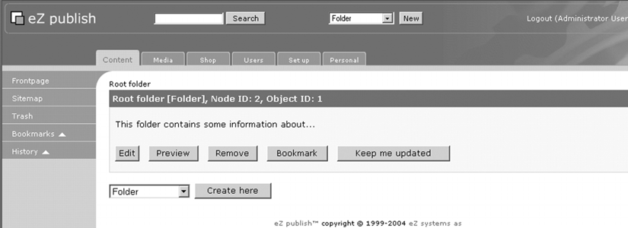
When you first log in to the admin site, you are directed to the content section. At the top, you will notice the various areas of the admin site. The top menu tabs give access to the Content, Media, Shop, Users, Set up, and Personal sections.

Creating Content Classes
To create a new content class, go to the Set up menu and choose Classes from the advanced part in the left menu box.
The first screen gives an overview of the class groups. Class groups are used to group similar classes by either content type or functionality. For example, the users class group holds the basic user-related classes for both individual users and user groups.
When entering a certain class group (or after creating a new group), you have the option to create a new class. Any new class has a few generic properties:
- Class name
- Class identifier
- A name pattern for objects created as instances of this class
The latter is important, as it will determine the URL part of this object when URL translation is configured.
With the new button and selection, you can add new attributes based on one of the 30 standard datatypes available. In the following screenshot, the generic attributes are shown as well as the first attribute created for the new class: a title that is defined as a text line datatype (also called ezstring). For the Object name pattern, the title is inserted as the primary component for subsequent object names.
If you change the object name pattern later, objects already published will not adhere to the new name pattern unless they are re-published.
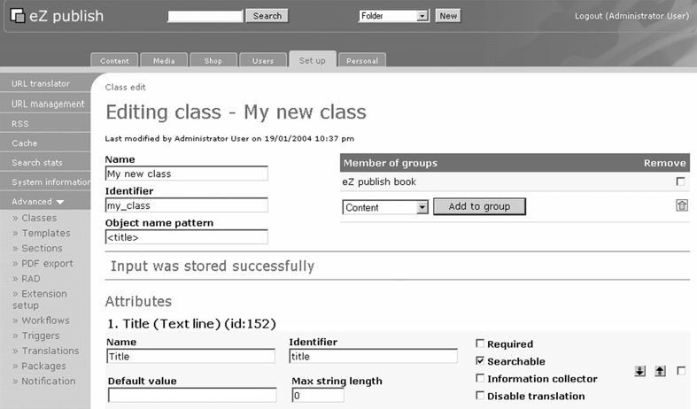

Datatypes
This section lists the available datatypes along with possible applications. The table with indicators for 'Searchable' and 'Information Collector' is meant to indicate whether the datatype can be indexed in the search engine or be used as an information collector.

ezauthor
The ezauthor datatype can be used to store one or more authors. The subfields are the author name and e-mail address. This datatype also checks for valid input for the e-mail address. This datatype actually can hold more than one author and can be used to specify a list of authors for a certain object (like a document).

Searchable | Information Collector
Yes | No
The ezauthor datatype is not related to the users defined in your eZ publish site.

ezbinaryfile
The binary file datatype can be used to store any file. The indexing for the search engine is done with external programs if the content is not simple ASCII text. The configuration for these external handlers is done in settings/binaryfile.ini.
You can specify an upload limit size in MB (or 0 for no limits). You can use this datatype to upload legacy documents, for example Acrobat PDF or MS Word files.

Searchable | Information Collector
Yes | No

ezboolean
This datatype corresponds to a checkbox-type datatype. It is typically used for controlling further template elements, like the display of a button for adding comments.

Searchable | Information Collector
Yes | Yes

ezdate, ezdatetime, and eztime
The date- and time-related datatypes allow for adding date and time as attributes. The input validation code checks for correct values. Although you cannot use these attributes
in the normal search functions, you can use them in custom searches inside templates like most other datatypes (see Chapter 3).
Searchable Information Collector
No No
The ezdate values are stored as UNIX timestamps in the database. Therefore, you are limited to a certain date range depending on the platform.

The year range on Linux/UNIX is 1901 to 2038. On Windows-based systems, the range of valid years includes only the years 1970 through 2038. If you need a larger range, you need to either use a string function, which of course has its limitations, or create a new extended date datatype in PHP.
Note that the validation of input data is not foolproof; some checks are not performed on date items; for instance, there are no checks on the limits of date items, such as on the day of a month. This could possibly result in unwanted behavior—you could try to enter a non-valid date like March, 56 2004 and the system might not complain.

ezemail
A single e-mail address can be stored with this datatype. The input is validated for the correct format. Currently, this check only applies to the format, and not the actual existence of the e-mail address or its domain part.
Searchable Information Collector
No No

ezenum
The ezenum is deprecated from version 3.3 onwards because of its complexity and performance issues related to it. For new classes, you should avoid this datatype in favor of the ezselection datatype. This datatype is included in the eZ publish package only for reasons of backward compatibility.
With the ezenum datatype, you can present the user with a predefined set of values. These can be either specified as a single selection or multiple selections. The style can also be set to either use radio buttons (single selection) or checkboxes (multiple selection). This datatype is similar to the ezselection datatype discussed later.
Searchable | Information Collector
Yes | No

ezfloat
The ezfloat datatype stores floating-point numbers. You can specify the minimum and maximum value at the class level for input validation.

Searchable | Information Collector
No | No

ezinteger
The ezinteger datatype is similar to the float datatype where you can specify a minimum, maximum, and default value. Contrary to the float datatype, integers can be searched for with the search engine.

Searchable | Information Collector
Yes | No

ezidentifier
The ezidentifier datatype can be used for constructing (sequential) identifier strings such as doc-xxx-en, where xxx is a numerical value with a predefined number of digits. You can set a prefix and a suffix, the number of digits to use, and the number part to start from. The values for the number part are created automatically and cannot be edited. The number part does not increase when new versions of objects are created. You need to be careful when you update the attribute definition; for example, when you change the prefix and/or suffix, you must change the initial value at its primary setting. Identifiers assigned earlier on remain unchanged.

Searchable | Information Collector
Yes | No
You could use this datatype to automatically assign a serial number for articles, photographs, or products.

ezimage
The ezimage datatype is used to store bitmaps in various formats. The supported formats are defined in settings/image.ini, where you can specify a number of predefined sizes
with a label (such as medium, small, large). Upon uploading the image, new variations in size for the image are created according to the defined sizes.
Searchable Information Collector
No No

ezinisetting
This is a special datatype that can be used to modify or display various INI settings. The INI setting to be modified is defined in the class by specifying the siteaccess, ini file, ini section, and ini parameter. In addition, the type of setting needs to be specified and can be one of the following: text, enable/disable, true/false, integer, float, and array. To determine the type of setting you need to use, you need to look at the settings in the default INI file(s) shipping with eZ publish.
A word of caution here: since the content of this datatype is determined at the class level, it is possible to have more than one object that can alter an INI setting. On the other hand, this may be wanted behavior for cases where you want different administration profiles. For example, you can create a class that allows for the modification of a large set of INI settings along with a class with the ability to modify a restricted set of INI settings.
Searchable Information Collector
No No

ezisbn
The ezisbn datatype is used to store an ISBN; the input validation checks for the correct ISBN format.
Searchable Information Collector
Yes No

ezkeyword
The ezkeyword datatype can be used to specify keywords as a list of comma-separated strings. An advantage of this datatype is that it can be used to link objects of the same class; whenever there is one or more common keyword, a list of keyword-related objects is available for use when displaying the content object. Note that the relations are within the same class. When you use keyword attributes in different classes, there is no automatic linking of related objects.
Searchable | Information Collector
Yes | No

This datatype can be used to enhance the user experience: for example, in a document archive where you can provide a See also list of documents that share one or more keywords with the current object.

ezmatrix
The ezmatrix datatype can be used for data that is best stored as a matrix or in a table. You need to specify the maximum number of columns and the initial number of rows. Upon object creation, the author can add more rows to those initially specified.

Searchable | Information Collector
Yes | Yes

This datatype comes in handy when you need to input a varying number of items within a content object. With clever template programming, the matrix datatype becomes one of the most versatile available in the standard distribution of eZ publish.

ezmedia
The ezmedia datatype is used for storing media clips and currently supports the following formats: Flash, RealPlayer, Quicktime, and Windows media. You can also specify a maximum file size to upload, or 0 to remove any size limit.

Searchable | Information Collector
No | No

ezobjectrelation
You can use this datatype to specify one related object upon creating or editing an object. This datatype can be useful when you need to assign a single item out of a pool of existing objects to a newly created object. There is no way to restrict the object class of the related object.

Searchable | Information Collector
No | No

ezobjectrelationlist
The object relation list is a powerful datatype that can even be used to create compound objects (of different classes). Alternatively, it can be used to create categories of related objects. When the creation of objects is enabled, you also can specify a restricted set of classes from which the object can be composed. A further parameter specifies the default node at which newly created objects can be placed.
In the content.ini file, under the [ObjectRelationDataTypeSettings] section, you can specify parameters to assign default nodes to start browsing. The node can be specified by the node name or the node ID.

Searchable | Information Collector
Yes | No

ezoption
This datatype can be used to specify a number of options upon object creation. This is most useful for collecting information through forms. At object creation, you specify the options with a name and value pair.

Searchable | Information Collector
No | Yes

ezpackage
The ezpackage datatype is used in administration classes to specify the available packages. You need to specify the type as a text field, and the mode of displaying the available packages as a combo box or a group of icons. For this, you can specify an image such as a screenshot for guiding the user with each package.

Searchable | Information Collector
No | No

ezprice
The ezprice datatype is used in product classes for representing prices. If one of the attributes is of this type, the standard view templates automatically add buttons for adding the object to a shopping cart or the wish list of a current logged in user.
Searchable | Information Collector
No | No

ezselection
The ezselection datatype is used to specify a number of options from which you can specify single or multiple values. The definition of the options is done upon class creation and comprises a certain number of values—this is different from the ezoption datatype, where the options are for object creation.

Searchable | Information Collector
Yes | Yes
A modified version of this datatype where you can specify an option name and value has contributed by the eZ community.

ezstring
The string datatype is used to hold short strings, such as titles, with less than 255 characters.

Searchable | Information Collector
Yes | No

ezsubtreesubscription
The ezsubtreesubscription datatype is used for the notification system and behaves like a boolean variable (checkbox) upon object creation (not class creation). When the creator of an object selects this checkbox, a notification rule is added, where the creator gets e-mail notifications when the object is updated or child nodes are created/changed.

Searchable | Information Collector
No | No

eztext
The eztext datatype is used for plain text, such as simple forum messages. The size of the text is limited only by the database and possible browser constraints. By default, eZ publish uses the text datatype to store the value of a text field in MySQL (65,534 bytes). You can choose larger sizes by modifying the database setup for versions up to 3.3. From version 3.4 onwards, the default size is increased to MySQL medium text fields.
Searchable | Information Collector
Yes | Yes

ezurl
As its name implies, the ezurl datatype is used to store the URL (contents of the href attribute) and a display string. The interesting feature with eZ publish is that the link is also stored separately in the database to allow link-checking with a cron job or some other scheduler. When a URL becomes invalid, you can change this to a new value from the admin interface, and all instances of the URL's use are automatically updated.

Searchable | Information Collector
No | No

ezuser
The ezuser datatype is a special datatype that is connected to the User module of eZ publish. Indeed, you can create several user classes in your system, grouped under the User class group in the class list. This datatype specifies the following properties:
- A login name
- An e-mail address
- A password
You can use this feature for several types of users, mainly with different metadata (attributes) depending on the type. Although modifying the base user class is in principle not a problem, you can take the safest approach and create your own. To use it as the default User class, you can set the class ID in site.ini under the [UserSettings] section.

Searchable | Information Collector
Yes | No

ezxmltext
The XML text datatype is used to store rich-text content through a well-structured yet simple variant of XML. It supports some elements of the XHTML 2.0 specification and is further characterized by the possibilities of specifying special input and output handlers. For instance, there are handlers to format the contents in plain XML, XHTML, or PDF (introduced in eZ publish 3.3).
Searchable | Information Collector
Yes | Yes

There is one caveat: your editors or end users will have to learn the syntax for providing or editing this rich-text content.
A browser-based DHTML editor known as the Online Editor is available from eZ systems. It offers WYSIWYG editing for the easy creation of structured (and formatted) text.
The structured text is rendered as XHTML, and you have control over the display through the template system.

XML Tags Available with ezxmltext Datatypes
As the ezxmltext datatype is used for enabling structured blocks of text, it provides several XML tags, by default, which you can use. Furthermore, it is possible to extend the available XML tags through custom-defined XML entities.
All XML entities can have a class parameter. This parameter is normally used in the
tag templates to specify a CSS class, but you are free to use sophisticated transformations with the eZ publish template language. For example, a header can be made of the chapter class and will be rendered in a more complex layout than available in CSS alone.

Headings
Headings and titles can be tagged by making use of either the <h> or the <header> tag. You can specify two optional parameters: level and class. The level parameter can be used to define the size or the level of the heading.
<header [level="1-6"] [class="packt"]>My header</header>

Lists
Lists are tagged in the same way as their XHTML counterparts for ordered and unordered lists with the help of the <ol><li>...</li></ol> and <ul><li>...</li></ul>.
Lists cannot be nested in eZ publish up to version 3.3 (and, at the time of writing, 3.4 as well).

Emphasizing Text
To emphasize text portions, you can use a variety of XML tags that correspond to their use in traditional XHTML markup. By default, emphasized text can be rendered in italic or bold typefaces. Here is a list of available tags:
- <i [class="test"]>Italic text.</i>
- <em [class="test"]>Emphasized text.</em>
- <emphasize [class="test"]>Emphasized text.</emphasize>
- <b [class="test"]>Bold text.</b>
- <bold [class="test"]>Bold text.</bold>
- <strong [class="test"]>Bold text.</strong>

Literal (Unformatted) Text
The <literal> tag can be used to render unformatted text, for example, program source code, HTML code, XML source, and so on. Everything that is inside a literal block will be rendered in the same way (character by character) as it was input into the XML text field. By default, this effect is achieved using the XHTML <pre> tag.

Hyperlinks
Hyperlinks can be inserted by making use of the <a> or <link> tags. Both tags accept a target parameter, which is used in the same way as the corresponding XHTML parameter. It accepts the _self or _blank values. The href parameter is required, and needs to be set to a valid URL.
In addition to the href parameter, a parameter called id can also be used. This is because eZ publish stores every hyperlink used in XML text datatypes in a separate ezurl table. The automated link checking (enabled through cron jobs) validates these URLs, and is very convenient when you need to fix any broken links. The id parameter should be assigned a value (number) corresponding to the ezurl ID.
The <anchor> tag makes it possible to insert XHTML anchors inside the XML text datatype field. An inserted anchor will work just like a standard XHTML anchor: it accepts a name parameter that should be unique in the collection of anchors used in the final rendered XHTML output.

Tables
Tables in XML text datatype fields are created in the same way as in XHTML. The
<table> tags accept values for the border and width parameters. Rows are created with the <tr> tag, table headers with the <th> tag, and table data with <td> tags. The <th> and
<td> tags accept the width, colspan, and rowspan parameters.

Objects
The <object> tag is a special and unique eZ publish feature that can be used to embed other eZ publish objects inside XML text fields. This is typically used for embedding
images, but you can use an object of any class you define. It accepts a parameter ID corresponding to the object ID (not the node ID!).
Further parameters can be used to specify alignment (with align accepting the values left, right, or center), size (a size parameter that accepts small, medium, and large as values), and a view parameter with values embed or text_linked. Finally, href and target parameters can be specified to turn the embedded object into a link to whatever you wish.

Custom Tags
You can also define your own custom tags. A custom tag is defined inside [CustomTagSettings] in an override for the content.ini configuration file. It accepts a name parameter that corresponds to the definition in the content.ini configuration file. In accordance with CSS stylesheets, you can specify a custom tag as being inline (like
<i>) or a block style (like <p>).
By default, a few custom tags are defined in the standard eZ publish distribution, such as
<superscript> and <subscript>.

Datatypes as Information Collectors
Some datatypes can serve as information collectors. Objects created with datatypes marked as information collectors can be used as a mechanism in forms where data is sent to a preconfigured e-mail address or stored in the database (to make polls, for instance).
This can be useful in small surveys or feedback-type applications. The main way to collect information for your site is of course by creating new objects that are placed in an appropriate node in the node tree.

Creating a New Content Object
New content objects are created in the Content section of the admin area. In this section, you can browse through the node tree and create new objects in certain locations.
The following screenshot shows the Content section, where we want to create a new object (a simple folder).

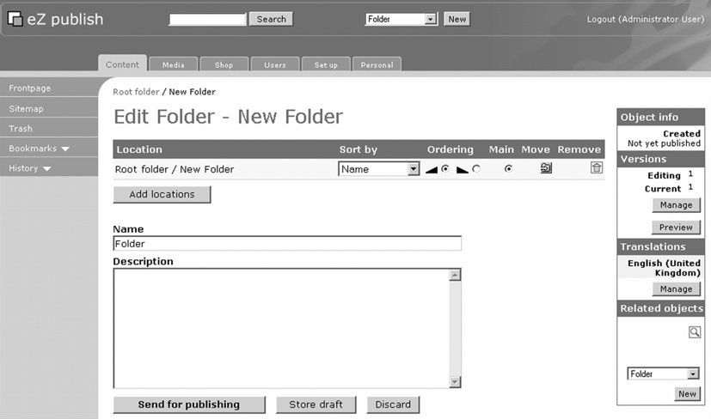
The selection box shows the newly created class, after pressing the Create Here button; a new edit screen is then presented where you can fill in the required and optional attributes for the object created.
A small toolbar is displayed on the edit screen, with information on the current location, the default sorting method for child objects, and the sort order (ascending and descending).
The Main field in the toolbar is used for determining the main node location for an object.
By using the Move button, you can change the main location by browsing through the node tree.
With the Remove icon (the little trashcan icon), you can delete one or more locations assigned for this object.
Clicking on the Add locations button brings up a browse view of the node tree that you can use to select additional locations for the object.
The following screenshot shows the edit screen for a newly created article object. From this point on, there exists a draft object with a corresponding object ID and location specified by the node ID.

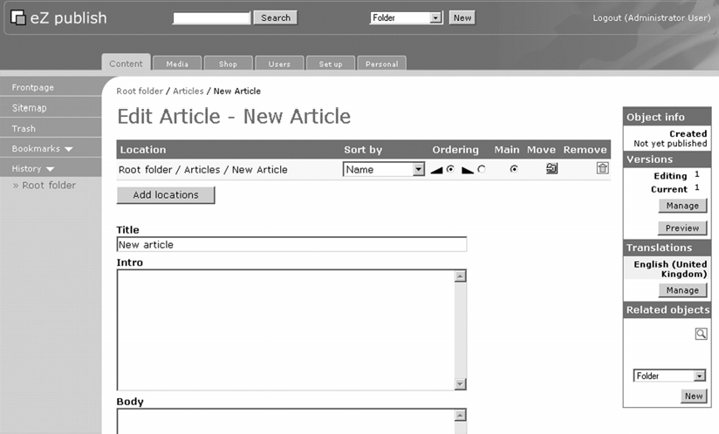
Further in the edit screen, you can create content by filling in the attribute parts.
The prime effect of adding additional node locations is that additional links can be created. For example, you could assign a new location to an article inside the news tree of your site, for display on the default page that a user sees when accessing your site. When a normal (full) view of the object is requested, the display will be done according to the main object placement parameters.
When you add another placement, the child nodes do not inherit these extra placements. For applications where you need to display the children at these locations, you will have to resort to template programming, look up the main node placement, and fetch the children on the basis of their IDs.

Editing Objects and Versioning
With the version management part in the edit screen, you can go back and copy one of the older versions to a new draft and publish it again. This is illustrated in the following screenshot, where you can either continue to work on the current draft (provided this draft is created by you) or select an older version for copying to a new version. A radio button is used to select the version you want to edit or copy and edit. The selection button is used to remove versions.

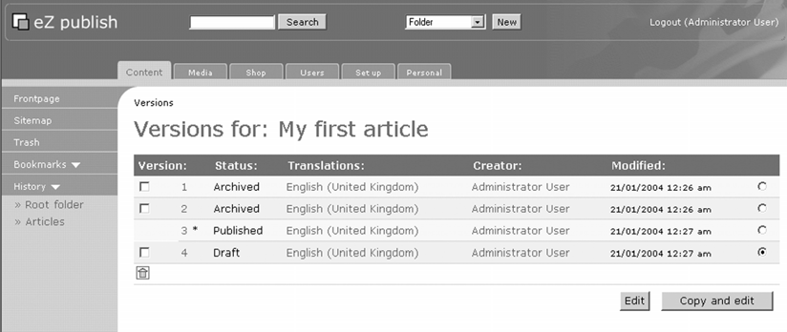

Managing Translations
If you did not specify the available languages for translation during the installation of eZ publish, you can still add them in the Set up menu as shown in the following screenshot:
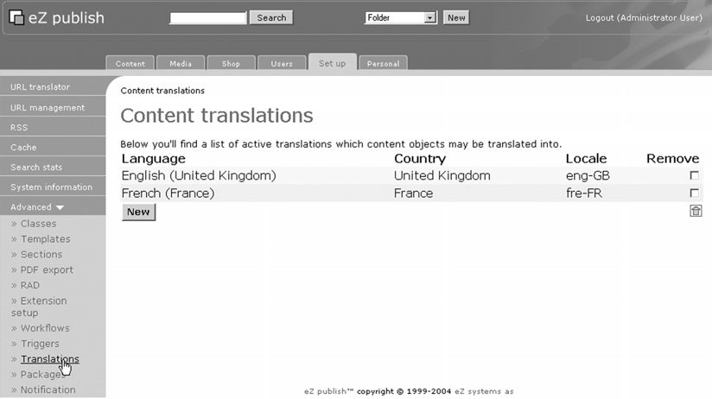
To add translations for content objects, edit an object and then click the Manage button in the Translations section of the edit screen that you saw earlier. This brings you to a screen where you first select the additional languages (provided that you have configured
your site to be multilingual) after which you can add a translation to your new content object.
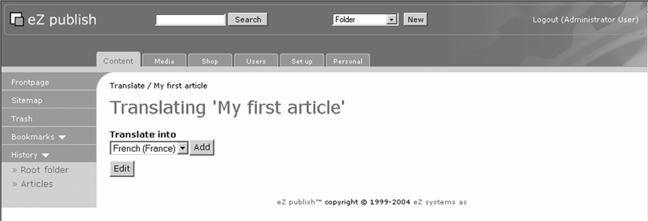
By selecting the language you want to translate the content into and clicking the Add button, you arrive at the translation screen. This is shown in the following screenshot, where the original text is displayed on the right side of the screen along with the newly translated version so as to guide the translator.
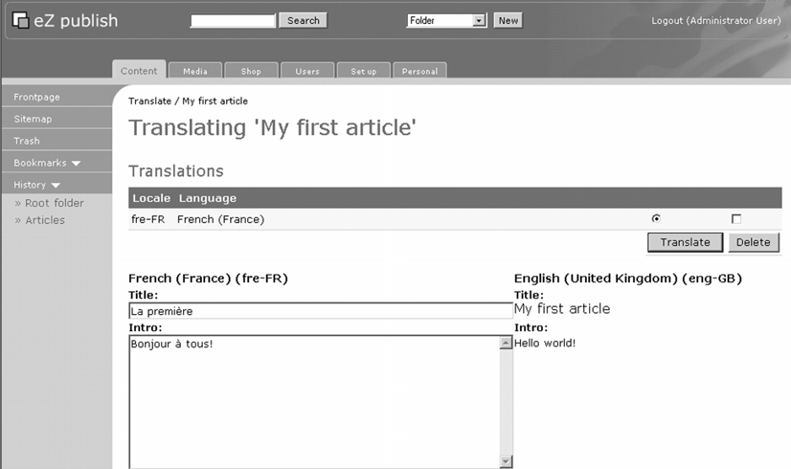

Related Content
Relating content objects in eZ publish is a very powerful feature that can be accomplished in two ways:
- By the general object relation mechanism available with any content object.
- By using one of the two special datatypes (objectrelation or objectrelationlist). The object relation can hold a single relation while the object relation list can hold one or more object relations.
The following screenshots show how you can add a generic object relation to an object (by clicking the magnifying glass icon in the Related objects panel in the edit screen). The action is fairly straightforward from there on, as you can browse through the node tree and select an existing object.
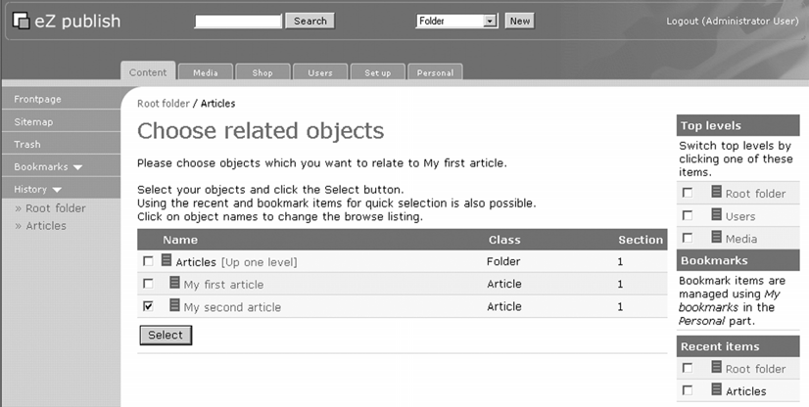
Clicking the Select button brings you back to the edit screen where the newly related object is added to the list in the Related objects panel:
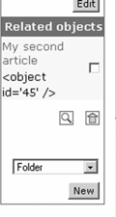
The page on which all users should start browsing can be customized (by default it is the main content node) by changing settings in the browse.ini file and the [AddRelatedObject] section. For newly created related objects, the same browse.ini file offers various settings (both default and per class). You can specify where the main node for such objects can be placed upon creation.
An interesting alternative is to use the ezobjectrelation and ezobjectrelationlist datatypes. The ezobjectrelationlist is a very powerful alternative to generic object relations as it allows categorizing related objects (create more than one ezobjectrelationlist attribute) and limiting the possible classes or related objects. You can even nest object relation lists by relating classes that in turn contain other object relation lists. The initial placement can again be configured in the content.ini file.

Workflows
A workflow can perform certain actions in the background (without user interaction) or require a user to perform certain tasks like approving an object before it can be published.
The workflow system of eZ publish provides the basics for implementing business procedures in electronic workflows. In the normal distribution of eZ publish, you have a few basic building blocks called workflow event types, but the workflow system can be extended with your own event types through PHP programming.

Triggers
Triggers launch the actual workflow chain. They are available for pre- and post- publishing workflows, as well as some shop functions. For each trigger, you can specify a workflow to execute. The list of triggers can be seen from the Triggers link of Set up, which becomes visible by expanding the Advanced section:
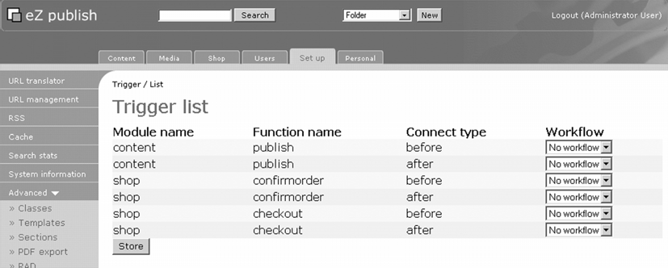
You may think that you can have only one workflow per trigger. This is more or less true, but workflows can be parallel. In particular, the multiplexer event type is actually a hub for launching specific workflows depending on the object class and section (another use for sections!) Furthermore, you can specify an exclude-list of a group of users that cannot activate a specific workflow. For example, "approvers" who do not need to approve their own created objects need not activate approval workflows.

Workflow Events
A workflow consists of one or more workflow events. Currently, eZ publish comes with four predefined event types:
- Event/Multiplexer
- Event/Approve
- Event/Wait until date
- Event/Simple Shipping
The multiplexer event is a very versatile tool that allows multiple workflows to run for a given trigger. It provides a filtering on sections, classes, and users who are not the subject of a workflow, and then allows another defined workflow to run.
The approve event can filter on sections and define the users who can approve and the groups of users that do not need approval.
The wait-until-date event filters on classes, but relies on the presence of a date attribute of the class of the objects for which it enforces delayed publishing. You can specify more than one class and the date attribute on which publishing should occur. Normally, the publishing date of an object is set when a user issues a "send for publishing" action. In the wait-until-date event, you can override this with the actual publishing date defined by the class-specific date attribute.
The simple shipping event can be used in e-commerce or shop applications to add a shipping cost to an order. The values are not set in the workflow definition in the admin interface, but are obtained from appropriate values defined in the workflow.ini configuration file.
The following screenshots show the creation of a simple approval workflow for articles (a default class installed with the base distribution). First, a workflow is created consisting of a single approval event where the administrator user has to approve publishing (this is valid only if called from the pre-publish trigger). To do so, click on the Workflows menu entry under the Advanced section of the Set up tab. This will bring you to workflow groups. In a certain workflow group, select the New button to create your new workflow.

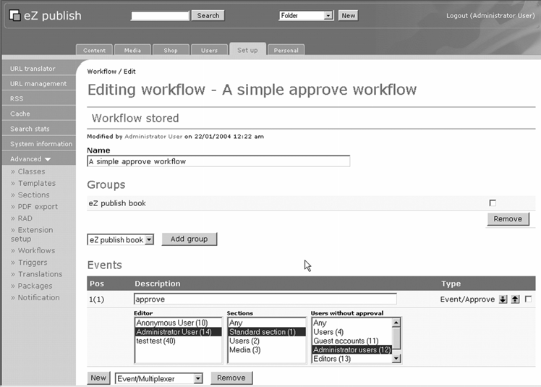
Next, a multiplexer workflow is created. This will be attached to the pre-publish trigger.
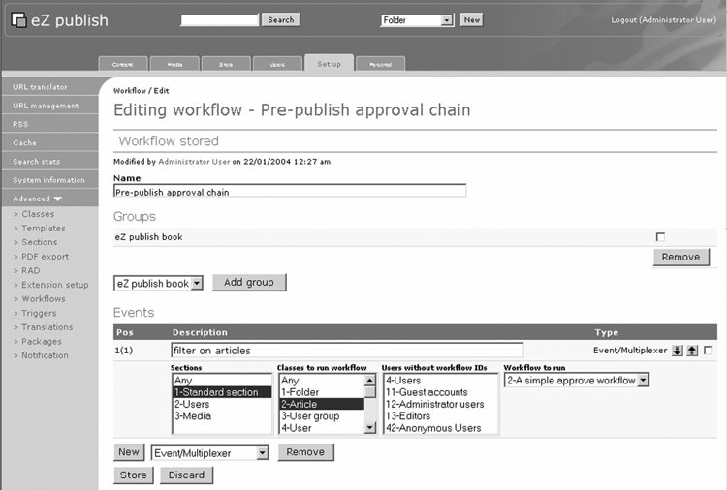
An example of a delayed publishing workflow event is shown next. This should be attached to a new multiplexer event in the base workflow just created.
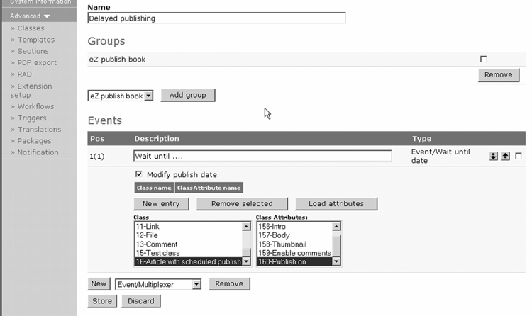

Permissions/Roles
The permissions in eZ publish are based on roles. On one hand, this involves the definition of roles, and on the other hand, the users and user groups to whom the workflow is assigned.
Unlike traditional user-group systems, nesting of user groups is not supported
in versions of eZ publish before 3.4. This is in spite of the fact that you can create hierarchies in the Users section of eZ publish. You can do this for other purposes (such as displaying an organization chart, for example), but for the role system, you needed to specify "flat" user groups—groups with user objects and without child user groups. Inheritance of user groups is supported in eZ publish version
3.4 onwards.
Users, user groups, and roles are created in the Users section of the admin interface:

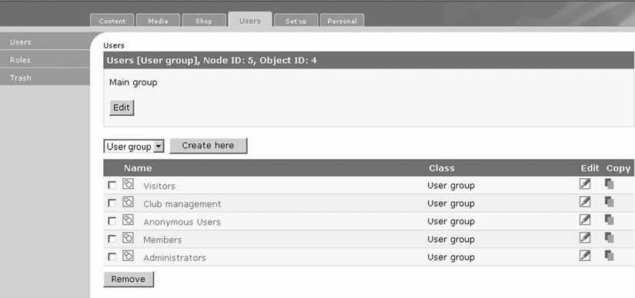
Roles can be created in the Roles submenu, where you can define the policies associated with a role and the assignment to users and user groups. For example, here we see the creation of a typical role for users with limited editing capabilities.
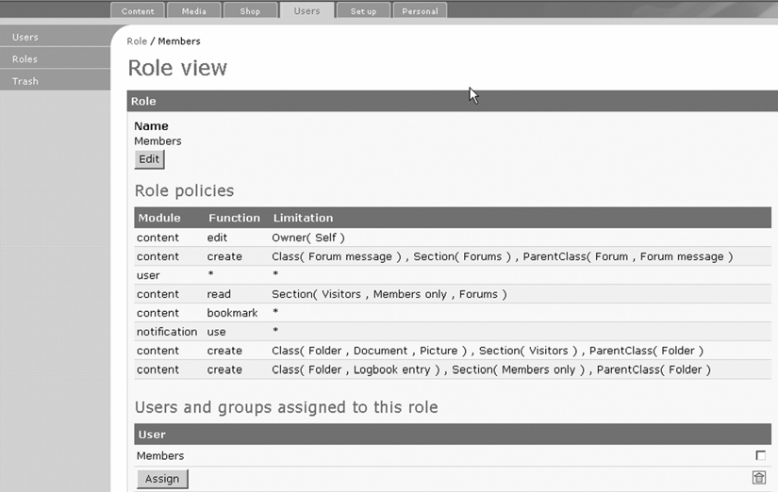
These users will be able to:
- Log in
- Create (and edit) articles beneath folders
- Remove their own articles
Additionally, these power users are allowed to create bookmarks.
There needs to be an edit policy along with the create policy, because eZ publish generates a draft version upon content creation that is then edited.

Templates
The Template submenu in the Set up section can be used to edit and create override templates. By default, the templates available in the standard design directory are used.
However, for each template defined there (or in the directory tree below design/<your design>/templates), you can create templates that will override the default template for a given class, section, or other qualifier.
Some of the common qualifiers are accessible from the Templates submenu, but the complete power is only released by editing the override.ini.append file in settings/siteaccess/<your siteaccess>.
An advantage of template editing through the admin interface is that any cached version gets deleted after editing. This is not always true when using a standalone editor action within the file system when you edit the files directly instead of through the admin interface.
Upon first entry into the template edit system, you are presented with a list of common templates. This list is generic in the sense that it contains a predefined set of templates including hard-coded templates in the setup module of the kernel and the templates found in the design/<your design>/templates directory:

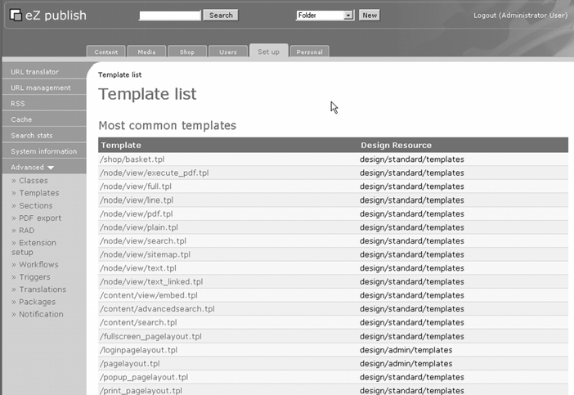
To actually work on templates, you will first need to select a type of template to work on. For example, select /node/view/full.tpl, and then select the siteaccess for which you want to edit or add override templates:
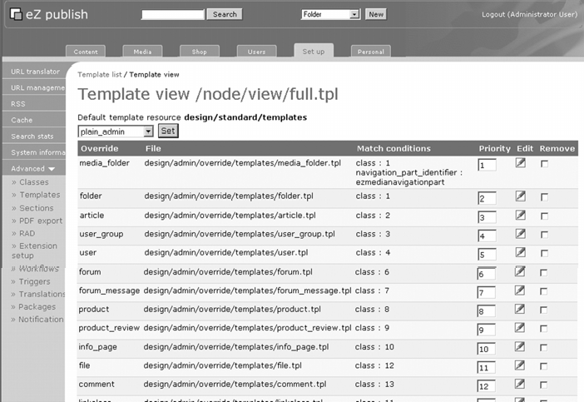

More Administrator Functions
In this section, we will look at some of the common functions found in the administration area of eZ publish.

Removing and Restoring Objects
You can remove objects in the admin interface from the Content section. Since version 3.3, you have the option to put objects into a trashcan so they can be restored later or to remove an object permanently. Here we see the result of a remove action:
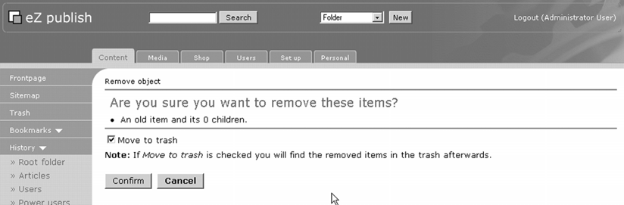
And here is the trashcan view:
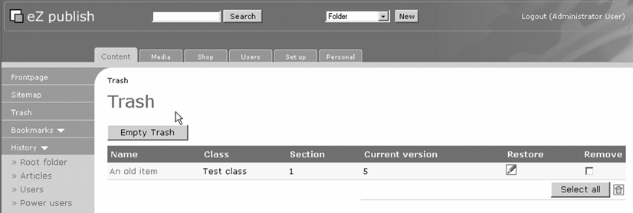
From the trashcan you can restore objects into their original location by default.

URL Translation
eZ publish provides a mechanism for URL translation. This can be handy for the construction of easy-to-remember URLs like http://mysite.com/about, which in
reality points to an article deep inside the site node tree. You can also use this to translate entire hierarchies into a new location or handle old URLs that are no longer valid.
When moving objects around in your eZ publish site, you strictly do not need to retranslate locations; eZ publish will redirect to the new location automatically.

URL Management
Every URL in your eZ publish site, entered either from the ezlink attribute or as an external link inside an ezxmltext attribute, is stored separately in the database. When properly set up, the scheduled cron jobs will check all these URLs for validity. This is one of the unique features in eZ publish and the admin interface provides access to this functionality as it gives a list of valid and invalid URLs used in your site:
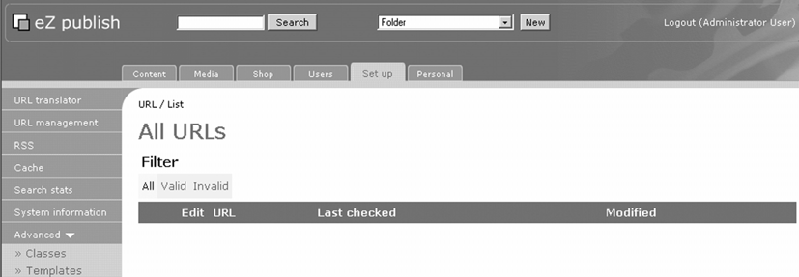
For each URL, you can also see the objects that make use of the URL. This can help you decide to edit the objects or simply replace the invalid URLs with new valid values.
If your server is behind a firewall that blocks outgoing HTTP requests, you need to modify the cron job for URL management to make use of a proxy or contact your network administrator to allow outgoing HTTP traffic.

RSS Export and Import
eZ publish adheres to major standards and RSS is one of them. You can do both RSS exports and imports from a variety of sources. The current implementation supports RSS import of versions 0.9, 1.0, and 2.0. RSS exports can be configured for RSS version 1.0 or 2.0. For exports, you can define the mapping of the children of a particular node (one level of depth and limited to five items). The following screenshots demonstrate RSS import and export respectively.

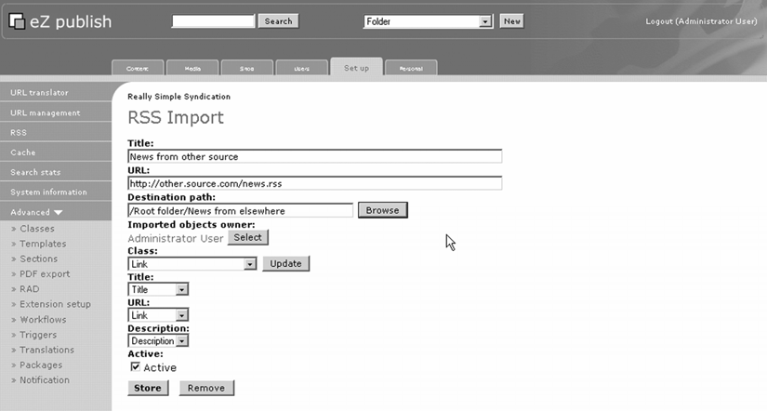
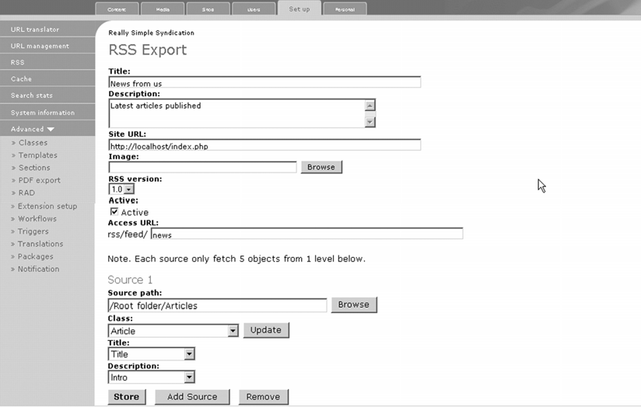
For both import and export, you need to map the RSS fields to the eZ publish class and attributes. For RSS import, the default link class is a good candidate. Imported RSS items are stored in a node tree location that can be specified in the RSS configuration admin interface.

Cache Administration
eZ publish is a powerful application, but is also resource intensive. To minimize the use of resources (CPU and memory), cache mechanisms are implemented for the major parts of the underlying kernel functions and libraries. Roughly, caching is active in for the following operations:
- Content views
- Template compiling
- INI file caches
You can use the cache administration screen to clear any of the sections of the cache, or even make a fine-grained selection to clear, such as the template block cache:
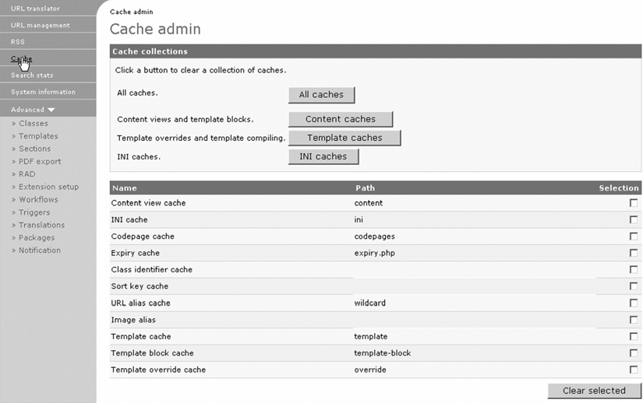
Normally, cache clearing is necessary during development or after upgrades that you should perform only in a development environment instance of your site. However, small changes on a live (production) site gain from the cache interface. The fine-grained control is especially useful for live sites.

Caches should be cleared after major updates in design (templates) and system upgrades (eZ publish upgrades). Make sure that you also clear the caches from PHP accelerators when executing system upgrades, as these can become corrupt due to changes in the PHP classes used.

Search Stats
While eZ publish by default does not keep track of the objects visited, it does keep statistics on search phrases and words. This helps you determine if the taxonomy of your site matches the average expectation of your target audience. The Search stats page shows a view of these statistics and also allows the clearing of statistics gathered this far:
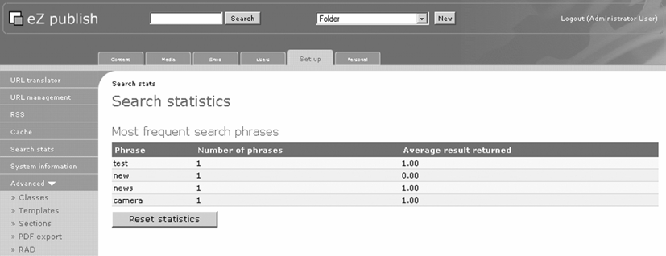

System Information
The system information page shows details of the current setup, including PHP version, PHP extensions, and other important settings. This is useful in determining if the PHP configuration, HTTP server (mostly Apache), and other items meet the requirements of eZ publish.

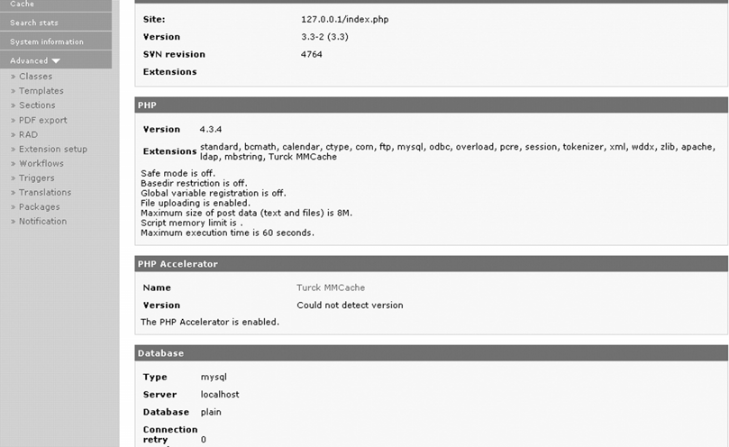

Section Setup
In the Sections page, you can define or remove section definitions. Here we see the basic (minimum) sections as defined for the plain demo package:
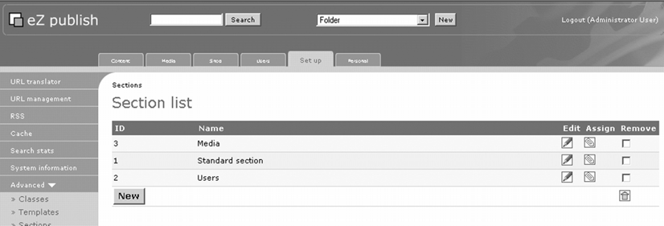
When adding sections, you can specify a navigation part that can be used in templates. For example, the admin interface itself makes use of this to map certain parts of the content to other navigation tabs. Normally, you do not want to do this except for assigning a gallery of images and multimedia parts of your node tree to the Media tab.

A common error in eZ publish administration is the deletion of the Users section by accident. This leads to the situation that the Users tab no longer displays the left-hand menu for users and roles. To restore this functionality, you need to create a new section that is assigned to the users root node and has Users as the navigation part. The integer value known as the section ID is not important here.

PDF Export
eZ publish not only provides web content through normal web browsing or RSS feeds, but also delivers content as an Acrobat PDF file. This is done in the PDF export submenu where you can define several PDF export configurations for parts of your site. Due to the heavy processing involved, you should limit the generation of PDF files of your content to relatively few objects (at least in version 3.3 of eZ publish).
The following screenshot shows an example entry for PDF export where you can define the node or node tree, classes, introductory page elements, and the way of publishing (either direct download or a cached PDF file).
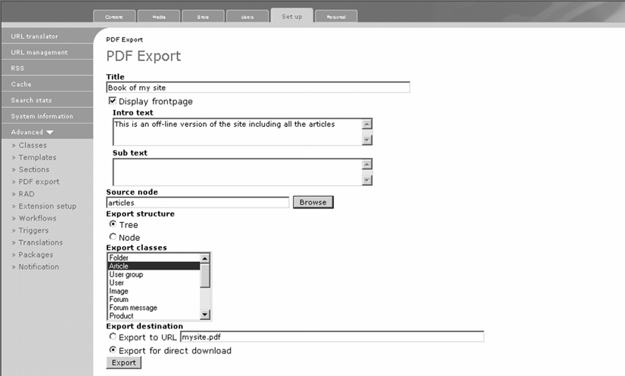

Rapid Application Development (RAD)
The RAD menu currently provides tools for generating skeleton PHP files for the creation of new template operators or datatypes. It is expected that later releases will include more options.

Extension Setup
You can activate third-party extensions such as the Online Editor in the extension setup menu. These need to be enabled in the appropriate INI files. Most extensions come with an explanation of how to do this, and any requirements specific to enabling the extension.

Packages
With the Packages menu, you can install or remove packages in the eZ publish native format. Currently supported types are class packages and design packages (CSS files). This is useful when you create several classes that you may need on other installations. Third-party submissions from the eZ publish community may come in this format for convenient installation.
When importing a package with new classes, make sure you have all the included datatypes installed. If not, the package import will fail, leaving the contentclass and contenclassattribute tables in a dirty state.

Notification
The notification system can be run ad hoc from the notification section. The functions provided here are used mainly during development to test the proper functioning as they should normally be executed from a scheduled cron job. It can be used as a workaround for installations that do not allow access to a cron system or scheduler during development.

Personal
The Personal tab provides some useful functions for individual users (provided that you have created and assigned the necessary policies). It provides:
- Drafts for listing objects in draft mode by the users currently logged in.
- A pending list that details objects that have a pending workflow event, such as approval or delayed publishing.
- Notification settings for sending e-mails about new or updated objects (somewhat limited in version 3.3, but this will improve with later releases).
- Bookmarks for storing nodes of interest at the server level (independent of the browser or computer that the current user is working from).
- Collaboration—currently this holds the items for which an action is required by the currently logged-in user, such as approvals.
- Password management for changing the password of the current user. The administrator can also do this in the Users section for any user.

Shop
The Shop tab provides some functions for e-commerce (shopping) like different types of taxes or discounts to apply for certain objects and user classes. When users add items to their baskets, the admin interface provides simple handling of shopped items.

Creating an Example Site
This section is all about the first few steps that you need to take to build your own sites with eZ publish. To jumpstart, you should install the plain package that comes with the default distribution of eZ publish.
We begin with an overview of typical requirements of our project: setting up a portal for a nature photography and astronomy club website.
The portal for the nature photography and astronomy club should provide the following feature set:
- A public part with documents, pictures from members organized in galleries, discussion forums, calendar of activities, logbooks, news (with subscription service), and a few personalization features (for registered users)
- A private part for the club management for statutory documents, meeting reports, actions, and private discussions

Creation of Basic Classes
Now that you have learned about the powerful features of eZ publish to accommodate whatever high-level data model and structure you want for your website, a little analysis of the requirements soon brings forward a number of solutions. Indeed, with eZ publish you often have more than one way of accomplishing your goals.
Using the example website, the requirements can be synthesized as follows.

Documents
The term document means different things, yet we want to limit the number of document types for our website. Roughly speaking, we want both structured documents, where the different parts such as title, introduction, body, keywords are separated, and legacy documents in the form of PDF files or typical word-processing documents. This is possible if we use a super-document class consisting of the following elements:
- Title (text line)
- Intro (XML text field)
- Body or summary (XML text field)
- A file as attachment (binary file)
- A keyword list (keyword datatype, as an automated form of related documents)
- Miscellaneous related items (object relation list)
- A flag for allowing/disallowing comments (as with the default provided article class)
- A flag to signal that a document should appear as a news item on the home page
Another type of document is a logbook—a kind of dedicated weblog. This is in fact a collection of logbook entries linked to each user registered with our site. The logbook itself will be a simple folder object. A logbook entry will consist of a simple list of elements:
- A subject (text line)
- A body (XML text field)
- A list of related items published elsewhere on the site (object relations list)

Images
Images won't be just an image with a caption. Our nature photography and astronomy friends are eager to provide information on the equipment they used, location, date and time, and perhaps a few other details. Since this is not a book on astronomy, we'll nevertheless limit the number of attributes.
After some deliberation with the website project team (the webmaster and his daughter in this case), the image class will consist of:
- A title (text line)
- A description (XML text field)
- Image file
- Caption to display with each picture (text field)
- Equipment used (XML text field)
- Date and time (datetime field)
- Location (XML text field)
- Keywords

Discussion Forums
For the forums, we basically need a list of topics, sticky forum messages (the ones that are displayed at the top of each forum containing important information), and a forum folder. The folder will be just the standard folder object as delivered with a plain eZ publish distribution, consisting of a title (text line) and a description (XML text field). The forums are also folder-like objects, but nevertheless we'll create a new class for them adding an icon as a new attribute. Messages or topics (a top-level message) will consist of the following attributes:
- A subject (text line)
- A message body (plain text field)
- The type of message (selection datatype) to distinguish between a question, a remark, important news, and so on

Calendar of Activities
Activities can be of different types, but nevertheless we want them to be implemented with only one class. A calendar item therefore consists of the following attributes:
- Subject (text line)
- Description (XML text field)
- Location (XML text field)
- Start date and time (datetime)
- End date and time (datetime)
- Keywords (keyword)
- Category (selection)
- Related items (object relation list)
The navigation will also need a calendar; the kind of component you may be familiar with from groupware applications.

Personalization
With respect to personalization, we want each registered user (member if you wish), to be able to have his or her own mini-site with details on their level of skills, equipment, and other information. In addition, we want to offer some preferences and access to notifications, a draft space, and user-interface preferences. We can implement this under an umbrella (a folder) object with subfolders containing user-specific details.

Miscellaneous
We will need one more class: a generic object with only a name. We will use objects created for hosting special functionality, such as a home page, in the templates later on. Our dummy class will be:
- Name (text line).
- For each of the nodes associated with this class, we will make a dedicated template overriding the default. It will hold things like the entry point of My site with preferences, statistics, and more.
- Furthermore, we also want a links or bookmarks section of general interest (not to be confused with the bookmarks functionality in eZ publish). For this, the standard link class will be used, which consists of a title, a description, and the link itself with a URL and the display name (the thing you generally put between <a ...> and </a>).
- Finally, we need comments that will be added by members. This will be done in the templates, which we look at in the next chapter.

Creating Classes
Creating a class is left as an exercise for you by using the default admin interface delivered with eZ publish. The mechanics of this has been covered in some detail in the Creating Content Classes section.

Taxonomy or Structure
The site structure will be straightforward, and the visual experience will be made mainly through the use of powerful template functions provided by eZ publish. When viewed as a tree-like structure, the taxonomy will consist of:
- Home (a dummy object) aggregating news and other items
- News (show all the news items with a navigator for archived news)
- Documents
- Technical documents
- Meeting reports
- Miscellaneous
- Calendar of events
- Links
- Astronomy related
- General photography
- Galleries
- Astronomy
- Nature
- Forums
- Announcements (by the club management)
- Astronomy related
- Nature related
- My site (personal stuff)
- Restricted part for the club management
- Forum
- Statutory documents
Here we see the sitemap view in the admin interface (the sitemap template has been modified to show the class name of the objects).
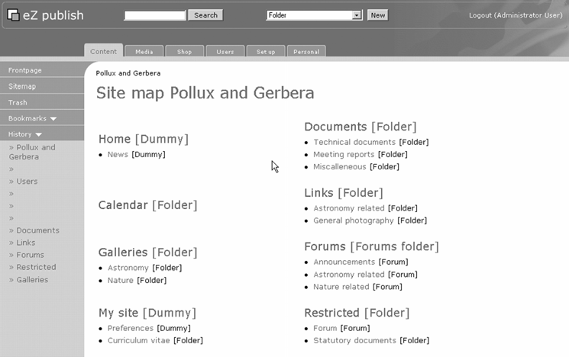

Users and Roles
For the roles settings, we want users (members) and the general public to be able to read everything except for information in the restricted parts. Regular members should also be able to create new forum messages and topics, and submit documents and images (which would be reviewed by the club management). Self-registration will be disabled—every member will be created by the club management. For example, they could grant membership on the condition that applicants have paid their annual membership fee.

Sections Setup
To make it easier to implement permissions and roles, we will assign sections to the various parts of the site. By default when new folders are created, they inherit the section from the parent (or top-level) element, usually the Standard section. For our purposes, we can make the following sections and assign them to subtrees in the taxonomy described earlier:
- A restricted section for club management
- A section for forums where only members can post
- A section where each member can view the details of other members, but which is not accessible to the broad public (anonymous users in eZ publish)
- A visitors section for all users, including anonymous users, which is assigned to the top-level elements (Home, Documents, Calendar, Forum)
Here we see the result of creating these sections:
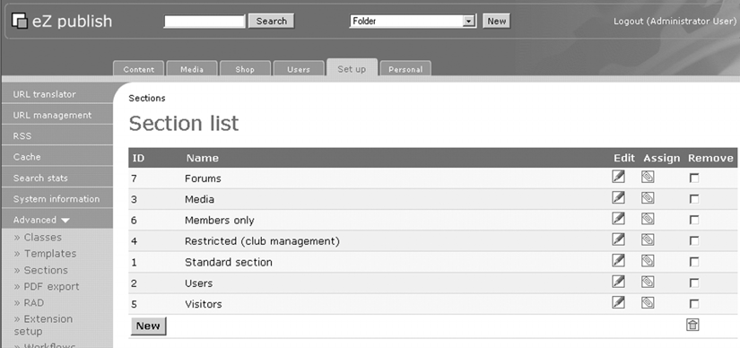
The following screenshot is the result of their assignments:

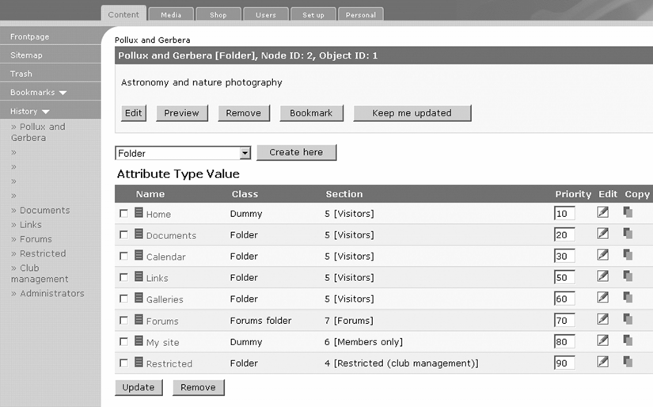
In this screenshot, the template from the admin interface was slightly modified to show the section-access details in square brackets alongside the section ID.

User Groups
Basically, there are four categories of users:
- Anonymous users
- Visitors (non-members registered with the site)
- Members (assigned by the club management)
- Club management
For each of these categories, you need to create user groups. The default group for non members will be the visitors group. This has to be set in the settings/override/site.ini.append.php file in the [UserSettings] section with
the DefaultUserPlacement parameter. For example, in the tutorial site, the node ID of the Visitors group is 12, so the configuration line should look like:
File: settings/override/site.ini.append.php [UserSettings]
...
DefaultUserPlacement=12
...
Here are the final user groups:

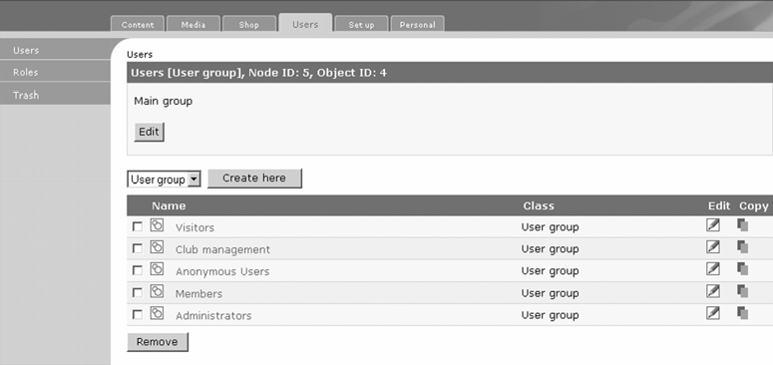

Roles and Role Assignments
For clarity, each type of user (defined in their separate user groups) is assigned a role definition.

Anonymous
An anonymous user gets a content/read policy for access to the visitor section and has the permission to log in. You can also disable policy checking in the [RoleSettings] section in settings/override/site.ini.append.php by specifying PolicyOmitList[]=user/login (default setting at the time of writing).
The role view of the anonymous role is shown in the following screenshot:
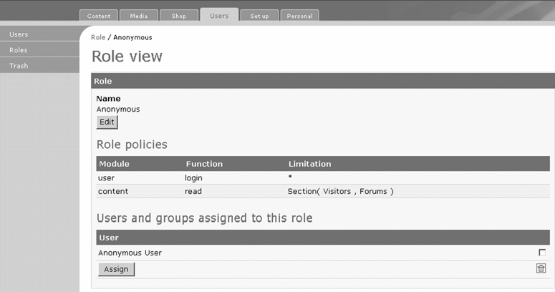

Visitors (Registered Non-Members)
Registered users have almost the same permissions as the anonymous user, except that they have two additional permissions—creating bookmarks and notifications.
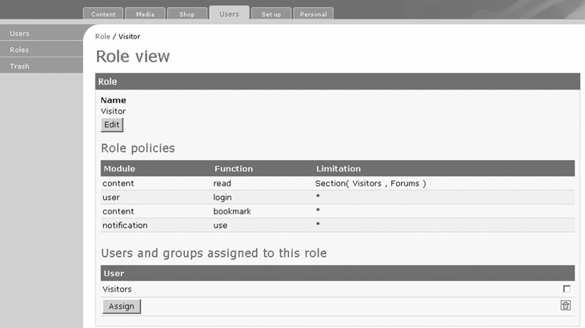

Members
Members are granted the ability to create documents, upload pictures, and keep their logbooks in addition to the policies defined for visitors.
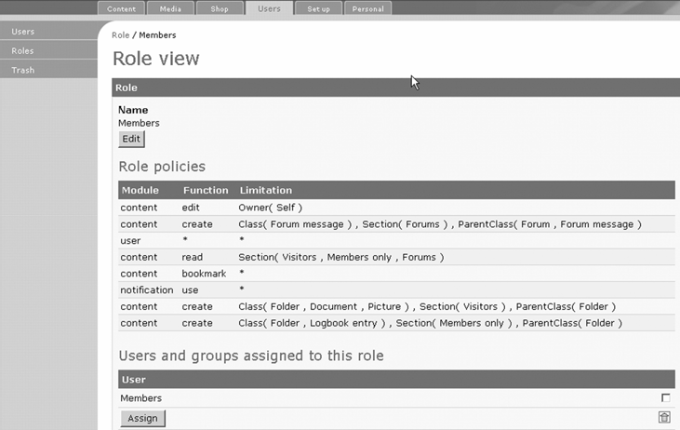

Club Management
The club management can do almost anything with the content and users, so the policies are rather simple:
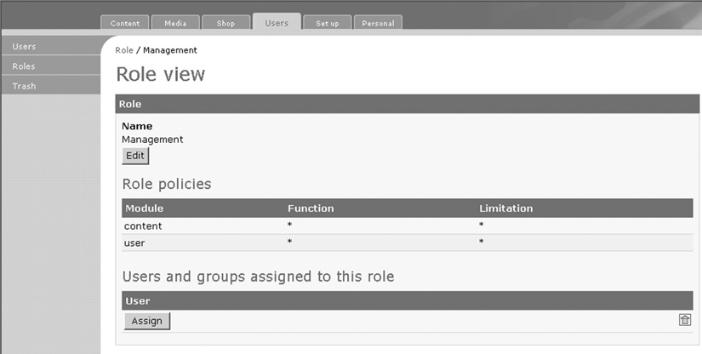

Summary
In this chapter, we have seen how to use eZ publish for content management. We looked at the fundamentals of an eZ publish site and content handling within it, including content classes and objects, versioning, and how eZ publish displays your content.
We moved on to the administrative interface of eZ publish, and how it is used to add content to your site. We looked at the default datatypes that are available with eZ publish from which can construct your content objects, as well as how the other main concepts of eZ publish are realized in the administrative area.
We concluded the chapter with a tutorial on the basics of creating a sample astronomy and nature photography site, and walked through the basic classes and roles required by the site.
In the next chapter, we look at the templating system of eZ publish, which is at the heart of content display in eZ publish.

3

Displaying Content with eZ
publish Templates

eZ publish comes with a powerful template engine that is capable of presenting the content in various output formats, including XHTML and PDF. Template files can also be used to create functionality that is sometimes described as portlets (portal components) in other content management systems.
You already know how eZ publish can be used as a content management system from a pure content perspective. The next layer for gaining knowledge is the template system and how it can be used to extract and present content to the user. The caveat is that the syntax of the template system means another language to learn.
In eZ publish, every page is generated dynamically, based on templates that are processed to add the content. This is because the architecture of eZ publish separates design and presentation logic (including internationalization) from content and processing, which happens mainly in the kernel modules.
Templates are generally a mix of XHTML and the eZ publish template language, providing access to the data (in the database or file system) and functions of the underlying application and content management framework.
In the next section, the overall idea of the template system is explained. The subsequent sections go into the details and show you how to use the template language.

Principles
The eZ publish template system is designed in a hierarchical fashion, where some
first-level templates (pagelayout.tpl) control the rendering of more specific blocks like the content views and navigation structures (menus). Content views are rendered through templates, which can be tied to specific classes and view modes. The datatypes that make up a class are also controlled by individual templates. Further down the template hierarchy, even individual elements are controlled by templates (for example, the
<header> tags in XML text fields). Almost all templates can be overridden by custom templates, depending on the section, class, depth in the node tree, and so on.

Page Layout and Content Views
When you visit the main eZ publish site or most of the sites created with it, you are presented with a page containing navigation elements (such as top-level menus), polls, and content, such as article listings, image galleries, and so on.
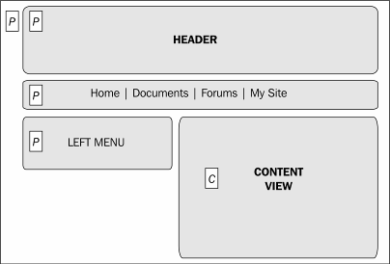
eZ publish distinguishes between page layout templates and content view templates. Page layout templates are used to present the user with a global page layout. This includes everything except the main content. The main content referred to here is what is actually requested by the URL, and displays along with the navigation elements to assemble the whole page.
However, because of the power of eZ publish, the distinction between page layout elements and content presented here can be blurred by your specific needs, imagination, and creativity.
The template system is component based, which means that a template generally calls other template files for common parts or when you need a particular functionality, or intrinsically by the hierarchical organization of templates from the top level (page layout) to individual objects, object attributes, and the XML text tags of XML text attributes.

Page Layout
The main template that is always called is the pagelayout.tpl template. This template will be used to display the overall page layout, <head> elements such as cascading stylesheets, the <body> section top-level menus, navigation parts, a search box, etc.
The page layout template can be overridden by specific instances. For example, the 'home' page layout may be different from the page layout used for presenting a catalog of articles or products.
You can also define additional page layouts for a printer-friendly version or for pop-up windows. These are called by prepending the normal URL part with /set/layout/<your pagelayout.tpl override>/.

Content Views
View templates are mostly associated with the content views. The content view is actually a presentation of the content or page requested by the user through the URL. For example, http://www.example.com/content/view/full/2/ refers to viewing the content in full view mode of node 2.
When you activate 'nice URLs', the URL actually does not contain a view mode. The full view mode is implicitly tied to the nice version of the URL.
There are more standard view modes that can be called in the URL, such as http://www.example.com/content/view/sitemap/2/, where a sitemap View template is called to present the content of node 2.
Alternatively, you can create your own view modes and call them with a name you see fit (and which is not yet defined). The only thing you need to do is to create a file with your specific view name in the default directory for View templates:
design/mydesign/templates/node/view/
For example, if you want to have a view mode that displays more information than the full view template, you can create a template called extended.tpl, which could add, for instance, the audit trail (version history), the date when the content was last modified and by whom, related objects, and so on.
These custom views can further be subjected to the template override system, effectively adding another dimension to the possibilities of the eZ publish template system.
A second class of often-used view templates corresponds to view modes as used in lists (the line view) or when embedded within XML text attributes (the embedded view).
Like page layout templates, content view templates may be overridden for specific classes and also depending on which section is active or which node is being called.

Attribute Templates
The templates in eZ publish are further broken down in components for object attributes; these constitute the attribute view templates. They are normally used for abstraction in the display of normal view templates for nodes. For example, the default view template for the full view just loops over all the available attributes and calls a generic template function (attribute_view_gui), which takes care of the proper display, depending on the datatype. The attribute view templates are located in the /design/standard/ templates/content/datatype/view/ directory.
Attribute templates can also be overridden for specific classes, nodes, and sections.

Template Modularization
Template code can be reused by placing it in specific template files. These can be included in other template files by using the include template function. Along with this function, you can specify parameters to pass to the included template. In this way, templates can become the equivalent of small applets that take input parameters.
Some typical examples of these are:
- <head> elements for specifying style sheets
- A calendar widget
- Navigators
- Menu/navigation blocks

StyleSheets and Images
To adhere to the design standards of eZ publish, most of the style information should be put in CSS files, leaving only pure XHTML and template code in the template files. CSS files should be placed in design/mydesign/stylesheets.
If you need to use images that are not part of the content of your site (such as navigation icons or logos) in your template, you should place them in the design/mydesign/images directory.

Edit Templates
For a lot of websites, the edit functionality you offer to the end user may be quite limited. However, for intranet portals and other highly collaborative sites, you may not be content with the default edit functionality of the admin interface. To get around this, you can
create edit templates to allow specific users to modify part of the content and offer tailored edit interfaces that are integrated seamlessly within the same site design, coupled to the normal site access.

Templates and Caching
As the template mechanism is used for abstracting the data from presentation, the processing involved is considerable and the page-processing time is typically an order of magnitude larger than spaghetti-style PHP with HTML embedded or vice versa. Since version 3.1, the template engine also includes a template compiler that converts the eZ publish template code into native PHP code. This code is stored in the var/cache directory of your installation (the most daring among you are invited to look at the generated PHP code: it is impressive). You can enable or disable template compiling in your site.ini.append.php files.
Not only the template code, but also the content retrieved from the database is cached as PHP code. This is called view-mode caching and actually combines data (node structures converted to multidimensional arrays) with template output (normally XHTML).

Cascading and Overriding Templates
When you learned about configuring your site in Chapter 1, the structure of design directories was introduced. The template system partly depends on this structure to determine the template file to use. Along this directory-traversing algorithm, you can override the templates depending on specific conditions defined in the override.ini.append.php file.
In this way, you can specify a certain template to be used according to a specific node, the depth in the tree, the class of the object, or some other parameters (explained later in this chapter).

Working with eZ Publish Templates
After this general overview of the principles, the next step is to explore the various aspects of the template system in more detail.

Overview
The main prerequisite for the template system to work properly is that the configuration parameters should be correctly specified, according to the instructions in Chapter 2.
Where appropriate, some details on configuration settings are treated with specific topics.

Where Does the Content (Data) Come From?
To manipulate the content for display in templates, it is important to know where the content (or part thereof) comes from. The following list should provide a decent idea:
- Navigation elements, such as menus, or banners: Navigation elements could be hard-coded in the page layout template, but they are, in general, tied to the site structure or taxonomy of your site. Therefore it is sensible to fetch the site structure dynamically and use the results to build menus and other navigation elements.
- Applets where content is explicitly fetched like polls, news, or RSS feeds: Applets are generally built using applet-specific templates and called with certain parameters, which are usually nodes somewhere in your site.
- The module_result.content as the main content delivered from the requested module or function: The main result of the module/function called is handled by specific content templates, but you can use a few elements from the result set for other purposes.
- Additional content implicitly fetched by the main module/function result(s): Finally, the main content, as it is being handled by the view templates, is a rich object structure that you can use where appropriate.
The following sections discuss the basic syntax of the eZ publish template system. As stated before, the template system employs an eZ publish-specific language which you can use in your own templates. We are now actually getting into the template files, so buckle up!

Comments
It is good practice is to add comments to your template files. Although comments generate a little overhead in parsing the template files, you should not be economic in their usage. Document the objectives and implementation for your custom templates in terms of features, methods, and expected outcome.
Comments are enclosed between {* and *}. The content between these delimiters is never sent to the client. Actually, it is ignored even by the compiled template code.
{* this is a comment *}
{* This is a multi line
comment with a portion of code commented out:
{let fruit=array(apple,orange,strawberry)}
{section loop=$fruit}
{$:item}
{/section}
{/let}
*}
If you really want or need comments sent to the client, you can use XHTML comments. However, be aware that these comments are also parsed by the template subsystem, so you need to make sure that are no clashes with the template syntax.
Also, be careful with JavaScript in templates, especially the { and } characters, which are treated as 'block start' and 'block end' by the template parser. This means you cannot input them directly in the template code to get a { or } on the web page. Instead, you must use the {ldelim} and {rdelim} functions, as shown in the following example:
{* use of the left and right delimiters *}
Hi, the next piece of template code uses {ldelim} and {rdelim} tags
This produces the following:
Hi, the next piece of template code uses { and } tags
Note that the comment block does not appear in the output!
To ignore larger blocks of template code with potential conflicting delimiters, you can also use the {literal} construct. For example, to make sure JavaScript code blocks will work, surround them with this tag, as shown in the following example:
{literal}
<script language="JavaScript">
<!--
function MyJavaScriptFunction ( Param ) { Param=1
}
// -->
</script>
{/literal}

Variables
Variables are containers for various types of content, and are set either by operators and functions of a module, or explicitly inside templates.
The variables that you define inside a template file will have their scope for that particular template.

Setting and Modifying Variables
To set or modify variables, use the constructs {let ...}, {set ...}, or {default ...}.
{let} and {default} declare variables, and with {set}, you can modify them further.
{let} and {default} require closing equivalents {/let} and {/default} respectively, which also un-set the variables they defined.
{let a=3
b='a string' c=false() }
{$a} times {$b} is {$c}
{set c=true()}
{$c}
{/let}
This code will output the following:
3 times a string is 1
{default} is special, since it will assign a value to a variable unless it is already defined by a parameter passed to the template where {default} is used. This helps make templates more robust and modular.
To assign the result of complex template code to a variable or for larger text fragments, variables can also be set with {set-block}. The syntax is:
{set-block name=<name> scope=<scope> variable=<myvariable>}
{* things you want to assign to, including further eZ
template expressions*}
{/set-block}
The name parameter is optional and introduces a new namespace (discussed further in the sections on variables and namespaces). scope can be global, root, or relative, and variable is the identifier to use. The scope parameter makes it possible for a template to return different text fragments, as opposed to a single output block. This is used, for example, in e-mail templates where the subject and body text are set separately.
With the global keyword for the scope parameter, you can even set variables that live in the global namespace, which is mostly outside of the current template. For example, you can define a variable called extra_javascript in the <head> section of your pagelayout.tpl file, in which you can set blocks of JavaScript from within a view template. This is handy for reusing JavaScript files or adding a JavaScript file from within an extension, as the eZ publish Online Editor does.
{append-block} is similar to {set-block}, but instead of setting (replacing) the content of a variable, you append content to an existing variable. This is used in the Online Editor product, which appends instructions for including the JavaScript files in the <head> section for the extra_header_data variable. The syntax is the same as with {set- block}, but without the name parameter:
{append-block scope=<scope> variable=<myvariable>}
{* things you want to assign to *}
{/append-block}
Both {set-block} and {append-block} can be used to modify variables outside the current namespace.

Variable Types
Both atomic (simple) and compound variable types can be used in the template language of eZ publish.

Simple Types
The common simple variable types supported by eZ publish are numeric values (integers and floats), strings, and boolean values (although booleans are special functions).

Compound Types
The compound types supported by eZ publish are arrays and objects. Arrays also come in two flavors: classical arrays with a numerical index, and associative arrays.
Objects are only generated by the kernel functions and operators of eZ publish. Arrays can be created in templates with the array and hash functions, much like in PHP.

Type Creators
Some types can only be created from PHP, by using operators. Arrays are created with the array or the hash operator and booleans with the true() and false() operators. Objects cannot be created in templates directly, but for object-like structures, you can use nested (multidimensional) arrays. Note that like the general objects, there are also methods involved, not only static data.

true()
Creates a true boolean. Remember to use brackets:
{true()}

false()
Creates a false boolean. Remember to use brackets:
{false()}

array()
Creates an array.
{array(1,2,'tree')} {*creates a mixed type array consisting of numbers and a string*}
{array(true(),true(),false()} {*creates an array of boolean values*}
Like PHP, array elements can be mixed types with numbers, literals, other arrays, and objects.

hash()
Creates an associative array, with the keys being the odd parameters and the values being the even parameters.
{hash(haircolor,'none, bald',age,41)}

Accessing Elements of Arrays and Objects
Elements of arrays and objects are accessed by the '.' operator. For example, a member called member of an object called object is accessed as:
$object.member
Array elements are accessed in the same way:
$array.0 {*selects the first element in an array*}
$array.mykey {*selects the element of a hash array with key "mykey"
*}

Sections in Templates and their Effects on Variables
Sections are not just restricted to group nodes and node-trees; they are also used in the template language for a variety of constructs. They are used for loops and constructs like if-then-else, and also appear subtly when defining and using variables, even in constructs that do not bear the section name.
This is all due to the use of variable namespaces inherently created by using section, let, and other constructs for which you can assign a name parameter.

Variable Namespaces
In general, every variable in an eZ publish template is associated with a namespace. By introducing sections for loops and other constructs, a variable defined one of these sections is assigned to the namespace associated with that section. Failure to understand this is one of the main causes of errors in template programming.

Predefined Variables
Most templates have one or more template variables available for use within them. Some are passed from a template higher in the template stack; others are set by the eZ publish kernel modules and functions.
The following sections list the most common and useful variables, but plenty more exist, and even more will be present in future releases.

Effects of Caching and Availability of Predefined Variables
Caching has a major influence on the available predefined variables. As a rule of thumb, it is best to always think of the situation with view caching 'on'. The main variables used are $module_result (in the page layout templates) and $node (in the view templates).

Variables Available in the Page Layout Templates
$module_result is the basic variable available in page layout templates. For instance,
$module_result.content contains the result of module/function processing and template compiling/processing in the form of XHTML output.

$module_result

Attribute | Type (in template) | Comments
content | string | Content generated by the requested module/function
node_id | string | Current node ID
content_info | object | Compound object containing useful data

$module_result.content_info

Attribute | Type | Comments
site_design | string | Current site design used.
node_id | string | Current node ID.
parent_node_id | string | Parent node ID of the current node.
node_depth | string | Current node depth.
url_alias | string | Current URL alias for use in nice URLs.
object_id | string | Object ID (a numerical value).
class_id | string | Class ID (a numerical value).
section_id | string | Current section ID (a numerical value)
navigation_part_identifier | string | Current navigation part (used in admin templates).
viewmode | string | Current viewmode: very useful for determining navigation elements.

Attribute Type Comments

language | string | Current language.
view_parameters | array | Additional view parameters. Since version 3.3, this array contains the offset parameter for the Google or plain navigators and year, month, day parameters for the monthview navigator. These navigators are templates you can include in your own template (see the files in design/standard/templates/ navigators).
role_list | array | Array of role objects for the current user.
role_id_list | array | Array of the role IDs.

The navigators mentioned in the view_parameters entry add navigation elements in the style of Previous and Next to your pages, much like the elements used to move between pages on Google search results. The monthview navigator displays links to objects published on certain dates.

Variables Available in Content Views
The main variables set in the view templates are $node and $view_parameters. The former is an entire object, with a wealth of data ranging form generic node attributes, such as creator, creation date, depth in the node tree, to others that give access to attributes, related objects, and more. On the attribute level, along with the available content, depending on the datatype, many object methods and specifiers offer additional output formats (for example, XML text fields converted to XHTML and image variations).

$node

Attribute | Type | Comments
node_id | string | Current node ID
parent_node_id | string | Parent node ID
main_node_id | string | Main node ID (an object can have multiple locations or nodes)

Attribute Type Comments

contentobject_id | string | Content object ID, necessary for editing
contentobject_version | string | Current version of the object
contentobject_is_published | string | Can be either 1 (published) or 0 (not published)
depth | string | Depth in the node tree, 1 is the root node
name | string | Name of the object, as defined in the class it is derived from
path_identification_string | string | Part of the URL
data_map | array | Array of ezcontentobjectattribute  objects
object | object | Class: ezcontentobject
parent_object | object | Class: ezcontentobject of the parent node
sort_array | array | Sort method, as defined in the admin interface
path_array | array | Array with the node IDs starting from 1, the root node and so on
subtree | array | Entire subtree of this node
children | array | Array of child objects at the level immediately below this node
contentobject_version_object | object | Current version of the object as a version object
creator | object | User object of the creator: you can use  $node.creator.name for displaying the owner of the object

$node.object
The $node.object variable exposes the content object assigned to the current node.

Attribute | Type | Comments
section_id | string | Current section ID
owner_id | string | Owner ID
contentclass_id | string | Class ID of the object
class_name | string | Class name of the object
name | string | Name of the object; should be the same as $node.name
published | string | datetime value of the creation time as UNIX timestamp
modified | string | datetime value of the last modified time as a UNIX timestamp
can_read , can_create, can_edit, can_translate, can_remove | boolean | Show what the current user can do with this object and whether the current user can create children of the current object
can_create_class_list | array | Array of class IDs, for which the current user can create child objects
related_contentobject_array | array | Array of related objects, as defined in the admin interface
related_contentobject_count | string | Number of related objects, as defined in the admin interface

View Parameters
In some cases, view parameters like offset and limit are passed to templates. Mostly, this is done from a template file higher in the template stack. These are accessible by the
$view_parameters.offset and $viewparameters.limit variables.

Variables Available in Edit Templates
In edit templates, the main variables are $class and $object. From these (compound) variables, the relevant items such as class attributes, (initial) node placement, versions, and related objects are obtained for editing objects.
It is perhaps challenging at first sight, but you should take a look at the edit templates in design/standard/content to see how edit templates are set up. You can override these edit templates to incorporate them in your site design.

Other Mechanisms
One of the mechanisms to have variables is to use the ezpreference system. You can set user-bound preference variables with /user/preferences/set/<variable name>/<value>. The variables can be accessed by ezpreference('<variable name>').
Be careful when using the preference system, as it is not part of the content view cache mechanism. You will have to resort to disabling the view caching with
{set-block scope=root variable=cache_ttl}0{/set-block} and use cache blocks to optimize the response times.

Using Variables across Templates
This topic is currently not addressed in eZ publish, in spite of its obvious benefits. From version 3.4, a mechanism will be introduced where variables can be passed by adding them to the URL in a special way. The URL-passed variables are then also part of the default view cache keys.
The mechanism is as follows: you simply append a variable enclosed in brackets followed by a slash and the value of the variable. For example:
http://mysite.com/content/view/full/2/(myvariable)/myvalue
This assigns the value myvalue to the myvariable variable. Its value can be called as a child of the predefined $viewparameters template variable. So:
{$view_paramters.myvariable}
This will output the myvalue string.
You can also override normal view parameters, such as offset and limit, by using these as your custom template variables.
In version 3.3, the best method is to use the ezpreference mechanism.
If your parameter values contain spaces, they will be converted to a URL encoded form by most browsers. Therefore, you should always decode these values before using them. The urldecode operator is not specified by default in 3.3, but you can easily add this operator through the template.ini file, which contains the urlencode operator as a direct match to the PHP equivalent.

Controlling Template Output Flow
Here we will look at some of the basic language constructs that allow us to control the flow of template output:
- The {section} construct
- Looping with {section}
- {switch} constructs
At the end of the section, we will revisit namespaces and see how to better handle the problem of a variable definition being tied to the section in which it is defined.

Section
{section} is one of the most important functions in the template engine. It provides looping over arrays and numeric ranges (equivalent to a for statement), and conditional control of blocks and sequences (if-then-else). It is controlled by a series of input parameter and sub-functions.
An example of its use for looping is:
{let myarray=array(1,2,3)}
{section name=myloop loop=$myarray}
{$myloop:item}
{delimiter},&nbsp;{/delimiter}
{/section}
{/let}
This will output the string "1, 2, 3".
In general the syntax for {section} is:
{section name=<myname>
show=<showcondition> loop=<array> sequence=<sequence-array> max=<max iterations>
offset=<offset in the index for loops>}
{* code if showcondition is true *}
{delimiter}
--- {* this is printed/executed except for the last iteration *}
{/delimiter}
{section-else}
{*code if showcondition is false*}
{/section}

Parameters
Having seen the basic syntax of the {section} function, let's look more closely at each of its parameters.

name
name defines the namespace for all generated template variables; see loop and sequence
for a list of generated variables.

loop
loop defines the data that the section should loop over. For every iteration of the loop, it sets the template variable $name:item. The data can be an array (array of scalars or an array of objects), in which case each item in the array is traversed sequentially.
The data can also be a number that determines the number of iterations (a negative number makes the iteration go backwards).
It's possible to constrain the number of iterations performed and control the iteration of single elements. See parameters max and offset and sub-children {section-exclude} and {section-include}.
Each time the section iterates, it sets four template variables in the new namespace. The variables are index, number, key, and item.
- index: A number that starts at 0 and increases for each iteration.
- number: Behaves in the same way as index but starts at 1.
- key: If an array is being iterated, key holds the key of the current item. Otherwise, the current iteration index is set.
- item: If an array is being iterated, item holds the value of the current item. Otherwise, the current iteration index is set.

show
This parameter determines whether the section block should be shown or not. If the parameter is not present or is true (either a boolean true, non-empty array, or non-zero value) the {section} block is shown, otherwise the {section-else} block is shown. This is quite useful for conditional inclusion of template code depending on a variable.
When the {section-else} block is used, no looping occurs.

sequence
Defines a sequence that is iterated as the normal loop parameter. However, the difference is that the sequence will wrap and only support arrays. The current item will be set in the sequence template variable. This parameter is useful if you want to create, for instance, alternating colors in lists.

max
Determines the maximum number of iterations. The value must be an integer or an array; if it's an array, the number of elements of the array is used.

offset
Determines the start of the loop array for the iterations. The value must be an integer or an array; if it's an array, the number of elements of the array is used.

section-else
Determines the start of the alternative block that is shown when show is false.

delimiter
{delimiter} determines a block of template elements that should be placed between two iterations.

section-exclude and section-include
{section-exclude} and {section-include} add filter rules for excluding or including a loop item. The rules will be run one after another, as they are found. The rule will read the match parameter, which expects a boolean value, and changes the current accept/reject state for the current item. The default action is to accept all items. The match parameter can match any template variable available, including loop iterators, keys, and items, but not the loop sequence itself.
Sequences and iteration counts (number and index) will not be advanced if the loop item is discarded.
For example:
{section name=Myloop loop=array(a,b,c,d,e)}
{section-exclude match=true()}
{section-include match=array(c,d)|contains($Myloop:item)}
{$Myloop:item}[key:{$Myloop:key}][number:{$Myloop:number}]{delimiter}
,{/delimiter}
{/section}
This will produce:
c[key:2][number:1],d[key:3][number:2]
Note that the $Myloop:number variable only increments for each iteration while the variable $Myloop:key is still the correct array key (which starts at 0 for ordinary arrays).

If-then-else Constructs with Section
If-then-else constructs are carried out using the show parameter. This parameter expects a boolean or the equivalent of a boolean (a zero or non-zero value). A non-empty array will evaluate to true. For example:
{let a=array(1,2,3,4)}
<p>-if-then-else</p>
{section name=if show=$a}
{*this loop will be selected because an array will evaluate to true if it has one ore more elements*}
{section loop=$a} a={$:item}
{/section}
{section-else}
<p>nothing to show</p>
{/section}
{/let}
The output will show:
if-then-else a=1 a=2 a=3 a=4

Loops with Section
The following examples demonstrate how to use loops:

A Fairly Normal Loop using a Sequence Array
{section name=myloop loop=array(1,2,3,4,5) sequence=array('odd','even')}
{delimiter} --- {/delimiter} <br/>
{$myloop:item} - {$myloop:sequence} <br/>
{/section}
This will output:
- - odd
---
- - even
---
- - odd
---
- - even
---
- - odd

A Negative Loop:
<p> A negative loop: <br />
{section loop=-3}
{$:item} &amp;
{/section}
</p>
This will output:
-1 & -2 & -3 &

A Positive Loop with Limits and an Offset:
<p> A positive loop with offset
{section loop=8 max=4 offset=2}
{$:item} {delimiter} &amp; {/delimiter}
{/section}
</p>
This will output:
3 & 4 & 5 & 6
You may also use {run-once} blocks inside loops to make sure parts are only processed once for all iterations. A trivial example:
{section loop=array(1,2,3,4)}
{run-once}
<p>Here come 4 iterations of a loop</p>
{/run-once}
{* here a nameless loop is used, so the name is omitted but not the colons *}
<p>{$:item}</p>
{/section}
This will output:
<p>Here come 4 iterations of a loop</p>
<p>1</p>
<p>2</p>
<p>3</p>
<p>4</p>

Switch Constructs
The {switch} function allows conditional control of output and is an alternative for if- then-else constructs, when many possibilities need to be coped with. For instance, you can display some XHTML code, depending on a template variable. The matching can be directly between two types or for an element in an array.
The matching is done by creating one or more {case} blocks inside the {switch} block.
For eZ publish versions up to 3.3, there must always be one default case present. A default case is created by inserting a {case} block without any match parameters. From version 3.4 onwards, the default case is not required.
The parameter to a case can either be match, which determines the value to match against, or in, which must contain an array. match does a direct match, while in looks for a match among the elements in the array. The in parameter behaves differently if the key
parameter is used, which must be an identifier. It then assumes that the array sent to in has an array for each element and uses the key to match a key in the sub-array. Take a look at the following examples:

Simple Scalar Matching
{let matchme='Skien'}
{switch name=city match=$matchme}
{case match='Paris'} This does not match
{/case}
{case match='Skien'}
This matches, lets visit the ez crew
{/case}
{case}
default, must be present!!
{/case}
{/switch}
{/let}

Matching with an Array
{let matchme=4}
{switch name=city match=$matchme}
{case in=array(1,2,3,4,5)}
This matches, you gained 4 points
{/case}
{case}
{* default, must be present for versions up to 3.3!!*}
{/case}
{/switch}
{/let}

Variable Namespaces Revisited
Now that you have learned about the various section constructs, it's time to tackle the effects on variable namespaces more deeply.
In general, a variable definition is tied to the section in which it is defined. At the top level, variables are associated with the implicit root namespace of a template. When defining variables inside sections, they are associated with the depth level of their section by the namespace built using the section names, separated by a colon (:).
For example:
{* start of template *}
{let a=2
b=array(1,2,3)
}
{* variable $a is now in the root namespace *}
{section name=level1 loop=$b}
{let a=$level1:item}
<p> a inside loop is {$level1:a} </p>
<p> root level variable a is {$a} </p>
{/let}
{/section}
{/let}
This will output the following:
a inside loop is 1
root level variable a is 2 a inside loop is 2
root level variable a is 2 a inside loop is 3
root level variable a is 2

Sections without a Name Parameter
In the absence of a name parameter, you access the current namespace with $:. When using a named {let name=myname} construct surrounding a nameless section, the namespace will actually inherit the namespace from the {let} construct.

Set or Change a Variable from an Outer Namespace
You cannot use {set} for changing variables outside a loop, but the {set-block} can be used to achieve the desired results. For example:
{let a=3
b=array(1,2,3,4,5)}
{section name=test loop=$b}
{let a=$test:item}
<p>local a={$test:a}, global a={$a}</p>
{set-block scope=root variable=a}{$test:a}{/set-block}
<p>again after set-block, local a={$test:a}, global a={$a}</p>
{/let}
{/section}
{/let}
This will produce the following output:
local a=1, global a=3
again after set-block, local a=1, global a=1 local a=2, global a=1
again after set-block, local a=2, global a=2 local a=3, global a=2
again after set-block, local a=3, global a=3 local a=4, global a=3
again after set-block, local a=4, global a=4 local a=5, global a=4
again after set-block, local a=5, global a=5

Avoiding Namespace Problems
Since version 3.3, you can deal with (or avoid) namespace problems by introducing the var parameter in sections. var specifies a variable name that is valid inside the loop and every sub-level of it.

For example:
{section var=outer loop=array(a,b,c)}
{section var=myloop loop=array(1,2,3,4,5)}
{$myloop.item}{$outer.item}{delimiter}-{/delimiter}
{/section}
{delimiter}<br />{/delimiter}
{/section}
This will result in:
a:1 - a:2 - a:3 - a:4 - a:5
b:1 - b:2 - b:3 - b:4 - b:5
c:1 - c:2 - c:3 - c:4 - c:5
From eZ publish version 3.4 onwards, you can also use the var parameter instead of a
name parameter in {switch} constructs to determine the iterator.

Using Functions from Kernel Modules
The eZ publish kernel modules can expose some of their functions for use in templates. This is done by the standard module file ezfunctiondefinition.php, which you will find in various modules such as content, user, collaboration, and so on.
The general syntax is as follows:
fetch(module, function, parameters)

Functions in the Content Module
We will now discuss the most common functions from the content and user modules. The following table provides a summary of the available functions. Some of the important functions are treated in more detail.

Function | Description
node | Fetches a single node based on the node ID.
object | Fetches a single object based on the object ID.
list | Fetches all or filtered subset of child nodes with a certain depth (default depth = 1).

tree | The same as lists, but with unlimited depth.
list_count | Gives the number of child nodes for a given node with a certain depth (default depth = 1).
tree_count | Gives the total number of child nodes for a given node.
search | Searches for objects with specified criteria.
locale_list | Returns the locale objects defined for the current  siteaccess.
translation_list | Returns the translations defined for the current  siteaccess.
non_translation_list | Returns the list of possible translations for a certain object, excluding those that already exist.
class | Returns the class object structure for a given class ID.
class_attribute_list | Returns the class attributes as an array of attribute objects for a given class ID (and optional version).
class_attribute | Returns a single class attribute structure with a given attribute ID and optional version.
trash_count | Returns the number of objects in the trash.
trash_object_list | Returns the objects in the trash.
draft_count | Returns the number of drafts for the current user.
draft_version_list | Returns the objects in draft for the current user.
pending_count | Returns the number of pending objects for the current user (objects that are not yet published because they are subject to a pre-publishing workflow).
pending_list | Returns the array of pending objects for the current user.

Function  version_count | Description  Returns the number of versions for a given content object.
version_list | Returns the versions for a given object (with optional limit and offset).
can_instantiate_class_list | Returns the classes for which the current user can create objects with optional parent node ID and class group ID.
can_instantiate_classes | Same as above, but only for a optional given parent node ID.
contentobject_attributes | Returns the attributes for a given version object with optional language code.
bookmarks | Returns the list of bookmarks for the current user.
recent | Returns the list of recent items for the current user.
section_list | Returns the list of sections IDs defined.
tipafriend_top_list | Fetches a list with node objects based on the most tipped objects. Offset and limit may be supplied.
view_top_list | Fetches a list of most viewed node objects. Needs the log file counter script to be run.
collected_info_count | For the information collector system; fetches the number of collected items for a given object if object_id is sent, or a specific attribute if object_attribute_id and value is sent. This can for instance be used to display the results of a poll (attribute with ezoption) or the number of feedbacks from a form.
collected_info_count_list | Similar to collected_info_count but counts a given attribute (by its ID) and returns a list of counts for each element in that attribute. This assumes that the attribute is of type ezoption. Again, this is useful for polls.

collected_info_collection | Fetches the collection with a given ID if collection_id is specified. If the contentobject_id parameter is used instead, it will find the first collection item that is related to the current user and object ID. This works for both anonymous and registered users. This can, for instance, be used to fetch a user's response to a given form object. If there are multiple collections, the first (may be randomly selected) is chosen.
object_count_by_user_id | Returns the number of objects created by a given user ID and class ID. Useful for statistics.
same_classattribute_node | Returns a list of nodes where the value for a given attribute ID and datatype name are the same. This is faster than a search function.
keyword | Returns the keywords and nodes that have keywords matching a certain portion defined in the alphabet parameter. Useful to create keyword indexes and is used by the PDF export system.  Optional parameters are a limit and offset for browse interfaces.
keyword_count | Returns the number of keywords for a given class and 'alphabet string'.

Fetching a Single Node or Object
To fetch a single node data structure, you need to provide the <node id> as an integer value:
fetch(content, node, hash(node_id, <node id>))
For example, to get the current node in a page layout template, you can use the following code fragment.
{let thisnode=fetch(content, node, hash(node_id,
$module_result.node_id))}
...
{$thisnode.name} {* print out the node name *}
...
{/let}
If you have only an object ID available, you can fetch it with this command:
fetch(content, object, hash(object_id, <object id>))
In general, the use of fetching objects by object ID is not necessary as the object data structures are available directly.

Fetching Node Lists and Node Trees
The syntax is fetch(content, list|tree, hash(<parameters>)).
The difference between the list and tree functions is only the default depth parameter. For list, the depth is by default set to 1; with tree the default depth is set to 0 (meaning unlimited depth). All other parameters are shared by both functions.
Parameters are specified by an associative array. Some parameter values also be arrays.

Parameter name | Type | Required | Default | Description
parent_node_id | integer | yes | none | The node ID for which you want to fetch the children.
sort_by | array | no | node name | The sort method you want to apply.
offset | integer | no | false() | The subnode to start from, mainly used for navigation lists.
limit | integer | no | false() | The maximum number of nodes to return.
depth | integer | no | 1 or false() | The depth of subnodes to recurse. For lists, this is preset at 1, for tree, this is preset at false (unlimited depth). 0 also means unlimited depth.
depth_operator | string | no | le | The operator to use for determining how to treat the depth value. By default this is set to le but you can also use eq to specify the nodes at a certain depth level only. Other operators are not yet implemented.

Parameter name Type Required Default Description

class_id | integer | no | false() | Limit the subnodes to the given class (single).
attribute_filter | array | no | false() | Select nodes returned based on attribute values.
extended_attribute  _filter | array | no | false() | The extended attribute filter can call filter functions from an extension. Currently, no such extensions are in the base distribution.
class_filter_type | string | no | false() | Type of filter: either include  or exclude.
class_filter_array | array | no | false() | Array of class identifiers (names) or class IDs (integers).
group_by | array | no | false() | Group nodes together (currently only for date parts of published and modified object attributes).
main_node_only | boolean | no | true() | When an object has more than one location, this flag ensures that only the main node is used (avoids duplicates in for example 'what's new' lists).

Some of the parameters are discussed here in more detail.

Filtering
Filtering can be done based on (an array of) class IDs, and also attributes. The syntax for class filtering is based on two parameters: the class_filter_type, which can be either include or exclude, and the array of numeric class IDs or class identifiers. For example:
{let mylist=fetch(content,tree,hash(...,class_filter_type, 'exclude',class_filter, array(12, 14)}
For portability of templates, you can use class identifiers as follows:
{let mylist=fetch(content,tree,hash(...,class_filter_type, 'exclude',class_filter, array('book','magazine')}
The general syntax for attribute filtering is an array of arrays that are combined with the keyword and or or. The array elements are the attribute ID (as found in the class attribute list in the administrator interface), an operator, and a value. For example:
{let mylist=fetch(content,list,hash(..., attribute_filter, array('or',array('myclass/color','=','blue'),
array('myclass/width','>',20))}
Instead of using the numeric attribute ID, you can also specify a combination of class and attribute identifiers such as 'book/title', which enhances portability of templates. The usual operators can be specified: >, <, >=, <=, =, and !=.

Sorting (with sort_by)
Sorting can be done either on one of the basic object attributes or on the value of an attribute. You can also combine sorting methods in an array, for example, to sort by class and then sort by name. With a boolean, you can specify whether a sort rule should be ascending or descending.
The syntax for sorting on the basic object attributes is as follows:
{let mylist=fetch(content,list, hash(..., sort_by, array( array('class',true()), array('name',false())}

Counting the Objects of Certain (or All Types)
Counting nodes can either be done with the tree_count or list_count functions. The difference between them is only the default depth parameter, which is '1' for list_count. Both functions expect the following parameters:

Parameter name | Type | Required | Default value | Description
parent_node_id | integer | yes | none | The node tree starting from this node ID
depth | integer | no | 1 or 0 | Depth 0 for tree_count, 1 for list_count
class_filter_type | string | no | false() | Either 'include' or 'exclude'
class_filter_array | array | no | false() | An array with class IDs or class identifiers

Parameter name
Type
Required Default
value
Description

attribute_filter | array | no | false() | Array of attribute filters as in list and tree functions
main_node_only | boolean | no | true() | Counts only the main node placements in case of objects with multiple placements

The syntax for the parameters is the same as discussed for the tree and list functions.

Displaying Version Information
To display version information, you can use either the supplied version_list function (best used in page layout templates) or from the $node.object structure (best used in view templates to minimize the processing overhead).
The syntax for the version_list() function is:
{let versions=fetch(content,version_list, hash(contentobject,
$object, limit, $limit, offset, $offset))}

Parameter name | Type | Required | Default value | Description
contentobject | object | yes | false() | The object for which you want to list the versions
limit | integer | no | false() | The number of versions to fetch
offset | integer | no | false() | An offset in the list of versions

The version_list function returns a list of version objects. A method for showing audit trails with the $node.object structure is discussed in the tips and tricks section.

Fetching the Current User
The current logged-in user and its associated object can be obtained by using the current_user function from the user module. If there is no logged-in user, the anonymous user is returned. The user object has the basic parameters from any object,
and user-specific attributes set from the ezuser datatype (user ID, login ID, and e-mail). If you use the default user class, the other attributes are name and firstname.
The object structure returned also contains user-specific data on the roles that are assigned and the user groups the user belongs to.

Others
Listing all the functions here would be reaching too far, but some functions to consider using are the bookmark lists (which can be used as user-specific menus), pending lists and collaboration items (for workflows), and so on. You should consult the online documentation and the user forum for more information.

Increasing Performance with Caching
Besides the overall caching mechanisms (view caching, INI caching, template compilation), you can also manipulate the caching of parts of your templates by using customized cache blocks.

Overall Caching
The main cache use is controlled by INI variables in the template and content sections of the site.ini.append.php file. During template development, you may want to disable view caching and template caching (compiling), so that your modifications show up immediately without resorting to caching.
For small edits to your templates, you can also consider using the admin interface. When you change templates and save them, the relevant portions of the cache are selectively cleared.

Cache Blocks
Cache blocks store the result of dynamic template code contained in these blocks in a plain text file. The next time the same code is requested, the plain text file is loaded without template processing overhead (but the template blocks also introduce processing overhead that can grow significantly if you employ many cache blocks).
The {cache-block} construct normally needs two parameters: the cache block keys, which control the scope of the cache block, and an expiry period.
Whether or not you provide keys, the template cache system will create additional ones based on the template file name and path, the position (!) of the cache block in the file and the current siteaccess. So, multiple cache-blocks in a template file with no explicit
keys still get a unique key. This works even for different site accesses that use the same design (and templates within), in which the content differs with site access.
The use of keys is mandatory when you use the cache block in a template and the content of the cache block can be different. For view templates, I would recommend at least the node ID and the user ID (if different users have different roles). You may add other variables here too.
Alternatively, when you have a large number of users who share a few roles, you may be better off with using the role_id_list of the $current_user object for cache block keys in page layout templates.
View templates employing cache blocks can be necessary when you provide more than the basic attribute content, provided you first switch off the view cache at the top of the template with the directive {set-block scope=root variable=cache_ttl}0{/set- block}
For use in page layouts, and when you have navigation menus which remain constant, it is safe to use no keys at all for the surrounding cache block. Otherwise, you will need a key which discriminates the different content (for example, the user ID when roles affect the menus to display).

Keys
The keys parameter uniquely identifies a cache block. The default keys used by eZ publish are the template name and block position. You can specify a key either as a single variable or as an array. This means that when you use, for example, the array of role IDs as key, each type of user defined by assigned roles will cause a new cache block to be created.
For example, in a page layout template you may want to surround a treemenu block with:
{cache-block keys=$module_result.node_id}
{*template code*}
{/cache-block}

Expiry
If you don't specify the expiry parameter, eZ publish will automatically expire the cache block in two hours or if any content is published. This means that if you publish anything on your site all cache blocks will be expired. However, you can disable content expiry for certain blocks with the ignore_content_expiry parameter:
{cache-block ignore_content_expiry}
{* Always cached template output,regardless of the new objects being published*}
{/cache-block}
If the default expiry does not fit your needs, you can specify the expiry time manually, in seconds.
The following example expires a certain cache block every five minutes:
{cache-block expiry=300}
{* comment list *}
{/cache-block}

Custom Template Operators
As eZ publish is an extensible CMS, you can create your own template operators and functions. An easy way to add more operators is to use (standard) PHP functions that take a single argument; you can add their definitions to the template.ini file.
For example, the following settings are commonly added for the author's eZ publish portals in settings/override/template.ini.append:
[PHP]
PHPOperatorList[lefttrim]=ltrim PHPOperatorList[urldecode]=urldecode PHPOperatorList[striptags]=strip_tags
This makes available the new template operators lefttrim (like the trim function, but operates only on the start of a string), urldecode (reverse of the urlencode operator, which is added as a PHP operator in the default template.ini) and striptags (which strips XML and HTML tags of a given string). When you edit your template.ini file, remember to clear the INI cache in the admin->setup->cache interface.

The Template Override System
The template system itself can be configured to provide a dedicated mechanism of choosing which templates are used. This is accomplished by the specification of design directories and their specific content. For example, when you place a pagelayout.tpl file in design/<yourdesign>/templates, it will take precedence over the pagelayout.tpl found in /design/standard/templates.
Through the mechanism provided by the override system (with the override.ini.append file in your site access settings directory), the flexibility is virtually endless and can be controlled down to a single node based on one or more conditions, such as the class of the object, a certain class of an XML tag, the depth of a node in the node tree, and more.

Using Cascading Effects in Templates
The template system will first start by looking for a given template file in the override.ini file. However, if nothing is defined there, the search logic is implemented to first look in the design/<your design>/templates directory structure. If nothing is available there, it will go through the additional design directories specified in site.ini.append. Finally, it will fall back to the default design directory, which should be standard.
To know which template should go where, you need to study the
design/standard/template directory structure.

Overriding Templates Using Specific Conditions
The override.ini file contains entries that are matched from top to bottom. The first match found is used. This is also why you can specify a priority in the template admin interface. When editing the file manually (which you will want to do, since the Admin interface does not provide all the possible features), be careful about what you put where.
It is important that you put the most stringent specifications at the top, because if a more general match is encountered, it will be used. This is an error made by a lot of novices, who wonder why their template is not used.

Syntax of override.ini.append.php
The override.ini.append.php specifies blocks identified by a 'header' surrounded by square brackets. You can put anything in this header, as its sole function is to separate a certain block from other blocks. However, best is to use a meaningful identifier. When editing the templates through the admin interface, the header is simply the filename of your template stripped from the trailing .tpl. You may also use this convention as it makes sense provided you use meaningful filenames. The example below is from a hypothetical eZ publish site and design:
<?php /* #?ini charset="iso-8859-1"? [calendar_folder] Source=node/view/full.tpl MatchFile=calendar_folder.tpl Subdir=templates
Match[class]=1 Match[node]=65
[calendar_event_line] Source=node/view/line.tpl MatchFile=calendar_event_line.tpl Subdir=templates
Match[class]=28
*/ ?>
[calendar_folder] and [calendar_event_line] are the headings denoting the start of a new block. The parameters Source, MatchFile, Subdir, and Match[condition] are defined below.

Source
Source is the template that will be called by default, if you do not provide your own template file.

SubDir
SubDir is the directory inside your design/<yourdesign>/override directory, which holds the template overrides.

MatchFile
MatchFile specifies the filename of your template that will override the Source file relative to the SubDir directory.

Match
Match can actually consist of more than one Match condition; specify them with one entry for each condition to match.
The conditions are listed in the following table:

Condition | Value type | Description
class | numeric, class ID | Matches one (or more) of your object classes
node | numeric, node ID | A specific node
depth | numeric, node depth | The depth of the node in the node tree
section | numeric, section ID | A specific section
object | numeric, object ID | A specific object regardless of its node location
navigation_part_identifier | navigation part identifier | Used in the admin interface to determine which navigation part it belongs to (content, setup, etc.)

Condition Value type Description

parent_node | numeric, node ID | Matches the node ID of the parent
url_alias | string | Matches the URL alias of a node
class_identifier | string | can be used instead of class  (from version 3.4 onwards)

Common Template Tasks
In this section, we will look at some common template tasks and how to solve them. We will look at:
- Navigation menus
- Adding edit functions to your pages
- Date and time tasks
- String and text manipulation
- A custom user experience
- Further miscellaneous tasks

Navigation Menus
Providing suitable menus for users to navigate your site is a must to make your site both usable and accessible. In this section, we will look at how to create three of the most common types of navigation menus.

Top Level Menu
Let's create a top-level menu by fetching the top-level elements just below the root node, using the treemenu operator. It is to be used inside a pagelayout.tpl file.
In the following code, the top-level nodes are all of class folder with class ID one. The first parameter to the treemenu operator, module_result.path, contains the required array of node IDs from the top-level node to the current node. The top-level node, specified in the second parameter, is set to 2 (the default node of the root-level node for the content tree). The next parameter is the class of the nodes (folder). Then comes depthskip, which is set to 1, and the final parameter indicates the depth from there (zero, because we don't want to go any deeper than the level immediately below the root node).
{let topMenus=treemenu($module_result.path,2,array('folder'), 1, 0)}
{section name=topMenu loop=$topMenus}
{section show=$topMenu:item.is_selected}
<a href={$topMenu:item.url_alias|ezurl} title="{$topMenu:item.text}" class="topmenuselected">{$topMenu:item.text}</a>
{section-else}
<a href={$topMenu:item.url_alias|ezurl} title="{$topMenu:item.text}">{$topMenu:item.text}</a>
{/section}
{/section}
{/let}
In this example, the class attribute is used to define an appropriate CSS highlight for the current part of the node tree.

Breadcrumb Navigation
In order to create breadcrumb-like navigation structures, the path array is used to loop over the nodes from the top level down to the current node. To avoid very long strings, the link display is shortened to 60 characters per path item. A cache block is also used for performance.
{cache-block keys=array("path",$module_result.node_id)}
<p class="path"> HOME &gt;
{* we'll skip the root node name here by usign an offset of 1 to loop over the node ids *}
{section name=Path loop=$module_result.path offset=1 }
{section show=$Path:item.url}
<a href={$Path:item.url_alias|ezurl}>
{$Path:item.text|shorten(60)|wash}
</a>
{section-else}
{$Path:item.text|shorten(60)|wash}
{/section}
{delimiter}
/
{/delimiter}
{/section}
</p>
{/cache-block}

Tree Menus
This time we use the efficient treemenu operator to create a genuine tree-like menu. In the following example, we start one level below the root node (hence the depthskip of 1) and allow for five levels down the node tree.
To indent, we use the depth level with $:item.level to change the margin-left
property, shifting the menu entry ten pixels to the right with every depth level.
{cache-block keys=array($module_result.node_id)}
<div style="width: 150px; border: none">
<div class="menuhead">{$module_result.path.1.text}</div>
<ul>
{let mainMenu=treemenu
($module_result.path,$module_result.node_id, false(),1, 5)}
{section name=Menu loop=$mainMenu}
<li style="margin-left: {$:item.level}0px;"
{section show=$:item.is_selected}class="menuselected"
{section-else}class="menu"{/section}>
<a href={$:item.url_alias|ezurl}
{section show=$:item.is_selected} class="menuselected"
{/section}
title="{$Menu:item.text}">
{$Menu:item.text|shorten(50)}</a>
</li>
{/section}
{/let}
</ul>
</div>
{/cache-block}

Adding Edit Functions to Your Templates
There are a number of times when you may wish to have facilities for users with sufficient privileges to add, edit, or remove content directly from the page where it is displayed. Here is a selection of such situations.

Allow Users to Add Content to Your Site
Adding a button and a menu to create objects of certain classes is defined in the roles settings. This is accessed in the current node variable. In view templates this variable is available by default, but if you want to use this in a pagelayout.tpl file, you will have to fetch the $node variable explicitly.
{section show=count($node.object.can_create_class_list)}
<form method="post" action="/content/action">
<input type="hidden"
name="NodeID" value="{$module_result.node_id}" />
<select name="ClassID">
{section name=Classes loop=$node.object.can_create_class_list}
<option value="{$Classes:item.id}">
{$Classes:item.name|wash}</option>
{/section}
</select>
<input class="button" type="submit" name="NewButton"
value="{'Create here'|i18n('design/standard/node/view')}"/>
</form>
{/section}

Adding an Edit Link
The following code snippet adds an edit link to full-view or line-view templates:
{section show=$node.object.can_edit}
&nbsp;<a href={concat("content/edit/",$node.object.id)|ezurl}>
[Edit]</a>
{/section}

Adding a Remove Button
In order to present users with a button to remove content, provided they have sufficient privileges to do so, a little more work is required. Instead of a simple link, you need to create a small <form> structure. In the following code, the existence of a suitable icon in the <your design>/images/small directory is assumed. The form structure expects both the node ID and content object ID to be present.
{section show=$node.object.can_remove}
<form method="post" action={"content/action"|ezurl}>
<div style="display: inline;">
<input type="hidden" name="ContentNodeID" value="{$node.object.main_node_id}" />
<input type="hidden" name="ContentObjectID" value="{$node.object.id}" />
<input type="image" name="ActionRemove" src={"small/edittrash.gif"|ezimage} />
</div>
</form>
{/section}

Adding a Comment Button
To add a comment button, you can use a small form in which the content class is preset. The only other parameter to provide is the parent node ID.
<form method="post" action={"content/action"|ezurl}>
<input type="hidden" name="NodeID" value="{$node.main_node_id}" />
<input type="hidden" name="ClassID" value="13" />
<input class="button" type="submit" name="NewButton" value="New comment" />
</form>

Date and Time Tasks
To format date and time output, you can use the l10n (with one of the date-related modifiers date, time, shortdate, datetime) or the datetime operator for more
fine-grained control. In general, the l10n operator should be used since it is tied to the locale setting of your site access.

Displaying Tomorrow's Date
To display a date in the future with a fixed offset, you only need to use the localization operator l10n and the sum and currentdate operators. The offset for tomorrow needs to be specified in seconds and added to the current datetime value. A full day is 86,400 seconds, so the code below uses this hard-coded value.
<p>Tomorrow: {sum(currentdate(),86400)|l10n( shortdate )}</p>
You could further enhance this by creating a small template file that expects a reference datetime expressed in seconds since the epoch, and a number of days.
{default ref_date = currentdate() number_of_days = 1}
{sum($ref_date,mul( 86400 , $number_of_days))|l10n( shortdate )}
By using the default construct, you are sure some sensible default values are used when this template is called without parameters.

String and Text manipulation
The most basic text-manipulation tasks involve shortening and converting strings, as we shall see in the following subsections.

Limiting Text Output
For limiting text output, you can use the shorten operator. For example, to limit node names in line views you can use:
{$node.name|shorten(80)}

Limiting XML Text Output
For limiting XML or XHTML text output from the XML text datatype attributes, you cannot simply use the shorten operator, due to the presence of the tags. If you implemented the example in the Custom Template Operators section earlier in this chapter, you should have the striptags operator available for use. The following is an example of a line view of the default link class. The relevant part is highlighted:
{default node_name=$node.name}<a href={$node.url_alias|ezurl}>{$node_name|wash}</a> <a href={$node.data_map.link.content} style="color: red;">[Direct Link]</a> ({$node.object.published|datetime(custom,"%Y-%m-%d
%H:%s")})
<div style="padding-left:20px; padding-bottom:1px; font-size: 80%;">
{$node.data_map.description.content.output.output_text|striptags|shor ten(180)}
</div>
{/default}
The XHTML text is first retrieved, has its tags stripped, and is then shortened (operator cascading is from left to right).

Automatic Linking and Conversion
For manipulating plain-text fields (for example, a plain-text forum message), you can add operators for washing, introducing line breaks, and converting links to real XHTML links as follows:
{$forum_text|wash|break|auto_link}
Remember that operators are executed from left to right.

Providing a Custom User Experience
You can make certain nodes behave like 'administration' pages by overriding the template with specific (sometimes hard-coded) content. I usually employ a dummy class holding just one attribute—a text string—and then create override templates for the nodes created with this class.

Creating Dummy Nodes
The start of a custom user experience can be created easily with a dummy node called something like My Site below the root node. This page does not relate to content directly. Below this dummy node, you can create other dummy nodes where the content is not set by the content object residing at that node, but by template code inside a dedicated override template. For the example code below, dummy nodes called Preferences, My Groups, and Statistics are created.

A Specific User Panel
Inside a dedicated page layout for a My Site node, the following menu structure can be created. Part of the menu is copied from the default administration interface menu for Personal, but other menu entries point to sub-nodes of My Site. For readability, no CSS styles or l18n operators are used.
<ul>
<li><a href={"/content/draft/"|ezurl}>My drafts</a></li>
<li><a href={"/notification/settings/"|ezurl}>My notification settingsa></li>
<li><a href={"/content/bookmark/"|ezurl}>My bookmarks</a></li>
<li><a href={"/collaboration/view/summary"|ezurl}>Collaboration</a></li>
<li><a href={"/content/pendinglist/"|ezurl}>Pending list</a></li>
<li><a href={"/my_site/preferences/"|ezurl}>Preferences</a></li>
<li><a href={"/my_site/my_groups/"|ezurl}>Groups &amp; Roles</a></li>
<li><a href={"/user/password/"|ezurl}>Change your password</a></li>
</ul>

Putting the User Preferences Function to Work
The template code shown here is to be placed inside the override template for the Preferences node. It is imperative that you disable the view cache for this kind of interactive page, otherwise the preference values will not be updated in successive renderings.
The user preference variable set in the example is about showing audit trails. This variable is used in the audit trail example further in this chapter and can be set to ON or OFF.
{set-block scope=root variable=cache_ttl}0{/set-block}
<h1>{$node.name}</h1>
<table>
<tr>
<td>Show audit trails</td>
<td>Current:
{section show=ezpreference('audittrail')}
<b>{ezpreference('audittrail')}</b>
{section-else}
<b>--</b>
{/section}
</td>
<td>Change to:
{section show=eq(ezpreference('audittrail'),'on')}
<a href={"/user/preferences/set/audittrail/off"|ezurl}>OFF</a>
{section-else}
<a href={"/user/preferences/set/audittrail/on"|ezurl}>ON</a>
{/section}
</td>
</tr>
</table>

Showing a User's Groups and Roles
This template code for overriding the view template of the My Groups node below My Site shows the usergroups the current logged-in user belongs to, and the defined roles:
{set-block scope=root variable=cache_ttl}0{/set-block}
<h2>{$node.name}</h2>
{let current_user=fetch(user,current_user) parent_nodes=$current_user.contentobject.parent_nodes my_roles=$current_user.roles }
{cache-block keys=array($current_user.contentobject_id,"usergroups")}
<ul>
{section name=mygroup loop=$parent_nodes}
<li>
{let thisnode=fetch(content,node,hash(node_id,$mygroup:item))}
{$mygroup:thisnode.name} ({$mygroup:thisnode.url_alias})
{/let}
</li>
{/section}
</ul>
<h2>Assigned roles</h2>
<ul>
{section name=myrole loop=$my_roles}
<li>{$myrole:item.name} </li>
{/section}
</ul>
{/let}

Miscellaneous
Finally, here are some miscellaneous useful template tasks.

Show a Version History Audit Trail
To show an audit trail in view templates, you will have to control the cache lifetime for your view templates. This is best done by turning off view caching in the template file itself with the following code fragment at the top of your view template file:
{set-block scope=root variable=cache_ttl}0{/set-block}
Alternatively, you can also disable view caching, but this is not recommended because this will affect all your view templates. To compensate for the performance loss, cache blocks are used with relevant keys.
The following code extract looks for a user preference variable audittrail. You may omit this code, but then the audit trail will always be shown.
{let showaudit=ezpreference('audittrail')}
{cache-block keys=array($node.object.modified,$node.node_id,$showaudit)}
{section show=eq(ezpreference('audittrail'),'on')}
<div style="font-size: small; background: lightyellow; border: 1px solid blue;">
<h3>Audit trail (document history)</h3>
<table width="100%">
<tr><th><p>Version</p></th>
<th><p>Modified by</p></th>
<th><p>Date</p></th>
</tr>
{section name=versions loop=$node.object.versions sequence=array(lightgrey,lightblue)}
<tr style="background: {$versions:sequence};">
<td><p>{$:item.version}</p></td>
<td><p>{$:item.creator.name}</p></td>
<td><p>{$:item.modified|l10n(shortdatetime)}</p></td>
</tr>
{/section}
</table>
</div>
<p style="text-align: right;"><a href={"/user/preferences/set/audittrail/off"|ezurl}>Hide audit trail</a></p>
{section-else}
<p style="text-align: right;"><a href={"/user/preferences/set/audittrail/on"|ezurl}>Show audit trail</a></p>
{/section}
{/cache-block}
{/let}

Show Creator, Modifier, and Publishing Date
The following code snippet displays the original author, the publishing date as well as the last modified date, and the user who modified the content:
<p class="date" style="text-align : right;">(Published:
{$node.object.published|l10n(shortdate)}, last modified:
{$node.object.modified|l10n(shortdatetime)})
</p>
<p class="date" style="text-align : right;">(Owner:
{$node.object.owner.name}, last edited by:
{$node.contentobject_version_object.creator.name})
</p>

Listing keywords and their Automatically Related Objects
The following code example can be used in view mode. The view caching is first disabled at the top of the view template with:
{set-block scope=root variable=cache_ttl}0{/set-block}
After this, surround your normal attribute list with a cache block (with the node ID for the keys parameter) and add the following code to display the list of keyword-related objects of the same class:
<h2 class="title">Keywords</h2>
{cache-block keys=array($node.object.data_map.keywords.content.keyword_string,
$node.node_id)}
{let related=$node.object.data_map.keywords.content.related_objects}
{section show=$related}
<h3 class="luna">Related documents containing one or more of the same keywords</h3>
<ol>
{section name=Related loop=$related}
<li><a href={$:item.url_alias|ezurl}>{$:item.name}</a></li>
{/section}
</ol>
{/section}
{/let}
<br />
{/cache-block}

Advanced Keyword Facility
The normal keyword list provided by the keyword attribute structure may be a bit too limiting. For example, the related objects are all of the same class as the node they are derived from.
You can create a dummy node somewhere in your node tree that does more than displaying its content. The strategy is simple, and consists of overriding the template for
the keyword datatype and providing links to the node that will service the advanced keyword functionality.
The override template for the keyword attribute is placed as a cascading template inside the design-specific templates:
design/<yourdesign>/templates/content/datatype/view/keyword.tpl
The content of keyword.tpl becomes:
{let kwarr=$attribute.content.keyword_string|explode(',')}
{section name=kw loop=$kwarr}
<a href={concat('/home/services/keyword/(keyword)/',
$kw:item|trim(' ')|urlencode)|ezurl}>{$kw:item}</a>
{delimiter} | {/delimiter}
{/section}
{/let}
In this template code, /home/services/keyword is the special node for which we will create an override template. The next part of the URL is the custom template variable (available in eZ publish 3.4) with the name keyword and with a value of the actual keyword properly trimmed and URL encoded.
In an override template, you can put the following code, which will be the template code for the /home/services/keyword/ node:
{set-block scope=root variable=cache_ttl}0{/set-block}
<h1>Keywords</h1>
<p>{$view_parameters.keyword|urldecode}</p>
{* if the keyword is in fact a phrase, split it and allow for more drill-down of the keywords *}
{section show=$view_parameters.keyword|count_words|gt(1)}
<p>Maybe try the compound words too:
{section loop=$view_parameters.keyword|urldecode|explode(' ')}
<a href={concat('/home/services/keyword/(keyword)/',$:item)|ezurl}>
{$:item}</a>{delimiter} | {/delimiter}
{/section}</p>
{/section}
{* do we really have a keyword from the url? *}
{section show=count($view_parameters.keyword)}
{* url decode needed for example to put back special characters *}
<h2>Keywords containing {$view_parameters.keyword|urldecode}</h2>
{let keynodes=fetch(content,keyword,hash(alphabet,concat('%',
$view_parameters.keyword|urldecode)))}
{section name=kwlist loop=$keynodes}
{* the keyword list with objects/nodes will only for the first item in the keyword group contain the actual keyword. We will use this fact to build our list. Counting the characters does the trick*}
{section show=count($kwlist:item.keyword)}<h2>Matching objects for keyword <span style="color:red;">{$kwlist:item.keyword|urldecode}</span></h2>
{/section}
<p><a href={$kwlist:item.link_object.url_alias|ezurl} title="{$kwlist:item.link_object.name}">
{$kwlist:item.link_object.name|shorten(70)}</a>
</p>
{/section}
{/let}
{section-else}
<p>No keyword specified</p>
{/section}

Creating a Threaded Forum Template
This is simple: use the depth of the current child node relative to the top-level node in the forum to indent the item.
Suppose $node contains the main forum message object and $Child the array of child nodes of this main forum message. You can then use the following inside the loop to create an indented, threaded display:
{* inside loop for child forum messages *}
{let usedepth=sub($Child:item.object.main_node.depth,
$node.object.main_node.depth,1)}
<div style="margin-left: {$usedepth}em;">
{node_view_gui content_node=$Child:item view="line"}
</div>

Summary
In this chapter, we have looked at eZ publish's powerful template engine, which is used to extract and present content to the user. To make use of the template engine, the language of the template system has to be learned.
We looked at the general principles of the template system, at page layout templates and content views, attribute templates, and edit templates. We saw how eZ publish uses caching to store template output for improved performance, and the template override system that allows a particular template to be used for a specific node, the depth in the site tree, the class of the content object, or other parameters.
We moved on to look at the basics of the template language—working with variables, and the constructs for controlling the flow of template output. We had a detailed look at the template functions available, and how to fetch, filter, and sort node lists, and display user information. The final part of the chapter showed how to implement common template tasks.
The eZ publish template engine is a very powerful beast, and in this chapter, we have only scratched the surface. You will find a reference to many of the template operators in Appendix A: Operators and Functions.

4

A Glimpse Inside the Core

eZ publish is not just another content management system that only allows you to add and modify content from an administrative interface—it actually provides a framework for creating your own extensions to the system, and allows you to work programmatically with many of the objects that you have seen over the last few chapters.
There is an extensive object model at the heart of eZ publish's core framework, and in this chapter, we take a look at some of the classes that relate to the concepts already discussed, and prepare you for creating your own extensions in the following chapters.
We also look at some of eZ publish's fundamental objects, the kernel classes, and see how they are realized at the code level. These classes, found in the kernel/classes folder, drive eZ publish's low-level functionality, and deal with activities such as persisting objects to the database, content handling, permissions and workflows,
and datatypes.

Permissions
Restrictions on what a user can do are handled by roles in eZ publish. A role consists of one or more policies. A policy is related to a certain module and one or all functions of a module. Depending on the module function being applied to the policy, there will be certain policy limitation options that restrict or allow actions upon a section, node, or subtree, or other options that might be provided by the module definition.
The following database diagram shows the relations between objects, roles, permissions, and limitations:

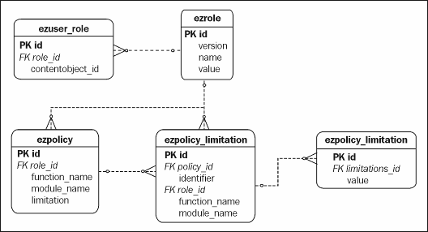
Currently, the following limitations of policies are known to eZ publish. They are available for all modules. This list shows the actual identifiers for the limitation:
- Class
- Section
- Owner
- Status
- Node
- Subtree
- ParentClass
Here is how you set permissions in the module definition—the next chapter contains more information on module definitions.
$FunctionList['read'] = array( 'Class' => $ClassID,
'Section' => $SectionID, 'Owner' => $Assigned, 'Node' => $Node, 'Subtree' => $Subtree);
The following example gives an overview of how the main execution script can determine whether a user is allowed to access the module functionality.
The first thing that needs to be done is identify the user. When you have a user ID, you will know which roles this user has. From these roles, you can obtain the permission list:
include_once( "kernel/classes/datatypes/ezuser/ezuser.php" );
$currentUser =& eZUser::currentUser();
$accessResult = $currentUser->hasAccessTo($module->attribute('name'),
$runningFunctions[0] );
The hasAccessTo() function returns information about the role, based on the name of the module and the function the user is attempting to access. hasAccessTo() returns an array with two keys of data, the accessResult. The accessWord will have the values yes, no, or limited. If the accessWord is limited, another key, policies, will be filled with a list of objects of eZPolicy that apply to that user. eZ publish will take one of the following actions based on the result:
- If the access result is yes, grant full execution rights to the user.
- If the result is limited, assign the list of policies to a global variable. Policies are individually handled for every module function.
- If the result is no, deny access to the user.
We will now look at a limitation check inside an eZ publish module. Actually, these limitations are not controlled by the module—they are controlled by the classes that handle content objects, such as eZContentObject, eZContentObjectTreeNode, and eZSearchEngine.
You should be able to find the limitations in the following global variable. However, they are submitted as a parameter to the module. Consider:
$GLOBALS['ezpolicylimitation_list']
And
$params['Limitation']
The module parameter has a higher priority than the global variable.
This following code demonstrates how eZContentObjectTreeNode::subTreeCount() handles the limitation by building the proper SQL query. Only the content objects that match the limitation are fetched.
if ( count( $limitationList ) > 0 )
{
$sqlParts = array();
foreach( $limitationList as $limitationArray )
{
$sqlPartPart = array();
$hasNodeLimitation = false;
foreach ( $limitationArray as $limitation )
{
if ( $limitation->attribute( 'identifier' ) == 'Class' )
{
$sqlPartPart[] = 'ezcontentobject.contentclass_id in ('.
$limitation->attribute( 'values_as_string' ).')';
}
elseif ( $limitation->attribute( 'identifier' ) == 'Section' )
{
$sqlPartPart[] = 'ezcontentobject.section_id in ('.
$limitation->attribute( 'values_as_string' ) . ')';
}
elseif( $limitation->attribute( 'identifier' ) == 'Owner' )
{
user =& eZUser::currentUser();
$userID = $user->attribute( 'contentobject_id' );
$sqlPartPart[] = "ezcontentobject.owner_id = '" .
$db->escapeString( $userID ) . "'";
}
The following error codes are used by the system. They mostly apply to access and permission issues.
- Access denied (1)
- Object not found (2)
- Object not available (3)
- Module not found (20)
- Module view not found (21)
- Module or view disabled (22)
- No DB connection (50)

Object Persistence
eZ publish features a persistent object model for classes to store their data in the database. Providing metadata that links the code object to the corresponding database table makes it straightforward to store, fetch, or delete an object without having to explicitly construct SQL statements. This functionality is achieved through the eZPersistentObject class.
The eZPersistentObject class can be viewed as a database abstraction layer between the application and the eZDB database interface. By creating a class that inherits from eZPersistentObject, just like the eZContentClass and eZContentObject classes, you obtain all the data-access functionality for free, and after specifying the object metadata, you have an easily persistable object.
For such persistable objects, there is a uniform way to access their fields or methods and also to provide object metadata—attributes. Attributes provide an easy mapping between database fields and the equivalent fields of the object representing the data. They also provide the mapping to member functions of the object, which allow for setting of data that goes beyond simple values stored in object fields.
The attributes of an object are defined and returned by its definition() function. Each class that inherits from eZPersistentObject will need to implement this function to provide object metadata.
The definition() function returns (a reference to) an associative array that includes the following information:

Value | Description
Fields | An associative array of field mappings, mapping the database field to the object field. This array also contains metadata about the datatype of the field, the default value, and whether the field is required.
function_attributes | An associative array of attributes that map to member functions, used for fetching data with functions.
set_functions | An associative array of attributes that map to member functions, used for setting data with functions.
keys | An array of fields that are the keys of the database table, and are used to identify a row in the table.
increment_key | The name of the field incremented on table inserts.
class_name | The class name used for instantiating new objects when fetching from the database.
name | The name of the underlying database table.

By way of an example, here is a class that manages a list of names stored in the eznames
database table with the two columns id and name:
class eZNames extends eZPersistentObject
{
function eZNames( $row = array() )
{
$this->eZPersistentObject( $row );
}
function &definition()
{
return array( "fields" => array(
"id" => array( 'name' => 'ID',
'datatype' => 'integer', 'default' => 0, 'required' => true ),
"name" => array( 'name' => "Name",
'datatype' => 'string', 'default' => '' 'required' => true ) ),
"keys" => array( "id" ),
"increment_key" => "id",
"sort" => array( "name" => "asc" ), "class_name" => "eZNames",
"name" => "eznames" );
}
}
The two database fields, id and name, map to the object fields ID and Name respectively, as indicated by the name value of their array.

Getting Attribute Values
The attribute() function is used to get the value of an attribute by passing in the name of the attribute. This function returns the value of the member function or field corresponding to the attribute. The attribute() function is provided by the eZPersistentObject base class.
Note that some classes provide their own implementation that explicitly checks the name of the attribute and calls a specific function based on the name, and passes to the base class implementation for other attributes. For example, here is the attribute() implementation in the eZBasket class:
function attribute( $attr )
{
if ( $attr == "items" )
return $this->items();
else if ( $attr == "total_ex_vat" ) return $this->totalExVAT();
...
else
return eZPersistentObject::attribute( $attr );
}
This class does not have any mapping between database fields and member functions defined in the definition() function, and chooses to handle it here in the attribute() method.

Setting Attribute Values
Attribute values are set through the setAttribute() function of the eZPersistentObject base class, by passing in the name of the attribute and the value to store. Once again, this function determines which member function or field is to be used to hold the value.

Other Attribute Functions
Two other functions in eZPersistentObject complete the attribute handling functionality: attributes() and hasAttribute().
The attributes() function returns an array that contains the name of all the attributes, both field and function mappings. One thing to note about the eZBasket situation is that the attributes listed in its attribute() function would not be returned in the array from attributes()—this function returns the attributes specified in the definition() function.
The hasAttribute() function indicates whether the specified attribute is defined for that object.
Another thing to note about the definition() function is that if you inherit from a class that already provides a definition() function, your new implementation of definition() will override the list of attributes from the parent class.

Persistent Storage
Through the use of attributes and the metadata specified by the definition() function, the eZPersistentObject class can:
- Fetch a fully-populated object (or list of objects) representing data stored in the relevant database table
- Store a populated object into the appropriate fields in the relevant database table

Fetching Data
Single objects can be fetched with the fetchObject() function. This calls the fetchObjectList() function, which fetches a collection of objects, but fetchObject() only takes the first result from this list. For example, to fetch the name field for a given record from the eznames table, we would use:
$object->fetchObject(eZNames::definition(),array('id' =>$id))
$name = $object->attribute('name');

Storing Data
Using all the metadata provided by the definition() function, eZPersistentObject can generate the SQL statement required to persist the object to the database. It can also work out if this data needs to be an INSERTT or an UPDATE, so a call to store() removes much of the data-access code that is usually required for saving objects to the database.
The following code inserts a new value in a table and gets the ID:
$object = & new eZNames(array('name'='Bjoern'));
$object->store();
$id = $object->attribute('id');

Other Data Manipulation
eZPersistentObject has other methods for general manipulation of data, such as deleting or moving rows within the database.
For example, to remove a row from our eznames table by specifying the ID of the row, you can use:
$object->remove(array('id' => $id));
Now that you have seen how eZ publish persists object to the database, let's move on to look at how content classes and content objects are handled by the system.

Content Classes
A content class in eZ publish is represented by the eZContentClass class. This class offers methods for creating, modifying, deleting, and fetching content classes. Content classes usually have multiple content class attributes assigned, and these are in turn managed by the eZContentClassAttribute class.
In the code download for this chapter, you will find a script called create.php that creates a content class with two content class attributes: the datatypes ezstring and ezimage. In this section, we will walk through the important points of the process using this example as an illustration.
The steps to create a content class are:
- Create a new empty eZContentClass instance.
- Define and add content class attributes.
Each content class has two important properties that are used throughout the system. The first is the identifier. This is a name pattern that can be used instead of the numerical ID. Always try to use your named identifiers before you use content object class IDs. This will make your code more portable and easier to maintain. The other important property is the object name. The name of an object can consist of a list of strings and values of content object attributes.
A class can have three states that can be defined when creating new classes:
  - Current active class: EZ_CLASS_VERSION_STATUS_DEFINED
  - Draft of a class: EZ_CLASS_VERSION_STATUS_TEMPORARY
  - Modified class not active: EZ_CLASS_VERSION_STATUS_MODIFED

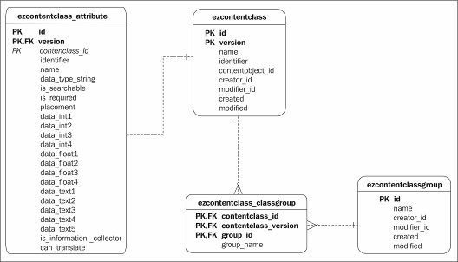
To begin creating a new content class, we get a new instance of eZContentClass, fetching the current user to be the object owner:
$user =& eZUser::fetch($user_id);
$user_id = $user->attribute( 'contentobject_id' );
$class =& eZContentClass::create( $user_id );
Next, we set the class's attributes, its version (the version is always 0 for a content class), name, identifier, and the pattern for content objects that can be created from this class:
$class->setAttribute( 'version', 0);
$class->setAttribute( 'name', 'My Custom Class' );
$class->setAttribute( 'identifier', 'custom_class' );
$class->setAttribute( 'contentobject_name', 'Custom Class <id>' );
Next, we store the class:
$class->store();
Finally, we assign the content class to a content class group. We will assign it to the group Content, which has a group ID of 1. We also need the class ID and the version of the class:
$ClassID = $class->attribute( 'id' );
$ClassVersion = $class->attribute( 'version' );
$ingroup =& eZContentClassClassGroup::create( $ClassID,
$ClassVersion, GroupID, $GroupName );
$ingroup->store();
Now that we have created our basic content class, we can add content class attributes.

Content Class Attributes
Content class attributes are represented by the eZContentClassAttribute class. To create a content class attribute for a content class, we specify the class ID and the datatype of the content class attribute.
In the previous chapters, we saw the datatypes that ship with eZ publish. Datatypes are actually classes that inherit from eZDataType, and the standard ones can be found in the kernel/classes/datatypes folder.
Continuing our example, we will create two content class attributes for our content class: one of type ezstring and the other of type ezimage. First, the ezstring type:
$DataTypeString = 'ezstring';
$new_attribute =& eZContentClassAttribute::create( $ClassID,
$DataTypeString );
We need to set the version, name, and identifier for this content class attribute:
$new_attribute->setAttribute( 'version', $ClassVersion);
$new_attribute->setAttribute( 'name', 'new attribute
'.$DataTypeString );
$new_attribute->setAttribute( 'identifier',
'new_identifier_'.$DataTypeString );
The datatype can initialize the content class attribute (this is not the same as providing a default value for the content object attribute):
$dataType = $new_attribute->dataType();
$dataType->initializeClassAttribute( $new_attribute );
The new attribute is stored to the database:
$new_attribute->store();
We follow a similar process to add a content class attribute of type ezimage:
$DataTypeString = 'ezimage'
$new_attribute =& eZContentClassAttribute::create( $ClassID,
$DataTypeString );
$new_attribute->setAttribute( 'version', $ClassVersion);
$new_attribute->setAttribute( 'name', 'new attribute '.$DataTypeString );
$new_attribute->setAttribute( 'identifier',
'new_identifier_'.$DataTypeString );
$dataType = $new_attribute->dataType();
$dataType->initializeClassAttribute( $new_attribute );
$new_attribute->store();
Now that the content class attributes are in place, we can proceed with creating content objects from the content class.

Content Objects
In this part of the book, we look at handling content objects of eZ publish at a low level. With the help of these objects, you can define your site tree. A content object is assigned to a certain user and section. Usually, every object is assigned to one or more nodes out of the content object tree.
Content objects are represented by the eZContentObject class, and the following diagram shows the database tables that relate to the underlying ezcontentobject content object table:
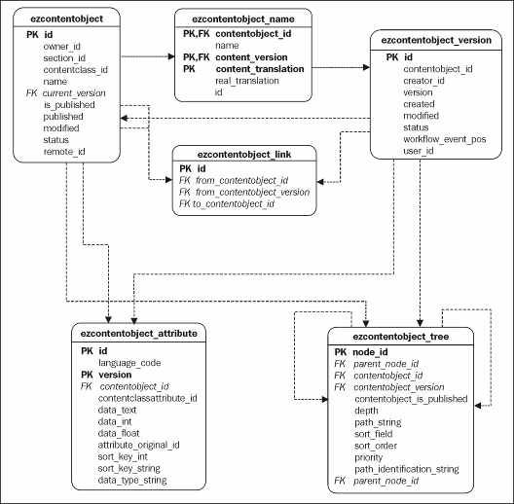

Creating a Content Object
An object definition is needed before an actual content object can be populated. Content objects are defined through content classes. Further on, we will also need to assign a certain node or placement to this object. This placement is called the parent node. The parent node has a unique node ID like any other node in the system. A content object has three states it can be assigned to:
- EZ_CONTENT_OBJECT_STATUS_DRAFT
- EZ_CONTENT_OBJECT_STATUS_PUBLISHED
- EZ_CONTENT_OBJECT_STATUS_ARCHIVED
To create and populate a content object, we need to go through the following steps:
- Create a content object instance from its content class.
- Create content object node assignments.
- Store the empty content object.
- Fill the content object attributes.
- Store the filled content object.
- Publish the object if needed.
We will now go into the process of creating a new content object from a certain class. In the first step, we will need to instantiate an object from the content object class.

Create a Content Object Instance
The requirements to create a new content object are a system user and a section ID. The system user will be the owner of the content object. For creating a node assignment, we will also need a related parent object. We can draw the objects section from the parent object.
$parentNodeID=2;
$class = eZContentClass::fetchByIdentifier('custom_class');
$parentContentObjectTreeNode =
eZContentObjectTreeNode::fetch($parentNodeID);
$parentContentObject = $parentContentObjectTreeNode-
>attribute("object");
$sectionID = $parentContentObject->attribute( 'section_id' );
$contentObject =& $class->instantiate( $user_id, $sectionID );

Content Object Node Assignments
In this step, we will place the empty object inside the site tree. This node will be also the main node of the content object. To properly assign this content object, we also need to set a parent node to this object.
$nodeAssignment =& eZNodeAssignment::create( array( 'contentobject_id' => $contentObject->attribute('id'), 'contentobject_version' => $contentObject-
>attribute('current_version' ),
'parent_node' => $parentContentObjectTreeNode->attribute
('node_id' ),
'is_main' => 1));
Now we can store the information about this node in the content object tree:
$nodeAssignment->store();
You should always create the first node assignment before you enter any data into the object.
Before we add the content class attributes, we need to define the name attribute of the content object:
$contentObject->setAttribute( 'name', 'Custom Class Number One' );
We will now store the current object in the database, before adding any of the content class attributes:
$contentObject->store();

Content Object Attributes
We will now save data for every content object attribute the content class provides to our content object.
First, we need to get all content object attributes.
$attribs =& $contentObject->contentObjectAttributes();
We will loop through each attribute and process each one depending on the identifier.
$loopLength = count($attribs); for($i=0;$i<$loopLength;$i++)
{
switch($attribs[$i]->attribute(
"contentclass_attribute_identifier"))
{
case 'new_identifier_ezstring':
$attribs[$i]->setAttribute('data_text', "Some input string");
$attribs[$i]->store();
break;
case 'new_identifier_ezimage':
$content =& $attribs[$i]->attribute( 'content' );
//Image init data
$imageAltText="Alternate Text";
//name on disk
$filename="logo.gif";
//how we name it
$originalFilename="logo.gif";
$content->initializeFromFile($filename,
$imageAltText,
$originalFilename);
$content->store();
$attribs[$i]->store(); break;
}
}
The main attributes of eZContentObjectAttribute that hold data are:
- data_float
- data_int
- data_text
In the final step, we set the status of the content object, and make it available as a draft for the user we selected before.
$contentObject->setAttribute( 'status', EZ_VERSION_STATUS_DRAFT );
$contentObject->store();
It could be also nice to run some operation on this object. We could, for example, publish it:
$operationResult = eZOperationHandler::execute('content', 'publish',
array( 'object_id' =>
$contentObject->attribute( 'id' ), 'version' => 1 ) );
Executing this operation will execute a group of other functions and triggers.

Workflows and Triggers
The following diagram shows the main database tables and the relations between them that handle the interplay between objects, workflows, and triggers:

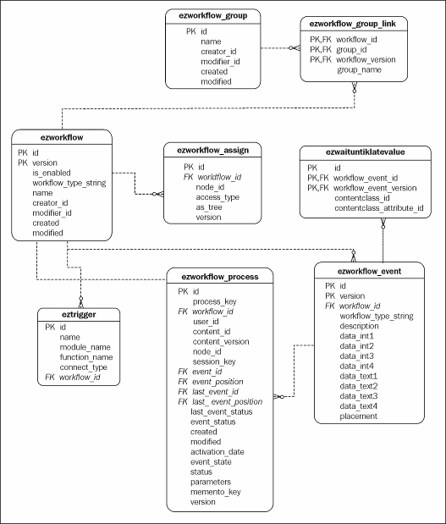
Workflows are triggered by the operation definition of the operation. The triggers are defined in the operation_definition.php file of each module:
$OperationList['publish'] = array( 'name' => 'publish','body' => array(
'type' => 'trigger',
'name' => 'pre_publish',
'keys' => array( 'object_id','version')
)
)
array( 'type' => 'method',
'name' => 'set-object-published', 'frequency' => 'once',
'method' => 'setObjectStatusPublished',
'parameters' => array( array( 'name' => 'object_id', 'type' => 'integer',
'required' => true ),
)
)
An operation consists of triggers and methods. For example, the operation could be processed in this way:
- Run the first trigger before anything else (trigger)
- Do something useful (method)
- Run the second trigger (trigger)
- Do something else (method)
- Run the last trigger at the end of the operation (trigger)
We find an example in the content/edit/ module, which corresponds to the file content/edit.php. When this example is executed, a content object will be published. We will now look closer into the process of running a workflow connected to the pre_publish trigger.
if ( $module->isCurrentAction( 'Publish' ) ){
include_once( 'lib/ezutils/classes/ezoperationhandler.php'
);
$operationResult = eZOperationHandler::execute(
'content', //module 'publish', //operation
array(
'object_id' => $object->attribute( 'id' ), 'version' => $version->attribute( 'version' ) ) );
eZOperationHandler() is now executing the publish operation out of the content module on a certain version of a content object. eZOperationHandler() has a helper, the eZModuleOperationInfo() function, which switches control of the process of execution and fails if the operation definition is not properly set. The utilities that deal with operation handling are found in the eZUtils library.
Each trigger will return the status of the current operation. eZ publish currently knows three statuses:
- EZ_MODULE_OPERATION_CANCELED
- EZ_MODULE_OPERATION_HALTED
- EZ_MODULE_OPERATION_CONTINUE
The status tells eZ publish whether the operation is canceled, stopped temporarily, or can be continued. If the operation is executed again on the same object and version, it will continue from where it had stopped the last time. The following code shows the pre_publish trigger being executed:
$status = eZTrigger::runTrigger(
$triggerName, $this->ModuleName, $operationName,
$operationParameters, $triggerKeys);
eZ publish provides the following return statuses for triggers:
- EZ_TRIGGER_STATUS_CRON_JOB
- EZ_TRIGGER_WORKFLOW_DONE
- EZ_TRIGGER_WORKFLOW_CANCELED
- EZ_TRIGGER_NO_CONNECTED_WORKFLOWS
- EZ_TRIGGER_FETCH_TEMPLATE
- EZ_TRIGGER_REDIRECT
- EZ_TRIGGER_WORKFLOW_RESET
A workflow is processed when it is connected to a trigger. If the workflow hasn't started earlier, eZ publish will now create the new workflow process; otherwise it will process the existing one. The identifier for a workflow process is the process key.
$processKey = eZWorkflowProcess::createKey( $parameters, $keys );
$workflowProcessList =& eZWorkflowProcess::fetchListByKey(
$processKey );
If the fetch returns no result, we can create a new one:
$workflowProcess =& eZWorkflowProcess::create( $processKey,
$parameters );
$workflowProcess->store();
return eZTrigger::runWorkflow( $workflowProcess );
eZ publish provides the following return statuses for Workflows:
- EZ_WORKFLOW_STATUS_NONE
- EZ_WORKFLOW_STATUS_BUSY
- EZ_WORKFLOW_STATUS_DONE
- EZ_WORKFLOW_STATUS_FAILED
- EZ_WORKFLOW_STATUS_DEFERRED_TO_CRON
- EZ_WORKFLOW_STATUS_CANCELLED
- EZ_WORKFLOW_STATUS_FETCH_TEMPLATE
- EZ_WORKFLOW_STATUS_REDIRECT
- EZ_WORKFLOW_STATUS_RESET
When running the workflow, eZ publish will process all workflow events that are assigned to the workflow in a loop until a proper return has been found. Each time the loop starts over, an event of the workflow is processed.
An eZWorkflowtype should return one of the following—watch your returns on module development:
- EZ_WORKFLOW_TYPE_STATUS_NONE
- EZ_WORKFLOW_TYPE_STATUS_ACCEPTED
- EZ_WORKFLOW_TYPE_STATUS_REJECTED
- EZ_WORKFLOW_TYPE_STATUS_DEFERRED_TO_CRON
- EZ_WORKFLOW_TYPE_STATUS_DEFERRED_TO_CRON_REPEAT
- EZ_WORKFLOW_TYPE_STATUS_RUN_SUB_EVENTT
- EZ_WORKFLOW_TYPE_STATUS_WORKFLOW_CANCELLED
- EZ_WORKFLOW_TYPE_STATUS_FETCH_TEMPLATE
- EZ_WORKFLOW_TYPE_STATUS_FETCH_TEMPLATE_REPEATT
- EZ_WORKFLOW_TYPE_STATUS_REDIRECTT
- EZ_WORKFLOW_TYPE_STATUS_WORKFLOW_DONE
- EZ_WORKFLOW_TYPE_STATUS_REDIRECT_REPEAT
- EZ_WORKFLOW_TYPE_STATUS_WORKFLOW_RESET

Notifications
eZ publish has a built-in notification system. On certain events, a system user is able to receive a notification about this event. The events are based on a plug-in implementation. The following events are known to the eZ publish system by default:
- Collaboration
- Publish
- Current time
The following sub-diagram of the database shows the relations between content objects and the notification system:

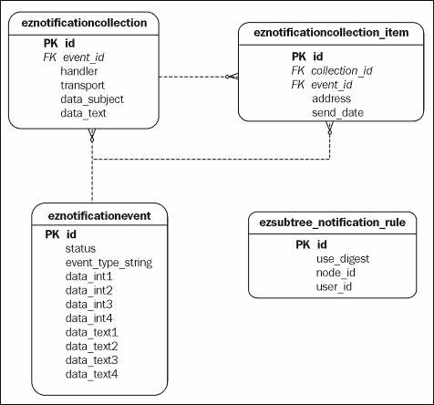
Notification events are placed inside the kernel/classes/notification folder.
There are several handlers that process notification events. The following handlers are known to the system by default:
- Collaboration notification
- General digest
- Subtree notification
We will look at the process of the subtree notification on a publish event.
Each time a content object or content object version is published through the content module, the publish operation is used:
$operationResult = eZOperationHandler::execute( 'content',
'publish', array
( 'object_id' => $contentObject->attribute( 'id' ),
'version' => $contentObject->attribute( 'current_version' )
)
);
The publish operation invokes a method call to eZContentOperationCollection:: createNotificationEvent():
array(
'type' => 'method',
'name' => 'create-notification', 'frequency' => 'once',
'method' => 'createNotificationEvent',
),
This call will result in a new event of the type ezpublish being created and stored to the database.
include_once( 'kernel/classes/notification/eznotificationevent.php'
);
$event = & eZNotificationEvent::create (
'ezpublish', array
(
'object' => $objectID, 'version' => $versionNum
)
);
$event->store();
This event can be processed by zero, one, or more notification handlers. eZNotificationEventFilter will start this process. If the handler knows how to handle a certain event that is identified by the event_type_string, it will be processed.
include_once('kernel/classes/notification/
eznotificationeventfilter.php' ); eZNotificationEventFilter::process();
eZ publish will now loop though every unhandled event and try to run it with every available handler in the system. If every notification has been sent successfully, the event can now be deleted from the system.
$eventList =& eZNotificationEvent::fetchUnhandledList();
$availableHandlers =&
eZNotificationEventFilter::availableHandlers(); foreach( array_keys( $eventList ) as $key )
{
$event =& $eventList[$key];
foreach( array_keys( $availableHandlers ) as $handlerKey )
{
$handler =& $availableHandlers[$handlerKey];
$handler->handle( $event );
}
$itemCountLeft =&
eZNotificationCollectionItem::fetchCountForEvent(
$event->attribute( 'id' ) );
if ( $itemCountLeft == 0 )
{
$event->remove();
}
else
{
$event->setAttribute( 'status',
EZ_NOTIFICATIONEVENT_STATUS_HANDLED );
$event->store();
}
}
A handler can return the following statuses that describe the current state:
- EZ_NOTIFICATIONEVENTHANDLER_EVENT_HANDLED
- EZ_NOTIFICATIONEVENTHANDLER_EVENT_SKIPPED
- EZ_NOTIFICATIONEVENTHANDLER_EVENT_UNKNOWN
- EZ_NOTIFICATIONEVENTHANDLER_EVENT_ERROR

Information Collection
The eZ publish information collector can gather information or feedback about a content object. This information will be stored in the database and can be also sent via e-mail.
The storage and presentation of a collected item is defined through the information collector type. This diagram shows the relations between the relevant database tables.
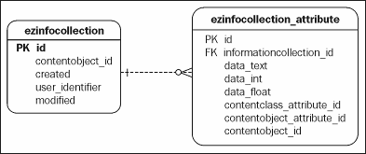
eZ publish comes with several information collector types by default.
- Poll
- Form
- Feedback
The information collector is setup through the collect.ini file and has various options that can be modified. A type can be also assigned through an attribute of a content object. By default, the attribute identifier is collection_type:
TypeAttribute=collection_type
In the collection setting, you can define how the submission of user information should work or what policies should apply.
CollectAnonymousData can be set to enabled, allowing an anonymous user to submit information to a type:
CollectAnonymousData=enabled
You can override each setting per type individually:
CollectAnonymousDataList[poll]=disabled
You can also set a content object attribute that will pass the setting to the information collector:
CollectAnonymousDataAttribute=collection_anonymous
eZ publish offers three policies on how user input is handled. Once again, just like CollectAnonymousData, you can set the definition globally, per type, or per content object:
- multiple: Each user can submit multiple data
- unique: One set of data per user, if data already exists give a warning
- overwrite: One set of data per user but new entry overwrites old one
Users are tracked by their user ID, and if they are anonymous to the system, their remote IP will be used to identify them.
Setting the global policy:
CollectionUserData=multiple
Setting the policy per type:
CollectionUserDataList[poll]=overwrite
Setting the policy per content object
CollectionUserDataAttribute=collection_userdata

Searching
eZ publish offers an eZSearch class for including your own search engine. All the existing implementations are used as plug-ins to the system. They can be found under kernel/search/plugins. By default, eZ publish uses the eZSearchEngine plug-in. OpenFTS is also available as a plug-in, but it doesn't seem to be fully implemented.
OpenFTS can be only used with PostgreSql. Writing your own search engine is quite a lot of work.
The following database diagram shows the relations between objects and the eZSearchEngine search engine plug-in. The ezsearch_tmp_0 and ezsearch_tmp_1 tables are temporary tables, and are created on demand. Each temporary table gives the
result from one word of the search phrase. The result of a search in eZ publish is a combination of all temporary tables. The tables ezsearch_search_phrase and ezsearch_return_count are only important for the purpose of the search statistics (kernel/search/stats.php).
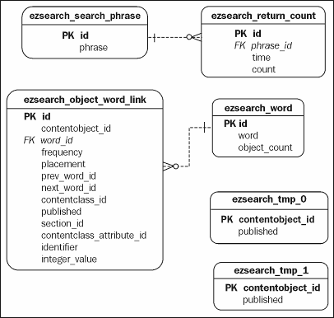
eZSearch (kernel/classes/ezsearch.php) is the interface to the plug-in. You will find its setup in site.ini:
[SearchSettings] SearchEngine=eZSearchEngine #SearchEngine=openFts SearchViewHandling=default LogSearchStats=enabled MaximumSearchLimit=30 AllowEmptySearch=disabled
Every time a content object is edited, the object must be deleted and inserted into the search again. Here is how the kernel/content/edit.php file uses the eZSearch interface:
eZSearch::removeObject( $object ); eZSearch::addObject( $object );
If a content object is removed or put into trash, only a single function is called:
eZSearch::removeObject( $object );
eZ publish offers two module views that you can use for searches. Both are very similar and work in the same way. Both perform their search over the interface of eZSearch (eZSearch::search()). The content/search view uses the fulltext search type by default, and the content/advancedsearch view uses a wide spectrum of search types and filters offered by the plug-in.
With those two steps, the advanced search will get the requested information from the eZSearch engine. eZSearch::buildSearchArray() prepares a search definition depending on the plug-in. eZSearch::search() returns an associative array with information about the result (array of eZContentObjectTreeNodes, SearchCount, and StopWordArray).
$searchArray =& eZSearch::buildSearchArray();
$searchResult =& eZSearch::search(
$searchText,
array( 'SearchSectionID' => $searchSectionID, 'SearchContentClassID' => $searchContentClassID, 'SearchContentClassAttributeID' =>
$searchContentClassAttributeID,
'SearchSubTreeArray' => $subTreeArray, 'SearchDate' => $searchDate,
'SearchTimestamp' => $searchTimestamp, 'SearchLimit' => $pageLimit,
'SearchOffset' => $Offset ),
$searchArray );
The available general search filters for eZSearchEngine are:
- class: Filters a content object class
- publishdate: Filters a certain creation date
- subtree: Filters a certain subtree
- section: Filters a certain section
- offset: Where to start with the result
- limit: Where to end the result

Summary
In this chapter, we took a brief look at realizing eZ publish fundamentals at the code level, and how objects are persisted to the database.
The next chapter looks at the process of creating an eZ publish extension.

5

Extending eZ publish

The eZ publish system contains a collection of modules and libraries that together provide a wide range of functionality for users. In order for eZ publish to address the needs of the growing CMS market, users must be able to add functionality of their own. This is achieved by using custom-designed extensions.
The modular nature of eZ is reinforced through the use of extensions. Extensions allow for template operators, datatypes, functions, and whole modules that can co-exist with one another to be developed separately and added to the eZ publish install. A functional extension may be something as small as a new template operator, or something as critical as an interface to your other business applications.
The aim of this chapter is to discuss how to use the extension mechanism. With almost every area of eZ publish open to the extension system, the areas covered by this chapter include:
- Modules
- Datatypes
- Template operators
- Workflow events
- Actions
- Notifications
We will also discuss examples of how to use eZ for data interoperability with other systems, including using SOAP and RSS as a means of facilitating the transfer of data.

Why Create an Extension?
Before embarking on creating an extension, you need to understand why you are creating an extension. It also is worth spending time researching eZ publish forums and reviewing the functionality that will be available in the next release of eZ publish. You may
discover that a feature is already available in the SVN code repository at
http://pubsvn.ez.no.
There are several reasons why you may need to write an extension:
- eZ publish does not have the functionality you require.
- A similar but not exact feature may be available, in which case you can submit a feature request to the eZ team.
- The feature may have bugs, preventing it from being used as intended. This should be reported as a bug, but if time is short, a quick extension can be used as a temporary solution.
- The feature may be proprietary to your company and essential for use in your CMS.
- The feature may facilitate import/export functions for data from/to another system.
When naming your extensions, make sure you use a unique name, as this will prevent problems with duplicate names in the future. Do not use a hyphen "-" to separate text, as this will not work. For example, eZ systems always prepend eZ to their extensions. Prepend a useful name before the function of the extension.
In addition to the functions available in eZ publish, there is a community effort to build extensions to offer additional functionality. You can check this out at http://pubsvn.ez.no.

Adding an Extension
To add a new extension:
- Decide upon the kind of extension to be created, based upon the previous discussion.
- Create a new directory with the name of your new extension. eZ publish expects extensions to be located within the extension directory of the eZ publish root directory.
- Inform eZ publish about your new extension by adding it to the configuration file: site.ini.
For example, to activate the newExtension extension, add the following to the main configuration file (settings/site.ini):
File: settings/site.ini
[ExtensionSettings] ActiveExtensions[]=newExtension
If the extension is to be used for a specific site design, a different site.ini must be used instead. For example, the standard site design for users is named user, but as of eZ publish 3.2, there are additional designs such as news, intranet, and so on. If you wish your extension to be present in one of these site designs but not the others, add the extension to the configuration file for that particular design:
File: settings/siteaccess/<mydesign>/site.ini.append
[ExtensionSettings] ActiveAccessExtensions[]=newExtension
Here <mydesign> is the specific site design where your extension is to be used.

Locating Your Extension
Each extension requires its own subdirectory within the extension directory. The extension called newExtension will be located within the extension/newExtension subdirectory.
Within this new directory, eZ publish expects to find a settings file that describes what type of extension it is. Depending upon this type, other directories are expected to exist. The following table lists the standard set of subdirectories that can be recognized and used by an extension:

Directory | Description
actions/ | New actions for forms
datatypes/ | New datatypes to enhance a class
eventtypes/ | New event types for workflows
modules/ | New kernel modules and views
settings/ | Settings for this extension
translations/ | New translation extensions
design/ | New design extensions
There is no need to include all these directories in your extension. If, for example, your extension is a new datatype, then only the settings, design, and datatypes directories need be included.

The settings directory is always present, as it contains files used to inform eZ of the nature of the extension. The only exception is with template operators, as discussed later in this chapter.

Example Directory Extensions
The following examples list the files and subdirectories associated with a typical extension directory. Notice that the subdirectories within each extension area follow the same structure as those within the eZ publish kernel and design areas.
Later in this chapter example, the content of these files will be given.
Depending on the type of the extension, you would typically have the subdirectories listed in the following sections inside your extension/newExtension/ folder:

Datatype Extension
A datatype extension contains settings that notify eZ publish that there is a new datatype (specified in the content.ini) and that the extension design directory should be used (specifically, the design.ini file).
Here is a list of files typically affected by the creation of a datatype extension:
settings/content.ini.append settings/design.ini.append datatypes/newDatatype/newDatatypetype.php
design/standard/templates/content/datatypes/edit/newDatatype/newDatat ype.tpl design/standard/templates/content/datatypes/view/newDatatype/newDatat ype.tpl

Module Extension
For a very simple module with only a single view and no functions, the extension directory would typically contain the following files:
settings/module.ini.append settings/design.ini.append modules/newModule/module.php modules/newModule/newView.php design/standard/templates/newView.tpl

Workflow Eventtype Extension
The following workflow is again very simple, with a single new eventtype and template to show that view.
settings/workflow.ini.append settings/design.ini.append eventtypes/event/myEvent/myEventtype.php
design/standard/templates/workflow/eventtype/result/event_myEvent.tpl
These examples may be used either as separate extensions or within the same extension, depending on your design needs. It may be the case that your extension is large and requires the addition of new datatypes, workflow events, modules, and other additions. If you use separate extensions, ensure that each is named appropriately.
The directories discussed here are automatically recognized by eZ publish, but others can be added for your own use. For example, documentation should be handled in the same way and given its own documentation subdirectory.
In some cases, it is good practice to follow the directory structure eZ publish employs, for example, when files such as database updates are added. Here files containing the SQL update code are specified as follows, with a second file describing what the update file does.
update/database/mysql/3.2/dbupdate-3.1-1-to-3.2-1.sql update/database/mysql/3.2/dbupdate-3.1-1-to-3.2-1.info

Documentation on Extensions
Popular coding languages use documentation generators to create human-readable documents, based on the code structure and comments entered by developers. PHP is no exception to this, and there are several documentation generators available. eZ systems have chosen to design their comments to the format that doxygen uses. Doxygen can be found at http://www.doxygen.org. If you have this installed on your system, you can build your documentation by running the following command from the eZ publish system directory.
>doxygen doc/doxygen/Doxyfile
This allows the documentation to be referenced from within the eZ publish administration site through the URI http://<your-admin>/reference/view/ez.
This documentation provides very useful low-level details of PHP files, linked together to allow navigation.
For a high-level view of the eZ publish system, the eZ publish documentation is located on the eZ publish website at http://ez.no/ez_publish/documentation.
Also available is a good introduction to the system, although only for versions 3.0 and 3.1, found at http://pubsvn.ez.no/sdk/ and http://pubsvn.ez.no/manual.

Modules
The first type of extension we will look at is a module. Having registered the new extension as described, the next step is to inform eZ publish that the extension contains modules. This is accomplished by adding a module.ini.append file containing the name of the extension as shown.
File: extension/moduleExtension/settings/module.ini.append [ModuleSettings]
ExtensionRepositories[]=moduleExtension
If the module contains templates to render output from the module, then once again, eZ publish must be told to use the templates from the design directory in the extension as shown below.
File: extension/moduleExtension/settings/design.ini.append [ExtensionSettings]
DesignExtensions[]= moduleExtension

Module Definitions
Modules allow information to be displayed through the view mechanism. An object is normally shown by a call to /content/view or when edited by /content/edit. Here content is the module and view and edit are the views.
Each module view is defined within the module definition file, module.php, located within the modules directory underneath the module name extension/moduleExtension
/modules/newModule/module.php.
Notice that we have declared the name of the module to be newModule. eZ publish automatically recognizes new modules if they have a unique name and contain a separate module.php file. There is no need to specify this name within a configuration file.
This module definition file contains the specification for each module view, the access permissions granted to users, which parameters are used, and other features that will be discussed in the coming sections.

Module Names and Views
To enable eZ publish to interoperate with new module extensions, the definition file must use recognized variables, such as $Module, $ViewList, and $FunctionList.
An array variable named $Module must be initialized with the name of the module:
$Module = array("name" => "newModule" );
Module views are initialized by declaring the variable $ViewList as an array:
$ViewList = array();
With the views initialized, a simple view can be added:
$ViewList["newview"] = array("script" => "newView.php" );
This points the view newview to the correct PHP file newView.php. The URI for this view would be http://<your-site>/newmodule/newview.

View Permissions
Permissions allow users to have a predefined access to a view. Once permissions are declared in the definition file, the administrator can use these within the administration interface. If no permission is set for a module, it is left up to the main site configuration file, site.ini, to decide whether a whole module is accessible or not. By default, the module and its views are not available to anyone but the Administrator role.
Permissions for a view can be added by first declaring the permission as a
$FunctionList variable, and then adding this to the view definition. For instance, to add a permission called read to a view, the following code can be used:
$ViewList["newview"] = array("script" => "newView.php",
"functions" => array('read' ) );
$FunctionList['read'] = array();
In this example, the read permission is declared and then added as an array element to the $ViewList["myview"] array. Note that the order of declaration is not important here.
Another view may allow editing, and shown below are two views, one with read permissions, and the other allowing editing:
$ViewList["newview"] = array("script" => "newView.php",
"functions" => array('read' ));
$ViewList["neweditview"] = array("script" => "newEditView.php",
"functions" => array('edit' ));
$FunctionList['read'] = array();
$FunctionList['edit'] = array();
Here the permissions are used separately; one for read and another for editing, but such permissions can be applied to a single view:
$ViewList["newview"] = array("script" => "newView.php",
"functions" => array('read', 'edit' ));
$FunctionList['read'] = array();
$FunctionList['edit'] = array();
It is important to note that it is up to the developer of the module and view to test the permissions that a user has and to present the appropriate response to the user request.

View Parameters
Module views are not very useful on their own unless parameters are passed in to allow adequate customization of the view response.
eZ publish expects uses to be declared for each parameter view, and performs checks to ensure that these parameters are valid for their declared type. For example:
$ViewList["newview"] = array("script" => "newView.php",
"functions" => array('read' ), "params" => array("ViewMode", "NodeID"

),

"Language",
);
"unordered_params" =>
array("language" =>
"offset" => "Offset" )

$FunctionList['read'] = array();
There are two types of view parameters:
- params: Parameters that follow directly from the module and view in the URI and are listed in left-to-right order. For instance, if the URI was
/newmodule/newview/full/20, then ViewMode will be full and NodeID
would be 20.
- unordered_params: The unordered term implies that these parameters can come in any order after the ordered params. For example, if the URI was
/newmodule/newview/full/20/offset/10/language/en, ViewMode and NodeID are the same as before, and the value for Offset will be 10 and Language will be en (representing English).
Note the use of an associative array ("offset"=>"Offset") for unordered_params. This means one form of the parameter can be used in the URI (offset) and another in the PHP script (Offset). Ordered parameters do not use associative arrays so the name of the parameter has to be the same as the one available in the module view script.
Unordered parameters may also be available to the template, after the module has been processed. Currently eZ publish returns the variable $view_parameters to the template, and if offsets have been used, this is available as $view_parameters.offset.

View Actions and Post Variables
Parameter values are passed to module views by means of HTML POST variables. Normal HTML is used to encode the data, and the form is submitted to the module view. When the data arrives, an action might occur, depending upon the input data.
The following example lists several actions that can occur:
$ViewList["newview"] = array("script" => "newView.php",
"single_post_actions" => array('ConfirmButton' => 'Confirm',
'CancelButton' => 'Cancel' ), "post_actions" =>
array('BrowseActionName' ),
"post_action_parameters" => array('Confirm' =>

array('ConfirmParameter' => 'ConfirmValue' )));
There are four parts to viewing actions.

single_post_actions
A web form has a single action to perform. The eZ template will set an input tag with the desired action, and when the submit button clicked, its name will be passed through to the specified eZ module view. The submit buttons allow either a confirmation or a cancellation action. For example:
<form method="post" action="/newModule/newview/">
<input type="submit" name="ConfirmButton" value="Confirm" />
<input type="submit" name="CancelButton" value="Cancel" />
</form>
An associative array is used to transform the POST action name to a name that will be used by the view script. This is examined by the script as follows:
if ($Module->isCurrentAction('Confirm' ) )
{
/* Do something */
}
if ($Module->isCurrentAction('Cancel' ) )
{
/* Do something else */
}

post_actions
The post_actions variable offers flexibility with the naming of POST variables. When the system sets the action for the module it first examines whether the POST variable matches anything within single_post_actions. Failing that, it will look in post_actions to find a match.
The system will take the name of the single_post_action as the module action, but will take the value of the post_actions variable as the module action.
This allows the developer to avoid needing to explicitly declare actions within the module configuration file.
<form method="post" action="/newModule/newview/">
<input class="button" type="submit" name="BrowseActionName" value="MyNewAction" />
</form>
Note that the name of the input tag matches with the previously declared post_actions value in the view definition. The value of the input tag is used as to set the current action and is retrieved as earlier:
if ($Module->isCurrentAction('MyNewAction' ) )
{
/* Do new action */
}

post_action_parameters
post_action_parameters are parameters for each action. These allow the script to refine how the action will be processed.
In the above example, the post_action parameter is defined as an associative array, the current action Confirm is used as the key, and its value is defined as another associative array. The key for this second array is used as the name for the actions parameter, ConfirmParameter, and the value, ConfirmValue, is taken from the input tag, as shown by the following example:
<form method="post" action="/newModule/newview/">
<input type="submit" name="ConfirmButton" value="Confirm" />
<input type="hidden" name="ConfirmValue" value="Yes, confirm" />
</form>
This happens when processing the following code:
if ($Module->isCurrentAction('Confirm' ) )
{
if ($Module->hasActionParameter('ConfirmParameter' ) )
{
$test = $Module->actionParameter('ConfirmParameter' );
}
}
In this example, the value of $test will be "Yes, confirm".

Normal Post Variables
Lastly, ordinary POST values can be checked for and used within the script without any mention in the definition of the view. If the HTML code is as follows:
<form method="post" action="/newmodule/newview/">
<input type="submit" name="NewTestButton" value="Push me" />
</form>
the script could check for this POST variable as follows:
include_once('lib/ezutils/classes/ezhttptool.php' );
$http =& eZHTTPTool::instance();
if ($http->hasPostVariable('NewTestButton' ) )
$testButtonValue = $http->postVariable('NewTestButton' );
Here the eZ HTTP library is invoked to retrieve the POST variable.

View Navigation
Assigning a view navigation variable is a method eZ publish employs to structure the administration interface. Each view is a member of a particular area, such as Set up or Media, and is shown in the left-hand side navigation bar of the administration interface.
This allows the interface to perform some action such as highlighting the area tab when the view is active.
To assign a navigation area to a view, set a default_navigation_part parameter to the view definition as shown:
$ViewList["newview"] = array("script" => "newView.php",
"default_navigation_part" =>
'ezsetupnavigationpart');
An example of this in action is shown by the following screenshot, where the Set up tab is highlighted:

Module Coding
Now that we've seen the module definitions and configuring the permissions and the parameters we will require, we will move on to look at the details of coding the module.

Reading Module Input
In the previous section, the module definition file was shown to declare the expected parameters a view takes as input. Parameters are passed to the view with the $Params array. For example:
$Module =& $Params['Module'];
$NodeID = $Params['NodeID'];
$Offset = $Params['Offset'];
For parameters that are unordered and therefore either present or not, it is good practice to check the input values and declare a default in case the variable is not present. For example:
$Offset = $Params['Offset']; if (!is_numeric($Offset ) )
$Offset = 0;

Returning Information
The eZ publish system uses a template array variable called $module_result to hold the output from a module view. For example, the output from the kernel/view module view contains the following information in an array:
module_result Array Examples | Description
content | Direct output from the module view held as a string
view_parameters | Specifies the parameters used by the module
path | Array of elements that describes the path to the current element
title_path | Similar to the path but without the root element
section_id | Section identifier of the current node
node_id | Identifier of the current node
navigation_part | The navigation area to which the view is assigned

Not every view uses all of these parameters as part of the module result. The recommended minimum is to use content and path. Others can be added depending on what your template expects. For example,
File: extension/moduleExtension/modules/newModule/newView.php
$Result = array();
$Result['content'] = "Hello there! ";
$Result['path'] = array(array('url' => false,
'text' => 'New Module' ), array('url' => false,
'text' => 'New View' ) );
In this example, the content parameter is assigned a string value. The path is assigned a simple list containing information about the module and its view—in practice, the path will be more descriptive and would likely contain the current node_id and maybe other information such as the URL alias of the node.

Processing a Template
The advantages of using a module view become apparent when templates are used to customize the output in the view.
Before the template can be used, it must be initialized as shown:
File: extension/moduleExtension/modules/newModule/newView.php include_once('kernel/common/template.php' );
$tpl =& templateInit();
If the template requires input values to be present as parameters, these can be set:
File: extension/moduleExtension/modules/newModule/newView.php
$tpl->setVariable('my_parameter', $myParameter );
$tpl->setVariable('my_other_parameter', $myOtherParameter );
This assigns the PHP variables $myParameter and $myOtherParameter to the my_parameter and my_other_parameter template variables respectively. The template code {$my_parameter} and {$my_other_parameter} will retrieve the values as expected.
Assigning the value of $Result['content'] invokes the processing of the template, as shown:
$Result = array();
$Result['content']=$tpl->fetch("design:newmodule/newview.tpl");
In this example, the template is retrieved from the appropriate design folder and processed by the call to $tpl->fetch(). The content element will contain a string representing the output from the processed template.

Redirecting a Module
Some modules and views act as wrappers for other modules and views. For example, within the content module, there is the action view that redirects input according to the value of POST variables.
eZ publish provides several routines to aid with redirection.

redirectTo
The simplest redirectTo() method takes a path as its parameter. This allows you to move the processing from your view to another module, which will provide output in a predetermined way. For example, you can redirect to the home page if something irregular occurs, or as in the following example:
$Module->redirectTo('/content/view/full/2/' );

redirect
A common use for redirect() is to invoke the processing abilities of another module and view given parameters that have been determined from the current view. For example, here the code invokes the edit view of the content module, with the object ID, its current version, and the currently used language:
$Module->redirect('content', 'edit', array($contentObjectID, $version,
$language) );

redirectToView
This method is a convenient method that assumes the view parameter to be within the current module, with the final array parameter the same as before:
$Module->redirectToView('edit', array($contentObjectID, $version,
$language) );

redirectionURI
In some cases, you may need to add a parameter to the location in the redirectTo() method, but first of all you will need the basic URI. This is where redirectionURI() will help you:
$Module->redirectionURI('content', 'edit', array($contentObjectID,
$version,$language) );
This method only creates a valid redirection URI, and does not perform the redirection.

Module Functions
Functions invoked by the template author use the fetch command. The aim is to perform a check of some kind either from the present environment or to find values from the database. eZ publish provides a large number of utility functions to make the task of a function author relatively simple.
The remainder of this section will discuss how to create a function by showing how to build one that returns information for the following example:
{let my_function_output=fetch('newmodule','newfunction',hash(number,999))} Output from function is: {$my_function_output}
{/let}
The function performs a simple calculation to compute the square of 999.

Registering a Function
Functions must be defined in a definition file called function_definition.php and located in the same directory as module.php.
File: extension/moduleExtension/modules/newModule/function_definition.php
$FunctionList = array();
$FunctionList['newfunction'] = array('name' => 'newfunction',
'operation_types' =>

array('read' ),

array('include_file'

'call_method' =>

=>'extension/moduleExtension/modules/newModule/newModuleFunctionColle ction.php',

'newModuleFunctionCollection',

) );
'class' =>
'method' => 'fetchNumber' ), 'parameter_type' => 'standard', 'parameters' => array(array(
'name' => 'number', 'type' => 'integer', 'required' => true )

The name of your function should be the same as the key to the PHP array:
$FunctionList['newfunction'] = array('name' => 'newfunction',
The purpose of the operation_types function is to allow access to the function:
'operation_types' => array('read' ),
The call method informs eZ of your script location, the class name, and the method inside the class to be used when the function is invoked:
'call_method' => array('include_file' =>
'extension/moduleExtension/modules/
newModule/newModuleFunctionCollection.php',
'class' => 'NewModuleFunctionCollection', 'method' => 'fetchNumber' )
In this example, the PHP file holding the function is kept within the module directory, which is standard practice.
Finally, the function parameters must be defined. The type of parameter should be set as
standard. If you use different types, the type should be mixed.
At the moment, eZ publish does not check the type of function parameters. This may change in the future.
'parameter_type' => 'standard', 'parameters' => array(
array('name' => 'number', 'type' => 'integer',
'required' => true ) ) );
In this example, there is a single integer type parameter called number and it must be included when the function is included. If it is not included, eZ publish will display an error message.

Coding Functions
With the function defined and registered with eZ publish, all that remains to be written is the function code itself:
File: extension/moduleextension/modules/newmodule/
newmodulefunctioncollection.php class NewModuleFunctionCollection
{
function NewModuleFunctionCollection() {} function &fetchNumber($object_id )
{
return array('result' => 'Square of found number '.$number.'
is '.$number*$number);
}
}

Datatypes
The default datatypes with eZ publish 3.2 are comprehensive and sufficient for most sites. When there is need for a new datatype, however, it is relatively easy to include.
The benefits of creating a new datatype balance the cost for its design, implementation, and testing. The aim is to make the management of objects easier and less
time-consuming. If an existing datatype works but is difficult for the user to work with, it is worthwhile thinking about a new datatype to resolve the issue.
In this section, we will show how to create new datatypes. To do this, we need to inherit from the eZDataType.php base class and override a number of its functions, which allows the datatype to perform our new actions when objects are viewed and edited.
In the next chapter, a detailed example of a complex datatype will be presented.

Datatype Settings
The datatype configuration file, content.ini.append, is where eZ is informed about the datatype.
File: extension/datatypeExtension/settings/content.ini.append [DataTypeSettings]
ExtensionDirectories[]=datatypeExtension AvailableDataTypes[]=newDatatype
A difference here is the use of the AvailableDataTypes[] array. In addition to letting eZ publish know about the datatype within the extension, the name of the datatype must be explicitly declared.
As usual there will be designs for the datatype, and eZ publish must know of the design directory:
File: extension/datatypeExtension/settings/design.ini.append [ExtensionSettings]
DesignExtensions[]=datatypeExtension

Datatype Templates
When designing a new class, an attribute is created from a datatype representation. To render this attribute within the class edit view, a template is required. Similarly when an object is being viewed or edited, there must be a template for the attribute/datatype for it to be shown.
For most situations a datatype can be declared within a class, with only its name and identifier required to be entered—eZno—if it is allowed, in case the developer forgets to fill in a value for each content object created from it.
If a datatype requires options to be set that influence the choices that the developer will have to make when creating the content object, an extra template is required. For example, the ezselection datatype requires the developer to define the enumeration to be used for the content object, and whether the selection will be a multiple choice or single selection.
A special class edit template for the newDatatype datatype, which would likely contain choices for the developer to select, can be found at:
extension/datatypeExtension/design/standard/templates/class/ datatype/edit/newDatatype.tpl
Once the class has been created, two different templates allow the datatype within that
new content object to be both viewed and edited:
extension/datatypeExtension/design/standard/templates/
content/datatype/edit/newDatatype.tpl extension/datatypeExtension/design/standard/templates/
content/datatype/view/newDatatype.tpl

The Datatype Wizard
The datatype wizard allows the developer to create a generic PHP file that can be further customized by the developer to create the datatype. This wizard is part of the RAD tools found within the Set up section of the administration site.
The datatype wizard is found at http://<admin>/setup/datatype and consists of the following steps:
- The Introduction to datatypes welcome screen.
- You are asked for the name of the datatype. This should be something suitable as it will be used in your templates. If your datatype requires further class edits, like the ezselection example described before, tick the checkbox in Settings. This will allow for input at the class level instead of the normal object level.

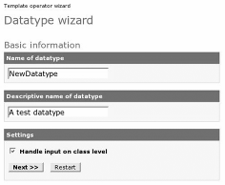
- From your responses, the information in the next screen is prefilled. Note that your datatype name is now part of the PHP class name. Make sure you do not put spaces in your operator, otherwise PHP will complain.
- The following screenshot displays the remaining questions. Once finished, click the Download button to save your datatype:
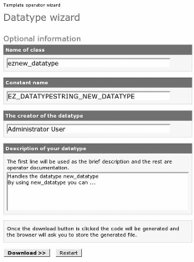
This information helps prefill the comment text within the PHP file, but does not help with coding the datatype. Hence, the user will need to pursue this further. The wizard is used for creating the generic datatype file ez<name>type.php, where <name> is the name given to the datatype. Read on for details on how to make a useful datatype.

Implementing the Datatype
Each datatype inherits from the base class eZDataType. The file name of the new datatype must end with type.php, for example, newdatatypetype.php, for the system to use the file. This file can be created manually or by using the datatype wizard:
extension/datatypeExtension/datatypes/newDatatype/newDatatypetype.php

Constructing a Datatype
The general skeleton code for a datatype is as follows:
<?php include_once("kernel/classes/ezdatatype.php" );
define("EZ_DATATYPESTRING_NEWDATATYPE", "newdatatype" );
class newDataTypeType extends eZDataType
{
function newDataTypeType()
{
$this->eZDataType(EZ_DATATYPESTRING_NEWDATATYPE, "None" );
}
}
eZDataType::register(EZ_DATATYPESTRING_NEWDATATYPE, "newdatatypetype"
);
?>
The newDataTypeType() constructor registers with the base class by passing the name of the datatype to it. Notice that the datatype is registered with the system at the end of the file using the same name.
eZDataType::register(EZ_DATATYPESTRING_NEWDATATYPE, "newdatatypetype"
);

Storing Datatype Information
For each datatype within the eZ publish system there are two types of attributes. Class attributes store information about which class they are part of, the name of the attribute, any default values the object attribute should have, and other custom information the object attribute may find useful. Object attributes use the information from the class attributes to store run-time information about the attribute. Any number of object attributes can be created from the class attributes.
The attributes of an object examine the fields within the SQL database for its class attributes during the creation of the object. For example, the class attribute for the ezstring datatype stores default information within the SQL column data_text1, which is read by the object attribute for ezstring, and stored within the SQL column data_text. Similarly, a class attribute for ezinteger stores default information within a column named data_int1, and the object attribute stores the result within data_int. All
datatypes work in the same way, and some may use more database fields to store information.
It is worth examining the PHP class files responsible for class and object attributes to better understand the relationship they have with the database. With this understanding in place, it becomes easier to create complex datatypes. These files are:
kernel/classes/ezcontentclassattribute.php kernel/classes/ezcontentobjectattribute.php
If you investigate existing datatypes, there are good examples of other SQL column values being used in various situations.

Initializing with Default Values
For most datatypes, it is possible to assign a default value to be used when an object is created from the class. In the absence of a user-defined default value, the developer can make suitable provisions from the developing stage itself.
There are two function interfaces the developer can use to assign a default value.

Class Default Values
This interface allows the class attribute for the datatype to be assigned a value, which can then be changed by the user and stored. For example:
function initializeClassAttribute(&$classAttribute )
{
if ($classAttribute->attribute('data_int1' ) == null )
{
$classAttribute->setAttribute('data_int1', 10 );
}
$classAttribute->store();
}
Here the data_int1 parameter refers to a database column from the ezcontentclass_attribute database table. It is queried to find whether it has a value assigned to it; if not, a new value is stored. This function is used when the class is edited and there is no value present. Depending upon the datatype, other SQL columns may be used to store a default value, for example, data_float1 for floating-point numbers or data_text1 for textual information.

Object Default Values
The second interface applies to the object attribute. It examines whether there is a default value assigned to the class attribute, and uses it to set the default for the content object.
function initializeObjectAttribute(&$contentObjectAttribute,
$currentVersion,

)
{
if ($currentVersion != false )
&$originalContentObjectAttribute

{
$dataInt = $originalContentObjectAttribute-
>attribute("data_int" );
$contentObjectAttribute->setAttribute("data_int", $dataInt
);
}
else
{
$contentClassAttribute =& $contentObjectAttribute->
contentClassAttribute();
$default = $contentClassAttribute->attribute("data_int1" ); if ($default !== 0 )
{
$contentObjectAttribute->setAttribute("data_int", $default
);
}
}
}
With this example the concept of versions is used when initializing the object. If the object being edited is at its current version then the default value used is the same as the previous version. In the case of a new version, where the object is not at the current version, then the default value from the class attribute is used instead (data_int1).

Working with Class Attributes
When the user wishes to alter the default value into something more suitable, the following functions are used.

Reading Input Values
The fetchClassAttributeHTTPInput() function retrieves the values of the variable from the POST variable that was submitted when the user stored the class.
function fetchClassAttributeHTTPInput(&$http, $base, &$classAttribute
)
{
$defaultName = $base."_NewDatatype_".$classAttribute-
>attribute('id');
if ($http->hasPostVariable($defaultName ) )
{
$defaultValue = $http->postVariable($defaultName ); if ($defaultValue == "")
{
$defaultValue = "0";
}
$classAttribute->setAttribute("data_int", $defaultValue );
}
return true;
}
The variable $defaultName is constructed using information from the class attribute based on the knowledge that it is dealing with a class attribute.
Input tags within web forms must be assigned names that eZ publish can recognize, and a typical example of such a tag would be:
<input type="text" name="ContentClass_NewDatatype_20" value="" size="8"
maxlength="20" />
The $base parameter, when used for class attributes, is always ContentClass. Hence,
$defaultName will be a valid POST variable than can be used to retrieve the value.
This method also stores the value of the POST variable. Normally, this is performed by the storeClassAttribute() function, but almost all current eZ publish datatypes store the value after it has been fetched from the web form.

Validating Datatype Input
Input that will be stored within the database should be validated before it is entered. The validateClassAttributeHTTPInput() function performs this task and returns a value indicating the result of the validation. In the following example, only the values "0" and "1" are acceptable, with "1" being a special case—any other value is invalid.
function validateClassAttributeHTTPInput(&$http,
$base, &$classAttribute )
{
$defaultName = $base . "_NewDatatype_" .
$classAttribute->attribute('id' ); if ($http->hasPostVariable($defaultName ) )
{
$postValue = $http->postVariable($defaultName );
if (is_numeric($postValue)
{
if ($postValue == "0" )
{
return EZ_INPUT_VALIDATOR_STATE_ACCEPTED;
}
else if($postValue == "1" )
{
return EZ_INPUT_VALIDATOR_STATE_INTERMEDIATE;
}
}
}
return EZ_INPUT_VALIDATOR_STATE_INVALID;
}
If the result is invalid, the user is informed that the input was wrong, and if it is acceptable, the input is stored. If, however, the returned value was EZ_INPUT_VALIDATOR_STATE_INTERMEDIATE then the
fixupClassAttributeHTTPInput() function is called to repair the value.
Depending upon the nature of the datatype, a value can be reset to another. For instance, if boundary conditions are not met, the value may be moved to the nearest boundary. This
feature exists to help the user make the right choice and ensure data integrity within the database.
In the following example, the fix routine will set the POST variable to 0 if the input value was 1.
function fixupClassAttributeHTTPInput(&$http, $base, &$classAttribute
)
{
$defaultName = $base . "_NewDatatype_" .
$classAttribute->attribute('id' ); if ($http->hasPostVariable($defaultName ) )
{
$defaultValue = $http->postVariable($defaultName ); if ($defaultValue == "1" )
{
$http->setPostVariable($defaultName, "0");
}
}
}

Working with Object Attributes
Object attributes work in a very similar manner to class attributes and therefore follow the same reasoning. Instead of repeating examples that are almost identical to class attribute examples, the object attribute APIs are presented for use in your own functions:
function validateObjectAttributeHTTPInput(&$http, $base,
&$contentObjectAttribute)
function fetchObjectAttributeHTTPInput(&$http, $base,
&$contentObjectAttribute)
function storeObjectAttribute(&$contentObjectattribute) function fixupObjectAttributeHTTPInput(&$http, $base,
&$contentObjectAttribute)
The $base variable is defined as ContentObjectAttribute within the context of content object attributes.
One of the main differences between class and object attributes is in the use of database columns. With class attributes, there is a wide range of columns the user can use to store various defaults and current states, whereas the content object attributes columns store the values that will be displayed as part of a web page.

Other Datatype Functions
Apart from working with class and object attributes, the datatype can implement other API functions that inform the system what this datatype is able to do.
- isIndexable(): Returns a boolean value to indicate whether the values of this datatype should be used as search data:
function isIndexable()
{
return true;
}
- isInformationCollector(): Returns a boolean value to indicate that the datatype should be used as an information collector. If the boolean returns true, this adds a checkbox in the administration class edit view to allow the user to choose whether the datatype acts as an information collector. A value of false prevents the checkbox from being shown.
function isInformationCollector()
{
return true;
}
- title(): Selects which part of the datatype to use for the title of the datatype. This gives the datatype its name.
function title(&$contentObjectAttribute )
{
return $contentObjectAttribute->attribute('data_text' );
}
- metaData(): Selects which text to use when storing search data.
function metaData(&$contentObjectAttribute )
{
return $contentObjectAttribute->attribute('data_text' );
}

Template Design
Earlier it was stated that input tags within web forms need the correct name for the datatype, otherwise the system will not recognize the input. Within the context of a class or object attribute, it is possible to define the name of the input tag in a dynamic manner.
extension/datatypeExtension/design/standard/templates/class/datatype/ edit/newDatatype.tpl

{default name=concat("ContentClass_NewDatatype_",
$class_attribute.id)
value=$class_attribute.data_text1}
<input type="text" name="{$name}" value="{$value|wash}" size="30" maxlength="60" />
{/default}
Class edit templates have the variable $class_attribute available:
extension/datatypeExtension/design/standard/templates/content/datatyp e/edit/newDatatype.tpl

{default name=concat("ContentObjectAttribute_NewDatatype_data_text_",
$attribute.id) value=$attribute.data_text}

<input type="text" name="{$name}" value="{$value|wash(xhtml)}" size="70" />
{/default}
Content object attributes, like class attributes, have the variable $attribute available to templates:
extension/datatypeExtension/design/standard/templates/content/datatyp e/view/newDatatype.tpl
{$attribute.data_text|wash(xhtml)}
This view example is very simple and displays only the textual string from the database value. This value is washed before being rendered in case the string contains strange values for the browser.

Complex Datatypes
Some datatypes, such as the object relation list and XML data field, are complex and require further explanation. All complex datatypes also use the datatype API to provide the connection with the system, but beyond this, they use complex data structures to achieve their purpose.
In the next chapter, there will be an example of a complex datatype used for an e- commerce system, the category datatype.

Template Operators
Template operators act like program functions; they take parameters and return a single value. Thankfully, that single value may be an array, which allows you to return more than one value!
Template operators can be handled like ordinary extensions, but in fact are not treated like other extensions by eZ. There is no specific directory that eZ looks for when a template directory is declared. However, this section will present examples of using template operators within the extension environment to maintain consistency.

Adding a PHP Command
As of eZ publish 3.2, the ability to assign a simple PHP command as a template operator has been made available. In most cases, this allows the use of a PHP command through to the template level. It is activated by the declaration of the operator within the template.ini configuration file.
File: settings/template.ini [PHP]
PHPOperatorList[]
PHPOperatorList[upcase]=strtoupper
In this example, the PHP function strtoupper() is referenced using the upcase() template operator. To add your own command, a new item must be added to the PHPOperatorList configuration array. For example:
PHPOperatorList[downcase]=strtolower
When active, such operators work as normal; for example, {"my string"|upcase}
produces "MY STRING".
There is one limitation to remember with eZ publish 3.2: the operator will not work as expected with more than one parameter. No parameters or just one will be fine; others will be ignored. You must therefore be careful when selecting the PHP operator you wish to use. If you require more than one parameter in your operator then keep reading and learn how to build your own.

The Template Operator Wizard
The template operator wizard allows you to create a generic PHP file that can be further customized to create the required operator. This wizard is part of the RAD tools found within the Set up section of the administration site, at http://<admin>/setup/templateoperator.
The operation of the template operator wizard is the same as for the datatype.
- A welcome screen provides an introduction to operator templates.
- You are asked for the name of the operator. This should be something intuitive, for it will be used in your templates. You are also asked whether the operator should handle input, provide output, and handle parameters:
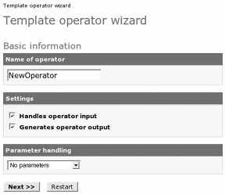
- Based on your responses in the previous screen, some information in this screen is pre-filled. Note that your operator name is now part of the PHP class name. Make sure you do not put spaces in your operator, otherwise PHP will complain.
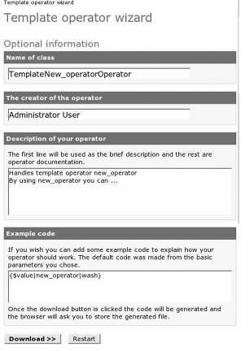
- Once finished, click the Download button to save your PHP file.
The wizard creates a file similar in function to the one created by the datatype wizard. When the download button is clicked, the generic operator file (template<name>operator.php) is generated, where <name> is the name given to the operator. As earlier, further coding of the operator including its setup, is left to the user. Essentially, the wizard only creates the generic template operator file, and even with the help of the operator wizard, much of the hard work for building an operator must still be carried out.

Writing an Operator
Writing your own operator gives the freedom to implement any functionality you need. As mentioned earlier, operators act like program functions by accepting parameters and returning a single value.

Registering the Operator
The site.ini file contains a setting that informs eZ about the location of template operators. When the system looks for operators, it first looks in system directories for a file called eztemplateautoload.php. This file contains the names of the operators that can be used. For example:
File: settings/site.ini
[TemplateSettings] AutoloadPath=lib/eztemplate/classes/kernel/common/
It is good coding practice not to add operators to existing files, and instead to create a new eztemplateautoload.php file within the extension area.
To activate this, the configuration file should be modified to include the new path, as follows:
settings/site.ini

[TemplateSettings] AutoloadPath=lib/eztemplate/classes/kernel/common/extension/operatorE xtension/
eZ now expects the file extension/operatorExtension/eztemplateautoload.php
to exist. Create this file and include within it the following code:
File: extension/operatorExtension/eztemplateautoload.php
<?php
$eZTemplateOperatorArray = array();
$eZTemplateOperatorArray[] = array('script' => 'extension/operatorExtension/randomtemplateoperator.php',
'class' =>

'RandomTemplateOperator',

array('randomtemplateoperator' ) );
?>
'operator_names' =>

This code declares a new template operator named randomtemplateoperator. The RandomTemplateOperator class within the file is used when a template invokes the operator.

Coding the Operator
Template operators are far simpler than other PHP classes described before. The class does not need to inherit from any other class, and the constructor may remain empty.
class RandomTemplateOperator
{
function RandomTemplateOperator()
{
}
}

Initializing the Operator
In order for eZ publish to register the operator, it must be declared. This is accomplished by the operatorList() function:
function &operatorList()
{
return array('randomtemplateoperator' );
}

The namedParameterList() function declares the parameters for the operator. Each parameter has a type and can be optional. If the parameter is required and
not passed to the operator, eZ publish will log the problem.
For our template operator, this function is as follows:
function namedParameterList()
{
return array('first_param' => array('type' => 'string',
'required' => false,
'default' => 'default
text')));
}
This declares the parameter as first_param and defines it as an optional string with a default value.
Executing the Operator
The operator is executed by the modify() function using the information supplied to it:
function modify(&$tpl, &$operatorName, &$operatorParameters, &$rootNamespace,
&$currentNamespace, &$operatorValue, &$namedParameters)
{
$firstParam = $namedParameters['first_param']; switch ($operatorName )
{
case 'randomtemplateoperator':
{
$operatorValue=rand(0, $firstParam );

}
break;
}
}
In this instance, the simple rand() function is used along with the parameter, and the $operatorValue variable is used to store the result. This is a simple example, but you can use any PHP function to produce the results that you need.
It must be noted that there is no explicit return value because $operatorValue is passed by reference, and any change to it will still exist once the function completes execution.

Workflow Events and Triggers
Every CMS system requires a workflow engine to allow users to collaborate effectively. eZ publish includes a workflow system with a selection of default workflow events and triggers to activate events.
Common workflows include publishing and unpublishing articles. If, for example, an author writes a document and publishes it, the workflow system will not publish it until the editor has approved it. The editor would view the results from the template event_ezapprove.tpl and possibly approve the document. If approved, the event would perform the action of publishing the document.
This section discusses how to create and use your own workflow events and triggers.

Workflow Settings
As with all extensions, the configuration file for workflows must declare to the system that there is a new workflow within the extension.
File: extension/workflowextension/settings/workflow.ini.append
[EventSettings]
ExtensionDirectories[]= workflowExtension AvailableEventTypes[]=event_newEvent
Included here is the declaration of the newevent event, which will be located within:
extension/workflowextension/eventtypes/event/newevent/
If the workflow requires a template, then the design directory must also be declared:
File: extension/workflowextension/settings/design.ini.append
[ExtensionSettings] DesignExtensions[]=workflowExtension
As with datatypes, the name of the event is used to find the appropriate PHP file. Each event name must end with type.php, for example:
extension/workflowextension/eventtypes/event/newevent/neweventtype.php
Template directories for workflow events are located in a different place. The result directory is used instead of the regular view directory. With this example, the template path would be:
extension/workflowextension/design/standard/templates/workflow/eventtype/ result/event_newevent.tpl

Workflow Events
The following example code contains the information required to create a basic event class:
File: extension/workflowextension/eventtypes/event/newevent/neweventtype.ph p
define("EZ_WORKFLOW_TYPE_NEWEVENT", "newevent" ); class newEventType extends eZWorkflowEventType
{
function newEventType()
{
$this->eZWorkflowEventType(EZ_WORKFLOW_TYPE_NEWEVENT, "None");
}
function execute(&$process, &$event ) {}
}
eZWorkflowEventType::registerType(EZ_WORKFLOW_TYPE_NEWEVENT, "neweventtype");
Each event type must inherit from the eZWorkflowEventType workflow parent class.
The constructor of the event has the same name as the class and calls the constructor of the parent class by its name.
At the end of the event, it is registered with the eZ system as follows:
eZWorkflowEventType::registerType(EZ_WORKFLOW_TYPE_NEWEVENT, "neweventtype");
The workflow event must implement the execute() function, which will decide what to do about the workflow depending on its current state. For example:
function execute(&$process, &$event )
{
if ($http->hasPostVariable("FINISHED_WORKFLOW" ) )
{
return EZ_WORKFLOW_TYPE_STATUS_ACCEPTED;
}
else
{
$process->Template = array('templateName' => 'design:workflow/ eventtype/result/event_newevent.tpl',
'templateVars' =>
array('request_uri' =>
eZSys::requestUri() ) );
return EZ_WORKFLOW_TYPE_STATUS_FETCH_TEMPLATE_REPEAT;
}
}
The workflow in this example expects this function to return a value reflecting the state of the workflow. If the workflow is finished, then the return value of EZ_WORKFLOW_TYPE_STATUS_ACCEPTED should be used. Otherwise, the function loads the template named event_newevent.tpl and indicates that the workflow should repeat. For the user, each time the event is triggered, this event will repeat the showing of the template until an exit condition is met allowing the template to post the FINISHED_WORKFLOW POST variable.
This is a very simple example, but it illustrates that the nature of an event is to examine whether this workflow is finished, or whether something else has still to occur.
The following table presents the available status commands for the workflow. When a new event type is created, it can use a single status or a combination to determine what should occur next.
Workflow Event Type Status Status Description
EZ_WORKFLOW_TYPE_STATUS_ACCEPTED The workflow event has finished.
EZ_WORKFLOW_TYPE_STATUS_WORKFLOW_DONE

EZ_WORKFLOW_TYPE_STATUS_REJECTED

EZ_WORKFLOW_TYPE_STATUS_WORKFLOW_ CANCELLED

EZ_WORKFLOW_TYPE_STATUS_DEFERRED_TO_ CRON
EZ_WORKFLOW_TYPE_STATUS_DEFERRED_TO_ CRON_REPEAT

EZ_WORKFLOW_TYPE_STATUS_FETCH_TEMPLATE
EZ_WORKFLOW_TYPE_STATUS_FETCH_TEMPLATE_ REPEAT
The workflow is rejected. The workflow is cancelled.
The workflow is deferred to the cron
daemon.

The workflow points the user to a template page and waits for the next workflow call.

Workflow Event Type Status Status Description

EZ_WORKFLOW_TYPE_STATUS_REDIRECT EZ_WORKFLOW_TYPE_STATUS_REDIRECT_REPEAT
The workflow redirects the user to another view and waits for the next workflow call.

EZ_WORKFLOW_TYPE_STATUS_NONE The default status, which does nothing
for now.

EZ_WORKFLOW_TYPE_STATUS_RUN_SUB_EVENT

EZ_WORKFLOW_TYPE_STATUS_WORKFLOW_RESET
The workflow runs another event if there is one.

The workflow is reset for reuse.

Workflow Triggers
Workflow triggers enable an event type to run based on a user action. After the creation of a workflow (http://<your-admin>/workflow/grouplist/) from within the administration interface, a trigger should be assigned to it (http://<your-
admin>/trigger/list/).
By default there are four triggers that come with eZ publish, each containing a before and after connect type. A connect type is a method that allows a workflow to be associated with a function. The following figure presents this default list as shown by the administration interface:
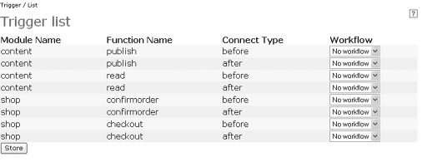
For example, if you have declared your workflow to activate before content is published, the workflow event code will be executed before content is published, and vice versa when the connector is set to activate after the content is published.

Defining Triggers
An additional file named operation_definition.php can be added to the module directory to specify new triggers. Its composition is very similar to the file function_definition.php, as shown:
$OperationList = array();
$OperationList['newtrigger'] = array('name' => 'newtrigger',
'default_call_method' => array('include_file' =>
'extension/triggerExtension/modules/
newModule/newmoduleoperationcollection.php',
'class' => 'eZTriggerExtensionOperationCollection' ), 'parameter_type' => 'standard',
'parameters' => array(array('name' => 'node_id',
'type' => 'integer', 'required' => true ) ),
'keys' => array('node_id' ),
'body' => array(array('type' => 'trigger',
'name' => 'pre_newtrigger', 'keys' => array('node_id' ) ),
array('type' => 'method', 'name' => 'say-hello', 'frequency' => 'once', 'method' =>
'sayHello',) ) );
In this example, the trigger newtrigger is defined, and a single before connect type declared as pre_newtrigger. There is no after connect type, so assigning a workflow to this will not do anything.
The body item defines the order for the trigger to operate. The before connect type will activate the pre_newtrigger and the workflow behind it. Once the workflow completes, the methods within the body will run; in this example, this is the sayHello() function. If there was a post_newtrigger designed, it would have run the workflow assigned to the after connect type.
Functions in this example are defined within the
eztriggerextensionoperationcollection.php file.
The specified parameters are passed to every method and trigger defined within the body. The keys are used to identify information during the workflow.
The final stage is to inform eZ publish about the new file. Unfortunately it does not pick up this information automatically, requiring an addition workflow.ini setting:
File: extension/triggerextension/settings/workflow.ini.append
[OperationSettings] AvailableOperations=content_publish;content_read;shop_confirmorder;
shop_checkout;newModule_newtrigger
This is similar to the original workflow.ini but with the mention of our new trigger. eZ publish will look for the newModule module and then for the operations file.
For further information on this aspect of workflows, read the documentation at:
http://pubsvn.ez.no/sdk/tutorials/view/workflows/

Actions
eZ publish relies upon the use of web forms to provide two-way communication between a user and a database. Actions inform the system of the user's wishes within a particular context and allow it respond appropriately. For example, there are defined actions for events such as creating, editing, publishing, deleting, adding items to shop baskets, and many more. An action extension is required when you need to provide functionality that uses a different type of action.
At its simplest, an action is a redirection mechanism. For example, if the user wishes to edit an object, the edit action will redirect the user to the edit module. Besides simplifying the use of forms, implementing an action within your extension also helps to remove coding dependencies. Your HTML will not contain hard-coded URI paths to your module, and therefore, if the code within the extension changes, you do not need to change your HTML.
The kernel/content/action.php kernel file defines the standard set of actions and related responses. Any additions can be made within the actions subdirectory of the extensions directory.
The new action list is registered by informing the system through the
content.ini.append.php configuration file:
File: extension/actionExtension/settings/content.ini.append.php
[ActionSettings]
ExtensionDirectories[]=actionExtension
eZ publish now expects the content_actionhandler.php file containing the actions to exist, and it will be used for processing an action if the action is not found within kernel/content/action.php. The path to the content handler file is as follows:
extension/actionExtension/actions/content_actionhandler.php
Two example actions are:
File: extension/actionExtension/actions/content_actionhandler.php
function actionExtension_ContentActionHandler(&$module, &$http, &$objectID )
{
if ($http->hasPostVariable("ActionDoSomething" ) )
{
echo "<p>Found ActionDoSomething</p>";
}
else if ($http->hasPostVariable("ActionDoSomethingElse" ) )
{
echo "<p>Found ActionDoSomethingElse</p>";
}
return;
}
Both of these actions print out a simple line of text to indicate that an action is being run.
The HTML required to activate this action would be:
<form method="post" method="post" action={"content/action"|ezurl}>
<input name="ActionDoSomething" type="submit" value="Do Something">
<input name="ActionDoSomethingElse" type="submit" value="Do Something">
<input name="ContentObjectID" type="hidden" value="99">
</form>
The input tags are named after the actions we wish to use. The user can select either action to invoke the correct routine.
It must be noted that for the action extension to activate a content object, a value must included with the POST values; without these, the extension will fail to activate.

Translations
Following on from all other extensions, translation extensions are activated by including the presence of the new translation in the site.ini file:
File: extension/translationExtension/settings/site.ini.append.php
[RegionalSettings] TranslationExtension[]=translationExtension
This setting informs eZ that the translation.ts translation file exists within the following path:
extension/translationExtension/translations/
Note that we are assuming that the programs ezlupdate and Linquist have been used to create the translation.ts file.
When the user performs a translation within a template, they must specify the extension directory within which to activate translation. For example:
{"Translate this"|i18n("newExtension"}
There can only be a single translation file present for an extension.

Overriding Translations
A translation extension has an additional benefit apart from providing new translations. It is possible to override translations in the default eZ system with new translations from your extension.
To do this, you use a translation file created from an existing locale, and edit it to remove all entries apart from those you wish to override. Now use the Linquist program to re-translate this file. If the translation is active within your extension, your new values should now be used instead of the original values.

Notifications
eZ publish provides a configurable notification mechanism where users can be informed that an event has occurred. Notification instances could be when objects are updated or published, when workflows execute, and so on. Users can choose to receive notifications in the form of a single e-mail or as a digest of messages. Users can configure their notifications by browsing to http://<your- site>/notifications/settings. This screen presents the current notification settings and options to configure these.

Notification Events
The settings file settings/notification.ini controls which events a user can configure, as shown:
File: settings/notification.ini
[NotificationEventTypeSettings] RepositoryDirectories[]=kernel/classes/notification/event/ AvailableNotificationEventTypes[]=ezpublish AvailableNotificationEventTypes[]=ezcurrenttime AvailableNotificationEventTypes[]=ezcollaboration [NotificationEventHandlerSettings] RepositoryDirectories[]=kernel/classes/notification/handler/ AvailableNotificationEventTypes[]=ezgeneraldigest
AvailableNotificationEventTypes[]=ezcollaborationnotification
AvailableNotificationEventTypes[]=ezsubtree
This file defines the available notification event types and the event handle
will respond to an event.
A very simple event type is presented below:
define('EZ_NOTIFICATIONTYPESTRING_NEWNOTIFICATIONEVENT',
'newnotificationevent' );
class NewNotificationEventType extends eZNotificationEventType
{
function NewNotificationEventType()
{

rs that
$this->eZNotificationEventType( EZ_NOTIFICATIONTYPESTRING_NEWNOTIFICATIONEVENT );
function initializeEvent(&$event, $params )
{
}
function eventContent(&$event )
return "hello";
}
eZNotificationEventType::register(
EZ_NOTIFICATIONTYPESTRING_NEWNOTIFICATIONEVENT,
'newnotificationeventtype' );
In this example, the event type implements two important function interfaces, initializeEvent() and eventContent(), used in other parts of the system. When the event is first created, it will be initialized with content, and when the handler runs, it will ask the event for this content. When anything causes an event, such as an object being updated, the handler will execute the handle() function as shown:
class NewNotificationEventHandler extends eZNotificationEventHandler
{
....
function handle(&$event )
{
if ($event->attribute('event_type_string' ) ==
'newnotificationevent' )
{
print "Event content is: ".$event->content();
}
}
....
}
Extensions can include new notifications. Shown below is an example configuration file for notifications:
File: extension/newextension/settings/notification.ini.append
[NotificationEventTypeSettings] ExtensionDirectories[]=notificationExtension AvailableNotificationEventTypes[]= newnotificationevent
The system will now expect the event type to be located at:
extension/notificationExtension/notificationtypes/newnotificationevent/ne wnotificationeventtype.php
Unfortunately, at the time of writing, there is no extension capability for event handlers in eZ publish 3.2. The main configuration file (notification.ini) must be used to specify new locations for event handlers if they are present in your extension.
File: settings/notification.ini
[NotificationEventHandlerSettings] RepositoryDirectories[]=kernel/classes/notification/handler/
RepositoryDirectories[]=extension/notificationExtension/notificationh andlers/
AvailableNotificationEventTypes[]=newnotificationevent
The system will now expect the event type to be located at:
extension/notificationExtension/notificationhandlers/newnotificationevent
/newnotificationeventhandler.php

Adding Collaborations
A collaboration is an extension of the notification system and provides notifications from the workflow system. As shown below from the settings/collaboration.ini file, the default option is to inform authorized users when the approval notification runs:
File: settings/collaboration.ini
[HandlerSettings] Extensions[]
Repositories[]=kernel/classes/collaborationhandlers Active[]=ezapprove
This system works by utilizing collaboration handlers to notify subscribed users when a workflow is used. Handlers can be written for each workflow event type, but at present, the system only has one available for the ezapprove event.
Extensions can incorporate their own handler for new event types by declaring the extension that the handler is part of:
File: extension/collaborationExtension/settings/collaboration.ini.append
[HandlerSettings] Extensions[]=newExtension Active[]=newevent
The system will now expect the handler to be located at:
extension/collaborationExtension/collaboration/newevent/
neweventcollaborationhandler.php
It is left for the reader to implement their own handler.

SOAP Server
SOAP (Simple Object Access Protocol) is a protocol that enables you to communicate with other systems and data sources using HTTP and XML without having to know about the programming language or operating system.
SOAP works in a client-server pair to achieve its data transfer, with the client being the requestor and the server taking the requests and passing back the requested information. The good news is that eZ publish has an implementation of both a client and server for SOAP communication. In this chapter, we will show
how you can quickly set up a SOAP server and client to demonstrate SOAP usage.
The example will do two things:
- Return a text string of our choice—in this case "example 1"
- Interact with eZ publish to return system information
To work with this example you will need a copy of the latest eZ publish installed. You need to ensure that you can call both soapclient.php and soapserver.php. If you are using virtual named hosts, you will need to set up two new URLs:
soapserver.example.com soapclient.example.com
If you prefer to use http://localhost set up for this example, you will need to include the name of the PHP file you are running in the URL. We have included the VirtualHost setup as it is the one recommended by eZ.
This should be set up to point at soapserver.php and soapclient.php respectively. Your Apache setup for the SOAP server may look something like:
<VirtualHost *:80>
<Directory /path/to/files>
Options FollowSymLinks Indexes ExecCGI AllowOverride None
</Directory> RewriteEngine On
RewriteRule !\.(gif|css|jpg|png|ico|js)$
/path/to/files/soapserver.php DocumentRoot /path/to/files ServerName soapserver.example.com
</VirtualHost>
Once you have set up your Apache configuration, you are ready to add the code for the server in soapserver.php.
This first section includes routines that we need to work with in the example and creates a new SOAP server object that will wait for incoming SOAP requests:
<?php
// Include the eZ soap server library include_once("lib/ezsoap/classes/ezsoapserver.php" ); include_once("lib/ezutils/classes/ezsys.php" );
// Create a new server object
$server = new eZSOAPServer();
We now register the function that needs to be exposed and made available. In this example, we have two, exampleName and systemInfo, that need to be registered.
// Register functions
$server->registerFunction("exampleName");
$server->registerFunction("systemInfo", array("infoType" => "integer"
) );
We now process the incoming request using processRequest, which takes the incoming POST variables and checks for the function that needs to be called.
$server->processRequest();
We have two functions in this example; the first is a simple return of a string:
// Example version name function exampleName($noFiles )
{
$return = "example 1"; settype($return, "string" ); return $return;
}
The second is a routine that takes the parameter passed by the SOAP client and returns the required information. In this example, the SOAP client will be requesting the operating system and hostname for the eZ publish server. Most of the example is basic PHP except the settype() function. This enables you to set the type of the data you are passing.
// System information
function systemInfo ($infoType )
{
switch ($infoType )
{
case "os":
{
$return = eZSys::osType();
} break;
case "hostname":
{
$return = eZSys::hostname();
} break;
}
settype($return, "string" ); return $return;
}
?>
As of eZ publish v 3.3, the following datatypes are implemented for passing data via SOAP:
- String
- Integer
- Float
- Boolean
- base64
- Array
- SOAPStruct
Now that the server is created, we need to create the client that will communicate with the server. The client in this example is called soapclient.php.
The following table gives an outline of the major functions required for the SOAP client connectivity:
Code Description
eZSOAPClient() Prepares the SOAP client.
eZSOAPRequest() Prepares the request object ready for parameters.
addParameter() Fills the object with the request information.

send() Sends the request correctly formatted in XML over HTTP to the SOAP server. The response from this request is then placed in the $response variable for you to query.

IsFault() Checks to see if an error occurred in the call.

As before, the first part of the code includes libraries that will be required; in this case, the SOAP client and request. The SOAP client is also created here with the location of the SOAP server we wish to call: in this case,
soapserver.example.com.
<?php
// Include the eZ soap client libraries include_once("lib/ezsoap/classes/ezsoapclient.php" ); include_once("lib/ezsoap/classes/ezsoaprequest.php" );
// Create a new client object
$client = new eZSOAPClient("soapserver.example.com", "/" );
?>
The first client example will call the exampleName() SOAP server function. This is actioned by first creating a request object that will handle the request. The request string is then placed in $request:
<h2> First SOAP example </h2>
<?php
// Create a new request to find the number of files
$request = new eZSOAPRequest("exampleName",
"http://soapserver.example.com");
The created request is then sent to the SOAP server:
// Send the request to the server and fetch the response
$response =& $client->send($request );
Now $response contains the response from the SOAP server, and it is checked to ensure that a fault has not occurred. If all is OK, then the response example1 is displayed:
// Check for SOAP fault
if ($response->isFault() )
{
// Print the SOAP fault informationt
print("SOAP fault: " . $response->faultCode(). " - " .
$response->faultString() . "" );
}
else
{
// If everything is ok, print the result print("Example name is : " . $response->value() );
}
?>
The second example builds on the first by passing a parameter to the SOAP server requesting information. You can change the returned information by changing the value of $infoType from os to hostname.
<h2> Second SOAP example </h2>
<?php
// Create a new requet to list files
$request = new eZSOAPRequest("systemInfo",
"http://soapserver.int.visionwt.com" );
// Add parameters
$infoType = "os";
$request->addParameter("infoType", $infoType );
// Send the request to the server and fetch the response
$response =& $client->send($request );
// Check for SOAP fault
if ($response->isFault() )
{
// Print the SOAP fault information
print("SOAP fault: " . $response->faultCode(). " - " .
$response->faultString() . "" );
}
else
{
// If everything is ok, print the result print("System information : " . $response->value() );
}
?>
To run these routines, you will need to open a browser and point it at the location of your files. If you are using virtual hostnames for both server and client, you will need to call soapclient.example.com.
If all has gone well, then your SOAP server and client should be able to communicate. Of course, the eZ publish libraries protect you from working with raw XML. For completeness, here are two examples that show the request from the client and the response from the server. As you can see, the libraries are doing a lot of the hard work for you.

Client XML request to server
<?xml version="1.0" encoding="UTF-8"?>
<SOAP-ENV:Envelope xmlns:SOAP- ENV="http://schemas.xmlsoap.org/soap/envelope/" xmlns:xsi="http://www.w3.org/2001/XMLSchema-instance"
xmlns:xsd="http://www.w3.org/2001/XMLSchema"
xmlns:SOAP-ENC="http://schemas.xmlsoap.org/soap/encoding/">
<SOAP-ENV:Body xmlns:req="http://www.example.com">
<req:exampleName />
</SOAP-ENV:Body>
</SOAP-ENV:Envelope><?xml version="1.0" encoding="UTF-8"?>
<SOAP-ENV:Envelope xmlns:SOAP- ENV="http://schemas.xmlsoap.org/soap/envelope/" xmlns:xsi="http://www.w3.org/2001/XMLSchema-instance"
xmlns:xsd="http://www.w3.org/2001/XMLSchema"
xmlns:SOAP-ENC="http://schemas.xmlsoap.org/soap/encoding/">
<SOAP-ENV:Body xmlns:req="http://www.example.com">
<req:systemInfo>
<infoType xsi:type="xsd:string">os</infoType>
</req:systemInfo>
</SOAP-ENV:Body>
</SOAP-ENV:Envelope>

XML response from server
<?xml version="1.0" encoding="UTF-8"?>
<SOAP-ENV:Envelope xmlns:SOAP- ENV="http://schemas.xmlsoap.org/soap/envelope/" xmlns:xsi="http://www.w3.org/2001/XMLSchema-instance"
xmlns:xsd="http://www.w3.org/2001/XMLSchema"
xmlns:SOAP-ENC="http://schemas.xmlsoap.org/soap/encoding/">
<SOAP-ENV:Body>
<resp:exampleNameResponse xmlns:resp=" http://www.example.com ">
<return xsi:type="xsd:string">example 1</return>
</resp:exampleNameResponse>
</SOAP-ENV:Body>
</SOAP-ENV:Envelope><?xml version="1.0" encoding="UTF-8"?>
<SOAP-ENV:Envelope xmlns:SOAP- ENV="http://schemas.xmlsoap.org/soap/envelope/" xmlns:xsi="http://www.w3.org/2001/XMLSchema-instance"
xmlns:xsd="http://www.w3.org/2001/XMLSchema"
xmlns:SOAP-ENC="http://schemas.xmlsoap.org/soap/encoding/">
<SOAP-ENV:Body>
<resp:systemInfoResponse xmlns:resp=" http://www.example.com ">
<return xsi:type="xsd:string">unix</return>
</resp:systemInfoResponse>
</SOAP-ENV:Body>
</SOAP-ENV:Envelope>
In this example, we have demonstrated that with a few lines of code you are able to create the SOAP client and server. You should be able to build on this to interrogate other functions within eZ publish. It is advisable to review the security arrangements of the SOAP server to ensure that the SOAP server does not provide a back door into system functions. For this reason, eZ publish has implemented a username/password system into the SOAP server.
In Chapter 7, we will discuss some of the ways in which you can use SOAP to bridge to other data stores in a real-world example.

RSS (Really Simple Syndication)
RSS (Really Simple Syndication) is a technology that enables the sharing of content from one server to another. You could say that this sounds like SOAP. This is true; there are similarities between the two technologies. However, RSS has been designed to fulfil a particular need whereas SOAP is more of a general- purpose protocol. At the time of writing, eZ publish v3.3 is in beta stage and has a full implementation of RSS 2.0. We will use this for our discussion.
The benefit of using an RSS import feed is that you can import the information directly into an article or other eZ publish class of your choice. No additional coding is required to implement this type of system using the eZ SOAP interface. This means that you can update the feed once at night via a cron job and that information will be available for your site visitors. This is a benefit when you cannot guarantee that the external RSS server will be available when visitors view your site.
RSS feeds are used to give freshness to a site and help generate an element of "stickiness". This can be used in the traditional news format, where you get the RSS feeds from a news provider, such as The Register, allowing your site to benefit from the latest information and give it a fresh feel.

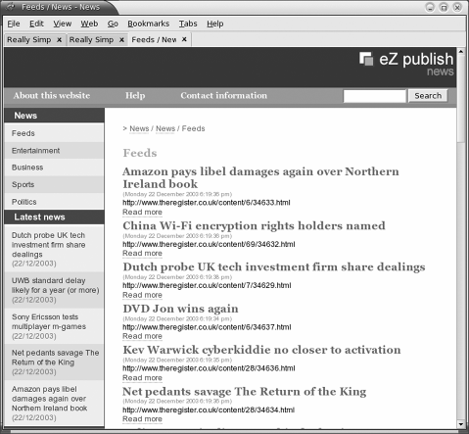
RSS is now simpler to set up via an RSS admin page in the Set up menu. This enables you to create RSS 1.0 and RSS 2.0 exports from your site by selecting the items you want to be shared. This means you can enable single or multiple RSS exports without writing a single line of code.

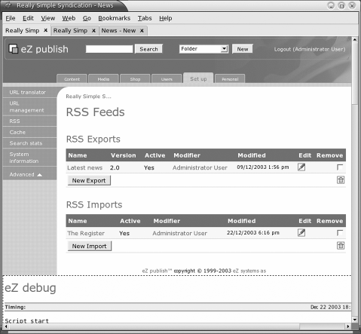
The same process is followed for RSS imports, where you can choose the files you want to import from the admin interface. This means you can import news from an RSS feed directly to your news section. In this example, we have chosen to take the RSS feed from The Register news feed from
http://www.theregister.co.uk/feeds/latest.rdf.

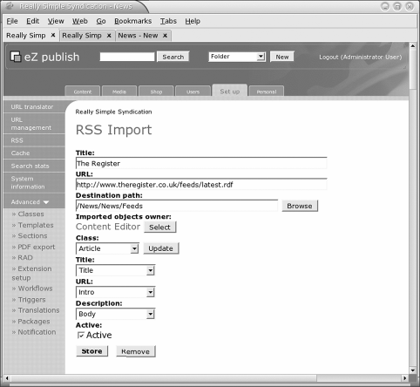
A growing use of RSS is in the area of content syndication, where it is used to distribute information around an organization. One example of this would be when you have both an Intranet and Internet server and want to distribute information between the two. You could use the RSS protocol on the Intranet server to pull relevant articles off the Internet server. The Internet server can use the RSS export features that are configured to serve RSS feeds on a regular basis, thereby preventing your editors needing to enter the information on both servers. In some large organizations, this can represent a reasonable cost saving in time and effort for editors.

Data Interoperability
The import and export of information is a key component of any CMS. With its present feature set and extensibility, eZ publish is an attractive package for centralizing information from other systems and for providing it to others.
Version 3.3 of eZ publish has started to provide improved import/export functionality, allowing the system to interoperate with other systems in a much easier fashion. In addition to SOAP and RSS mentioned within this chapter, the new functionality includes class and template import/export and PDF export.
Until now, it has been left to program developers to write additional code to move information around.
This section will discuss some of the issues regarding importing, and give an example of the code required to import information into an eZ publish object.
The export of information is not covered explicitly because the same methods and eZ APIs are used for this. In addition, the previous sections on SOAP and RSS have covered examples of data export in detail.

Importing Information
The new package format, introduced in eZ publish 3.2 and improved upon in 3.3, allows for classes and templates to be imported and exported. Unfortunately, content objects are not yet dealt with, but it is relatively simple to add your own using the eZ publish API.
Importing information concerns setting values of attributes with the information you want to import. For example, if you want to import text from a document, you will need to import that text into the body attribute of an article. If you want to store category information, then several folder-content objects will be required, one for each category.
The following example will show how to create a simple folder-content object and then publish it.

Publishing a Folder Object
This example uses parts of the complete file import.php that is present in the download code for this chapter.
As with the administration interface, content objects are created from classes at the code level. The following code will retrieve a class instance given a class identifier as the parameter:
$contentClassID=1;
$class =& eZContentClass::fetch($contentClassID );
The class identifier value can be found in the administration interface; for example, a folder is always assigned the number 1 and an article is assigned the number 2. To create a folder, assign the value of 1 to the $contentClassID variable.
$sectionID=1;
$userID=14;
$contentObject =& $class->instantiate($userID, $sectionID );
Then, we create a content object from the class by instantiating it. This builds an unpublished, empty content object. eZ attaches an object to a node and positions it within a tree structure, which can be coded as follows:
$nodeAssignment =
& eZNodeAssignment::create(array(
'contentobject_id' => $contentObject-

>attribute('id'),
>attribute(
),
'contentobject_version' => $contentObject-
'current_version'
'parent_node' => 2,
'sort_field' => 2,
'sort_order' => 0, 'is_main' => 1 ) );

$nodeAssignment->store();
This code inserts the object into a node and places it within the root directory of the administration interface. The parent_node array key identifies the parent nodes, and therefore the object's location within the tree; in this example, node 2 is the root node.
With the content object created and assigned to a node, its version information should be updated. This allows eZ to display status information about this node.
$contentObjectVersion =& $contentObject->version($contentObject-
>attribute(
'current_version' )
);
$contentObjectVersion->setAttribute('status', EZ_VERSION_STATUS_DRAFT
);
$contentObjectVersion->store();
The current version of the content object is retrieved and the status is set as a draft. This status will be changed once the object is published.
The content object is now ready for information to be entered into its attributes. When the object is created through the class instantiation function call, each attribute is also created. At the moment these are empty:

$contentObjectAttributes =& $contentObjectVersion-
>contentObjectAttributes();
First, you need to retrieve a list of attributes from the current version of the object:

foreach (array_keys($contentObjectAttributes) as $key)
{

it.
$contentObjectAttribute =& $contentObjectAttributes[$key];
$contentClassAttribute =& $contentObjectAttribute->
contentClassAttribute();
// Each attribute has an attribute called 'name' that identifies if ($contentClassAttribute->attribute("name") == "Name")
{

$contentObjectAttribute->setAttribute("data_text", "My new folder");
$contentObjectAttribute->store();
}
}
If you know the precise attribute you need, you can reference it directly as you would with any PHP array. However, for illustration purposes, this code loops through all attributes looking for the single attribute called Name. This attribute is a simple string, and the text My new folder is assigned to it. Other attributes will require additional code to assign information.
Note that it is at this point that the import has occurred. The text assigned could easily be the result of a function call to another routine, which has the information ready to be stored.
The final stage is to publish the object, which is done by the following function call:
$operationResult = eZOperationHandler::execute('content', 'publish', array('object_id' => $contentObject-

>attribute('id' ),

) );
'version' => $contentObject->
attribute('current_version' )

Login Handlers
You already use a login handler for eZ publish, the default one. This enables you to gain access to your system and its content and features. However, there are times when you may need to integrate your system with an environment that already has a method of storing user details. If this is the case, you need to use a different login handler. This section will demonstrate the current options available to you.
Custom login handlers enable you to state that users are being managed externally. In addition, each user of a system will need to be defined within the eZ

publish system to enable access to the eZ publish system. This method allows you to manage the updates and access status of the user.

LDAP (Lightweight Directory Access Protocol)
LDAP has been supported in eZ publish since version 3.2 and incorporates the ability to customize the login handler such that it can use a LDAP server instead of the information stored with the eZ publish SQL database.
By default, the login handler is set to the default or standard handler in site.ini: LoginHandler[]=standard
To configure your system to use the login information in the ldap.ini override file, you should change this to:
LoginHandler[]=LDAP
Sometimes, though, you may also want to allow the standard eZ publish logins to work for users such as the administrator. To enable this, list both login methods in the order you require them to be accessed in:
LoginHandler[]=standard LoginHandler[]=LDAP
You will also need to override ldap.ini. You will need to contact the LDAP administrator to get the information required to ensure that your system connects to the LDAP system correctly. Once this information is set, the system will handle logins by using the kernel/classes/datatypes/ezuser/ezldapuser.php file.
eZ publish integrates with LDAP by matching already existing user IDs in both your local eZ publish system and the remote LDAP server. This information is then updated from the LDAP server whenever the cron job
/cronjobs/ldapusermange.php is executed.
For the LDAP updates to work, initially you will need to add the user information to both eZ publish and LDAP systems. Once this is completed, the cron job will update the first name, last name, e-mail, user group, password, and the enabled status from the LDAP source.
This means the LDAP handler removes the need to manage users' details on the eZ publish system on a day-to-day basis, but you will still need to add new users to both systems.
You will need to open your firewall to allow the chosen LDAP communication port; by default this is port 389. PHP will need to have LDAP enabled for this method to work.
?ini charset="iso-8859-1"?
# eZ publish configuration file for connection to LDAP server #
[LDAPSettings]
# Set to true if use LDAP server LDAPEnabled=true
# LDAP host LDAPServer=
# Port nr for LDAP, default is 389 LDAPPort=389
# Specifies the base DN for the directory. LDAPBaseDn=
# Could be sub, one, base.
LDAPSearchScope=sub
# Use the equla sign to replace "=" when specify LDAPBaseDn or LDAPSearchFilters
LDAPEqualSign=--
# Add extra search requirment. Uncomment it if you don't need it. # Example LDAPSearchFilters[]=objectClass--inetOrgPerson LDAPSearchFilters[]
# LDAP attribute for login. Normally, uid LDAPLoginAttribute=uid
# Could be id or name LDAPUserGroupType=id
# Default place to store LDAP users. Could be content object id or group name for LDAP user group,
# depends on LDAPUserGroupType. LDAPUserGroup=
# LDAP attribute type for user group. Could be name or id LDAPUserGroupAttributeType=name
# LDAP attribute for user group. For example, employeetype. If specified, LDAP users
# will be saved under the same group as in LDAP server.
LDAPUserGroupAttribute=employeetype
# LDAP attribute for First name. Normally, givenname LDAPFirstNameAttribute=givenname
# LDAP attribute for Last name. Normally, sn LDAPLastNameAttribute=sn
# LDAP attribute for e-mail. Normally, mail LDAPEmailAttribute=mail

Text File Login
With the introduction of the login handler, you can have other methods of authentication; one of the provided methods is to verify login by using a text file. This is essentially the same as LDAP, but it uses a file to store login information, and the eztextfileuser.php file as its login handler.
The layout for the text file handler can be found in textfile.ini in the settings
directory.

Summary
It is clear that eZ publish is a complex system with myriad ways to extend it. We have discussed many of these situations and given examples of how to begin interaction with eZ publish on each of these levels. A very important part of this discussion was to identify and separate each extension area to enable you, the developer, to use the correct tools and extensions to build your application.
In the next chapter, we will move on to practical examples of extending eZ publish using the methods introduced in this chapter.

6

Extension Development

In this chapter, we will look at some examples and concepts that put the contents of the previous chapter into real-world contexts as we tackle the general problem of extension development.
Two extensions are covered—one is a new e-commerce module for working with the WorldPay payment engine, which will enable you to implement payment solutions from your eZ publish site. The other is a category datatype—this helps to resolve the problem of category lists in articles or products.
Finally, we will discuss integrating external applications with eZ publish, and the problems and choices that you may have to deal with.
We begin with a brief summary of extension development practices in eZ publish.

Extension Development Practices
As with any development project, when creating an extension it is a good idea to have a clear idea of what you want to achieve, so get out the pen and pad and start writing!

Designing Your Extension
The development issues can be broken down into the following areas:
- Goals and targets of the extension
- Preparing to test your extension
- Timescales
- Anticipating the learning curve

Goals and Targets of the Extension
You need to define what you want to achieve by identifying key areas that are required for development. This allows you to understand the problem and build an outline of how you intend to resolve it.
Having a good understanding of the goals of a project can help prevent later problems, such as scope creep, which cost time and money in a project. This step lets you plan out the individual elements of the extension and understand general issues related to it.

Preparing to Test Your Extension
Take the listed goals and from them build a brief plan of how each element is to be tested. At the end of the project, this will help you confirm that you have created exactly what you needed.

Timescales
Identifying time limits and time issues early on paper focuses the mind and helps you figure out the 'nice to have' features as opposed to the mandatory elements of your extension.
Key elements are client deadlines, the time available for development, and eZ publish release schedules. These schedules, if late, could force you to deliver a project using beta software, so always try to keep a month's buffer after the release date if you plan to roll out an extension, as most first releases contain at least some bugs.
Bear in mind that you will be writing an extension with the eZ publish libraries, so you will need to add a little extra time in the first couple of projects so you can learn the libraries and the various integration methods.

Anticipate the Learning Curve
If you cannot resolve all the problems yourself, you may need help from others. Support from the forums can take a while if you are not paying for it. Even in the basic paid support package, issues normally take three days to solve, so plan carefully based on your needs.
Bear in mind that around major eZ publish release times, free forum support can be affected because eZ staff and developers are working on the latest release.

Software Requirements
If you use a feature in your extension that is only available in the latest version of eZ publish, but the project uses a previous version, you will probably experience a problem.
Remember that not all hosting environments support the latest version of PHP and MySQL; always ensure that your development environment is the same as your deployment platform.
It is always a good idea to test all new features on your deployment platform early, as this prevents problems during testing.

Development Tools
Various tools can be used in the development of an extension. CVS (Code Versioning System) and SVN (Software Version Number) are invaluable in tracking your code changes and have been incorporated into many integrated development environments. Some recommended open source IDEs that work well with eZ publish are Eclipse (www.eclipse.org) and Quanta Plus (http://quanta.sourceforge.net).
If these two IDEs are not to your liking, it is worthwhile spending time looking for a tool you feel comfortable with that works with HTML, PHP, SQL, and eZ publish template files, as you will be regularly changing all these file types.

Sharing with the Community
eZ publish has a dual license that enables you to share or not share depending on whether you pay eZ publish a development fee.
The eZ publish dual license gives you two options. If you are not paying eZ systems for a developer license, you need to make your code public. See a copy of this on http://www.gnu.org/copyleft/gpl.html. This means that any extensions you write that use eZ publish libraries or functions must themselves become GPL. This involves adding the GPL license information to each of the programs you wish to share. There are several ways for sharing your extension:
- eZ publish contributions
- Public SVN
- SourceForge
The recommended choice is to contribute via the eZ publish site and add your contribution (http://ez.no/community/contributions). We suggest you upload your contribution here first. Once it is added, you can let people know by posting a message to the developer forum saying that you have written an extension and providing a brief description. Although this is not strictly necessary, it does start a thread for people to discuss the extension. You will generally get good feedback from the community and someone could help develop your contribution further.
Public SVN is a new location set up to enable community projects to be hosted centrally in a change-controlled format (http://pubsvn.ez.no/community-development.html). At the time of writing, this is a very new service, so try to visit the website.
SourceForge has many open source projects available for download and contribution and is a good choice if you want to share and actively develop your extension without hosting it yourself. However, move to SourceForge only after reviewing the first two options, so that eZ publish developers can have a central source for all extensions.

Upgrading eZ publish
Future major releases of eZ publish could well take advantage of the new features available in forthcoming versions of PHP and MySQL, so this is something worth bearing in mind.
It is worth making a note of the major requirements of your extension so that you can
quickly check for any functionality changes with any new release of eZ publish.
When these updates do occur, there will be guidelines from eZ systems and from the community to help developers.

Documentation
If you have ever gone back to review a project or extension after a period and not been able to decipher how it works, or it has taken you a long time to figure out where a problem is, then you are a prime candidate for documentation. This subject usually evokes the greatest procrastination from developers! Unfortunately, documentation is essential and you're going to have to do it. Some key areas for documentation include:
- Overview of the goals of the extension
- Requirements
- Installation instructions
- eZ publish version
- PHP version
- Database requirements and setup
A documentation tool has been integrated into eZ publish to help you document your code. It is called Doxygen (http://doxygen.org). This is one of the many documenting tools that are freely available and helps take the tedium out of documenting.

Creating the WorldPay Extension
In the previous chapter, we discussed all the elements of an extension. In this section we will take these ideas and concepts and apply them to something virtually every e- commerce site needs—a payment engine.
This example uses the WorldPay Direct account (http://www.worldpay.co.uk/sme/) and will communicate with the WorldPay service using the WorldPay Junior integration service (http://support.worldpay.com/integrations/jnr/index.html). Most
payment services are similar so this forms a good base for all payment engines. Once you have looked through the code you will be able to see where it can be modified to work with other payment services. The WorldPay module requires that we use both events and modules together to get the payment engine to work, as we need to integrate with the checkout workflow from both a user and a remote-call perspective.

Creating the Environment
If you are recreating this example on your own machine, it is assumed that you have eZ publish up and running on it. This step involves installing the latest eZ publish system, running the setup, and following the wizard so you can see the site and administration screens correctly. This is covered in Chapter 2 and will not be duplicated here.
Think of an extension as an application that uses the eZ publish environment, and for it be effective, you should have all the files you need within your project directory. This will ensure extension mobility—you will be able to take the written code and move it to another project easily. If you take the directory structure as the starting point, your directory will look like this:
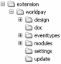
The following table contains an example of the content required for each directory:
Directory Contents of the Directory
design All stylesheets, JavaScript, images, and eZ publish templates.
doc All the documentation required for someone to install and use the extension.
eventtypes New custom events that you are creating.
modules New modules that the project uses.
settings Any new ini settings required by your project.
update Any updates to eZ publish that are required. This includes database and code patches.

In this extension, we are not using multiple languages, new datatypes, or actions, so we do not need to include their directories.
The main eZ publish environment needs to know that an extension is available and should be made available to the site. For this, change the site.ini.append.php file. Add the following settings to activate the extension:
File: settings/override/site.ini.append.php
[ExtensionSettings] ExtensionDirectory=extension ActiveExtensions[]=worldpay
This lets eZ publish know that you have an extension called worldpay that it needs to know about. If you have ever used the ezdhtml extension for the online editor, you will know that these settings are needed as you need to add similar commands for eZ publish to see the editor.
eZ publish will now look into this directory for any overrides that the extension might need.

Creating Workflow Events and Triggers
In the following example for a payment engine, we want the action to take place before the checkout event has occurred and the items are all in the baskets ready for payment. Before we can select a dropdown from the workflow list, a workflow needs to be created.
To create the Worldpay workflow:
- Click on Workflows in the set-up menu. This will show you a list of existing workflows. To this, add a new group called Worldpay.
- Once this group has been created, click on the Worldpay group link to view the available workflows. As this is a new group, there will be no workflows, so you need to create one by selecting the New workflow button.
- To name the workflow, add Worldpay to the Name field.
- Select Event/Worldpay from the drop-down event list at the bottom of the page and click the New button.
If you do not see the Worldpay item in the list, verify that you have declared
Worldpay as an extension in the site.ini files.
- You do not need to enter a description for the event, so go ahead and click
Store to save the workflow.
Now that the workflow event has been created, you need to come back to this screen by selecting Setup | Triggers and select Worldpay next to shop | checkout | before.
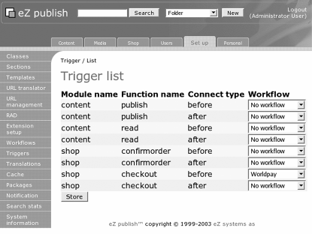
- Create the eventtype extension environment. As this workflow will be part of a larger project, it will need to live somewhere. Create the extension directory (if you don't already have one) in your project directory. Then create a directory worldpay below it:
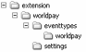
- Create the Worldpay eventtype. The eventtypes directory contains the program that gets executed when a trigger is activated. The name of the file follows the format of nametype.php.

Overview
The Worldpay eventtype needs to take the current checkout information and create the form screen that is required for input to the WorldPay system. This involves taking the price and billing information from the basket and sending it to WorldPay as an HTML form post.

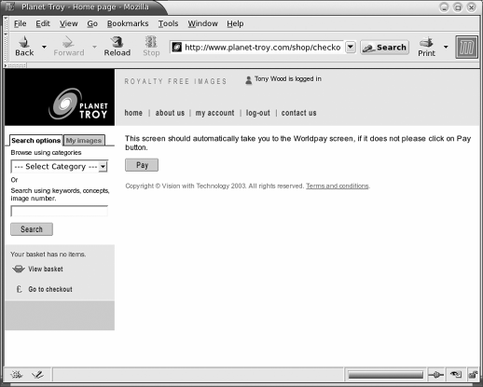

PHP Implementation
Take a couple of moments to review the worldpaytype.php source file. As you can see, there are various includes and definitions at the top, but the most important elements you need have been stripped out and shown here:
<?php
define( "EZ_WORKFLOW_TYPE_WORLDPAY_ID", "worldpay" ); class WorldpayType extends eZWorkflowEventType
{
/*! Constructor
*/
function WorldpayType()
{
$this->eZWorkflowEventType(EZ_WORKFLOW_TYPE_WORLDPAY_ID,
"Worldpay" );
}
function execute( &$process, &$event )
{
......
}
}
eZWorkflowEventType::registerType(EZ_WORKFLOW_TYPE_WORLDPAY_ID,
"worldpaytype" );
?>
The WorldPay example is slightly more complicated than a normal event as it is called two separate times—once by the customer when they click the checkout button and again by the WorldPay servers in their callback routine that tells the eZ publish system that the credit card has been accepted and the transaction is a success. As an extra check the amount paid and other variables sent to WorldPay are also returned so the WorldPay extension can confirm these details as well.
The new workflow routine does the following:
- Retrieves order information from the eZ basket or the HTTP POST.
- Uses the information retrieved from the previous bullet to interrogate the eZ database to see if this order is new or old.
- If this requires a new order, creates an HTML form pre-filled with information required by WorldPay for payment and processes workflow for this event.
- If this is an existing order, checks whether the order has been approved by the callback routine. If yes, the workflow is finalized and the order status moved from 'in progress' to 'complete'.
In this example, there is an extra file called worldpaydb.php that handles all communications with the persistent datastore, in this case a MySQL table. This is to ensure that this module is consistent with the eZ publish object-orientated method of database communication. It also ensures that all data manipulation functions are stored in one place.
You could just as well use a postgreSQL database, but this example has only been tested on MySQL 4.0 and 4.1 (alpha).

ini Settings
The WorldPay example has the standard set of overrides required for an extension to work as discussed in previous chapters, but it also contains its own extension-specific ini file (worldpay.ini.append.php) that stores information peculiar to this extension.

Problems
At the time of writing, there is a problem: the basket is cleared when the first checkout routine is run. This is an issue if a customer does not complete the payment stage and wants to return to their basket to continue shopping.
This problem occurs because the system uses the current session key for the operation memento data key; this means that the basket will not be cleared upon checkout if the operation is not continued from the browser session that added the items to the basket. This is the case as the order is continued and completed from the WorldPay servers.
A future fix for this would be to send the current session to the WorldPay server and then get it back in the callback. When you get it back, you set it as the current session using eZHTTPTool::getSessionKey() and run the operation as normal.
For now, the WorldPay routine uses an ini setting in site.ini that is required to resolve this issue.
If you do not add this setting, then there is the problem with order clearing that enables customers to add items to the basket after purchase, which will then appear in the order as purchased. Not a very nice situation for the merchant!
[ShopSettings]
# Whether to clear the basket on checkout or not
# if disabled the basket will be cleared after the checkout is # complete
ClearBasketOnChEckout=enabled

WorldPay Module
Although modules are not necessary for some smaller projects, they are required for doing anything extensive. Modules are powerful, and like eventtypes, they enable you to interact with every part of eZ publish from templates to roles.
In this example, we will take the knowledge gained from the previous chapter and create the callback feature for the WorldPay module. Callback is a well-used mechanism that helps you ensure that your payment provider has approved the purchase and allows you to check exactly what has been purchased. This is an added feature that helps prevent fraud. Some payment mechanisms do not provide this feature and it is a simple matter for a fraudulent user to change the amount required and get the goods at a reduced price.
To enable callback within the WorldPay system, modify your WorldPay settings in the CMS (WorldPay’s Customer Management System). Select the configuration options page and enable Callback enabled and Use callback response and add the URL to your site into the Callback URL: www.example.com/worldpay/callback.
Both PayPal and WorldPay use this mechanism, but as this is a WorldPay module, we will discuss how to enable this with WorldPay.

Creating the Module Extension Environment
As this module will be part of a larger project, it will need to live somewhere. So create the extension directory (if you don't already have one) in your project directory. Then create a directory called worldpay below it.


Creating the Module
This extension requires a page for WorldPay to call back to when the payment transaction is finished. So, you need to define a page called callback so the WorldPay servers can post information to www.myserver.com/worldpay/callback.
To create the callback page, the following files are required:
- Module definition file (module.php): This file informs the eZ publish system what scripts are available in this module.
<?php
$Module = array( "name" => "Worldpay",
"variable_params" => true, "function" => array("script" => "callback.php") );
$ViewList = array();
?>
- Function collection file (worlpdayfunctioncollection.php): This is a dummy file in the example, but normally it contains any functions that eZ publish needs to know about.
<?php
// debug
include_once( "lib/ezutils/classes/ezdebug.php" );
// Order list
include_once( "kernel/classes/ezorder.php" ); are these
required? include_once( "kernel/classes/ezproductcollectionitem.php" ); class WorldpayFunctionCollection
{
function WorldpayFunctionCollection()
{
}
}
?>
- Your module file (callback.php): This file contains the code that checks the post from WorldPay and sends an HTML response, which WorldPay then displays. This enables the end user to confirm that they have purchased item(s) or tells them that an error has occurred and they need to speak to customer service.
The callback.php file and workflow routine use additions to the standard user class, so please read manual.txt in the extension for the latest information before installation.
Throughout the module you will see eZDebug. This displays your debug messages if you have DebugOutput=enabled in your site.ini. It is worth using instead of printf() or other functions, as it will format the output and also display any variable you throw at it.
As a general tip, to see what posted variables values are being sent to you, in this case by the payment engine, you may find the following snippet useful:
#check calling parameters
$y="";
foreach ($_POST as $x)
{
$y=$y.", ".$x;
}
$tpl->setVariable( "Params", $y);
You will need to pass this variable to callback.tpl so the result will be visible to you.
If you look at the source, you will see that the program starts by getting the variables passed to it. This is handled by the eZHTTPTool eZ library routine, which is used to query POST and GET variables. As shown in the following example, http is used to store the HTTP variables, which are then sent to the functions for processing:
$ini =& eZINI::instance( "worldpay.ini" );
$http =& eZHTTPTool::instance();
$tpl =& templateInit();
$status=VWT_PAYMENT_FAILED;
if ( !isWorldPayCall( $ini, $http ) )
These variables are then passed to the check functions used for payment validation. Note that the payment approved status ($status) is set to false at the beginning of the
callback.php script and is only changed when all the checks have been completed and
the payment is shown to be acceptable.
We'll now look at some of the key functions in the extension that handle most of the payment functionality:
- isWorldPayCall()
- isAmountOK()
- isPaymentOK()
WorldPay has a range of servers that send responses, so a check needs to be made to prove that the IP address comes from these servers. The IsWorldpayIPOK function called from isWorldPayCall() uses the settings in the worldpay.ini.append.php file to figure out the correct settings. You will need to check these with WorldPay and don't forget to add your own development IP range here, else your routine will fail every time. If you have debugging enabled, you will spot this problem early on. The other check handled here is verifying that the installation ID is correct—this ensures that you are working with the correct WorldPay installation. This is useful as the Junior service consists of two installations and it is best not to get them mixed up.
The isAmountOK() function verifies that the payment approval matches the amount you sent to the payment engine. This prevents people from falsifying the call from WorldPay by changing the amount to a lower figure without your approval.
The problem with checking the price is that most of the time you will need to handle more than one currency. This routine needs to:
- Check the exchange rate for the currency
- Convert it back to your site's pricing currency
- Ensure that the difference is within a defined limit
If the price difference is greater than the PriceDifference set in the worldpay.ini.append.php file, the order will not be approved, but the money is still taken from the credit card. In such a situation, it is likely that you will get a customer service call from the customer, and you will need to resolve the situation manually.
This differential amount can be set by you in the worldpay.ini.append.php ini file as follows:
#Price difference +/- allows when currency is converted PriceDifference=1.00
The exchange rates used for this routine are available from WorldPay and if you have access to a cron job, they can be retrieved and stored in an eZ publish directory using the following routine:
>wget 'https://select.worldpay.com/wcc/info?op=rates&instId=99999'
-O /path/to/worldpay/module/xrate.ini.append.php
The isPaymentOK() function goes through the final checks in the module. It confirms that the information stored earlier by the workflow eventtype matches the information sent to you by the WorldPay servers. If the information is correct, the payment flag is set to approved.
If the payment is deemed correct, the workflow needs to be marked as completed. This is achieved by the following command that calls the workflow giving it the order ID from the order. This will complete and clear the workflow from the system and create the completed order information that is shown in the order list within the admin section of the system:
$operationResult = eZOperationHandler::execute( 'shop', 'checkout', array( 'order_id' => $order_id ) );
If the order is not approved or deemed incorrect, the module will return an error message relating to the type of error. In this example an error is created after a customer hits Cancel order in the WorldPay screens:
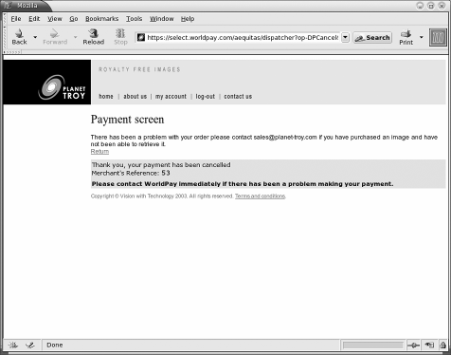
When the workflow runs, it marks the order as complete and fires off the order e-mails you love if you run an online business! Finally, you need to let the customer know the outcome of their transaction. This step is completed by sending a blank template wp_pagelayout.tpl filled with the outcome and necessary details. WorldPay has a surrounding menu structure so we need a new template file to ensure that just the response is sent to WorldPay and not the menu and navigation:
$Result['pagelayout'] = 'wp_pagelayout.tpl';

Reviewing the ini Settings
It is worth taking a moment to review the ini settings in the extension:

File | Description
worldpay.ini.append.php | Stores the password, installation settings, price difference, and WorldPay server ranges
content.ini.append.php | Contains the available extensions and datatypes
design.ini.append | Specifies the design extensions used
layout.ini.append | Specifies the page layout to be used in this extension
module.ini.append | Defines modules available in this extension
workflow.ini.append | Lists the eventtypes used in this project

User Settings
The extension code uses a modified user class. To get the extension to work, you need to make a couple of changes to the user class. The main change is using a matrix datatype for storing the address, because you can never know how many lines an address will be, especially if you consider country differences.
The worldpaytype.php file requires the user class to contain the correct attributes. These are, in order:

Name | Datatype
First name | Text line
Last name | Text line
User account | User account
Company name | Text line
Address | Matrix
Telephone Number | Text line
Country | Country or Text Line

Once the class is changed, you need to ensure that the definition in worldpaytype.php is set up. Here is an example:
File: eventtypes/event/worldpay/worldpay.php define( "VWT_FIRST_NAME", 0 );
define( "VWT_LAST_NAME", 1 ); define( "VWT_USER", 2 ); define( "VWT_COMPANY", 3 ); define( "VWT_ADDRESS", 4 );
define( "VWT_TEL", 5 ); define( "VWT_COUNTRY", 6 );
Note that Country is an unpublished datatype but is based on the ezcountry datatype in http://ez.no/community/contributions/datatypes/datatype_ezcountry. If you do not want to use the Country datatype, you can use a text line for the country instead.
If you do not want to use the main user class and instead create a new class for shop users, read the following online documentation:
http://ez.no/developer/ez_publish_3/documentation/incoming/
tutorial_using_userregister. This document explains some of the issues surrounding users and registration.

Permissions
You need to give shop users access to the WorldPay extension via the roles administration screen (http://www.example.com/role/list). This ensures that they have access to the templates and PHP.
You also need to ensure that the WorldPay servers have permissions for callback. For this you need to allow anonymous users access to the WorldPay extension.

Callback Testing
The one area that can be difficult to test is the callback element of the extension. This is because you need a live URL for the WorldPay server to send back its response. For this reason the wpcheck.html file is included to recreate the WorldPay server callback HTTP POST.
You will need to set the URL to your test server and the Installation ID in the file. Then for each test you carry out you will need to get the following information from your checkout screen. Just remove setTimeout('document.worldpayForm.submit()',0); from your event_worldpay.tpl and it should be a simple matter to cut and paste the variable information into the wpcheck.html file to make it ready for use!
File: doc/wpcheck.html
<input type=hidden name="M_email" value="nospam@visionwt.com">
<input type=hidden name="M_PHPSESSID" value="555rrc54442a048b6152444d38d8b">
<input type=hidden name="M_USERID" value="147">
<input type=hidden name="M_ORDERCREATED" value="1067446530">
All you need to do now is run wpcheck.html from your browser once the checkout workflow has been enabled and you have a quick and safe way of testing callback without the risk of developing on a live URL.

Creating the Category Datatype
The need for a category datatype arose during the development of an e-commerce site using the WorldPay module. In this project, each product belongs to a category that is used for search results. The use of other datatypes such as enumerations and text lines was considered but they have inherent problems. Existing datatypes require that category name changes be made to the class. After publishing the change to the class, eZ publish does not automatically update the affected objects with the new information—this must be performed manually. With the e-commerce site, the number of products/objects was (and still is) considerable and would have incurred a large amount of non-budgeted work each time a category was altered.
The category datatype prevents this situation because the update of the category is moved from the class to the object.

Category Datatype Design
This datatype addresses the main issue of allowing objects to add and remove categories as they wish. The design of this datatype includes the use of a new SQL table and new PHP classes that utilize eZ functions to communicate with the new table.

Setting Up the Extension Environment
The category datatype is actually a separate extension from WorldPay, but from the systems point of view both extensions are active.
First we inform eZ publish that the extension is active, from the main configuration file:
File: settings/site.ini
[ExtensionSettings] ActiveExtensions[]=category
Within the extension, the system must be told about the new datatype and the design directory it uses. For the category include:
File: extension/category/settings/content.ini.append [DataTypeSettings]
ExtensionDirectories[]=category AvailableDataTypes[]=category
For the design directory, include:
File: extension/category/settings/design.ini.append [ExtensionSettings]
DesignExtensions[]=category

The Category Database Table
This new database table will associate categories using the attribute ID, which belongs to the object that the category datatype is part of. A content object attribute ID can be used to find the content object itself, and within the context of the e-commerce system, objects using this datatype are classed as products.
You need to create the table in the MySQL file using the provided SQL create table script:
File: extension/category/update/mysql/category.sql CREATE TABLE category_information
(
id integer NOT NULL auto_increment, category varchar(255) NOT NULL,
objectattribute_id integer NOT NULL default '0', PRIMARY KEY (id)
);
In this table the column id is set as the primary key, ensuring that each new row will be unique. The category column is a string with a maximum length of 255 characters. The final column, objectattribute_id, is used to record the identifier of the attribute that corresponds with the datatype created, and the object it resides within.
When a category is added to this table, it exists as a row within the database. The following table shows some sample content for this database table:

id | Category | objectattribute_id
53 | Nature | 159
54 | Work | 159
55 | Miscellaneous | 159
56 | Miscellaneous | 165
In this table there are three categories associated with attribute 159. Attribute 165 contains only one category, but it is the same as the previous attribute. This structure allows each product to update the categories associated with it.
Please refer to your database documentation to learn how to add this table to your eZ publish system.

Database Communication
The eZ publish system defines a database object as a persistent object. Utility classes are provided that perform the mechanics of communicating with the database at an abstract level; this allows the user to ignore the type of database being used. By extending the parent eZPersistentObject class it is possible to define variables that correspond to columns in the category table on a one-to-one basis.
The category PHP file created for this purpose is very long and, for the purpose of this discussion, only the function names will be shown. Please refer to the code download to see the complete code.
File: extension/category/lib/category_db.php
class PersistentCategory extends eZPersistentObject
{
function PersistentCategory( $row ) function &definition()
function &remove( $id )
function &fetch( $id, $asObject = true )
function &fetchByCategory( $category, $asObject = true ) function &fetchByCategoryAndAttribute( $category,
$objectattribute_id,
$asObject = true )
function &fetchByAttribute( $objectattribute_id, $asObject = true ) function &fetchAllCategories( $asObject = true )
function &create ( $category, $objectAttributeID ) function hasAttribute( $name )
function &attribute( $name ) var $ID;
var $Category;
var $ObjectAttributeID;
}
The definition() function is the key to the database communication. Each persistent object implementation must implement this with a definition that matches variables to columns. With this in place, the fetch() functions can query the database. For example, the fetchByCategoryAndAttribute() function will return a database object that matches the category and attribute ID values that are passed in as parameters.
The functions create() and remove() respectively create and delete a database row. The attribute() function provides template access to the persistent object, which will be discussed later. The variables $ID, $Category, and $ObjectAttributeID correspond to the columns of the database tables.

Category Discussion
In addition to the regular Categorytype class for this datatype, there is an additional PHP class named Category that is used to fetch and store category information from the database. There will be no use of class attributes for this datatype, but if you feel a default value is needed, then by all means add your own.
Normally the fetching and storing of user input is performed by accessing the content object attribute or the content class attribute. Instead, here the content of the attribute is set to the value of the instantiated category.php object. For example:
File: extension/category/datatypes/category/categorytype.php function fetchObjectAttributeHTTPInput( &$http, $base,
&$contentObjectAttribute )
{
if ( $http->hasPostVariable( $base . "_Category_data_"
.$contentObjectAttribute->attribute( "id" ) ) )
{
$data =& $http->postVariable( $base . "_Category_data_"
.$contentObjectAttribute->attribute( "id" ) );
$category = new Category();
// parse the input data into the category array
$categories = explode(",",$data);
// add categories to the category class for later storage
$category->initialiseCategory( $categories );
// inform the content object of this content.
$contentObjectAttribute->setContent( $category ); return true;
}
return false;
}
The information passed in from the template is first processed through the PHP explode() function, so that multiple categories can be entered by means of a single comma-delimited string. Thus, a string such as "nature, work, miscellaneous" will be split into three different categories.
The Category class is initialized with this array and the content of the attribute is set with this class. When the system invokes the storeObjectAttribute() function, the categorytype will try to store the new information through the use of the new class:
File: extension/category/datatypes/category/categorytype.php function storeObjectAttribute( &$contentObjectattribute )
{
$category =& $contentObjectattribute->content(); if ( is_object( $category ) )
{
$category->store( $contentObjectattribute );
}
}
The category store() function performs a few simple checks before entering the information into the database:
- If the category already exists for the attribute, there is no need to re-enter it.
- If the category is not present, it is entered as expected.
- If the database contains categories that are not part of the input list, they are removed.
File: extension/category/datatypes/category/category.php function store( &$attribute )
{
// Assign the attribute id
$attributeId = $attribute->attribute( 'id' );
// Get present categories for the attribute
$existingCategories =&
PersistentCategory::fetchByAttribute($attributeId);
// Find out which categories to remove, if any foreach ( $existingCategories as $existingCategory )
{
// Check whether the current category is part of the new list if ( !in_array($existingCategory->attribute('category'),
$this->CategoryArray) )
{
PersistentCategory::remove($existingCategory-
>attribute('id'));
}
}
// Find which categories to add.
foreach ($this->CategoryArray as $newCategory)
{
$newCategoryObject =&
PersistentCategory::fetchByCategoryAndAttribute($newCategory,
$attributeId);
// Test if the present category exists. If not add it as new. if (!is_object($newCategoryObject))
{
$createNewCategoryObject =&
PersistentCategory::create($newCategory,
$attributeId);
$createNewCategoryObject->store();
}
}
}
The use of the Category class for the content for the attribute also allows the template to access it. This class implements the following API for attributes:
File: extension/category/datatypes/category/category.php function hasAttribute( $name )
function &attribute( $name )
This associates attributes that a user has access to within a template to functions that return the requested information. For the category class, the category_string attribute returns a string listing the categories the attribute belongs to in a comma-delimited fashion. It does this by querying the database for categories belonging to a particular attribute ID using the function fetchByAttribute(). Once it has this list, it uses the PHP implode() function to concatenate the list into a single, comma-delimited string:
File: extension/category/datatypes/category/category.php function &categoriesString()
{
return implode( ', ', $this->CategoryArray );
}

Category Templates
Two templates are required for this datatype. One is used to edit the datatype within a content object:
File: extension/category/design/standard/templates/content/datatype/
edit/category.tpl
{let name=concat("ContentObjectAttribute_Category_data_",$attribute.id)
value=$attribute.content.category_string}
<input class="box" type="text" size="70" name="{$name}" value="{$value|wash(xhtml)}" />
{/let}
The other is used to display the categories as a simple string:
File: extension/category/design/standard/templates/content
/datatype/view/category.tpl
{$attribute.content.category_string|wash(xhtml)}

The Category Datatype in Action
Now that we've seen the construction of the Category datatype, let's have a quick look at it in action before we move on. The following screenshots show how you can edit the class and object, and then view the object.

Editing the Class
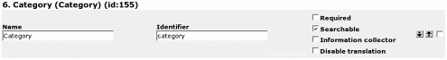

Editing the Object

Viewing the Object
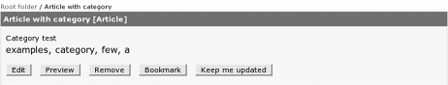

Integrating Existing Code with eZ publish
One of the questions faced by developers is "Do I create a new application or hack an existing one?" There are pros and cons for both, but since you're reading this book it is assumed you prefer to use a solid base and then customize it, rather than working on an entire system from scratch. This philosophy can continue into your extension writing as you can use the skills gained in previous chapters to build links to other applications. If you plan to do this, read on.
Bear in mind that when you link to another application, you immediately double the complexity of your application and its support requirement. It is a lot of work to maintain and update an eZ publish site with demanding customers; if you also have to update and maintain other applications and any middleware between them, it could prove to be too much!
When choosing to bridge to another application, ensure that it is not faster to write routines or customize some of the native functionality in eZ publish than to link to a best- of-breed package for features such as forums. This may be the case when choosing to integrate an existing best-of-breed forum package like phpBB with eZ publish.
With eZ publish and PHP you can pretty much integrate with anything—after all eZ publish is a development framework and as such perfectly extensible. As you will have read in previous chapters, you can make individual datatypes, eventtypes, and modules, and the WorldPay extension is an example of integrating a supplier's existing code with eZ publish. This means you are well equipped to handle all that is thrown at you!

Making a Bridge to External Applications
External applications could include operating systems, PHP applications, compiled applications—pretty much anything! If you can connect to the application from your system, for example using TCP, UDP, Unix sockets, or named pipes, then you can bridge to it using eZ publish. Some common examples for integration are:
- External systems via SOAP
- RSS feeds
- Databases: MySQL, dBase, Oracle
- Accounts systems
- Application service providers
- Legacy systems
- E-mail
- Open instant messaging systems, such as Jabber
- .NET integration
These are just a few examples of the types of systems you can integrate with. The biggest problem you will face is that some systems do not want you to integrate with them. This is because they have agreements with other proprietary systems or partners that want money before you can integrate. They may require you buy their 'integration add-on' before you can connect to their system. It is worth checking the costs of any add-ons you may need before you start out, as you may find them prohibitively expensive. The good news is that most of the add-ons for PHP are free so again it is worth staying with open source solutions if you can.
Let's take a couple of the items from the list and explore the possibilities.

Strategies
You will come across several strategies when working with external systems—the good news is that they are not restricted to eZ publish, and relate to all systems that need to get information from an external source. If you have an application on your desktop that goes to the Internet several times a day to collect your e-mail via POP3 you are using one.
With strategies, you have two basic choices:
- Import data to a local database
- Connect to external data for every request
The first choice is to take the external data and import it into your eZ publish database environment. This is a good choice if the link to the external site is unreliable or slow, or you are taking information from an external source that does not allow connection from the Internet. One example of this could be a site that uses information from a legacy system such as an ERP system. This would mean that you get the prices of products updated each day via a text file upload. You would have a routine that would run once the file is uploaded and perform the following functions:
- Check that the file has been uploaded
- Check the validity of the data
- Backup existing data prior to import
- Import the data into a special price table or update the product prices directly
- Update logs with the results of the job
As you can see from the fourth item in the list, there are two options. The first is to create a new table and store the information in it. This would require you to write a new datatype that would replace the current price field so that it would use the product ID in the product class to find the correct price in the new table.
Alternatively, you could update the product prices directly when the file is imported. This would involve a modification to the import routine so that it searches for the products and replaces the prices with the prices from the new import file.
Of course, you can increase this functionality by adding synchronization routines so you only upload changed products, but synchronization is a subject beyond the scope of this chapter.

Who Am I?
As part of your bridging extension, you will need to tell the external server who you are. This can be done on a trusted server basis where the user ID and password are stored within an ini file and used to authenticate you. Interestingly, this is how eZ publish works when it uses authenticated SMTP and also when it talks to your database server. Review site.ini to see the default settings.

Authentication
Before you read the authentication and security sections, bear in mind that millions of people send their user IDs and passwords over the Internet every day when they connect to e-mail servers via POP3 and don't give it a second thought.
These e-mail accounts probably contain just as sensitive information as that in accounting systems, but it is a risk people are willing to take for convenience.
Note that if you only receive/send encrypted e-mail or use SSL to talk to your mail server account, your connection is secure.
Your development budget should include security expenses. Don't take security for granted just because other people may ignore it.
If you want to use your eZ publish system as the main authentication point, you need to ensure that the external application can connect to eZ publish and check the status of the user. The following code can be used in an eZ publish extension to create the current user and session ID that can be passed to the external application:
// User id
$user =& eZUser::currentUser();
$user_id = $user->attribute( "contentobject_id" );
// Session ID
$mysessionid=eZHTTPTool::getSessionKey();
This information could then be used by the external application to get the user-relevant information for that user and either log in or pre-fill information.
Placing the eZ publish server into an existing environment means there is likely to be an existing, central method for managing user information. This method may be LDAP, Kerberos, Microsoft Windows domain controller, or another method.
To enable greater interoperability, eZ publish has opened up the login handler so you are able to write your own custom handlers. As mentioned at the end of the previous chapter,
these can work as a central update mechanism such as LDAP or a login replacement such as text file handlers. In either case, you will still need the user set up in the eZ publish system.
The issue here is that any authentication you perform must work and be secure and reliable. Now depending on the information you are securing, it can be less stringent in its checking but must still be reliable. For this reason you can use a token-based system such as Kerberos (http://web.mit.edu/kerberos/www/#what_is). Unfortunately, Kerberos integration with eZ publish is not yet available so it is probably better to go for a shared authentication point such as an LDAP file.
LDAP and eZ publish login methods are great, but they only allow users to log into a single system. They do not allow a user to move from system to system without having to login again. This is a problem if you have many systems that a user needs to access.

Single Sign-On
With this sign-on mechanism, upon successful authentication with eZ publish, the user's browser is presented with a cookie for the eZ publish site. Along with the cookie, the user's browser is redirected to an authentication application on the external server. This application validates the URL details sent by the user's browser and assigns the user an appropriate external single sign-on cookie, then redirects the user's browser to the eZ publish site.
The advantage of this method is that users are unaware that they have been authenticated over multiple servers, and see only a single login event.
The disadvantages of this approach are:
- Application code has to be written on the external server to provide an authenticator class to accept and validate URLs sent during redirection.
- If existing authentication methods on the external server are required to continue operating, the authenticator class must exist as a separate application and be configured to use its single sign-on facility.
- It requires cookies to be enabled on the client browser, which cannot always be guaranteed.
- A mechanism is required to synchronize the user database between eZ publish and external servers.

Variations
If a variation of the sign-on method is needed, this could take the shape of a form that is presented to the user from the external server in the following steps:
- You present a login form on your eZ publish site.
- The user submits their user ID and password on the form.
- The form posts to the external server using a form-based external authenticator.
- On success, the external application gives the users a normal external session authentication cookie. They're redirected back to eZ publish with some authentication token on the URL, which you use to initiate an eZ publish session.
- On failure, you bounce back to an eZ publish failure page.
So, there are various ways to handle authentication. In the end it is a choice that needs to be made on a project-by-project basis.

Sharing Information
When it comes to sharing information, you want to ensure that enough information is stored within your object (article, file, or even video clip) to enable it to be traced, should the system you are sharing with have a request from a user for updated or more information. An example of this is when you write a document about a particular version of software, and a reader wants to know if you have updated it for the latest version.
Fortunately, this work has already been completed by a group called the Dublin Core Metadata Initiative (http://www.dublincore.org/). They have a common set of items that are used by governments and companies alike to help identify the information they store. The UK Government currently uses the simple Dublin Core as the basis of its metadata standards (http://www.e-envoy.gov.uk/Resources/Guidelines/fs/en).
The metadata used by the UK government falls into the following sets:

Item | Usage
Creator, Date, Subject.Category, Title | Mandatory
Accessibility, Identifier, Publisher | Mandatory if applicable
Coverage, Language | Recommended
The definitions of items can be seen on the e-envoy website. Notice that all the information is either available by default, such as Date and Title, or can be added into the class definition by the developer. This shows that eZ publish can quite happily live in the public sector and fulfill the requirements that governments have for data definition.
This information could be made available via a SOAP interface and in the HTML meta tags at the top of the document. This enables you to correctly mark up information to be shared with other systems.

Communicating with Google
SOAP is a protocol that provides a standard method of communicating between applications regardless of what they are written in. This makes it perfect for us as we can communicate with anyone using the pre-built and ready-to-use tools within eZ publish.
The following example builds on the examples in the previous chapter to get information from a search engine, Google. You will use the eZ publish SOAP client to communicate with Google and retrieve the results to the search and display them in the browser.
The following example uses the eZ libraries lib/ezsoap/classes/ezsoapclient.php and lib/ezsoap/classes/ezsoaprequest.php to communicate with the Google search engine.
In order to use the following Google-based example, you will need to get your API key from http://www.google.com/apis/.
To see our example in action you need to have eZ publish installed and working, and then add a new virtual host to your setup, which should resemble something like this:
<VirtualHost *:80>
<Directory /my/path/to/ez>
Options FollowSymLinks Indexes ExecCGI AllowOverride None
</Directory>
RewriteEngine On
RewriteRule !\.(gif|css|jpg|png|ico|js)$ /my/path/to/ez/google.php
ServerAdmin admin@mysite.com DocumentRoot /my/path/to/ez ServerName mysite.myserver.com
</VirtualHost>
This example gives you that "instant fix" that you need to see something working well and is immediately useful. Save the following example as google.php in your project root directory.
The first few lines just create the HTML required to gather and display the request from Google.
<html xmlns="http://www.w3.org/1999/xhtml" xml:lang="en" lang="en">
<head>
<title>My Google search</title>
</head>
<body>
<h2>Google SOAP search</h2>
<form method="get">
<input type="text" size="40" name="q" value="<? print( $q ); ?>" />
<input type="submit" value="Search" />
</form>
Next, we include the required eZ libraries for working with SOAP:
<?php
include_once( "lib/ezsoap/classes/ezsoapclient.php" ); include_once( "lib/ezsoap/classes/ezsoaprequest.php" );
The first real coding step is to create the eZ SOAP object and the eZ SOAP response object. This is to prepare the client and request object so they are ready to receive the parameters and send the request to Google:
// Instantiate a client object for communication with Google
$client = new eZSOAPClient( "api.google.com",
"/search/beta2" );
// Create a new request object
$request = new eZSOAPRequest( "doGoogleSearch",
"urn:GoogleSearch" );
Now we retrieve the query text, and provided our query is non-empty, we can begin to create our request. We load our request object with the parameters that Google needs for its search API. You can find more information on the parameters used here on the Google API website.
// Fetch the query text from HTTP GET
$q = $_GET['q'];
// Check for a non-empty query if ( $q != "" )
{
// Add parameter, key. You can get your own key from Google
$request->addParameter( "key",
"add your key here from http://www.google.com/apis/" );
// Send the query text as a parameter
$request->addParameter( "q", $q );
// Show the first results
$request->addParameter( "start", 0 );
// Show maximum 10 results at the time
$request->addParameter( "maxResults", 10 );
// Send misc. default parameters
$request->addParameter( "filter", true );
$request->addParameter( "restrict", "" );
$request->addParameter( "safesearch", false );
$request->addParameter( "lr", "" );
$request->addParameter( "ie", "latin1" );
$request->addParameter( "oe", "latin1" );
The next step is to send the request. The eZ SOAP libraries will take the information you have given through the addParamter() function and create an XML request that is then sent via HTTP to the Google servers:
// Send the request to Google
$response =& $client->send( $request );
If the SOAP server returns a fault, it will be picked up here and the fault code displayed:
// Check for SOAP fault
if ( $response->isFault() )
{
// Print the fault
print( "SOAP fault: " . $response->faultCode(). " - " .
$response->faultString() . "" );
}
else
{
If the POST to the SOAP server is a success, we will set $value to the results returned by Google:
// All went ok, fetch the value from google.
$value =& $response->value();
This information is stored as an array and will need to be broken apart to display the results. This information is then formatted so that a page of human-readable HTML can be displayed.
// Print number of pages found print( "<p>Pages found: " .
$value["estimatedTotalResultsCount"] .
".</p>" );
// Print all search results
$searchResult = $value["resultElements"]; foreach ( $searchResult as $item )
{
$snippet = $item["snippet"];
$size = $item["cachedSize"];
print( "<font color='green'>" . $item["title"] .
"</font><br/>" );
print( "$snippet<br>" );
$url = $item["URL"];
print( "<a href='$url'>$url</a> $size<br/><br/>" );
}
}
}
?>
</body>
</html>
If all has gone well with your example, the following page will be served:

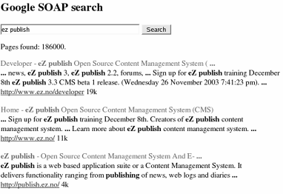

Modifying Existing Code
You can truly integrate eZ publish with your application by making your application a native eZ publish extension. This means that it will need to be in PHP, but it is the best way to go and even better if it is a new project. You can use all the wrapper features of eZ publish such as authentication, content management, caching and so on, so all you do is concentrate on the core functionality of your application itself.

Summary
In this chapter, we looked at various methods of extending eZ publish. You can increase functionality via routines your have written yourself. You can integrate into the very core of eZ publish, enabling you to make your eZ publish site everything you want it to be.
The world is changing and not every site can offer the services and requirements for all users. For this reason, integrating seamlessly with external applications is a must. This ability is given to us via the SOAP. Using eZ publish, you can communicate with anyone using a common SOAP interface. We showed eZ credentials in the Google example where you are able to retrieve search results and use them as you wish. However, this is just the beginning, as more and more services come online you will be able to increase the functionality of your site in ways that were previously impossible. One example of this is to look at the number of retailers on the web that are starting to open up their environment to other sites so that all may benefit. One example of this is Amazon, which is opening up its services via a SOAP interface. Using eZ publish you are well placed to benefit from these technologies as they mature.

7

Deploying eZ publish

In this chapter, we will look at some of the strategies and techniques useful for deploying eZ publish projects. This chapter is not designed to explain how to install a server, but instead focuses on what eZ publish needs in order to work well in your deployment environment. Installing a server is a large subject in its own right and cannot be covered here in one chapter.
Although eZ publish runs quite well on *BSD, Macintosh, and MS Windows environments, it is most widely deployed in its Linux flavor. For this reason, we will focus on deploying eZ publish to a Linux environment.
This chapter will explain how to modify your server environment for it to work well with eZ publish 3 and greater.

Define Your Hosting Requirements
Before you deploy an eZ publish solution, make a note of all the hosting requirements. It is worth spending a little time at the start of development to ensure that problems do not occur at the deployment stage.
Unforeseen problems occurring at deployment equate directly to increased costs in your project.
Described below are a number of areas that need to be reviewed to ensure that you have a good picture of the deployment needs, prior to parting with your money for a hosting environment.

Number of Visitors
How many users will be visiting your site? You need to examine your current statistics or marketing plan to get a rough idea of whether hundreds, thousands, or millions of unique visitors will be visiting your site every month. At the very least, you need to make an
educated guess at this number, as the power required of the hosting server depends on this, and will indeed decide whether you need more than one machine to support your user base.
The next task is to find out how often they will be visiting—whether they visit once an hour, day, week, or month. It is good practice to overestimate this figure to ensure that your site visitors get a good quality of service. Remember that traffic will not always be evenly distributed, and is likely to peak to match the site's marketing initiatives.

User requirements
Users per hour
Concurrent users
Total users
This information will be useful if you intend to enable user accounts. The more users you have, the more disk space you will need to store their information. eZ publish 3 test installations take around 70MB of file system space and 2MB of database space. Add to this the amount of space you will need for caching page and image files and the required space soon adds up!

System requirements
File system size
Database size
Bandwidth requirements
The price of bandwidth can be a real variable with ISPs, and cannot be avoided! You could ask your ISPs to fix the bandwidth available to your site, but then you risk disappointing your visitors. So, you will need to get a sympathetic ISP that will allow you to burst traffic to your site to allow for the occasions where lots of visitors come to your site at once. It is worth getting a firm idea of the costs that this extra bandwidth will cost you, ahead of time, to help plan for these additional costs.

Security Needs
You should review the information that you will store on the site and decide on what level of security is required to protect this information. Generally, the more security you require, the more the system will cost to install and maintain.
In an ideal world, you could ensure that your site is secured to the best of the ISP's or your ability. In the real world, budgets dictate the security levels on a site. The more money you have, the better is the system administrator and time made available to you.
The good thing is that you can choose the level of security according the type of content you are going to host.
The following content types are listed according to their typical level of importance:
- Credit-card/Medical details
- Personal details
- Articles
- News
Credit-card details usually constitute the most valuable content, but this is not necessarily true. For example, the news section could contain news for a product launch that is confidential, and if released could cause serious problems. For this reason, you need to evaluate each type of content from a company perspective to protect yourself adequately, and then budget according to that level of the risk.
The more sensitive the information stored, the more secure you need to make it.
There may already be guidelines on the level of security you need to implement. Take the time to review the requirements of your country so you do not break any local laws.
Once you have decided on the security mechanism, you need to review the type of access required to the system. In this area, there are generally three types:
  - Internet: Open to all
  - Extranet: Open to authenticated users via the Internet
  - Intranet (Closed system): Open only to internal local users
As the phenomenon of individuals working from home and remote offices is now widespread, few business applications can be seen as truly Intranet-only applications, so we are actually talking about authentication and authorization for our sites.
For unprotected files, you only need to ensure that the information is valid and only updated by authorized editors.
For protected information, you need to ensure that only authorized users can edit and see the files. For this you need to use the eZ publish authentication system by assigning roles for people to edit and view the information.
To increase the level of security within eZ publish:
  - Ensure that the information sent to the server cannot be read by a third party. This is normally achieved using Secure Socket Layer (SSL).
  - Ensure that the users are who they say they are. The user name and password are already set up, but if this is not sufficient, you need to implement a digital identity system such as a Public Key Infrastructure (PKI) that will help identify a user wishing to log in to the eZ system.
  - Implement MD5 or SHA security to transmit the password when logging in to the eZ publish site. This will make it harder for an intruder to sniff passwords.

Reporting Requirements
Decide on the level of reporting you want from the server. Fortunately, eZ publish provides you with information about the content searches that have been made on your site. For any further information, you need to use third-party tools provided by your web server or ISP.
The following information is usually required:
  - Web statistics: Number of users
  - Server performance: Speed of machine, number of concurrent users
  - Bandwidth usage: Amount of bandwidth your site uses
Web statistics are probably the most common and widespread requirement for reports, as these enable you to gather information about how many times your pages are being accessed, and by whom. As the usability of the reports created varies from package to package, it is worth reviewing the package used to create the statistics to ensure that it meets your needs.
Some common open source web access analyzer packages are:
  - Awstats (http://awstats.sourceforge.net)
  - Webalizer (http://www.mrunix.net/webalizer)
  - Analog (http://analog.sourceforge.net)

Budget
You will probably have a good idea of the budget available for hosting, but the general rule is that the more you want, the more you pay. Although the hardware and support costs will be fixed, it is unlikely that the bandwidth costs will be. Always reserve a portion of your budget for bandwidth costs as they can rocket on a highly popular site.

Time Limits
Define the amount of time you have to prepare the deployment environment and the amount of time you have to deploy the finished system. You can use the following table:

Time
Live date
Time to deploy
Deployment environment ready date

Shared or Dedicated
Once you have defined your needs, you need to figure out whether they will be best fulfilled by a dedicated server environment or a shared one. There is a large price difference between a shared and a dedicated hosting service; a shared environment is much more economical.
Whether you use a shared or dedicated environment, you will need to ensure that the environment has the correct software available. The general rule of thumb is that if your deployment environment has Apache/IIS, PHP, and MySQL/PostgreSQL running on it already, you will probably be able to run eZ publish 3 without problems. That said, some shared environments have peculiar setups that have been created to provide extra security; these can sometimes include routines that interfere with eZ publish's smooth running. In this situation you may find that eZ publish does not run properly.
It is worth running a check on the shared server before parting with your hard earned money to be safe. You can use the eZ publish Setup Wizard that we saw in the first chapter to run a quick test. The Setup Wizard will take you through the whole process of getting a test eZ publish site ready.
If the setup screen does not appear, you will need to change the site.ini setting.
[SiteAccessSettings] CheckValidity=true
This will cause eZ to run the setup test the next time you point your browser at it. You can test most functions of eZ publish by choosing one of the inbuilt demo sites.
From an eZ publish point of view, you generally only need a web interface to complete all of the operations needed. This means you can survive with a shared service that does not give you command-line access via SSH, as long as you have FTP and HTTP access. The following is a quick checklist for a shared service:
  - Speed of service
  - Number of sites you share the server with
  - Cost of extra bandwidth
eZ publish can take its toll on a server, so ensure that the shared server has enough power for all the eZ publish sites it is hosting.

Is My Server Powerful Enough?
Whether you go for a dedicated or a shared server, you need to ensure that the server is powerful enough for your needs. Generally, eZ publish is heavy on CPU and memory usage, so it is worth ensuring your server has enough memory and CPU power for the number of users you envisage visiting your site.
You can test the system by running tests based on the number of users and the amount of information you will be storing as described in the Define Your Hosting Requirements section.
Even if you choose a dedicated solution, some ISPs will dictate the type of server you are able to use. If they do, ensure that they give you statistics for the server, including a test of how it works under load, running an eZ publish site. Ask your hardware provider the following questions:
  - Model name: What server are they selling? Is it a known brand? If not, details about spares and repairs.
  - Hard disk: What is the size of the disks; what RAID do they use? What is the space available for the database and for data? How fast are the disks?
  - CPU: How many CPUs does the server use and what are their speeds?
  - UPS: What is the battery life? Will the UPS be pre-configured for you?
  - Operating system: Is this configured so you can gain SSH access?
  - Upgrade paths: What are the options and prices, if you need to increase the number of machines or machine power for your site?
One way to measure the server's capabilities is to run tests. A good testing tool is Siege, which enables you to run speed tests for concurrent users. Try loading up a test site and run Siege increasing the number of current users until the server slows to a crawl. You will then be able to find the limits of your server.
Find out more about Siege from http://www.joedog.org/siege/index.php.
Using Siege is straightforward; the following example simulates two users hitting a dummy site for an hour:
>siege -uhttp://www.example.com -v -c2 -t1h -l
This example tests the server for 25 concurrent users:
>siege -uhttp://www.example.com -v -c25 -t1h -l
To ensure that the siege tests run correctly, you will need to run the test from a box on the same LAN, otherwise you will be limited by the bandwidth available on your Internet connection.
If you are testing on a live site, this will completely disrupt your stats for the site. It may be worth changing your statistics log location for this test.
Information about eZ publish tests can be found at:
http://ez.no/community/news/ez_publish_3_enterprise_setup_test

Documentation
Ensure that you have full and up-to-date documentation for the server, so that you have all the information you need to maintain or recover information in case of a disaster.
We will now discuss some of the areas to cover in your documentation.

How and When to Update the Documentation
This document will be a living document, so a guide on how to update it and where it is stored is a must. This information ensures that everybody who needs to update the documentation understands their responsibilities.

Contact Details
In the event of a problem, you will need to know who to contact, so that valuable minutes are not lost trying to find the number and the name of the right person at your ISP or support company.
Details should include whom you need to contact for each part of the system: your ISP, hardware supplier, and support personnel.

Location
This is the address and physical location of your where your hardware is located. It can be useful to take a photograph of your server too, for easy identification should the need arise.

Hardware
This is a complete specification of the hardware, CPU, memory, and hard disk configuration. You will need this during replacements and upgrades.

Operating System
This is the operating system your server is running, and its version.

Software
This is a complete list of the software installed on your server, with the license details. You should also note the location of any CDs or required installation media.

Patching Process
A log of the patches with the name of the administrator who applied them should be kept. This will help you rebuild the server (in the event of a failure), or troubleshoot (should things not work), as you can identify the last patch applied to the server. Some distribution providers, such as RedHat, provide tools that keep this information for you.

DNS Information
This is a list of the URLs used by the site with their expiry or renewal dates. It is worth keeping any IP mapping from DNS to IP in this section as well.

TCP/IP Information
Keep a log of all the IP addresses used by the machine. You can retrieve some of this information by running the ifconfig command as root. It is worth asking your ISP or administrator for a network map of your environment so you can see how their environment fits together.

Access Control
A list of all the authorized users for your system, along with their system privileges should be kept. This should be reviewed at regular intervals, especially when there are personnel changes.

Upgrade Roadmap
If you hate surprises, you should create scenarios where traffic to your site grows and you require extra bandwidth, CPU power, or memory. Use these projections to plan your upgrade path and agree on prices with your ISP. This way, you will get a better price than if you wait until you have no time to negotiate!

Disaster Recovery
Create a detailed plan of how you will recover the server or service should there be a problem. This plan should be printed out and stored at your current location and at an off-site location. Inform the people responsible for it of its location and keep it updated.

Preparing the Linux Environment
Installing eZ publish on Linux is like cooking a good pizza. If the base is firm and well formed, you are unlikely to get many problems. For this reason, it is worth spending time to choose the flavor of *NIX you should work on.
eZ publish is supported on the Linux, Solaris, HP-UX, and FreeBSD UNIX systems. Other *NIX systems may work as well. In addition, eZ publish has been tested by the community on Mandrake 9.x and RedHat ES U1.
For more information on available Linux distributions, take a look at the Distrowatch website at http://www.distrowatch.com/.
eZ publish comes with complete install solutions for RedHat 7.3, 8.0, 9.0, and FreeBSD to get your test environment up and running.
Although these installers will get your test environment going, do not use them for deploying your live site: they are not designed for this and will give you problems.
If you currently use one of the full system installers, you should review all of the security and installation settings for the packages it installs, to ensure they will run efficiently and securely.
Given that eZ publish runs on most Linux bases, it is worth finding a good base that fulfils your needs and will be supported for patches and security fixes. You will not want to be changing the environment every six months unless you have plenty of time and money on your hands. This is relevant, as RedHat is removing support for RedHat 7, 8, and 9, so these are not good choices unless you want to pay for its enterprise systems.
It is worth configuring eZ publish locally before you roll out to a live deployment box. This will let you know before you part with any money if you have the correct skills to deploy a live server.
There is one simple rule when installing and configuring deployment servers:
If in doubt, don't go live.
Installing on an Internet-accessible box is very different from installing on a local area network box, as the Internet box will get compromised extremely quickly. There are lots of *NIX security books available to help you, but you may want to run some local tests such as Tripwire or root kit checkers (http://www.chkrootkit.org/#related_links) to help achieve some peace of mind.
If you have a distribution that has all the components you need supplied as packages, you will not need to compile any packages. However, if you are working from a distribution that does not meet all your needs, you may need to compile one or all of your packages. Compiling does have its advantages, and enables you to ensure the application is tuned for your environment.
In this section we will walk through the main parts of the environment, and see how to configure them appropriately for a production eZ environment.

Apache
Apache is the web server of choice for the Linux platform and is at the time of writing going through a transition from version 1 to version 2. We will deal with version 1 as version 2 has not yet been approved for production purposes by the PHP development team. There are reports of eZ publish working well with Apache 2, but until it is off the experimental list from PHP, it is a risk.
For more information on the PHP and Apache 2 situation, take a look at
http://www.php.net/manual/en/install.apache2.php.
If your distribution does not have the version of Apache you need, you can compile from source. This can be done in two ways. In either case you should uninstall the current
version of Apache before you continue. The first and long winded way is to define each of the modules you need:
./configure --sysconfdir=/etc/httpd/conf –prefix=/usr/lib/apache -- enable-module=env --enable-shared=env --enable-module=userdir -- enable-shared=userdir --enable-module=usertrack --enable- shared=usertrack --enable-module=auth_anon --enable-shared=auth_anon
--enable-module=auth --enable-shared=auth --enable-module=alias -- enable-shared=alias --enable-module=vhost_alias --enable- shared=vhost_alias --enable-module=rewrite --enable-shared=rewrite -- enable-module=speling --enable-shared=speling --enable- module=log_config --enable-shared=log_config --enable- module=log_agent --enable-shared=log_agent --enable- module=log_referer --enable-shared=log_referer --enable-module=dir -- enable-shared=dir --enable-module=access --enable-shared=access -- enable-module=so --enable-module=ssl --enable-shared=ssl --enable- rule=EAPI
The second and shorter way is to compile all of them:
./configure --sysconfdir=/etc/httpd/conf --prefix=/usr/lib/apache -- enable-module=all --enable-shared=max--enable-rule=EAPI
Once you have run the configure command, you need to compile and install the package using the following commands:
make
make install
Now that the package is installed, it is a good idea to check the installation with a simple HTML (not PHP) page. Once you have confirmed that Apache works, you are ready to install PHP.
You will need to configure your httpd.conf file to ensure that Apache is set up to view the file. This is not covered here. For more information on installing Apache, visit http://httpd.apache.org/docs/install.html.

PHP
You may well need to compile PHP, as problems have been reported using eZ publish with PHP versions below 4.2.3. The good news is that compiling PHP is very simple. The following configure command contains the features you will need for most eZ publish sites:
./configure --with-apxs=/usr/lib/apache/bin/apxs --with- mysql=shared,/usr --with-ttf --with-gd -enable-gd-native-ttf -- enable-trans-sid --enable-inline-optimization --includedir=/usr -- with-zlib=/usr --with-layout=GNU --prefix=/usr --exec-prefix=/usr -- bindir=/usr/bin --with-openssl --with-xml --with-config-file- path=/etc --with-layout=GNU --enable-mbstring --with-jpeg-dir
Once the configure command has successfully run, you need to reissue the following commands:
>make
>make install
The configure string contains all the options required for your standard eZ publish site. If you require more, you can, of course, modify the compilation.
If you are compiling PHP, consider joining the QA program (http://qa.php.net/), as this will not only help the PHP project but also help you find out if there are any problems with your environment. It will also help you fix any bugs you may encounter. Visit http://uk.php.net/manual/en/installation.php for more information on installing PHP.

Database (MySQL/PostgreSQL)
eZ publish works with both MySQL and PostgreSQL. If you need to compile from source, you can find more information on how to do so on their sites. However, it is preferable to use the RPMs provided by these providers.
In this section we will review how to set up the most commonly used database for eZ publish: MySQL.
The first step is to install MySQL from source or via the RPMs from the MySQL site. Once MySQL is installed, you can create an empty MySQL database via the following command:
>mysqladmin -uroot -p create test
Then access the MySQL database and grant access:
>mysql -uroot -p
mysql>grant all on test.* to myuser@localhost identified by 'xxxxx';
Now that the environment is ready, you can restore the data from your backup:
>mysql -umyuser -p test < test-backup.sql
It is tempting to store the password on the command line: mysql -uroot -pgod—don't do this. If you do, all your passwords will be faithfully stored in .bash_history, and any user with access could run:
>sudo cat /home/myuser/.bash_history > /home/baduser/myusers-history
to gain access to the root MySQL password, or run:
>history | grep mysqladmin
if your machine is left unattended.
If you require your site to be UTF-8 (UNICODE) compatible, you will need to convert the character set used by the MyISAM files. To do this, you need to shut down the MySQL database and run:
>myisamchk -r -q --set-character-set=utf-8
/path/to/mysql_data_files/mydatabase/ez*.MYI
This database is now ready for UTF-8 data when you install the eZ publish data.
For more information on MySQL and PostgreSQL, visit http://www.mysql.com/ and
http://www.postgresql.com/ respectively.
Two graphics engines can be used in eZ publish: GD and ImageMagick. These have been covered in Chapter 1.

GD Graphics library
The advantage of using GD is that since PHP 4.3.0, GD has been packaged directly into the PHP source code, making it always available. For more information on GD, visit http://www.boutell.com/gd/.

ImageMagick
ImageMagick is a command-line graphics engine to manipulate images. It can normally be found as part of the big Linux distributions and is available on Windows. For more information on ImageMagick, visit http://www.imagemagick.com/.

Cron Jobs
eZ publish 3 has a variety of jobs that need to be run outside of normal operations. These include:
- Workflow
- Notification
- Linkcheck
- Unpublish
- RSS import
Although these routines can be run from the admin interface, it is usually more convenient to run them via a cron job.
Before you let the cron job loose, it's worth checking the job first from the command line.
>cd /path/to/ez/project
>php -C runcronjobs.php
This will let you know that the routine runs correctly. If it does, you will now need to automate the process using a script run from your cron engine. For most distributions this is in /etc/cron.daily/. You will need to create a script following the conventions of your Linux distribution. In our example, we will use S99_ezpublish_cron.sh as we want this task to be one of the last tasks run in the daily routine.
#!/bin/sh
cd /path/to/ez/project/;
php -C runcronjobs.php 1>/log/ez/ez_cron
This will work, but it runs the eZ routine as root, so it is advised that you run as another user with less permissions. In this example we have created a user called ezuser.
#!/bin/sh
su -l --command='cd /path/to/ez/project/; php -C runcronjobs.php 1>/log/ez/ez_cron' ezuser
Running the eZ routine as this user lessens its authority and reduces the security risk of having maliciously modified code having root access to your system. You could also create a user cron file and store the jobs to run in /var/spool/cron/crontabs/<user>.

SMTP
If you want to send e-mail from the server rather than via a remote SMTP server, you will need to install a Message Transfer Agent (MTA) such as Sendmail or Postfix to ensure that eZ publish can send its e-mails. To test if this is working, run:
mail myemail@example.com Subject: test for eZ testing eZ publish mail
.
Cc:
If you receive this mail, the mail functionality will work with eZ publish.

PHP Accelerators
eZ publish has been designed to utilize PHP accelerators to speed up its execution. By using an accelerator, you will see as much as a 60%-80% speed increase over a non- accelerated site.
It does seem like a no-brainer, but it is worth picking your accelerator carefully. You may find that some do not work fully with your entire site with eZ publish extensions or may have an upper limit to the number of pages they can successfully cache.
Some cache engines have been known to fail when you have tens of thousands of cached files, so test with a fully laden site or sites.
Several accelerators work with eZ publish:
- Turck MMCache (http://turck-mmcache.sourceforge.net/)
- ionCube accelerator (http://www.phpaccelerator.co.uk/)
- APC Alternative PHP Cache (http://apc.communityconnect.com/)
- Zend performance Suite (http://www.zend.com/store/products/zend- performance-suite.php)
Installation instructions for each of these packages are provided on their respective websites.

Deploying
Now that the production environment is up and running, it is time to move your project from your local development and testing environment to the deployment site.
It is worth going through the checklist presented later to see if you are ready. It is an example of the general items needed. There are a few things you need to change when moving from development to deployment, so it's worth having a list so you don't miss any. After all, you don't want live orders going to your test mailbox, do you?
It is a common misconception that the binary installation packages supplied with the eZ publish Setup Wizard are ready to go from a deployment point of view—this is simply not the case. These installers are only meant as an example of use and require tweaking if they are to be used in a live environment.
Ensure that all the default settings match your needs. Check all the .ini files and templates for areas that could give your site problems from an embarrassment or security point of view.
Run through the following deployment checklist:
- URL mapping: If you are using map as your HostMatchType, you will need to change these for the production values.
- E-mail addresses: Review your .ini files and classes for any test e-mail addresses that have been used and change them to the production ones.
- ImageMagick convert location: Ensure that the convert binary location is set for the deployment box in your image.ini override.
- File permissions: Ensure that you set the file permissions to prevent world-access to your files.
- Users and roles: Ensure that no test user names and passwords are still present. Also ensure that any default passwords/permissions are changed to
the production settings. In particular, ensure that the admin password is no longer publish.
- Debug settings: Make sure this is turned off or set to an IP-specific location.
- Cache settings: Ensure that this is turned on.
- Images: If you have changed the database and uploaded new images, grab a copy of var/storage and place it on the server. If you have not done this, eZ publish will try to display images that are not in your deployment file system.
- Database: Grab a snapshot of the prepared database ready for the deployment box.
Once you have gone through this checklist, you are ready to upload the project to the production environment.

New Project Deployment
It is easier to deploy a new project than it is to update an old one. With a new project, you only need to take a copy of the entire project base with its database, and upload it to the deployment environment.

Updating Project Deployment
When updating a project, when you are dealing with existing data, you need to ensure the previous site is running right up until the point of your new release.
First, decide whether your update requires changes to the database and how extensive they are. If you deem it necessary, you could freeze content changes for a period of time before your update, to give yourself a chance to make updates to the system.
Of course your project may be different, especially if bringing the database to your location is not an option. In this case you will need to make other plans. The following example gives a general outline of the tasks involved.
Here is a quick script for changing permissions on an eZ publish directory:
#!/bin/sh
# Prepare project directory after update for current directory ldir="./"
cd $ldir echo "start"
# Check to see if we are in the right directory if [ -d kernel ]; then
echo "directory exists" else
echo "directory does not exists, ending" pwd
exit
fi
echo "clean up permissions" chown -R apache.ezpublish * chown -R apache.apache var
# ensure that apache user "apache" does not have write access to the files
# ensure group has full access to files chmod -R 570 *
chmod -R 770 var echo "complete"

Backups
To ensure that your system is backed up, you will need to back up the change data and file locations. This entails backing up the var directory tree in your project directory and the database.
This can be achieved via a cron job, by running a tarball for the changing files daily:
>tar cvzf /backup/myproject-daily-ddmmyyyy.tgz
/path/to/my/project/var
or monthly:
>tar cvzf /backup/myproject-full-ddmmyyyy.tgz /path/to/my/project
and a dump for the database:
>mysqldump -umybackup -ppassword --add-drop-table --lock-tables –complete-insert mydb >/backup/mysql/mydb-ddmmyy .sql
No backup is complete until it has been tested, so download the files and try to recreate the system using your backups on your local box.
To automate this project, you could use a great backup tool called REOBACK at http://sourceforge.net/projects/reoback/, or DrakBackup, which comes with the Mandrake 9.2 Linux distribution.

Ports
eZ publish in its basic form only needs to have port 80 available, so unless you need to run SSL (port 443), you should lock external access to port 80. You need to ensure that your server works with DNS, e-mail, and so on, so you will need to review their requirements.
To ensure that only the correct ports are open, you can use a port scanning tool. One such widely used tool is nmap (http://www.insecure.org/nmap/).

Summary
In this chapter we reviewed the main elements of deploying a site, from the analysis and requirements, to hosting, testing, and deployment. Hopefully, this will have given you an insight into what is involved in deploying your own eZ publish site.
The process of deployment and the live environment are possibly two of the highest-risk elements in any project. In an ideal world, deployment should be painless, be on time with the environment being secure and reliable, and meet the users needs for functionality, speed and flexibility.
These are high ideals, and most deployments will have some (if only minor) problems. For this reason, your deployment needs the most careful planning and execution. The goal is to be prepared and practiced in a safe environment beforehand. If you have created your plan, tested it, and followed it, most problems will be reduced to only minor issues. However, remember that your site is going into a place where not all are nice and friendly. Plan for the worst that can happen and you will not go far wrong.
Finally, some people say that running a web site is like bringing up a child. Well, if that is the case, then by deploying it correctly you have given it the best start in life. The task now is to ensure that the site receives regular attention to ensure that its growth is secure and sustained.

8

Center for Design at RMIT
Case Study

So far in the book we have covered almost every aspect of eZ publish. We started with installation and configuration, moved on to adding content and understanding content types, working with templates, and understanding the core framework.The later chapters discussed how to extend the functionality of eZ publish, develop our own modules, and finally how to deploy and optimize our installation.
In this chapter, we will take an in-depth look at the implementation of an eZ publish site. This case study will take you through an entire project, from conception to deployment, explaining all the stages of the project, along with the various problems encountered at each stage and their resolution. We begin with a discussion of the client.

The Client
The Centre for Design promotes environmental sustainability through a directed program of research, consulting, professional development, and knowledge sharing. It is recognized internationally as a leader in the development of design methods and tools that support sustainable product design. Its programs focus on sustainability and
eco-efficiency as a source of innovation and responsible development.
The organization is supported by the Royal Melbourne Institute of Technology (RMIT) but must make its full budget through commercial commissioned consulting work. It is based in the Faculty of the Constructed Environment at RMIT's city campus in Melbourne. RMIT is one of Australia's largest and most respected technical and design universities. The integrity of their consulting service comes from their university-based research and yet they have to be commercially realistic to survive and grow. Their revenue is from research and consulting services, training, and publishing reference material in three areas of design: sustainable products and product systems, sustainable buildings, and life cycle assessment.
By way of example, here is some of the work they have done and are doing:
- A pilot stewardship project—Beyond the Dead TV: Managing end-of-life consumer electronics in Victoria. The aim of the project was to develop sustainable solutions that helped reduce and ultimately eliminate hazardous materials from end-of-life electronics (e-waste) entering landfill and presenting ecological or human health problems. More than 3,500 TVs, computer monitors, and VCRs were diverted from landfill during the project. Every year, a large number of discarded electrical and electronic products enter the waste stream. There are significant opportunities to recover and reuse much of the metal, plastics, glass, and other materials. Barriers to collection, as well as expected costs for collection and disassembly operations, were studied.
- The EcoHome: A new model project home (the EcoHome) was built in Deer Park, in outer western Melbourne. This research project investigated the sustainability outcomes possible in outer suburban project homes using current building and design technologies, and the barriers to the uptake of these technologies more broadly in outer suburban project homes. The outcomes included a critically needed decision support tool to help the industry meet regulatory requirements for more sustainable housing.
- Centre for Education and Research in Environmental Strategies: RMIT is working with CERES (Centre for Education and Research in Environmental Strategies) through the Centre for Design to assist in developing an urban water conservation demonstration and research facility.
Being a cross between a commercial organization and a University's research division, the Centre for Design is treading a fine path of commercial promotion and a reference authority. This project was essentially a challenge to deliver a site that met both objectives with integrity.
Being the centre for design and the national leading authority on design issues for environmental sustainability, the site needed to reflect this positioning in its information structure, navigation, and visual design.
This organization's value lies in its information—the value of the information is in its depth of non-commercial research. Sharing information increases the reputation and value of the organization. A website is the perfect place to transfer knowledge globally.
As environmental design is the way of the future, the Centre and its public presentation materials had to project the intention, depth, value, and professionalism of the organization.

The Existing Site
The first website was built in 1996. At that time, most websites were built with HTML and simple graphics. This site was no exception. The navigation was implemented using a series of icons that allowed the user to click through to each section of the site. While clever, the icons had little intrinsic meaning and no text to explain where you would end up if you clicked them. However, most pages had regular hyperlinks that gave the user a better idea of what the site contained.
What was interesting about the existing site was how it had grown over time. The site was updated fairly regularly over a seven-year period by many people with varying levels of technical skill. The result was an extremely difficult-to-navigate website with a remarkable amount of content. Updating sections of the site became the responsibility of the managers that ran those areas within the business. One of the larger sections of the site, Life Cycle Assessment (LCA), was maintained by the Manager of LCA for the Centre for Design. This section of the site had internal consistency as one person was in charge of its content and maintenance. However, the structure of the content in the LCA section differed from other parts of the website. The colors, navigation, and structure were all unique to this section.
Over seven years, the existing site had become so fragmented and disjointed that even staff within the CFD had trouble finding content. A copy of the existing site was archived before deploying the new site using the eZ publish CMS to ensure that content would not be lost.

The Project
Initially, the requirements were to provide a consistent look and feel to the existing information as well as the ability to update certain sections. The focus was purely on the content and its presentation. As the need for content management was limited to only some of the sections, we initially proposed a custom-built CMS. However, we also stated that the needs of content management could go beyond expectations, so a full content management system would be a better long-term option. This proposal was presented in November 2002.
When we discussed the proposal with the client, it became clear that the needs of the new website could not be fulfilled with a simple custom-built CMS. The depth and scope of content was far too wide. A custom-built CMS might have provided an acceptable
short-term solution, but considering the life span of the previous site (seven years) we knew that this site had a minimum two year life span and an expected life span of five years. Based on this, we went back to the client in December 2002 to establish the detailed requirements of the site.

The Process
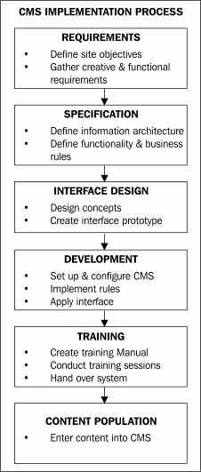

Requirements
Requirements gathering was conducted over several meetings and finalized in January 2003. The requirements covered the following areas:

Key Objectives
- Promote the organization and its services
- Clearly define what CFD are about
- Create a knowledge base
- Publish information in order to change current practices

Creative
- Present CFD as they wished to be seen
- Show an understanding of the target market
- Recognize local & international considerations

Functionality
- All content to be managed in-house without needing technical skills
- Intuitive and easy-to-use browser-based administration interface
- Multiple users with different permission levels (namely author, editor, and publisher)
- Consistent presentation for all content
- Site search facility (including searching Word documents & PDFs)
- Complex publication rules (for example, content added to one section can automatically appear in other sections)
- Accommodate different types of content
- Workflow for creation, review, and publication of content
- Version tracking
- Ability to update look and feel without rebuilding the entire site

Content
- Review existing content
- Establish patterns
- Establish ideal structure

Hosting Environment
Sorting out the hardware was straightforward. We already had a server configured that hosted other eZ publish sites. The client agreed that we would host the new site.

Hardware
- Hewlett Packard LC 2000R
- Dual PIII 1GHz processors
- 1Gb Ram
- 3 x 9Gb SCSI Hot Swappable Hard Drives
- RAID 5 Array
- DAT tape back up facility with daily tape rotation
- Dual Redundant Power Supply

Software
- Red Hat Linux
- Apache web server
- Tomcat 4 servlet container
- PHP 4
- MySQL 3

Selecting a CMS
What made this project unique was the combination of the number of authors, the number of content types, and the rules for how content was to be displayed. Individually, these requirements weren't difficult, but combined, they became far more complex.
We had previously evaluated CMS solutions and found that eZ publish could immediately satisfy the majority of the requirements at face value. The only requirement not covered was searching Word and PDF documents, but this was on the roadmap for
implementation within the next 12 months. Our experience with eZ publish gave us confidence that it was the right solution for this project.
Once the requirements had been established and eZ publish had been selected as the CMS solution, we had to work out the requirements to be implemented as a part of Stage 1.
The aim was to have the site live by the end of May 2002. Given this timeframe and the budget, we knew that it would not be possible to deliver all the requirements. We discussed priorities with the client to establish what had to be in Stage 1 and what could wait until later stages.
The priority was to get the site up, as the Centre was not keeping up with best practices in their field; this was having an impact on their reputation both nationally and internationally. Another priority was making sure the content was properly structured and presented. It was agreed that the implementation of workflow with multiple levels of permissions could wait until Stage 2.

Specifications
Now that we were clear what to achieve, and by when, we needed to specify exactly how we planned to make it happen. We did this by creating an information architect document that contained the following sections:
- User View
- Admin View
- Content Model
- Display Templates
- Content Types

User View
Most of the work for this was done in the initial audit. We started by defining a tree structure of what the main sections of the site were, and then defined sub-sections as well as the dynamic content.

Home
About the Centre
Article A Article B, etc.

Sustainable Products
Article A etc.
Client A Client B etc. Publication A
Publication B etc.
Link A
Link B, etc. Project A Project B, etc. Training A

Research & Consulting
Article A Article B

Publications
Publication A Publication B Sustainable Products
Publication A, B, etc.

Sustainable Buildings
Publication A, B, etc.

Life Cycle Assessment
Publication A, B, etc.
Note: Items in italics were added by the client.
Most of the structure was straightforward. There were a number of sections, and in each section, different types of content could be stored. The complexity arose when content placed in one section was to also appear in another section. For example, a publication appearing in the main section Sustainable Products would also appear under the main section Publications in the Sustainable Products sub-section.
Although the tree structure accurately captured how the user was to view the site, we found that it was difficult for the client to visualize how this would translate into a website. It also did not clearly show that a publication shown in different sections was in fact the same content (just one key feature of a CMS). In later implementations, we
replaced the tree view with a simple sitemap, which has proved to be far more effective. To show the rules of where content was to appear, we used a content model.

Admin View
The Admin view is how people managing the content see the site. However, this is not necessarily how the user sees the site—from a display perspective as well as the structuring of information. As mentioned earlier, a user view is best represented by a sitemap; for the Admin view we found the tree structure to work well. The Admin view is about where to add, edit, and delete content. It's like a file server where the content is organized in a logical manner for easy access. How that content is viewed by the user is a different thing altogether. The purpose of the Admin view is to make things easier for the people creating and managing the content. The Admin view became a working area, a repository of information that needed to be structured appropriately.
As content entered in one area was to appear in other areas, we initially proposed that the admin section be structured according to the content types. Thus when logging into the admin section, rather than getting a list of sections as defined in the user view, we proposed providing a list of content types:
Content Type Appears In
Publications Sustainable Products Sustainable Buildings Life Cycle Assessment Publications
Projects Sustainable Products Sustainable Buildings Life Cycle Assessment
Training Sustainable Products Sustainable Buildings Life Cycle Assessment Training
Although on the surface this made sense to both us and the client, the implementation did not prove to be intuitive from a usability perspective. The end decision was to implement a hybrid approach. We listed the main sections as per the user view, also listing content types that didn't have their own dedicated section, for example, Links.
The admin page would contain the following sections:
- Sustainable Products
- Sustainable Buildings
- Life Cycle Assessment (LCA)
- Training
- Research & Consulting
- Publications
- Links
- News
- Misc
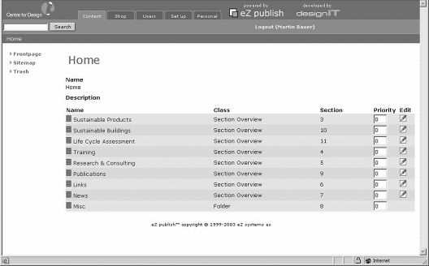
Most of these sections worked in a straightforward manner: you simply clicked on the section and added content. Where content should appear was defined within the system, so the administrator didn't have to worry about adding the content in more than one place. The exceptions to this were Links and Misc.

Links
In the existing site, links had great importance as a part of the knowledge base and were of great value to people using the existing site as a research tool. It was important that the new site allow for the links to have the same level of importance and to be presented in a similar way. To allow for this, we extended the directory-style approach, categorizing them into different sections and then sub-sections.
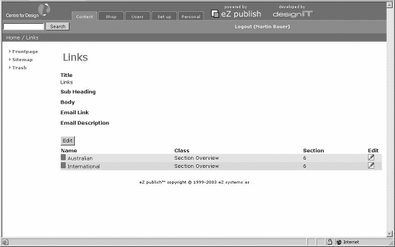
A link was either local or international, and would fall into one of the following sub- sections:
- Case Studies
- Centre for Design
- Documents/Guides
- Government
- Industry
- Journal/Conference
- Other
- University/Research Groups

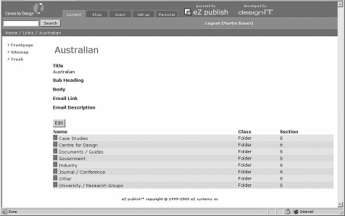

Miscellaneous
This covered all the single pages within the site that are better described as utilities ("Don't Make Me Think", Steve Krug, New Riders). In Misc, we put content for things such as the copyright message, disclaimer, sitemap, credits, and so on.
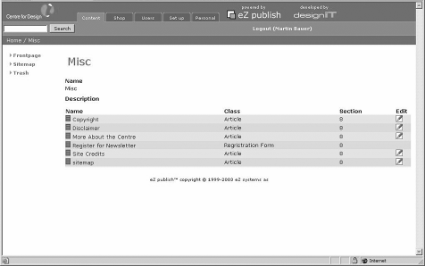
It was a repository for anything that was information about the site or the centre, rather than the information that CFD provided. Links to these items appeared in the footer on each page of the site.
In recent implementations, we have found it useful to add another section, Library. In it, we store files (such as Word documents or PDFs) or images that are used in more than one place on the site. It is especially handy for reusing graphics. We've found that some clients use the library a bit like a file server and create sub-directories to help structure the content. The inclusion of a Media view in the admin templates of the version 3.2 of eZ publish makes the management of a library of images much more user-friendly.

Content Model
Having defined the way users would see the site and how administrators would work with the content, we had to define the business rules that would control not only what the user saw in each section, but also what the administrators would be able to add in each section. In the user view we used a sitemap and in the Admin view we used a tree structure, but neither of these approaches was effective in capturing the business rules of what content could go where. It was important to capture the rules in a manner that had enough detail for the developer to work with but was also easy enough for the client and designer to understand.
Traditionally, sites with a database are displayed using a sitemap and a line to a database. The details of the database are defined separately in a schema, which in itself has different views: for example, table definition and relationship diagram. We needed to combine the sitemap with the content types and show the relationship between them and other parts of the site.
After several attempts at trying to combine the sitemap with database schema type diagrams, we decided to adopt a different approach that started with the content rather than where the content went. Adding to this, we borrowed from Peter Coad's approach to object modeling in color (Java Modeling in Color with UML, Peter Coad, Eric Lefebvre, Jeff De Luca, Prentice Hall). The end result is what we call a content model.
To create the content model, we start by representing each content type at the top of the page, each with a different color. We then represent each of the main sections of the site underneath. The next step is to draw a line between the content type and each section that the content type can appear in. This establishes the rules of what can go where.
Once the main rules are defined, we look to capturing when content should be published in two places simultaneously. In the following diagram, a news article stored in the speeches section is also published on the home page. A publication stored in the LCA section is also published in Publication under the LCA sub-section.

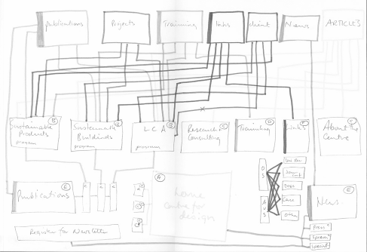
Original Content Model
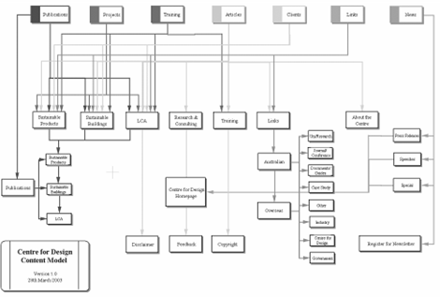
Final Content Model
This approach proved to be quite powerful. It was easy for the client to understand the relationship between the content and the site. At the same time, the developer was provided with a high-level view of the relationships that would be implemented within the CMS.
In the same way that an object model captures the objects within a business domain and how they work together, the content model brought together the content, the site, and the business rules in a single effective representation. Because the content model brings so many elements together, it is the most important part of the specification to get right.
Get the content model right and everything else will fall into place.

Display Templates
Having captured the high-level user view and the content model, the next step was to work out the details of how the navigation was to work and how content was to be displayed. We created a series of display templates (or wireframes) and documented all the elements that would be displayed on that page; in other words, the presentation logic.
We started with the global template and then moved on to each section and sub-section until we had captured how any and every page on the site would be displayed. The following template defines the elements that appear on all pages:
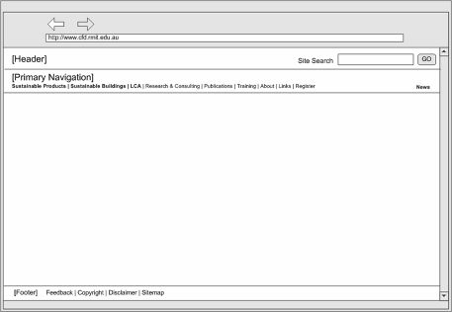
The various sections of this template were:
- Header: Displays logo & search window
- Primary Navigation: Displays all primary navigation items
- Footer: Displays feedback, copyright link, disclaimer, and sitemap
Once we had defined the global elements, we looked at each section to define what content was to appear in it, the sub-navigation, and the specific rules that defined how and where the content would be displayed on the page.

Sustainable Products, Sustainable Buildings, and LCA Template
This template was for the main sections of the site. All the global elements are displayed. The sub-navigation is displayed as links under the type of content that they link to: for example, links to Project A and Project B under the heading Projects:
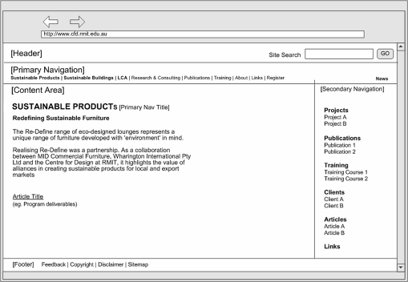
The sections of this template are:
- Global Elements: Display all
- Secondary Navigation: Display all secondary navigation items under category headings and titles as links to full content
- Content Area (Sustainable Products / Sustainable Buildings / LCA): Display selected primary navigation title, selected primary navigation overview article, and article title as link to full article

Content Types
Defining all the content types proved to be one of the bigger challenges. It was difficult to identify patterns in the existing site to use as a basis to accommodate all of the content. For example, not all training courses had the same information; some had a breakdown of the content, others didn't. It took a number of revisions to be able to consolidate all of the content into eight content types that would allow CFD to port everything on the existing site to the new site.
The content types were as follows:
- Overview Article
- Article
- Project
- Training Course
- Publication
- Link
- Client
- News
The next step was to define each content type in more depth. Borrowing from database definition and OO terminology, we defined each content type in terms of attributes and datatypes.
An attribute represented each element of a content type: for example, heading and description. The datatype represented how the information was to be stored, for example, rich text, plain text, or numeric.
We also provided an example of each attribute as a part of the definition to ensure that the name of the attribute was meaningful and the datatype was appropriate. This was a very important step.
In a previous implementation, we found that although the content type definition made sense during the specification stage, the definition no longer worked when it came to adding the actual content, and changes had to be made.
Adding an example at this definition stage is a simple but effective way of checking that you are on the right track.
The end result was a table for each content type. Here is the table for the Publication content type:
Attribute Type Example:
Title* Text line Design + Environment: A global guide to designing greener goods
Author* XML text Field Helen Lewis & John Gertsakis with Tim Grant, Nicola Morelli & Andrew Sweatman

Date of Publication*
DateTime No example

Publisher Text Line Greenleaf Publishing Limited, 2001, Sheffield UK
Image Image Image of front cover of publication

Description of Contents*
XML text Field There is a scarcity of good, practical resources for those interested in minimizing the environmental impacts of products. A new book, called Design + Environment from Greenleaf Publishing, has been specifically written to address this paucity. The authors—Helen Lewis and John Gertsakis with Tim Grant, Nicola Morelli and Andrew Sweatman - have all been involved in EcoReDesign(TM), the innovative program developed by the Centre for Design at RMIT. The aim of EcoReDesign(TM) is to collaborate with Australian companies to improve the environmental performance of their products by following design for environment (DfE) principles.
Download order form as a PDF file.

Cost XML text Field A$50

Attachment (order form pdf)
Attachment Description
File

Text Line Download order form

The final step in defining the content types was to work out how the information was to be displayed. To do this, we created a sample display template for each content type that would show each attribute. This was an important step, as in some cases seeing the information laid out suggested changes to the definition of the content type that produced a better end result. It was far easier and quicker to make changes to the definition or display template at this point than after the site was built.
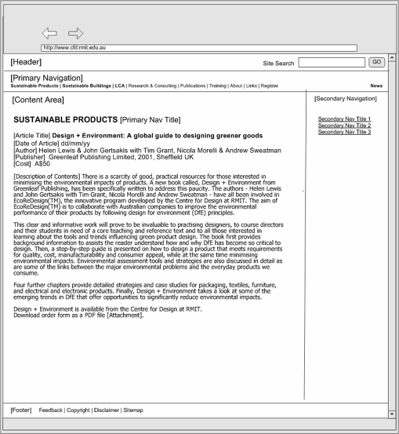
The process of creating the information architecture document was long and difficult. The document went through several revisions and reviews with the client. During these reviews, we went through every element of the specification until we were sure that we had captured everything correctly. After each revision, we made sure both the designer and developer also had a chance to give their input from an implementation perspective.
Overall, this process took approximately two months from start to finish; it took time to organize the reviews and coordinate getting all the right people together at the same time.
Although it was a very difficult and complex process, it proved to be a wise investment; the end result required very few changes from what was contained in the information architecture document.

Interface Design
As the client had such an outstanding reputation with world thinkers in the environment design sector, it was imperative that the site looked and felt like it was a unique individual with best-practice design sensibilities and an inspirational interface.

Visual Design
Earlier, the Centre for Design had a terrible logo – very 90's, hard, and academic. The first job was to talk the Centre into getting a good visual device, i.e. a logo, to associate their name with. We recommended a logo designer and with the brief he came up with a logo the Centre is very happy with. We then moved on to navigation.
Once we sorted the exact number, type, and informational priority of navigation items, it became easy to display them in an innovative, yet clear and logical manner.
The home page design needed to have a real personality and the secondary pages needed to draw on that personality to surround the internal content without intrusion:
- The site had to say: we are modern, eco-sensitive, unique, dramatic, and 'we are where design is at'
- It had to be: non-threatening, classic, timeless, and easy to navigate
- It had to have: the Centre's purpose clearly displayed, and the navigation near that area
Our initial concepts are shown in the following screenshots:




The winner (shown below) was only selected after it was repeatedly put forward by us as we felt it had all the answers. The Centre grew to love it too.

All the Centre's print background material of graduated blue was incorporated, but without dominating the site. This way all the Centre's presentation material design was aligned with the site being the pinnacle of their offering.
We proposed that the secondary page should look like the following, reflecting elements from the home page:


HTML Prototype
For every template defined in the information architecture, we created an HTML page that combined the information design with the interface design. These pages were then linked together to create an HTML prototype of how the site would work once implemented.
The HTML prototype is like a static hand-built version of what the end site look like. Every path and navigation option is displayed, and style issues, such as how and where headers and images are displayed are addressed. The HTML prototype becomes the style guide for the site. The actual HTML is then used as the basis for the templates created in the CMS.
This step is important for two reasons:
- Client review: After many months of meetings to gather requirements and work out specifications, the HTML prototype is the first tangible result that the client gets that is not a document. They can look and interact with the HTML prototype. They can comment on how it works, how it looks, whether it meets their expectations, and so on. It's much easier to comment on something that you can interact with, rather than a document you just read.
- Testing: The HTML prototype also provides an excellent opportunity to test the information and interface design as well as the actual HTML in various browser/OS combinations. Once applied to the CMS, it takes a lot more work to make changes, which may also flow on effects. As the implementation has only started, this gives us the chance to fine tune and update without having to rewrite code, which is easier and far more cost effective.
In the case of the CFD site, the HTML prototype raised a number of issues.

The Home Page
The home page looked fine as a design presented in .jpg format, but when constructed, we encountered problems with browser compatibility and scalability. The design was optimized for 800 x 600 resolution, so for screens with greater resolution we needed to ensure the background extended gracefully. This was easy to fix in the more popular browsers but was a bit trickier in older browsers such as Netscape 4.

Section Pages
Most of the section pages were straightforward, with the main navigation on the left of the screen, sub-navigation down the right, and content in the center column, i.e. the classic three-column layout. This was easy to scale for different resolutions on the common browsers. The only issue we found on most section pages was making sure the sub-navigation allowed for long link names, for example, "Process of delivering Sustainable Buildings and CM education". Our previous experience taught us that clients have a habit of having very long titles, which the CMS uses as the link to that content.
The section page that proved more difficult was Publications. On this section page, the content was split into three columns and there was no right-hand sub-navigation.
It took us several iterations to balance getting the code to work, making the page look good, and keeping it flexible enough for the content.

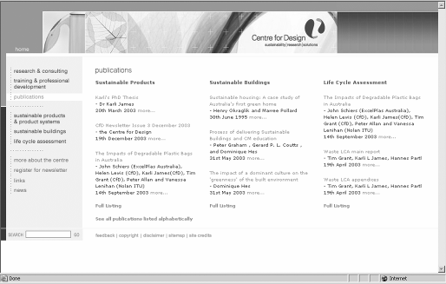
Publications Section

Research Section


Sustainable Buildings Section

Content Pages
For every content type, we had to create an HTML page that displayed every element within each content type. Browser compatibility was not a problem as these pages reused the structure of the three-column sections pages. The challenge was in setting the styles for the different elements for each content type as well as accommodating the formatting that the client would add through the online editor. We started by applying a standard style for the headings and content for the description of each element. Then we reviewed the examples of each content type to see if the style worked well or if there were certain elements within a content type that should be presented differently, for example, Introduction, Abstract, and Credits.


Project Content Page (Introduction shaded differently)
As an approach to test and refine our websites, we have found building HTML prototypes to be extremely valuable.

Development
The development phase started at the same time as the HTML prototype. We were able to do the initial setup and configuration while the prototype was being built.

Install eZ publish
For this project, the first release of eZ publish 3.0 (3.0-1) was used initially, and later upgraded to a bug fix release 3.0-2. Since then, there have been another two major releases that have introduced a much-improved configuration process.
Installation of the eZ publish system is a relatively simple process. We incorporated the setup of an eZ publish site into our existing development environment setup.

While the eZ publish initial configuration process has improved remarkably in subsequent releases, the installation process remains largely similar to the first version.
As a matter of policy, we use a regular site for the web server and a secure site for the admin section. For example:
http://projectname.devserver/ Regular site https://admin.projectname.devserver/ Admin site The main steps in the installation of eZ publish are:
- Set up virtual servers (regular and secure) as normal.
- Create a MySQL database and database user.
- Uncompress the eZ publish distribution in the site DOCROOTT.
- Change permissions and ownership on the var and settings directories to allow the web server to write to these.
- Visit the site URL and process through the eZ publish configuration screens.
- Manually modify the eZ publish configuration files to match our setup. (This involves changing the default way the regular site is distinguished from the admin site. By default, eZ publish uses the "URL" method, but we used port numbers. This part of the process is now included in the setup process via web pages).
- Setup and configure design directories for the admin and regular sites. The CMS is now ready for configuration.

Define Content Classes and Sections
Because of the time spent in getting the information architecture correct, the setup of the content type was a simple process. We used the existing content types Folder and Article, with the Article type requiring the addition of a number of attributes. The other content types were added using the Admin pages.

Configure Roles and Permissions
Due to the workflow requirements being left for a future production stage, the roles required for this project were limited to three—the default Administrator and Anonymous roles, and the additional Editor role for data entry.
The Administrator role has access to all functionality, including the creation, modification, and removal of content, and the ability to modify configuration of the CMS itself. We did not need to modify this role in any way.
The Editor role has access to create content where it is appropriate (this is based on the Content model outlined earlier), and to modify and delete this content. Items in the misc folder may only be edited, as these are statically linked in the templates and would break links if removed. Similarly, adding content to this folder would be of no advantage.
Access to the configuration aspects of the CMS is not permitted by this role.
The Anonymous role, like that of the Administrator, is an existing role. The only modification required to this role is to grant read access to the newly created content objects.
It is a common mistake not to give the Anonymous role read access to newly created content types. If you cannot view data in the site, check to see if the Anonymous role has read permission for that particular content type.
Each role was assigned to a corresponding user group, and a number of Editor users were created for the client for the content population staff.

Apply Display Logic and Templates
All page types (home, primary, secondary, tertiary), content types (article, folder, etc.), and sectional summary pages are defined in the Information Architecture document and created in a HTML prototype. This allows for the associated templates to be created directly from the HTML prototype. Also, this process becomes a simple copying of the core HTML and replacement of the sample data with the appropriate eZ publish template code.
Templates in the eZ publish system are divided into two main types: page layout and content templates. We will now see how these templates were created, along with the templates for navigation and summaries of content.
Specifically, we will look at how the templates were created for:
- Page layout
- Navigation
- Summarized content
- Content

Create Page Layout Templates
The first step in applying the templates is to create the page layout template. This template determines the layout of the page. This site has different page layouts for the home page and all secondary pages and this process is performed for both.
All external files (images, stylesheets, and JavaScript) are copied to the design directory on the eZ publish server. The HTML prototype is copied to pagelayout.tpl and all references to external files (images, stylesheets, and JavaScript) are converted to use the ezdesign and ezimage functions.
For example, the following HTML to include a JavaScript file:
<script language="JavaScript" src="script/common.js" type="text/JavaScript">
</script>
becomes:
<script language="JavaScript" src={"script/common.js" |ezdesign} type="text/JavaScript">
</script>
The following HTML to include a stylesheet:
<link rel="stylesheet" href="stylesheets/style.css" type="text/css">
becomes:
<link rel="stylesheet" href={"stylesheets/style.css"|ezdesign} type="text/css">
The following HTML to include an image:
<img src="images/nv_0202_montage.jpg" width="675" height="96" alt="Welcome to the Centre for Design">
becomes:
<img src={"nv_0202_montage.jpg"|ezimage} width="675" height="96"
alt="Welcome to the Centre for Design">
This tells the template system where to find the external files.
The main content area is then replaced with {module-result.content}. This is substituted by the template system with the content for a specific page.

Navigation
The next stage is for the navigation to be programmed. This process requires the CMS to be populated with sample content. It is always good to use real content if possible for this process as this gives a real sense of how the system will eventually work.

Primary Navigation on Home Page

Primary Navigation on Secondary & Content Pages The CFD site has the following top-level content areas
- Research and Consulting
- Training and Professional Development
- Publications
- Sustainable Products and Product Systems
- Sustainable Buildings
- Life Cycle Assessment
- Links
- News
These sections are created via the admin interface under the root node using the Section Overview content type.
With most websites, there is usually content associated with the site that describes the site or the content. A folder is created and called misc (short for Miscellaneous) and the following articles are created in this folder:
- More about the Centre
- Copyright
- Disclaimer
- Sitemap
- Site credits
- Register for newsletter
(The "Register for newsletter" item is a different content type used to collect e-mail addresses for the mailing list)
This provides us with a skeletal site into which the navigation can be programmed.
Footer on Home Page
Footer on All Other Pages

Setting Up
As the navigation differs for various sections of the site, the first step is to detect which section the current node belongs to and to set some variables. This is done by including an initialization (design/cfs/templates/common/initialization.tpl) file in the page layout template.
The initialization file detects which section of the site the user is currently in and stores the following items in variables:
- section_top_node_id: The node ID of the top node of this section
- section_img: The section banner image
- section_alt: The alt attribute for the banner image
- sec_nav: The secondary navigation for this section
The first step of the initialization is the setup of arrays that hold the information for each section. The first array holds the banner image and all text for items in the misc folder. These objects have individual banner images that we directly relate to their node ID; hence the key to the array is the node ID of each object in this folder.
This code creates and initializes variables that are used in this file:
{let section_hash=false() misc_node_hash=false() section_top_node=false()
}
The misc items information array is as follows:
{set misc_node_hash=hash( 31,hash('image','images/hdr_moreabout.gif',
'image_alt','more about the centre',
),
32,hash('image','images/hdr_copyright.gif', 'image_alt','copyright',
),
33,hash('image','images/hdr_disclaimer.gif', 'image_alt','disclaimer',
),
59,hash('image','images/hdr_sitecredits.gif', 'image_alt','site credits',
),
65,hash('image','images/hdr_sitemap.gif', 'image_alt','sitemap',
),
81,hash('image','images/hdr_register.gif', 'image_alt','register for newsletter',
),
)
}
The following array stores the section information. In addition to the banner information, the name of the file used for generating the secondary navigation for the section is added. The key for this array is the section top node ID.
{set section_hash=hash( 16,hash('section_img','images/hdr_susproducts.gif',
'section_alt','Sustainable Products &amp; Product Systems', 'sec_nav','program_navigation.tpl',
),
17,hash('section_img','images/hdr_susbuildings.gif', 'section_alt','Sustainable Buildings', 'sec_nav','program_navigation.tpl',
),
18,hash('section_img','images/hdr_lifecycle.gif', 'section_alt','Life Cycle Assessment', 'sec_nav','program_navigation.tpl',
),
21,hash('section_img','images/hdr_publications.gif', 'section_alt','Publications', 'sec_nav','publication_navigation.tpl',
),
20,hash('section_img','images/hdr_research.gif', 'section_alt','Research &amp; Consulting', 'sec_nav','research_navigation.tpl',
),
19,hash('section_img','images/hdr_training.gif', 'section_alt','Training &amp; Professional Development', 'sec_nav','training_navigation.tpl',
),
22,hash('section_img','images/hdr_links.gif', 'section_alt','Links', 'sec_nav','link_navigation.tpl',
),
23,hash('section_img','images/hdr_news.gif', 'section_alt','News', 'sec_nav',false(),
),
'Search',hash('section_img','images/hdr_search_results.gif', 'section_alt','Search results',
'sec_nav',false(),
),
24,hash('section_img',$misc_node_hash[$module_result.node_id]['image'], 'section_alt',$misc_node_hash[$module_result.node_id]['image_alt'], 'sec_nav',false(),
),
)
Of note in this array are the elements with the keys Search and 24. The Search entry is for search results pages. The element with key 24 is for items in the misc folder. The banner information is set using the misc_node_hash array and the current node ID.
The code to determine the top node ID of the current section follows:
{section show=eq($module_result.path[0].text,'Search')}
{set section_top_node='Search'}
{section-else}
{section show=$DesignKeys:used.depth|gt(2)}
{set section_top_node=$module_result.path[1].node_id}
{section-else}
{set section_top_node=$module_result.node_id}
{/section}
{/section}
We check if the current page is a search results page. If this is not the case, the depth of the current node is tested to see if we are not currently on one of the section top nodes (depth less than or equal to 2). If this is the case, we retrieve the section top node ID from the node path; otherwise we use the current node ID. The last step in this process is to assign values to the variables so they can be used in the pagelayout.tpl file.
{set-block variable=section_top_node_id}
{$section_top_node}
{/set-block}
{set-block variable=section_img}
{$section_hash[$section_top_node]['section_img']}
{/set-block}
{set-block variable=section_alt}
{$section_hash[$section_top_node]['section_alt']}
{/set-block}
These lines set the banner information and the section top node ID (used in primary navigation—see below):
{set-block variable=sec_nav}
{section show=$section_hash[$section_top_node]['sec_nav']}
{section show=array('publication','extended')|
contains($DesignKeys:used.viewmode)}
{set-block variable=section_top_node_id}21{/set-block}
{include uri="design:common/publication_navigation.tpl"}
{section-else}
{section show=ne($module_result.node_id,21)}
{include uri=concat(
"design:common/",$section_hash[$section_top_node]['sec_nav']) section_top_node_id=$section_top_node}
{/section}
{/section}
{/section}
{/set-block}
{/let}
This code block sets the sec_nav variable. For some sections there is no secondary navigation and this variable is empty. Apart from the publication section, this process is simply a matter of including the correct file to generate the navigation.

The following code from the pagepayout.tpl file displays the section banner:
<img src={$section_img|ezdesign} alt="{$section_alt}" width="370" height="26" border="0"><br>
The secondary navigation is simply added in the correct place in the template. The use of the section_top_node_id variable is detailed in the next section.

Primary Navigation: Navigation Highlighted by Border
All of the primary navigation items are hard-coded in to the page layout template using their unique node IDs. We initially used the URL alias feature but found that when a content editor changed the title of an object the URL alias also changed, breaking the hard-coded link.
The new URL Translator feature allows you to bypass this issue and will be implemented in Stage 2.
The node IDs of the items in the misc folder are recorded and the links in the
pagelayout.tpl are configured using the ezurl template function.
Each primary navigation link has 'on', 'off', and 'active' states. The on and off states are controlled by JavaScript using the onmouseover and onmouseout link attributes. The active and non-active states are controlled by the template logic.
The following code fragment shows how this is implemented for the More About the Centre link (node ID 31):
<a href={"content/view/full/31"|ezurl} onMouseOver="imgOn('nv_moreabout')">
{section show=eq($module_result.node_id,31)} onMouseOut="imgActive('nv_moreabout')">
<img src={"nv_moreabout_active.gif"|ezimage}
{section-else} onMouseOut="imgOff('nv_moreabout')">
<img src={"nv_moreabout_off.gif"|ezimage}
{/section}

</a>
width="175" height="20" border="0" alt="more about the centre" name="nv_moreabout">

This code fragment is repeated for all the miscellaneous primary navigation items.
The logic for displaying the navigation for the main primary navigation items is slightly different as these parts of the site have depth and it is not enough to check to see if the current node ID matches. In these cases we need to check if the current node is either the given node or is an ancestor of the given node.
The following code fragment shows how this is implemented for the Sustainable Products and Product Systems link (node ID 16):
<a href={"content/view/full/16"|ezurl} onMouseOver="imgOn('nv_susproducts')">
{section show=eq($section_top_node_id,16)} "onMouseOut="imgActive('nv_susproducts')">
<img src={"nv_susproducts_active.gif"|ezimage}
{section-else} "onMouseOut="imgOff('nv_susproducts')">
<img src={"nv_susproducts_off.gif"|ezimage}
{/section}
width="175" height="33" border="0" alt="sustainable products &amp; product systems" name="nv_susproducts"></a>
The variable $section_top_node_id is set in initialization.tpl.


Secondary Navigation for Life Cycle Assessment (Highlighted by Border)
The secondary navigation varies for the different sections of the site. First we'll examine the secondary navigation for the Programs (Sustainable Products & Product Systems, Sustainable Buildings, and Life Cycle Assessment) and Training & Professional Development.
Each program is created in the system as a folder and may contain objects of type Project, Publication, Training, Client, Articles, and Links. The secondary navigation displays all items grouped by their type.
The following code is used to produce the secondary navigation for each program's sections:
{let program_subsections=hash('Projects', 7,
'Publications',9, 'Training',8,
'Clients',11,
'Articles',2,
'Links',10,
)
}
<!-- 2nd navigation -->
<td valign="top">
<div class="sec_nav_column">
{section loop=$program_subsections}
{$:key}
{let item_list=fetch(content,list,
hash(parent_node_id,$section_top_node_id, class_filter_type,include, class_filter_array,array($:item)))

}
<ul>

{section show=$item_list}
{section loop=$item_list}

<li><a href={$:item.object.main_node.url_alias|ezurl}>
{$:item.name}</a></li>
{/section}
{section-else}
<li>No Items</li>
{/section}
</ul>
{/let}
{/section}
</div></td>
<!-- end 2nd navigation -->
{/let}
First we define an array of headings and their corresponding class IDs. This array is then looped and for each class type:
- The heading is outputted.
- All objects of that type that belong to the current program area ($section_top_node_id) are retrieved.
- Links to the objects are outputted.
If no objects of a particular type exist, the text No Items is outputted.
The content model allows for training objects to be optionally associated with one of the Programs. Additional training objects as well as any articles about training are placed in the Training folder. The secondary navigation for the training section displays the training objects grouped by their program plus any additional training objects and training articles.

Secondary Navigation for Training (Highlighted with a Border)

The following code is used to produce the secondary navigation for the Training section:
{
let programs=hash(
'Sustainable Products & Product Systems', 16, 'Sustainable Buildings',17,
'Life Cycle Assessment',18, 'Other',19
)
}
<!-- 2nd navigation -->
<td valign="top">
<div class="sec_nav_column">
{* list training *}
{section loop=$programs}
{$:key}
{

}
<ul>
let item_list=fetch(content,list,
hash(parent_node_id,$:item, class_filter_type,include, class_filter_array,array(8)))

{section loop=$item_list show=$item_list}

<li><a href={$:item.object.main_node.url_alias|ezurl}>
{$:item.name}</a>

</li>
{section-else} {* no matching content *}

<li>No Items</li>
{/section}
</ul>
{/let}
{/section}
{* list articles *}
{
let articles=fetch(content,list,
hash(parent_node_id,$section_top_node_id, class_filter_type,include, class_filter_array,array(2)))
}
Articles
<ul>
{section show=$articles}
{section loop=$articles}
<li><a href={$:item.object.main_node.url_alias|ezurl}>{$:item.name}</a></li>
{/section}
{section-else}
<li>No Items</li>
{/section}
</ul>
{/let}
</div></td>
<!-- end 2nd navigation -->
{/let}

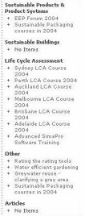
Similar to the Programs navigation, the first thing we do is define an array of items we want to display. In this case, the array contains program names and the associated node_id, as well as the Training node_id. This array is looped, and for each element of the array all Training objects (class_id = 8) are retrieved. Links to these are then displayed. If no training objects exist for a program then No Items is displayed.
The second part of the code retrieves and displays any articles that exist under the training folder. Again, if no objects exists then No items is displayed.

Summary Pages
Secondary pages usually provide a summary of information from a particular section or an alternative view of data from other parts of the site. These pages are programmed based on the Information Architecture document, which defines the source, type, order, and number of items displayed on the page.
The Publications page provides a summary of the publications associated with each program. Summaries of the three most recent publications from each program are displayed. Links to the full listing of all publications for each program and an alphabetical listing of all publications are also displayed.

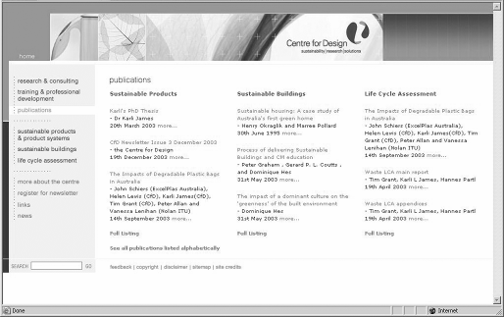
As Publication content types are located under each of the program folders, this page template must retrieve the three most recent publications from each of the program folders.
A publications folder is created at the top level to provide a point at which the user can access this information. The node ID of the publications folder is 21.
The template override system is used to call the publications template (publications.tpl).
The following entry in /settings/siteaccess/cfd/override.ini indicates that the publications.tpl template should be used instead of the default full.tpl template for node ID 21:
[publications] Source=node/view/full.tpl MatchFile=publications.tpl Subdir=templates Match[node]=21
The following code (/design/cfd/override/templates/publications.tpl) provides the required functionality:
{* Publication Main Template *}
{let programs=hash('Sustainable Products', 16,
'Sustainable Buildings',17, 'Life Cycle Assessment',18,
)
publication_limit=3
}
We begin by creating an array of the program types and their node IDs along with a publication_limit variable. The publication_limit variable allows us to easily change the number of publications displayed.
Next, the programs array is looped through. For each program, we retrieve the three most recent (sort_by,array(published,false())) publication objects (class_filter_type, include, class_filter_array,array(9)) that are children of the current program (parent_node_id,$:item).
<div style="width: 100%;">
<table border="0" cellpadding="0" cellspacing="0" align="left" width="100%">
<tr>
{section loop=$programs}
<td valign="top" width="33%">
<div class="heading_2">{$:key}</div>
{* Display 3 most recent items *}
{let publications=fetch(content,list, hash(parent_node_id,$:item,
class_filter_type,include, class_filter_array,array(9), sort_by,array(published,false()), limit,$publication_limit
)
)
}
A summary of each of the retrieved publications is displayed using the node_view_gui function with the line view mode. (The use of alternative view modes will be examined in detail in the next section.)
{section name=Publication loop=$publications}
{node_view_gui view=line content_node=$Publication:item}
{/section}
{/let}
{delimiter}
</td>
<td><img src={"images/spacer.gif"|ezdesign} alt="" width="30" height="1" border="0"></td>
{/delimiter}
{/section} {* programs *}
</tr>
<tr>
<td colspan="5">&nbsp;</td>
</tr>
<tr>
This process is repeated for all programs defined in the programs array. The
{delimiter} option of the section loop is used to close table data tags and place a spacer cell between the program columns.
The programs array is then looped again to produce the links to the full listing of publications for each program:
{section loop=$programs}
<td colspan="2">
<a href={concat('content/view/publication/',$:item)|ezurl}>
<b>Full Listing</b></a></td>
{/section}
</tr>
<tr>
<td colspan="5">&nbsp;</td>
</tr>
<tr>
<td colspan="5"><a href={concat("content/view/allpublications
/",$node.node_id)|ezurl}><b>See all publications listed alphabetically</b></a></td>
</tr>
</table>
{/let}
</div>

Alternative View Modes
This page uses three additional view modes, one for the summary (line) view of the publications, one for showing all publications for a specific program (publications), and one for the full alphabetical view of all publications (allpublications).
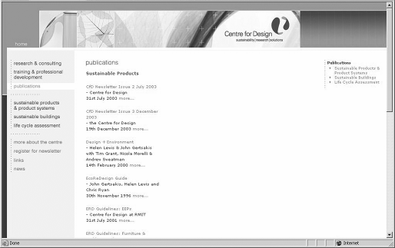
As with the Publications page, the template used for each of these cases needs to be overridden.
In the case of the publication summary (line) view, a combination of the view mode and the content class ID (9 for publications) is used to determine the template for displaying the information:
[publication_line] Source=node/view/line.tpl MatchFile=publication_line.tpl Subdir=templates Match[class]=9
This results in the file design/cfd/override/templates/publication_line.tpl
being used when publications are displayed with the line view mode.
The link that displays a full listing of publications for a specific program will look like
/content/view/publication/16. The system interprets this to display node ID 16 using the publication view mode.
There is no need to create an override.ini setting for this view mode. It is simply a matter of creating the design/cfd/templates/node/view/publications.tpl file. The same applies to the template to display all publications (design/cfd/templates/node/view/allpublications.tpl).

Content Templates
Finally, the content templates are programmed. These templates determine how each content type is displayed. They are based on the prototype and are usually a simple cut-and-paste of the HTML for the mock-up, where the content is replaced with the appropriate content type attribute variable.
Let's look at the process of creating the template for the Publication content type.
The publication object attributes are defined in the Information Architecture document and required attributes are marked with an asterisk (*). Refer to the table discussing the Publication content type, earlier in this chapter.
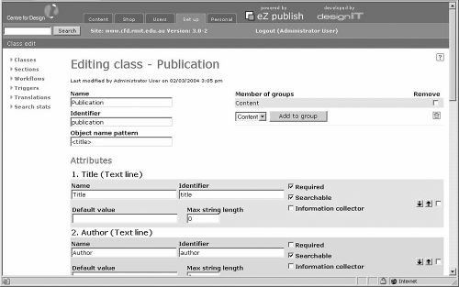
Admin View of the Publication Content Class


The override system is used to specify the particular template to use when displaying publication content objects. The following entry tells the system to use the template file design/cfd/override/templates/publication.tpl when displaying publication content objects (class_id = 9):
[publication] Source=node/view/full.tpl MatchFile=publication.tpl Subdir=templates Match[class]=9
The first step is to take the HTML from the prototype and replace the static content with the appropriate template variables. The HTML from the prototype follows:
<div class="heading_2">Design + Environment: A global guide to designing greener goods</div>
<div class="heading_3">by Helen Lewis & John Gertsakis with Tim Grant, Nicola Morelli & Andrew Sweatman</div>
<div class="heading_3">Greenleaf Publishing Limited, Sheffield UK</div>
<div class="heading_3">May 2003</div>
<div class="heading_3">$A50.00</div>
<div class="heading_3"><a href="#">Download order form as PDF file</a></div>
<p><img src="images/sample_publication.gif" alt="" width="175" height="215" border="0" align="left" hspace="5"></p>
<p>There is a scarcity of good, practical resources for those interested in minimising the environmental impacts of products. A new book called, Design + Environment from Greenleaf Publishing, has been specifically written to address this paucity. The authors - Helen Lewis and John Gertsakis with Tim Grant, Nicola Morelli and Andrew Sweatman - have all been involved in EcoReDesign(TM), the innovative program developed by the Centre for Design at RMIT. The aim of EcoReDesign(TM) is to collaborate with Australian companies
to improve the environmental performance of their products by following design for environment (DfE) principles. </p>
<p>This clear and informative work will prove to be invaluable to practising designers, to course directors and their students in need of a core teaching and reference text and to all those interested in learning about the tools and trends influencing green product design. The book first provides background information to assists the reader understand how and why DfE has become so critical to design. Then, a step-by-step guide is presented on how to design a product that meets requirements for quality, cost, manufacturability and consumer appeal, while at the same time minimising environmental impacts.
Environmental assessment tools and strategies are also discussed in detail as are some of the links between the major environmental problems and the everyday products we consume. </p>
<p>Four further chapters provide detailed strategies and case studies for packaging, textiles, furniture, and electrical and electronic products.
Finally, Design + Environment takes a look at some of the emerging trends in DfE that offer opportunities to significantly reduce environmental impacts.
</p>
<p>Design + Environment is available from the Centre for Design at RMIT.</p>
After replacing the sample content with the appropriate template variables, we end up with the following code in /design/cfd/override/templates/publication.tpl:
{default content_object=$node.object content_version=$node.contentobject_version_object}
<div class="heading_2">
{attribute_view_gui attribute=$content_version.data_map.title}
</div>
<div class="heading_3">by
{attribute_view_gui attribute=$content_version.data_map.author}
</div>
<div class="heading_3">
{attribute_view_gui attribute=$content_version.data_map.publisher}
</div>
<div class="heading_3">
{attribute_view_gui attribute=$content_version.data_map.cost}
</div>
<div class="heading_3">{$content_version.data_map.date.data_int|datetime(custom,"F
%Y")}</div>
<div class="heading_3">
<a href={concat("content/download/",
$content_version.data_map.order_form.contentobject_id, "/",
$content_version.data_map.order_form.id, "/file/",
$content_version.data_map.order_form.content.original_filename)|ezurl}> Download order form as PDF file</a></div>
<p>{attribute_view_gui attribute=$content_object.data_map.image alignment=left hspace=5 vspace=0 image_class=medium}</p>
{attribute_view_gui attribute=$content_version.data_map.description}
{/default}
The next step is to add some code so that any non-mandatory attributes (and associated static information such as a label) are not displayed. Mandatory attributes are indicated with an * in the content type table (refer back to the Content Types section). In this case only the title, author, and description of content attributes are mandatory. The final code follows:
{default content_object=$node.object content_version=$node.contentobject_version_object}
<div class="heading_2">{attribute_view_gui attribute=$content_version.data_map.title}</div>
<div class="heading_3">by {attribute_view_gui attribute=$content_version.data_map.author}</div>
{section show=$content_version.data_map.publisher.content}
<div class="heading_3">{attribute_view_gui attribute=$content_version.data_map.publisher}</div>{/section}
{section show=$content_version.data_map.cost.content}
<div class="heading_3">{attribute_view_gui attribute=$content_version.data_map.cost}</div>{/section}
<div class="heading_3">{$content_version.data_map.date.data_int|datetime(custom,"F
%Y")}</div>
{section show=$content_version.data_map.order_form.content}
<div class="heading_3"><a href={concat("content/download/",$content_version.data_map.order_form.contento bject_id,"/",$content_version.data_map.order_form.id,"/file/",$content_version
.data_map.order_form.content.original_filename)|ezurl}>
{section show=$content_version.data_map.order_form_description.content}{attribute_view_ gui attribute=$content_version.data_map.order_form_description}
{section-else}
Download order form as PDF file
{/section}
</a></div>
{/section}
{section show=$content_object.data_map.image.content}<p>{attribute_view_gui attribute=$content_object.data_map.image alignment=left hspace=5 vspace=0 image_class=medium}</p>{/section}
{attribute_view_gui attribute=$content_version.data_map.description}
{/default}
The order form is a binary file datatype. This code checks whether an order form has been uploaded as part of the object by checking if there is data in
$content_version.data_map.order_form_description.content. If yes, the appropriate link is generated. If a description of the binary file is present then the link is displayed, otherwise the text Download order form as PDF file is displayed:
{section show=$content_version.data_map.order_form_description.content}{attribute_view_ gui attribute=$content_version.data_map.order_form_description}
{section-else}
Download order form as PDF file
{/section}
Testing whether an attribute is empty is relatively straightforward (and is much easier now with the introduction of the is_empty function in the current version of eZ publish). For most attributes, if there is no associated content, the value content (such as
$content_object.data_map.publication.content) is set to false.

Testing
Leaving testing until the end of the project is usually a bad idea, because making changes at that stage is far more time consuming and expensive. We perform testing as a part of each stage of the project to minimize the chance of things going wrong later.

Requirements
We tested the requirements by reviewing them with the client and then with other staff within the organization that published content on the existing site. Different people may have different issues that their manager might not be aware of. Talking to more than one person gave us a more rounded and complete view.
We then thoroughly analyzed the existing site to ensure that the functionality set out in the requirements would cover all of the content the client currently published.

Specifications
Normally a specification document is quite technical and difficult for clients to review. We ensured that the specification document had the visual representations such as wireframes as well as technical details, so that the client was able to understand and provide meaningful feedback. We also got examples of real content and used them as a part of the specification. Using dummy data or made-up examples increases risk. With real examples we were able to pick up issues such as long titles for content and made sure that the datatypes we applied were correct.

Implementation
The majority of the testing was done with the HTML prototype to ensure that it not only accommodated the information design, but also worked in the required browsers and operating systems for the specified screen resolutions (discussed in the HTML Prototype section).

Functional Testing
Once the site was finished, it was simply a matter of going through every element of the site entering several examples of each content type into the system and cross checking against the HTML prototype to make sure that the CMS produced exactly what the client expected. As the HTML used to create the prototype was the same HTML used to create the templates in the CMS and that had already been tested, we minimized the risk of errors.

Content Population
This is the final test of correctness and functionality. After the training sessions, we provided the client with access to the site for content population. During this phase, we used a web-based issue tracking system (Mantis) so that the client could record any issues that arose during content population. Before putting the site live, we ensured that all the issues were resolved.

Deployment
Deployment involves the configuration of the live web server to mirror the configuration of the development server and the copying of the entire eZ publish directory to the live server.
With the CFD project, we were able to run the new site in parallel with the existing site and simply reconfigure the DNS to point to the new site once the client gave approval.
Our experience with CMS-based sites is that the client must start content population before the entire site is finished. Before the site is opened to the client to start content population it is important to ensure that the underlying structures are sound; once content population starts changes in the underlying content types may result in data having to be input again.

Maintenance and Support
During the development of this site, a maintenance release of the eZ publish CMS system was released. The upgrade proved to be a painless process and fixed a number of issues that were not affecting this project.
The site has been live for 5 months and has required minimal maintenance. There is a formal support package being drafted to cover helpdesk-type issues and to manage upgrades to new versions of eZ publish. When notified by eZ systems of any security patches that need to be applied, they are applied immediately to all installations.

Training
Even though the eZ publish admin interface is simple and easy to use, we knew from previous implementations that training was very important on two levels. Firstly, we found it was useful for people using the CMS to understand how it worked, how a CMS wasn't just a normal website, and to think of content as separate from how it was presented on the website. Secondly, it was important to familiarize people with the main functions provided by the admin screens.
We conducted two training sessions based on a training manual we had written for a previous project, which we then customized for this project. The training manual was broken down into five main areas:
- What is a CMS: The key message for this section was to explain that a CMS is made up of different layers that combine to produce the site. These layers, the content, the display templates, and the rules for how the content and templates combine, together create the website.
- General functions: The purpose of this section was to help familiarize people with the main areas of the eZ publish admin interface and how to navigate.
- Folders: This part of the manual talked about how the content was structured in the same way that files are stored in folders on computer. It also explained that there were rules that meant only certain content types could be put in certain folders.
- Managing content: This was the largest part of the manual and covered all of the functions that people would need to enter, preview, and manage content, including reverting to a previous version of an article.
- Formatting: Most of the formatting was covered by the templates but formatting could be applied to some areas. This part of the manual explained how to use the online editor or to use the standard formatting tags allowed by the CMS.

Project Assessment
The entire project took just under eight months. However, when you look at the breakdown of the project, you can see that the actual development was less than a quarter of the time of the entire project. In fact, the bulk of the time taken was in the gathering of requirements and specification phases of the project.
- Requirements – 2 months (elapsed)
- Specification – 2 months (elapsed)
- Development – 1.5 months (full time)
- Testing – 1 week
- Content Population & Review – 1.5 months (elapsed time)

Requirements and Specification Phases
The requirements and specification phases did not have a set timeframe. Both of these phases included discovery, which took longer than expected. Given the nature of gathering requirements, the need to review and analyze, it is hard and potentially dangerous to put a set timeframe on this phase.
With the specification phase, the difficulty of getting everyone together and facilitating feedback impacted the completion time. Had there been a set deadline, these phases could have been shortened.

Development Phase
Development was planned out in detail and was to cover four weeks.

Week One
- Commence build of interface templates
- Install eZ publish
- Configure content classes and sections

Week Two
- Complete build of interface templates
- Configure roles and permissions
- Apply logic display and template framework

Week Three
- Apply interface templates to eZ publish
- Implement site search
- Implement sitemap

Week Four
- Test and review functionality
In reality, the development took six weeks to complete. The main cause for delay was the review and update of the interface templates. The actual development time was close to what we had planned but we did not allow enough time for client reviews, which pushed the timeframe out.
This was the third site we completed with the eZ publish CMS, and while it was quite straightforward, we found that the lack of documentation meant that a significant amount of time was spent in research, trial and error, and code review of the CMS system itself.
With each new eZ publish site we complete, our knowledge of the system increases, and accordingly the quality of the implementation. It must be noted that the amount and quality of documentation has increased dramatically since the completion of this project.

Content Population and Review Phase
Given the amount of content and time pressure on the client, we allowed three weeks for content population. From previous experience, we knew that although we had fully tested all functionality, certain potential issues wouldn't arise until the site was populated with content.
After three weeks, the site was still not fully populated. We had underestimated the amount of work required to take content from the existing site and shape it to fit the structure of the content types in the CMS. There were also some policy issues that arose during this phase. The client decided to push back the deadline by two weeks to allow for these issues to be resolved.
On this, as well as other implementations, we found that unless the content is well prepared ahead of time, content population will always extend to the full time allowed and often take longer. A bit like a gas, it extends to fill the space allowed. This is big risk if there is a set deadline and it's important to ensure that the client understands how much work is involved in populating a site. Implementing the CMS is like setting the structure for a book; someone still has to write the content, and this is a significant task that should be planned for. In every implementation we have done, content population has taken longer than development.

Extending the Site
Before development commenced, we knew that we would have to address workflow as a part of Stage 2. During the testing and content population phases, other improvements were identified that would also form a part of Stage 2. We advised the client that we should note down all these requests to review after the site had gone live. In previous implementations, we found that what we thought should be added as a priority in Stage 2 hasn't always turned out to be the case. What we think we need and what proves to be valuable aren't always the same.
Three months after the site went live, we met with the client to review how things were going with the management of the site and how the public were reacting. What we found was the design and structure of the site was received well and didn't need any revision. We also found that the functionality was more than adequate.

Workflow
Although it was seen as important early on in the project, the need for workflow wasn't that important. The creation and review of content was being handled well as a manual system. The cost and effort for implementing workflow outweighed the benefits that it would bring.

Archiving
Before the site went live, we had identified that the way the sub-navigation was displayed would become unwieldy if there was a lot of content. We discussed possible solutions, the main one being the ability to put content into an archive so only the most recent or most important content would be displayed as a part of the sub-navigation in the section pages. It was agreed that an archive facility would be added as part of Stage 2.

Integration with CRM
What wasn't important earlier but became a priority was the ability to automate the registration for newsletters from the site into the CRM software used by the client. This project is to be scoped out in more depth soon.

Summary
This was our third implementation using eZ publish and was done at a time when the product was rapidly evolving and there was lack of important documentation. Very few details existed on how to best implement the system and we had to work out things along the way both in terms of process and implementation. We learned some valuable lessons that made future implementations much easier.
The most important lesson we learned was the value of receiving all of the content upfront. The requirements contained some complex rules for publishing content in different areas. This meant the specification became more complex, in particular the content model and display templates, which also made development harder. Having more of the content upfront, we could have better tested the validity of the requirements and simplified some of the rules, which would have made the specification and development phases easier without affecting the quality of the end result.
Another lesson learned was with our approach to building the HTML prototype. We used traditional layout techniques, i.e. heavy use of tables. We have since found that using an XHTML/CSS approach (i.e. all layout and styling defined in the CSS) we can dramatically reduce the amount of time it takes to convert the HTML prototype to eZ publish templates. It also reduces the page size, and increases accessibility and performance. This method fits in well with the modular approach to content that eZ publish dictates and has been very successful in subsequent projects. We are now converting the CFD site to XHTML/CSS to make any further changes easier to manage.
On the whole, we've found that the more time spent upfront, analyzing requirements, understanding the client, their needs, and their content leads to a much smoother implementation and a better end result. The better we understand the client's domain and their content, the better the solution we can come up with. In subsequent projects,
although the time spent in the requirements and specification phases has slightly increased, the time taken in the development phases has decreased significantly.
Finally, the task of creating, entering, and shaping content should not be underestimated. No matter how well structured the information architecture, how efficient the implementation, how elegant the design, or impressive the use of XHTML/CSS, it all becomes meaningless without quality content. The result of all this hard work is merely a system for managing content—and the system is only as good as the content itself.

9

Creating a Standards- Compliant eZ publish Site

In this case study chapter, we will look at the design and development of an XHTML and CSS-compliant eZ publish site. The intention of this case study is not to be an in-depth exploration of standards-based design, but to show the thought process behind designing and building such a site, and how the technology we use influences this process.
We will begin with an overview of web standards and the benefits they offer to web developers and the end users of the site, and then move on to discuss the specifics of the case study.
The site in question was created for the Department of Geomatic Engineering at University College London (UCL). It was built to replace an existing site that had grown unmanageable and to bring it in line with the new design guidelines set out by the university. The new eZ publish implementation can be seen at http://www.ge.ucl.ac.uk.
In this case study, we will look at:
- The client requirements
- Planning and preparation—site structure, choosing and defining the content types
- Designing and creating the page templates and CSS rules
- Designing and creating the content types, their templates, and CSS rules

What Are Web Standards?
The web began very simply; web pages consisted of just text and contained a very basic structure. As the web became more popular, however, designers began needing (or wanting) more control over the outcome of their designs and very quickly ran into the limitations of the medium. Basic HTML is very good at giving meaning to content on a
page; a header is a header, a paragraph is a paragraph, and so on. But when it comes to positioning elements on a page, it is very limited. Designers soon began to discover ways of subverting the markup to make the web do what they wanted it to do. The prime means of doing this was table-based design. Tables became the de facto standard for laying out a website, and despite the complexity they introduced to the markup of the document, they helped achieve a good layout for a web page as per a designer's requirements.
In his book, Designing with Web Standards (ISBN 0-7357-1201-8, New Riders Press), Jeffrey Zeldman likens this phase of web design to a time when it was acceptable to throw rubbish from your car window. These habits have both, fortunately, come to be seen as bad practice. We are entering a new era of web design that shuns the bad habits that web designers have become used to and promotes the new virtues of standards compliance and semantics.
But why should we do this if a table-based layout system has worked for us so far? Well, for a start, the markup of the design is hugely simplified, which allows us to make changes far more easily. This, combined with the ability to use an external stylesheet to define styles for an entire site, massively reduces the headaches associated with the maintenance of any large web design project.
XHTML and CSS are the most common standards used in this new design method, and they both work extremely well with eZ publish for reasons that will become clear in this case study. But first, we will go through a quick refresher of the core technologies. If you haven't come across these before, you will need more information—see some of the reference sites and books in the Resources section.

XHTML
If you know HTML, XHTML will be no big leap for you; it is essentially the same except that it is XML compliant. This simple factor implies that you can validate your code and ensure that it will be interpreted the same way in all compliant browsers.
The W3C provides both an XHTML and a CSS code validation service at
http://www.w3.org.
Modern browsers are very forgiving about badly formed markup and this has led to some extremely sloppy coding over the years. This also introduces an element of uncertainty over how each browser handles these errors.
By using valid XHTML, it is possible to eliminate these uncertainties because the errors that cause them will then not exist. From the web page of the group responsible for developing the standards we use, the W3C, XHTML is described as the successor to HTML. It is a means of introducing the rigor associated with XML to HTML. Well- formed, semantically correct XHTML is the cornerstone of an easily maintainable
website. It allows us to define a logical document structure that is independent of presentation and can be visually formatted as necessary using CSS.
When we talk about semantically correct markup, what we really mean is that each element in the page is marked according to what it is. For example, if you have a series of paragraphs on a page, do not use the <br /> tag to separate them and use the <p> tag instead because that is what it is for. This applies to items such as lists (use <ul> or <ol> and <li>), headers (use <h1>, <h2>, and so on), and other such items that you will need to put on a web page. This practice aids the separation of the presentation of the document from its content, one of the core tenets of standards-compliant design.

CSS
Cascading Style Sheets (CSS) are one of the driving forces behind the web standards movement. They allow web designers to have a great deal of control over the style and layout of a website and are extremely powerful when used appropriately. They work very simply; you can define a style for an element in the markup of a document and exercise a good degree of deal of control over its appearance. Visual attributes such as background color, border style, padding, spacing, font styling, and even the position of an element on a page accurate to the pixel can be controlled very accurately using CSS.
By using an external stylesheet for the entire site, a radical change in appearance can be achieved by editing just one file. By using CSS for the layout of the site, we can remove the need for the bandwidth-heavy, table-based designs that we have come to rely upon. This has the added effect of making the site more accessible to text-based browsers and screen readers. It has, however, taken some time since CSS was first introduced for it to be a feasible means of building a website.
A good example of the use of CSS is the CSS Zen Garden (http://www.csszengarden.com/), which set the challenge of redesigning a site by changing only the CSS and not the markup.
Although advanced CSS layouts may not render correctly in a browser such as IE 4 or Netscape Navigator 4.x, the usage of these browsers is so low that it is possible to remove them from the list of target browsers. Many people feel that it is a good thing not to support version 4 browsers, because this will push people on to using more recent standard-compliant browsers. Of course, if a large proportion of a site uses an older browser, it may be necessary to design accordingly, but this can still be done in a standards-compliant manner. Have a look at the Designing with Web Standards book for a good transitional approach to web page design.

Web Standards: Real-World Scenario
It is all very well when you are just talking about the virtues of XHTML and CSS, but unless you are able to sell some of their effects, often a client will want to stick with the old favorite of table-based design. Here are some good reasons to make the move to standards-based web design.

Accessibility
Websites that use a combination of XHTML and CSS are much easier to bring to accessibility standards such as the Section 508 guidelines (http://section508.gov) or the Web Accessibility Initiative guidelines (http://www.w3.org/wai). It is not only good practice to make your site accessible to visually impaired users; in many cases it is a legal requirement. A well-formed, semantically marked up XHTML document is much easier for a screen reader to make sense of than a table-based soup of HTML. An added benefit of using accessible design is that, because the underlying structure of the site makes sense, search engines can also make more sense of it. This often results in a higher placement in search results.

Bandwidth
Sites using XHTML and CSS for their layout and styling will often reduce the size of the files used by one third (or more in extreme cases). The reduced bandwidth has a number of benefits, mainly reduced bandwidth costs and faster-loading sites. Often, fewer images are used in the site (such as spacer gifs and text substitutes), which again results in less calls to the server and a more responsive site. The CSS file is usually cached by the browser, which means that it does not need downloading from the server every time a site loads.

Future Proofing
Because the site is designed using standards, it is easier to be certain that future browsers will continue to interpret our code in the same way as we had intended. By sticking to standards, we create a common ground that reduces inconsistencies in web page display.

Ease of Maintenance
Because all the styling for a site is held in one place (if an external stylesheet is used), it is possible to make changes to this one file that will affect the entire site. By separating the content from the presentation, the template files need never be altered because all visual styling takes place in the stylesheet.

eZ publish and Web Standards
It may seem that all of this evangelism is unrelated to the use of the eZ publish Content Management System, but this is far from being the case. Two of the major benefits of developing with eZ publish are:
- Separation of presentation logic from the application code through the use of templates
- Modularity and reusability of the content structures that are set up
These benefits have parallels in the design of the actual pages using XHTML and CSS; there is a clean separation between content and presentation, and we can use a modular approach to designing the site in terms of its content. It makes sense to aim for a consistency between the internal data structures of the CMS and their external representation on the web page. This makes for a far more manageable site, while at the same time continuing the underlying application logic on to the web page. It is this technique that we will be looking at in further depth in this chapter.

The Client Requirements
The client for the project that we will study in this chapter was the Department of Geomatic Engineering at UCL. The client needed a website providing information about the department, such as course details, news, and contact info, as well as showing past and present projects. They already had an existing website that had been developed in- house. It was built with static pages that were made up of images that had been sliced in a program such as Adobe ImageReady.
The limitations of such a system quickly became apparent; it was difficult to update, and the knowledge of web design required to modify or add pages implied that only a couple of people were able to edit the site. The client needed a system that was easily editable by any member of staff, yet flexible enough to deal with the specific requirements that had been developed based on the usage of the existing site. The following screenshot shows the previous design for the Department of Geomatics website:


The site was earlier being hosted in-house on a relatively low-powered server, but to upgrade the site to one that was dynamically generated, it was necessary to upgrade the server. A dual 500MHz Pentium III machine with 512Mb of RAM was used. The design requirements for the site were that it should use the style guidelines set out by the main university website. This brought about an interesting issue; the templates were table based and did not use semantic markup. So the challenge was to match the design while using CSS for layout.
It was decided that the existing structure of the website should be used as a guide for the new website. The structure was as follows:

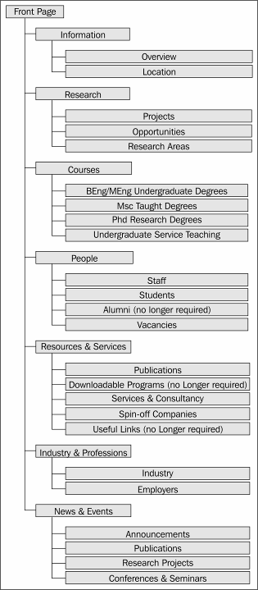

Planning and Preparation
After carefully considering the existing layout, it was clear that there was some redundancy and room for optimization. The structure shown in the following tables was determined to be more optimal. The parts of the site that would require custom content classes have been indicated.
Page Type of Content
Front page Different menu system Latest News Story What is Geomatics?
Featured Projects Next 5 News Articles Quick Links
Information Overview of the Geomatic Engineering Department

Directions Simple page with a map

What Is Geomatic Engineering?
Simple page, but will also appear on front page
Data Class: Simple Page

Publications Needs to have a list of publications grouped by year
Data Class: Publication
Vacancies Needs to show all vacancies for PhD, Research, and others
Data Class: Vacancy

Research Simple Page Summarizing All Research Areas

Research Areas with Projects
Simple page for each research area. Projects to be added under each area.
Data Class: Project

Projects Collection of projects from the research areas. Grouped by area.
Opportunities Shows all of the research vacancies.

Courses Simple Page with a Summary of Each Course
Undergraduate Degrees Collection of pages describing the undergraduate
degree.
MSc Taught Degrees Collection of pages for the areas of the MSc degrees.
Each area has student projects in it.
PhD Research Degrees Simple page outlining PhD research degrees.

Undergraduate Service Teaching
Simple page outlining undergraduate service teaching.

People
List of Categories of People
Ability to Add People to Different Categories Data Class: Person
Staff Categorized list of staff.
Students Categorized list of students.
Commercial Activities Simple Page Describing This Section

Spin-off Companies Need to be able to add links to different spin-off
companies. Data Class: Link
Industry Simple page.
Employers Simple page with a list of employers.
Services and Consultancy Need to be able to add simple pages under this node.
News
Ability to add News stories and vacancies to this section.
Data Class: News Story

The changes in structure were as follows:
- The Publications and the Vacancies pages were added to the Information section.
- The Spin-Off Companies and Services and Consultancy pages were merged with the Industry section to become part of the Commercial Activities section.
- The News section was simplified.

All other sections remained mostly the same. By analyzing the site in this way and streamlining it, it is easier to work out any custom classes that may be necessary. In more detail, the specifics of each class are as follows:

Simple Page | Publication | Vacancy
Title | Authors' names | Title
Content | Title of paper | Intro
Image | Place published | Body
 | Optional PDF | Thumbnail
 |  | Valid
Project | Person | News Article
Title | Name | Title
Start Date | Title | Intro
End Date | E-mail | Body
Summary | Phone Number | Thumbnail
Description | Fax Number | Valid
Image | Website
 | Description
 | Image
Link
Link Name
URL
Description

Template Design
The design of the site matches the design guidelines set down by UCL. There are two main styles for this site:
- The front page, which has more color and elements such as the latest news stories and featured projects
- The rest of the site, which is much plainer and has static navigation
Because the elements on the front page are used only once, there is no need to use individual templates for each of these elements, as no gains will be made due to caching. For the rest of the site, there are some key elements that remain the same throughout:
- Date Bar: Shows the current date as well as the accessibility, privacy, and disclaimer links
- Logo and search bar: Displays the UCL logo, the Geomatics title, and a search box
- Breadcrumbs: Provides a navigational aid throughout the site—a "You are here" function
- Left-hand menu: A two-level navigation that expands to show the current section
- Content: Displayed within the other elements
- Right-hand image: Displays a default image; if a node has an attached image, that is used instead
- Footer: Displays relevant information about the department and the site, such as address, copyright, and credits
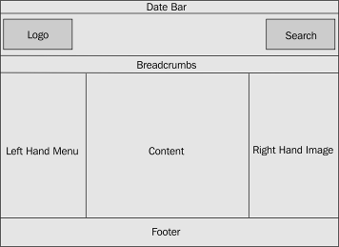
At this point it is useful to understand a little more about CSS, as this will aid us in creating the document structure. There are two key points of difference between IDs and classes and the use of selectors. IDs are used as follows:
<div id="myID">hello world</div>
#myID {
background-color:red;
}
They are used to identify elements in the document to which we want to apply styles. The key aspect of using IDs is that they should only appear once in the entire document. This makes them useful for applying to these base elements as we have just described.
CSS classes can be used as many times as desired in a document, which makes them extremely useful for applying to repeating elements. They have the following syntax:
<div class="myClass">hello world</div>
.myClass {
background-color:red;
}
By using a number of IDs for the base elements of our document, it is possible to streamline the code needed to achieve our design through the efficient use of selectors. The main selector is the descendant selector that allows us to specify an element that is a descendant of another, for example:
#navigation a {
text-decoration:none;
}
This will select all of the <a> elements that are defined in the #navigation ID. This allows us to be more efficient because we can define a general style for all of the <a> tags in the document, and then override that rule with a more specific rule, such as the one illustrated earlier. For more information and a great tutorial on selectors, see http://css.maxdesign.com.au.
The basic XHTML structure for the elements we defined earlier would be:
<html>
<head><title>template outline</title></head>
<body>
<div id="date">date goes here</div>
<div id="logo">logo goes here</div>
<div id="breadcrumbs">breadcrumbs go here</div>
<div id="navigation">Navigation goes here</div>
<div id="content">Content goes here</div>
<div id="image">image goes here</div>
<div id="footer">footer goes here</div>
</body>
</html>
Now that we have our basic structure defined, we can begin to deal with each element and add the functionality defined earlier. I have used a number of include files to make the functions of each element clear and self-contained. The basic template file looks like:
{*?template charset=latin1?*}
<!DOCTYPE html PUBLIC "-//W3C//DTD XHTML 1.0 Transitional//EN" "http://www.w3.org/TR/xhtml1/DTD/xhtml1-transitional.dtd">
<html xmlns="http://www.w3.org/1999/xhtml" xml:lang="en" lang="en">
<head>
{include uri="design:page_head.tpl"}
</head>
<body>
{include uri="design:header.tpl"}
{include uri="design:navigation.tpl"}
<div id="content">
{$module_result.content}
</div>
{include uri="design:image.tpl"}
{include uri="design:footer.tpl"}
</body>
</html>
This has five files included in it, each providing a different and clear function, as well as the template call that will insert the content view into the document. The more expanded HTML tag as well as the DOCTYPE declaration are necessary if we are to use valid XHTML. These serve the purpose of informing the browser about the markup language that a document was written in as well as the international language that the document is written in.
We will now go through each of these templates and examine how they are put together.

page_head.tpl
Some of the following code is taken from the default template that comes with eZ publish and is used to give the page a title. The only addition we have made is a link to the stylesheet that will be used to style the site; note that we have added extra formatting to the code here for easier reading:
{*?template charset=latin1?*}
{default enable_glossary=true() enable_help=true()}
{set-block variable=site_title}
{section show=is_set($module_result.title_path)}
{$site.title|wash} -
{section name=Path loop=$module_result.title_path}
{$:item.text|wash}
{delimiter} ::
{/delimiter}
{/section}
{section-else}
{$site.title|wash} -
{section name=Path loop=$module_result.path}{$:item.text|wash}
{delimiter} ::
{/delimiter}
{/section}
{/section}
{/set-block}
<link rel="stylesheet" type="text/css" href={"stylesheets/main.css"|ezdesign} />
{/default}
<title>{$site_title}</title>

header.tpl
We can see the three parts of this include file, which make up the three parts of the header we defined earlier: the date, logo, and breadcrumbs.
{*?template charset=latin1?*}
<div id="date">
<div class="align-right">
<a href="http://www.ucl.ac.uk/disclaimer/" title="Disclaimer">Disclaimer</a> |
<a href="http://www.ucl.ac.uk/accessibility/" title="Accessibility">Accessibility</a> |
<a href="http://www.ucl.ac.uk/priv/" title="Privacy">Privacy</a>
</div>
{currentdate()|datetime(custom,"%l %d %F %Y")}
</div>
<div id="logo">
<form name="google_search" id="google-search" method="get" action="http://www.google.com/univ/ucl">
<img src="/design/geomatics/images/search_white.gif" height="12" width="113" alt="Search Geomatics" />
<label for="q">Enter Search Text:</label>
<input type="text" size="15" maxlength="255" name="q" id="q" value=""
tabindex="1" />
<label for="sa"></label>
<input type="submit" name="sa" id="sa" value="Go" tabindex="2"
/>
<input type="hidden" name="sitesearch" id="sitesearch" value="ge.ucl.ac.uk" />
</form>
<a href="http://www.ucl.ac.uk" title="Main UCL Site">
<img class="ucl-logo" src="/design/geomatics/images/ucl_logo_white.gif"
width="39" height="49" alt="ucl logo" />
</a>
<a href="/" title="GE Home Page">
<img class="ucl-geo-logo" src="/design/geomatics/images/ucl_geo_logo_white.gif" width="165" height="49" alt="ucl geomatics logo" />
</a>
</div>
<div id="breadcrumbs">
<ul>
{section name=Path loop=$module_result.path}
{section show=$Path:item.url}
<li><a href={concat("/",$Path:item.url_alias)|ezroot}>
{$Path:item.text|wash}</a> &#8250;&#8250;
</li>
{section-else}
<li>{$Path:item.text|wash}</li>
{/section}
{/section}
</ul>
</div>
The reason why the breadcrumbs are placed in an unordered list (<ul>) is because, effectively, they are a list of the elements in the path that defines the current location on the site. This is generally considered good practice and is more semantically correct than if each one were placed in a span or a div container. For the search box we use a label; this is considered a good practice when building accessible sites.

navigation.tpl
By using nested unordered lists, we can define a logical structure for the menu. This makes an enormous difference when viewed in a text browser, because the structure is much clearer than if we had used div or plain href tags.
It also allows us to use CSS styling to visually design the navigation. The li selector applies to all elements in the list, whether they are top level or in the sub-level. The selector li li will only apply to the sub-level, allowing us in this case to indent the links to demonstrate their structure in the navigation. This kind of navigation would have required some cunning using a table-based layout, probably using some invisible spacer GIFs or the like. Using CSS, we have a lean markup that can be transformed using some simple CSS to manipulate the layout as we please:
<div id="navigation">
{let folder_list=fetch( content, list, hash(parent_node_id, 2, sort_by,
array( array( priority ))))}
<ul>
{section name=top_level loop=$folder_list}
<li><a href={concat("/",$folder2:item.url_alias)|ezroot}>
{$folder2:item.name|wash}</a>
{section show=$top_level:item.node_id| eq($module_result.path[1].node_id)}
{let sub_folder_list=fetch( content, list, hash(parent_node_id,
$module_result.path[1].node_id, sort_by, array( array( priority ))))}
<ul>
{section name=sub_level loop=$top_level:sub_folder_list}
<li><a href={concat("/",$top_level: sub_level:item.url_alias)|ezroot}>{$top_level: sub_level:item.name|wash}</a></li>
{/section}
</ul>
{/let}
{/section}
</li>
{/section}
</ul>
{/let}
</div>
The following screenshot shows the breadcrumbs and navigation bar viewed in the Lynx text browser. You can see the clear navigational structure achieved as a result of using lists:

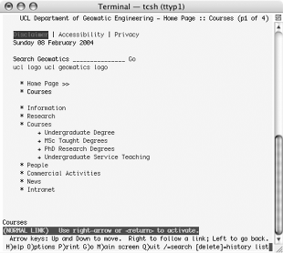

image.tpl
This template is slightly more complicated because of the variables that are available for use in the different templates. In templates like this one that are manually included (and not related to a particular node), the $node variable is not available. Instead, we have to use the $module_result variable if it is necessary to access data for the current node.
In our case it is necessary to use the image for the node, so we quickly fetch the object for that node and check if it has an image. If it does not have an image, the default image is used.
This website was created using eZ publish 3.1, but in version 3.3, the mechanism for showing images has changed quite dramatically.
<div id="image">
{let mynode=fetch('content', 'node', hash(node_id,
$module_result.node_id))}
{section show=$mynode.object.data_map.image.content}
{attribute_view_gui attribute=$mynode.object.data_map.image.content[side]}
{section-else}
{let default-side=fetch('content', 'node', hash(node_id, 605))}
{attribute_view_gui attribute=$default- side.data_map.image.content[side]}
{/let}
{/section}
{/let}
</div>

footer.tpl
Again in this file, because we do not have the $node variable, we must fetch the object for the node to reference the time it was last modified. The only other template code in this include file is the one that shows the current year, which passes the currentdate() function into the datetime() formatting function. Everything else in here is regular XHTML:
{let mynode=fetch('content', 'node', hash(node_id,
$module_result.node_id))}
<div id="footer">
Department of Geomatic Engineering - University College London<br
/>
Gower Street, London, WC1E 6BT | Tel: +44 (0)20 7679 2740 | Fax:
+44 (0)20
7380 0453<br />
Copyright &copy; 1999-{currentdate()|datetime(custom,"%Y")} UCL | Last modified: {$mynode.object.modified|datetime(custom,"%d %F
%Y")} |
<a href="mailto:www-admin@ge.ucl.ac.uk">www- admin@ge.ucl.ac.uk</a><br />
search by <a href="http://www.google.com/">google</a> | powered by <a href="http://ez.no">eZ publish</a> |
<a href="http://jigsaw.w3.org/css-validator/validator">CSS</a> |
<a href="http://validator.w3.org/check/referer">XHTML</a>
</div>
{/let}
Now that we have defined these basic template features, we can apply the CSS rules to the document to put it in shape. The following images show the difference between the site with and without the stylesheet.

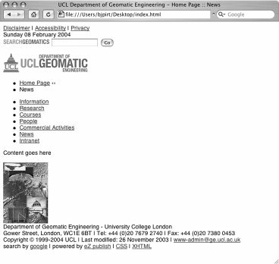
This image shows the unstyled page—you can see that the information on the unstyled page still makes sense because a logical structure was used for the XHTML. The following image shows the document with the stylesheet applied:
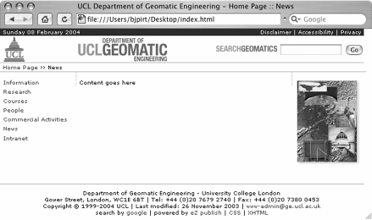

CSS Rules
The rules that were used to perform this transformation are as follows:
body {
margin:0px; padding: 0px;
background-color: #FFF !important;
font-family: Verdana, Arial, Helvetica, sans-serif; font-size:70%;
}
This rule sets the margin and padding for the document to zero and ensures that the background stays white with the !important declaration. This is a good place to specify the font used in the document as it will cascade down into all of the other elements and eliminate redundant style declarations. The font-size declaration is a little trick found at http://www.thenoodleincident.com/tutorials/typography/ and is used to get around the problem associated with specifying font sizes and accessibility in Windows Internet Explorer.
The problem is this—accessibility rules suggest that the user should be able to resize the text on a page using the browser's built-in text-resizing feature. This presents a problem in IE when you specify the text size in pixels—the text will not resize. The other problem is that if you specify a font-size of say 0.7em, it will actually come out extremely small and not 70% of the user's default font size.
By specifying the font size as a percentage, we can leave the default text size alone, and scale down the font size of the whole document. Now we can resize the text in IE, while maintaining consistency across browsers.
The following rules for the date ID simply set background colors and float the relevant text to the right:
#date {
padding-left:5px; background-color:#1C1C73; color: white;
}
#date .align-right { float:right; display:inline; margin-right:5px;
}
#date .align-right a { color: white;
text-decoration: none;
}
The following rules lay out the logos and the Google search box in the correct places on the page:
#logo {
background-color:#FFF; height:49px;
border-bottom:1px solid #AAA; border-top:1px solid #1C1C73;
}
#logo a img.ucl-logo { margin-left:7px; display:inline; border:none;
}
#top-logo a img.ucl-geo-logo { margin-left:94px; display:inline;
border:none;
}
#logo #google-search { position:absolute; right:0; display:inline; float:right; height:35px;
}
#logo #google-search input { margin-top:16px;
}
#logo #google-search img { padding-top:10px;
}
The following rules lay out breadcrumb elements and tell the browser to display the list elements as inline, which means that they will all flow on the same line as we want for our breadcrumbs:
#breadcrumbs { padding:2px 5px 2px 0; margin:0;
width:100%; background-color:#FFF;
border-bottom:1px solid #AAA;
}
#breadcrumbs ul { display:inline; padding:0; margin:0;
}
#breadcrumbs li { display:inline; padding:0; margin:0;
}
The set of rules outlined here positions the navigation on the page, and then, using multiple selectors, styles the menu items in a way that makes sense with the structure of the navigation:
#navigation { float:left; left:0;
padding-top:13px; width:140px;
}
#navigation ul {
list-style-type:none; margin:0;
padding:0;
}
#navigation ul ul { margin-top:6px;
}
#navigation li { padding-left:6px; margin:0 0 5px 0; display:block;
}
#navigation li li { margin-left:13px; padding:0; display:block;
}
#navigation a { margin:0; padding:0; display:inline;
}
Because we have floated the navigation to the left-hand side, we set a left margin on the main content to cover this distance, effectively creating two columns. We do the same on the right-hand side to create the third column for the image. By adding borders we can delineate between these three columns.
#content { padding:13px 5px 0;
margin-right:0 132px 0 140px; border-left:dotted 1px #AAA; border-right:dotted 1px #AAA;
}
#image { float:right; width:110px;
padding: 0 7px 7px 0; margin-right:6px;
}
The image is floated right and overlaps the margin we set in the #content div tag.
Earlier, we mentioned bandwidth as a reason for using XHTML and CSS instead of table-based design. Because the template used by UCL utilizes tables, we are in a
position to make a direct comparison between the two techniques. The two bare templates were compared:

File | Size (in bytes)
UCL table-based template | 9,842
XHTML template | 4,769
CSS file | 4,986
XHTML + CSS file | 9,755
Well, a saving of 87 bytes, over a day that might even add up to 1KB of bandwidth savings. But that is not the whole story. First, the CSS file contains the styling for the entire site, and so only needs loading once. Secondly, it is also cached, which means that on subsequent page loads it will not need downloading again. This means that if a user looks at, say 20 pages, they will be using only 51% of what they would if they were downloading the table-based version. If a transitional approach were used, where tables were used for layout and stylesheets for the rest of the styling, we could expect to see bandwidth usage somewhere between these two scenarios.
This section has shown the planning that went into building the framework into which the content of the site is placed. The link between planning the parts of the layout, the structure of the templates, and the design of the CSS should be clear. By breaking the design of the site down into logical parts and using these to define our CSS, we can achieve a clear and consistent approach to the design of the site. We will take this one step further when we design the content that fits into the template we have just put together.

Designing the Content
The building block of our standards-compliant eZ publish site is the div tag. By encapsulating all of our objects into div tags with suitably named classes, we can gain a large degree of consistency between the internal structure of eZ publish and the external structure of the document. In the previous section of this case study, we saw how we can create a highly modular document structure through the use of div tags with IDs. In this section, we will continue this by aligning the classes of data types in eZ publish with the classes we create in the stylesheet.
We will look at one of the content classes to illustrate the way this process works and ensure consistency in all areas of the application.

The News Article Class
There are three parts to creating a new class:
- Defining the data class using eZ publish, where we decide upon the datatypes that the class should contain.
- Creating the templates for eZ publish to use when displaying the page. There may be multiple templates for each class, depending upon the different views of the data.
- Creating corresponding CSS rules to style the output.

The Data Class Definition
We saw the fields that were necessary for this class earlier, but here we will go into a little more detail:

Data Field | Datatype | Description
Title | Text Line (Required) | The title of the article
Intro | Text Line | The introduction to the article
Body | XML Text Field | The full story of the article
Valid | Checkbox | Whether the article is still valid or not
Once we have defined the data class using eZ publish, we can then look at creating the templates to output this information.

Class Templates
Overrides are one of the most powerful features of the eZ publish templating system. The main files that we will be overriding are /node/view/full.tpl and
/node/view/line.tpl. These templates provide the two main views of our classes, and both are used when we use the templating function node_view_gui(). If you recall, the full template is normally used when we want to show a view of only one node, and the line template is used when we want to show a list of nodes on one page. Both templates show different views of the same information. In this case, the site only has the News Article class in one section so we can define a site-wide override for this class. If we wanted to show a News Article class with different formatting in different parts of the site, it would be necessary to define sections in eZ publish, and then to create overrides for the different sections.
For our site, we define the following overrides:
File: override.ini.append.php
[news_full] Source=node/view/full.tpl MatchFile=news_full.tpl Subdir=templates Match[class]=20 [news_line] Source=node/view/line.tpl MatchFile=news_line.tpl Subdir=templates Match[class]=20
These tell eZ publish to use the files person_full.tpl and person_line.tpl for the full and line views respectively.

news_full.tpl
This is a very simple view of the data that simply presents the title of the story as the header and emphasizes the introduction. The styles that will be applied to this are the same styles that are defined for the rest of the website. This illustrates one of the strong points of CSS; the ability to redefine existing HTML elements such as the <em> and <h1> tags. By defining overall styles for the site, a great degree of consistency can be achieved with very little effort. It also shows that not everything needs wrapping in a <div> tag.
<h1>{$node.name}</h1>
<em>{attribute_view_gui attribute=$node.object.data_map.intro}</em>
{attribute_view_gui attribute=$node.object.data_map.body}
{attribute_view_gui a attribute=$node.object.data_map.valid}

news_line.tpl
This template just shows the title of the story, which acts as a link to the full story. It is all enclosed in one <div> so that we can style a surrounding box.
<div class="news-line">
<a href={concat("/",$node.url_alias)|ezroot}>
{$node.data_map.title.data_text|wash}
</a>
<p>
{attribute_view_gui attribute=$node.data_map.intro}
</p>
</div>

CSS Rules
Now that we have the classes defined, we can create the CSS rules to style them.
.story
{
border:solid 1px #CCC; background-color:#EFEFEF; margin-bottom:5px;
}
.story a
{
display:block;
padding:1px 5px;
border-bottom:solid 1px #CCC;
}
.story p
{
display:block; padding:1px 5px; margin:0;
}
These will style the line view of the story so that there is a grey box around it as shown in the following image. The full view of the news story uses the global CSS rules for these elements.
The following image shows the line view of the News class:
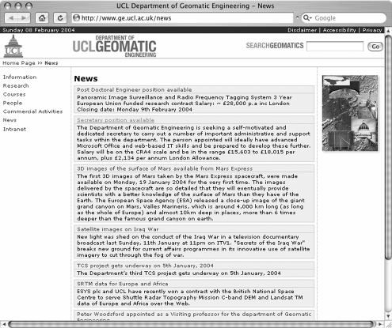
And here we can see the full view of the News Class:


Performance
While the default settings for eZ publish are good for development, they are unsuitable for production use. To increase the performance of eZ publish, there are a number of things we can do:
- Enable view caching
- Enable template compiling
- Enable template caching
- Use cache blocks in the templates
- Install a PHP accelerator

View Caching
View caching takes the content of the override templates you have created and caches them so that all eZ publish needs to do is insert the correct data into the right places in the template. It is best to disable this during development because any changes you make to the templates will not be seen on the site until you flush the cache. View caching can be enabled with the following setting:
File: site.ini.append.php
[ContentSettings] ViewCaching=enabled

Template Compiling
Template compiling involves compiling templates that use the templating language used by eZ publish into templates that use native PHP. This obviously speeds up the lengthy templating process quite considerably. Without this option enabled, the templating process takes up a large majority of the time it takes to output a page. To enable this setting, use the following configuration:
File: site.ini.append.php
[TemplateSettings] TemplateCompile=enabled

Template Cache Blocks
View caching and template compiling will improve the performance of eZ publish with a relatively small amount of effort. Using cache blocks, however, takes a bit more effort but can also have the greatest rewards. Cache blocks are a way of caching the output of dynamic content in a template into a plain HTML file, which is then simply included in the output. In its simplest form, the cache block statement works as follows:
{cache-block}
Lots of dynamic code here
{/cache-block}
However, if we want to apply this to something like our menu system or the breadcrumbs, this would be of no use because every page would be given the same menu or breadcrumbs. To get around this, we can use the keys parameter, which gives a unique identifier to each state of the cache block. For example, if we had some code that was different on every page, we could use a variable that is unique on each page, such as
$uri_string, which would give us:
{cache-block keys=$uri_string}
Lots of code here which is different on every page
{/cache-block}
Alternatively, if we have a site that changes very regularly, we can specify an expiry time in seconds like so:
{cache-block expiry=180}
Lots of code here which expires every 3 minutes
{/cache-block}
So if we apply this knowledge to our main pagelayout.tpl template, we get the following:
<!DOCTYPE html PUBLIC "-//W3C//DTD XHTML 1.0 Transitional//EN" "http://www.w3.org/TR/xhtml1/DTD/xhtml1-transitional.dtd">
<html xmlns="http://www.w3.org/1999/xhtml" xml:lang="en" lang="en">
<head>
{cache-block}
{include uri="design:page_head.tpl"}
{/cache-block}
</head>
<body>
{include uri="design:header.tpl"}
{cache-block keys=$module_result.path[1].node_id}
{include uri="design:navigation.tpl"}
{/cache-block}
<div id="content">
{$module_result.content}
</div>
{cache-block keys=$module_result.node_id}
{include uri="design:image.tpl"}
{include uri="design:footer.tpl"}
{/cache-block}
</body>
</html>
This template caches in the following ways:
- page_head.tpl will be cached the same for every page.
- The navigation will be cached for two levels of navigation from the path variable.
- The image and footer will be different for every page.
Furthermore, within header.tpl, we would tell eZ publish to cache the date bar according to the current date, the logo and search box for every page, and the breadcrumbs according to the individual node.

PHP Accelerators
It is always a good idea to install a PHP accelerator if it is possible on your server. It often speeds the site up by a factor of 2. There are several accelerators that work well with eZ publish:

Cache URL
Alternative PHP Cache http://apc.communityconnect.com/ IonCube PHP Accelerator http://www.phpaccelerator.co.uk/ Turck MMCache http://turck-mmcache.sourceforge.net/
Of these, I have used both the IonCube PHP Accelerator (on the UCL site) and Turck MMCache with success. See individual sites for instructions on how to install these extensions to PHP.

Benchmarking
Benchmarking is a very good idea if you want to understand the effects your performance tweaks have had on the server. The simplest technique for measuring performance is a utility that comes with the Apache web server called ab.

ab
ab stands for the Apache Benchmarking tool and is used to test a server for the number of requests it can deal with in a period of time. It is used as follows:
ab -n 100 -c 4 www.ge.ucl.ac.uk/
This command means that it will make 100 requests (-n) with a concurrency of 4 (-c), and will report back with results that look like:
Server Software: Apache/2.0.40 Server Hostname: www.ge.ucl.ac.uk Server Port: 80
Document Path: /
Document Length: 6375 bytes
Concurrency Level: 4
Time taken for tests: 14.216923 seconds Complete requests: 100
Failed requests: 0
Write errors: 0
Total transferred: 687000 bytes HTML transferred: 637500 bytes
Requests per second: 7.03 [#/sec] (mean) Time per request: 568.677 [ms] (mean)
Time per request: 142.169 [ms] (mean, across all concurrent requests)
Transfer rate: 47.13 [Kbytes/sec] received Connection Times (ms)
min mean[+/-sd] median max
Connect: | 0 0 0.0 | 0 | 0
Processing: | 278 559 309.6 | 467 | 1955
Waiting: | 223 535 311.0 | 462 | 1955
Total: | 278 559 309.6 | 467 | 1955

Percentage of the requests served within a certain time (ms) 50% 467

66% | 578
75% | 678
80% | 709
90% | 953
95% | 1226
98% | 1629
99% | 1955
100% 1955 (longest request)
From this output we can see that this setup can serve 7 pages per second with this level of concurrency. This is suitable for a site that is not extremely busy and the loading time of approximately half a second is small enough to make the site feel quite responsive. With less concurrency, the response time becomes faster as shown here:

Concurrency | 1 | 2 | 3 | 4
Requests per Second | 3.58 | 6.88 | 6.98 | 7.04
Time per Request (mean) | 279.547ms | 290.838ms | 429.864ms | 567.885ms
Time per Request (mean, all requests) | 279.547ms | 145.419ms | 143.288ms | 141.971ms

Effects of Optimization
Having covered various ways of improving the performance of your eZ publish installation and then looking at how to measure them, you can now see their effects, as measured by ab, in the following graph:
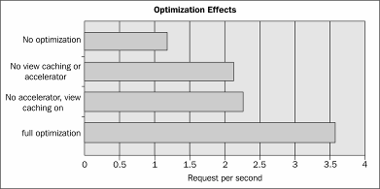

Resources

Resource Where to find it

Designing with Web Standards – Jeffrey Zeldman
ISBN: 0-7357-1201-8

CSS: The Definitive Guide – Eric Meyer ISBN: 1-56592-622-6 Eric Meyer on CSS ISBN: 0-7357-1245-X
CSS Discussion list on Incutio http://css-discuss.incutio.com
Glish resources on CSS http://www.glish.com/css/
Maxdesign CSS tutorials http://css.maxdesign.com.au/index.htm
A List Apart http://www.alistapart.com/
The W3C http://www.w3.org

Summary
In this chapter, we began with a brief introduction to web standards and their real-world benefits. We then looked at the design of a site; beginning with the data classes that are needed and their CSS class counterparts.
We saw the design decisions behind the layout of the overall site template and the eZ publish components that are behind it. We then looked at maintaining a consistency between standards-based design and the underlying structure of eZ publish. Using one of the data classes as an example, we followed the design process from defining the data class to writing the CSS classes for its display.
After building the site, we went on to examine ways of speeding it up using various optimizations, such as PHP accelerators and caching, and their settings in eZ publish. Through the use of benchmarking, we were able to test the performance of our site and determine the effect these optimizations had. You should now understand the thought process behind the design of this site and hopefully be able to apply this to future sites of your own.

A

Template Operators and
Functions

Operators
Operators are used to modify the content for presentation or to perform other useful manipulations. The coming sections discuss the available functions and operators in detail, per category. The categories are:
- String operators
- Array operators
- Mathematical operators
- Localization operators
- Miscellaneous
Operators modify content by using the '|', much like UNIX pipes. For example:
{"Hello"|count} {*results in 5 *}
Operators can take one or more optional parameters, which are put in parentheses and separated with a comma.

String Operators
A general note for Unicode-enabled sites: consult the documentation on http://www.php.net regarding mb_string and the configuration options in php.ini. This allows for Unicode-safe operations for most (but not all) of the string functions mentioned here. Note that the operators upcase, downcase, upfirst, and upword require the server or PHP set to the correct locale to work properly. eZ publish doesn't support proper Unicode case mapping yet, so you may get strange results with a wrong locale.
The following table gives an alphabetical overview of string operators and their functions:
Operator | Purpose
append | Appends element(s) to a string.
begins_with | Checks if a string starts with a specific element/sequence.
break | Replaces newlines with XHTML line breaks (same as nl2br).
chr | Creates a string based on an array of ASCII/Unicode values.
compare | Compares the contents of two strings.
concat | Concatenates values to one string.
contains | Checks if a string contains a specific element.
count_chars | Counts and returns the number of characters (string length).
count_words | Counts and returns the number of words within a string.
crc32 | Calculates the CRC32 polynomial of a string.
downcase | Converts all alphabetical characters to lowercase.
ends_with | Checks if a string ends with a specific element/sequence.
explode | Splits a string into an array of substrings.
extract | Extracts a portion from a string.
extract_left | Extracts a portion from the start of a string.
extract_right | Extracts a portion from the end of a string.
indent | Indents a string by inserting characters at its start.
insert | Inserts stuff at specified position in a string.
md5 | Calculate the md5 hash of a string.
mimetype_icon | Converts a mimetype string into an icon. (from version 3.4)
nl2br | Converts newlines to HTML <br /> (see also the break operator)
ord | Returns characters in a desired sequence.
pad | Makes sure a string is at least n characters long.
prepend | Prepends a custom sequence to a string.
remove | Removes element(s) from a string.
repeat | Repeats the contents of a string.
reverse | Reverses the contents of a string.
rot13 | Performs a rot13 transform on a string.

Operator | Purpose
shorten | Shortens a string to a few characters and adds trailing sequence.
simplify | Transforms multiple consecutive characters into one.
trim | Strips whitespace from the beginning and/or end of a string.
upcase | Converts all alphabetical characters to uppercase.
upfirst | Converts the first character to uppercase.
upword | Converts the first character of all words to uppercase.
wash | General text wash. Translates potentially bogus strings to friendly ones.
wordtoimage | Replaces special sequences of text with images.
wrap | Wraps text to lines at a specified length.

String Transformations
The majority of these operators actually transform strings in one way or another.

Changing the Case of Characters
The following examples illustrate the changing of case:
{"Making me shout!"|upcase}
This returns the string "MAKING ME SHOUT!"
{"STOP MAKING ME SHOUT!"|downcase}
This returns the string "stop making me shout!"
{'you are invited to my party!'|upfirst}
This returns the string "You are invited to my party!"
{'commodore amiga user'|upword}
This returns the string "Commodore Amiga User"

Inserting Breaks, Shortening, Padding, or Trimming Text
For display purposes, text can be transformed using the break (or nl2br), trim, wash, simplify, wrap, and shorten operators. For example:
{"The next summer conference will take place in June "|break}
This returns "The next summer<br />conference will take<br />place in June<br />" Stripping whitespace from the start and end of a string is done using the trim operator.

In spite of what the online docs say, you have to provide an argument like whitespace (tested eZ publish 3.3-3), when using this operator.
For example:
{" I want you to want me "|trim(' ')}
This returns the string "I want you to want me".
For reducing spaces inside strings, use the simplify operator. You can also reduce duplication of characters within strings. For example:
{"aabcaabcaaaabc"|simplify('a')}
This returns the string "abcabcabc". Duplicate instances of the letter 'a' have been trimmed to one.
To wrap text to limit the width of text blocks, you need to use the wrap operator. The wrap operator needs three parameters, as in wrap(width, break_sequence, cut). By inserting the break_sequence characters into $string, the wrap operator wraps given text at a specified width. All parameters are required (version 3.3-2). The break_sequence parameter specifies a string containing the desired break sequence to use; the default is \n (newline). The cut parameter specifies whether the string should be wrapped at the specified width. In other words, if you have a word that is larger than the given width, it is broken apart. For example:
{"Good morning fellow eZ publish user withalongname"|wrap(8,'- ',true())}}
This returns the string "Good-morning-fellow-eZ-publish-user-withalon-gname". Now consider:
{"Good morning fellow eZ publish user withalongname"|wrap(8,'- ',false())}
This returns "Good-morning-fellow-eZ-publish-user-withalongname".
wash is a general character/string washing operator. The washtype parameter specifies the washing type: e-mail, PDF, or XHTML (default). If you have a string that contains bogus characters (or sequences) that could alter the intended result, you should 'wash' it before outputting it. For example:
{"A nasty string with a <br>"|wash}
This returns "bogus string &lt;br&gt;".
{"bf@ez.no"|wash("email")}
This returns "bf[at]ez[dot]no".

The conversion of e-mail characters is controlled by the ini file settings
[WashSettings] in template.ini(.append)
The shorten operator shortens string to maxlength characters and adds a trailing ellipsis sequence. Note that maxlength also includes the length of the trailing sequence. If the input string is shorter than maxlength, it will not be shortened. For example:
{"This string is too long and needs to be shortened!"|shorten(17)}
This returns the string "This string is...".
The pad operator makes sure that the input string is at least length characters long by inserting extra characters at the end (padding). It is possible to specify what character to use with the pad_char parameter. The default pad character is a space. For example:
{"Too short!"|pad(16)}
This returns the string "Too short! "
{"Too short!"|pad(16,"-")}
This returns the string "Too short! "
Joining, Extracting, and Further Manipulation of Text Portions The concat operator can be used to join an arbitrary number of strings (or any other values that are implicitly converted to strings). For example:
{concat("Good "," morning" , " Norway"}
This returns the string "Good morning Norway".
You can also use the implode operator (actually an array operator) to join words, as explained further in Chapter 3. This also concatenates strings with an optional separator.
The append and prepend operators are useful alternatives when you need to add text to the beginning or end of a string. The repeat operator is used to repeat text patterns, for example:
{"My way"|append ( "… ")| repeat (2)}
This returns "My way… My way…"
The extract, extract_left, and extract_right operators extract text portions from a given string. The returned portion is defined by the offset and length parameters. If length is omitted, the rest of the string from the offset will be returned. For example:
{"A new car"|extract(2,7)}
This returns the string "new car".
{"Hello sun!|extract_left(5)}
This returns the string "Hello".

Counting and Comparing Strings
The count_words operator simply counts and returns the number of words that are found within the inputted string. For example:
{"How many times did you try to install eZ publish"|count_words}
This returns an integer with its value set to 10.
The count_chars operator counts and returns the number of characters (string length). For example:
{"General protection fault!"|count_chars}
This returns an integer with its value set to 25.
You can also use the general count operator, which behaves exactly as the count_chars
operator for strings.
In general, strings can be compared using the standard boolean operators, but the eZ publish template engine provides a few additional ones. The begins_with and ends_with operators check for the existence of a substring at the beginning and end of strings. For example:
{'Linux is great!'|ends_with('great!')}
This returns true().
{'Linux is great!'|begins_with('great')}
This returns false().
The contains operator can be used as a substring match operator, for example:
{'A nice phrase'|contains('nice')}
This returns true().
{'A long phrase is to avoid'|contains('short')}
This returns false().

Array Operators
The array constructors array and hash are not repeated here. The following table lists the available array functions:

Operator | Purpose
append | Appends element(s) to an array.
array | Builds an array using specified elements.
begins_with | Checks if an array starts with a specific element/sequence.

Operator | Purpose
compare | Compares the contents of two arrays.
contains | Checks if an array contains a specific element.
counts | Counts the number of array elements
ends_with | Checks if an array ends with a specific element/sequence.
explode | Splits an array into an array of sub-arrays.
extract | Extracts a portion from an array.
extract_left | Extracts a portion from the start of an array.
extract_right | Extracts a portion from the end of an array.
hash | Creates a hash (associative array).
implode | Joins array elements with strings (see previous section).
insert | Inserts an element/sequence at specified position in array.
merge | Merges input and passed arrays into one array.
prepend | Adds element(s) to start of an array.
remove | Removes element(s) from an array.
repeat | Repeats the contents of an array.
reverse | Reverses the contents of an array.
array_sum | Calculates the sum of values in an array.
unique | Removes duplicate values from an array.

The merge operator will merge the $input_array variable with two or more arrays passed as parameters into a single array (the values of an array are appended to the end of the previous array). It returns the resulting array. For example:
{array(7,2)|array_merge(array(6,3),array(5,4))}
This returns an array with content: (7,2,6,3,5,4).
The unique operator removes duplicate elements from an array, for example:
{array(1,1,1,3,4,4,5)|unique}
This returns the following array: (1,3,4,5).
The array_sum operator calculates the sum of values in an array and returns the value (integer or float), for example:
{array(13,4,8)|sum}

This returns an integer with its value set to 25.
The implode operator returns a string containing a string representation of all the array elements (from the inputted array) in the same order, with the separator string between each element, for example
{array('tree','flower')|implode(' | ')}
This returns the string "tree | flower".
With arrays, the explode operator expects the parameter to be an integer offset, specifying where to split the array in two. It will return an array containing the two resulting arrays, for example:
{array('f','g','g','th','e')|explode(3)}
This returns the following array: ( array('f','g','g'), array('th','e') ).
The extract operator will return a part of an input array. The returned portion is defined by the offset and length parameters. If length is omitted, the rest of the array from the offset (remember array indices start at 0) will be returned. For example:
{array(a,b,c,e)|extract(2)}
This returns the array (e).
{array(1,2,3,4,5,6,7)|extract(3,3)}
This returns the array (4,5,6).
The extract_left operator extracts a portion from the start of an array or a string. The
length parameter defines the desired portion:
{array(1,2,3,4,5,6,7)|extract_left(3)}
This returns the array (1,2,3).
The extract_right operator extracts a portion from the end of an array; the length
parameter defines the desired portion. For example:
{array(a,b,c,d,e)|extract_right(3)}
This returns the array (c,d,e).
The begins_with operator checks if the array begins with a specified element/sub-array. It returns true() or false().
For example:
{array(1,2,3,4,5,6,7)|begins_with(1,2,3)}
This returns true().
{array(1,2,3,4,5,6,7)|begins_with(2,3,4)}
This returns false().
The ends_with operator checks if the input array ends with a specified element/. It returns true() or false().
For example:
{array(1,2,3,4,5,6,7)|ends_with(5,6,7)}
This returns true().
{array(1,2,3,4,5,6,7)|ends_with(4,5,6)}
This returns false().
The repeat operator returns a repeated version of an array. The times parameter defines the number of times the array should be repeated. The result returned is the array. For example:
{array(a,b)|repeat(2)}
This returns the array (a,b,a,b).
The reverse operator simply returns a reversed version of an inputted array. For example:
{array(1,2,3)|reverse}
This returns the array (3,2,1).
This operator insert inserts a sequence of elements at a specified position in an array. The position is counted from 0 for arrays and 1 for strings. For example:
{array(1,2,3,6,7)|insert(3,4,5)}
This returns the array (1,2,3,4,5,6,7).
{array(a,b,c,d)|insert(2,array(g,h))}
This returns the array (a,b,array(g,h),c,d).
The remove operator simply removes element(s) from an array or string and returns the chopped version of the array. The offset parameter defines the start of the portion to be removed while the length parameter defines the length of the portion. Note that position is counted from 0 for arrays and 1 for strings. For example:
{array(a,b,c,d,e,f)|remove(3,3)}
This returns the array (a,b,c).
The append and prepend operators add element(s) to the end or beginning of arrays, as shown in the following examples:
{array(a,b)|append(c,d)}
This returns the array (a,b,c,d).
{array(c,d)|prepend(a,b)}
This returns the array (a,b,c,d).
The compare operator simply compares the contents of two arrays and returns true() if they are the same or false() if they are not the same.
For example:
{array(a,b)|compare(array(c,d))}
This returns false().
{array(a,b,c)|compare(array(a,b,c))}
This returns true().

Mathematical Functions
The available mathematical functions are briefly described in this section.

sum and sub
sum returns the sum of all parameters, including the input parameter (if used), while sub
subtracts all extra parameters from the first parameter. For example:
sum( $a, $b, $c, $d ) results in $a + $b + $c+ $d;
$a|sum( $b, $c, $d ) results in $a + $b + $c + $d; sub( $a, $b, $c ) results in $a - $b - $c.
If an input parameter is supplied, it will be considered the first element and the parameters the subtractors. For example,
$a|sub( $b, $c, $d ) results in $a - $b - $c - $d.

inc and dec
Increases or decreases either the input value or the first parameter by one. For example:
{set i=0|inc} will set $i to 1
and
{set i=dec( $i )} if used after the previous {set} will decrement $i to 0 again.

div
Divides the first parameter by all extra parameters. For example:
div( $a, $b, $c ) results in $a / $b / $c.
If an input parameter is supplied, it will be considered the dividend, and the parameters the divisors. For example:
$a|div($b, $c, $d ) equals $a / $b / $c / $d.

mod
Returns the modulus of the first input parameter divided by the second, for example:
mod( 5, 3 ) returns 2.

mul
Multiplies all parameters and returns the result. If an input parameter is supplied, it will be included in the multiplication, for example mul( $a, $b, $c ) results in $a * $b * $c and $a|mul( $b, $c ) results in $a * $b * $c.

Max and min
Returns the largest or smallest value of all numeric parameters. Strings are evaluated as 0. For example:
{max(1, 'tree', 'four', 5,' a long string')} returns 5;
{min(1, 'tree', 'four', 5,' a long string')} returns 0;
{min(-3,3,5)} returns -3.

abs
Returns a positive value of either the input value or the first parameter. Strings are evaluated as 0 but quotes may be used around a legitimate number. For example:
{abs(-3)} and {abs('-3')} and {abs('-three')} results in "3 and 3 and 0".

ceil and floor
ceil returns the next highest or lowest integer value by rounding up the input value, if necessary. For example, {ceil(3.14)} results in 4.
floor returns the next lowest integer value by rounding down the input value, if necessary. For example, {floor(3.14)} results in 3.

round
Returns the rounded value of the input value. For example, {round(3.14)} results in 3 and {round(8.8)} results in 9.

Localization and Translation Operators
Localization operators and translation operators are useful for multilingual sites as well as for transforming certain values into the appropriate output format.
datetime is used for converting date or datetime values to an output format that you desire. You can define and use presets from datetime.ini or specify a custom format inline by using the special custom keyword.
The l10n operator can also be used for dates and times, and can also format numbers and currencies. The currently supported parameters are:
- time
- shorttime
- date
- shortdate
- datetime
- shortdatetime
- currency
- clean_currency
- number
The l18n operator is used to mark strings for translation. The translation can be in different languages and character sets. Optional arguments are the context in which the translation occurs, a more descriptive comment of what the string actually means (this helps translators) and a hash, which contains entries for substitutions that are needed in the translation of a string.
For example:
{let email='myname@mycompany.com'}
{"Please contact %email about this"|l18n( 'design/standard/footers', '', hash( '%nemail', $email ) )}
{/let}
The strings marked for translation can be translated by a tool called Qt Linguist. See the eZ systems website for more.
The si operator handles unit display of certain values, mostly technical and scientific units. It expects a unit parameter and an optional prefix. The available unit types are meter, gram, second, ampere, kelvin, mole, candela, byte, and bit. The available prefixes are binary, decimal, none, and auto. Other units and prefixes can be specified in units.ini(.append.php).
For example,
{12|si(meter, milli)}
This returns "12,000.00 mm".
In previous versions of eZ publish, there used to be a x18n operator. Don't use it anymore: it is deprecated.

Logical Operators

ne
Returns true if one or more of the input parameters does not match. Matching is casual, meaning that an integer of value 0 will match a boolean of type false.

lt
Returns true if the input value is less than the first parameter. For example:
{1|lt(2)}
This returns true.

gt
Returns true if the input value is greater than the first parameter. For example:
{2|gt(1)}
This returns true.

le
Returns true if the input value is less than or equal to the first parameter. For example:
{1|le(1)}

and

{1|le(2)}

Both return true.

ge
Returns true if the input value is greater than or equal to the first parameter. For example:
{1|ge(1)}

and

{2|ge(1)}

Both return true.

eq
Returns true if the input value is equal to the first parameter. If no input value is available, it returns true if all parameters are equal. For example:
{1|eq(1)}

This returns true.
{eq(1,true(),false()|not,0|inc)}
This returns true.

null
Returns true if the input value is null, which is not the same as 0. For example:
{0|null()}
This returns false.

not
Returns true if the input value is false. For example:
{false()|not()}
This returns true.

true
Creates a true boolean. Remember to use brackets, for example {true()}.

false
Creates a false boolean. Remember to use brackets, for example {false()}.

or
Evaluates all parameter values until one is found to be true, and then returns that value. The remaining parameters are not evaluated. If there are no parameters or all elements are false, it returns false. For example:
{or(false(),false(),true(),false())}
This returns true.
You can also use other values than just true() or false() in the parameter list. For example:
{let count1=false() count2=5 count3=0}
{or( $count1, $count2, $count3 )}
{/let}
This will return 5 ($count2).

and
Evaluates all parameter values until one is found to be false, and then returns that value. The remaining parameters are not evaluated at all. If there are no parameters, it returns false, and if no elements were false, it returns the last parameter value. For example:
{and(false(),false(),true(),false())}
This returns false.

choose
Uses the input count to pick one of the parameter elements. The input count equals the parameter index. For example:
{0|choose("a","b","c")}
This returns "a".

contains
Returns true if the first parameter value is found in the input value, which must be an array.

Type Checking
These operators generally correspond to the PHP functions of the same name, where they exist.

Operator | Description
is_array | Returns true if the input or the first parameter is an array. If both input and parameter are supplied, the parameter will be used.
is_boolean | Returns true if the input or the first parameter is a boolean (true or false). If both input and parameter are supplied, the parameter will be used.
is_integer | Returns true if the input or the first parameter is an integer. If both input and parameter are supplied, the parameter will be used.
is_float | Returns true if the input or the first parameter is a floating-point number. If both input and parameter are supplied, the parameter will be used.
is_numeric | Returns true if the input or the first parameter is a number or a numeric string (a string consisting of numbers). If both input and parameter are supplied, the parameter will be used.
is_string | Returns true if the input or the first parameter is a string. If both input and parameter are supplied, the parameter will be used.

Operator Description

is_object | Returns true if the input or the first parameter is an object (as opposed to a simple type like integer or float). If both input and parameter are supplied, the parameter will be used.
is_class | Returns true if the input or the first parameter is a class. If both input and parameter are supplied, the parameter will be used.
is_null | Returns true if the input or the first parameter is null. Warning:  null is not the same as the integer 0.
is_set | Returns true if the first parameter is true. is_set does not take an input.
is_unset | Returns true if the first parameter is false. is_unset does not take an input.
get_type | Returns the type of the input or the first parameter as a string. If both input and parameter are supplied, the parameter will be used. If the data is an object, then the string "object" and the class name will be returned. If the data is an array, then the string "array" and the array count will be returned. If the data is a string, then the  string "string" and the string length will be returned. This function is mainly used for debugging and should not be used for comparisons.
get_class | Returns the class of the input or the first parameter as a string. If both input and parameter are supplied, the parameter will be used. If the data is not an object, false will be returned.

Image Handling
The template engine of eZ publish includes a powerful image sub-system. You can manipulate existing images for special effects or even create new images based on sets of existing images and images generated from text strings.
The image operators depend on an external image system, either ImageMagick or GD. This image system has to be installed and made available for eZ publish. Currently, three template operators are available for generating, manipulating, and displaying images. The imagefile and the texttoimage operators are used to generate images. The imagefile operator simply loads an image from the file system. The texttoimage operator creates an image of some text using a TrueType font. Both these operators return an image layer.
The layers generated by these two operators can be merged in various ways using the
image operator, which returns the actual image object.

image
This operator creates and returns an image object. The operator basically flattens (merges) the image layers that were specified as parameters of the image operator. However, a parameter can be something else than an image layer. A parameter to this operator can be one of the following:
- A string
- An image layer
- An array
If a parameter is a string, the contents of the string will be used as the alternative image text for the image object that is returned by the operator (the alt XHTML tag).
If a parameter is an image layer, the layer will simply be merged into the image object that is to be returned by the operator.
If a parameter is an array, the operator will assume that the first array element (element zero) is the image itself (an image layer created by either the imagefile or the texttoimage operator), and that the second element is a hash (associative array) containing parameters for that layer. The following parameters can be used:
Parameter Description
transparency Float value ranging from 0 to 1.0 (0 = 0% and 1 = 100%)
halign Horizontal alignment; use left, right, or center
valign Vertical alignment; use top, bottom, or center
x Absolute placement (works with left and right align)
y Absolute placement (works with top and bottom align)
xrel Relative placement; float value ranging from 0 to 1.0 (works with left and right align)
yrel Relative placement; float value ranging from 0 to 1.0 (works with top and bottom align)
The x and xrel parameters cannot be used at the same time. The same goes for the y and the yrel parameters.
When right or bottom alignment is used, the coordinate system will shift to accommodate the alignment. This is useful for alignment and placement, since the placement is relative to the current coordinate system. Right alignment will start the axis at the right (0) and go on to the left (width).
Bottom alignment will start the axis at the bottom (0) and go on to the top (height).
If the operator is called directly, the /design/standard/templates/image/ imageobject.tpl template will be used to display the image object that is returned by the operator. It is possible to override this template using the template override system.
The following code merges two images into one:
{image( imagefile( 'image1.png'|ezimage ), imagefile( 'image2.png'|ezimage ) )}
What happens here is that image1.png and image2.png are acted upon by the ezimage operator. This is simply done in order to prepend a valid path to the filenames. The imagefile operator is used to load the images (now with the correct path) from the file system. This operator returns an image layer. Finally, the image operator is used to merge these images (layers) together into one single image. The image operator will return an image object. In this case, the template system will insert the /design/standard/ templates/image/imageobject.tpl template in order to display the image (you can use override templates for the default template as explained further in Chapter 3).
The following template code will create an image object with 70% transparent text, aligned in the bottom right corner of the church image fetched from the var directory. The alternative image text is set to airplane.
{image( "airplane",
imagefile( 'var/cache/texttoimage/airplane.jpg' ), array( 'Let's fly'|texttoimage,
hash( transparency, 0.7, halign, right,
valign, bottom) ) )}

imagefile
This operator simply loads an image from the file system and returns it as an image layer. The layer can be used as a parameter to the image operator, which basically takes care of merging images.
For each image layer, the following information can be retrieved:

Attribute | Type
filepath | string
filename | string
width | integer
height | integer
alternative_text | string
imagepath | string
has_size | boolean

If the has_size parameter is set to false, the width and height parameters will contain the value false instead of zero-valued integers.
If the operator is called directly, the specified image will be displayed using a template associated with the image layer. This is the /design/standard/image/layer.tpl template. It is possible to override this template using the template override system.
Finally, an example of the default (eZ publish 3.3) definitions for image variations:
{'eZ publish rocks! archtura'|texttoimage('archtura')} <br />
{'eZ publish rocks! gallery'|texttoimage('gallery')} <br />
{'eZ publish rocks! object_text'|texttoimage('object_text')} <br />
{'eZ publish rocks! arial' |texttoimage('arial')} <br />
{'eZ publish rocks! 1942'|texttoimage('1942')} <br />
{'eZ publish rocks! a_d_mono'|texttoimage('a_d_mono')} <br />
{'eZ publish rocks! sketchy'|texttoimage('sketchy')} <br />
{'eZ publish rocks! smartie'|texttoimage('smartie')}
This produces the following result:
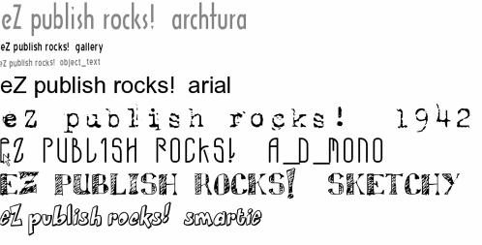

Other Template Operators
Let's now move on to other operators for the template.

count
Returns the "count" of the input value. The result depends on the type of the input value. The following table summarizes its effect.
Input type | Result of count
array | the number of elements in the array
object | the number of object attributes
string | the string length
numeric | the value of the numerical
boolean | 0 for false(), 1 for true()
other | 0

Examples:
{array( 1, 3, 5, 7 )|count} returns 4;
{'The quick brown fox'|count} returns 19.

Accessing Variables in the ini Files
ini variables can be read with the ezini operator. It takes three arguments:
- A section in the ini file (as put between [] brackets)
- The variable itself
- Optional: the ini file, if other than site.ini
{ezini('[section]','[variable]','[optional ini file]')}
For example:
{ezini('SiteAccessSettings','AnonymousAccessList')}
This returns an array of the modules and functions that do not require a real user logged in.
You are not limited to the standard eZ publish ini files. You could also create your own site specific ini files and sections to store design and layout parameters. This is handy if you need such parameters in different templates.

cond
The cond operator expects an array with pairs of a condition and a value that will returned upon a matching value of true.
For example:
{cond(false(),'red', true(),'blue')}
This returns the string "blue"

first_set
The first_set operator expects an array of values and/or variables and will return the first that is set.
For example:
{let $rootnode=2}
{first_set($myvar, $rootnode)}
{/set}
This returns $rootnode with a value of 2 unless $myvar is an existing variable and has a value assigned.

eZ publish Kernel Operators

ezurl
Makes sure that the URL works for both virtual hosts and non-virtual host setups. For the latter, this means the inclusion of index.php in the URL, together with hostname and siteaccess.

ezroot
This is the same as ezurl, but will omit the index.php from the url, regardless of your server configuration mode.

choose
Uses the input as an index to pick an element from the array parameter. For example:
{1|choose('america', 'russia', 'china')} returns "russia".

contains
Returns true if the first parameter value is found in the input value, which must be an array. Currently it works the same way as the PHP function in_array(). For example:
{array(1,3,5,7)|contains(4)} returns false().

currentdate
The currentdate operator returns the current timestamp. For display purposes, you can feed this value through the datetime operator:
{currentdate()| datetime('custom','%Y-%m-%d %H:%m')}
This returns the current date and time.
For custom displays, you can use the following format characters:

Format Character | Description
%a | Lowercase Ante meridiem and Post meridiem
%A | Uppercase Ante meridiem and Post meridiem
%B | Swatch Internet time
%d | Day of the month, 2 digits with leading zeros
%D | A textual representation of a day, three letters
%F | A full textual representation of a month, such as January or March
%g | 12-hour format of an hour without leading zeros
%G | 24-hour format of an hour without leading zeros
%h | 12-hour format of an hour with leading zeros
%H | 24-hour format of an hour with leading zeros
%i | Minutes with leading zeros
%I | Whether or not the date is in daylight savings time
%j | Day of the month without leading zeros
%l | A full textual representation of the day of the week
%L | Whether it's a leap year
%m | Numeric representation of a month, with leading zeros
%M | A short textual representation of a month; three letters
%n | Numeric representation of a month, without leading zeros
%O | Difference to Greenwich time (GMT) in hours
%r | RFC 2822 formatted date
%s | Seconds, with leading zeros
%S | English ordinal suffix for the day of the month; 2 characters

Format Character Description

%t | Number of days in the given month
%T | Timezone setting of this machine
%U | Seconds since the Unix Epoch (January 1 1970 00:00:00 GMT)
%w | Numeric representation of the day of the week
%W | ISO-8601 week number of year, weeks starting on Monday (added in PHP 4.1.0)
%Y | A full numeric representation of a year; 4 digits
%y | A two digit representation of a year
%z | The day of the year (starting from 0)
%Z | Timezone offset in seconds. The offset for timezones west of UTC is always negative, and for those east of UTC is always positive.

treemenu
The treemenu operator can be used to build tree-like menu structures. It expects the following arguments:

Parameter | Type | Default | Required | Description
path | array | false() | yes | An array of node IDs which form the path to the current node
node_id | integer | false() | yes | The current node ID
class_filter | array | if false(), actually array(1,8) | no | An array of class IDs to include, as in the content/list function
depth_skip | int | false() | no | The start depth in the node tree where you want your menu structure to start from the root level
max_level | int | false() | no | The maximum depth your menu should have

The returned array consists of sub-arrays containing:
- $tmpNodeID: The node ID
- level: The depth level relative from the root level
- url_alias: The URL alias for this item
- url: The normal URL for this item
- text: The node name
- is_selected: A boolean to determine if the item is on the current node path
The following example illustrates the use for a top-level menu consisting of just one level. Here we don't want the "tree" functionality, but rather the element that is "active" for highlighting.
{let menuLevel1=treemenu($module_result.path,
$module_result.node_id, array('folder'),
0,
1)}
{* loop over the menus and build the menu structure *}
{section name=Menu loop=$menuLevel1}
{section show=$Menu:item.is_selected}
<a href={$Menu:item.url_alias|ezurl} class='menuselected'>
{$Menu:item.text}</a>
{section-else}
<a href={$Menu:item.url_alias|ezurl} class='menus'>
{$Menu:item.text}</a>
{/section}
{delimiter} | {/delimiter}
{/section}
{/let}

GNU Free Documentation License

GNU Free Documentation License
Version 1.3, 3 November 2008
Copyright (C) 2000, 2001, 2002, 2007, 2008 Free Software Foundation, Inc. https://fsf.org/
Everyone is permitted to copy and distribute verbatim copies of this license document, but changing it is not allowed.

0. PREAMBLE
The purpose of this License is to make a manual, textbook, or other functional and useful document "free" in the sense of freedom: to assure everyone the effective freedom to copy and redistribute it, with or without modifying it, either commercially or noncommercially. Secondarily, this License preserves for the author and publisher a way to get credit for their work, while not being considered responsible for modifications made by others.
This License is a kind of "copyleft", which means that derivative works of the document must themselves be free in the same sense. It complements the GNU General Public License, which is a copyleft license designed for free software.
We have designed this License in order to use it for manuals for free software, because free software needs free documentation: a free program should come with manuals providing the same freedoms that the software does. But this License is not limited to software manuals; it can be used for any textual work, regardless of subject matter or whether it is published as a printed book. We recommend this License principally for works whose purpose is instruction or reference.

1. APPLICABILITY AND DEFINITIONS
This License applies to any manual or other work, in any medium, that contains a notice placed by the copyright holder saying it can be distributed under the terms of this License. Such a notice grants a world-wide, royalty-free license, unlimited in duration, to use that work under the conditions stated herein. The "Document", below, refers to any such manual or work. Any member of the public is a licensee, and is addressed as "you". You accept the license if you copy, modify or distribute the work in a way requiring permission under copyright law.
A "Modified Version" of the Document means any work containing the Document or a portion of it, either copied verbatim, or with modifications and/or translated into another language.
A "Secondary Section" is a named appendix or a front-matter section of the Document that deals exclusively with the relationship of the publishers or authors of the Document to the Document's overall subject (or to related matters) and contains nothing that could fall directly within that overall subject. (Thus, if the Document is in part a textbook of mathematics, a Secondary Section may not explain any mathematics.) The relationship could be a matter of historical connection with the subject or with related matters, or of legal, commercial, philosophical, ethical or political position regarding them.
The "Invariant Sections" are certain Secondary Sections whose titles are designated, as being those of Invariant Sections, in the notice that says that the Document is released under this License. If a section does not fit the above definition of Secondary then it is not allowed to be designated as Invariant. The Document may contain zero Invariant Sections. If the Document does not identify any Invariant Sections then there are none.
The "Cover Texts" are certain short passages of text that are listed, as Front-Cover Texts or Back-Cover Texts, in the notice that says that the Document is released under this License. A Front-Cover Text may be at most 5 words, and a Back-Cover Text may be at most 25 words.
A "Transparent" copy of the Document means a machine-readable copy, represented in a format whose specification is available to the general public, that is suitable for revising the document straightforwardly with generic text editors or (for images composed of pixels) generic paint programs or (for drawings) some widely available drawing editor, and that is suitable for input to text formatters or for automatic translation to a variety of formats suitable for input to text formatters. A copy made in an otherwise Transparent file format whose markup, or absence of markup, has been arranged to thwart or discourage subsequent modification by readers is not Transparent. An image format is not Transparent if used for any substantial amount of text. A copy that is not "Transparent" is called "Opaque".
Examples of suitable formats for Transparent copies include plain ASCII without markup, Texinfo input format, LaTeX input format, SGML or XML using a publicly available DTD, and standard-conforming simple HTML, PostScript or PDF designed for human modification. Examples of transparent image formats include PNG, XCF and JPG. Opaque formats include proprietary formats that can be read and edited only by proprietary word processors, SGML or XML for which the DTD and/or processing tools are not generally available, and the machine-generated HTML, PostScript or PDF produced by some word processors for output purposes only.
The "Title Page" means, for a printed book, the title page itself, plus such following pages as are needed to hold, legibly, the material this License requires to appear in the title page. For works in formats which do not have any title page as such, "Title Page" means the text near the most prominent appearance of the work's title, preceding the beginning of the body of the text.
The "publisher" means any person or entity that distributes copies of the Document to the public.
A section "Entitled XYZ" means a named subunit of the Document whose title either is precisely XYZ or contains XYZ in parentheses following text that translates XYZ in another language. (Here XYZ stands for a specific section name mentioned below, such as "Acknowledgements", "Dedications", "Endorsements", or "History".) To "Preserve the Title" of such a section when you modify the Document means that it remains a section "Entitled XYZ" according to this definition.
The Document may include Warranty Disclaimers next to the notice which states that this License applies to the Document. These Warranty Disclaimers are considered to be included by reference in this License, but only as regards disclaiming warranties: any other implication that these Warranty Disclaimers may have is void and has no effect on the meaning of this License.

2. VERBATIM COPYING
You may copy and distribute the Document in any medium, either commercially or noncommercially, provided that this License, the copyright notices, and the license notice saying this License applies to the Document are reproduced in all copies, and that you add no other conditions whatsoever to those of this License. You may not use technical measures to obstruct or control the reading or further copying of the copies you make or distribute. However, you may accept compensation in exchange for copies. If you distribute a large enough number of copies you must also follow the conditions in section 3.
You may also lend copies, under the same conditions stated above, and you may publicly display copies.

3. COPYING IN QUANTITY
If you publish printed copies (or copies in media that commonly have printed covers) of the Document, numbering more than 100, and the Document's license notice requires Cover Texts, you must enclose the copies in covers that carry, clearly and legibly, all these Cover Texts: Front-Cover Texts on the front cover, and Back-Cover Texts on the back cover. Both covers must also clearly and legibly identify you as the publisher of these copies. The front cover must present the full title with all words of the title equally prominent and visible. You may add other material on the covers in addition. Copying with changes limited to the covers, as long as they preserve the title of the Document and satisfy these conditions, can be treated as verbatim copying in other respects.
If the required texts for either cover are too voluminous to fit legibly, you should put the first ones listed (as many as fit reasonably) on the actual cover, and continue the rest onto adjacent pages.
If you publish or distribute Opaque copies of the Document numbering more than 100, you must either include a machine-readable Transparent copy along with each Opaque copy, or state in or with each Opaque copy a computer-network location from which the general network-using public has access to download using public-standard network protocols a complete Transparent copy of the Document, free of added material. If you use the latter option, you must take reasonably prudent steps, when you begin distribution of Opaque copies in quantity, to ensure that this Transparent copy will remain thus accessible at the stated location until at least one year after the last time you distribute an Opaque copy (directly or through your agents or retailers) of that edition to the public.
It is requested, but not required, that you contact the authors of the Document well before redistributing any large number of copies, to give them a chance to provide you with an updated version of the Document.

4. MODIFICATIONS
You may copy and distribute a Modified Version of the Document under the conditions of sections 2 and 3 above, provided that you release the Modified Version under precisely this License, with the Modified Version filling the role of the Document, thus licensing distribution and modification of the Modified Version to whoever possesses a copy of it. In addition, you must do these things in the Modified Version:
- A. Use in the Title Page (and on the covers, if any) a title distinct from that of the Document, and from those of previous versions (which should, if there were any, be listed in the History section of the Document). You may use the same title as a previous version if the original publisher of that version gives permission.
- B. List on the Title Page, as authors, one or more persons or entities responsible for authorship of the modifications in the Modified Version, together with at least five of the principal authors of the Document (all of its principal authors, if it has fewer than five), unless they release you from this requirement.
- C. State on the Title page the name of the publisher of the Modified Version, as the publisher.
- D. Preserve all the copyright notices of the Document.
- E. Add an appropriate copyright notice for your modifications adjacent to the other copyright notices.
- F. Include, immediately after the copyright notices, a license notice giving the public permission to use the Modified Version under the terms of this License, in the form shown in the Addendum below.
- G. Preserve in that license notice the full lists of Invariant Sections and required Cover Texts given in the Document's license notice.
- H. Include an unaltered copy of this License.
- I. Preserve the section Entitled "History", Preserve its Title, and add to it an item stating at least the title, year, new authors, and publisher of the Modified Version as given on the Title Page. If there is no section Entitled "History" in the Document, create one stating the title, year, authors, and publisher of the Document as given on its Title Page, then add an item describing the Modified Version as stated in the previous sentence.
- J. Preserve the network location, if any, given in the Document for public access to a Transparent copy of the Document, and likewise the network locations given in the Document for previous versions it was based on. These may be placed in the "History" section. You may omit a network location for a work that was published at least four years before the Document itself, or if the original publisher of the version it refers to gives permission.
- K. For any section Entitled "Acknowledgements" or "Dedications", Preserve the Title of the section, and preserve in the section all the substance and tone of each of the contributor acknowledgements and/or dedications given therein.
- L. Preserve all the Invariant Sections of the Document, unaltered in their text and in their titles. Section numbers or the equivalent are not considered part of the section titles.
- M. Delete any section Entitled "Endorsements". Such a section may not be included in the Modified Version.
- N. Do not retitle any existing section to be Entitled "Endorsements" or to conflict in title with any Invariant Section.
- O. Preserve any Warranty Disclaimers.
If the Modified Version includes new front-matter sections or appendices that qualify as Secondary Sections and contain no material copied from the Document, you may at your option designate some or all of these sections as invariant. To do this, add their titles to the list of Invariant Sections in the Modified Version's license notice. These titles must be distinct from any other section titles.
You may add a section Entitled "Endorsements", provided it contains nothing but endorsements of your Modified Version by various parties—for example, statements of peer review or that the text has been approved by an organization as the authoritative definition of a standard.
You may add a passage of up to five words as a Front-Cover Text, and a passage of up to 25 words as a Back-Cover Text, to the end of the list of Cover Texts in the Modified Version. Only one passage of Front-Cover Text and one of Back-Cover Text may be added by (or through arrangements made by) any one entity. If the Document already includes a cover text for the same cover, previously added by you or by arrangement made by the same entity you are acting on behalf of, you may not add another; but you may replace the old one, on explicit permission from the previous publisher that added the old one.
The author(s) and publisher(s) of the Document do not by this License give permission to use their names for publicity for or to assert or imply endorsement of any Modified Version.

5. COMBINING DOCUMENTS
You may combine the Document with other documents released under this License, under the terms defined in section 4 above for modified versions, provided that you include in the combination all of the Invariant Sections of all of the original documents, unmodified, and list them all as Invariant Sections of your combined work in its license notice, and that you preserve all their Warranty Disclaimers.
The combined work need only contain one copy of this License, and multiple identical Invariant Sections may be replaced with a single copy. If there are multiple Invariant Sections with the same name but different contents, make the title of each such section unique by adding at the end of it, in parentheses, the name of the original author or publisher of that section if known, or else a unique number. Make the same adjustment to the section titles in the list of Invariant Sections in the license notice of the combined work.
In the combination, you must combine any sections Entitled "History" in the various original documents, forming one section Entitled "History"; likewise combine any sections Entitled "Acknowledgements", and any sections Entitled "Dedications". You must delete all sections Entitled "Endorsements".

6. COLLECTIONS OF DOCUMENTS
You may make a collection consisting of the Document and other documents released under this License, and replace the individual copies of this License in the various documents with a single copy that is included in the collection, provided that you follow the rules of this License for verbatim copying of each of the documents in all other respects.
You may extract a single document from such a collection, and distribute it individually under this License, provided you insert a copy of this License into the extracted document, and follow this License in all other respects regarding verbatim copying of that document.

7. AGGREGATION WITH INDEPENDENT WORKS
A compilation of the Document or its derivatives with other separate and independent documents or works, in or on a volume of a storage or distribution medium, is called an "aggregate" if the copyright resulting from the compilation is not used to limit the legal rights of the compilation's users beyond what the individual works permit. When the Document is included in an aggregate, this License does not apply to the other works in the aggregate which are not themselves derivative works of the Document.
If the Cover Text requirement of section 3 is applicable to these copies of the Document, then if the Document is less than one half of the entire aggregate, the Document's Cover Texts may be placed on covers that bracket the Document within the aggregate, or the electronic equivalent of covers if the Document is in electronic form. Otherwise they must appear on printed covers that bracket the whole aggregate.

8. TRANSLATION
Translation is considered a kind of modification, so you may distribute translations of the Document under the terms of section 4. Replacing Invariant Sections with translations requires special permission from their copyright holders, but you may include translations of some or all Invariant Sections in addition to the original versions of these Invariant Sections. You may include a translation of this License, and all the license notices in the Document, and any Warranty Disclaimers, provided that you also include the original English version of this License and the original versions of those notices and disclaimers. In case of a disagreement between the translation and the original version of this License or a notice or disclaimer, the original version will prevail.
If a section in the Document is Entitled "Acknowledgements", "Dedications", or "History", the requirement (section 4) to Preserve its Title (section 1) will typically require changing the actual title.

9. TERMINATION
You may not copy, modify, sublicense, or distribute the Document except as expressly provided under this License. Any attempt otherwise to copy, modify, sublicense, or distribute it is void, and will automatically terminate your rights under this License.
However, if you cease all violation of this License, then your license from a particular copyright holder is reinstated (a) provisionally, unless and until the copyright holder explicitly and finally terminates your license, and (b) permanently, if the copyright holder fails to notify you of the violation by some reasonable means prior to 60 days after the cessation.
Moreover, your license from a particular copyright holder is reinstated permanently if the copyright holder notifies you of the violation by some reasonable means, this is the first time you have received notice of violation of this License (for any work) from that copyright holder, and you cure the violation prior to 30 days after your receipt of the notice.
Termination of your rights under this section does not terminate the licenses of parties who have received copies or rights from you under this License. If your rights have been terminated and not permanently reinstated, receipt of a copy of some or all of the same material does not give you any rights to use it.

10. FUTURE REVISIONS OF THIS LICENSE
The Free Software Foundation may publish new, revised versions of the GNU Free Documentation License from time to time. Such new versions will be similar in spirit to the present version, but may differ in detail to address new problems or concerns. See https://www.gnu.org/licenses/.
Each version of the License is given a distinguishing version number. If the Document specifies that a particular numbered version of this License "or any later version" applies to it, you have the option of following the terms and conditions either of that specified version or of any later version that has been published (not as a draft) by the Free Software Foundation. If the Document does not specify a version number of this License, you may choose any version ever published (not as a draft) by the Free Software Foundation. If the Document specifies that a proxy can decide which future versions of this License can be used, that proxy's public statement of acceptance of a version permanently authorizes you to choose that version for the Document.

11. RELICENSING
"Massive Multiauthor Collaboration Site" (or "MMC Site") means any World Wide Web server that publishes copyrightable works and also provides prominent facilities for anybody to edit those works. A public wiki that anybody can edit is an example of such a server. A "Massive Multiauthor Collaboration" (or "MMC") contained in the site means any set of copyrightable works thus published on the MMC site.
"CC-BY-SA" means the Creative Commons Attribution-Share Alike 3.0 license published by Creative Commons Corporation, a not-for-profit corporation with a principal place of business in San Francisco, California, as well as future copyleft versions of that license published by that same organization.
"Incorporate" means to publish or republish a Document, in whole or in part, as part of another Document.
An MMC is "eligible for relicensing" if it is licensed under this License, and if all works that were first published under this License somewhere other than this MMC, and subsequently incorporated in whole or in part into the MMC, (1) had no cover texts or invariant sections, and (2) were thus incorporated prior to November 1, 2008.
The operator of an MMC Site may republish an MMC contained in the site under CC-BY-SA on the same site at any time before August 1, 2009, provided the MMC is eligible for relicensing.

ADDENDUM: How to use this License for your documents
To use this License in a document you have written, include a copy of the License in the document and put the following copyright and license notices just after the title page:
Copyright (C) YEAR YOUR NAME.
Permission is granted to copy, distribute and/or modify this document
under the terms of the GNU Free Documentation License, Version 1.3
or any later version published by the Free Software Foundation;
with no Invariant Sections, no Front-Cover Texts, and no Back-Cover Texts.
A copy of the license is included in the section entitled "GNU
Free Documentation License".
If you have Invariant Sections, Front-Cover Texts and Back-Cover Texts, replace the "with … Texts." line with this:
with the Invariant Sections being LIST THEIR TITLES, with the
Front-Cover Texts being LIST, and with the Back-Cover Texts being LIST.
If you have Invariant Sections without Cover Texts, or some other combination of the three, merge those two alternatives to suit the situation.
If your document contains nontrivial examples of program code, we recommend releasing these examples in parallel under your choice of free software license, such as the GNU General Public License, to permit their use in free software.

Index

A
ab, 335
access control limitations, 32 accessibility standards, 310
action extension, 183
actions, 183
add an extension, 150 adding content
create content classes, 37 admin view, case study, 261 administrator functions, 61
advanced keywords, 122 anonymous user submissions, 146 Apache Benchmarking tool, 335 Apache virtualhost, 7
APC Alternative PHP Cache, 249 array matching, 99
array operators, 344-348
array_sum operator, 344
attribute() function, 130, 221
attribute templates, 82 authentication methods
external, 227
internal, 227
Kerberos, 227
LDAP, 227
Microsoft Windows domain controller, 227 single sign-on, 228
authorization, 31
Awstats, 238

B
backup, 251
bandwidth, 236
begins_with operator, 344
benchmarking, 335 benefits of eZ publish, 311 blog site package, 17
breadcrumb navigation, 115
C
cache administration, 64 cache block parameters
expiry, 110
keys, 110
cache blocks, 333
cache blocks, 109 callback
about, 212
creating callback, example, 213-214 enabling callback, 212
passing variables, 214
permissions, 218
testing, 218
user settings, 217
cascading templates, 112 case
mandatory attributes, 299
case study 1
archiving, 305
client, 253- 254
client requirements, 257
client training, 301
CMS selection, 258
content areas, 282
content model, 265 content model, final, 266
content model, original, 266 content population, review, 304 CRM integration, 305
deployment, 301
development lifecycle, 303 development, display logic, 280 development, installation, 278
development, navigation, 282 development, roles and permissions, 279 development, sections, 279
development, templates, 281
existing site, 255 extending the site, 304

HTML prototype, 274
interface design, 272
maintenance, 301
process flowchart, 256
comparing strings, 344 configuration file extensions, 10 content classes
about, 28, 132

project assessment, 302 attributes, 134
project requirements, 255 create, 132-133
sections, admin view, 261 how to create, 133
sections, links, 263 identifier, 132
sections, miscellaneous, 264 states, 132

sections, user view, 259 site specifications, 259
support, 301
template design, 267
testing, 300
content management system, 25 content model, 265
content module functions, 101-104 content object classes, 127
content object versions, 29

workflow, need for, 305 content objects case study 2 about, 27-28, 135
client, 311 attributes, 137
content design, 328-331 create, 48, 136
CSS rules, 328 editing, 50
existing design, 311 related content, 53
existing structure, 312 states, 136
optimization effects, 336 translations, 51
performance, 332 content sources, 84
planning, 314 content types, case study 1
resources, 337 Article, 269
structural changes, 315 client, 269
template design, 316-323 links, 269
changing case, 341 news, 269
class templates, 329 Overview Article, 269
classes publication, 269
Categorytype, 221 training course, 269
eZContentClass, 128-132 content view, 30, 81
eZContentClassAttribute, 134 contentless nodes, 119

ezContentObject, 135
eZContentObject, 128
ezContentObjectAttribute, 138
eZPersistentObject, 128, 221
eZSearch, 146
corporate site package, 17 count operator, 357
create() function, 221 creating a new class, 329 creator, showing, 122

coding functions, 163 cron jobs
coding operators, 177 about, 247
comment button, adding, 117 runcronjobs.php script, 9
commenting files, 84 crontab, 9
comments, 84 cross-template variables, 93
community sharing CSS, 309
eZ publish contributions, 205 custom content type, publication
public SVN, 205 attachment, 270
SourceForge, 206 attachment, description, 270

author, 270 time limits, 239

cost, 270
date, 270
description of contents, 270 publisher, 270
title, 270
custom operators, 176
custom threaded forum template, 124 custom-built CMS, 255
design folder, 6, 12
directories, 207
disable a module/function, 36 displaying date, 117 documentation
access control, 243
contact details, 241
disaster recovery, 243
DNS information, 242

D extension, 206

data import/export, 187-190
data interoperability, 196
datatype extension, 152 datatype functions
fetchClassAttributeHTTPInput(), 169
fixupClassAttributeHTTPInput(), 170
metaData(), 172
storeClassAttribute(), 170
title(), 172
validateClassAttributeHTTPInput(), 170
datatype wizard, 165
datatypes, 164
class attributes, working with, 169
hardware, 242 how to update, 241 location, 242
operating system, 242
patches, 242
software, 242
TCP/IP information, 242
upgrading, 243 download eZ publish, 5 Doxygen, 153
dummy nodes, 119

E

complex datatypes, 173 e-commerce module extension, category

construction, 167
datatype

datatype wizard, 165-166 activation, 219
default class values, 168 database table, 220
default object values, 168 database, communication, 221
implementation, 167 editing the class, 224
initialization, 168 editing the object, 224
object attributes, working with, 171 templates, 224
settings, 164 viewing the object, 224
storing information, 167 working, 221-223
templates, 164 e-commerce module extension, WorldPay
types of, 38-45 create workflows, 208
date tasks, 117 eventtype directory, 209
dedicated hosting, 239 extension directory, 209, 213
definition() function, 129, 221 how it works, 215-216
deploying eZ publish ini settings, 211-217 budget, 239 key functions, 214
deployment checklist, 249 known issues, 212
hosting requirements, 5 module, creating, 213-214
number of visitors, 236 overview, 209
reporting, 238 PHP source code, 210
security needs, 237 requirements, 207
system requirements, 236

workflow routine, 211
WorldPay module, 212
extract operator, 343-346
extract_left operator, 343

edit functions, 116 extract_right operator, 343
edit link, adding, 117 ezauthor datatype, 38
edit template variables, 92 ezbinaryfile datatype, 38
edit templates, 82 ezboolean datatype, 38
ends_with operator, 344 ezdate datatype, 38
error codes, 128 ezdatetime datatype, 38
example site ezdesign integration, 281
activities calender, 71 ezemail datatype, 39
create basic classes, 69 ezenum datatype, 39
discussion forums, 71 ezfloat datatype, 40
document types, 70 eZHTTPTool eZ library routine, 214
images, 70 ezidentifier datatype, 40
members, 77 ezimage datatype, 40
personalization, 72 ezimage integration, 281
role assignments, 76 ezinisetting datatype, 41
roles, 74 ezinteger datatype, 40
sections setup, 74 ezisbn datatype, 41
user groups, 75 ezkeyword datatype, 41
visitors, 77 ezlink attribute, 62
execute() function, 179 ezmatrix datatype, 42
executing operators, 177 ezmedia datatype, 42
expiry, cache blocks, 110 eZModuleOperationInfo() function, 140
explode() function, 222 ezobjectrelation datatype, 42, 54
extension development, practices ezobjectrelationlist datatype, 43, 54
defining goals, 204 eZOperationHandler() function, 140
development tools, 205 ezoption datatype, 43
documentation, 206 ezpackage datatype, 43
sharing, 205 eZPersistentObject class, functions
software requirements, 204 fetching data, 131
support forums, 204 hasAttribute(), 131
testing, 204 other functions, 132
timescales, 204 storing data, 131
upgrades/updates, 206 ezpreference system, 93 extensions ezprice datatype, 43
actions, 183 eZSearchEngine plug-in, 146
add an extension, 150 searching, 65
category datatype, 219 available filters, 148
designing an extension, 203-206 description, 146
documentation, 153 module views, 148
e-commerce module, example, 206 setup, 147
locate an extension, 151 ezselection datatype, 44, 165
subdirectories, 151 ezstring datatype, 44
template operators, 173 ezsubtreesubscription datatype, 44
third party extensions, 68 eZ systems, 1
translations, 184 eztext datatype, 44

eztime datatype, 38 remove(), 221
ezurl datatype, 45 setAttribute(), 130
ezuser datatype, 45 store(), 222
ezxmltext attribute, 62 storeObjectAttribute(), 222
ezxmltext datatype strtoupper(), 174
about, 45 tree(), 105
custom tags, 48 upcase(), 174
headings, 46 validateClassAttributeHTTPInput(), 170
hyperlinks, 47 version_list(), 108

lists, 46
objects, 47
tables, 47
view(), 31

G

text emphasis, 47 gallery site package, 17
unformatted text, 47 GD, 8, 11
Google integration, 230-232

F
fetch() function, 104, 221 H
fetchByAttribute() function, 223 hasAccessTo() function, 127
fetchByCategoryAndAttribute() function, 221 hasAttribute() function, 131
fetchClassAttributeHTTPInput() function, 169 hosting, choosing
fetch parameters, 105-106 time limits, 239
fetching a single node, 104 hostname site access type, 18
fetching node lists, 105 htaccess, 7, 20
fetching the current user, 108
filtering classes, 106
I
folder object, publishing, 197

folders, 6
forum site package, 17 forum template, custom, 124 functions
attribute(), 130, 221
attributes(), 131
create(), 221
definition(), 129, 221
execute(), 179
explode(), 222
eZModuleOperationInfo(), 140
eZOperationHandler(), 140
fetch(), 104, 221
fetchByAttribute(), 223
fetchByCategoryAndAttribute(), 221
fetchClassAttributeHTTPInput(), 169
hasAccessTo(), 127
hasAttribute(), 131
implode(), 223
list(), 105
redirect(), 161
image operator, 355
image optmization,
about, 8, 354
GD, 8, 247
image operator, 355
ImageMagick, 8, 247
image.ini, 10
imagefile operator, 356
ImageMagick, 8, 11
implode() function, 223
implode operator, 346
information array, 284 information collector
about, 48
policies, 146
setting up, 145
types, 145
ini files
browse.ini, 54
collect.ini, 145
content.ini, 29

content.ini.append.php, 183, 217
design.ini.append, 217
i18n.ini, 10
image.ini, 10
layout.ini.append, 217
K
kernel
classes, 5
folder, 10

ldap.ini, 200
module.ini.append, 217
override.ini, 10
override.ini.append.php, 112
site.ini, 10
template.ini, 173
workflow.ini.append, 217
module functions, 101
operators, 359
keys, cache blocks, 110 keywords, advanced, 122
keywords, listing, 122

L

worldpay.ini.append.php, 217 l10n operator, 350
initialization files, example, 283 l18n.ini, 10
initializing operators, 177 lib folder, 6
installation libraries
Apache setup, 244 lib/ezsoap/classes/ezsoapclient.php, 230
Apache virtual host settings, 7 lib/ezsoap/classes/ezsoaprequest.php, 230 database setup, 246 limitation checks, 127
e-mail setup, 248 links, case study, 263
Image settings, 8 list() function, 105
Initialize the database, 6 listing keywords, 122
linux environment, 243 logical operators, 351-353
PHP accelerators, 248 login handlers
PHP setup, 245 LDAP, 199
Setup Wizard, 10-22 text file, 201
troubleshooting, 22
Unpack files, 5 M
integration, 225 mathematical functions, 348-349
authentication, 227 media tab, 66
bridging external applications, 225 menus
communicate with Google, 230 breadcrumb navigation, 115
identification, 227 top level, 114
modifying existing code, 233 tree, 115
SOAP, 230 metadata standards, 229
strategies, 226 missing users sections, 67
interface design, case study mod_rewrite, 7
HTML prototype, 274 modifier, showing, 122
modularization, 82
visual design, 272
intranet site package, 17

ionCube accelerator, 249

J
joining strings, 343
module extension, 152
module functions, 162 coding a function, 163 registering a function, 162

modules
about, 153
coding, 159

defining a module, 154 processing, 140
module functions, 162 statuses, 140

processing a template, 160 reading input, 159 redirecting a module, 161 registering a module, 153 returning information, 159
using templates, 160
view actions, 156
view parameters, 155
view permissions, 155
OpenFTS plug-in, 146 operators
choose, 359
coding, 177
contains, 359
count, 357
count_chars, 344
creating, 176
currentdate, 359

multi-language support, 16 executing, 177
extract, 343
- ezini, 358

nameless sections, 100
navigation menus, 114
newDatatype datatype, 165, 167 news site package, 17
nice urls, 81
nmap, 251
node tree, 26 nodes
counting, 107
fetching, 104
filtering, 106
sorting, 107
nodes without content, 119 nodes, counting, 107 normal post variables, 158 notification events, 142, 185
collaborations, 187
event handlers, 143
notification system, 68
publish operation, 143
statuses, 145
subtree notification, 143
ezroot, 359
ezurl, 359
image, 355
imagefile, 356
initializing, 177
kernel, 359
localization, 349
logical operators, 351
registering, 176
shorten, 118
striptags, 118
translation operators, 349
treemenu, 361
type checking operators, 353-354 wrap, 342
override folder, 9
override.ini, 10
override.ini.append.php, syntax, 112
overrides, 329
overriding templates, 112

P

notification handlers, 144 packages, 68
pad operators, 343
- page layout template, case study 1

object model, 5 objects
attributes, 128
persistent object model, 128 removing/restoring, 61
operation, 139
definition, 139
determine top node ID of section, 285 development lifecycle, 281
information array, 284
initialization files, 283
initialize variables, 283
primary navigation, 286
secondary navigation, 288 secondary navigation, code, 290

variables, assign values, 285 redirect() function, 161
page layout view, 30 redirecting modules, 161
PDF export, 67 registering functions, 162
performance, improving, 109 registering operators, 176
permissions, related content, 53
about, 5, 57 related objects panel, 53
folder permissions, 12 relationships
identifying users, 127 content objects and notification system, 143
setting up, 126 eZContentObject class and tables, 135
persistent object model, 128 objects and eZSearchEngine plug-in, 147
personal tab, 68 objects, roles, permissions, and limitations,
PHP accelerators 126
about, 234, 248 workflows and triggers, 139

Alternative PHP Cache, 335 IonCube PHP Accelerator, 335 Turck MMCache, 335
phpMyAdmin, 7 plain site package, 17 plug-ins, 146
policies, 5, 31
policy limitations, types, 126 port scanning, 251
port site access type, 18 ports, 251
remove button, adding, 117 remove() function, 221 restrictions. See permissions reusing template code, 82 role system, 35
roles, 5, 31
RSS, 62, 193,
RSS admin page, 194 RSS import, 195

S

post variables, 156 sample site, create, 69
post_action_parameters variable, 157 scalar matching, 99
post_actions variable, 157 searching, See eZSearchEngine plug-in
PostgreSQL, 14 section function, 94-98
pre_publish trigger, 140 section parameters, 94
problems sections, 27, 66, 88
memory limits, 22 Secure Socket Layer (SSL), 238
PHP running as CGI, 23 security
processing an operation, 140 htaccess, 20

project reqirements. See typical project
requirements
Public Key Infrastructure (PKI), 238 publication content type, See custom content
levels, 237
requirements, 237
virtualhost mode, 7, 20

type, publication security, requirements, 237

publish operation, 143-144 publishing date, showing, 122

Q
semantically correct markup, 309
sendmail, 13
seperation, content and application logic, 30 server, choosing, 240
setAttribute() function, 130

Qt Linguist, 350 settings folder, 6, 9, 12
Setup Wizard, 10-22
R shared hosting

RAD, 68
time limits, 239
Shop tab, 69

shorten, 343 system information, 65
shorten operator, 118
single sign-on, 228 T
site access types template compiling, 333
Hostname, 18 template functions
Port, 18 {append-block}, 86
URL, 18 {default}, 85
site packages, 17 {let}, 85
site statistics {section}, 94-97
reporting, 238
{set}, 85
site structure
{set-block}, 100
content class attributes, 28

content classes, 28
content object, 28
node tree, 26
sections, 27
site.ini, 10
siteaccess folder, 9
SOAP, 149, 187-197, 225-233
example, 188
required functions, 190 XML client request, 192 XML server response, 192
SOAP example, 230-232
standards. See accessibility standards
accessibility, 310
Section 508 guidelines, 310
web, 307
Web Accessibility Initiative, 310
standards, advantages, 310
store() function, 222
storeObjectAttribute() function, 222 string conversion, automatic, 119 string manipulation
automatic linking, 119
comparing strings, 343
counting strings, 344
extracting strings, 343
joining strings, 343 limiting text output, 118 matching, 341
string operators, 339-341
striptags operator, 118
structuring content, 26
supported systems, 243 SVN code repository, 150 switch function, 98
{switch}, 98
template operator wizard, 174 template operators, 173
template operators, adding your own, 111 template output
controlling flow, 94 template override system, 111 template parameters
match, 113
matchfile, 113
source, 113
subdir, 113
template tasks, 114
templates, 59, 319-323 templates, edit functionality, 116 testing, case study 1
content population, 301
functional testing, 300
implementing, 300
requirements, 300
specifications, 300
text file login, 201 translation extension, 184
overriding, 185
URL translation, 61
tree() function, 105
tree menus, 115
triggers, 54, 138
return statuses, 141 troubleshooting, see problems Turck MMCache, 249
type checking operators, 353-354 typical project requirements, 257-258

upcase() function, 174
U view templates, 81
virtualhost, 7, 20

URL site access type, 18 URL translation, 61
W

user groups, show, 120 user panel, creating, 119
user preferences function, 120 user roles, show, 120
user view, case study, 259

V
validateClassAttributeHTTPInput() function, 170
Web Accessibility Initiative, 310
web standards, 307
CSS, 309
XHTML, 308
Webalizer, 238
webshop site package, 17 wireframes, 267
wizards
datatype wizard, 165 template operator wizard, 174

var folder, 6, 12 workflow, 54, 138
var parameter, section function, 101 operation, 140
variable scope, 85-86 parent class, 179
variables settings, 178
$attribute, 173 triggers, 138, 181
$class_attribute, 172 workflow events, 55
$FunctionList, 154 workflow eventtype extension, 152
$Module, 154 WorldPay extension. See e-commerce module

$module_result, 89, 159
extension, WorldPay

$module_result.content_info, 89 wrap operator, 342
$node, 90
$node.object, 92
X
$ViewList, 154

changing variables outside a loop, 100 content view variables, 90
definition, 85
edit template variables, 92 ini variables, 358
XHTML, 307-334
XHTML compliance, 307
XML tags, 47-48

Z

namespaces, 88, 99 Zend performance Suite, 249
pagelayout template variables, 89
predefined variables, 88 setting and modifying, 85 type creators, 87
types, 87
version history audit trail, showing, 121 version information, displaying, 108 version_list() function, 108
version, content objects, 29 view() function, 31
view actions, 156
view caching, 333
view navigation, 158
view parameters, types, 156

