安全工程概论题库
PS 红字为正确答案，黄字为曾经错选

Quiz1
Topic The fire problem
Reading:AB P1-9,P17-25
- The Commission believes that a reduction of _______ in deaths, injuries, and property losses is possible within the next generation.
  - 75%
  - 10%
  - 100%
  - 25%
  - 50%
- At the time of the America Burning report, approximately how many deaths were caused by fire?
  - 50000
  - 12000
  - 25000
  - 10000
  - 5000
- According to the America Burning report, what accounts for 20 to 30 percent of all service calls in large cities in the U.S.?
  - False alarms
  - Chemical processing
  - Arson
  - Lightening
  - Hot work
- When America Burning was published, what was the main recommendation that the Commission made to the U.S. Congress?
  - Standardization
  - Distribute fire loss equally throught the government
  - Establish a U.S. Fire Administration
  - Collect more data
  - Spend more money
- According to the America Burning report, which one of the following alternatives for the future was an official recommendation made by the Commission?
  - Hire people with college degree
  - Consolidation of police and frighters
  - Part volunteer, part paid firefrighters
  - Auxiliary firefighters
  - Women power
- When America Burning was published, about 5 cents of every dollar spent on the fire services is used to extinguish fires; only about 95 cents is spent on efforts-mostly fire prevention inspections and public education programs – to prevent fires from starting.
  - True
  - Flase
- According to the America Burning report, the best way to improve fire protection is more money.
  - True
  - False
- According to the America Burning report, there is an old saying in the fire protection field, to the effect that fire has three causes. What are they?
  - Pets
  - Mother nature
  - Men
  - Women
  - Children
- When America Burning was published, what trends occurring in the U.S. were affecting effective response to fires?
  - Urbanization
  - Natural disasters
  - Increased cost
  - Population boom
  - Technological revolution
- Most large cities have  fire departments; many smaller communities are protected by 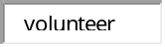 departments.

Quiz2
- Which is not a fire and life safety inspection category?
  - Issuance of a permit
  - Imminent hazard
  - Routine
  - Change in building ownership
- Which of the following categories of inspections is required when an existing structure is altered?
  - Response to a compliant
  - Change in occupancy
  - Issance of a permit
  - New construction
- Which of the following categories of inspections occurs when it becomes obvious that the occupancy poses a hazard to life and property?
  - Response to a compliant
  - Change in occupancy
  - Issuance of permit
  - Change in ownership
  - Imminent hazard
- The statement “a fire that does not occur is the one that is most easily controlled” accurately describes the ultimate goal of what?
  - Fire Department
  - Legislation
  - Compliance procedure
  - The public sector
  - Fire and life safety inspection programs
- Inspectors must follow procedures when conducting inspections and document all actions taken. Put the following inspection actions in order of how they are generally enacted.
  - Written notification of infractions
  - Follow-up inspection
  - Sancation
  - Prosecution
- AHJ stands for what Authority Having Jurisdiction
- All levels of government have created fire inspection and code enforcement organizations with the authority to manage certain programs. It is their _______ to accomplish the goal of protecting lives and property from uncontrolled fires and other hazards.
  - Liability
  - Civil right
  - Duty
  - Authurity
  - Requirement
- ______________ is defined as commission of an unlawful act that is knowingly committed by a public official.
  - Malfeasance
  - None of the answers are correct
  - Nonfeasance
  - Public duty doctrine
  - Misfeasance
- Model fire codes grant the AHJ ___________ as often as necessary to perform an inspection or to execute any duties authorized by the fire code.
  - Right of entry
  - Authority
  - Search warrants
  - Liability
  - Duty
- An inspector is given the ___________ to perform his or her duties based on the laws adopted by the AHJ or regulations established by the private sector organization.
  - Authority
  - Search warrant
  - Duty
  - Obligation
  - Right of entry

Activity1
国际性机构组织的缩写以及目的，略

Quiz3
- Air consists of about ___ percent oxygen.
  - 100
  - 50
  - 21
  - 18
  - 25
- Which of the following is the transfer of heat within an object or to another object by direct contact?
  - Rollover
  - Conduction
  - Radiation
  - Convection
  - Incipient
- Which of the following is the transmission of energy as an electromagnetic wave without an intervening medium?
  - Incipient
  - Rollover
  - Radiation
  - Conduction
  - Convection
- Class B fires involve what types of fuels?
  - Flammable liquids
  - Animal fats
  - Wood and paper
  - Combustible metals
  - Energized electrical equipment
- Which of the following is a condition where the un-burned fire gases accumulated at the top of a compartment ignite and flames propagate through the hot-gas layer or across the ceiling?
  - Incipient
  - Flammable
  - Rollover
  - Flashover
  - Backdraft
- Which stage of fire occurs when all combustible materials in the compartment are burning?
  - Growth
  - Rollover
  - Incipient
  - Decay
  - Fully developed
- A flammable liquid has a has a flashpoint that is _BELOW__ a temperature of _100华氏度 .
- Exothermic reactions absorb energy as they occur.
  - True
  - False
- Water has a specific gravity of 1.0
  - True
  - Flase
- What are the four elements of the fire tetrahedron?
  - Chemical chain reaction
  - Conduction
  - Fuel
  - Heat/source of ignition
  - Air/oxygen
  - Convection
  - Vaporization
  - Pyrolisis

Quiz4
- Using ___________, building officials and code enforcement personnel can gain a reasonable expectation of the hazard level in a building.
  - Building permits
  - Occupancy classifications
  - Authority
  - Construction types
  - Fire load
- The International Code Council has how many general occupancy categories?
  - 9
  - 6
  - 10
  - 7
  - 8
- Fire Load____________ is used as a measure of the potential heat release of a fire within a compartment.
- Trusses typically use a _____________ configuration to provide stability and efficiently transfer the applied loads.
  - Triangular
  - Circular
  - Rectangular
  - Linear
  - Cylindrical
- Which type of wall will support the weight of a roof?
  - Load-bearing
  - Nonload-bearing
- Which is not a factor in determining the type of construction used in a building?
  - Building size
  - Presence of automatic sprinklers
  - Fire resistance of construction materials
  - Occupancy type
  - Building owner
- Which construction type is least likely to contribute to the spread of a fire?I
- What is the most common example of Type V construction?
  - School
  - Warehouse
  - Single-family house
  - Church
  - Retail store

Activity2
观看视频并且标注各个阶段的时刻

Avtivity3
看图并且识别建筑类型以及墙体结构
T15Type 3
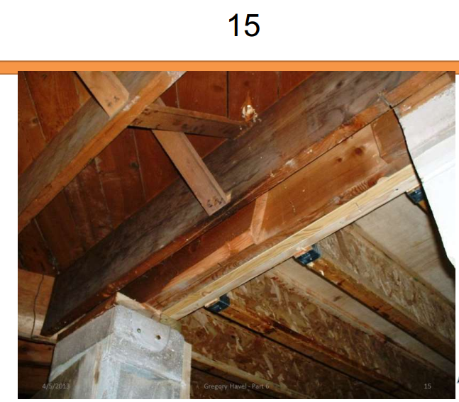
T19Type 5
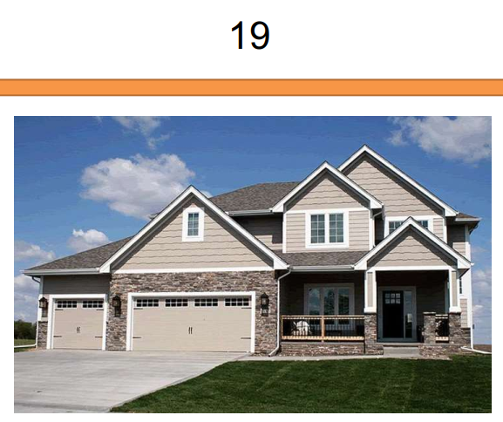

T2、4
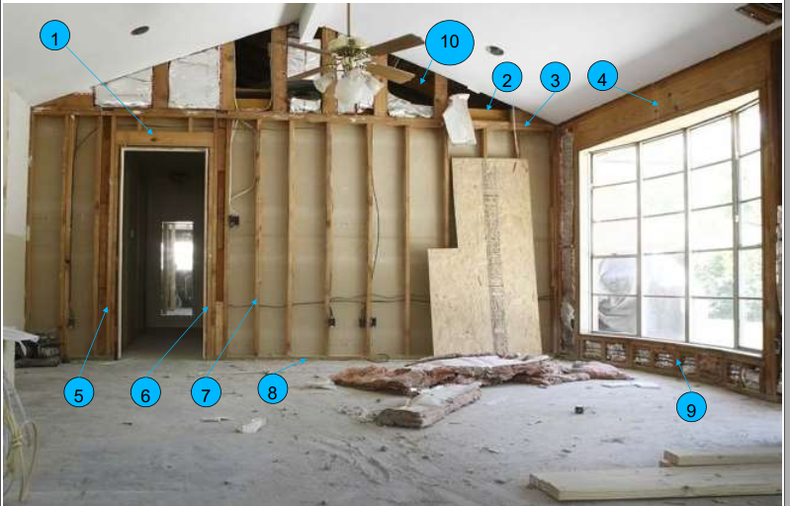
Joist
header

Quiz 5
- Which is not one of the common factors that continues to be cited during investigations associated with means of egress systems?
  - Inaccessible exits
  - None of the answer is correct
  - Overcrowded occupancies
  - In properly designed or marked exits
- Name three basic elements of an egress system
  - Exit discharge
  - Exit access
  - Corridor
  - Door
  - Exit
  - Hallway
- Match the term with its definition.
  - Exit
  - Exit discharge
  - Exit access
  - Means of egress
  - Common path of travel
- A public way must have a clear width of _____feet and a clear height of _____feet
- The total number of people for which the means of egress of a building or portion thereof is designed is call the:
  - Occupancy max
  - Exit load
  - Occupancy classification
  - Building load
  - Occupant load
- Model codes permit escalators, elevators, or moving walkways to be considered as part of a means of egress in new occupancies regardless of design.
  - Ture
  - False

Quiz 6
- Connecting an object that conducts electricity to the soil with something that is a conductor is known as:
  - Arcing
  - Melding
  - Grounding
  - Bonding
  - Hot work
- Connecting two objects that conduct electricity with something that is also a conductor is known as:
  - Arcing
  - Melding
  - Grounding
  - Bonding
  - Hot work
- According to your textbook, which of the following are not physical hazards
  - Toxicity
  - Flammability
  - Reactivity
  - Oxidizer
  - Pyrophoric
  - Corrosives
- What are pyrophoric materials
  - Materials with the potential to self-heat when they come in contact with air
  - Liquids, solids, or gaseous materials that in small quantities and without external ignition sources can ignite within 5 minutes of coming into contact with air
  - Materials that may not be stored in locations or in a manner where they can become combustible or dangerous
  - Liquids, solids,or gaseous materials that are capable of causing a fire through friction or retained heat
- Safety cans are a maximum of5gallons in size
- Which of the following is a device that opens well below any pressure that would threaten the integrity of a tank?
  - Ventilation valve
  - Pressure-relief valve
  - Regulator
  - Frangible bulb
  - Safety vent
- 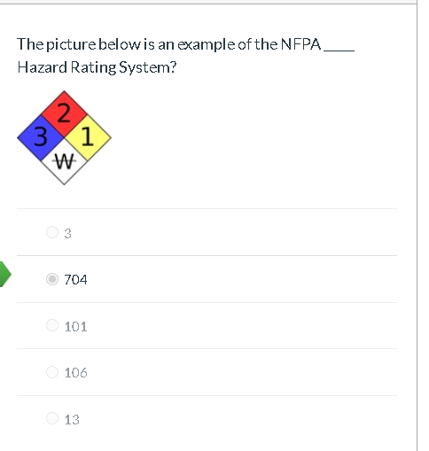
- SDS stands for:
  - Safety Data Sheet
  - Sheets for Data Safety
  - Safety Defined Standards
  - Supplier Data and Safety information
  - Safety Data Sources
- 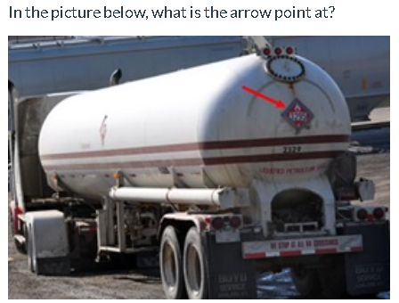
  - Placard
  - Sign
  - ID
  - Label
  - Warning

Activity 4
Using NFPA 30 Flammable and Combustible Liquids Code, match the term with its definition.
- Class 1A Flammable Liquid
  - Class IA liquids — those liquids that have flash points below 73°F (22.8°C) and boiling points below 100°F (37.8°C)
- Class 1B Flammable Liquid
  - Class IB liquids — those liquids that have flash points below 73°F (22.8°C) and boiling points at or above 100°F (37.8°C)
- Class 1C Flammable Liquid
  - Class IC liquids — those liquids that have flash points at or above 73°F (22.8°C), but below 100°F(37.8°C).
- Class II Combustible Liquid
  - Class II Liquid — any liquid that has a flash point at or above 100°F (37.8°C) and below 140°F (60°C)
- Class IIIA Combustible Liquid
  - Class IIIA — any liquid that has a flash point at or above 140°F (60°C), but below 200°F (93°C)
- Class IIIB Combustible Liquid
  - Class IIIB — any liquid that has a flash point at or above 200°F (93°C).

Quiz 7
- Which classification is assigned to fires involving energized electrical equipment?
  - Class A
  - Class B
  - Class C
  - Class D
  - Class K
- What is the potential threat of clean-agent fire-extinguishing systems?
  - Chenmical burns
  - Smoke inhalation
  - Asphyxiation
  - Thermal burns
  - Dehydration
- Water are the best agent to extinguish fires involving__fuels
  - Class D
  - Class C
  - Class B
  - Class K
  - Class A
- Proper placement of fire extinguishers results in extinguishers that are
  - Away form normal path of travel
  - Near points of egress
  - Stored behind equipment
  - In closest to propect them
  - Discretely placed
- NPFA 10 recommends that fire extinghisher inspections be performed
  - Annually
  - Quarterly
  - Monthly
  - Biennially
  - Semiannually
- Wet chemical extinguish systems are most effective on fire involving what type of equipment
  - Class C
  - Commercial cooking
  - Oil and gas production
  - Retail gas pump
  - Class A fuels
- What is the name of the test used to check the integrity of fire extinguisher cylinders
  - Audit
  - Operational
  - Hydrostatic
  - Inspection
  - Maintenance
- Which standard governs portable fire extinguisher installation, inspection and maintenance requirements?
  - NFPA 13
  - NFPA 70
  - NFPA 10
  - NFPA 600
  - NFPA 72
- Dry chemical and dry powder extinguishing agents are essentially the same.
  - True
  - False
- Water can be used in class D fire
  - True
  - False
Activity5
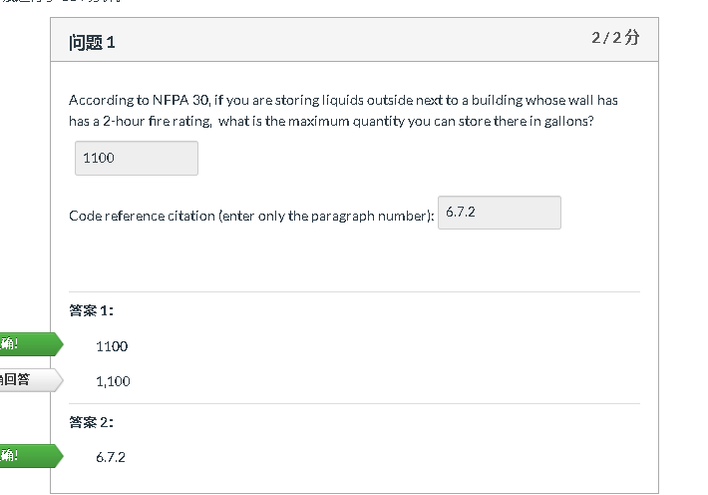
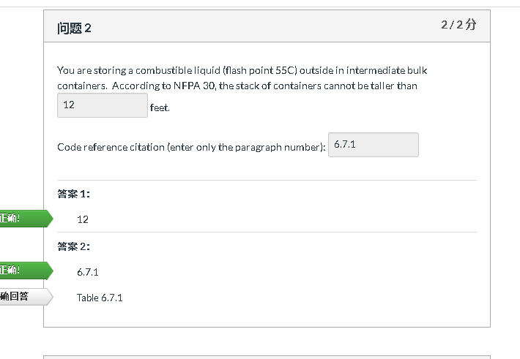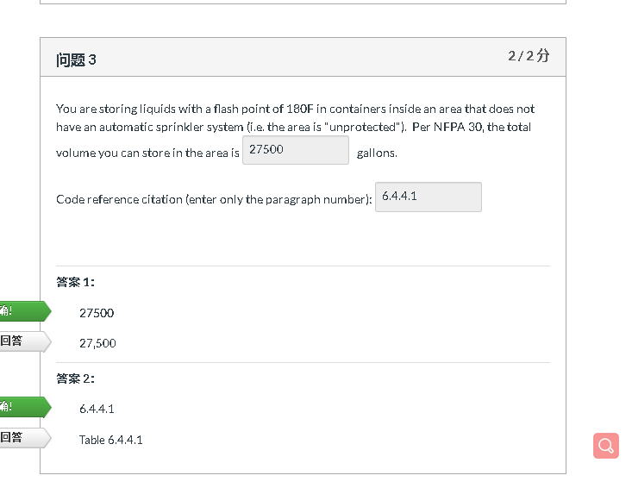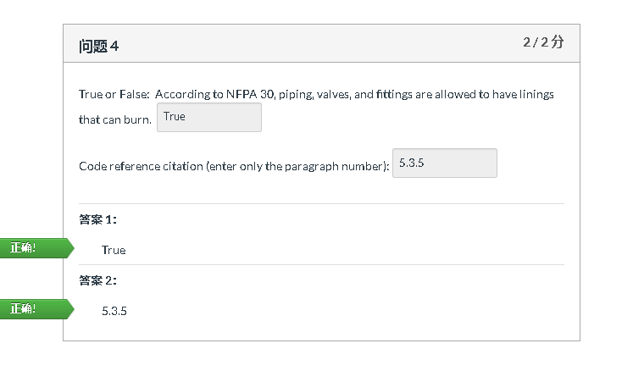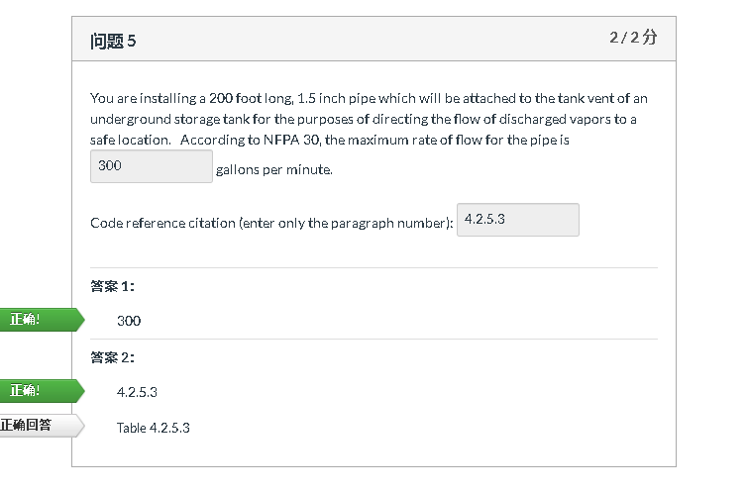
Quiz 8
- Which is not a type of smoke detector?(select all that apply)
  - Rate compensation
  - Ionizing
  - Rate of rise
  - Photoelectric
  - Air-sampling
- Which is not a type of flame detector?(select all that apply)
  - UV
  - IR
  - Ionizing
  - Fire sprinkler
  - Rate of rise
- Which is not an example of notification device?
  - None of the answers are correct
  - Smoke detector
  - Bells
  - Speakers
  - Store lights
- The National Fire Alarm Code for the US isNFPA72
- Which alarm system is widely used in large commercial or industrial applications?
  - Central station
  - Protected premises
  - Proprietary
  - Remote station
  - Local
- Which alarm system sends an alarm signal directly to the fire department?
  - Proprietary system
  - Remote station
  - Central station
  - Local
  - Protected premises
- Which alarm system is widely used only to notify occupants on the premises?
  - Proteted premises
  - Public emergency alarm reporting
  - Proprietary system
  - Remote station
  - Central station
- Which is not an example of fire alarm initiating device
  - Strobe
  - Fire sprinkler system water flow sensor
  - Manual pull station
  - Smoke detector
  - Heat detector
- The name of the fire detector typically found in a house is a smoke detector.
  - True
  - False
- Photoelectric smoke detectors usually respond quicker to smoldering fires.
  - True
  - False

Quiz 9
- Which views are two-demisional views of a site and building as seen from directly above the area?
  - Detailed views
  - Floor Plans
  - Sectional views
  - Elevation views
  - Site Plan views
- Which views are vertical views of a building as if it were cut into two parts?
  - Plan views
  - Floor Plans
  - Sectional views
  - Detailed views
  - Elevation views
- Which views are two-demensional views of a building as seen from the exterior
  - Sectional views
  - Floor Plans
  - Elevation views
  - Detailed views
  - Plan views
- Which views are provided when it is necessary to show a feature in lager size than what is on a small-scale drawing in order to show specifics?
  - Sectional views
  - Detailed views
  - Elevation views
  - Floor Plan
  - Plan views
- Floor plans include all of the following EXCEPT:
  - Walls
  - Stairs if applicable
  - Sprinklers
  - Windows
  - Doors
- Before checking proposed building fire sprinkler systems, plans reviewers must first:
  - Classify the hazard by occupancy
  - Obtain manufacturer’s cut sheets
  - Calculate storage capacity
  - Determine occupant load
  - Obtain hydraulic calculations
- Which is not an example of supporting documentation for construction documemts
  - Sprinkler calculations
  - Hydraulic calculations of applicable
  - Safety Data Sheets
  - Cut sheets
  - As-built drawings
- Regarding submitted drawings for review, the determination of a building’s occupancy classification is the responsibility of the:
  - AHJ
  - Safety Professional
  - Inspector
  - Building owner
  - Architect
- After verifying occupant load of a space, the plans examiner needs to evaluate
  - Construction classification
  - Overall size of the building
  - Exit capacity
  - Occupancy classification
  - Meams of egress

