Contents
Enum Definition
Table Definition
ADMIN
CONFIRMATION
COUNTRY_X_LANGUAGE
COURSE
COURSE_X_MEDIA_FILE
CURRENCY
CUSTOM_TOUR
FAQ
FAQ_CATEGORY
GUIDE
GUIDE_EVENT_TYPE
GUIDE_X_LANGUAGE
GUIDE_X_LICENSE
KEYWORD
LANGUAGE
LOCATION_CITY
LOCATION_COUNTRY
LOCATION_STATE
MESSAGE
NOTICE
PRODUCT
PRODUCT_EVENT_TYPE
PRODUCT_IMPOSSIBLE_DATE
PRODUCT_PRICE
PRODUCT_RESERVATION
PRODUCT_X_CITY
PRODUCT_X_KEYWORD
PRODUCT_X_THEME
PUBLIC_FILE
SELLER_IMPOSSIBLE_DATE
SERVICE
SERVICE_TYPE
THEME
TOUR
TOURIST
TOURIST_EMAIL
TOURIST_FACEBOOK
TOURIST_GOOGLEPLUS
TOURIST_KAKAOTALK
TOURIST_TWITTER
TOUR_PLAN
TOUR_PLAN_X_THEME
TOUR_SCHEDULE
TOUR_SCHEDULE_DAY
TOUR_SCHEDULE_NODE
TOUR_SCHEDULE_NODE_MEDIA_FILE
TOUR_SKETCH
TOUR_SKETCH_NODE
UNIT_TOUR
USER_X_INTEREST_GUIDE
USER_X_INTEREST_PRODUCT
user

Enum Definition

Table Definition
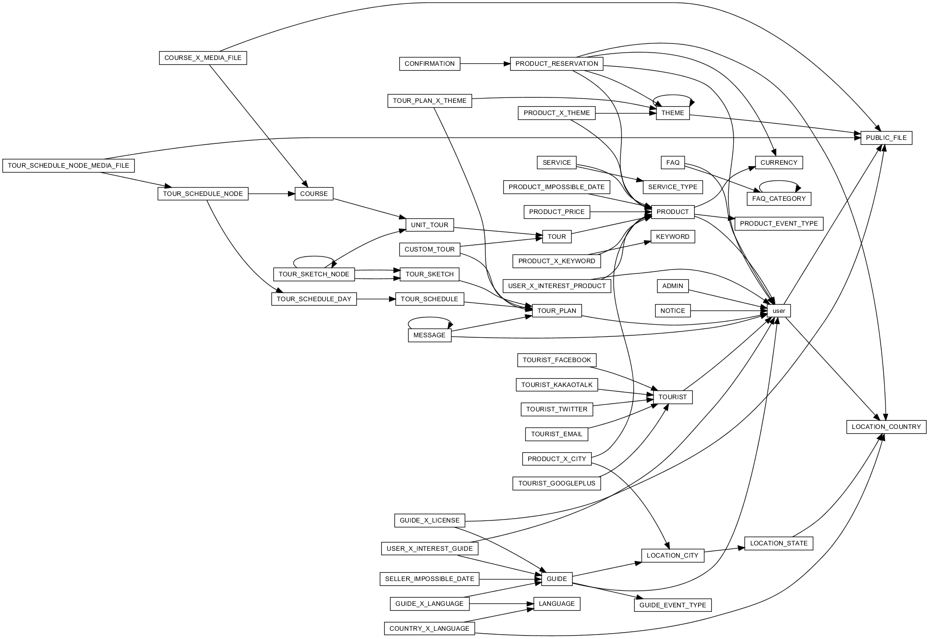

ADMIN
user of admin type
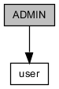
COLUMN | TYPE | NULLABLE | PKEY | DEFAULTED | REFERRED | REFER
ID | BIGINT |  | ● |  |  | [user] ID
LOGIN_ID | VARCHAR(100)
LOGIN_PASSWORD | VARCHAR(100)

UNIQUE KEY | COLUMNS | DESCRIPTION
CONSTRAINT_3B | ID
ADMIN_LOGIN_ID_KEY | LOGIN_ID

COLUMN | DESCRIPTION
ID | table identifier
LOGIN_ID | login ID
LOGIN_PASSWORD | login password

CONFIRMATION
serves as evidence of tour
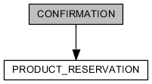
COLUMN | TYPE | NULLABLE | PKEY | DEFAULTED | REFERRED | REFER
ID | BIGINT |  | ● |  |  | [PRODUCT_RESERVATION] ID
NAME | VARCHAR(100)
ENGLISH_NAME | VARCHAR(100)
EMAIL | VARCHAR(100)
PHONE | VARCHAR(100)
TOUR_TITLE | VARCHAR(100)
TOURIST_NUM | VARCHAR(100)
TOUR_DATE | VARCHAR(100)
COST | VARCHAR(100)
PAID | VARCHAR(100)
CONTACTABLE_TIME | VARCHAR(100)
MEETING_PLACE | VARCHAR(100)
GUIDE_PHONE | VARCHAR(100)
GUIDE | VARCHAR(100)
CREATED_AT | TIMESTAMP |  |  | ●
UPDATED_AT | TIMESTAMP | ●
DELETED_AT | TIMESTAMP | ●

UNIQUE KEY | COLUMNS | DESCRIPTION
CONSTRAINT_73 | ID

COLUMN | DESCRIPTION
ID | table identifier
NAME | name of tourist
ENGLISH_NAME | english name of tourist
EMAIL | email of tourist
PHONE | phone number of tourist
TOUR_TITLE | tour title
TOURIST_NUM | tourist number
TOUR_DATE | day when tour start
COST | total tour cost
PAID | present payment
CONTACTABLE_TIME | contactable time with guide
MEETING_PLACE | place where meet with guide
GUIDE_PHONE | phone number of guide
GUIDE | name of guide
CREATED_AT | timestamp when this record is created
UPDATED_AT | timestamp when this record is updated
DELETED_AT | present that this record is deleted

COUNTRY_X_LANGUAGE
relationship of country with language. languages are used as representative country.
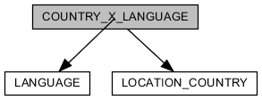
COLUMN | TYPE | NULLABLE | PKEY | DEFAULTED | REFERRED | REFER
ID | BIGINT |  | ● | ●
COUNTRY_ID | BIGINT |  |  |  |  | [LOCATION_COUNTRY] ID
LANGUAGE_ID | BIGINT |  |  |  |  | [LANGUAGE] ID

UNIQUE KEY | COLUMNS | DESCRIPTION
CONSTRAINT_DA | ID

COLUMN | DESCRIPTION
ID | table identifier
COUNTRY_ID | reference country
LANGUAGE_ID | reference language

COURSE
component what constitutes product. they are sequential about time.
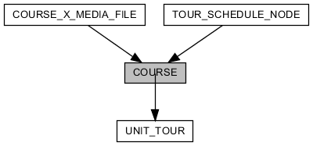
COLUMN | TYPE | NULLABLE | PKEY | DEFAULTED | REFERRED | REFER
ID | BIGINT |  | ● | ● | [COURSE_X_MEDIA_FILE] COURSE_ID  [TOUR_SCHEDULE_NODE] COURSE_ID
UNIT_TOUR_ID | BIGINT | ● |  |  |  | [UNIT_TOUR] ID
TITLE | VARCHAR(100) | ●
DESCRIPTION | CLOB(2147483647) | ●
SEQUENCE | INTEGER
CREATED_AT | TIMESTAMP |  |  | ●
UPDATED_AT | TIMESTAMP | ●
DELETED_AT | TIMESTAMP | ●

UNIQUE KEY | COLUMNS | DESCRIPTION
CONSTRAINT_76 | ID

COLUMN | DESCRIPTION
ID | table identifier
UNIT_TOUR_ID | reference product
TITLE | title of course
DESCRIPTION | description
SEQUENCE | sequence number
CREATED_AT | timestamp when this record is created
UPDATED_AT | timestamp when this record is updated
DELETED_AT | present that this record is deleted

COURSE_X_MEDIA_FILE
image file what is comprised in one course.
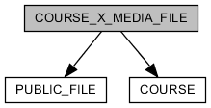
COLUMN | TYPE | NULLABLE | PKEY | DEFAULTED | REFERRED | REFER
ID | BIGINT |  | ● | ●
COURSE_ID | BIGINT |  |  |  |  | [COURSE] ID
PUBLIC_FILE_ID | BIGINT |  |  |  |  | [PUBLIC_FILE] ID
CREATED_AT | TIMESTAMP |  |  | ●
UPDATED_AT | TIMESTAMP | ●

UNIQUE KEY | COLUMNS | DESCRIPTION
CONSTRAINT_8 | ID

COLUMN | DESCRIPTION
ID | table identifier
COURSE_ID | reference course
PUBLIC_FILE_ID | reference image file
CREATED_AT | timestamp when this record is created
UPDATED_AT | timestamp when this record is updated

CURRENCY
define currency
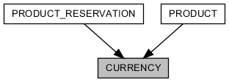
COLUMN | TYPE | NULLABLE | PKEY | DEFAULTED | REFERRED | REFER
ID | BIGINT |  | ● | ● | [PRODUCT] CURRENCY_ID  [PRODUCT_RESERVATION] CURRENCY_ID
NAME | VARCHAR(2048)

UNIQUE KEY | COLUMNS | DESCRIPTION
CONSTRAINT_5 | ID
CURRENCY_NAME_KEY | NAME

COLUMN | DESCRIPTION
ID | table identifier
NAME | name of currency

CUSTOM_TOUR
selling tour-product by guide manager
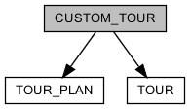
COLUMN | TYPE | NULLABLE | PKEY | DEFAULTED | REFERRED | REFER
ID | BIGINT |  | ● |  |  | [TOUR] ID
TOUR_PLAN_ID | BIGINT | ● |  |  |  | [TOUR_PLAN] ID

UNIQUE KEY | COLUMNS | DESCRIPTION
CONSTRAINT_182 | ID

COLUMN | DESCRIPTION
ID | table identifier
TOUR_PLAN_ID | reference tour plan

FAQ
frequently asked questions
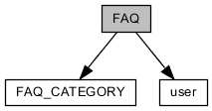
COLUMN | TYPE | NULLABLE | PKEY | DEFAULTED | REFERRED | REFER
ID | BIGINT |  | ● | ●
USER_ID | BIGINT |  |  |  |  | [user] ID
QUESTION | CLOB(2147483647)
ANSWER | CLOB(2147483647)
CREATED_AT | TIMESTAMP |  |  | ●
UPDATED_AT | TIMESTAMP | ●
DELETED_AT | TIMESTAMP | ●
CATEGORY_ID | BIGINT | ● |  |  |  | [FAQ_CATEGORY] ID

UNIQUE KEY | COLUMNS | DESCRIPTION
CONSTRAINT_10 | ID

COLUMN | DESCRIPTION
ID | table identifier
USER_ID | reference writer
QUESTION | question
ANSWER | answer
CREATED_AT | timestamp when this record is created
UPDATED_AT | timestamp when this record is updated
DELETED_AT | present that this record is deleted
CATEGORY_ID | reference category

FAQ_CATEGORY
category of "faq"
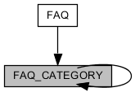
COLUMN | TYPE | NULLABLE | PKEY | DEFAULTED | REFERRED | REFER
ID | BIGINT |  | ● | ● | [FAQ] CATEGORY_ID  [FAQ_CATEGORY] REF_ID
NAME | VARCHAR(2048)
REF_ID | BIGINT | ● |  |  |  | [FAQ_CATEGORY] ID
CREATED_AT | TIMESTAMP |  |  | ●
UPDATED_AT | TIMESTAMP | ●
DELETED_AT | TIMESTAMP | ●

UNIQUE KEY | COLUMNS | DESCRIPTION
CONSTRAINT_6A | ID

COLUMN | DESCRIPTION
ID | table identifier
NAME | name of category
REF_ID | refer anyone of "faq_category"
CREATED_AT | timestamp when this record is created
UPDATED_AT | timestamp when this record is updated
DELETED_AT | present that this record is deleted

GUIDE
user of guide/guide manager type
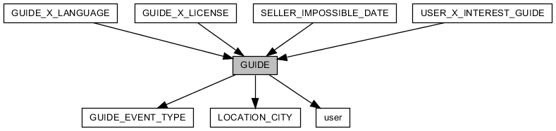
COLUMN | TYPE | NULLABLE | PKEY | DEFAULTED | REFERRED | REFER
ID | BIGINT |  | ● |  | [GUIDE_X_LANGUAGE] GUIDE_ID  [GUIDE_X_LICENSE] GUIDE_ID  [SELLER_IMPOSSIBLE_DATE] SELLER_ID  [USER_X_INTEREST_GUIDE] GUIDE_ID | [user] ID
STATUS | ENUM |  |  | ●
GUIDE_EVENT_TYPE_ID | BIGINT | ● |  |  |  | [GUIDE_EVENT_TYPE] ID
LOGIN_ID | VARCHAR(100)
LOGIN_PASSWORD | VARCHAR(100)
EMAIL_GENERATE_KEY | VARCHAR(255)
EMAIL_CERTIFIED_AT | TIMESTAMP | ●
SKYPE_ID | VARCHAR(40) | ●
RESIDENTIAL_CITY_ID | BIGINT |  |  |  |  | [LOCATION_CITY] ID
EXPERIENCE | INTEGER | ●
AGE | INTEGER | ●
CREATED_AT | TIMESTAMP |  |  | ●
UPDATED_AT | TIMESTAMP | ●

UNIQUE KEY | COLUMNS | DESCRIPTION
CONSTRAINT_41 | ID
GUIDE_LOGIN_ID_KEY | LOGIN_ID

COLUMN | DESCRIPTION
ID | table identifier
STATUS | approved by administrator
GUIDE_EVENT_TYPE_ID | promotion about guide
LOGIN_ID | login ID
LOGIN_PASSWORD | login password
EMAIL_GENERATE_KEY | generated key for certificating email
EMAIL_CERTIFIED_AT | timestamp when email is certificated
SKYPE_ID | skype ID
RESIDENTIAL_CITY_ID | city of residence
EXPERIENCE | n years experience about guiding
AGE | age
CREATED_AT | timestamp when this record is created
UPDATED_AT | timestamp when this record is updated

GUIDE_EVENT_TYPE
define promotion type about guide
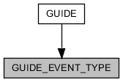
COLUMN | TYPE | NULLABLE | PKEY | DEFAULTED | REFERRED | REFER
ID | BIGINT |  | ● | ● | [GUIDE] GUIDE_EVENT_TYPE_ID
NAME | VARCHAR(255)
MARKER | VARCHAR(2048) | ●
CREATED_AT | TIMESTAMP |  |  | ●
UPDATED_AT | TIMESTAMP | ●
DELETED_AT | TIMESTAMP | ●

UNIQUE KEY | COLUMNS | DESCRIPTION
CONSTRAINT_D5 | ID
GUIDE_EVENT_TYPE_NAME_KEY | NAME

COLUMN | DESCRIPTION
ID | table identifier
NAME | name of promotion
MARKER | mark as
CREATED_AT | timestamp when this record is created
UPDATED_AT | timestamp when this record is updated
DELETED_AT | present that this record is deleted

GUIDE_X_LANGUAGE
relationship of guide with language. One guide has 1 guiding-language or more.
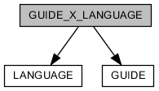
COLUMN | TYPE | NULLABLE | PKEY | DEFAULTED | REFERRED | REFER
ID | BIGINT |  | ● | ●
GUIDE_ID | BIGINT |  |  |  |  | [GUIDE] ID
LANGUAGE_ID | BIGINT |  |  |  |  | [LANGUAGE] ID

UNIQUE KEY | COLUMNS | DESCRIPTION
CONSTRAINT_49 | ID
GUIDE_X_LANGUAGE_GUIDE_ID_LANGUAGE_ID_KEY | GUIDE_ID LANGUAGE_ID

COLUMN | DESCRIPTION
ID | table identifier
GUIDE_ID | reference guide
LANGUAGE_ID | reference language

GUIDE_X_LICENSE
relationship of guide with license.
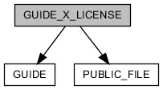
COLUMN | TYPE | NULLABLE | PKEY | DEFAULTED | REFERRED | REFER
ID | BIGINT |  | ● | ●
GUIDE_ID | BIGINT |  |  |  |  | [GUIDE] ID
LICENSE_PICTURE_FILE_ID | BIGINT | ● |  |  |  | [PUBLIC_FILE] ID
LICENSE_NAME | VARCHAR(255)

UNIQUE KEY | COLUMNS | DESCRIPTION
CONSTRAINT_7 | ID

COLUMN | DESCRIPTION
ID | table identifier
GUIDE_ID | reference guide
LICENSE_PICTURE_FILE_ID | reference picture file about license
LICENSE_NAME | name of license

KEYWORD
define keyword for product classification
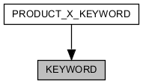
COLUMN | TYPE | NULLABLE | PKEY | DEFAULTED | REFERRED | REFER
ID | BIGINT |  | ● | ● | [PRODUCT_X_KEYWORD] KEYWORD_ID
NAME | VARCHAR(2048)

UNIQUE KEY | COLUMNS | DESCRIPTION
CONSTRAINT_F | ID
KEYWORD_NAME_KEY | NAME

COLUMN | DESCRIPTION
ID | table identifier
NAME | name of keyword

LANGUAGE
define language for guiding
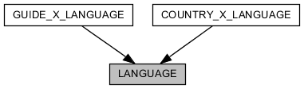
COLUMN | TYPE | NULLABLE | PKEY | DEFAULTED | REFERRED | REFER
ID | BIGINT |  | ● | ● | [COUNTRY_X_LANGUAGE] LANGUAGE_ID  [GUIDE_X_LANGUAGE] LANGUAGE_ID
NAME | VARCHAR(2048)
SORT_NAME | VARCHAR(100)

UNIQUE KEY | COLUMNS | DESCRIPTION
CONSTRAINT_C | ID
LANGUAGE_SORT_NAME_KEY | SORT_NAME

COLUMN | DESCRIPTION
ID | table identifier
NAME | name of language
SORT_NAME | name of language for sorting

LOCATION_CITY
real city
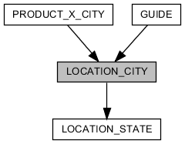
COLUMN | TYPE | NULLABLE | PKEY | DEFAULTED | REFERRED | REFER
ID | BIGINT |  | ● | ● | [GUIDE] RESIDENTIAL_CITY_ID  [PRODUCT_X_CITY] CITY_ID
STATE_ID | BIGINT |  |  |  |  | [LOCATION_STATE] ID
NAME | VARCHAR(100)
LATITUDE | DOUBLE | ●
LONGITUDE | DOUBLE | ●

UNIQUE KEY | COLUMNS | DESCRIPTION
CONSTRAINT_50 | ID
LOCATION_CITY_STATE_ID_NAME_KEY | STATE_ID NAME
LOCATION_CITY_LATITUDE_LONGITUDE_KEY | LATITUDE LONGITUDE

COLUMN | DESCRIPTION
ID | table identifier
STATE_ID | reference state
NAME | name of city
LATITUDE | latitude of city
LONGITUDE | longitude of city

LOCATION_COUNTRY
real country
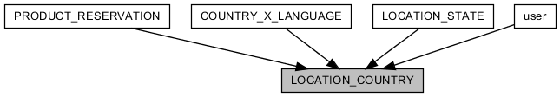
COLUMN | TYPE | NULLABLE | PKEY | DEFAULTED | REFERRED | REFER
ID | BIGINT |  | ● | ● | [COUNTRY_X_LANGUAGE] COUNTRY_ID  [LOCATION_STATE] COUNTRY_ID  [PRODUCT_RESERVATION] MOBILE_COUNTRY_ID  [user] MOBILE_COUNTRY_ID  [user] NATIONALITY_ID
NAME | VARCHAR(100)
SORT_NAME | VARCHAR(10)
KOREAN_NAME | VARCHAR(100) | ●
COUNTRY_CODE | INTEGER | ●
LATITUDE | DOUBLE | ●
LONGITUDE | DOUBLE | ●

UNIQUE KEY | COLUMNS | DESCRIPTION
CONSTRAINT_D | ID
LOCATION_COUNTRY_NAME_KEY | NAME
LOCATION_COUNTRY_SORT_NAME_KEY | SORT_NAME
LOCATION_COUNTRY_LATITUDE_LONGITUDE_KEY | LATITUDE LONGITUDE

COLUMN | DESCRIPTION
ID | table identifier
NAME | name of country
SORT_NAME | name of country for sorting
KOREAN_NAME | korean name of country
COUNTRY_CODE | international dialling code
LATITUDE | latitude of country
LONGITUDE | longitude of country

LOCATION_STATE
real state
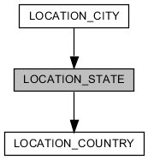
COLUMN | TYPE | NULLABLE | PKEY | DEFAULTED | REFERRED | REFER
ID | BIGINT |  | ● | ● | [LOCATION_CITY] STATE_ID
COUNTRY_ID | BIGINT |  |  |  |  | [LOCATION_COUNTRY] ID
NAME | VARCHAR(100)
LATITUDE | DOUBLE | ●
LONGITUDE | DOUBLE | ●

UNIQUE KEY | COLUMNS | DESCRIPTION
CONSTRAINT_B | ID
LOCATION_STATE_COUNTRY_ID_NAME_KEY | COUNTRY_ID NAME
LOCATION_STATE_LATITUDE_LONGITUDE_KEY | LATITUDE LONGITUDE

COLUMN | DESCRIPTION
ID | table identifier
COUNTRY_ID | reference country
NAME | name of state
LATITUDE | latitude of state
LONGITUDE | longitude of state

MESSAGE
message form user to user
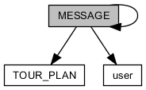
COLUMN | TYPE | NULLABLE | PKEY | DEFAULTED | REFERRED | REFER
ID | BIGINT |  | ● | ● | [MESSAGE] REF_ID
REF_ID | BIGINT | ● |  |  |  | [MESSAGE] ID
SENDER_ID | BIGINT |  |  |  |  | [user] ID
RECEIVER_ID | BIGINT |  |  |  |  | [user] ID
MESSAGE_HEADER | VARCHAR(1024) | ●
MESSAGE_BODY | VARCHAR(2048)
MESSAGE_FOOTER | VARCHAR(1024) | ●
READ | BOOLEAN |  |  | ●
SENDER_DELETED | BOOLEAN |  |  | ●
RECEIVER_DELETED | BOOLEAN |  |  | ●
CREATED_AT | TIMESTAMP |  |  | ●
UPDATED_AT | TIMESTAMP | ●
DELETED_AT | TIMESTAMP | ●
TAG | ENUM | ●
TOUR_PLAN_ID | BIGINT | ● |  |  |  | [TOUR_PLAN] ID

UNIQUE KEY | COLUMNS | DESCRIPTION
CONSTRAINT_6 | ID

COLUMN | DESCRIPTION
ID | table identifier
REF_ID | represented message
SENDER_ID | reference sender
RECEIVER_ID | reference receiver
MESSAGE_HEADER | header content of message
MESSAGE_BODY | body content of message
MESSAGE_FOOTER | footer content of message
READ | read message by receiver
SENDER_DELETED | deleted message by sender
RECEIVER_DELETED | deleted message by receiver
CREATED_AT | timestamp when this record is created
UPDATED_AT | timestamp when this record is updated
DELETED_AT | present that this record is deleted
TAG | for classification
TOUR_PLAN_ID | reference tour-plan

NOTICE
notify user(tourist/guide/guide manager) by administrator
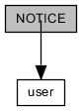
COLUMN | TYPE | NULLABLE | PKEY | DEFAULTED | REFERRED | REFER
ID | BIGINT |  | ● | ●
USER_ID | BIGINT |  |  |  |  | [user] ID
TITLE | CLOB(2147483647)
DESCRIPTION | CLOB(2147483647)
CREATED_AT | TIMESTAMP |  |  | ●
UPDATED_AT | TIMESTAMP | ●
DELETED_AT | TIMESTAMP | ●

UNIQUE KEY | COLUMNS | DESCRIPTION
CONSTRAINT_89 | ID

COLUMN | DESCRIPTION
ID | table identifier
USER_ID | reference writer
TITLE | title
DESCRIPTION | description
CREATED_AT | timestamp when this record is created
UPDATED_AT | timestamp when this record is updated
DELETED_AT | present that this record is deleted

PRODUCT
selling product by guide or guide manager
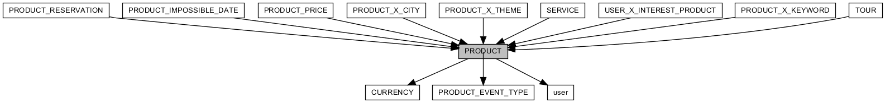
COLUMN | TYPE | NULLABLE | PKEY | DEFAULTED | REFERRED | REFER
ID | BIGINT |  | ● | ● | [PRODUCT_IMPOSSIBLE_DATE] PRODUCT_ID  [PRODUCT_PRICE] PRODUCT_ID  [PRODUCT_RESERVATION] PRODUCT_ID  [PRODUCT_X_CITY] PRODUCT_ID  [PRODUCT_X_KEYWORD] PRODUCT_ID  [PRODUCT_X_THEME] PRODUCT_ID  [SERVICE] ID  [TOUR] ID  [USER_X_INTEREST_PRODUCT] PRODUCT_ID
TITLE | VARCHAR(100) | ●
STATUS | ENUM | ● |  | ●
PRODUCT_EVENT_TYPE_ID | BIGINT | ● |  |  |  | [PRODUCT_EVENT_TYPE] ID
SELLER_ID | BIGINT | ● |  |  |  | [user] ID
CURRENCY_ID | BIGINT | ● |  |  |  | [CURRENCY] ID
IMAGE_ID | BIGINT | ●
SUMMARY | CLOB(2147483647) | ●
DESCRIPTION | CLOB(2147483647) | ●
INCLUSION | CLOB(2147483647) | ●
EXCLUSION | CLOB(2147483647) | ●
ETC | CLOB(2147483647) | ●
CREATED_AT | TIMESTAMP |  |  | ●
UPDATED_AT | TIMESTAMP | ●
DELETED_AT | TIMESTAMP | ●
UNLOAD | VARCHAR(1000) | ●
TYPE | ENUM |  |  | ●

UNIQUE KEY | COLUMNS | DESCRIPTION
CONSTRAINT_18 | ID

COLUMN | DESCRIPTION
ID | table identifier
TITLE | title of product
STATUS | approved by administrator
PRODUCT_EVENT_TYPE_ID | promotion about product
SELLER_ID | reference seller
CURRENCY_ID | base currency
IMAGE_ID | representative image of product
SUMMARY | summary of product
DESCRIPTION | description
INCLUSION | extra options what are include in the price
EXCLUSION | extra options what are not include in the price
ETC | extra description
CREATED_AT | timestamp when this record is created
UPDATED_AT | timestamp when this record is updated
DELETED_AT | present that this record is deleted
UNLOAD | request message for stop sale product
TYPE | product type(tour/service)

PRODUCT_EVENT_TYPE
define promotion type about product
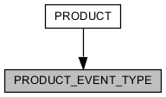
COLUMN | TYPE | NULLABLE | PKEY | DEFAULTED | REFERRED | REFER
ID | BIGINT |  | ● | ● | [PRODUCT] PRODUCT_EVENT_TYPE_ID
NAME | VARCHAR(255)
DISCOUNT | INTEGER |  |  | ●
MARKER | VARCHAR(2048) | ●
CREATED_AT | TIMESTAMP |  |  | ●
UPDATED_AT | TIMESTAMP | ●
DELETED_AT | TIMESTAMP | ●

UNIQUE KEY | COLUMNS | DESCRIPTION
CONSTRAINT_49B | ID
PRODUCT_EVENT_TYPE_NAME_KEY | NAME

COLUMN | DESCRIPTION
ID | table identifier
NAME | name of promotion
DISCOUNT | discount rate(0 ~ 99)
MARKER | mark as
CREATED_AT | timestamp when this record is created
UPDATED_AT | timestamp when this record is updated
DELETED_AT | present that this record is deleted

PRODUCT_IMPOSSIBLE_DATE
impossible date to reserve a product
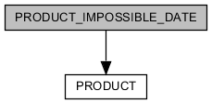
COLUMN | TYPE | NULLABLE | PKEY | DEFAULTED | REFERRED | REFER
PRODUCT_ID | BIGINT |  | ● |  |  | [PRODUCT] ID
DATE | DATE |  | ●

UNIQUE KEY | COLUMNS | DESCRIPTION
PRODUCT_IMPOSSIBLE_DATE_PKEY | PRODUCT_ID DATE

COLUMN | DESCRIPTION
PRODUCT_ID | reference product
DATE | impossible date

PRODUCT_PRICE
price information of product. price of one product is comprised one price information or more.
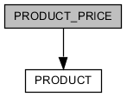
COLUMN | TYPE | NULLABLE | PKEY | DEFAULTED | REFERRED | REFER
ID | BIGINT |  | ● | ●
PRODUCT_ID | BIGINT |  |  |  |  | [PRODUCT] ID
MINIMUM_PEOPLE | INTEGER | ●
MAXIMUM_PEOPLE | INTEGER | ●
PRICE | DOUBLE | ●
CREATED_AT | TIMESTAMP |  |  | ●
UPDATED_AT | TIMESTAMP | ●

UNIQUE KEY | COLUMNS | DESCRIPTION
CONSTRAINT_42 | ID
PRODUCT_PRICE_PRODUCT_ID_MINIMUM_PEOPLE_MAXIMUM_PEOPLE_KEY | PRODUCT_ID MINIMUM_PEOPLE MAXIMUM_PEOPLE

COLUMN | DESCRIPTION
ID | table identifier
PRODUCT_ID | reference product
MINIMUM_PEOPLE | minimum number of people is affected by this price information
MAXIMUM_PEOPLE | maximum number of people is affected by this price information
PRICE | price
CREATED_AT | timestamp when this record is created
UPDATED_AT | timestamp when this record is updated

PRODUCT_RESERVATION
reservation of product
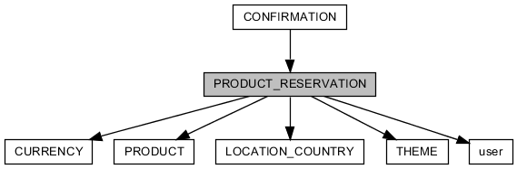
COLUMN | TYPE | NULLABLE | PKEY | DEFAULTED | REFERRED | REFER
ID | BIGINT |  | ● | ● | [CONFIRMATION] ID
USER_ID | BIGINT |  |  |  |  | [user] ID
PRODUCT_ID | BIGINT |  |  |  |  | [PRODUCT] ID
CURRENCY_ID | BIGINT |  |  |  |  | [CURRENCY] ID
BOOK_DATE | DATE
NUMBER_PEOPLE | INTEGER
AGE | ENUM | ●
PURPOSE_ID | BIGINT | ● |  |  |  | [THEME] ID
REQUEST_MESSAGE | CLOB(2147483647) | ●
STATUS | ENUM |  |  | ●
NAME | VARCHAR(100)
ENGLISH_NAME | VARCHAR(100)
MOBILE_COUNTRY_ID | BIGINT |  |  |  |  | [LOCATION_COUNTRY] ID
MOBILE | VARCHAR(20)
EMAIL | VARCHAR(100)
PAYOUT_STATUS | ENUM |  |  | ●
CREATED_AT | TIMESTAMP |  |  | ●
UPDATED_AT | TIMESTAMP | ●
DELETED_AT | TIMESTAMP | ●
EVENT_NAME | VARCHAR(255) | ●
EVENT_DISCOUNT | INTEGER |  |  | ●
ORIGINAL_PRICE | DOUBLE |  |  | ●
FINAL_PRICE | DOUBLE |  |  | ●
EPILOGUE_STAR_POINT | INTEGER | ●
EPILOGUE_COMMENT | CLOB(2147483647) | ●
EPILOGUE_WROTE_AT | TIMESTAMP | ●
EPILOGUE_REPLY | CLOB(2147483647) | ●

UNIQUE KEY | COLUMNS | DESCRIPTION
CONSTRAINT_3F | ID

COLUMN | DESCRIPTION
ID | table identifier
USER_ID | reference people who has booked
PRODUCT_ID | reference product
CURRENCY_ID | reference currency
BOOK_DATE | booked date
NUMBER_PEOPLE | number of people
AGE | age of representative
PURPOSE_ID | purpose of tour. reference trend theme.
REQUEST_MESSAGE | request message about tour
STATUS | tour progress situation
NAME | name of representative
ENGLISH_NAME | english name of representative
MOBILE_COUNTRY_ID | reference activated country of cellphone
MOBILE | mobile number of representative
EMAIL | email of representative
PAYOUT_STATUS | is paid
CREATED_AT | timestamp when this record is created
UPDATED_AT | timestamp when this record is updated
DELETED_AT | present that this record is deleted
EVENT_NAME | promotion about product
EVENT_DISCOUNT | promotion about product
ORIGINAL_PRICE | non-discounted price by event
FINAL_PRICE | discounted price by event
EPILOGUE_STAR_POINT | score (0 ~ 5) about tour satisfaction
EPILOGUE_COMMENT | comment of epilogue
EPILOGUE_WROTE_AT | timestamp when this epilogue is wrote
EPILOGUE_REPLY

PRODUCT_X_CITY
relationship of product with city. tour city is one or more.
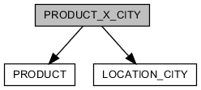
COLUMN | TYPE | NULLABLE | PKEY | DEFAULTED | REFERRED | REFER
ID | BIGINT |  | ● | ●
PRODUCT_ID | BIGINT |  |  |  |  | [PRODUCT] ID
CITY_ID | BIGINT |  |  |  |  | [LOCATION_CITY] ID
CREATED_AT | TIMESTAMP |  |  | ●
UPDATED_AT | TIMESTAMP | ●
DELETED_AT | TIMESTAMP | ●

UNIQUE KEY | COLUMNS | DESCRIPTION
CONSTRAINT_24 | ID
PRODUCT_X_CITY_PRODUCT_ID_CITY_ID_KEY | PRODUCT_ID CITY_ID

COLUMN | DESCRIPTION
ID | table identifier
PRODUCT_ID | reference product
CITY_ID | reference city
CREATED_AT | timestamp when this record is created
UPDATED_AT | timestamp when this record is updated
DELETED_AT | present that this record is deleted

PRODUCT_X_KEYWORD
relationship of product with keyword.
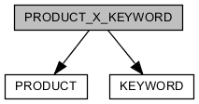
COLUMN | TYPE | NULLABLE | PKEY | DEFAULTED | REFERRED | REFER
ID | BIGINT |  | ● | ●
PRODUCT_ID | BIGINT |  |  |  |  | [PRODUCT] ID
KEYWORD_ID | BIGINT |  |  |  |  | [KEYWORD] ID
CREATED_AT | TIMESTAMP |  |  | ●
UPDATED_AT | TIMESTAMP | ●
DELETED_AT | TIMESTAMP | ●

UNIQUE KEY | COLUMNS | DESCRIPTION
CONSTRAINT_65 | ID

COLUMN | DESCRIPTION
ID | table identifier
PRODUCT_ID | reference product
KEYWORD_ID | reference keyword
CREATED_AT | timestamp when this record is created
UPDATED_AT | timestamp when this record is updated
DELETED_AT | present that this record is deleted

PRODUCT_X_THEME
relationship of product with theme
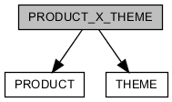
COLUMN | TYPE | NULLABLE | PKEY | DEFAULTED | REFERRED | REFER
ID | BIGINT |  | ● | ●
PRODUCT_ID | BIGINT |  |  |  |  | [PRODUCT] ID
THEME_ID | BIGINT |  |  |  |  | [THEME] ID
CREATED_AT | TIMESTAMP |  |  | ●
UPDATED_AT | TIMESTAMP | ●
DELETED_AT | TIMESTAMP | ●

UNIQUE KEY | COLUMNS | DESCRIPTION
CONSTRAINT_7B | ID

COLUMN | DESCRIPTION
ID | table identifier
PRODUCT_ID | reference product
THEME_ID | reference theme
CREATED_AT | timestamp when this record is created
UPDATED_AT | timestamp when this record is updated
DELETED_AT | present that this record is deleted

PUBLIC_FILE
saved file at server
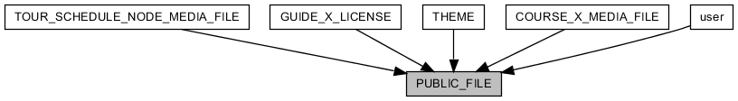
COLUMN | TYPE | NULLABLE | PKEY | DEFAULTED | REFERRED | REFER
ID | BIGINT |  | ● | ● | [GUIDE_X_LICENSE] LICENSE_PICTURE_FILE_ID  [COURSE_X_MEDIA_FILE] PUBLIC_FILE_ID  [THEME] BACKGROUND_IMAGE_ID  [THEME] IMAGE_ID  [TOUR_SCHEDULE_NODE_MEDIA_FILE] PUBLIC_FILE_ID  [user] PROFILE_IMAGE_ID
ORIGINAL_NAME | VARCHAR(256)
NAME | VARCHAR(256)
SIZE | BIGINT
CREATED_AT | TIMESTAMP |  |  | ●
UPDATED_AT | TIMESTAMP | ●
DELETED_AT | TIMESTAMP | ●

UNIQUE KEY | COLUMNS | DESCRIPTION
CONSTRAINT_4 | ID

COLUMN | DESCRIPTION
ID | table identifier
ORIGINAL_NAME | file name what is file name of user end side in uploading
NAME | saved file name at server side after upload
SIZE | file size
CREATED_AT | timestamp when this record is created
UPDATED_AT | timestamp when this record is updated
DELETED_AT | present that this record is deleted

SELLER_IMPOSSIBLE_DATE
impossible date to reserve a product what is sale by seller
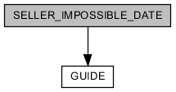
COLUMN | TYPE | NULLABLE | PKEY | DEFAULTED | REFERRED | REFER
SELLER_ID | BIGINT |  | ● |  |  | [GUIDE] ID
DATE | DATE |  | ●

UNIQUE KEY | COLUMNS | DESCRIPTION
SELLER_IMPOSSIBLE_DATE_PKEY | SELLER_ID DATE

COLUMN | DESCRIPTION
SELLER_ID | reference seller
DATE | impossible date

SERVICE
define service for service provide by guide or guide manager
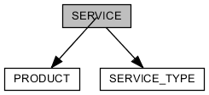
COLUMN | TYPE | NULLABLE | PKEY | DEFAULTED | REFERRED | REFER
ID | BIGINT |  | ● |  |  | [PRODUCT] ID
SERVICE_TYPE_ID | BIGINT |  |  |  |  | [SERVICE_TYPE] ID
TRANSPORTATION_TYPE | ENUM | ●

UNIQUE KEY | COLUMNS | DESCRIPTION
CONSTRAINT_A10 | ID

COLUMN | DESCRIPTION
ID | table identifier
SERVICE_TYPE_ID | representative service type
TRANSPORTATION_TYPE | kind of transportation in the service

SERVICE_TYPE
define service type for service provide by guide or guide manager
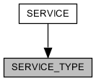
COLUMN | TYPE | NULLABLE | PKEY | DEFAULTED | REFERRED | REFER
ID | BIGINT |  | ● | ● | [SERVICE] SERVICE_TYPE_ID
NAME | VARCHAR(2048)

UNIQUE KEY | COLUMNS | DESCRIPTION
CONSTRAINT_A1 | ID
SERVICE_TYPE_NAME_KEY | NAME

COLUMN | DESCRIPTION
ID | table identifier
NAME | name of service type

THEME
define theme
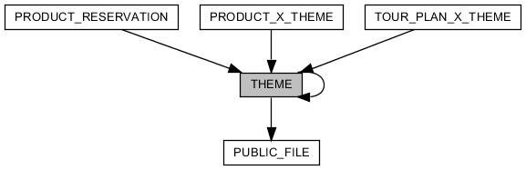
COLUMN | TYPE | NULLABLE | PKEY | DEFAULTED | REFERRED | REFER
ID | BIGINT |  | ● | ● | [PRODUCT_RESERVATION] PURPOSE_ID  [PRODUCT_X_THEME] THEME_ID  [THEME] REF_ID  [TOUR_PLAN_X_THEME] THEME_ID
NAME | VARCHAR(2048)
REF_ID | BIGINT | ● |  |  |  | [THEME] ID
TREND | BOOLEAN |  |  | ●
IMAGE_ID | BIGINT | ● |  |  |  | [PUBLIC_FILE] ID
BACKGROUND_IMAGE_ID | BIGINT | ● |  |  |  | [PUBLIC_FILE] ID
CREATED_AT | TIMESTAMP |  |  | ●
UPDATED_AT | TIMESTAMP | ●
DELETED_AT | TIMESTAMP | ●

UNIQUE KEY | COLUMNS | DESCRIPTION
CONSTRAINT_4C | ID

COLUMN | DESCRIPTION
ID | table identifier
NAME | name of theme
REF_ID | reference anyone of "theme"
TREND | is representative
IMAGE_ID | reference icon
BACKGROUND_IMAGE_ID | reference picture
CREATED_AT | timestamp when this record is created
UPDATED_AT | timestamp when this record is updated
DELETED_AT | present that this record is deleted

TOUR
selling tour-product by guide or guide manager
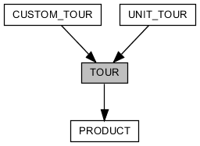
COLUMN | TYPE | NULLABLE | PKEY | DEFAULTED | REFERRED | REFER
ID | BIGINT |  | ● |  | [CUSTOM_TOUR] ID  [UNIT_TOUR] ID | [PRODUCT] ID
TYPE | ENUM
ADJUSTABLE_TIME | BOOLEAN | ● |  | ●
MUST_INQUIRE | BOOLEAN | ● |  | ●
TOUR_SCALE | ENUM | ●
DUE_DATE_TYPE | ENUM | ●
DUE_DATE | DOUBLE | ●

UNIQUE KEY | COLUMNS | DESCRIPTION
CONSTRAINT_27 | ID

COLUMN | DESCRIPTION
ID | table identifier
TYPE | tour type(unit tour/custom tour)
ADJUSTABLE_TIME | is adjustable when meet with guide
MUST_INQUIRE | must inquire, before reserve
TOUR_SCALE | tour type(independent travel/associated travel)
DUE_DATE_TYPE | unit about period of trip
DUE_DATE | period of trip

TOURIST
user of tourist type
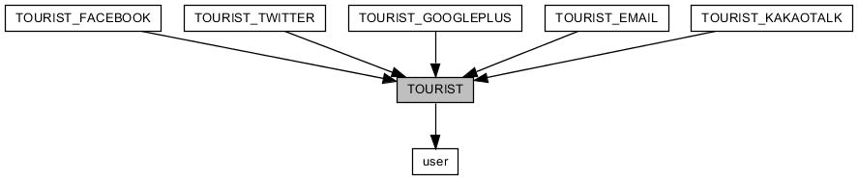
COLUMN | TYPE | NULLABLE | PKEY | DEFAULTED | REFERRED | REFER
ID | BIGINT |  | ● |  | [TOURIST_EMAIL] ID  [TOURIST_FACEBOOK] ID  [TOURIST_GOOGLEPLUS] ID  [TOURIST_KAKAOTALK] ID  [TOURIST_TWITTER] ID | [user] ID
CREATED_AT | TIMESTAMP |  |  | ●
UPDATED_AT | TIMESTAMP | ●

UNIQUE KEY | COLUMNS | DESCRIPTION
CONSTRAINT_E | ID

COLUMN | DESCRIPTION
ID | table identifier
CREATED_AT | timestamp when this record is created
UPDATED_AT | timestamp when this record is updated

TOURIST_EMAIL
joined tourist through input email information
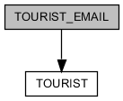
COLUMN | TYPE | NULLABLE | PKEY | DEFAULTED | REFERRED | REFER
ID | BIGINT |  | ● |  |  | [TOURIST] ID
EMAIL | VARCHAR(100)
PASSWORD | VARCHAR(100)
GENERATE_KEY | VARCHAR(255)
CERTIFIED_AT | TIMESTAMP | ●
CREATED_AT | TIMESTAMP |  |  | ●
UPDATED_AT | TIMESTAMP | ●

UNIQUE KEY | COLUMNS | DESCRIPTION
CONSTRAINT_496 | ID
TOURIST_EMAIL_EMAIL_KEY | EMAIL

COLUMN | DESCRIPTION
ID | table identifier
EMAIL | email of tourist. login ID
PASSWORD | login password
GENERATE_KEY | generated key for certificating email
CERTIFIED_AT | timestamp when email is certificated
CREATED_AT | timestamp when this record is created
UPDATED_AT | timestamp when this record is updated

TOURIST_FACEBOOK
joined tourist through facebook
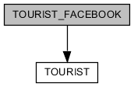
COLUMN | TYPE | NULLABLE | PKEY | DEFAULTED | REFERRED | REFER
ID | BIGINT |  | ● |  |  | [TOURIST] ID
SOCIAL_ID | VARCHAR(255)
FIRST_NAME | VARCHAR(100) | ●
MIDDLE_NAME | VARCHAR(100) | ●
LAST_NAME | VARCHAR(100) | ●
EMAIL | VARCHAR(255) | ●
GENDER | ENUM | ●
CREATED_AT | TIMESTAMP |  |  | ●
UPDATED_AT | TIMESTAMP | ●

UNIQUE KEY | COLUMNS | DESCRIPTION
CONSTRAINT_1 | ID
TOURIST_FACEBOOK_SOCIAL_ID_KEY | SOCIAL_ID

COLUMN | DESCRIPTION
ID | table identifier
SOCIAL_ID | facebook ID. login ID
FIRST_NAME | first name of tourist that is received from facebook
MIDDLE_NAME | middle name of tourist that is received from facebook
LAST_NAME | last name of tourist that is received from facebook
EMAIL | email of tourist that is received from facebook
GENDER | gender of tourist that is received from facebook
CREATED_AT | timestamp when this record is created
UPDATED_AT | timestamp when this record is updated

TOURIST_GOOGLEPLUS
joined tourist through googleplus
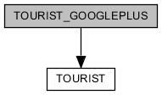
COLUMN | TYPE | NULLABLE | PKEY | DEFAULTED | REFERRED | REFER
ID | BIGINT |  | ● |  |  | [TOURIST] ID
SOCIAL_ID | VARCHAR(255)
FULL_NAME | VARCHAR(255) | ●
FIRST_NAME | VARCHAR(100) | ●
LAST_NAME | VARCHAR(100) | ●
EMAIL | VARCHAR(255) | ●
GENDER | ENUM | ●
CREATED_AT | TIMESTAMP |  |  | ●
UPDATED_AT | TIMESTAMP | ●

UNIQUE KEY | COLUMNS | DESCRIPTION
CONSTRAINT_57 | ID
TOURIST_GOOGLEPLUS_SOCIAL_ID_KEY | SOCIAL_ID

COLUMN | DESCRIPTION
ID | table identifier
SOCIAL_ID | googleplus ID. login ID
FULL_NAME | full name of tourist that is received from googleplus
FIRST_NAME | first name of tourist that is received from googleplus
LAST_NAME | last name of tourist that is received from googleplus
EMAIL | email of tourist that is received from googleplus
GENDER | gender of tourist that is received from googleplus
CREATED_AT | timestamp when this record is created
UPDATED_AT | timestamp when this record is updated

TOURIST_KAKAOTALK
joined tourist through kakaotalk
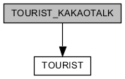
COLUMN | TYPE | NULLABLE | PKEY | DEFAULTED | REFERRED | REFER
ID | BIGINT |  | ● |  |  | [TOURIST] ID
SOCIAL_ID | VARCHAR(255)
NICKNAME | VARCHAR(255)
CREATED_AT | TIMESTAMP |  |  | ●
UPDATED_AT | TIMESTAMP | ●

UNIQUE KEY | COLUMNS | DESCRIPTION
CONSTRAINT_9 | ID
TOURIST_KAKAOTALK_SOCIAL_ID_KEY | SOCIAL_ID

COLUMN | DESCRIPTION
ID | table identifier
SOCIAL_ID | kakaotalk ID. login ID
NICKNAME | nickname of tourist that is received from kakaotalk
CREATED_AT | timestamp when this record is created
UPDATED_AT | timestamp when this record is updated

TOURIST_TWITTER
joined tourist through twitter
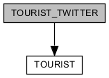
COLUMN | TYPE | NULLABLE | PKEY | DEFAULTED | REFERRED | REFER
ID | BIGINT |  | ● |  |  | [TOURIST] ID
SOCIAL_ID | VARCHAR(255)
SCREEN_NAME | VARCHAR(255)
NAME | VARCHAR(255) | ●
CREATED_AT | TIMESTAMP |  |  | ●
UPDATED_AT | TIMESTAMP | ●

UNIQUE KEY | COLUMNS | DESCRIPTION
CONSTRAINT_A | ID
TOURIST_TWITTER_SOCIAL_ID_KEY | SOCIAL_ID

COLUMN | DESCRIPTION
ID | table identifier
SOCIAL_ID | twitter ID. login ID
SCREEN_NAME | screen-name of tourist that is received from twitter
NAME | name of tourist that is received from twitter
CREATED_AT | timestamp when this record is created
UPDATED_AT | timestamp when this record is updated

TOUR_PLAN
plan tour by user. also it is used component of custom tour.
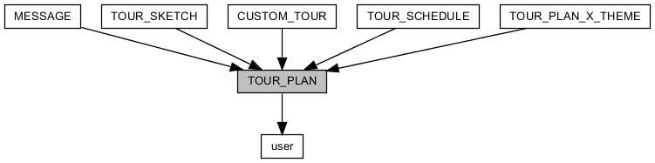
COLUMN | TYPE | NULLABLE | PKEY | DEFAULTED | REFERRED | REFER
ID | BIGINT |  | ● | ● | [CUSTOM_TOUR] TOUR_PLAN_ID  [MESSAGE] TOUR_PLAN_ID  [TOUR_PLAN_X_THEME] TOUR_PLAN_ID  [TOUR_SCHEDULE] TOUR_PLAN_ID  [TOUR_SKETCH] ID
USER_ID | BIGINT |  |  |  |  | [user] ID
TITLE | VARCHAR(200)
DESCRIPTION | CLOB(2147483647) | ●
START_AT | DATE | ●
END_AT | DATE | ●
CREATED_AT | TIMESTAMP |  |  | ●
UPDATED_AT | TIMESTAMP | ●
DELETED_AT | TIMESTAMP | ●

UNIQUE KEY | COLUMNS | DESCRIPTION
CONSTRAINT_D6 | ID

COLUMN | DESCRIPTION
ID | table identifier
USER_ID | reference writer
TITLE | title of tour-plan
DESCRIPTION | description
START_AT | start date of tour
END_AT | end date of tour
CREATED_AT | timestamp when this record is created
UPDATED_AT | timestamp when this record is updated
DELETED_AT | present that this record is deleted

TOUR_PLAN_X_THEME
relationship of tour-plan with theme
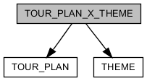
COLUMN | TYPE | NULLABLE | PKEY | DEFAULTED | REFERRED | REFER
ID | BIGINT |  | ● | ●
TOUR_PLAN_ID | BIGINT |  |  |  |  | [TOUR_PLAN] ID
THEME_ID | BIGINT |  |  |  |  | [THEME] ID
CREATED_AT | TIMESTAMP |  |  | ●
UPDATED_AT | TIMESTAMP | ●

UNIQUE KEY | COLUMNS | DESCRIPTION
CONSTRAINT_F6 | ID
TOUR_PLAN_X_THEME_TOUR_PLAN_ID_THEME_ID_KEY | TOUR_PLAN_ID THEME_ID

COLUMN | DESCRIPTION
ID | table identifier
TOUR_PLAN_ID | reference tour-plan
THEME_ID | reference theme
CREATED_AT | timestamp when this record is created
UPDATED_AT | timestamp when this record is updated

TOUR_SCHEDULE
schedule sheet of tour-plan
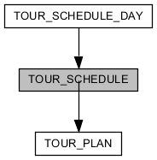
COLUMN | TYPE | NULLABLE | PKEY | DEFAULTED | REFERRED | REFER
ID | BIGINT |  | ● | ● | [TOUR_SCHEDULE_DAY] TOUR_SCHEDULE_ID
TOUR_PLAN_ID | BIGINT |  |  |  |  | [TOUR_PLAN] ID
CREATED_AT | TIMESTAMP |  |  | ●
UPDATED_AT | TIMESTAMP | ●
DELETED_AT | TIMESTAMP | ●

UNIQUE KEY | COLUMNS | DESCRIPTION
CONSTRAINT_5C | ID

COLUMN | DESCRIPTION
ID | table identifier
TOUR_PLAN_ID | reference tour-plan
CREATED_AT | timestamp when this record is created
UPDATED_AT | timestamp when this record is updated
DELETED_AT | present that this record is deleted

TOUR_SCHEDULE_DAY
information about specific day in tour-plan. they are sequential about time.
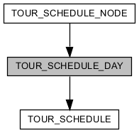
COLUMN | TYPE | NULLABLE | PKEY | DEFAULTED | REFERRED | REFER
ID | BIGINT |  | ● | ● | [TOUR_SCHEDULE_NODE] TOUR_SCHEDULE_DAY_ID
TOUR_SCHEDULE_ID | BIGINT |  |  |  |  | [TOUR_SCHEDULE] ID
SEQUENCE | INTEGER
TITLE | VARCHAR(100) | ●
DESCRIPTION | CLOB(2147483647) | ●
TRANSPORTATION_TYPE | ENUM | ● |  | ●
MEETING_TIME | VARCHAR(100) | ●
MEETING_LOCATION_NAME | VARCHAR(50) | ●
MEETING_LOCATION_MAP_ZOOM | INTEGER | ● |  | ●
MEETING_LOCATION_LATITUDE | DOUBLE | ●
MEETING_LOCATION_LONGITUDE | DOUBLE | ●
MEETING_LOCATION_DESCRIPTION | CLOB(2147483647) | ●
CREATED_AT | TIMESTAMP |  |  | ●
UPDATED_AT | TIMESTAMP | ●
DELETED_AT | TIMESTAMP | ●

UNIQUE KEY | COLUMNS | DESCRIPTION
CONSTRAINT_94 | ID

COLUMN | DESCRIPTION
ID | table identifier
TOUR_SCHEDULE_ID | reference tour-schedule
SEQUENCE | sequence number
TITLE | title
DESCRIPTION | description
TRANSPORTATION_TYPE | kind of transportation in the day
MEETING_TIME | when meet with guide
MEETING_LOCATION_NAME | name of place where meet with guide
MEETING_LOCATION_MAP_ZOOM | zoom level of google map about place where meet with guide
MEETING_LOCATION_LATITUDE | latitude of place where meet with guide
MEETING_LOCATION_LONGITUDE | longitude of place where meet with guide
MEETING_LOCATION_DESCRIPTION | description about place where meet with guide
CREATED_AT | timestamp when this record is created
UPDATED_AT | timestamp when this record is updated
DELETED_AT | present that this record is deleted

TOUR_SCHEDULE_NODE
information about course in specific tour day. detailed information about course is reference "product_course" entity.
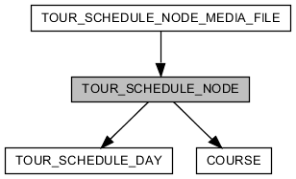
COLUMN | TYPE | NULLABLE | PKEY | DEFAULTED | REFERRED | REFER
ID | BIGINT |  | ● | ● | [TOUR_SCHEDULE_NODE_MEDIA_FILE] TOUR_SCHEDULE_NODE_ID
TOUR_SCHEDULE_DAY_ID | BIGINT |  |  |  |  | [TOUR_SCHEDULE_DAY] ID
COURSE_ID | BIGINT | ● |  |  |  | [COURSE] ID
START | INTEGER
SIZE | INTEGER
TITLE | VARCHAR(100)
DESCRIPTION | CLOB(2147483647) | ●
LATITUDE | DOUBLE | ●
LONGITUDE | DOUBLE | ●
CREATED_AT | TIMESTAMP |  |  | ●
UPDATED_AT | TIMESTAMP | ●
DELETED_AT | TIMESTAMP | ●

UNIQUE KEY | COLUMNS | DESCRIPTION
CONSTRAINT_2C | ID

COLUMN | DESCRIPTION
ID | table identifier
TOUR_SCHEDULE_DAY_ID | reference tour-schedule-day
COURSE_ID | reference course
START | start time. unit is minute. "0" is mean twelve at night.
SIZE | period time about course. unit is minute.
TITLE | title
DESCRIPTION | description
LATITUDE | latitude of course
LONGITUDE | longitude of course
CREATED_AT | timestamp when this record is created
UPDATED_AT | timestamp when this record is updated
DELETED_AT | present that this record is deleted

TOUR_SCHEDULE_NODE_MEDIA_FILE
image file what is comprised in one tour-schedule-node
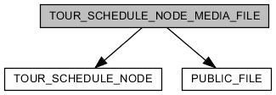
COLUMN | TYPE | NULLABLE | PKEY | DEFAULTED | REFERRED | REFER
ID | BIGINT |  | ● | ●
TOUR_SCHEDULE_NODE_ID | BIGINT |  |  |  |  | [TOUR_SCHEDULE_NODE] ID
PUBLIC_FILE_ID | BIGINT |  |  |  |  | [PUBLIC_FILE] ID
CREATED_AT | TIMESTAMP |  |  | ●
UPDATED_AT | TIMESTAMP | ●

UNIQUE KEY | COLUMNS | DESCRIPTION
CONSTRAINT_DA6 | ID

COLUMN | DESCRIPTION
ID | table identifier
TOUR_SCHEDULE_NODE_ID | reference tour-schedule-node
PUBLIC_FILE_ID | reference image file
CREATED_AT | timestamp when this record is created
UPDATED_AT | timestamp when this record is updated

TOUR_SKETCH
collection tour-information
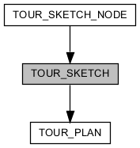
COLUMN | TYPE | NULLABLE | PKEY | DEFAULTED | REFERRED | REFER
ID | BIGINT |  | ● |  | [TOUR_SKETCH_NODE] TOUR_SKETCH_ID | [TOUR_PLAN] ID
CREATED_AT | TIMESTAMP |  |  | ●
UPDATED_AT | TIMESTAMP | ●

UNIQUE KEY | COLUMNS | DESCRIPTION
CONSTRAINT_F1 | ID

COLUMN | DESCRIPTION
ID | table identifier
CREATED_AT | timestamp when this record is created
UPDATED_AT | timestamp when this record is updated

TOUR_SKETCH_NODE
tour-information
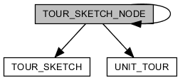
COLUMN | TYPE | NULLABLE | PKEY | DEFAULTED | REFERRED | REFER
ID | BIGINT |  | ● | ● | [TOUR_SKETCH_NODE] REF_ID
TOUR_SKETCH_ID | BIGINT |  |  |  |  | [TOUR_SKETCH] ID
SEQUENCE | DOUBLE
NAME | VARCHAR(200)
REF_ID | BIGINT | ● |  |  |  | [TOUR_SKETCH_NODE] ID
TYPE | ENUM
UNIT_TOUR_ID | BIGINT | ● |  |  |  | [UNIT_TOUR] ID
CREATED_AT | TIMESTAMP |  |  | ●
UPDATED_AT | TIMESTAMP | ●

UNIQUE KEY | COLUMNS | DESCRIPTION
CONSTRAINT_3A | ID

COLUMN | DESCRIPTION
ID | table identifier
TOUR_SKETCH_ID | reference tour-sketch
SEQUENCE | sequence number
NAME | name of information
REF_ID | reference tour-sketch-node
TYPE | tour-sketch-node is two types: folder(no information. for classification), item(belong folder-node)
UNIT_TOUR_ID
CREATED_AT | timestamp when this record is created
UPDATED_AT | timestamp when this record is updated

UNIT_TOUR
selling tour-product by guide
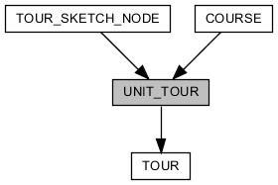
COLUMN | TYPE | NULLABLE | PKEY | DEFAULTED | REFERRED | REFER
ID | BIGINT |  | ● |  | [COURSE] UNIT_TOUR_ID  [TOUR_SKETCH_NODE] UNIT_TOUR_ID | [TOUR] ID
TRANSPORTATION_TYPE | ENUM | ●
MEETING_TIME | VARCHAR(100) | ●
MEETING_LOCATION_NAME | VARCHAR(50) | ●
MEETING_LOCATION_MAP_ZOOM | INTEGER | ● |  | ●
MEETING_LOCATION_LATITUDE | DOUBLE | ●
MEETING_LOCATION_LONGITUDE | DOUBLE | ●
MEETING_LOCATION_DESCRIPTION | CLOB(2147483647) | ●

UNIQUE KEY | COLUMNS | DESCRIPTION
CONSTRAINT_8B | ID

COLUMN | DESCRIPTION
ID | table identifier
TRANSPORTATION_TYPE | kind of transportation in the trip
MEETING_TIME | when meet with guide
MEETING_LOCATION_NAME | name of place where meet with guide
MEETING_LOCATION_MAP_ZOOM | zoom level of google map about place where meet with guide
MEETING_LOCATION_LATITUDE | latitude of place where meet with guide
MEETING_LOCATION_LONGITUDE | longitude of place where meet with guide
MEETING_LOCATION_DESCRIPTION | description about place where meet with guide

USER_X_INTEREST_GUIDE
relationship of user with guide.
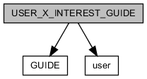
COLUMN | TYPE | NULLABLE | PKEY | DEFAULTED | REFERRED | REFER
ID | BIGINT |  | ● | ●
USER_ID | BIGINT |  |  |  |  | [user] ID
GUIDE_ID | BIGINT |  |  |  |  | [GUIDE] ID
CREATED_AT | TIMESTAMP |  |  | ●
UPDATED_AT | TIMESTAMP | ●

UNIQUE KEY | COLUMNS | DESCRIPTION
CONSTRAINT_2 | ID
USER_X_INTEREST_GUIDE_USER_ID_GUIDE_ID_KEY | USER_ID GUIDE_ID

COLUMN | DESCRIPTION
ID | table identifier
USER_ID | reference user
GUIDE_ID | reference guide
CREATED_AT | timestamp when this record is created
UPDATED_AT | timestamp when this record is updated

USER_X_INTEREST_PRODUCT
relationship of user with product.
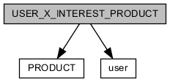
COLUMN | TYPE | NULLABLE | PKEY | DEFAULTED | REFERRED | REFER
ID | BIGINT |  | ● | ●
USER_ID | BIGINT |  |  |  |  | [user] ID
PRODUCT_ID | BIGINT |  |  |  |  | [PRODUCT] ID
CREATED_AT | TIMESTAMP |  |  | ●
UPDATED_AT | TIMESTAMP | ●

UNIQUE KEY | COLUMNS | DESCRIPTION
CONSTRAINT_DB | ID
USER_X_INTEREST_PRODUCT_USER_ID_PRODUCT_ID_KEY | USER_ID PRODUCT_ID

COLUMN | DESCRIPTION
ID | table identifier
USER_ID | reference user
PRODUCT_ID | reference product
CREATED_AT | timestamp when this record is created
UPDATED_AT | timestamp when this record is updated

user

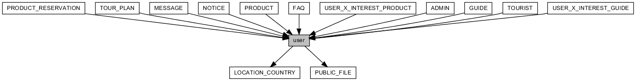
COLUMN | TYPE | NULLABLE | PKEY | DEFAULTED | REFERRED | REFER
ID | BIGINT |  | ● | ● | [ADMIN] ID  [FAQ] USER_ID  [GUIDE] ID  [MESSAGE] RECEIVER_ID  [MESSAGE] SENDER_ID  [NOTICE] USER_ID  [PRODUCT_RESERVATION] USER_ID  [PRODUCT] SELLER_ID  [TOURIST] ID  [TOUR_PLAN] USER_ID  [USER_X_INTEREST_GUIDE] USER_ID  [USER_X_INTEREST_PRODUCT] USER_ID
TYPE | ENUM
EMAIL | VARCHAR(100) | ●
FIRST_NAME | VARCHAR(100) | ●
MIDDLE_NAME | VARCHAR(100) | ●
LAST_NAME | VARCHAR(100) | ●
PROFILE_IMAGE_ID | BIGINT | ● |  |  |  | [PUBLIC_FILE] ID
PROFILE_DESCRIPTION | CLOB(2147483647) | ●
GENDER | ENUM | ●
MOBILE_COUNTRY_ID | BIGINT | ● |  |  |  | [LOCATION_COUNTRY] ID
MOBILE | VARCHAR(20) | ●
NATIONALITY_ID | BIGINT | ● |  |  |  | [LOCATION_COUNTRY] ID
ACCOUNT_STATUS | ENUM |  |  | ●
CREATED_AT | TIMESTAMP |  |  | ●
UPDATED_AT | TIMESTAMP | ●
DELETED_AT | TIMESTAMP | ●
AGREE_RECEIVE | BOOLEAN |  |  | ●
LOCALE | VARCHAR(16) | ●

UNIQUE KEY | COLUMNS | DESCRIPTION
CONSTRAINT_3 | ID

COLUMN | DESCRIPTION
ID | table identifier
TYPE
EMAIL
FIRST_NAME
MIDDLE_NAME
LAST_NAME
PROFILE_IMAGE_ID
PROFILE_DESCRIPTION
GENDER
MOBILE_COUNTRY_ID
MOBILE
NATIONALITY_ID
ACCOUNT_STATUS
CREATED_AT | timestamp when this record is created
UPDATED_AT | timestamp when this record is updated
DELETED_AT | present that this record is deleted
AGREE_RECEIVE
LOCALE

