Townsville, 28th of November 2014.

QUALITY CONTROL OF ADCP DATA WITH PRESSURE SENSOR AND EXTRACTION OF THE TOPMOST DEPTH STRATA

Alessandra Mantovanelli¹
Rebecca Cowley²
Craig Steinberg¹
Scott Heron³
David Williams^{1b}
Simon Spagnol^{1c}

¹ Australian Institute of Marine Science, AIMS, PMB No. 3, Townsville, QLD 4810, Australia
^{b} PO Box 40197, Casuarina NT 0811, Darwin, Australia
^{c} Oceans Institute, 35 Stirling Hwy, Crawley WA 6009, Australia
²The Centre for Australian Weather and Climate Research, CSIRO, TAS, Australia
³ NOAA/NESDIS/STAR, Coral Reef Watch; ReefSense

This report describes the quality control (QC) procedure of moored Acoustic Doppler Profiler (ADCP) data with pressure (depth) measurements available (pressure QC) and the extraction of current data at constant depth strata from the surface. The post-processing procedures and flagging are described. We recommend the inclusion of the tilting test as well as the tilt correction (bin-mapping) before applying the echo intensity and correlation tests. We describe an alternative test for the echo intensity criteria based on the normalized echo intensity profile (in dB). The temporal variation of the side-lobe contaminated cells as a function of the total depth is also taken into account.

Contents
Contents 2
1. Introduction 3
2. Instrumentation set-up 4
2.1. Data sets 4
2.2. ADCP set-up 5
3. ADCP post-processing and quality control procedure 6
3.1. Reading the ADCP binary files 7
3.2. Step 1 – magnetic declination correction and direction test 8
3.3. Step 2 – in and out the water test 8
3.4. Steps 3 and 4 – distance from the surface to the centre of each depth cell 9
3.5. Steps 5 and 6 – placing data on uniform depth strata 10
3.6. Step 7 – tilting angle test 10
3.7. Step 8 –side lobe test 11
3.8. Step 9 – coarse outlier removal 12
3.9. Additional flags 12
3.10. Extraction of the topmost valid depth cell 19
4. Assessing the percentage of data removed by each flag 20
5. Recommendations and improvements 23
6. References 25
Annexe 1: Calculation of the absorption loss 26
Annexe 2: QC Tests of the different deployments 27
Annexe 3: Flags’ plots 41

1. Introduction
This report proposes a technique to re-map ADCP currents on uniform depth strata, defining depth cells using the surface as reference instead of the ADCP head. The re-mapping procedure may be of interest for some users that want to compare ADCP data with other measurement platforms, such as high-frequency radars that sample always at fixed depth strata near the surface, or hydrodynamic model outputs. Although this procedure was designed and tested for four-beam broadband ADCPs (RDI Workhorse; Teledyne Instruments) of different operating frequencies (76.8 kHz, 153.6 kHz, 307.2 kHz and 614.4 kHz), it provides a methodology that can be adapted to other Doppler Profiles. The original RDI bin-mapping fixes the centre of each bin to the ADCP head. Therefore, measurements taken in a particular bin may be at different depths at different instances of time as the tides change.
ADCP data sets applied here were obtained from Australia’s Integrated Marine Observing System (IMOS) database (http://www.imos.org.au/) for the Queensland Great Barrier Reef (GBR, Q-IMOS) and Northern Australia (NA, WAIMOS) moorings. A total of 14 deployments were analysed, including both shallow (20-60 m) and deep (100-470 m) water moorings. All velocity measurements and quality-control parameters used to flag the data were placed into uniform depth strata (and matrices of uniform size) in order to compare the percentage of data removed by each flag.
Previous tests have shown that GBR and WAIMOS moorings are subjected to large tilting angles at some instances of time, with the instrument tilting increasing at peak tides for the shallow water moorings. Tilting can cause variations between the actual (i.e., tilted) and nominal (i.e., vertical) depths up to 3 bins (Mantovanelli et al., 2014; first Report). Large tilting angles render the velocity measurements unreliable, and therefore, the inclusion of a tilting test as a QC test is strongly recommended. Although the RDI ADCP bin-mapping algorithm corrects for instrument tilting when reporting the velocity components (u, v, w) and error velocity, the tilting is not corrected when reporting some of the ADCP performance descriptors, namely the echo intensity and correlation data (Darryl Symonds, pers. comm.). Therefore, the echo intensity and correlation data were bin-mapped (adopting the same bin configuration as RDI instrument) first, and posteriorly, placed into constant depth strata.
The temporal variation of the depth above the ADCP head (measured by the pressure sensor installed in the ADCP) was used to identify the dry cells (i.e., measurements performed in air when the instrument range is larger than the local depth) and to estimate the surface layer contaminated by side-lobe reflection at each instance of time. The total depth is also used to determine the distance of the centre of the bin to the surface at each instance of time.
The post-processing and flagging quality-control (QC) procedure presented here consisted of 16 steps, some of which need to be performed in the right order to achieve the desired results. Particularly, the first eight steps are essential. Some additional flags (outlier test, the correlation, echo intensity, percent of good, error velocity and vertical velocity) were also compared in terms of (i) amount of data removed by each flag and (ii) amount of data removed for each flag after the first nine steps of the QC have been applied to the data. Velocity data after applying Steps 0-9, after applying Steps 0-9 plus IMOS flags using the default toolbox cut-off limits and after applying Steps 0-9 plus IMOS flags with less restrictive cut-off limits were also compared. Ideally, the cut-off limits of each flag should be adjusted according with user’s requirements and the focused environment by an expert. Comparisons among the different flags were used to quantify the total amount of data that failure each QC test for each deployment, to identify the most relevant tests as well as the tests that can be flagging potentially good data.

2. Instrumentation set-up

2.1. Data sets
ADCP data sets applied here were obtained from Australia’s Integrated Marine Observing System (IMOS) data base (http://www.imos.org.au/) for the Queensland Great Barrier Reef (GBR, Q-IMOS) and Northern Australia (NA, WAIMOS) moorings (Figure 1; Table I), including: (i) three shallow GBR mooring stations (∼45-60 m deep), namely Heron Island North (HIN), Heron Island South (HIS), One Tree Island (OTE); (ii) the 100 m-deep Pilbara station (PIL, Western Australia); (iii) one NA station located in waters ∼470 m deep (TIS, Timor South); and (iv) Darwin National Reference Station Buoy (NRSDAR, ∼20 m deep).
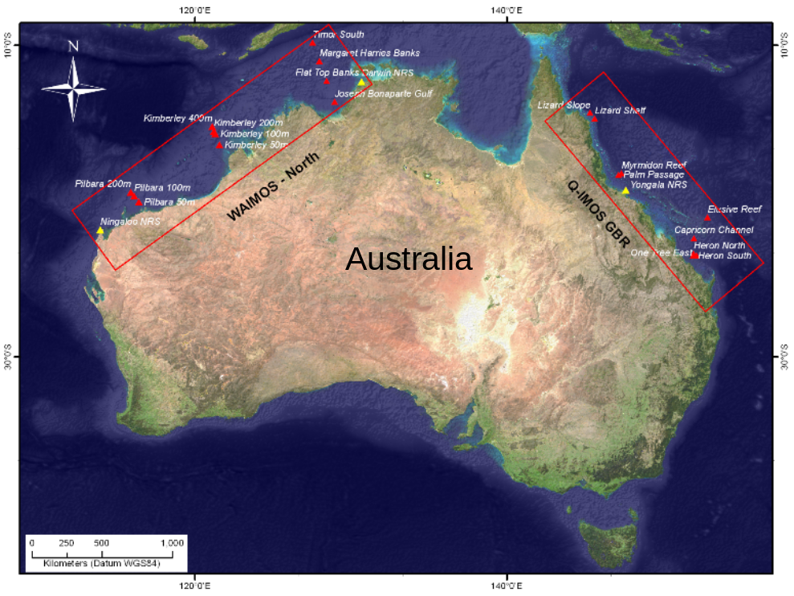 | 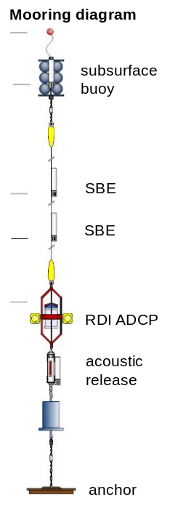
Figure 1. Location of the Queensland Great Barrier (Q-IMOS GBR) and Northern Australia (WAIMOS-North) mooring stations (left panel) and schematic ADCP mooring diagram (right panel). The upward-looking ADCP is deployed a few meters from the bottom and a subsurface buoy array holds the mooring line in a vertical position; additional temperature sensors (SBE) are present in most of the stations.

2.2. ADCP set-up
Table I summarises the instrument model, set-up configuration and the deployment period for each mooring site. All mooring were equipped with four-beam broadband ADCPs (RDI Instruments) with beam angles slanted at 20° in Janus configuration. The coordinate transformation option (Coord Xform (EX) 11111) was enabled to use tilting corrections, three beams solution and bin mapping which transforms the internal coordinate ADCP system (system XYZ) into an Earth coordinate system referred as ENU (East/North/Up) with correspondent velocity components denoted by (u, v, w).
The broadband ADCPs retrieve many samples per ping, which are typically averaged over a period of a few minutes (burst) to obtain reliable readings; these ping averages are termed ‘ensembles’. ADCP deployments lasted for about 6 months; the interval between ensembles (sampling rate) and number of pings per ensemble are specified in Table I. ADCPs were deployed in an upward-looking configuration a few meters above the bottom (Figure 1 right), with the number and size of bins varying for the different deployments (Table I).

Table I. Site name, the first and last good measurement for each deployment (day/month/year, hour:minutes in UTC time) are indicated in the first/second columns and the correspondent binary file in the last column. Details of instrument specifications (ADCP frequency in kHZ, beam angle), ADCP model, configuration (number of bins, bin size, sampling rate and number of pings per ensemble), site depth and distance of ADCP from the bottom, site location (latitude and longitude) for each analysed deployment. The mean magnetic declination value for each deployment is also shown. Deployments without pressure measurements were excluded.
site | first good | last good | frequency  (model) | bin number  x size (m) | sample rate  (min) | pings/  ens. | MD  (°) | depth/  off-bed  (m) | latitude/longitude | binary file (.000)
HIN (1) | 16/10/09 04:00 | 19/04/10 0:35 | 614.4 (1) | 50 x 1 | 30 | 170 | 9.71 | 45/ 4 | -23.3835°/ 151.9869° | HIN01000b
HIN (2) | 22/04/10 23:23 | 30/08/10 22:30 | 614.4 (1) | 50 x 1 | 30 | 170 | 9.70 | 46/ 4 | -23.3827°/ 151.9875° | HIN02000
HIN (3) | 02/09/10 02:04 | 10/03/11 04:37 | 614.4 (1) | 50 x 1 | 10 | 60 | 9.70 | 44.5/ 4 | -23.3804°/ 151.9873° | HIN03000b
HIS (1) | 26/04/10 04:54 | 31/08/10 01:50 | 614.4 (1) | 54 x 1 | 30 | 170 | 9.72 | 45/ 0.5 | -23.5128°/ 151.9542° | HIS02000
HIS (2) | 03/09/10 05:43 | 08/03/11 05:13 | 614.4 (1) | 28 x 2 | 10 | 60 | 9.72 | 45/ 0.5 | -23.5132°/ 151.9548° | HIS04000b
HIS (3) | 09/03/11 22:31 | 13/08/11 03:40 | 614.4 (1) | 28 x 2 | 10 | 60 | 9.71 | 45/ 1 | -23.5136°/151.9553 | HIS05000
OTE (1) | 12/10/09 03:00 | 19/04/10 23:26 | 614.4 (1) | 54 x 1 | 30 | 160 | 9.78 | 59/ 5 | -23.4836°/ 152.1722° | OTE01000b
OTE (2) | 05/09/10 05:06 | 10/03/11 02:19 | 307.2 (1) | 16 x 4 | 10 | 30 | 9.76 | 56/ 3 | -23.4836°/152.1727° | OTE03000
OTE (3) | 14/03/11 23:45 | 16/08/11 03:37 | 307.2 (1) | 15 x 4 | 10 | 40 | 9.75 | 60/ 8 | -23.4831/ 152.173 | OTE04000
TIS(1) | 30/05/11 04:10 | 10/01/12 06:45 | 76.8 (2) | 46 x 10 | 20 | 20 | 2.50 | 469/ 7 | -9.8176 °/127.5540° | TIS03000
TIS(2) | 11/01/12 02:00 | 21/07/12 22:18 | 76.8 (2) | 46 x 10 | 20 | 22 | 2.50 | 465/ 9 | -9.8174 °/127.5541° | TIS04000
PIL | 20/02/12 10:00 | 19/08/12 01:33 | 153.6 (3) | 12 x 8 | 10 | 42 | 1.28 | 100/ 8 | -19.6944 °/116.1115° | P1001000
NRSDAR(1) | 02/01/11 07:10 | 25/06/11 06:00 | 614.4 (1) | 40 x 0.75 | 10 | 120 | 3.23 | 23/ 1 | -12.3380 °/130.6965° | NEMO_NRSDAR1101_  CURRENTS_CONCATENATE
NRSDAR(2) | 14/01/12 07:08 | 26/07/12 22:31 | 614.4 (1) | 40 x 0.75 | 10 | 60 | 3.19 | 22/ 1 | -12.3381 °/130.6964° | NRSDAR1201_  RDI_CONCATENATED
ADCP model: (1) RDI Workhorse Sentinel, (2) RDI Workhorse Longranger, (3) RDI Workhorse Quartermaster

3. ADCP post-processing and quality control procedure
The QC procedure presented here was designed for four-beam broadband ADCPs (RDI Workhorse) and tested for instruments with different operating frequencies (76.8 kHz, 153.6 kHz, 307.2 kHz and 614.4 kHz). Sixteen sequential steps are performed to eliminate data points that are assuredly known to be unreliable and flagging suspicious data (Figure 2). Both systematic and random ‘bad data’ and coarse outliers identified in steps 1-9 are replaced with NaN by an automated routine implemented in MATLAB. Steps 10-16 generate flag matrices but do not removed the data; users can elect the set of flags and cut-off limits to be applied. Ten flag matrices are generated to quantify the data rejected by the designed QC test (Figure 2), namely: RDI test (flag 0), tilting test (flag 7), side lobe test (flag 8), outlier test (flag 9), normalized echo intensity top half of the water column only (flag 12top_half), normalized echo intensity whole water column (flag 12), echo intensity difference applied only to the top half of the water column (flag 12b), correlation test (flag 13a,b), percent of good (flag 14a,b), error velocity (flag 15a,b) and vertical velocity (flag 16).

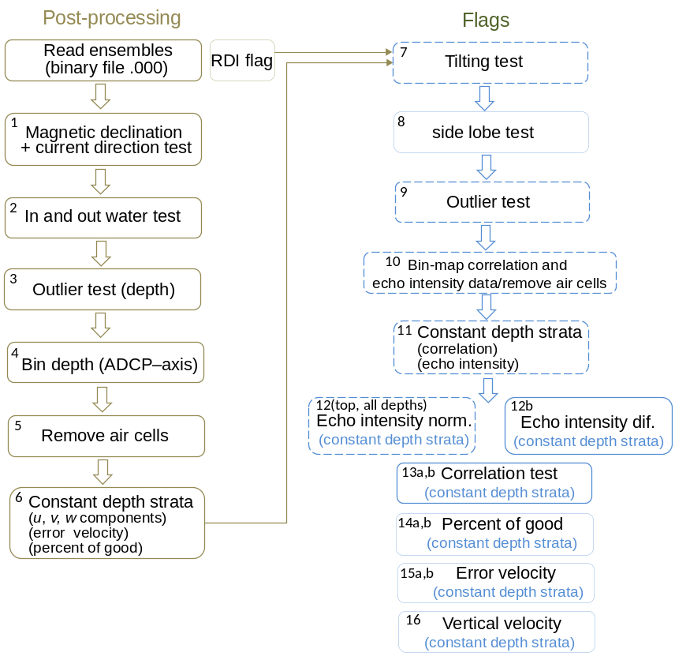
Figure 2. Steps for the ADCP post-processing (right side) and selected flags (left side). The flags with dotted line balloons indicate a new or modified flag from the currently applied IMOS flag, the flags with solid line balloons are the same as applied by IMOS.

All flags described above are prescribed in a matrix of uniform size with N (instants of time) x M (depth strata), which include wet cells only. The measurements performed in air were previously removed (Steps 5 and 10). Each flag test produces an individual matrix with data points with either value of 1 (if it failures the test) or 0 (if it passes the test). The sum of all values of each flag matrix gives the total number of data points rejected in each test. The sum of the flag matrix is divided by the total number of points (M . N) and multiplied by 100 to furnish the percentage of rejected points in each test (Table II). Some overlap may occur among the different flags, and therefore, the amount of data flagged by each additional flag after the applying Steps 0 to 9 is also quantified to assess the relative importance of each test (Table III). The flag 0 refers to horizontal (u, v) and vertical (w) velocity component data removed (replaced with NaN) a priori by the RDI software testing. Note that for the error velocity matrix may have more flagged values by the RDI testing than the velocity matrices because the error velocity cannot be calculated for the three beams’ solution.

3.1. Reading the ADCP binary files
The ADCP binary file is read (‘readWorkhorseEnsembles’ MATLAB code; http://code.google.com/p/imos-toolbox/) to extract some variables of interest extracted: the east (u), north (v) and vertical (w) components of current velocity; the error velocity; pitch and roll angles; acoustic backscatter intensity (echo intensity) and (iv) correlation magnitude of the four beams; percent of good (field1+field 4); bottom temperature; pressure; the number and size of the depth cells (bins); distance to the centre of the first depth cell; time (UTC or as setup).

3.2. Step 1 – magnetic declination correction and direction test
The magnetic declination has to be corrected before averaging the horizontal (u, v) velocity components. ADCPs are equipped with an internal fluxgate compass such that the v-component aligns with the magnetic north. In order to convert the magnetic direction to a true (geographical) north, the coordinate system must be rotated by an amount given by the local magnetic declination (Brook et al., 2007), which changes with geographical location and time. Estimations of magnetic declination can be manually obtained at Geoscience Australia website (http://www.ga.gov.au/oracle/geomag/agrfform.jsp) or from NOAA Geomag automated software (http://www.ngdc.noaa.gov/geomag/models.shtml). An averaged value of magnetic declination was adopted here for each deployment and inputted to the code (mag_decl).
In the code, the four-quadrant inverse tangent MATLAB function (atan2) is applied to reconstruct the azimuth angle (clockwise from North) from east and north velocity components, being 360° added to the negative angles. After this, azimuthal angles outside the 0 to 360° range are removed (current direction test). Positive to east (negative to west) magnetic declinations (MD in degrees) are added (subtract) to uncorrected azimuthal angle (D in degrees) yielding to a corrected azimuthal angle (D±MD). The corrected azimuthal angle is used to calculate the anticlockwise angle between the x-axis and the vector ($θ$ in radians, Equation 1) and to re-calculate the u- and v- velocity components (Equation 2).

$θ=(90-\left(D±MD\right))∙π/180$ (1)

$u=V∙cos⁡(θ)$ , $v=V∙sin⁡(θ)$, (2)

where $V=\sqrt{u^{2}+v^{2}}$ is the current speed magnitude or absolute velocity (m s⁻¹), which has the same value before and after the magnetic declination correction.

3.3. Step 2 – in and out the water test
Each deployment record contains information about time when the instrument was first in place (first good measurement; input start_t) and when it was removed for maintenance (last good measurement; input end_t; see http://www.aims.gov.au/imosmoorings/). This information is used to remove the outside the water measurements from the current velocity data (u, v, w), error velocity and total depth.

3.4. Steps 3 and 4 – distance from the surface to the centre of each depth cell
The distance of the centre of each bin along the beams is fixed in relation to the ADCP head. However, the depth of each cell varies as the total depth (DT) changes with tides and mooring tilting (Figure 3). Considering a classical logarithmic velocity profile with depth, then a particular depth cell (bin) may be sampling at different vertical positions within this profile in different instances of time. The bin-mapping algorithm supplied by RDI Instruments (the manufacturer) corrects the velocity components (u, v, w) and error velocity data for tilting when bin-mapping and Earth Coordinates set-up are enabled. The RDI ADCP bin-mapping algorithm aligns measurements vertically from the instrument head (Darryl Symonds, pers. comm.), selecting the range cell in each beam calculated to lie closest to the nominal (i.e., vertical) position of the depth cell (no interpolation is done; Gordon, 1996).
When bin mapping is used, time-dependent vertical depth (or surface distance SD, m) of the n^{th} depth cell (n = 1, 2…N = number of bins) is calculated as:

$SD_{n}\left(t\right)=DT\left(t\right)-\left({DHC}_{n}\right)$ , for upward looking ADCP
$SD_{n}\left(t\right)=DT\left(t\right)+\left({DHC}_{n}\right)$ , for downward looking ADCP (3)

where DT (m) is the total depth from the ADCP head to the surface, calculated from the measured pressure by the pressure sensor (p, dbar) using the TEOS-10 algorithm (IOC et al., 2010) and its Matlab toolbox (www.teos-10.org). Further, values of total depth (DT) larger than the averaged depth during each deployment plus or minus five times its standard deviation are removed (Step 3; Figure 2). This step is important to avoid spurious values when estimating the depth strata for re-mapping the currents (Step 6 in Figure 2).
The DHC (m) is the distance from the head of the ADCP to the centre of the n^{th} bin given by:

${DHC}_{n}=R_{1}+CL∙(n-1)$, (4)

where R₁ is the distance to the centre of the first bin, CL is the bin size and n is the bin number (n = 1, 2, …N). This simple calculation of depth is applicable to velocity and error velocity measurements only. The bin-mapping algorithm is not applied to the performance descriptors (echo intensity and correlation magnitude) supplied with the ADCP data (Darryl Symonds, pers. comm.). Proper quality control of the data using the ADCP QC fields requires the depths of each bin to be corrected for tilt (as described in item 3.9.1).

3.5. Steps 5 and 6 – placing data on uniform depth strata
At each instant of time, the velocity data (u, v and w components), error velocity and percent of good data are placed on uniform depth strata by inspecting the distance of a particular bin to the surface. Only one data point is usually located in each depth stratum. Air cells are removed before defining the depth strata by replacing any negative depth (SD_{n}) with NaN (Step 5; Figure 2). Only wet cells are kept in order to generate matrices of uniform size for flagging (see item 3.9). The depth strata are defined as: ${(N}_{w}∙CL,j∙CL,…2∙CL, 1∙CL, 0)$where CL is the bin size (or cell length),$j=1, 2, 3…N_{w}$, $N_{w}$ is the maximum number of wet cells estimated based on the maximum vertical depth ($SD_{n}$) observed during a particular deployment. Therefore, the first column of all averaged matrices corresponds to the deepest cell and the last column the shallowest cell.

3.6. Step 7 – tilting angle test
Self-contained RDI ADCPs furnish heading, pitch and roll angles. These orientation angles are used to transform data from XYZ to ENU. If the pitch and roll angles are nil, each beam pair sample the same depth cell. However, correspondent nominal depth cells of a tilted ADCP move up and down relative to one another (Figure 3). The bin-mapping algorithm cannot accurately correct tilting if angles are larger than about ±20°, a physical limit imposed by the tilt sensor output, excepting for the RDI Workhorse LongRanger with maximum output of ±50° and the new Sentinel V ADCP that provides tilt over complete ± 180 ° (Darryl Symonds, pers. comm.).

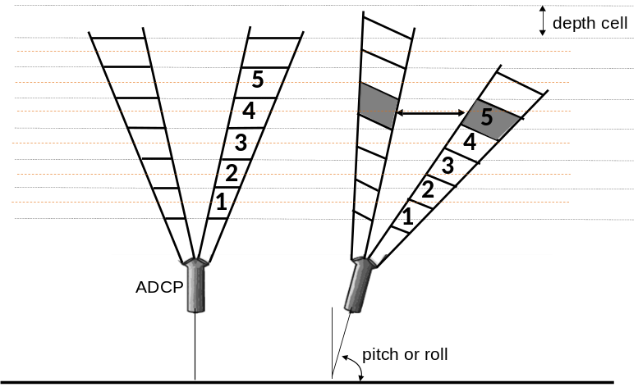
Figure 3. Tilting and correspondent change in the cell depth (highlighted) of a four-beam bottom-mounted upward-looking ADCP (adapted from Gordon, 1996).

The tilting test aims at eliminating data points subjected to large instrument tilting (above angle_cutoff = 20° for most instruments and angle_cutoff = 50° for the RDI Workhorse LongRanger). The tilt angle (T) can be estimated from the measured pitch (P) and roll (R) angles (Equations 5 and 6). Equation 5 was adapted from Equation 5 in Woodgate and Holroyd (2011), assuming beam angle equal to zero ($β$ = 0) that is equivalent to calculate the tilting between the main axis of the instrument pointing up (z-axis) and the vertical.

$\cos{T (t)=\sqrt{{1-sin}^{2}R\left(t\right)-\sin^{2}P(t)}}$ (5)

$T (t)=\cos^{-1}(\cos{T (t))}$ (6)

Equation 5 assumes that pitch is the angle of the axis through beam 4 and beam 3 to the horizontal, with positive pitch for beam 3 head higher than beam 4; roll is the angle of the axis through beam 2 and beam 1, with positive roll for beam 2 head higher than beam 1 (Woodgate and Holroyd, 2011). A flag7_tilting_angle matrix stores values equal to 1 for data points along all depth cells at instants of time with tilting angle larger than the specified limit (angle_cutoff) and 0 when instrument tilting is within the acceptable range.

3.7. Step 8 –side lobe test
After calculating the depth of each cell to the surface (item 3.4), the cells lying outside the water (i.e., SD(n, t) < 0; dry cells) are removed (Step 5; Figure 2). Dry cell measurements occur when the sampling range is larger than the local depth, a common set-up of the GBR and WAIMOS moorings. A second layer of spurious data is present below the dry cells, which results from side lobe contamination near the sea surface. The reflections from ADCP side lobes produce echoes stronger than those returning from ocean scatters which overwhelm the transducer side lobe suppression. The width of the side-lobe contaminated layer (SLW) and the number of depth cells contaminated by side lobe (n_SL) are given by (Gordon, 1996):

$SLW=ceil (DT∙\left(1-\cos\left(β\right)\right))$ (7)

$n_SL=ceil (SLW/CL)$ , (8)

where $β$ is the beam angle (equal to 20°), ceil is a MATLAB function that rounds the number to the nearest larger integer; DT (m) and CL (m) were previously defined. The final side lobe is equal to $n_SL*CL$ to guarantee that an integer number of bins is include in the side lobe affected layer; also if the side lobe width is less than a bin size, then the side lobe width is set as the bin size.
Current velocity data (u, v, and w components) from dry and side lobe contaminated depth cells are removed (replaced with NaN). A flag8_side_lobe stores values equal to 1 for the side-lobe contaminated cells and 0 for the remaining cells. The dry cells are not included in the flagging matrix.

3.8. Step 9 – coarse outlier removal
The time-averaged (each deployment) value of velocity magnitude (V as described in item 3.2) for each depth strata plus 5 times (user defined; ts_lim = 5 by default) its standard deviation is set as the cut-off limit above which values are removed (Step 9). This filter is applied twice. Note that absolute velocities are always positive. This criterion is based on the measured currents at each location/deployment instead of fixed cut-off limits. If an extreme event of short duration (such as a cyclone) occurs during the deployment, the data set should be carefully investigated during the period and different ts_lim tested. The cut-off limit can be increased (ts_lim = 10) for sites with large variability of the current intensity.

3.9. Additional flags
The additional flags (echo intensity, correlation magnitude, percent of good, error velocity and vertical velocity; Figure 2) are generated to identify potentially bad data. The standard processing by the RDI Instruments software reports the echo intensity and correlation magnitude as bins along the beams (Darryl Symonds, pers. comm.), and the tilting correction is not applied in this case (bin-mapping is only applied for u, v, w and error velocity; see section 3.4). Therefore the surface hit, identified as a peak in the echo intensity signal, will occur at different bins for each beam when the instrument is tilted. The instrument tilting has to be corrected when estimating the vertical depths from the sea surface to the centre of each cell depth for each beam. This correction is also required to ensure that the echo intensity and current velocity data correspond to the same depth layer before removing outliers on the current velocity matrices.

3.9.1. Tilting and surface distance calculation for the different beams
The distances from the sea surface to the centre of the bin along each ADCP beam (SD_B1, SD_B2, SD_B3, SD_B4) are calculated as:

$SD_B1\left(n,t\right)=DT\left(t\right)-\left(Ra(n)∙\cos{B1(t)}\right)$ (9)
$SD_B2\left(n,t\right)=DT\left(t\right)-\left(Ra(n)∙\cos{B2(t)}\right)$
$SD_B3\left(n,t\right)=DT\left(t\right)-\left(Ra(n)∙\cos{B3(t)}\right)$
$SD_B4\left(n,t\right)=DT\left(t\right)-\left(Ra(n)∙\cos{B4(t)}\right)$ ,

where DT is the distance from the head of ADCP to the surface, Ra is the range distance to the centre of the ‘n’ bin defined as ${Ra}_{n}= {{DHC}_{n}}/{\cos{β}}$, ${DHC}_{n}$ is defined in Equation 4 and $β$ is the beam angle. The cosines of the angle of all beams (B1, B2, B3, B4) to the vertical including tilting are given by (Woodgate and Holroyd, 2011):

$\cos{B1 (t)=-sin R sin β+ cos{β}\sqrt{{1-sin}^{2}R\left(t\right)-\sin^{2}P(t)}}$ (10)
$\cos{B2 (t)=+sin R sin β+ cos{β}\sqrt{{1-sin}^{2}R\left(t\right)-\sin^{2}P(t)}}$
$\cos{B3 (t)=+sin P sin β+ cos{β}\sqrt{{1-sin}^{2}R\left(t\right)-\sin^{2}P(t)}}$
$\cos{B4 (t)=-sin P sin β+ cos{β}\sqrt{{1-sin}^{2}R\left(t\right)-\sin^{2}P(t)}}$

where B1, B2, B3 and B4 represent the angles of each one of the four beams to the vertical and the other parameters were previously defined (Figure 4).
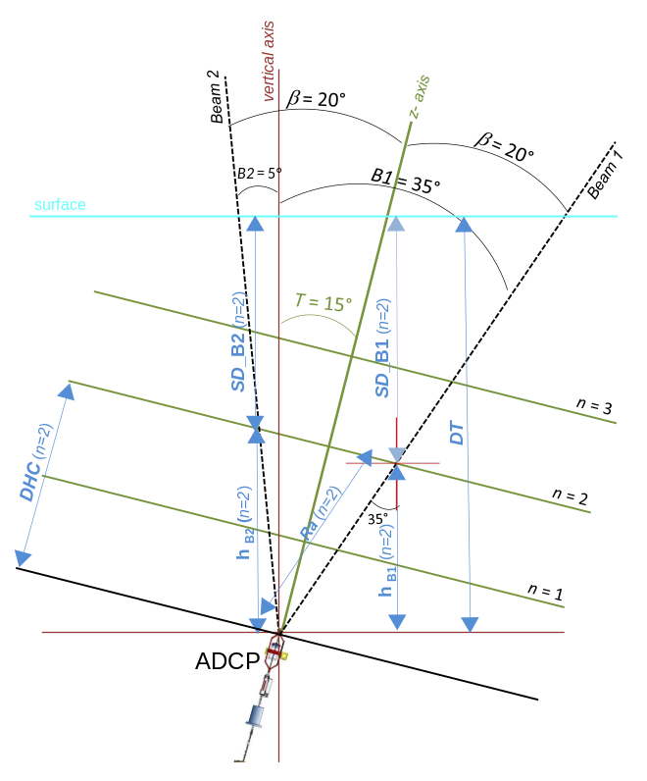
Figure 4: Schematic representation of beam 1 (B1 = 35 °) and beam 2 (B2 = 5 °) angles to the vertical after instrument tilting (T = 15 °) and correspondent distances from the centre of each depth cell to the surface (SD_B1, SD_B2) and to the ADCP head (h_{B1} = Ra cos B1, h_{B2} = Ra cos B2).

Examples of the depth (SD_B1, SD_B2, SD_B3, SD_B4) of each one of the four beams (on top) and the correspondent echo intensity and correlation magnitude profiles for large (∼19°) and small (∼1°) instrument tilting are shown in Figures 5a and 5b, respectively.
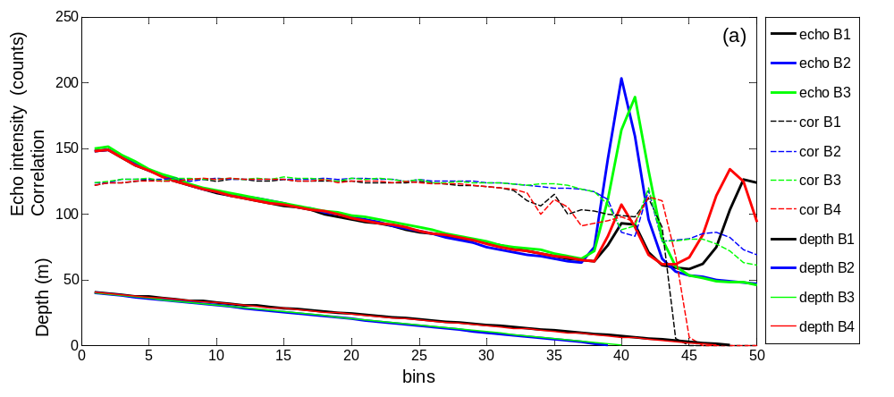
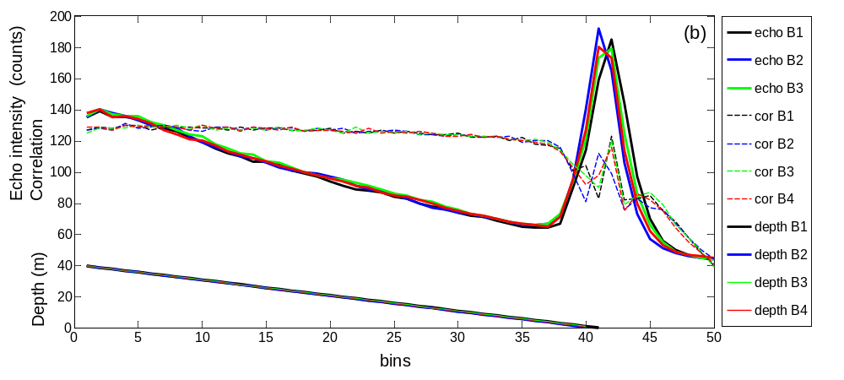
Figure 5: The recorded echo intensity (E, in counts; RSSI), correlation magnitude and the distances from the sea surface to the centre of the depth cells for the different beams (SD_B1, SD_B2, SD_B3, SD_B4) for (a) large tilt angle (19.2°) and (b) small tilt angle (1.3°). Beam 1 (black line), Beam 2 (blue line), Beam 3 (green line) and Beam 4 (red line). Example is for HIN02000.000 (HIS02, k=231,k=685).

Large tilting causes the different beams to cross the surface (zero) at different depth cells (bins), and just before the correspondent echo intensity peaks (Figure 5a). Conversely, all beams cross the surface approximately at the same depth cell when pitch and roll angles are small (Figure 5b).

3.9.1. 1. Bin-mapping echo intensity and correlation
The echo intensity and correlation were bin-mapped by calculating the distance from the ADCP head to the centre of the ‘n’ bin along the four different beams taking the tilting into account, as: h_{B1}(n) = ${Ra}_{n}$cos B1, h_{B2}(n) = ${Ra}_{n}$ cos B2, h_{B3} (n)= ${Ra}_{n}$cos B3, h_{B4} (n)= ${Ra}_{n}$cos B4 (see Figure 4). After, the distance from the ADCP head to the centre of each tilted bin is subtracted from the nominal distance (i.e. $h_{B1}-{DHC}_{n}$) to find the smallest difference between each actual (tilted) and nominal bin locations. In another words, the aim is to find the measurement for the tilted instrument that is closer to the centre of each nominal (vertical) beam. Then, the data point closest to each nominal bin at each instance of time is allocated to that bin, and therefore, correlation and echo intensity are bin-mapped into the same bin configuration used for the other measurements (i.e., u, v, w velocities). Further, if the maximum depth of a tilted ADCP is inferior to the range, all points above the maximum tilted depth are filled with zero (for correlation test) and with NaN for the echo intensity test. The RDI software also fills correlation with zero when the measurement was not possible.
After bin-mapping echo intensity and correlation, the echo intensity and correlation magnitude data are placed on uniform depth strata using the same depth strata range defined in item 3.5. Following, the specific tests for each criterion are applied to generate each flag.

3.9.2. Range normalized echo intensity (RE) test
The echo intensity (EI), i.e. the signal strength of the echo returning from scattering of the transmitted pulse, is the most indicative parameter for data quality, and useful to verify if the returning signal from scatters is larger than the ambient noise level (Shih et al., 2001) and to locate the surface, the bottom, or an obstruction (Symonds, 2006). The relative backscatter intensity (RE) produces a range-normalized echo intensity profile, supressing the reduction of the echo intensity towards the sea surface (for a bottom mounted ADCP) and generating an approximately straight RE profile (Figure 6b; RE in red). The use of the range-normalized echo intensity profiles facilitates the identification of spurious values. Gordon (1996) represents a simplified equation for echo intensity (EI, in dB):$EI=SL+SV+C-TL$, where SL is the transmitted power (dB), SV is the water-mass volume backscattering strength (dB), C is a transducer-specific constant, and TL is the transmission loss.
For operational purposes, the range normalized echo intensity (RE, dB) can be further simplied as the sum of the echo intensity and the two-way transmission loss (Thevenot et al., 1992):

$RE=EI+TL$ (11)

Replacing $EI= K_{c} (E-E_{r})$ in Equation 7 yields:

$RE=K_{c} (E-E_{r})+TL$ (12)

where E is the recorded echo intensity (in counts), termed as Reflected Signal Strength Indicator (RSSI); Kc is a scale factor that converts RSSI from counts to decibels (dB), being Kc = 0.45 dB/LSB adopted here (Deines, 1999); E_{r} is the baseline (in counts) which is the reference level for the echo intensity when no signal is present (Deines, 1999) and TL is defined in Equation 13. In the code, minimum values of echo intensity during the whole deployment are calculated for each beam and the larger value among them is stored (minecho). The instrument baseline (E_{r}) corresponds to the smallest value between minecho and a user defined value (instrument_baseline = 45 is default), being the same baseline values is adopted for the four beams. Typical baseline values are 40-48 counts (Deines, 1999; Kim et al., 2004). Values of echo intensity (E, counts) inferior than the baseline are removed. The transmission loss (TL) is calculated as:

$TL=20\log_{10}Ra+2Ra$ (13)

where Ra (m) is the radial (slant; item 3.9.1) distance from the transducer to the centre of the depth cell and is the absorption coefficient for water (dB/m; described in the Annexe 1). The first and second terms on the right side of Equation 13 account for the geometrical spreading (i.e., a logarithmic loss in echo intensity with increasing range, Ra) and absorption losses (Annexe 1), respectively (Figure 6a). The near-field correction of the geometrical spreading was disregarded.

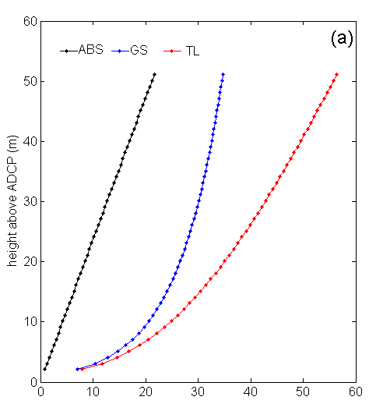 | 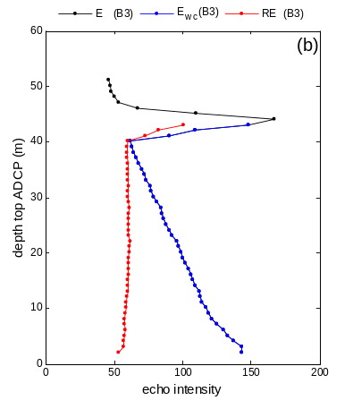 | 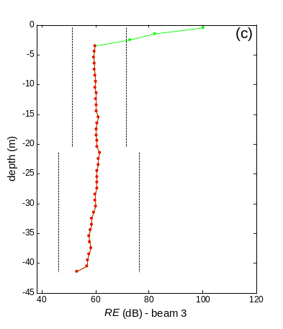
Figure 6: (a) Linear increase of absorption (ABS = 2 α Ra; black line), logarithmic increase beam spreading (GS = 20 log Ra; blue line) and transmission loss (TL; red line) with depth above the ADCP head; (b) depth profile of echo intensity (E in counts, black line) for Beam 3, the E profile after removing the dry cells (blue line), and the normalized relative echo intensity (RE in dB, red line); (c) RE profile over depth strata before (green line) and after applying the echo intensity QC criterion (red line). The accepted values are within the range indicated by the dotted lines applying cut-off limits of plus or minus 10 dB and 15 dB for the top layer and bottom layers, respectively (echo_lim_top = 10 dB; echo_lim_bottom = 15 dB). Example for Heron Island North (HIN) deployment (HIN02000.000; beam 1; 24/04/2010 19:55 UTC; k=125).

3.9.2.1. Echo intensity criterion (flag 12)
Echo intensity profiles of each beam (B1, B2, B3 and B4) are first bin-mapped (as described in item 3.9.1.1), second range-normalized by applying Equation 12, and then, and after placed onto uniform depth strata (as described in item 3.5). The mean value of the range-normalized echo intensity (RE (t)) over the water column is calculated at each instant of time, and a constant offset in dB (user defined) is both added and subtracted to the mean value to furnish a range of acceptable RE(t) values. In Figure 6c, this range is represented by dotted lines, with different limits for the top (echo_lim_top = 10 dB) and bottom layers (echo_lim_bottom = 15) been applied. The value used for these ranges (echo_lim_top and echo_lim_bottom) are user defined, and different limits can be applied for the different deployments. The range normalized echo intensity test is run for each beam separately, and if two or more beams failure the test (i.e., they have the data points outside the specified range), a flag equal to 1 (failure) is attributed to the tested depth cell (uniform depth strata cells) at that instant of time, otherwise the flag is equal to 0 (pass). Two flag matrices are generated: one that applies this test just to the top half of the water column and a second one that tests the whole water column. Note that the dry cells are previously removed before averaging the RE along the profile and they are not included in this test.

3.9.3. Echo intensity vertical difference test (flag 12b)
The raw echo intensity values (E, in counts) were bin-mapped (see item 3.9.1.1) and placed onto uniform depth strata (see item 3.5) before applying the echo intensity vertical difference test. The difference between two successive echo intensity values (E) along the water column was tested against a cut-off limit (here equal to 30 counts as the default in the IMOS toolbox) and all the data points above the depth cell (shallower in the upward configuration) that exceeded the set limit are also flagged as 1 (failure). Note that this test is only applied to the top half of the water column. The test is performed independently for each beam and if two or more beams failure the test (i.e., sum of the individual flags is larger or equal to 2) the final flag matrix will store a value of 1 (failure), otherwise the flag will be equal to 0.

3.9.4. Correlation magnitude test (flag 13)
Correlation magnitude is a measure of the pulse-to-pulse correlation in a ping for each depth cell showing a slightly variable value throughout the depth profile, and reflecting good data quality (high signal to noise) for high values and bad correlation for a zero value (Symonds, 2006). Correlations of each beam are individually checked against a cut-off limit, and if correlations of two or more beams are less than the cut-off limit a failure flag = 1 is attributed to the data point, otherwise flag = 0. Two cut-off limits were compared here: cut-off limit of 110 (default value at IMOS toolbox) and cut-off limit of 64. Correlation values below 64 usually relates to the “flattening out” of the echo intensity, indicating that the ADCP has reached its noise floor and cannot pick out the signal (Symonds, 2006). Correlation values were bin-mapped (see item 3.9.1.1) and placed onto uniform depth strata (see item 3.5) before applying the correlation test.

3.9.5. Percent of good (flag 14)
Percent good reports the percentage (0 to 100) of good data collected for each depth cell of the velocity profile, and data rejection is based on low correlation, large error velocity and fish detection (false target threshold; Symonds, 2006). Percent good is related to the expected noise (standard deviation) of your data but cannot detect the surface (echo intensity test) or if the data has good confidence (correlation test; Symonds, 2006). FIELD 1 equals the percentage of valid 3-beam earth solutions passing both the low correlation and the fish rejection thresholds. The FIELD 4 of percent of good gives the percentage of valid 4-beam earth solutions passing both the low correlation and the fish rejection thresholds. The sum of FIELD 1 and FIELD 4 of the percent of good is used for the percent of good test. The percent of good is placed onto uniform depth strata (using Equation 3), assuming that fields 1 and 4 of the percent of good have been bin-mapped. The percent of good is tested against a minimum acceptable value (cut-off limit) and data points below this value are rejected (flag = 1) and values above the cut-off limit are accepted (flag = 0). Two cut-off limits were tested here: 50 (IMOS tool box default) and 10 (less restrictive limit).

3.9.6. Error velocity (flag 15)
Each pair of beams measures one horizontal velocity component and one vertical velocity component. The error velocity is the difference between two independent estimates of vertical velocities from each pair of beams, therefore it can only be reported when the 4 beams solution is applied (Gordon, 1996). Error velocity allows you to evaluate whether the assumption of horizontal flow homogeneity is reasonable, and the error velocity approaches to zero when the flow is homogeneous (Symonds, 2006; QARTOD, 2013). The error velocity test (Flag 15a) rejects (flag = 1) data points with error velocity higher than ±0.15 m s⁻¹ and a second test uses as cut-off limit twice this value (i.e., ±0.3 m s⁻¹; Flag 15b). Error velocity data are previously bin-mapped by the RDI software, and posteriorly place onto uniform depth strata before applying the test. Note that this flag does not count values of error velocity removed by the RDI software (replace by NaN) when the 3 beams solution was applied.

3.9.7. Vertical velocity flags (flag 16)
Data points with vertical velocity higher than ±0.20 m s⁻¹ (as IMOS toolbox default) are rejected (flag = 1), otherwise flag = 0. Vertical velocity data are previously bin-mapped by the RDI software, and posteriorly place onto uniform depth strata before applying the test.

3.10. Extraction of the topmost valid depth cell
The nearest-to-the-surface (topmost) valid velocity data were extracted for each analysed deployment after placing the data in uniform depth strata using the surface as reference (see item 3.4 and 3.5). Both the topmost depth cell with a minimum of 50% of data temporal coverage during the deployment and the depth cell immediately below it were analysed (see Figures below).

4. Assessing the percentage of data removed by each flag

4.1. What is plotted in the figures:
The Annexe 2 shows pictures comparing the current magnitude (V, m s⁻¹) before and after the quality-control for the 14 analysed deployments. Two sets of figures are presented (A.i, with i = 1, 2,.., 14 deployments). The first set (A.i) presents the current magnitude (V, m s⁻¹) data along the water column and time (a-plots). Each subplot ‘a’ of Figures A.i(a) shows four depth x time x V plots which corresponds from the top to the bottom to: (i) the raw current magnitude (V, m s⁻¹) as outputted by the RDI software, (ii) the current magnitude (V, m s⁻¹) removing data points considered as bad after Steps 0-9 of the QC (see Figure 2), (iii) the current magnitude (V, m s⁻¹) removing data points considered as bad after Steps 0-9 of the QC plus all IMOS flags using the default toolbox values (namely echo intensity cut-off limit = 30; correlation cut-off limit = 110; percent of good cut-off limit = 50; error velocity cut-off limit = 0.15 m s⁻¹; vertical velocity cut-off limit = 0.2 m s⁻¹) and (iv) the current magnitude (V, m s⁻¹) removing data points considered as bad after Steps 0-9 of the QC plus all IMOS flags using less strict cut-off limits than the toolbox values (namely echo intensity cut-off limit = 30; correlation cut-off limit = 64; percent of good cut-off limit = 10; error velocity cut-off limit = 0.30 m s⁻¹; vertical velocity cut-off limit = 0.2 m s⁻¹).
Each subplot ‘b’, ‘c’ and ‘d’ of Figures A.i shows temporal series of current magnitude (V, m s⁻¹) before (raw data) and after QC for the two depth strata closest to the surface and the bottom, which have more than 50% of valid data during the deployment. For subplots ‘b’, the original data (raw data, black lines) are compared against data considered good after applying QC Steps 0-9 (flags 0 to 9; Figures A.i(b)). For subplots ‘c’, the original data (raw data, black lines) are compared against data considered good after applying QC Steps 0-9 (flags 0 to 9) plus all IMOS flags using default cut-off limit values of the toolbox (flags 12b, 13a, 14a, 15a and 16; Figures A.i(c)). For subplots ‘d’, the original data (raw data, black lines) are compared against data considered good after applying QC Steps 0-9 (flags 0 to 9) plus all IMOS flags using less strict cut-off limit values of the toolbox (flags 12b, 13b, 14b, 15b and 16; Figures A.i(d)).
Pictures of the flagged values along the water column for each deployment are shown in Annexe 3 (Figures B1, B2,…B14), where the rejected data points have values of 1 (yellow) and the accepted data points are equal to zero (green). The set of subplots on the left side show from the top to the bottom: (i) the amount of data flagged after steps 0 to 9; (ii) only the amount of data flagged for all IMOS flags using default values; (iii) only the amount of data flagged for all IMOS flags using less strict cut-off limits (as defined above); (iv) the amount of data flagged by the echo normalized test (flag 12top) for the top half of the water column and (v) the amount of data flagged by the echo difference test (flag 12b) for the top half of the water column. The set of subplots on the right side show from the top to the bottom: (i) the amount of data flagged by the beam correlation test (using a cut-off limit = 110; flag 13a); (ii) the amount of data flagged by the beam correlation test (using a cut-off limit = 64; flag 13b); (iii) the amount of data flagged by the percent of good test (using a cut-off limit = 50; flag 14a); (iv) the amount of data flagged by the percent of good test (using a cut-off limit = 10; flag 14b); and (v) the amount of data flagged by the error velocity test (using a cut-off limit = 0.15 m s⁻¹; flag 15a).

4.2. Percentage of data removed by each flag or combination of flags
Table II resumes the total percentage of data removed for each one of the individual flags, which may overlap. Note that the dry cells and outside position data had been previously removed and were not counted in the flags. The percentage of data removed after Steps 0 to 9 varied between ∼8 and 50% (∼21% in average) for all deployments, with the overlap for the Step 0-9 block varying between ∼0 and 6% (∼2% in average; Table II). The RDI (flag 0) flag removed 2-17% of the data (∼7% in average), and the side lobe test (Flag 8) removed from 6-9% of data (∼8% in average; Table II).

Table II. Percentage of data removed after Steps 0-9 (Flag_0_9_once that includes Flag 0, Flag 7, Flag 8 and Flag 9, the amount of overlap among the flags (Flag_0_9(overlap)), and total percentage of data removed by each individual flag for each deployment; note that individual flags may overlap. The flagging matrix included only the wet cells.
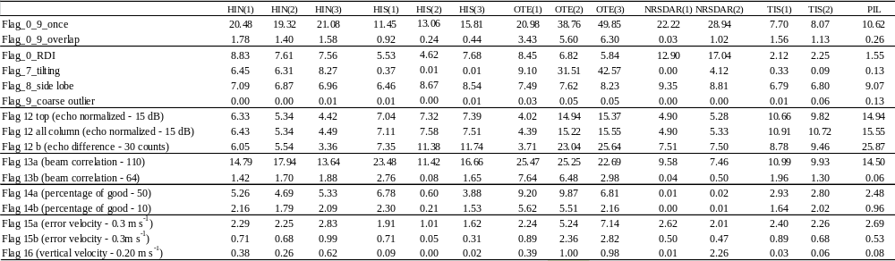

The amount of data flagged by the tilting test (Flag 7) was less than 8% for most deployments, excepting the three OTE deployments that had 9-43% of the data points removed (Table II). The velocity measurements were noisy under large tilting, particularly near the surface (e.g. OTE deployments Figures A7,8,9(b)). Further, OTE deployments had a large amount of data flagged near surface by the correlation test (Flag 13a) for a cut-off limit of 110 (Figures B7, B8 and B9) and larger error velocities likely associated with higher noise and spatial variability of the measurements under large mooring tilting. Further, the southern GBR ADCPs are likely exposed to less homogeneous flow conditions around the moorings and to a larger biological influence, which may have impacted the correlation magnitude and error velocity values at some instances of time. Conversely, the Darwin mooring (NRDRS) presented an overall good data quality, with small tilt, high correlation magnitudes (>100), and low error velocities and vertical velocities (± 0.20 m s⁻¹). This may reflect the uniform flow conditions in this shallow environment subjected to large tides (see Figures A13, A14 and B13, B14).
The coarse outlier test (Flag 9) picked up just a few points, representing a very small percentage (0-0.1%); however these points often present very high, unrealistic current velocities. The vertical velocity test (Flag 16) also flagged small amount of data (maximum of ∼2%). The error velocity tests (Flag 15a,b) flagged less than 3% of the data, excepting OTE02 and OTE03 deployments (subjected to large tilting) when data rejection reached 5-7% if a cut-off limit of 0.15 m s⁻¹ was applied (Table II).
Most of the data flagged by the echo normalized test were in the top layer. The echo normalized test for the top layer (Flag 12 top) rejected 4-15% (8% in average) of the data; the echo difference test (Flag 12b) rejected from ∼3-26 % (11% in average) of the data (Table II). The normalized echo intensity test (Flag 12 top) and the echo intensity difference test (Flag 12b) flagged additional data points below the side-lobe contaminated cells (Figures B1-14). Particularly the deep moorings (TIS01, TIS02 and PIL01) had a large amount of extra data (30-61%) rejected both by Flag 12 top and 12b that had not been flagged after Steps 0 to 9. More tests are needed to check if the data removed by these tests are potentially good.
Large differences were found in the amount of data rejected by the correlation test for the different cut-off limits. The amount of data rejected varied between 0 and 8% (2% in average) if the cut-off is set to 64, rising to ∼7-25% (16% in average) if the minimum cut-off limit is set to 110 (Table II). Most of the data flagged by the correlation are located near surface (see Figures B1-B14), and therefore using a more strict correlation cut-off limit would remove potentially good data near the surface for most of the analysed deployments (see Figures A1-14).
The percentage of good tests (Flag 14a and Flag14b) rejected 0 to 10% (3% in average) of the data (Table II). Both error velocity (Flag 15a and Flag15b) and the vertical velocity tests (Flag 16) rejected small amounts of data (<7%; 1% in average; Table II) for the analysed deployments. Error velocities give an indication of the horizontal homogeneity of the flow. Error velocities often augment towards the surface (in an upward mooring configuration) as the separation between beams (and sampled area) enlarges with increasing range (Taylor and Jonas, 2008). Therefore, most of the rejected values by the error velocity test are often located near surface (Figures B1-14).
There is a considerable amount (i.e. 7-22% and 11% in average) of overlap between all IMOS flags when the default values are applied; if all IMOS flags (default values) plus the data rejected for Steps 0_9 are considered, then the overlap rises to 9-27% (14% in average; Table III). The overlap between all IMOS flags (alone) varies between 0.1 and 9% when the lower correlation (64), percent of good (10) and higher error velocity (0.3 m s⁻¹) cut-off limits are applied (Table III). Most of the overlap among flags occurs in the top (shallowest) layer of the water column (see Figures B1-14 in Annexe 3).

Table III. Percentage of data rejected by adding: all IMOS flags using (i) default and (ii) less strict cut-off limits (low), (iii) by all IMOS flags (default values) plus Steps 0_9 and (iv) by Steps 0_9 plus flag 13b (correlation cut-off = 64); both the total amount of data rejected (once) and the amount of data flagged by more than one flag (overlap) are shown.
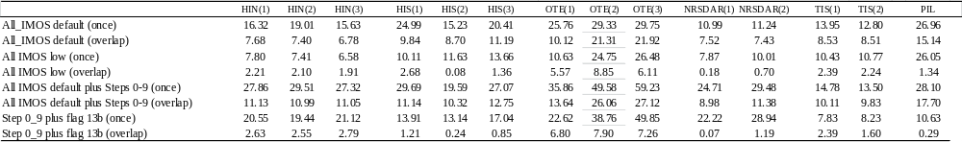

Applying Flag 0_9 plus all IMOS flags with default cut-off limits (namely echo intensity cut-off limit = 30; correlation cut-off limit = 110; percent of good cut-off limit = 50; error velocity cut-off limit = 0.15 m s⁻¹; vertical velocity cut-off limit = 0.2 m s⁻¹) rejects a larger amount of data near surface than applying the essential Flags 0 to 9. Particularly for the deeper moorings, applying Flag 0_9 plus all IMOS flags with default values would remove most or all data from the first two topmost depth strata selected (Figures A8c, A9c, A10c, A11c, A12c). Applying the Flags 0 to 9 only (Figures A1-14a) or Flags 0 to 9 plus Flag 13b (not shown) would preserve larger amounts of data near surface which seem to be within an acceptable velocity range, particularly for the second topmost bin.

5. Recommendations and improvements
The use of Flags 0 to 9 is strongly recommended as well as the correlation test with a minimum value of correlation equal to 64. Different combinations of additional flags can be chosen according to the environmental characteristics of each site and applied on the top of Steps 0-9. The main recommendations for the quality-control procedure are:

- The inclusion of the instrument tilting test (Step 5; item 3.6) as a new quality-control test. The angle cut-off limit is set according to the maximum measurement range of the tilting sensor and user requirements.

- The application of the correlation magnitude test is recommended, and the minimum cut-off limit is 64. Using correlation cut-off limit of 110 can potentially remove good data near the surface for most of the analysed deployments (see Figures A1-14b,c,d and B1-14). The correlation cut-off limit should be chosen according to the data application and deployment.

- The inclusion of the temporal variation of the depth for the determination of the dry and side-lobe contaminated cells based on the pressure measurements. A logical test has been implemented in the code to (i) remove the first depth strata when the side lobe width is inferior to the bin size and to (ii) round the side lobe width to an integer number of bins.

- A routine was implemented in the code to bin-map correlation and echo intensity data before placing the data on uniform depth strata; this avoids the averaging of correlation and echo intensity data and ensures compatibility among the flags.

- Correction of both the tides and instrument tilting (individually for each beam, item 3.9.1) for the echo intensity and correlation magnitude data can be achieved by (1) bin-mapping and (2) placing data on uniform depth strata (as defined for the velocity data).

- The correction of the tidal variation for the bin-mapped quantities (u, v, w velocity components and error velocity) by placing data on uniform depth strata will be suitable for some users.

- The use of all IMOS flags (with default values) is more conservative and will potentially remove some good data near the surface. The use of a combination of Flags 0_9 plus 13b (minimum beam correlation=64) seems more suitable but further tests, and comparisons with current measurements obtained by other instruments, are required.

- Guarantee that at least one pressure sensor is installed in the ADCP and operational, a backup pressure sensor for each mooring is advisable, since the lack of depth measurements compromises the ADCP quality-control and the data utilization.

- The application of the range normalized of echo intensity data will benefit users analysing the plankton community based on the echo intensity signal (item 3.9.2).

6. References

Book, J. W., Perkins, H., Signell, R. P., Wimbush, M. (2007). The Adriatic Circulation Experiment Winter 2002/2003 Mooring Data Report: A Case Study in ADCP Data Processing. Naval Research Laboratory Oceanography Division Stennis Space Center, MS 39529-5004NRL/MR/7330-07-8999.

Deines, K.L.(1999). Backscatter estimation using Broadband acoustic Doppler current profilers, Current Measurement, 1999. Proceedings of the IEEE Sixth Working Conference on 11-13 March, 249-253.

Gordon, R. L. (1996). Acoustic Doppler current profiler principles of operation a practical primer. RD Instruments, P/N 951-6069-00, 52 p.

IOC, SCOR and IAPSO, 2010: The international thermodynamic equation of seawater – 2010: Calculation and use of thermodynamic properties. Intergovernmental Oceanographic Commission, Manuals and Guides No. 56, UNESCO (English), 196 pp.

Mantovanelli, A., Steinberg, C., Williams, Spagnol, S., Munoz Mas, C., Rigby, P., Heron, S. 2014. Methods for the quality control of ADCP data (without pressure sensor) and extraction of the topmost valid current measurement, AIMS Report, 48 pp.

QARTOD (2013). Manual for Real-Time Quality Control of In-Situ Current Observations. A Guide to Quality Control and Quality Assurance of Acoustic Doppler Current Profiler Observations, Integrated Ocean Observing System (IOOS), 45 p.

Shih, H.H., Sprenke, J., Payton, C., Mero, T. (2001). Towing Basin Speed Verification of Acoustic Doppler Current Profiling Instruments, NOAA Technical Report NOS CO-OPS 033, 71 p.

Symonds, D. 2006. QA/QC Parameters for Acoustic Doppler Current Profilers, Application Note Teledyne Instruments, 17 pp.

Taylor, J.A., Jonas, A.M. 2008. Maximising data return: towards a quality control strategy for managing and processing TRDI ADCP data sets from moored instrumentation, Proceedings of the IEEE?OES?CMTC Ninth Working Conference on Current Measurement Technology, 80-88.

Thevenot, M.M., Terri L. P., Nicholas C. K. (1992). Tylers Beach, Virginia, Dredged Material Plume Monitoring Project, 27 September to 4 October 1991, Coastal Engineering Research Center; prepared for Department of the Army, US Army Corps of Engineers, 204 p.

Woodgate1, R. A., Holroyd, A.E. (2011) Correction of Teledyne Acoustic Doppler Current Profiler (ADCP) Bottom-Track Range Measurements for Instrument Pitch and Roll. UW Technical Report; http://psc.apl.washington.edu/BeringStrait.html Page 1:10.

Annexe 1: Calculation of the absorption loss
Water is a dissipative medium that absorbs part of the sound wave transmitted energy (absorption loss). The sound absorption in sea water depends on the acoustic frequency, salinity, temperature, pressure and acidity. The sea water absorption comes from pure water viscosity (above 100 kHz) and chemical relaxation effects, primarily due to boric acid at low frequencies (up to a few kHz) and magnesium sulphate at intermediate frequencies up to a few 100 kHz (Fisher and Simmons, 1977; Francois and Garrison, 1982; Ainslie and McColm, 1998). A simplified expression proposed by Ainslie and McColm (1998) is adopted to compute the absorption coefficient (α) which, assuming constant salinity (35) and pH (8), reduces to:

$α=0.106\frac{f_{1}f^{2}}{f^{2}+f_{1}^{2}}+0.52\left(1+\frac{T}{43}\right)\frac{f_{2}f^{2}}{f^{2}+f_{2}^{2}}e^{-z/6}+0.00049f^{2}e^{-(T/{27}+{z_{n}}/{17})}$ (1)

$f_{1}=0.78 e^{T/{26}}$ (for boron) , $f_{2}=42 e^{T/{17}}$ (for magnesium),

where f is the frequency in kHz, T is the temperature in °C measured at the transducer (ADCP head) and z_{n} is the depth of the n cell from sea surface (in km). Equation 1 gives α in dB/km which is posteriorly converted to dB/m to input Equation 8. Larger variations of the absorption coefficient are caused by changes in the ADCP frequency, water temperature, and to a lesser extent, in the water depth (see example in Figure A1). If field data are available, the α coefficient could be refined by incorporating salinity and temperature variations along the water column.

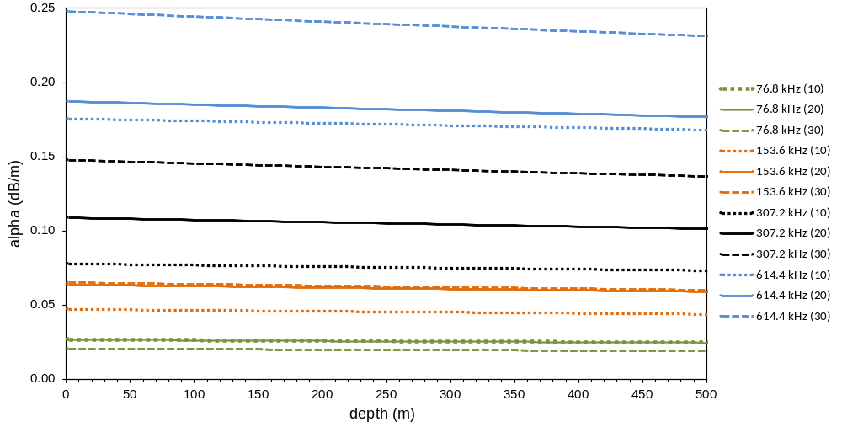
Figure A1: Variation of the absorption coefficient (α, dB/m) with depth (m), ADCP frequency (kHz, see legend) and temperature (10° C, 20° C and 30° C, indicated inside the parenthesis in the legend).

Annexe 2: QC Tests of the different deployments
(a)  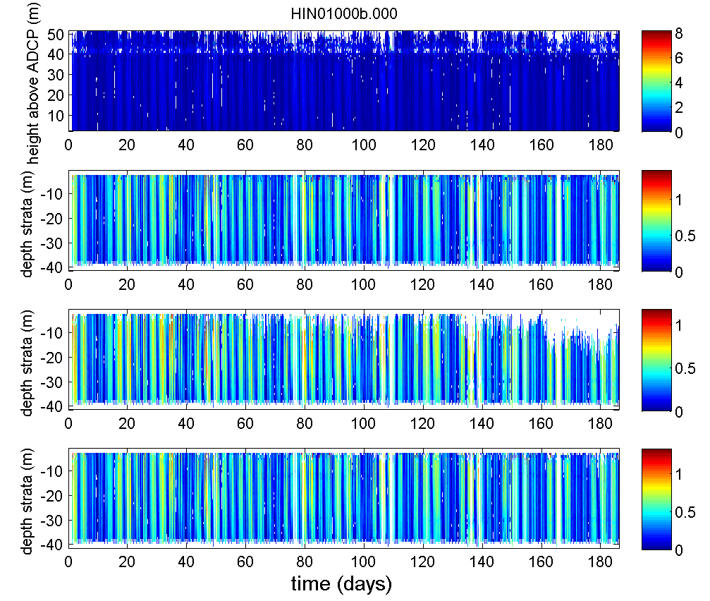 | (b)  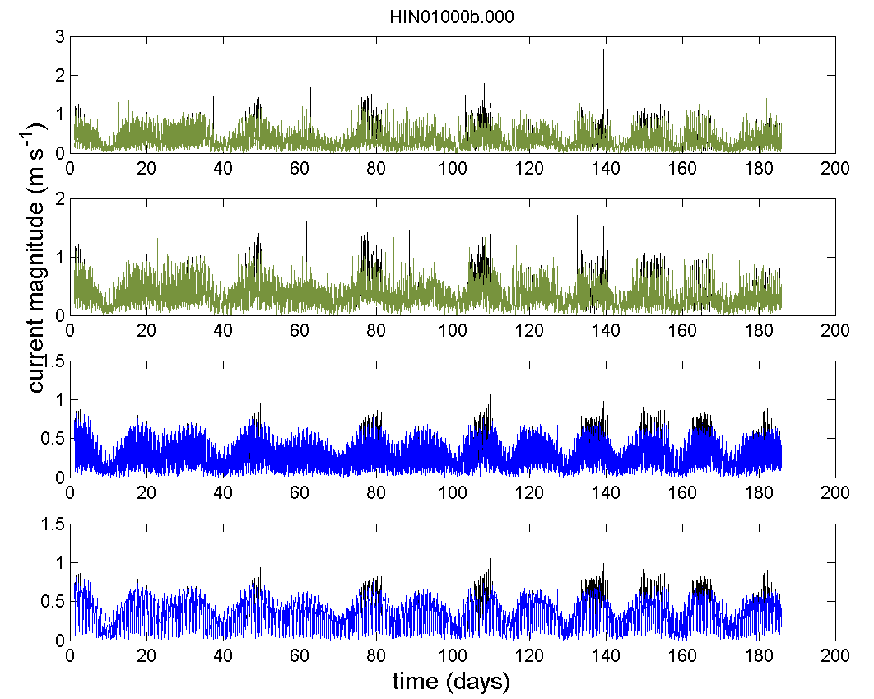
(c)  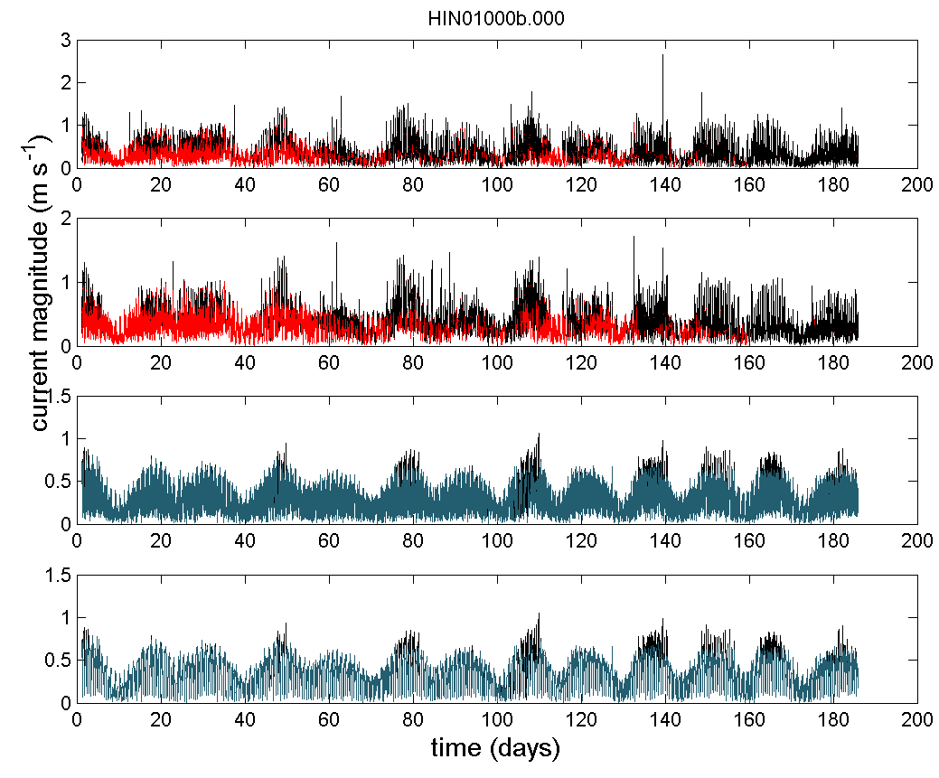 | (d)  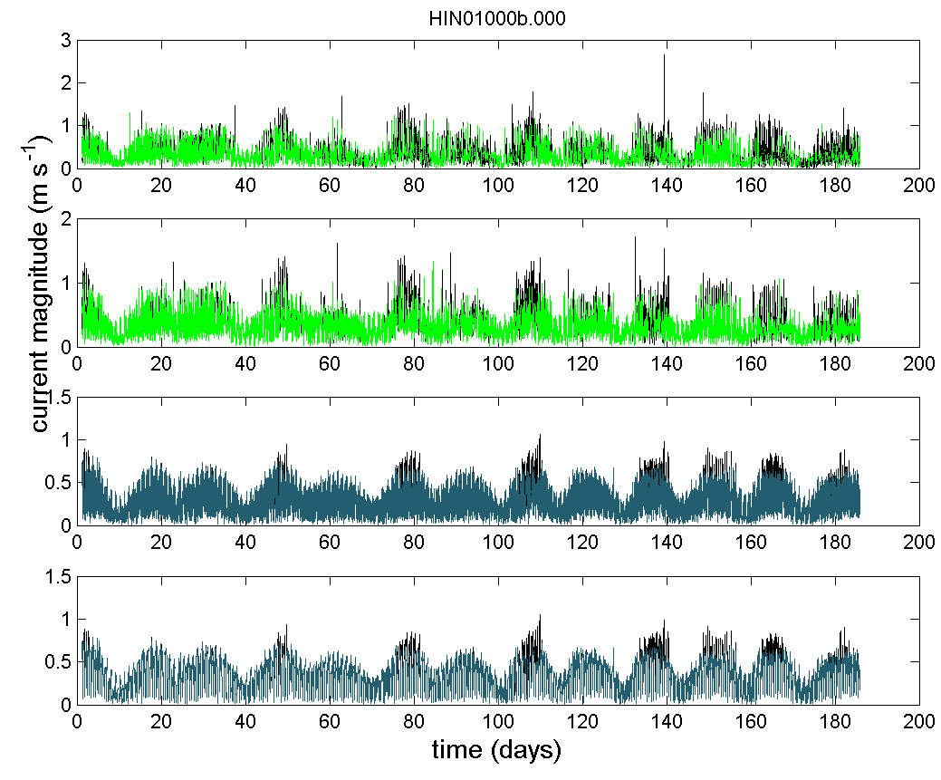
Figure A1: (a) current magnitude (V, m s⁻¹) along the water column during HIN01 deployment (16/10/2009 to 19/04/2010) for the raw data (top), data after QC Steps 0-9 (middle 1), data after QC steps 0-9 plus all IMOS flags using default cut-off limits (namely echo difference cut-off limit = 30; correlation cut-off limit = 110; percent of good cut-off limit = 50; error velocity cut-off limit = 0.15 m s⁻¹; vertical velocity cut-off limit = 0.2 m s⁻¹) and data after QC steps 0-9 plus all IMOS flags using less strict cut-off limits (namely echo difference cut-off limit = 30; correlation cut-off limit = 64; percent of good cut-off limit = 10; error velocity cut-off limit = 0.30 m s⁻¹; vertical velocity cut-off limit = 0.2 m s⁻¹) (bottom); (b) time series of current magnitude (V, m s⁻¹) for the top two bins (in green) and the bottom two bins (blue) with more than 50% of valid data after steps 0 to 9 (angle_cutoff = 20°, ts_lim=5); (c) time series of current magnitude (V, m s⁻¹) for the two top bins (in red) and the two bottom bins (blue) with more than 50% of valid data after steps 0 to 9 plus all IMOS flags using default cut-off limits and (d) time series of current magnitude (V, m s⁻¹) for the two top bins (in green) and the two bottom bins (blue) with more than 50% of valid data after steps 0 to 9 plus all IMOS flags using less strict cut-off limits.

(a)  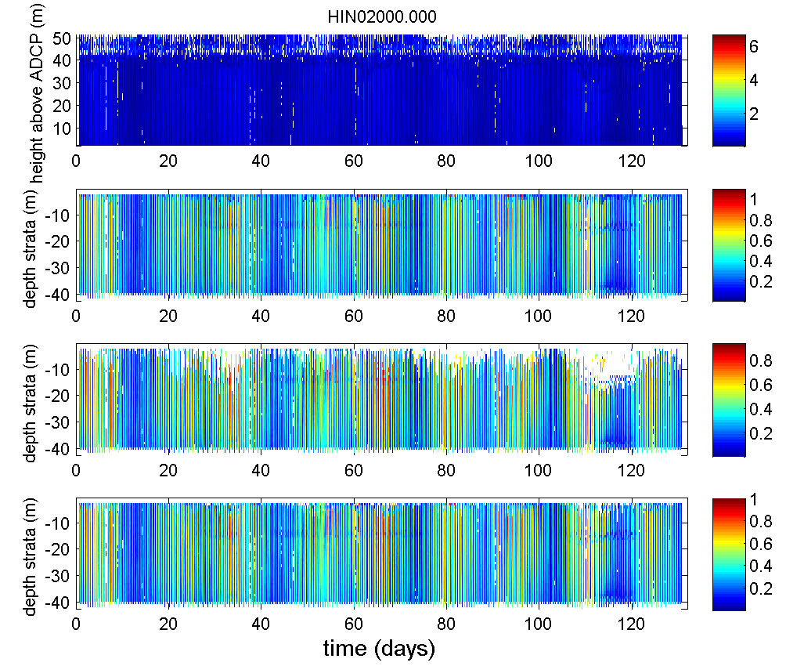 | (b)  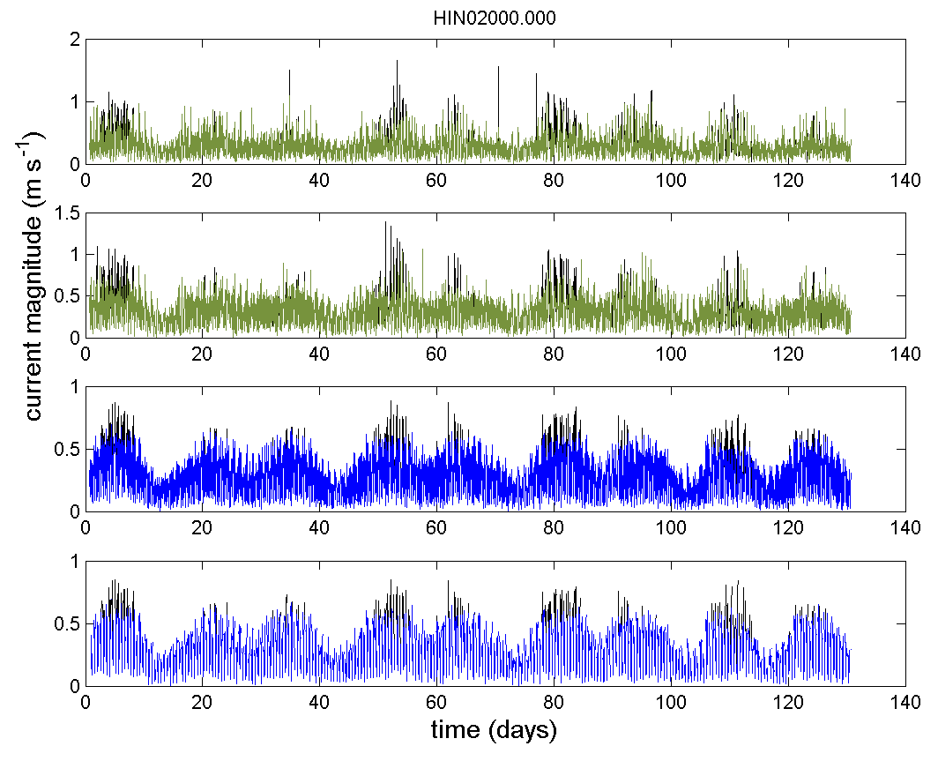
(c)  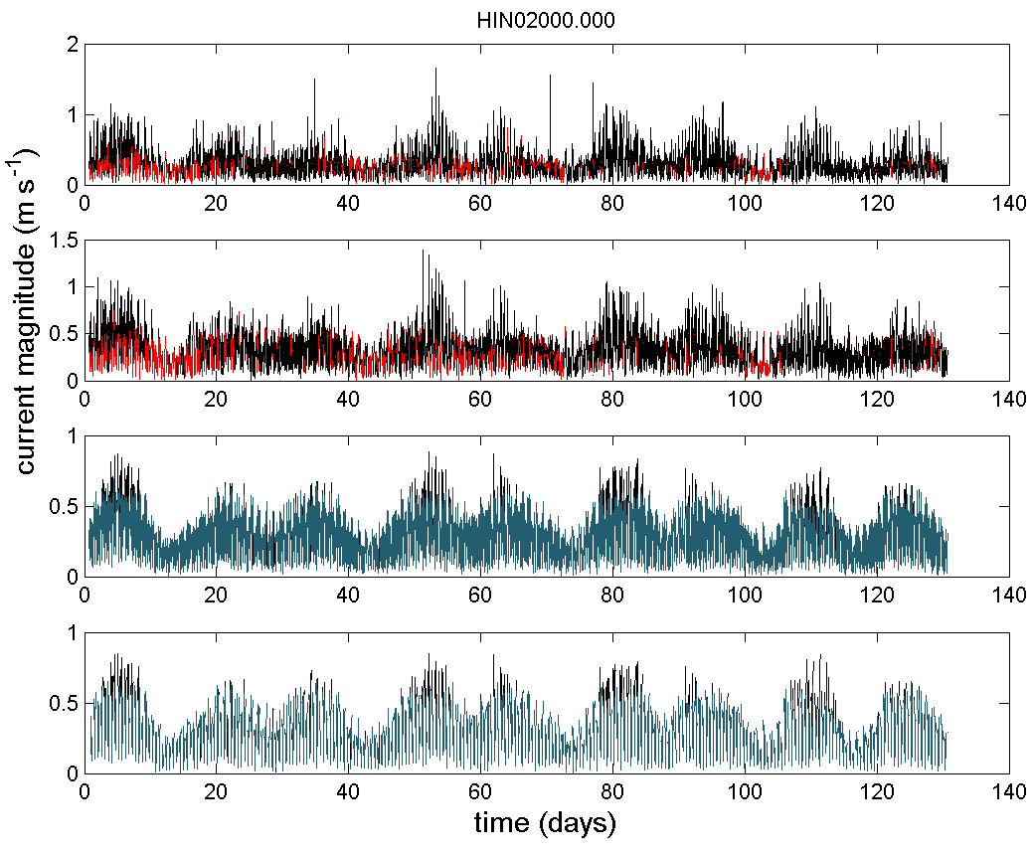 | (d)  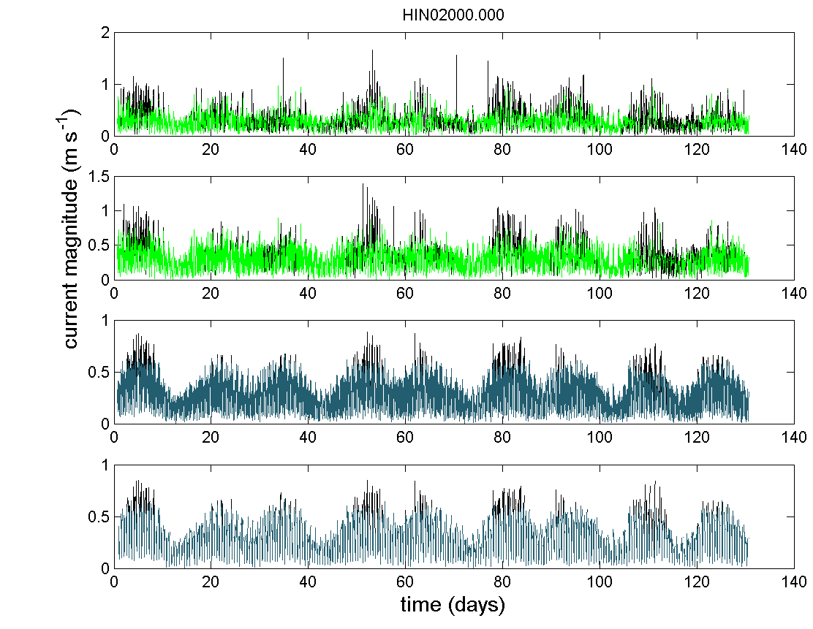
Figure A2: (a) current magnitude along the water column during HIN02 deployment (22/04/2010 to 30/08/2010) for the raw data (top), data after QC Steps 0-9 (middle 1), data after QC steps 0-9 plus all IMOS flags using default cut-off limits (namely echo difference cut-off limit = 30; correlation cut-off limit = 110; percent of good cut-off limit = 50; error velocity cut-off limit = 0.15 m s⁻¹; vertical velocity cut-off limit = 0.2 m s⁻¹) and data after QC steps 0-9 plus all IMOS flags using less strict cut-off limits (namely echo difference cut-off limit = 30; correlation cut-off limit = 64; percent of good cut-off limit = 10; error velocity cut-off limit = 0.30 m s⁻¹; vertical velocity cut-off limit = 0.2 m s⁻¹) (bottom); (b) time series of current magnitude (V, m s⁻¹) for the top two bins (in green) and the bottom two bins (blue) with more than 50% of valid data after steps 0 to 9 (angle_cutoff = 20°, ts_lim=5); (c) time series of current magnitude (V, m s⁻¹) for the two top bins (in red) and the two bottom bins (blue) with more than 50% of valid data after steps 0 to 9 plus all IMOS flags using default cut-off limits and (d) time series of current magnitude (V, m s⁻¹) for the two top bins (in green) and the two bottom bins (blue) with more than 50% of valid data after steps 0 to 9 plus all IMOS flags using less strict cut-off limits.

(a)  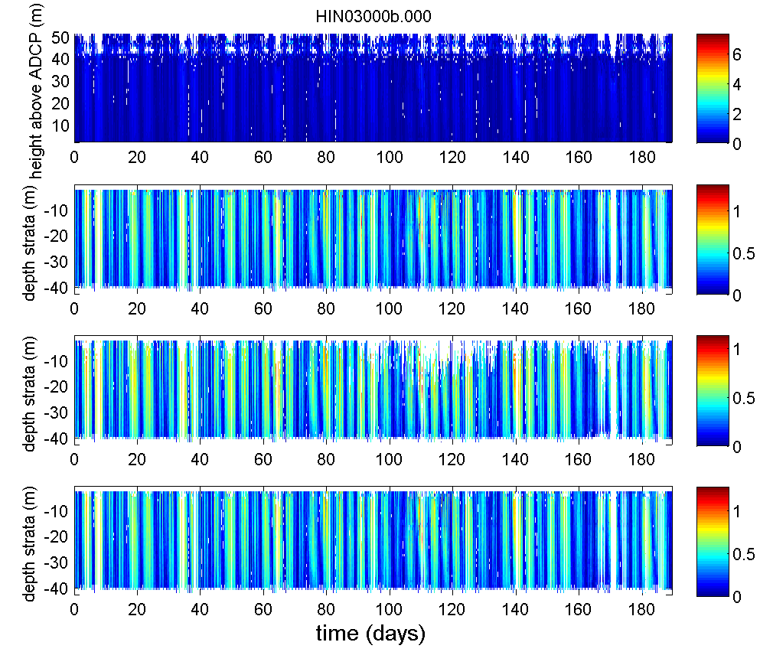 | (b)  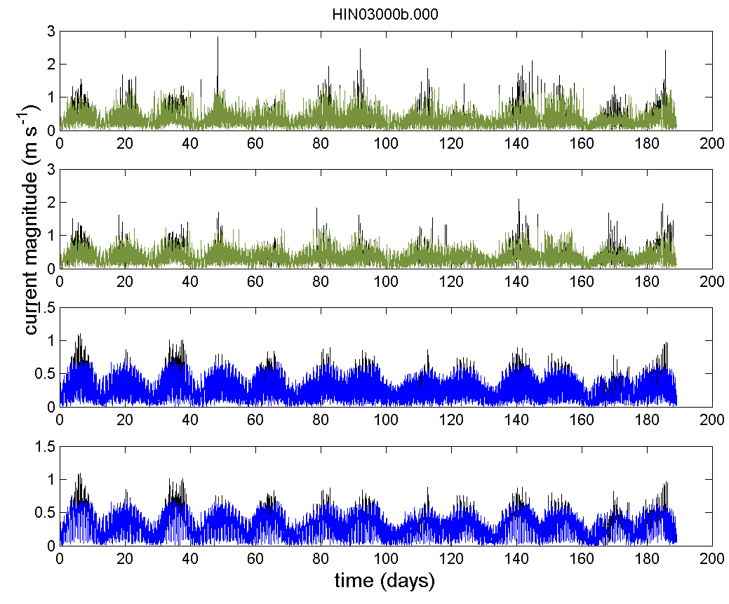
(c)  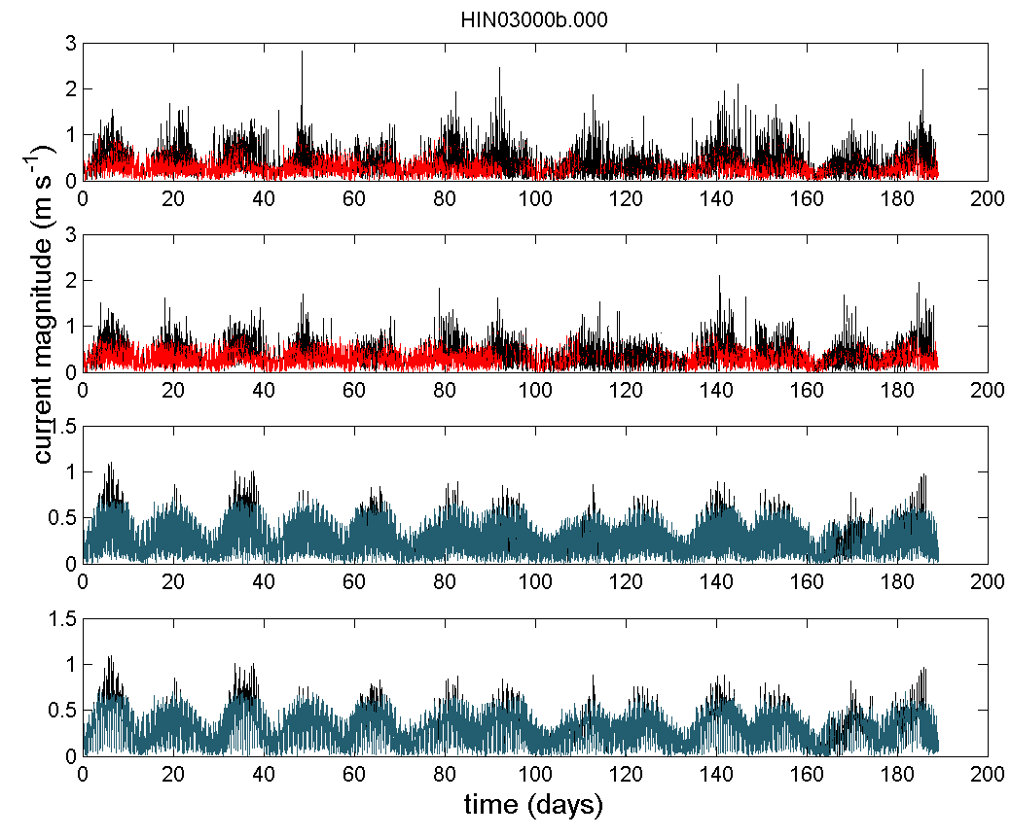 | (d)  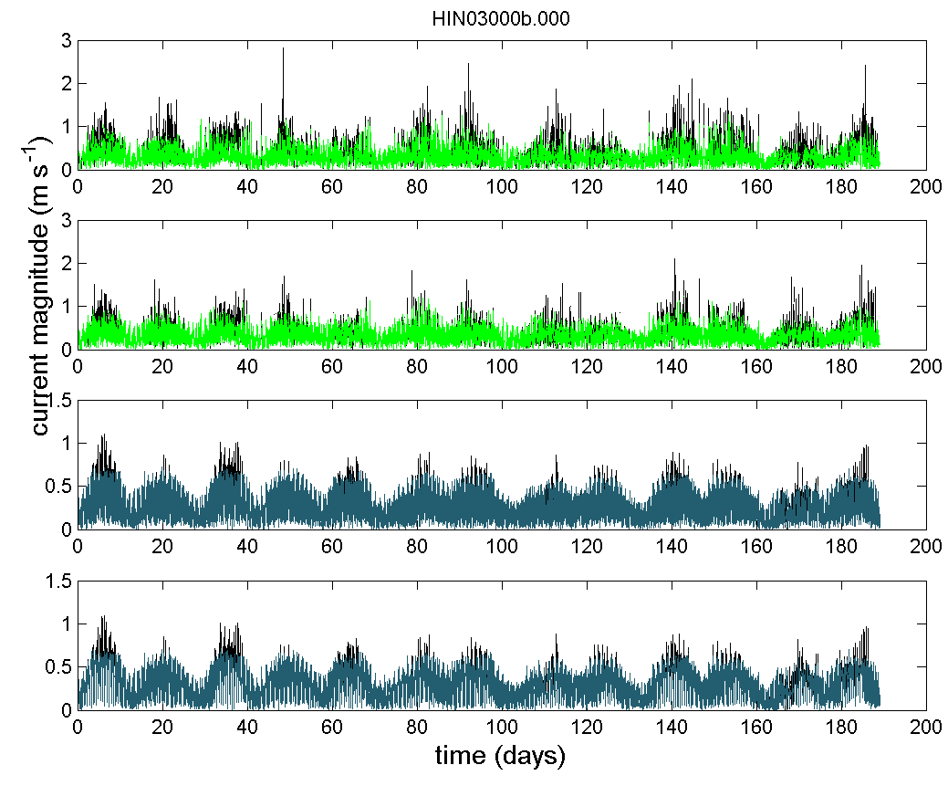
Figure A3: (a) current magnitude along the water column during HIN03deployment (02/09/2010 to 10/03/2011) for the raw data (top), data after QC Steps 0-9 (middle 1), data after QC steps 0-9 plus all IMOS flags using default cut-off limits (namely echo difference cut-off limit = 30; correlation cut-off limit = 110; percent of good cut-off limit = 50; error velocity cut-off limit = 0.15 m s⁻¹; vertical velocity cut-off limit = 0.2 m s⁻¹) and data after QC steps 0-9 plus all IMOS flags using less strict cut-off limits (namely echo difference cut-off limit = 30; correlation cut-off limit = 64; percent of good cut-off limit = 10; error velocity cut-off limit = 0.30 m s⁻¹; vertical velocity cut-off limit = 0.2 m s⁻¹) (bottom); (b) time series of current magnitude (V, m s⁻¹) for the top two bins (in green) and the bottom two bins (blue) with more than 50% of valid data after steps 0 to 9 (angle_cutoff = 20°, ts_lim=5); (c) time series of current magnitude (V, m s⁻¹) for the two top bins (in red) and the two bottom bins (blue) with more than 50% of valid data after steps 0 to 9 plus all IMOS flags using default cut-off limits and (d) time series of current magnitude (V, m s⁻¹) for the two top bins (in green) and the two bottom bins (blue) with more than 50% of valid data after steps 0 to 9 plus all IMOS flags using less strict cut-off limits.

(a)  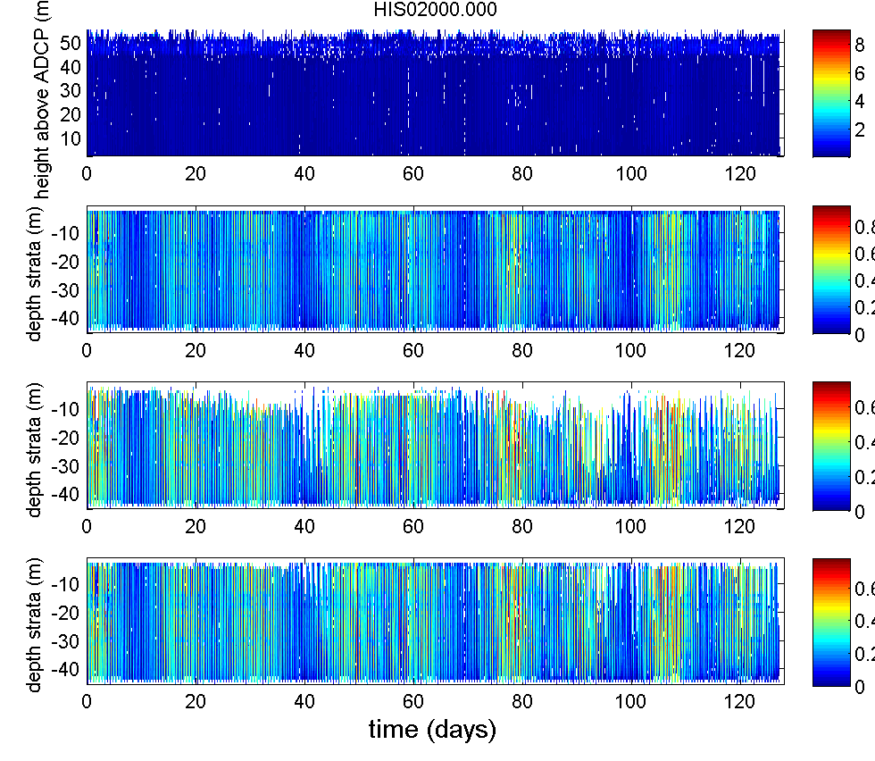 | (b)  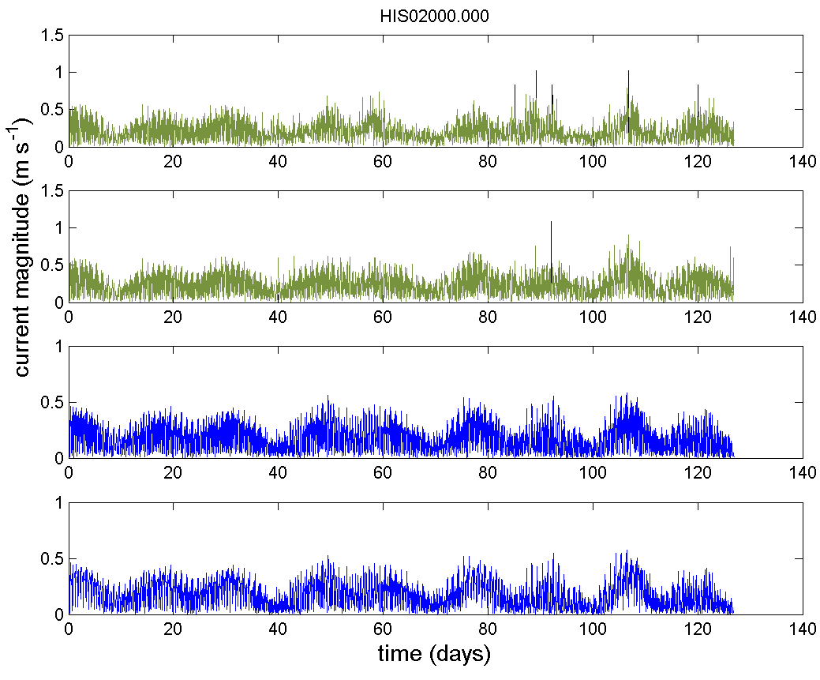
(c)  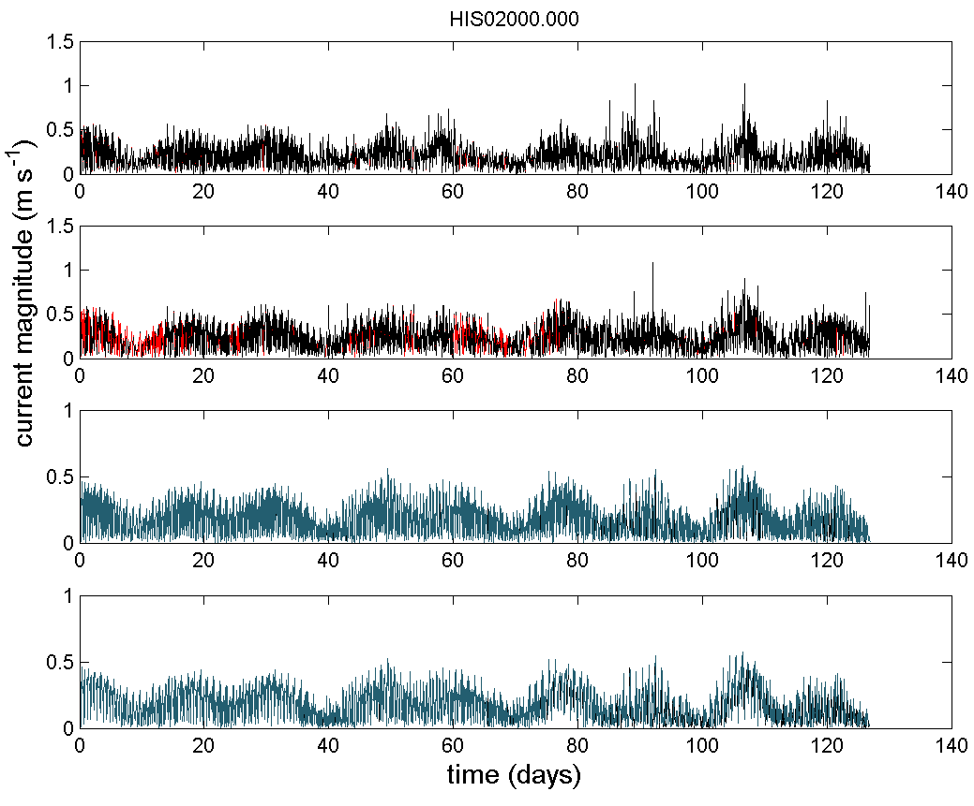 | (d)  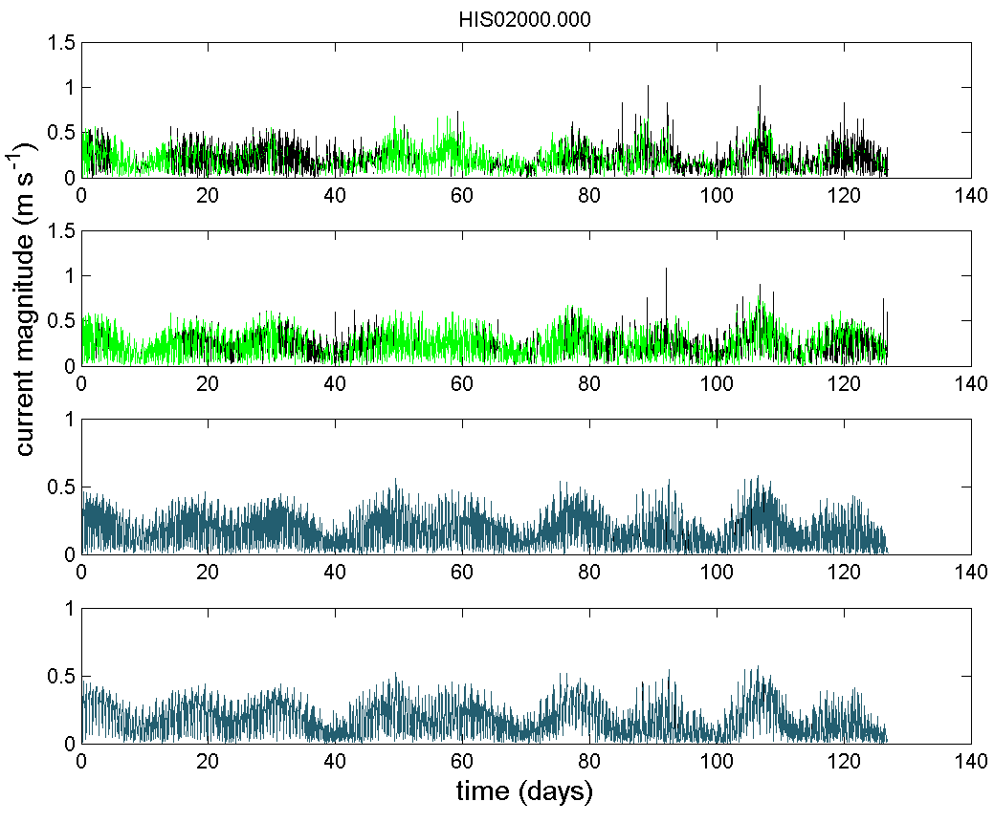
Figure A4: (a) current magnitude along the water column during HIS01deployment (26/04/2010 to 31/08/2010) for the raw data (top), data after QC Steps 0-9 (middle 1), data after QC steps 0-9 plus all IMOS flags using default cut-off limits (namely echo difference cut-off limit = 30; correlation cut-off limit = 110; percent of good cut-off limit = 50; error velocity cut-off limit = 0.15 m s⁻¹; vertical velocity cut-off limit = 0.2 m s⁻¹) and data after QC steps 0-9 plus all IMOS flags using less strict cut-off limits (namely echo difference cut-off limit = 30; correlation cut-off limit = 64; percent of good cut-off limit = 10; error velocity cut-off limit = 0.30 m s⁻¹; vertical velocity cut-off limit = 0.2 m s⁻¹) (bottom); (b) time series of current magnitude (V, m s⁻¹) for the top two bins (in green) and the bottom two bins (blue) with more than 50% of valid data after steps 0 to 9 (angle_cutoff = 20°, ts_lim=5); (c) time series of current magnitude (V, m s⁻¹) for the two top bins (in red) and the two bottom bins (blue) with more than 50% of valid data after steps 0 to 9 plus all IMOS flags using default cut-off limits and (d) time series of current magnitude (V, m s⁻¹) for the two top bins (in green) and the two bottom bins (blue) with more than 50% of valid data after steps 0 to 9 plus all IMOS flags using less strict cut-off limits.

(a)  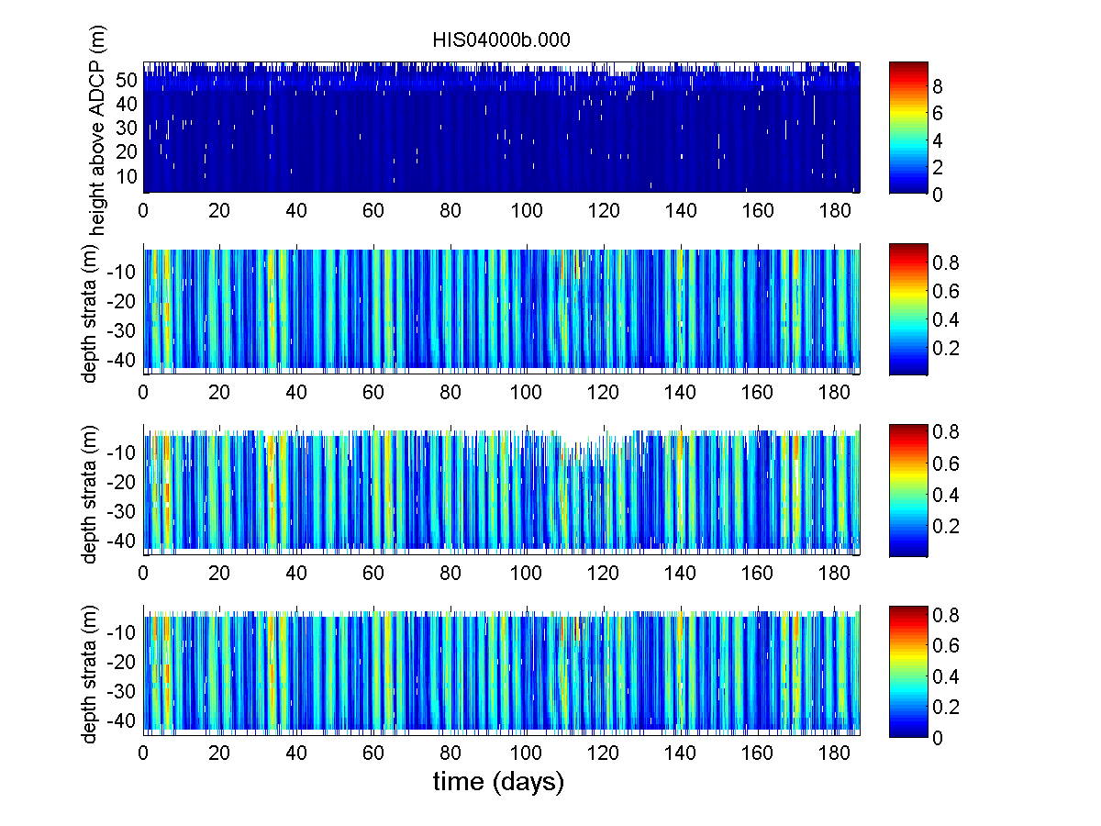 | (b)  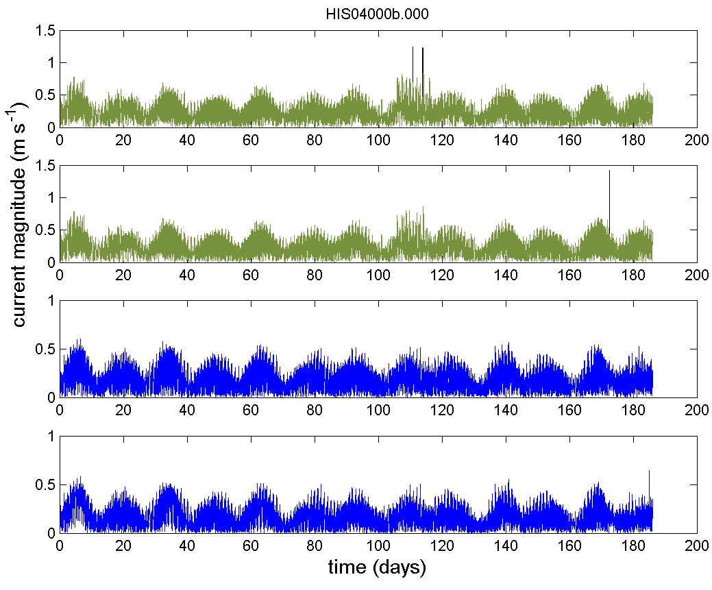
(c)  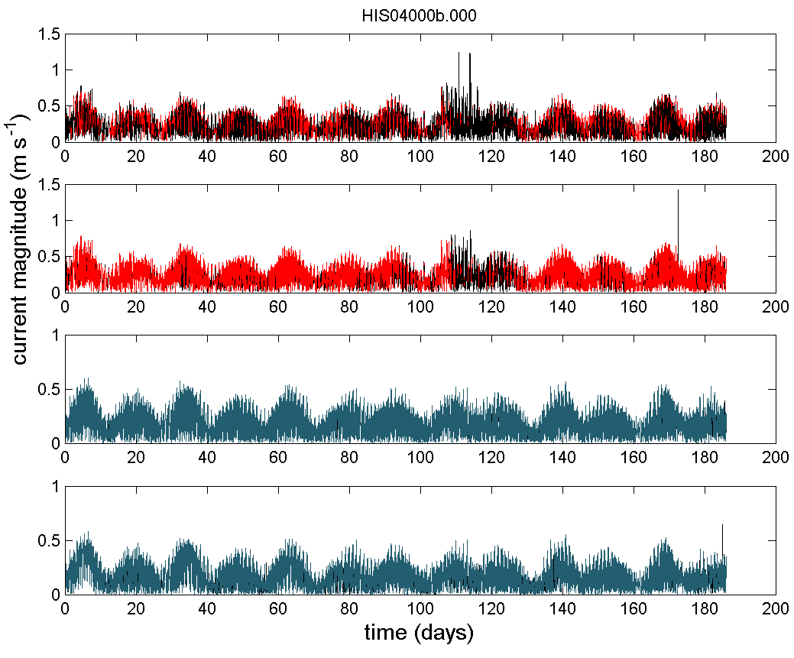 | (d)  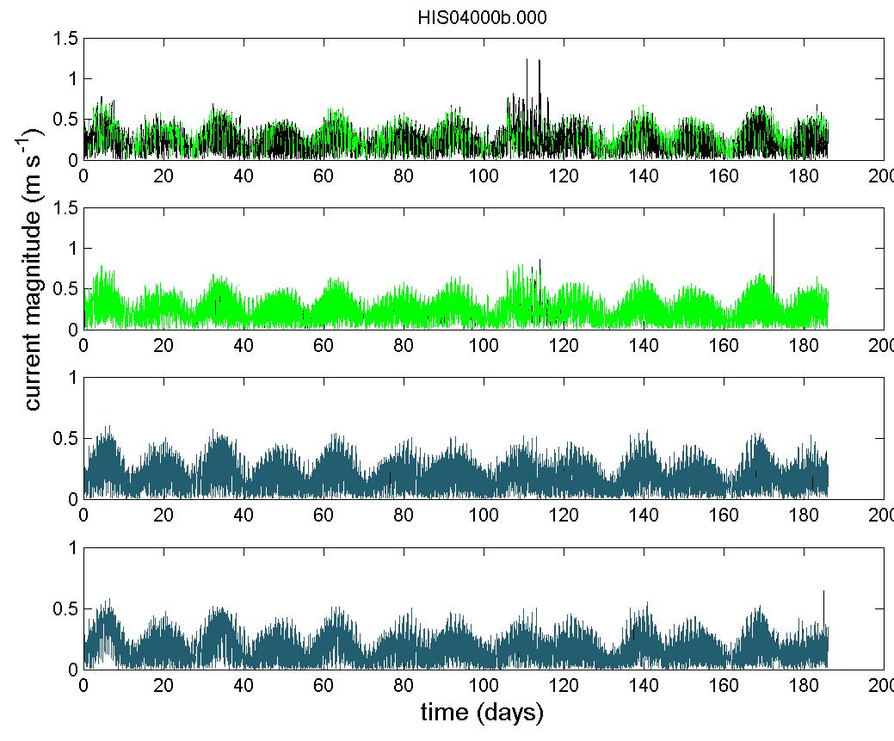
Figure A5: (a) current magnitude along the water column during HIS02 deployment (03/09/2010 to 08/03/2011) for the raw data (top), data after QC Steps 0-9 (middle 1), data after QC steps 0-9 plus all IMOS flags using default cut-off limits (namely echo difference cut-off limit = 30; correlation cut-off limit = 110; percent of good cut-off limit = 50; error velocity cut-off limit = 0.15 m s⁻¹; vertical velocity cut-off limit = 0.2 m s⁻¹) and data after QC steps 0-9 plus all IMOS flags using less strict cut-off limits (namely echo difference cut-off limit = 30; correlation cut-off limit = 64; percent of good cut-off limit = 10; error velocity cut-off limit = 0.30 m s⁻¹; vertical velocity cut-off limit = 0.2 m s⁻¹) (bottom); (b) time series of current magnitude (V, m s⁻¹) for the top two bins (in green) and the bottom two bins (blue) with more than 50% of valid data after steps 0 to 9 (angle_cutoff = 20°, ts_lim=5); (c) time series of current magnitude (V, m s⁻¹) for the two top bins (in red) and the two bottom bins (blue) with more than 50% of valid data after steps 0 to 9 plus all IMOS flags using default cut-off limits and (d) time series of current magnitude (V, m s⁻¹) for the two top bins (in green) and the two bottom bins (blue) with more than 50% of valid data after steps 0 to 9 plus all IMOS flags using less strict cut-off limits.

(a)  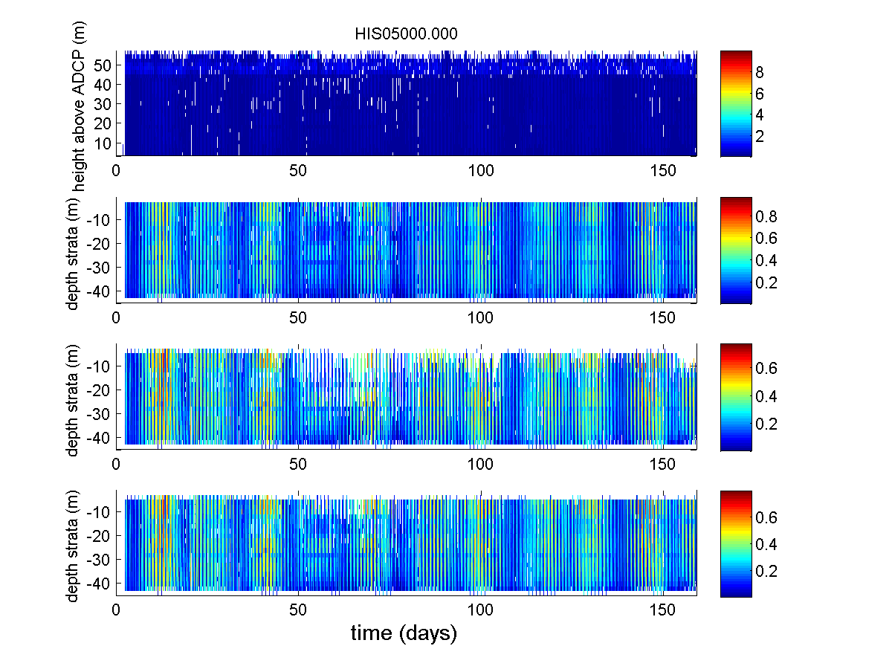 | (b)  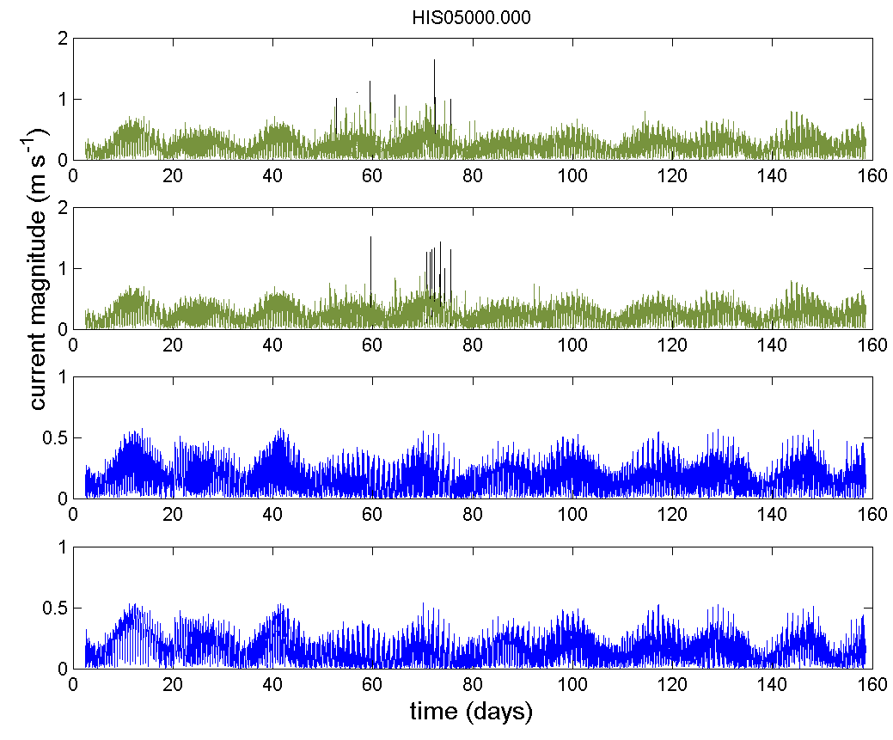
(c)  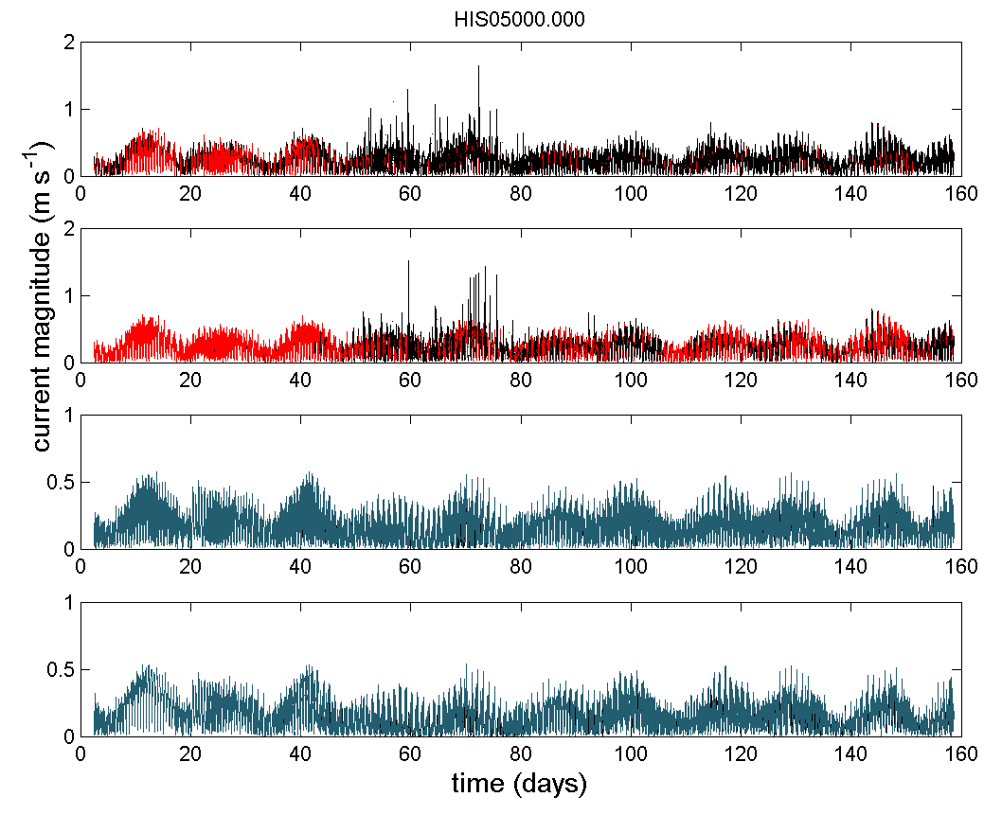 | (d)  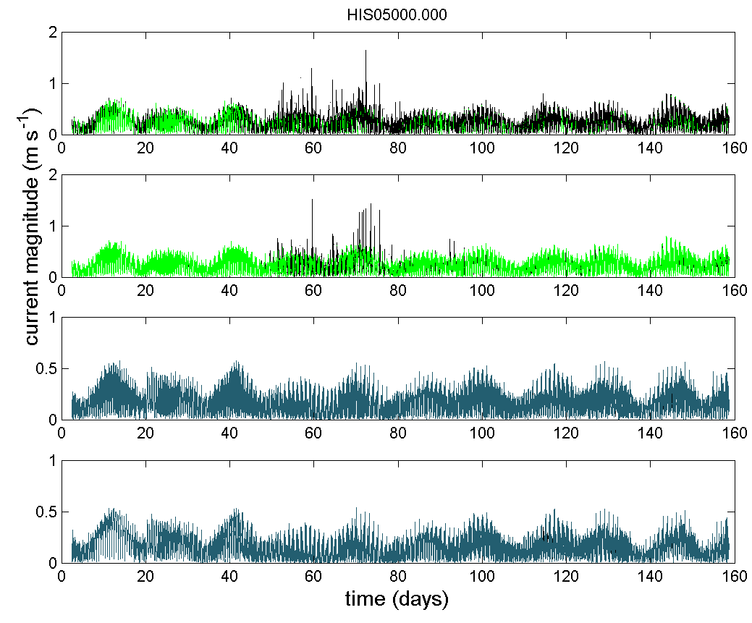
Figure A6: (a) current magnitude along the water column during HIS03deployment (09/03/2011 to 13/08/2011) for the raw data (top), data after QC Steps 0-9 (middle 1), data after QC steps 0-9 plus all IMOS flags using default cut-off limits (namely echo difference cut-off limit = 30; correlation cut-off limit = 110; percent of good cut-off limit = 50; error velocity cut-off limit = 0.15 m s⁻¹; vertical velocity cut-off limit = 0.2 m s⁻¹) and data after QC steps 0-9 plus all IMOS flags using less strict cut-off limits (namely echo difference cut-off limit = 30; correlation cut-off limit = 64; percent of good cut-off limit = 10; error velocity cut-off limit = 0.30 m s⁻¹; vertical velocity cut-off limit = 0.2 m s⁻¹) (bottom); (b) time series of current magnitude (V, m s⁻¹) for the top two bins (in green) and the bottom two bins (blue) with more than 50% of valid data after steps 0 to 9 (angle_cutoff = 20°, ts_lim=5); (c) time series of current magnitude (V, m s⁻¹) for the two top bins (in red) and the two bottom bins (blue) with more than 50% of valid data after steps 0 to 9 plus all IMOS flags using default cut-off limits and (d) time series of current magnitude (V, m s⁻¹) for the two top bins (in green) and the two bottom bins (blue) with more than 50% of valid data after steps 0 to 9 plus all IMOS flags using less strict cut-off limits.

(a)  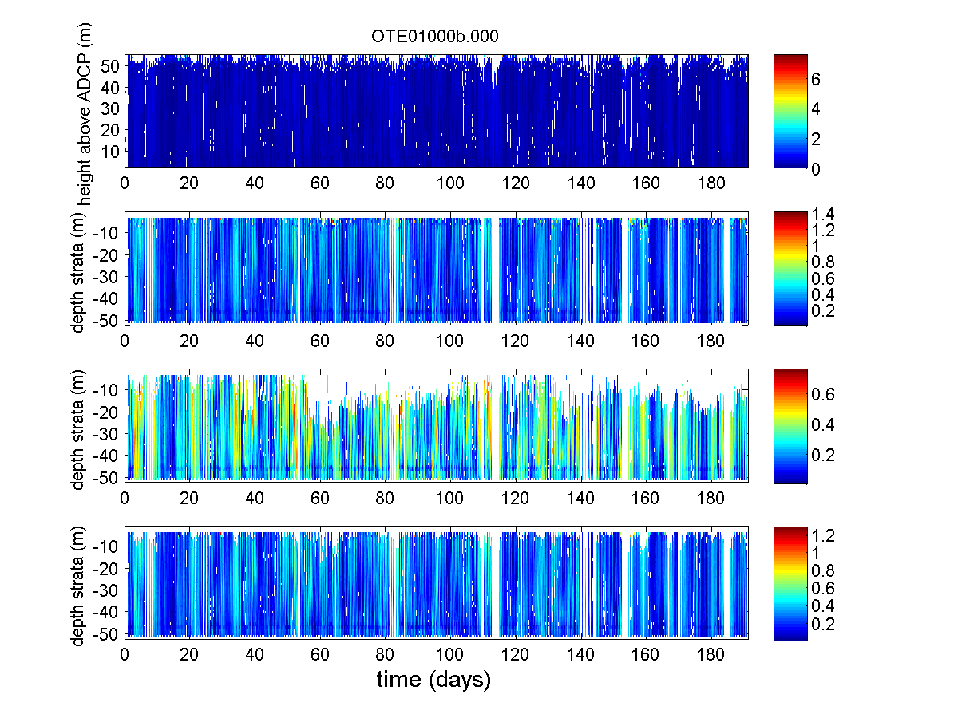 | (b)  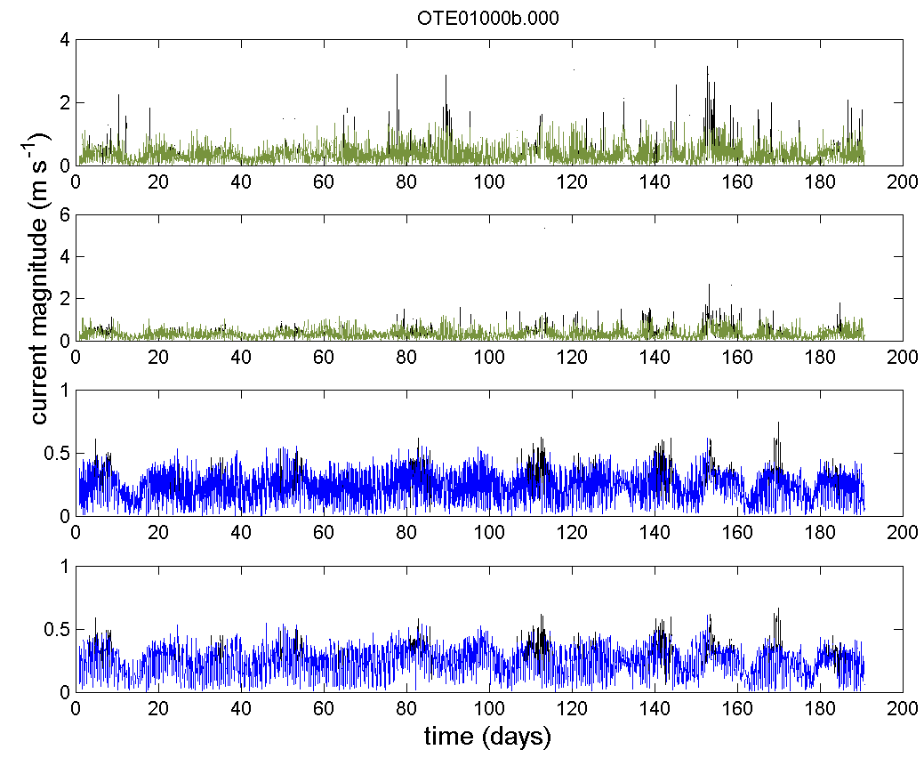
(c)  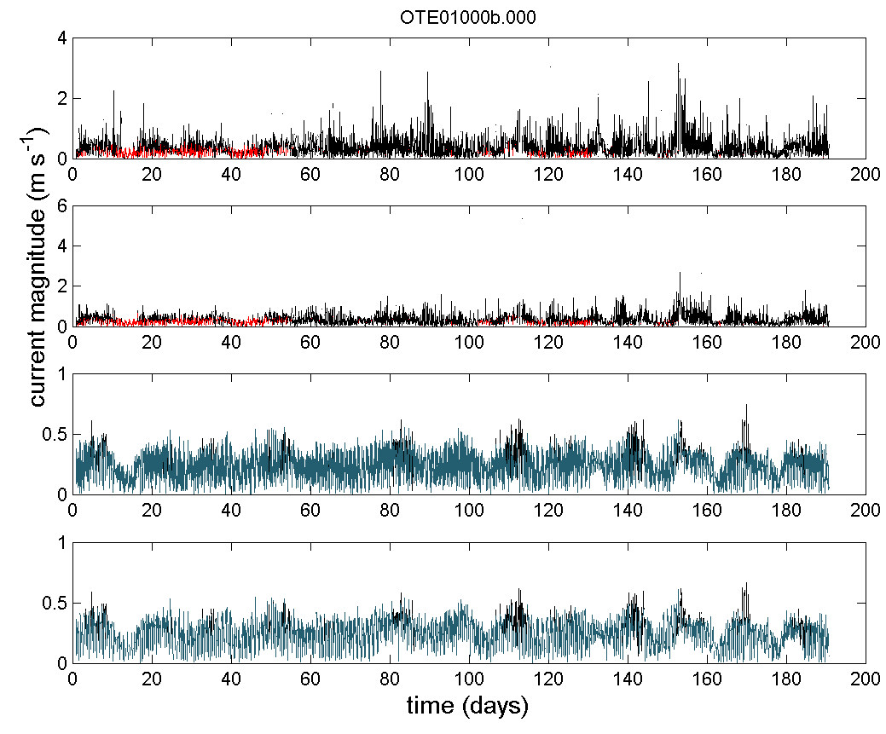 | (d)  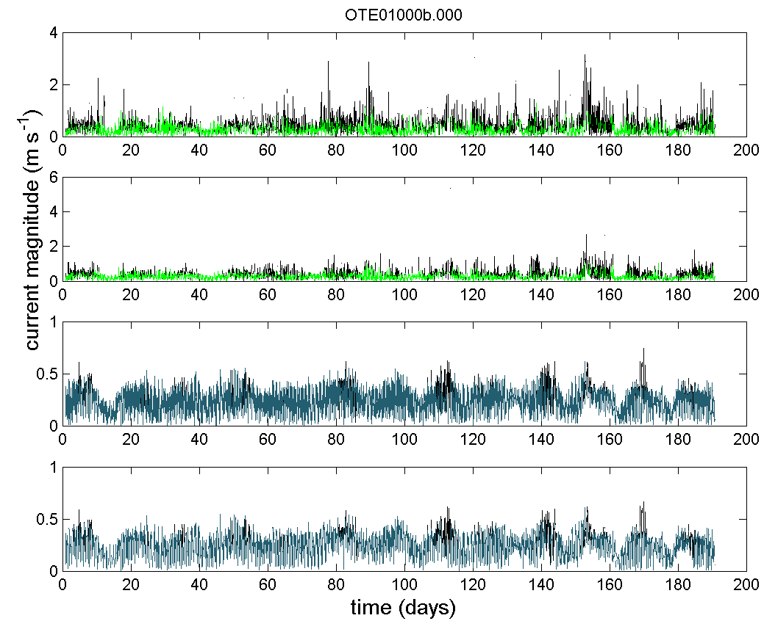
Figure A7: (left) current magnitude along the water column during OTE01 deployment (12/10/2009 to 19/04/2010) for the raw data (top), data after QC Steps 0-9 (middle 1), data after QC steps 0-9 plus all IMOS flags using default cut-off limits (namely echo difference cut-off limit = 30; correlation cut-off limit = 110; percent of good cut-off limit = 50; error velocity cut-off limit = 0.15 m s⁻¹; vertical velocity cut-off limit = 0.2 m s⁻¹) and data after QC steps 0-9 plus all IMOS flags using less strict cut-off limits (namely echo difference cut-off limit = 30; correlation cut-off limit = 64; percent of good cut-off limit = 10; error velocity cut-off limit = 0.30 m s⁻¹; vertical velocity cut-off limit = 0.2 m s⁻¹) (bottom); (b) time series of current magnitude (V, m s⁻¹) for the top two bins (in green) and the bottom two bins (blue) with more than 50% of valid data after steps 0 to 9 (angle_cutoff = 20°, ts_lim=5); (c) time series of current magnitude (V, m s⁻¹) for the two top bins (in red) and the two bottom bins (blue) with more than 50% of valid data after steps 0 to 9 plus all IMOS flags using default cut-off limits and (d) time series of current magnitude (V, m s⁻¹) for the two top bins (in green) and the two bottom bins (blue) with more than 50% of valid data after steps 0 to 9 plus all IMOS flags using less strict cut-off limits.

(a)  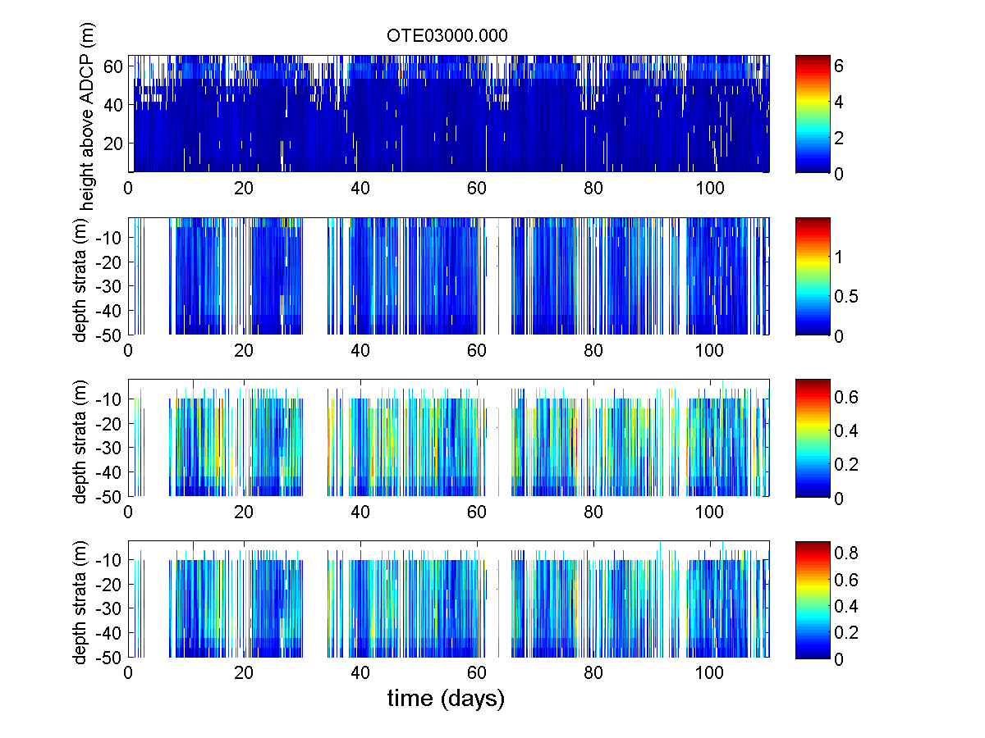 | (b)  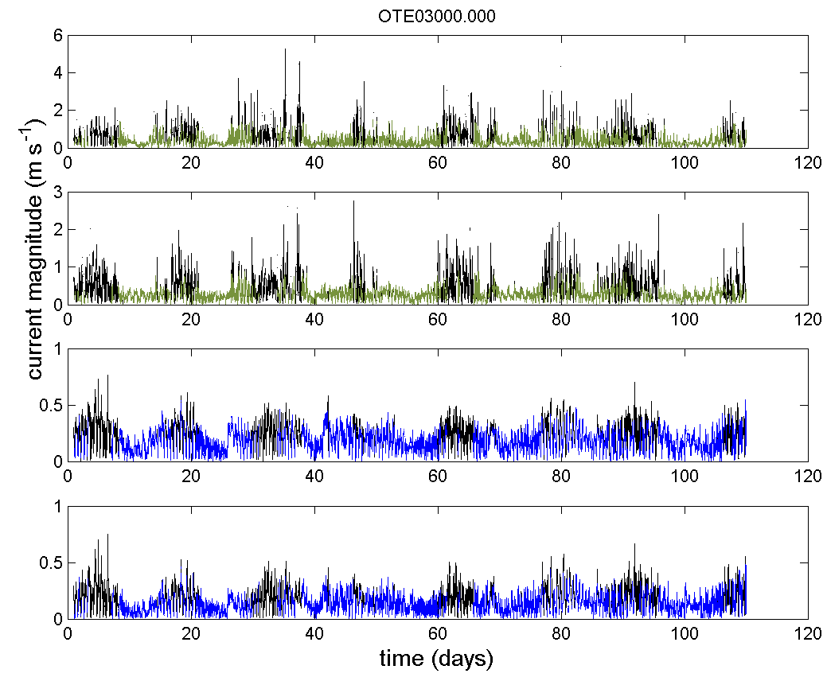
(c)  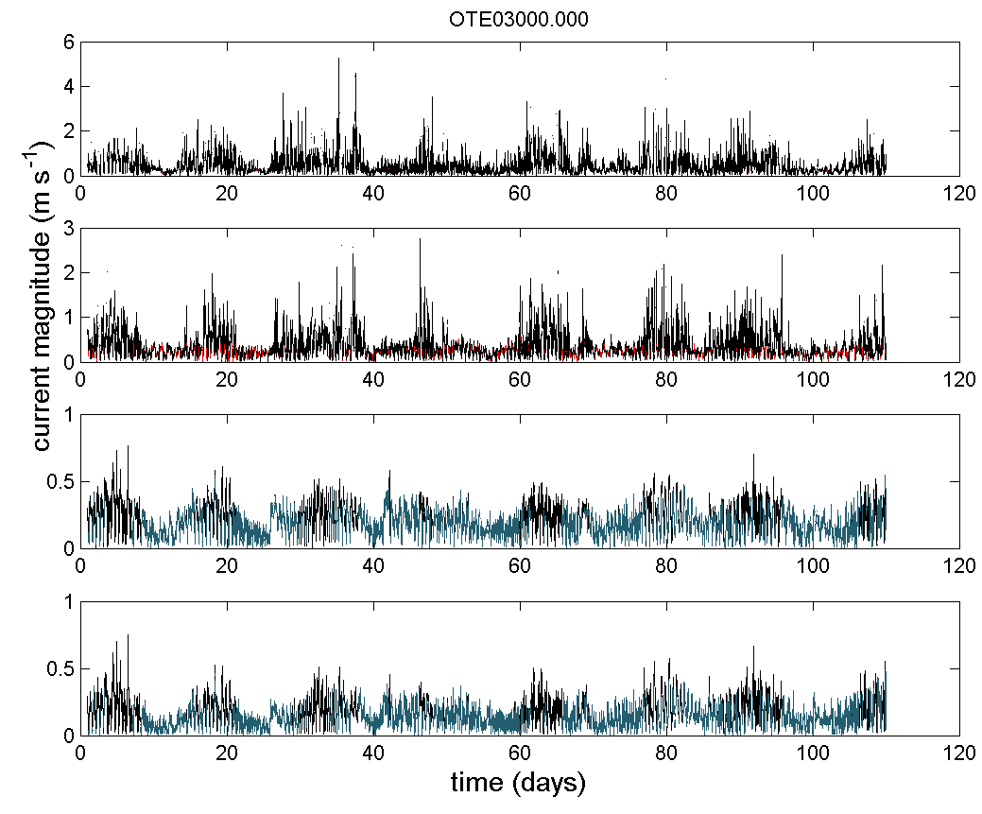 | (d)  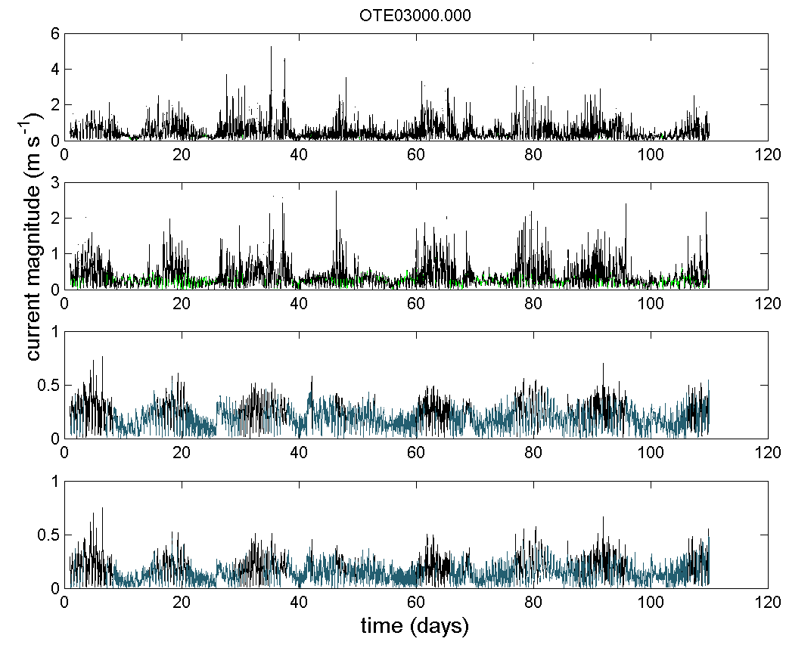
Figure A8: (left) current magnitude along the water column during OTE02 deployment (05/09/2010 to 10/03/2011) for the raw data (top), data after QC Steps 0-9 (middle 1), data after QC steps 0-9 plus all IMOS flags using default cut-off limits (namely echo difference cut-off limit = 30; correlation cut-off limit = 110; percent of good cut-off limit = 50; error velocity cut-off limit = 0.15 m s⁻¹; vertical velocity cut-off limit = 0.2 m s⁻¹) and data after QC steps 0-9 plus all IMOS flags using less strict cut-off limits (namely echo difference cut-off limit = 30; correlation cut-off limit = 64; percent of good cut-off limit = 10; error velocity cut-off limit = 0.30 m s⁻¹; vertical velocity cut-off limit = 0.2 m s⁻¹) (bottom); (b) time series of current magnitude (V, m s⁻¹) for the top two bins (in green) and the bottom two bins (blue) with more than 50% of valid data after steps 0 to 9 (angle_cutoff = 20°, ts_lim=5); (c) time series of current magnitude (V, m s⁻¹) for the two top bins (in red) and the two bottom bins (blue) with more than 50% of valid data after steps 0 to 9 plus all IMOS flags using default cut-off limits and (d) time series of current magnitude (V, m s⁻¹) for the two top bins (in green) and the two bottom bins (blue) with more than 50% of valid data after steps 0 to 9 plus all IMOS flags using less strict cut-off limits.

(a)  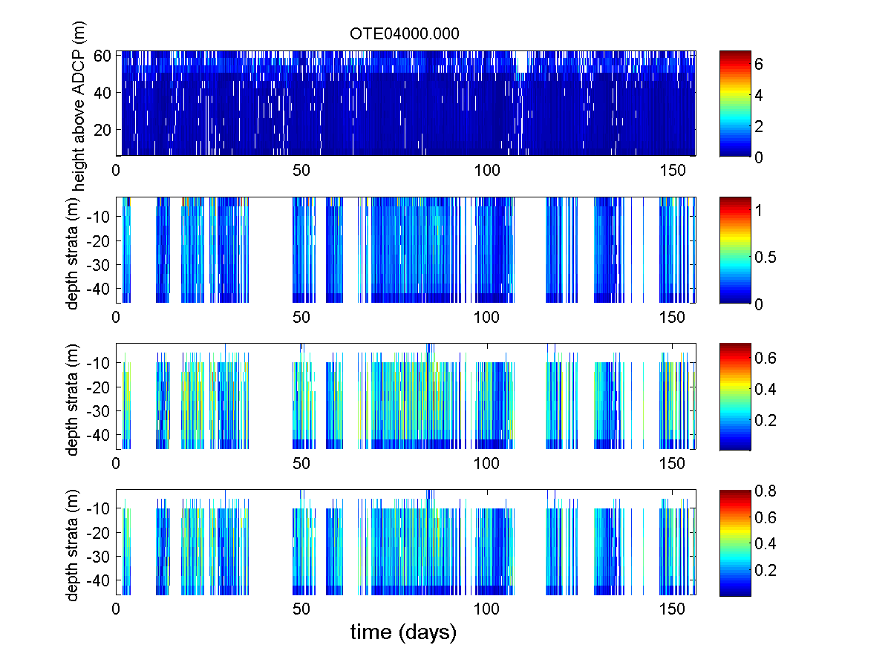 | (b)  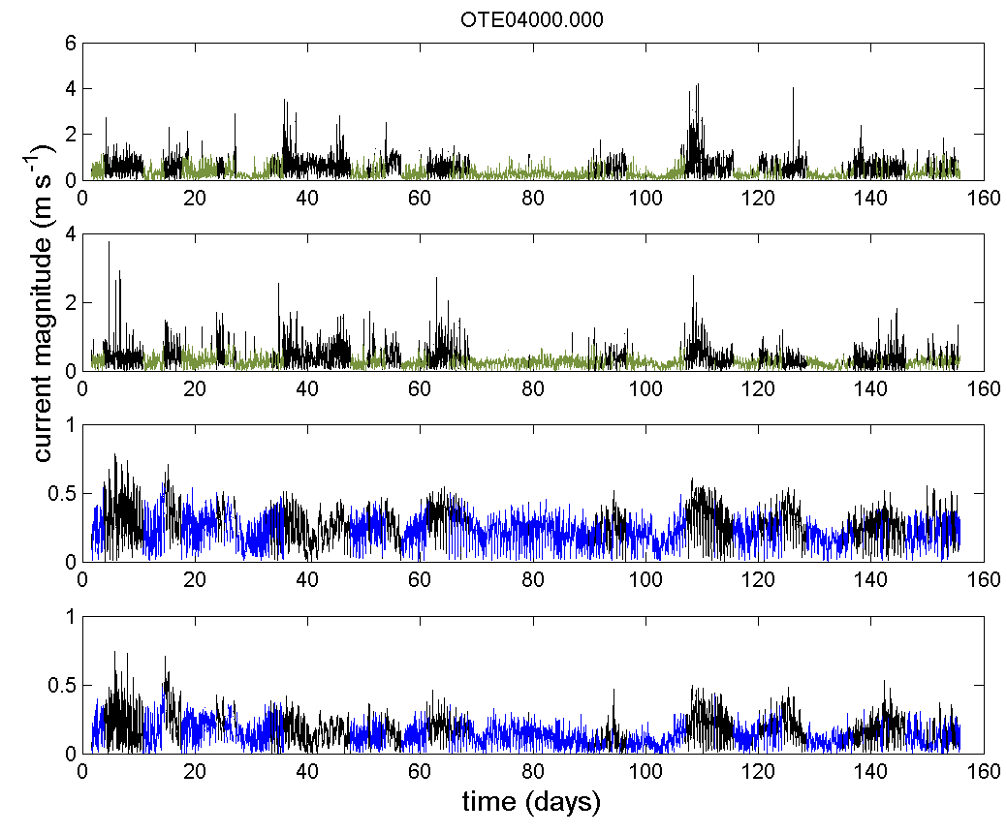
(c)  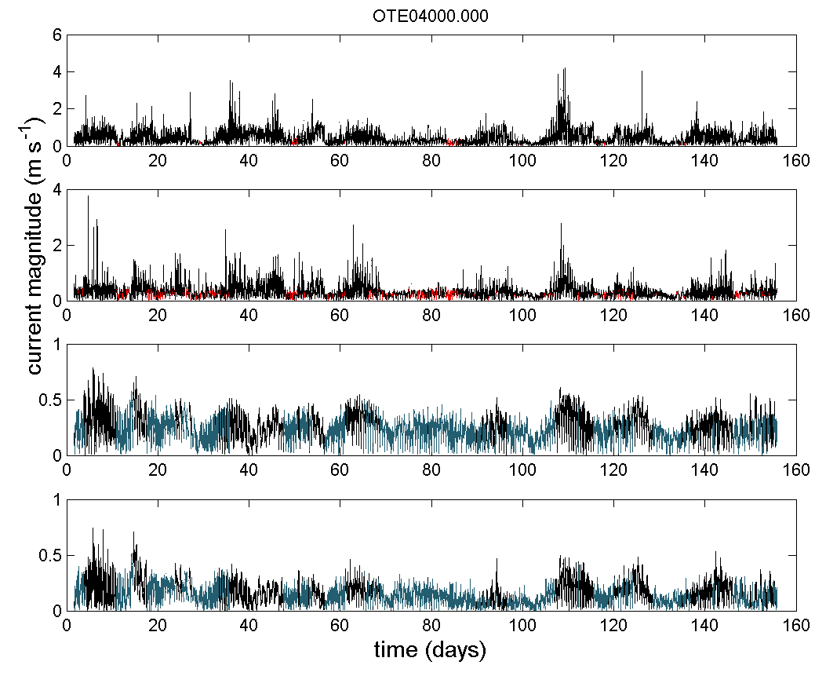 | (d)  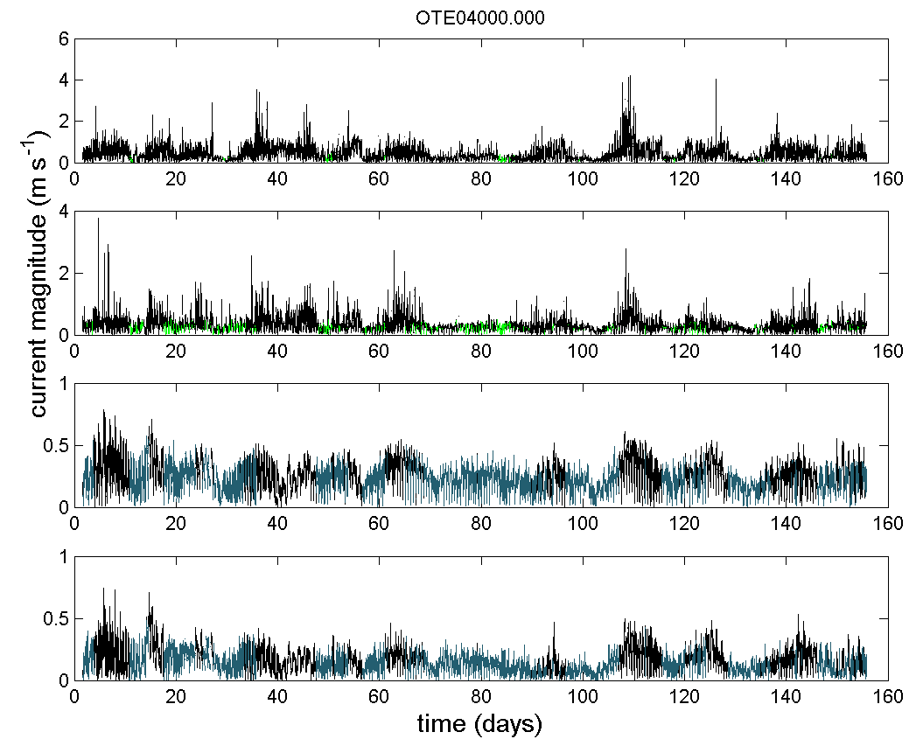
Figure A9: (left) current magnitude along the water column during OTE03 deployment (14/03/2011 to 16/08/2011) for the raw data (top), data after QC Steps 0-9 (middle 1), data after QC steps 0-9 plus all IMOS flags using default cut-off limits (namely echo difference cut-off limit = 30; correlation cut-off limit = 110; percent of good cut-off limit = 50; error velocity cut-off limit = 0.15 m s⁻¹; vertical velocity cut-off limit = 0.2 m s⁻¹) and data after QC steps 0-9 plus all IMOS flags using less strict cut-off limits (namely echo difference cut-off limit = 30; correlation cut-off limit = 64; percent of good cut-off limit = 10; error velocity cut-off limit = 0.30 m s⁻¹; vertical velocity cut-off limit = 0.2 m s⁻¹) (bottom); (b) time series of current magnitude (V, m s⁻¹) for the top two bins (in green) and the bottom two bins (blue) with more than 50% of valid data after steps 0 to 9 (angle_cutoff = 20°, ts_lim=5); (c) time series of current magnitude (V, m s⁻¹) for the two top bins (in red) and the two bottom bins (blue) with more than 50% of valid data after steps 0 to 9 plus all IMOS flags using default cut-off limits and (d) time series of current magnitude (V, m s⁻¹) for the two top bins (in green) and the two bottom bins (blue) with more than 50% of valid data after steps 0 to 9 plus all IMOS flags using less strict cut-off limits.

(a)  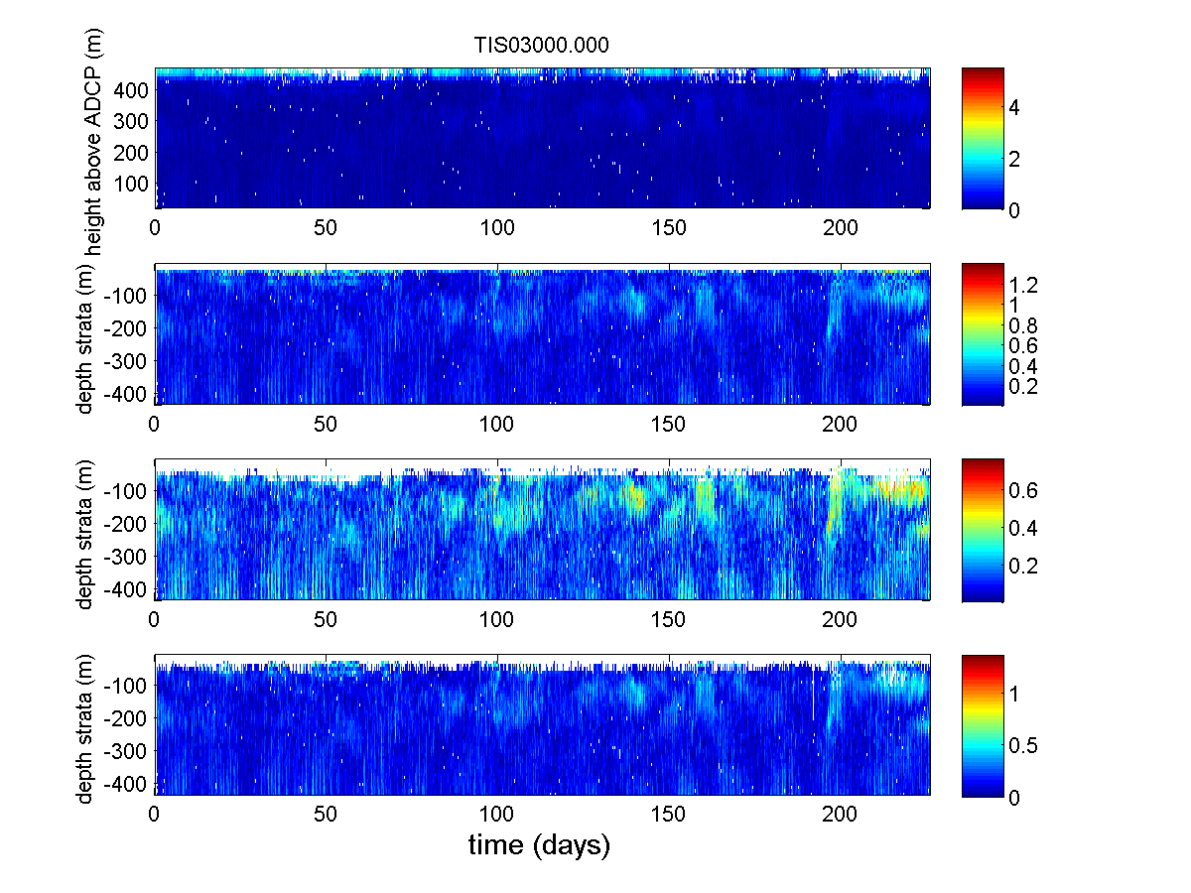 | (b)  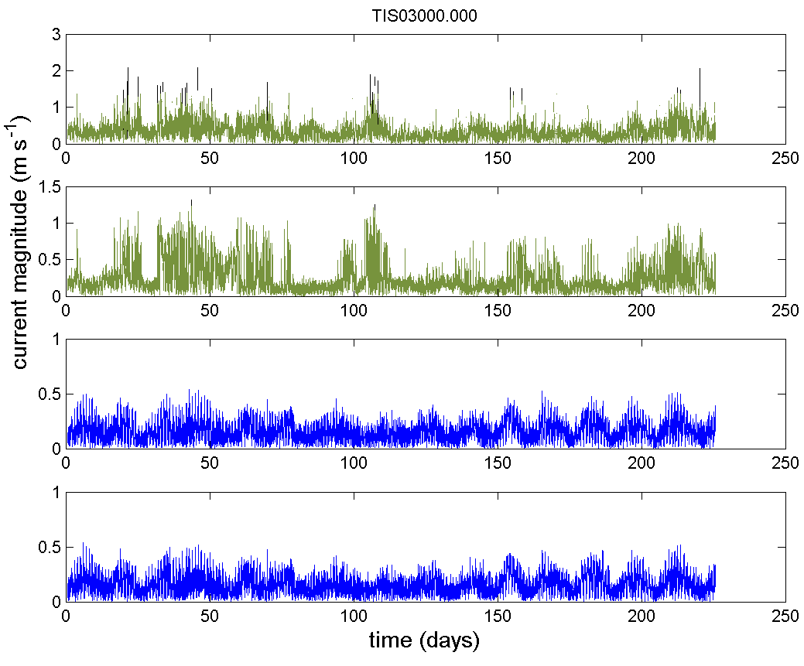
(c)  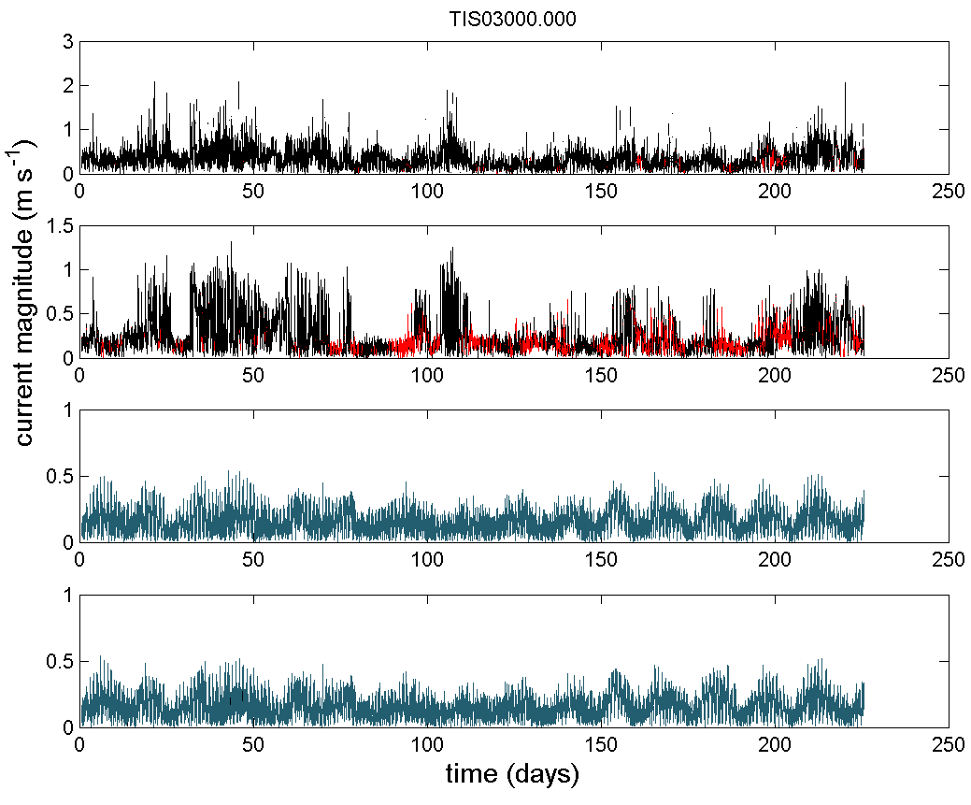 | (d)  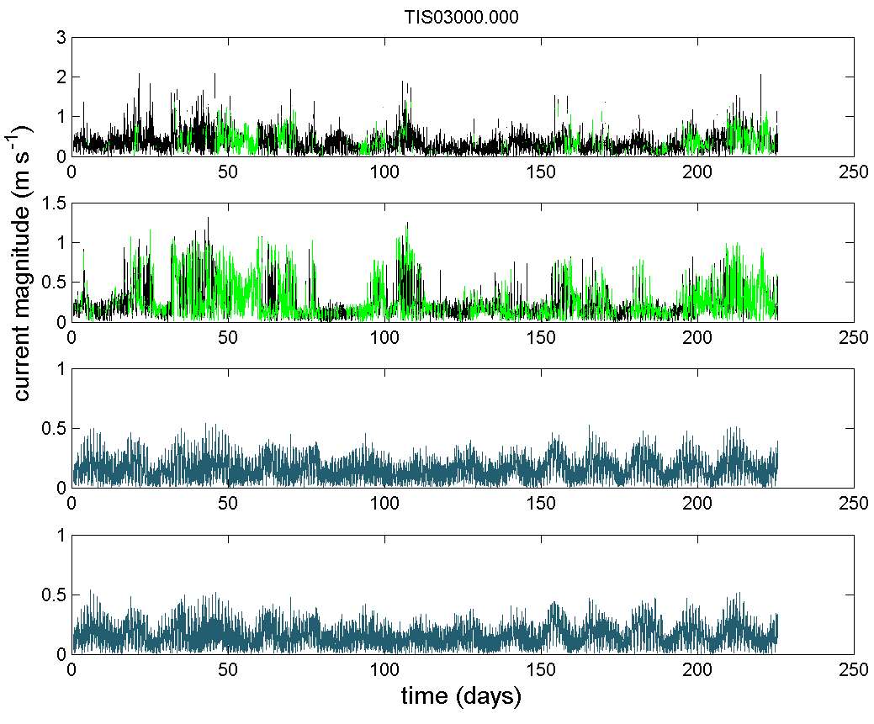
Figure A10: (a) current magnitude along the water column during TIS01 deployment (30/05/2011 to 10/01/2012) for the raw data (top), data after QC Steps 0-9 (middle 1), data after QC steps 0-9 plus all IMOS flags using default cut-off limits (namely echo difference cut-off limit = 30; correlation cut-off limit = 110; percent of good cut-off limit = 50; error velocity cut-off limit = 0.15 m s⁻¹; vertical velocity cut-off limit = 0.2 m s⁻¹) and data after QC steps 0-9 plus all IMOS flags using less strict cut-off limits (namely echo difference cut-off limit = 30; correlation cut-off limit = 64; percent of good cut-off limit = 10; error velocity cut-off limit = 0.30 m s⁻¹; vertical velocity cut-off limit = 0.2 m s⁻¹) (bottom); (b) time series of current magnitude (V, m s⁻¹) for the top two bins (in green) and the bottom two bins (blue) with more than 50% of valid data after steps 0 to 9 (angle_cutoff = 20°, ts_lim=5); (c) time series of current magnitude (V, m s⁻¹) for the two top bins (in red) and the two bottom bins (blue) with more than 50% of valid data after steps 0 to 9 plus all IMOS flags using default cut-off limits and (d) time series of current magnitude (V, m s⁻¹) for the two top bins (in green) and the two bottom bins (blue) with more than 50% of valid data after steps 0 to 9 plus all IMOS flags using less strict cut-off limits.

(a)  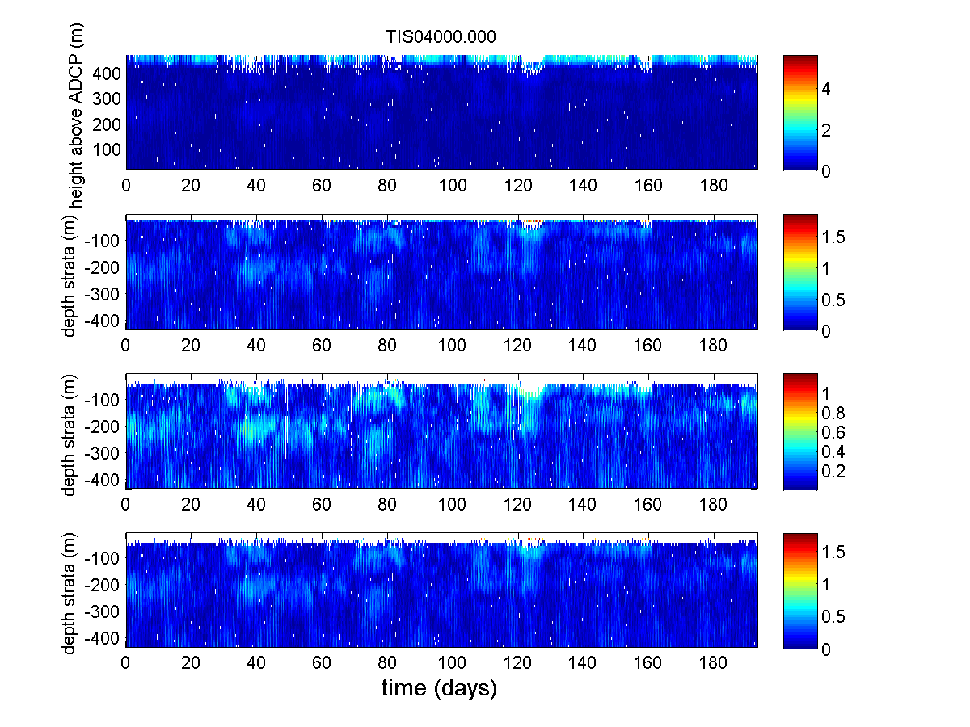 | (b)  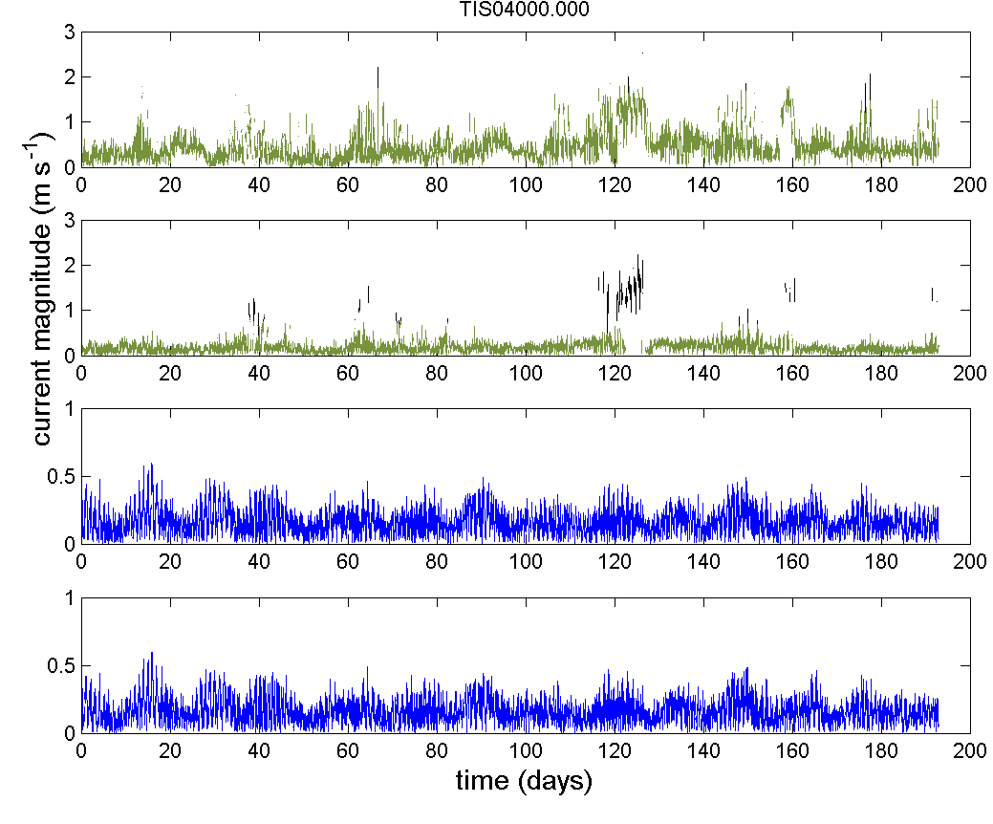
(c)  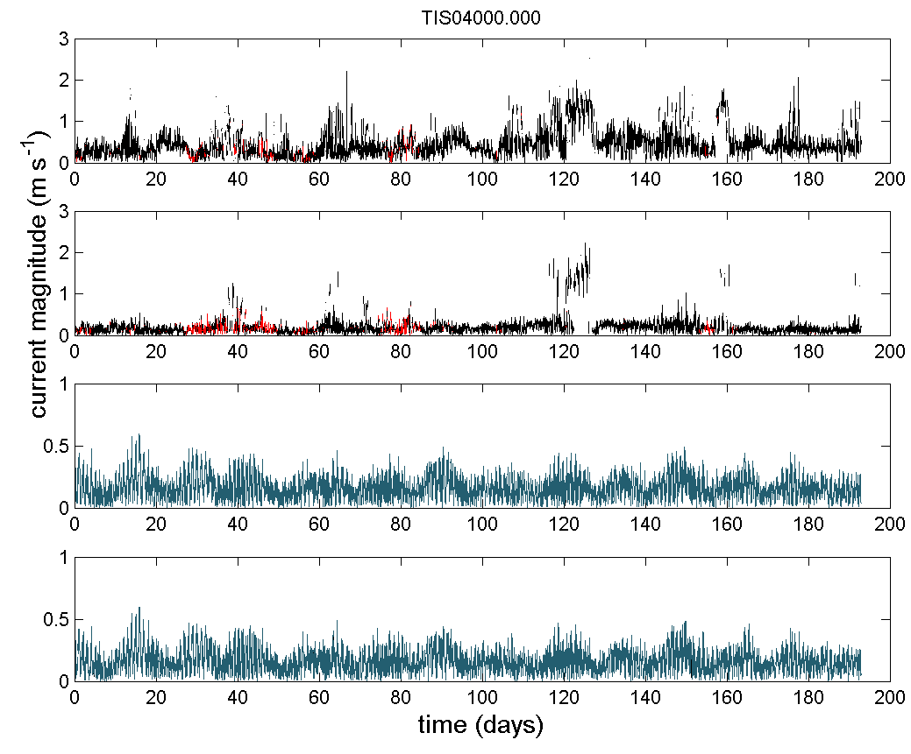 | (d)  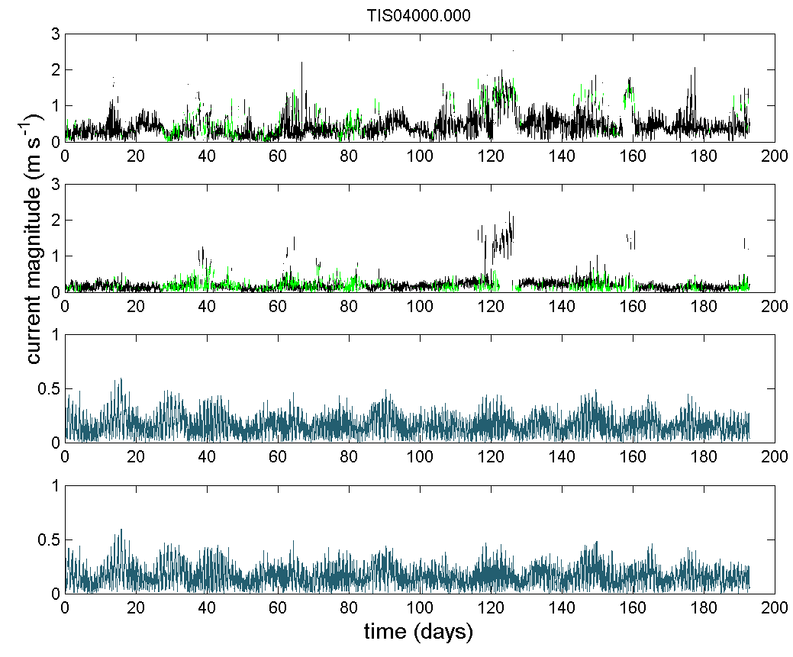
Figure A11: (left) current magnitude along the water column during TIS02 deployment (11/01/2012 to 21/07/2012) for the raw data (top), data after QC Steps 0-9 (middle 1), data after QC steps 0-9 plus all IMOS flags using default cut-off limits (namely echo difference cut-off limit = 30; correlation cut-off limit = 110; percent of good cut-off limit = 50; error velocity cut-off limit = 0.15 m s⁻¹; vertical velocity cut-off limit = 0.2 m s⁻¹) and data after QC steps 0-9 plus all IMOS flags using less strict cut-off limits (namely echo difference cut-off limit = 30; correlation cut-off limit = 64; percent of good cut-off limit = 10; error velocity cut-off limit = 0.30 m s⁻¹; vertical velocity cut-off limit = 0.2 m s⁻¹) (bottom); (b) time series of current magnitude (V, m s⁻¹) for the top two bins (in green) and the bottom two bins (blue) with more than 50% of valid data after steps 0 to 9 (angle_cutoff = 20°, ts_lim=5); (c) time series of current magnitude (V, m s⁻¹) for the two top bins (in red) and the two bottom bins (blue) with more than 50% of valid data after steps 0 to 9 plus all IMOS flags using default cut-off limits and (d) time series of current magnitude (V, m s⁻¹) for the two top bins (in green) and the two bottom bins (blue) with more than 50% of valid data after steps 0 to 9 plus all IMOS flags using less strict cut-off limits.

(a)  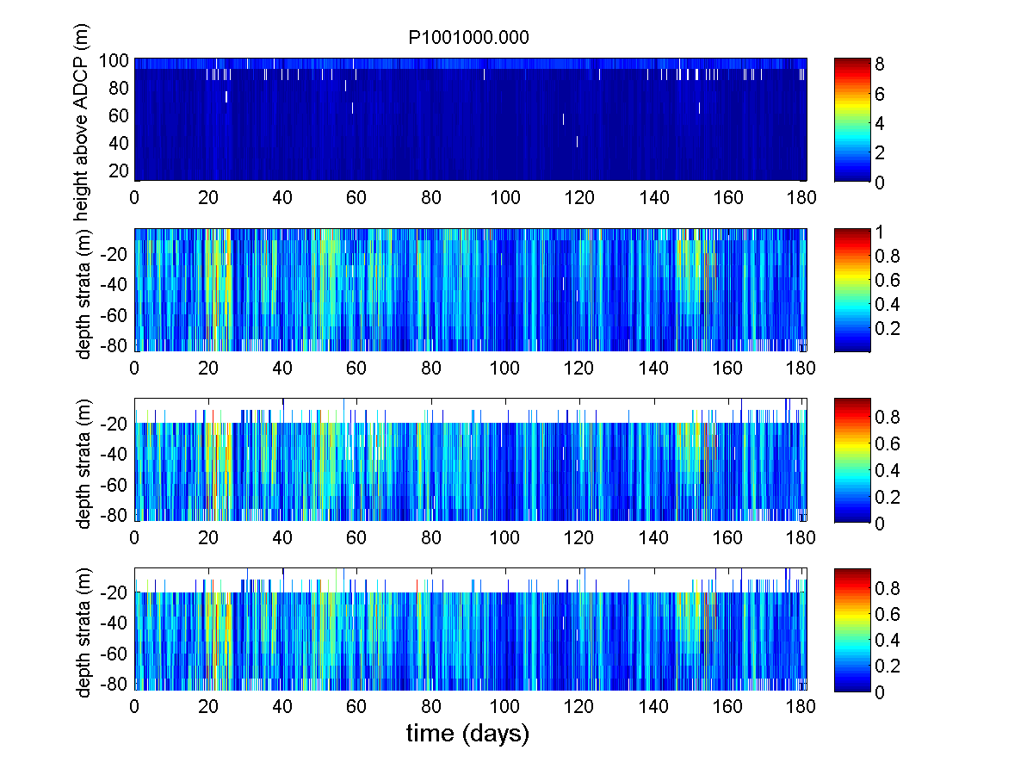 | (b)  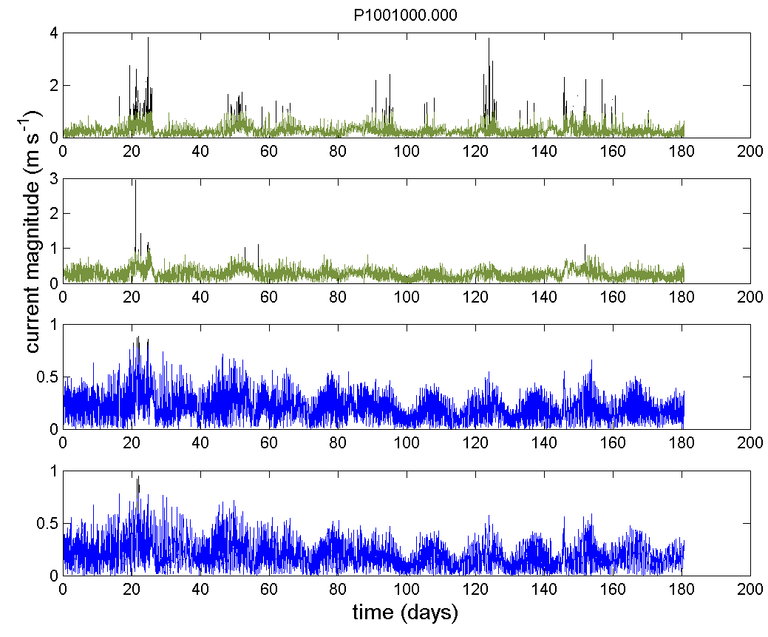
(c)  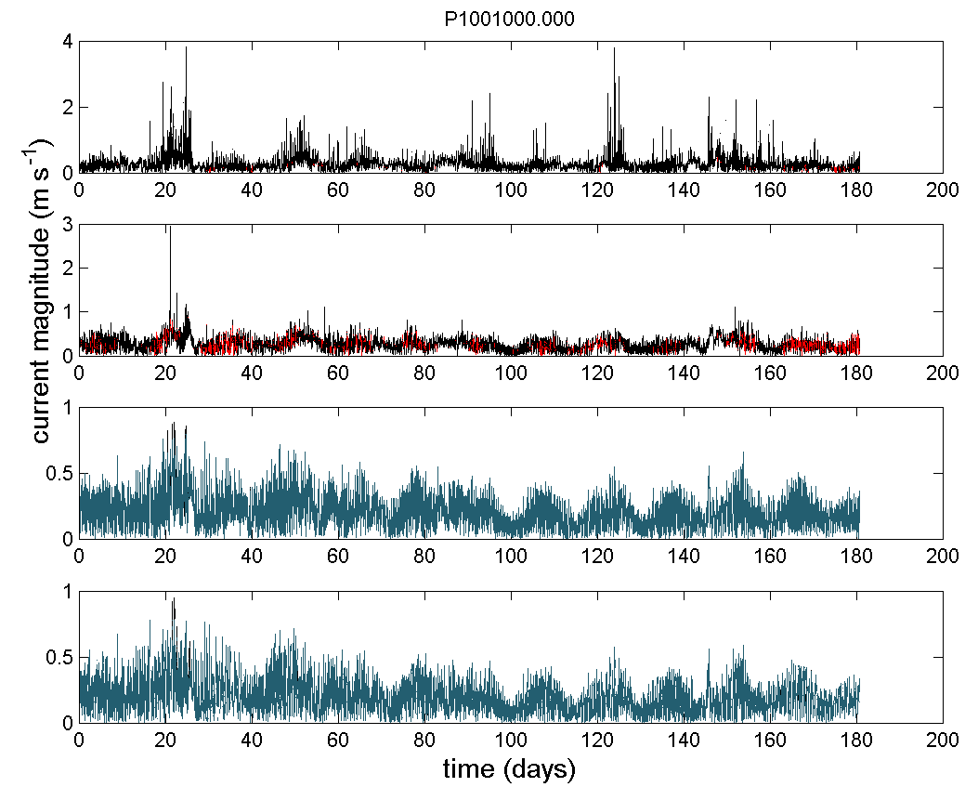 | (d)  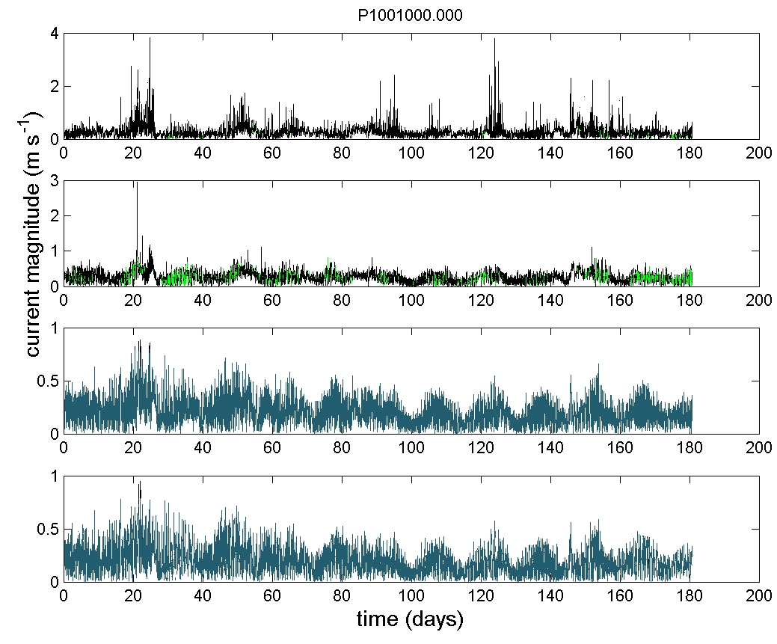
Figure A12: (left) current magnitude along the water column during PIL deployment (20/02/2012 to 19/08/2012) for the raw data (top), data after QC Steps 0-9 (middle 1), data after QC steps 0-9 plus all IMOS flags using default cut-off limits (namely echo difference cut-off limit = 30; correlation cut-off limit = 110; percent of good cut-off limit = 50; error velocity cut-off limit = 0.15 m s⁻¹; vertical velocity cut-off limit = 0.2 m s⁻¹) and data after QC steps 0-9 plus all IMOS flags using less strict cut-off limits (namely echo difference cut-off limit = 30; correlation cut-off limit = 64; percent of good cut-off limit = 10; error velocity cut-off limit = 0.30 m s⁻¹; vertical velocity cut-off limit = 0.2 m s⁻¹) (bottom); (b) time series of current magnitude (V, m s⁻¹) for the top two bins (in green) and the bottom two bins (blue) with more than 50% of valid data after steps 0 to 9 (angle_cutoff = 20°, ts_lim=5); (c) time series of current magnitude (V, m s⁻¹) for the two top bins (in red) and the two bottom bins (blue) with more than 50% of valid data after steps 0 to 9 plus all IMOS flags using default cut-off limits and (d) time series of current magnitude (V, m s⁻¹) for the two top bins (in green) and the two bottom bins (blue) with more than 50% of valid data after steps 0 to 9 plus all IMOS flags using less strict cut-off limits.

(a)  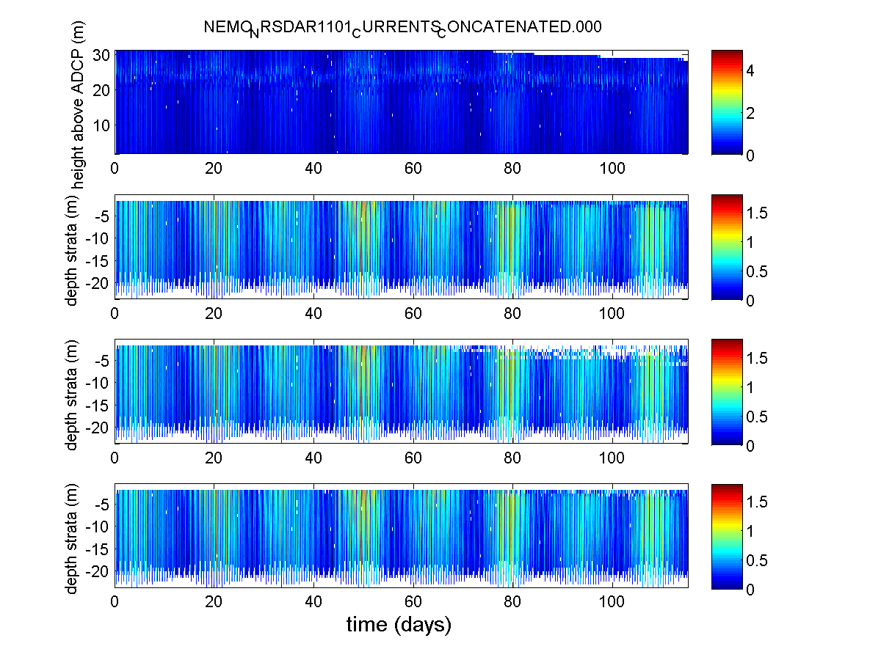 | (b)  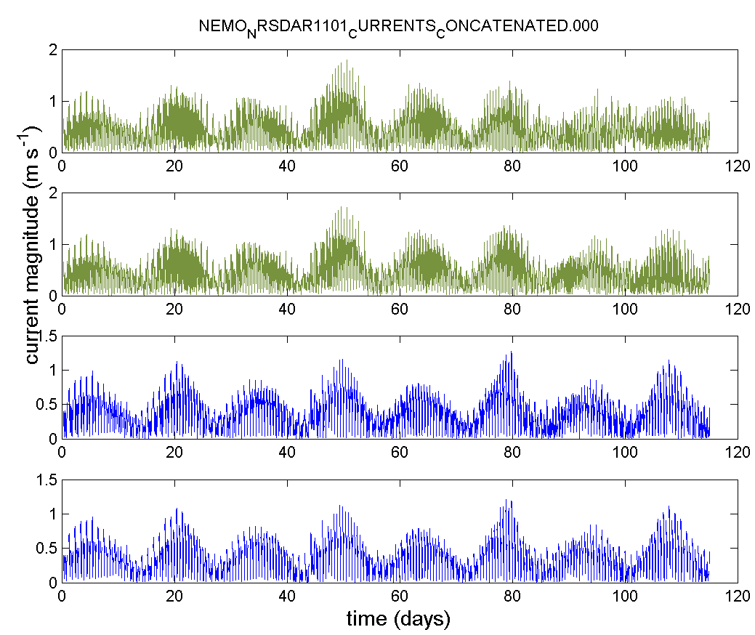
(c)  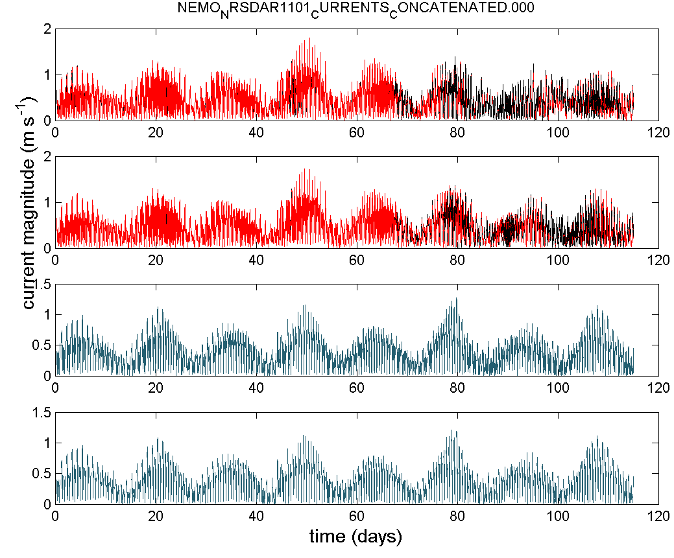 | (d)  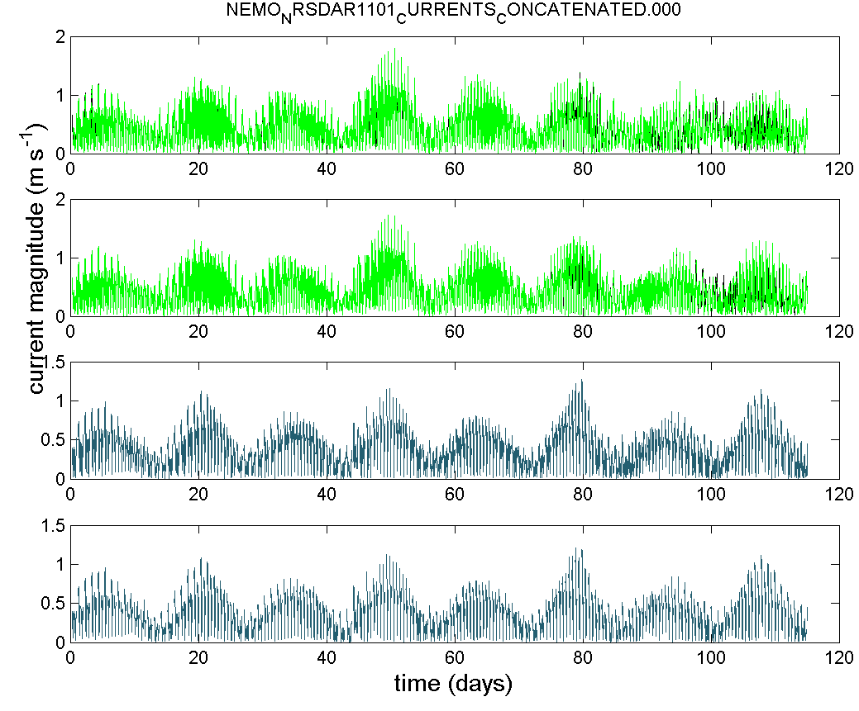
Figure A13: (left) current magnitude along the water column during NRSDAR01 deployment (02/01/2011 to 25/06/2011) for the raw data (top), data after QC Steps 0-9 (middle 1), data after QC steps 0-9 plus all IMOS flags using default cut-off limits (namely echo difference cut-off limit = 30; correlation cut-off limit = 110; percent of good cut-off limit = 50; error velocity cut-off limit = 0.15 m s⁻¹; vertical velocity cut-off limit = 0.2 m s⁻¹) and data after QC steps 0-9 plus all IMOS flags using less strict cut-off limits (namely echo difference cut-off limit = 30; correlation cut-off limit = 64; percent of good cut-off limit = 10; error velocity cut-off limit = 0.30 m s⁻¹; vertical velocity cut-off limit = 0.2 m s⁻¹) (bottom); (b) time series of current magnitude (V, m s⁻¹) for the top two bins (in green) and the bottom two bins (blue) with more than 50% of valid data after steps 0 to 9 (angle_cutoff = 20°, ts_lim=5); (c) time series of current magnitude (V, m s⁻¹) for the two top bins (in red) and the two bottom bins (blue) with more than 50% of valid data after steps 0 to 9 plus all IMOS flags using default cut-off limits and (d) time series of current magnitude (V, m s⁻¹) for the two top bins (in green) and the two bottom bins (blue) with more than 50% of valid data after steps 0 to 9 plus all IMOS flags using less strict cut-off limits.

(a)  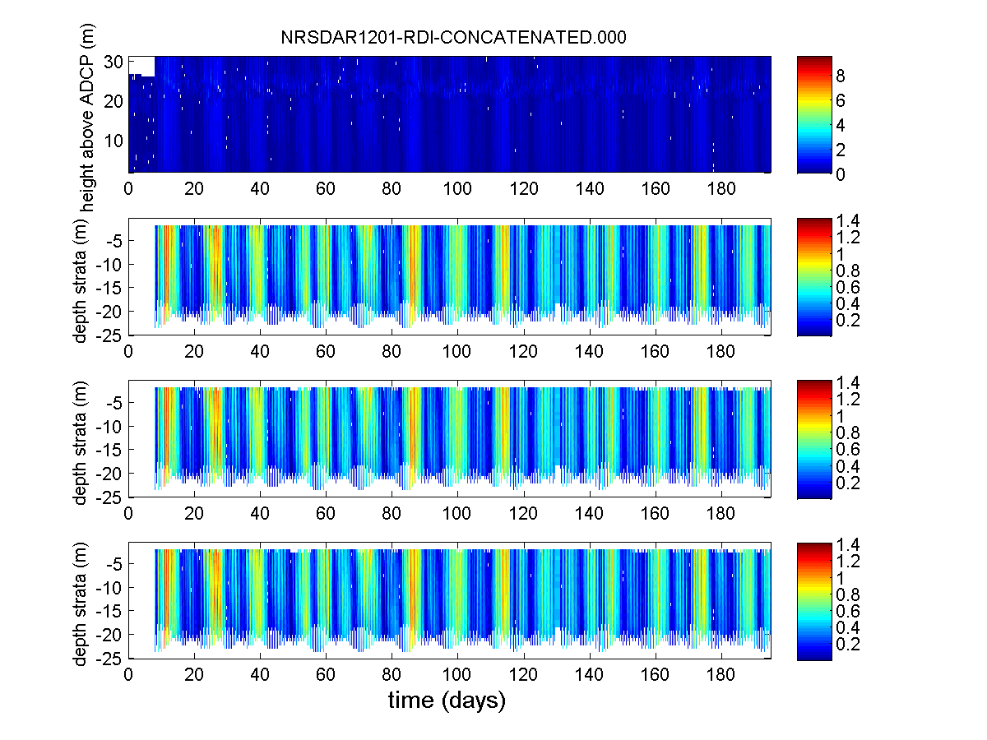 | (b)  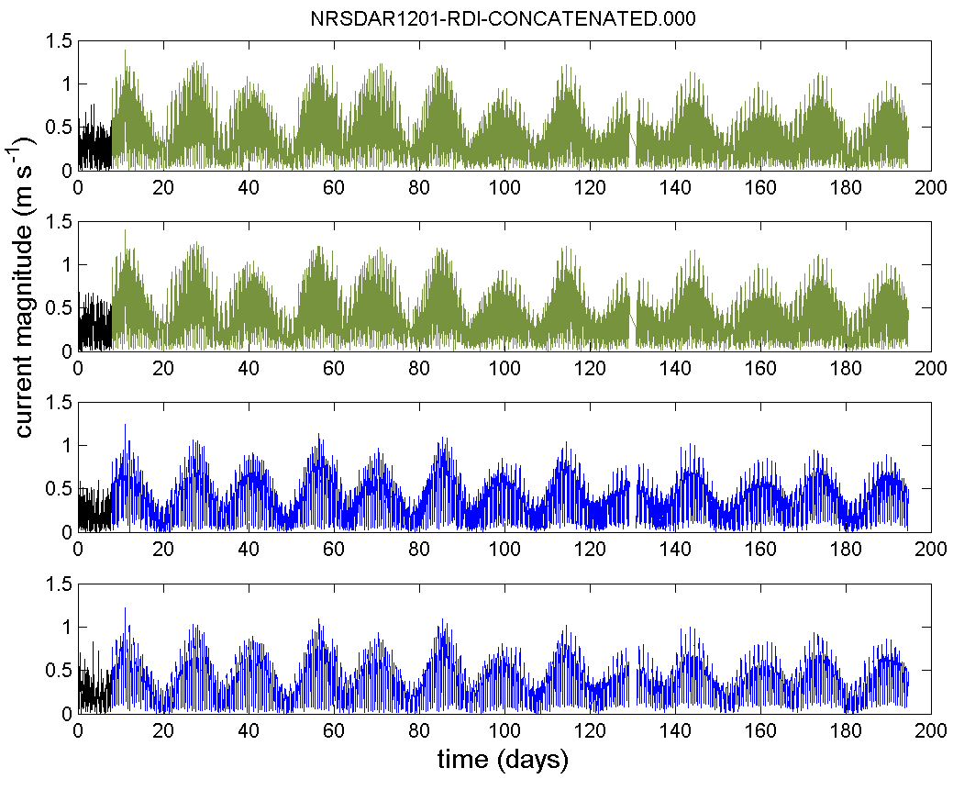
(c)  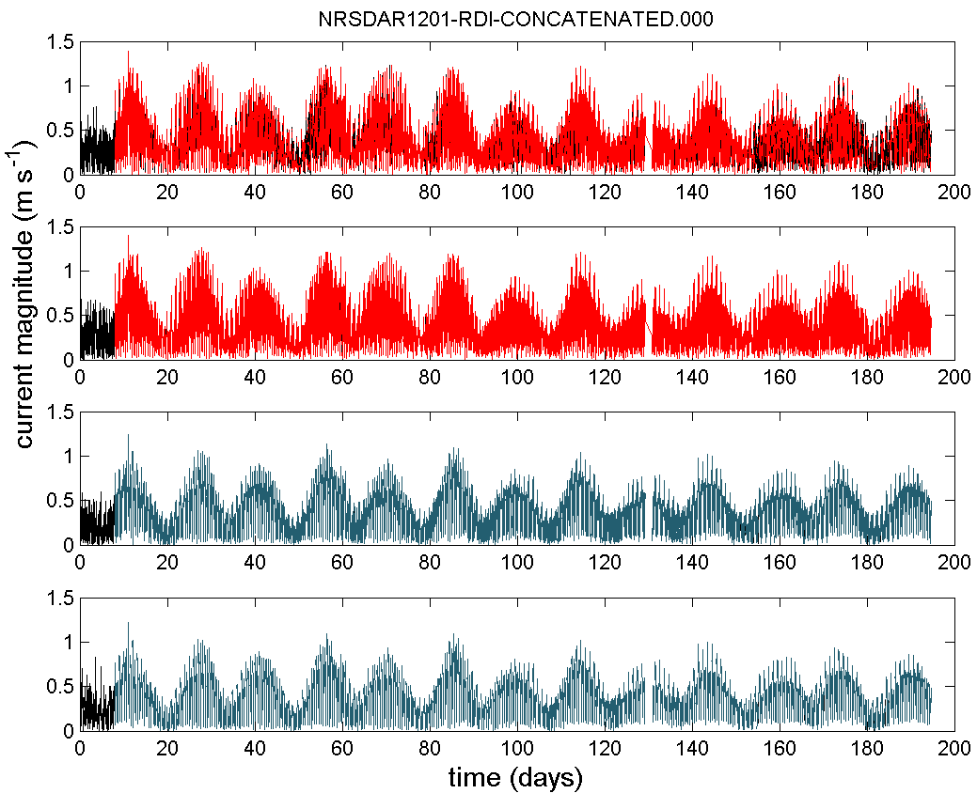 | (d)  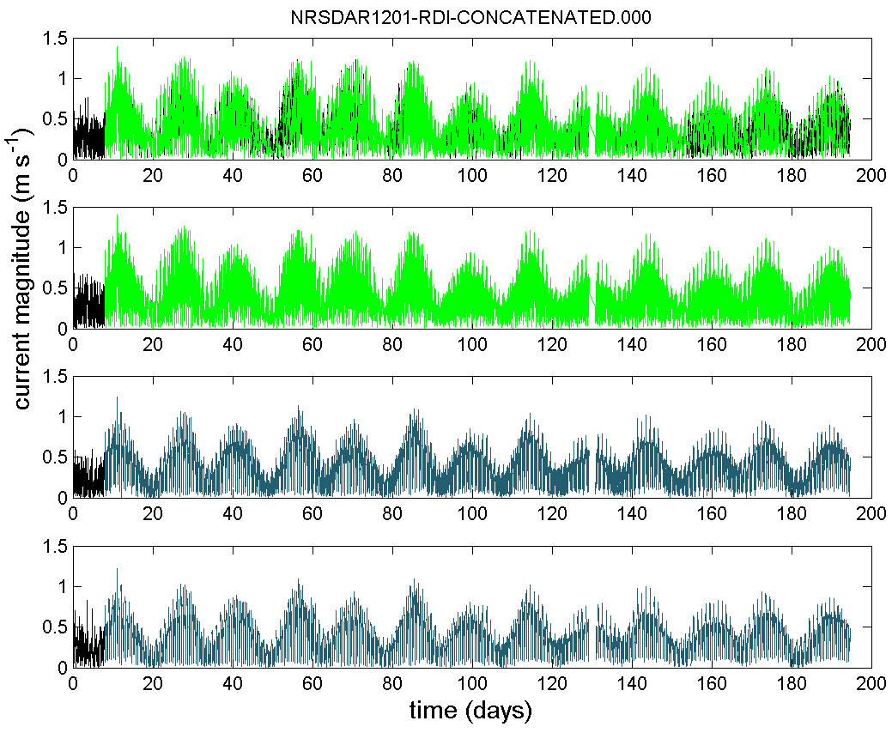
Figure A14: (left) current magnitude along the water column during NRSDAR02 deployment (14/01/2012 to 26/07/2012) for the raw data (top), data after QC Steps 0-9 (middle 1), data after QC steps 0-9 plus all IMOS flags using default cut-off limits (namely echo difference cut-off limit = 30; correlation cut-off limit = 110; percent of good cut-off limit = 50; error velocity cut-off limit = 0.15 m s⁻¹; vertical velocity cut-off limit = 0.2 m s⁻¹) and data after QC steps 0-9 plus all IMOS flags using less strict cut-off limits (namely echo difference cut-off limit = 30; correlation cut-off limit = 64; percent of good cut-off limit = 10; error velocity cut-off limit = 0.30 m s⁻¹; vertical velocity cut-off limit = 0.2 m s⁻¹) (bottom); (b) time series of current magnitude (V, m s⁻¹) for the top two bins (in green) and the bottom two bins (blue) with more than 50% of valid data after steps 0 to 9 (angle_cutoff = 20°, ts_lim=5); (c) time series of current magnitude (V, m s⁻¹) for the two top bins (in red) and the two bottom bins (blue) with more than 50% of valid data after steps 0 to 9 plus all IMOS flags using default cut-off limits and (d) time series of current magnitude (V, m s⁻¹) for the two top bins (in green) and the two bottom bins (blue) with more than 50% of valid data after steps 0 to 9 plus all IMOS flags using less strict cut-off limits.

Annexe 3: Flags’ plots
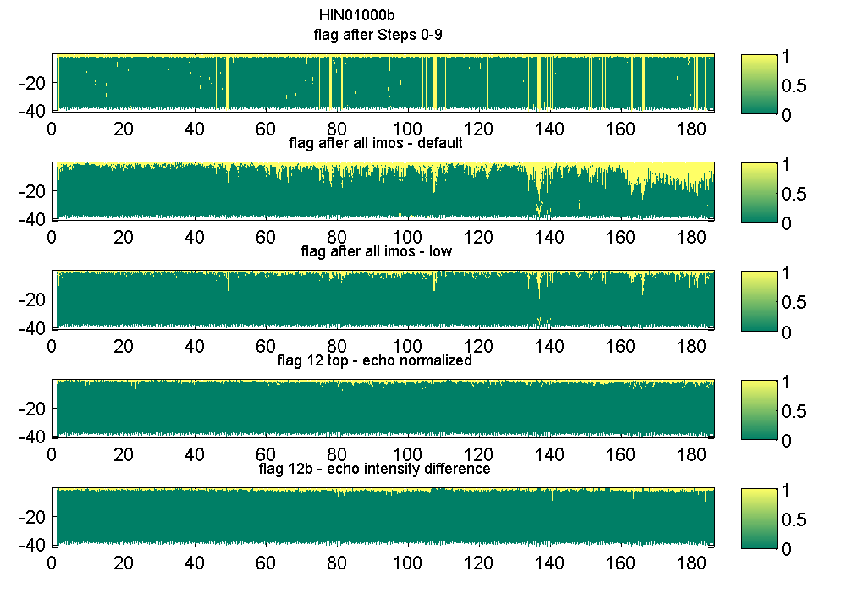 | 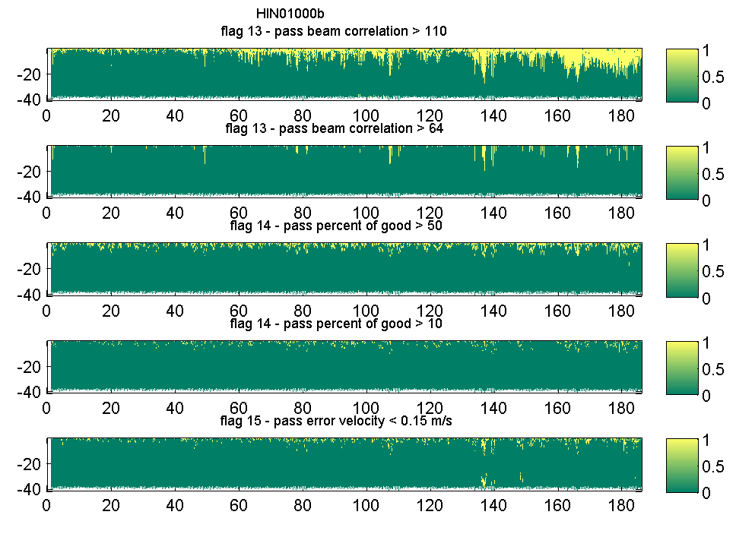
Figure B1: QC flags for the HIN01 deployment (16/10/2009 to 19/04/2010) along the water column (y-axis) and time (x-axis) with the rejected data points receiving flag = 1 (yellow) and accepted data points receiving flag = 0 (green); (left plots from top to bottom) – (i) Flags 0 to 9 together, (ii) all IMOS flag together using the default values, (iii) all IMOS flag together using the less strict cut-off limits, (iv) Flag 12 for the top half of the water column using the normalized echo intensity (cut-off = 15 dB), (vi) Flag 12b for the echo intensity difference (cut-off = 30 counts); (right plots from top to bottom) – (i) Flags 13a beam correlation (cut-off = 110), (ii) Flag 13b four beam correlation magnitude (cut-off = 64), (iii) Flag 14 the percent of good (cut-off = 50), (iv) Flag 14 the percent of good (cut-off = 10), Flag 15a for the error velocity (cut-off = 0.15 m s⁻¹).

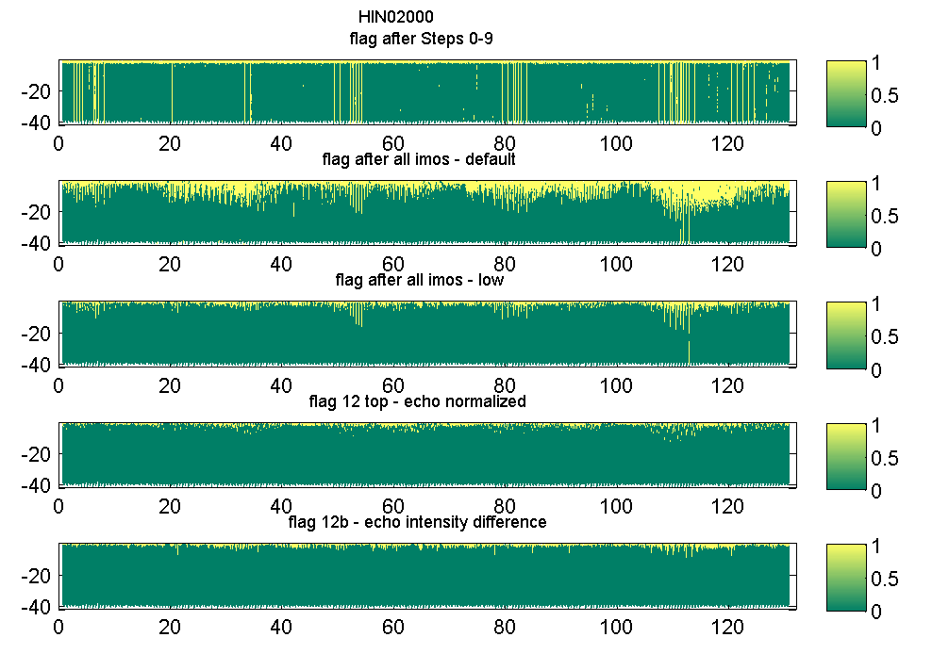 | 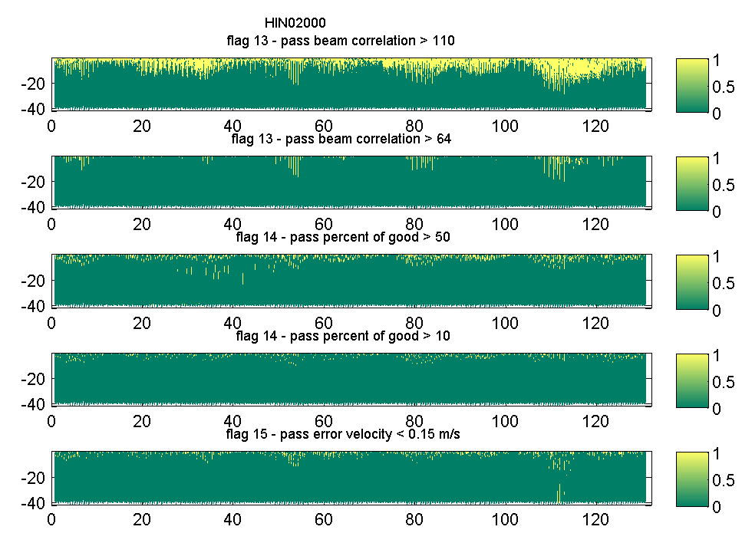
Figure B2: QC flags for the HIN02 deployment (22/04/2010 to 30/08/2010) along the water column (y-axis) and time (x-axis) with the rejected data points receiving flag = 1 (yellow) and accepted data points receiving flag = 0 (green); (left plots from top to bottom) – (i) Flags 0 to 9 together, (ii) all IMOS flag together using the default values, (iii) all IMOS flag together using the less strict cut-off limits, (iv) Flag 12 for the top half of the water column using the normalized echo intensity (cut-off = 15 dB), (vi) Flag 12b for the echo intensity difference (cut-off = 30 counts); (right plots from top to bottom) – (i) Flags 13a beam correlation (cut-off = 110), (ii) Flag 13b four beam correlation magnitude (cut-off = 64), (iii) Flag 14 the percent of good (cut-off = 50), (iv) Flag 14 the percent of good (cut-off = 10), Flag 15a for the error velocity (cut-off = 0.15 m s⁻¹).

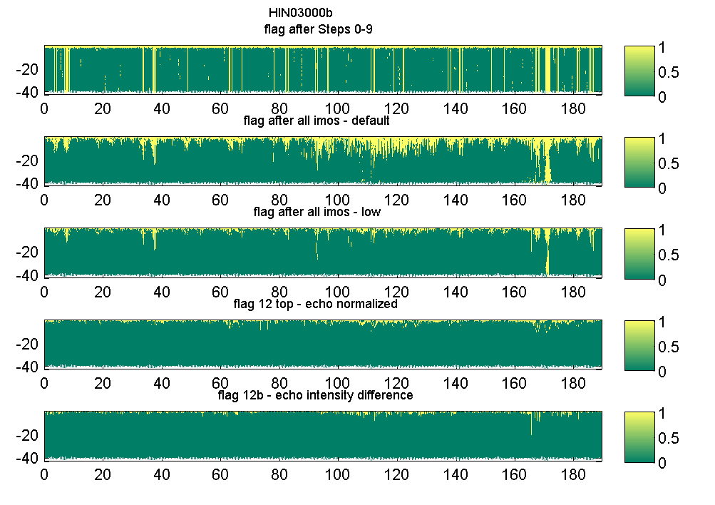 | 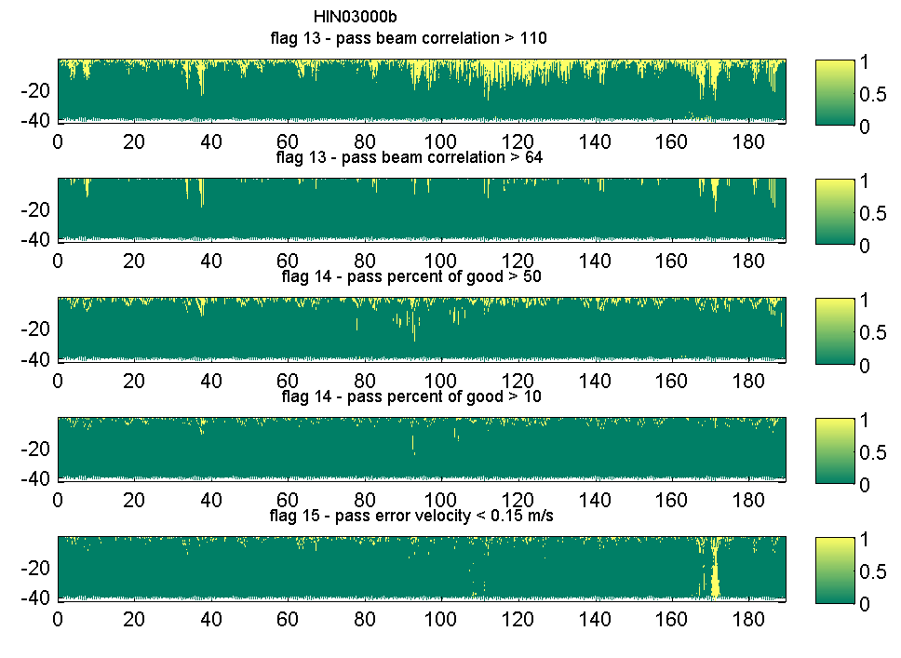
Figure B3: QC flags for the HIN03 deployment (02/09/2010 to 10/03/2011) along the water column (y-axis) and time (x-axis) with the rejected data points receiving flag = 1 (yellow) and accepted data points receiving flag = 0 (green); (left plots from top to bottom) – (i) Flags 0 to 9 together, (ii) all IMOS flag together using the default values, (iii) all IMOS flag together using the less strict cut-off limits, (iv) Flag 12 for the top half of the water column using the normalized echo intensity (cut-off = 15 dB), (vi) Flag 12b for the echo intensity difference (cut-off = 30 counts); (right plots from top to bottom) – (i) Flags 13a beam correlation (cut-off = 110), (ii) Flag 13b four beam correlation magnitude (cut-off = 64), (iii) Flag 14 the percent of good (cut-off = 50), (iv) Flag 14 the percent of good (cut-off = 10), Flag 15a for the error velocity (cut-off = 0.15 m s⁻¹).

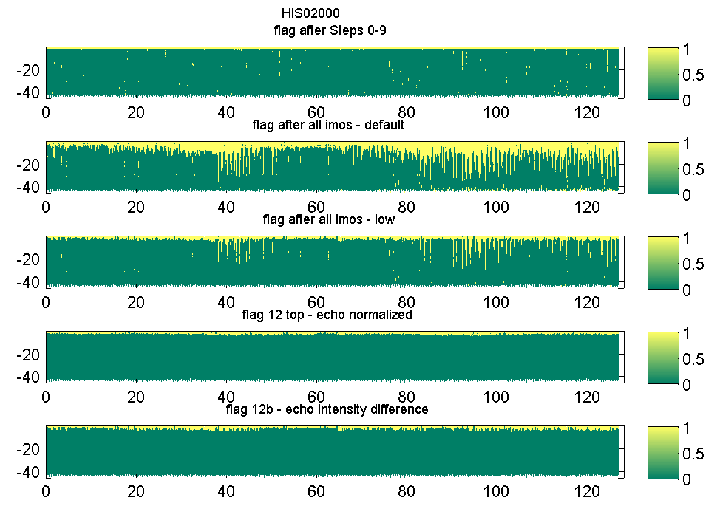 | 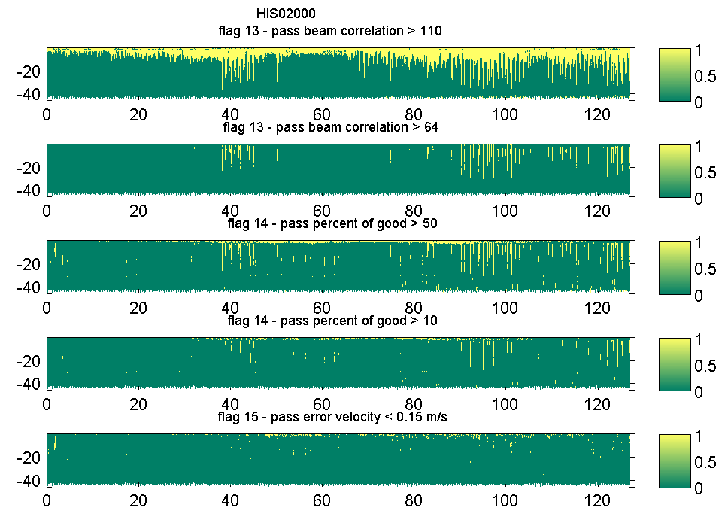
Figure B4: QC flags for the HIS01 deployment (26/04/2010 to 31/08/2010) along the water column (y-axis) and time (x-axis) with the rejected data points receiving flag = 1 (yellow) and accepted data points receiving flag = 0 (green); (left plots from top to bottom) – (i) Flags 0 to 9 together, (ii) all IMOS flag together using the default values, (iii) all IMOS flag together using the less strict cut-off limits, (iv) Flag 12 for the top half of the water column using the normalized echo intensity (cut-off = 15 dB), (vi) Flag 12b for the echo intensity difference (cut-off = 30 counts); (right plots from top to bottom) – (i) Flags 13a beam correlation (cut-off = 110), (ii) Flag 13b four beam correlation magnitude (cut-off = 64), (iii) Flag 14 the percent of good (cut-off = 50), (iv) Flag 14 the percent of good (cut-off = 10), Flag 15a for the error velocity (cut-off = 0.15 m s⁻¹).

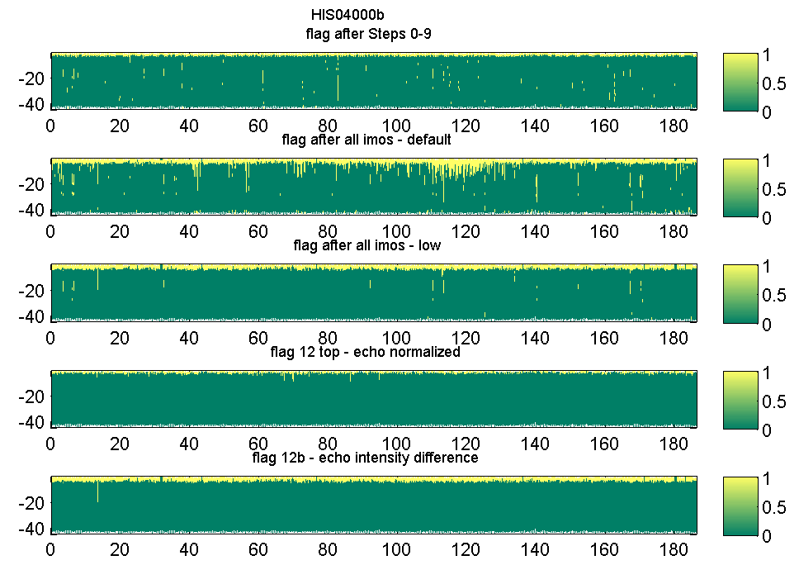 | 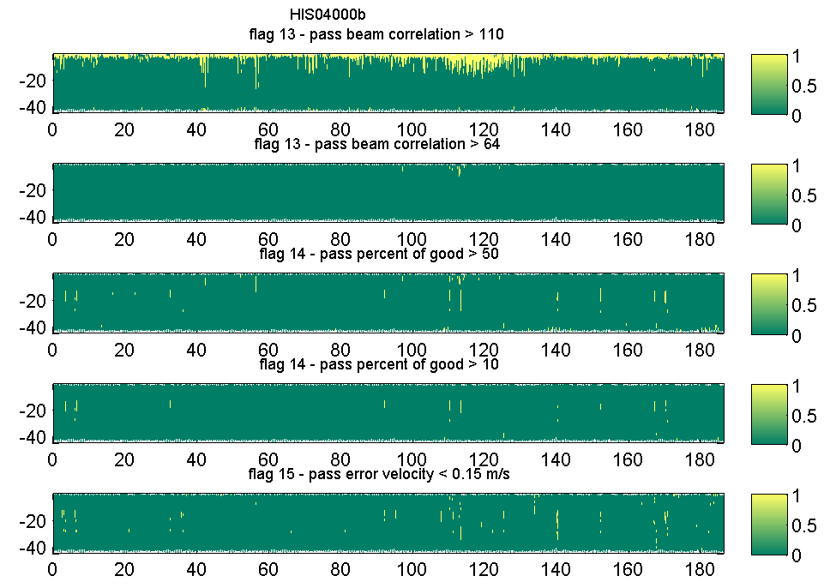
Figure B5: QC flags for the HIS02 deployment (03/09/2010 to 08/03/2011) along the water column (y-axis) and time (x-axis) with the rejected data points receiving flag = 1 (yellow) and accepted data points receiving flag = 0 (green); (left plots from top to bottom) – (i) Flags 0 to 9 together, (ii) all IMOS flag together using the default values, (iii) all IMOS flag together using the less strict cut-off limits, (iv) Flag 12 for the top half of the water column using the normalized echo intensity (cut-off = 15 dB), (vi) Flag 12b for the echo intensity difference (cut-off = 30 counts); (right plots from top to bottom) – (i) Flags 13a beam correlation (cut-off = 110), (ii) Flag 13b four beam correlation magnitude (cut-off = 64), (iii) Flag 14 the percent of good (cut-off = 50), (iv) Flag 14 the percent of good (cut-off = 10), Flag 15a for the error velocity (cut-off = 0.15 m s⁻¹).

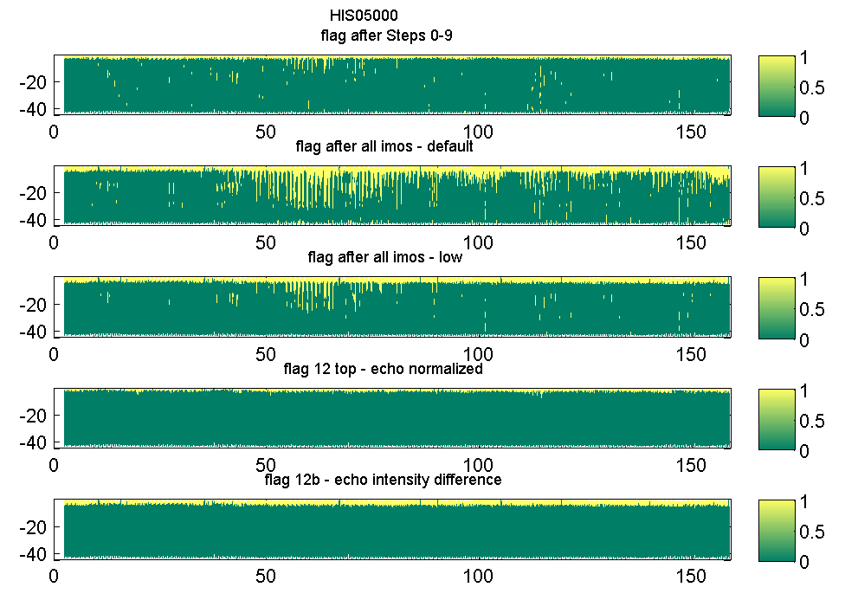 | 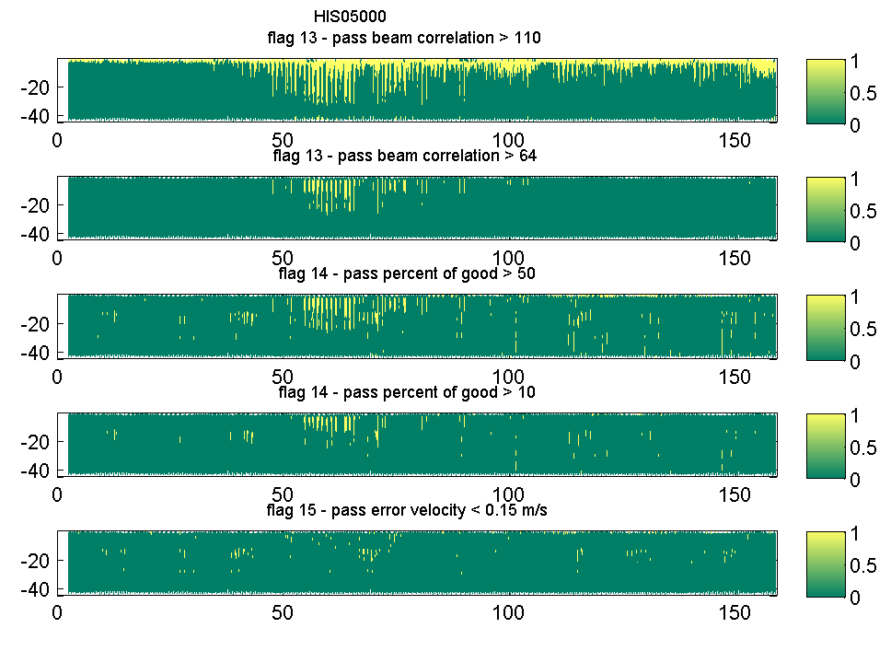
Figure B6: QC flags for the HIS03 deployment (09/03/2011 to 13/08/2011) along the water column (y-axis) and time (x-axis) with the rejected data points receiving flag = 1 (yellow) and accepted data points receiving flag = 0 (green); (left plots from top to bottom) – (i) Flags 0 to 9 together, (ii) all IMOS flag together using the default values, (iii) all IMOS flag together using the less strict cut-off limits, (iv) Flag 12 for the top half of the water column using the normalized echo intensity (cut-off = 15 dB), (vi) Flag 12b for the echo intensity difference (cut-off = 30 counts); (right plots from top to bottom) – (i) Flags 13a beam correlation (cut-off = 110), (ii) Flag 13b four beam correlation magnitude (cut-off = 64), (iii) Flag 14 the percent of good (cut-off = 50), (iv) Flag 14 the percent of good (cut-off = 10), Flag 15a for the error velocity (cut-off = 0.15 m s⁻¹).

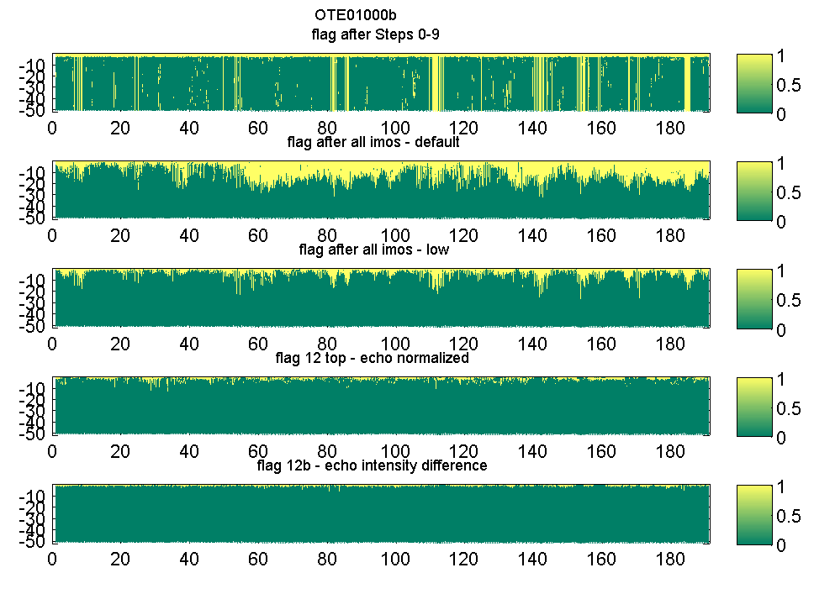 | 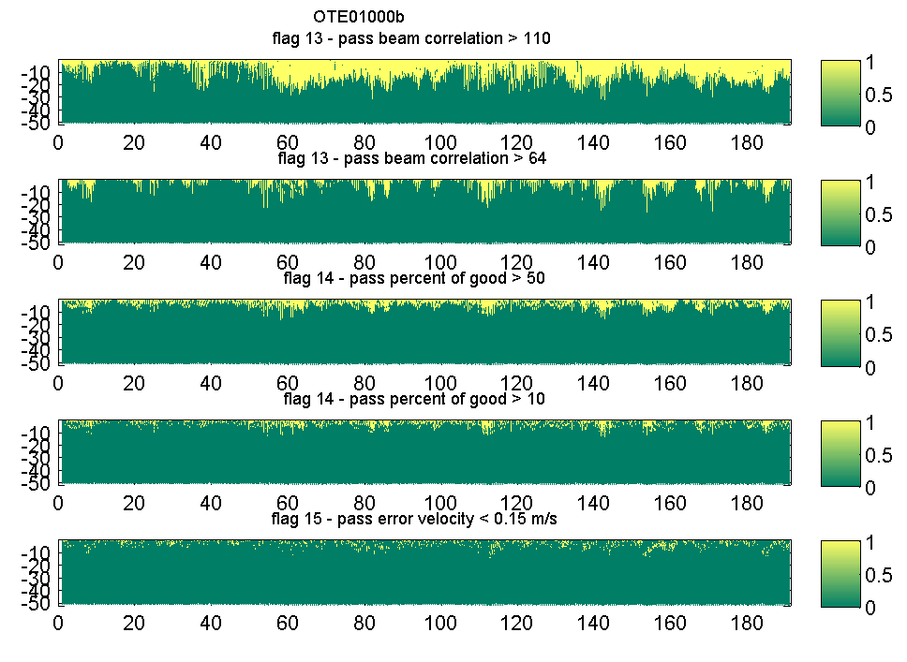
Figure B7: QC flags for the OTE01deployment (12/10/2009 to 19/04/2010) along the water column (y-axis) and time (x-axis) with the rejected data points receiving flag = 1 (yellow) and accepted data points receiving flag = 0 (green); (left plots from top to bottom) – (i) Flags 0 to 9 together, (ii) all IMOS flag together using the default values, (iii) all IMOS flag together using the less strict cut-off limits, (iv) Flag 12 for the top half of the water column using the normalized echo intensity (cut-off = 15 dB), (vi) Flag 12b for the echo intensity difference (cut-off = 30 counts); (right plots from top to bottom) – (i) Flags 13a beam correlation (cut-off = 110), (ii) Flag 13b four beam correlation magnitude (cut-off = 64), (iii) Flag 14 the percent of good (cut-off = 50), (iv) Flag 14 the percent of good (cut-off = 10), Flag 15a for the error velocity (cut-off = 0.15 m s⁻¹).

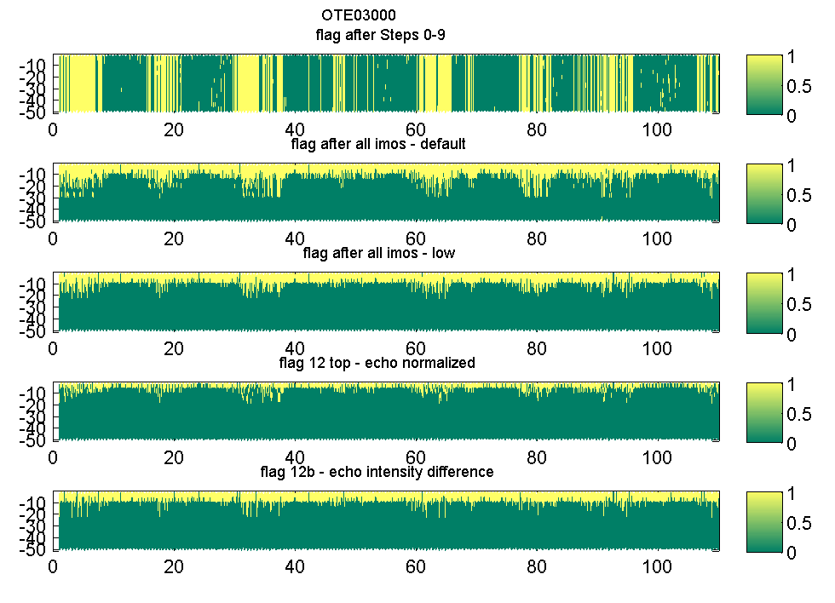 | 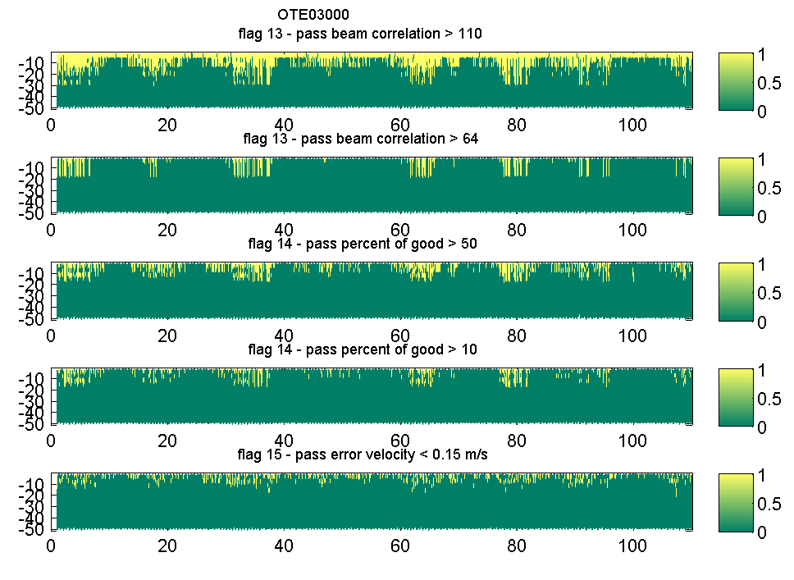
Figure B8: QC flags for the OTE02 deployment (05/09/2010 to 10/03/2011) along the water column (y-axis) and time (x-axis) with the rejected data points receiving flag = 1 (yellow) and accepted data points receiving flag = 0 (green); (left plots from top to bottom) – (i) Flags 0 to 9 together, (ii) all IMOS flag together using the default values, (iii) all IMOS flag together using the less strict cut-off limits, (iv) Flag 12 for the top half of the water column using the normalized echo intensity (15 dB), (vi) Flag 12b for the echo intensity difference (30 counts); (right plots from top to bottom) – (i) Flags 13a beam correlation (cut-off = 110), (ii) Flag 13b four beam correlation magnitude (cut-off = 64), (iii) Flag 14 the percent of good (cut-off = 50), (iv) Flag 14 the percent of good (cut-off = 10), Flag 15a for the error velocity (cut-off = 0.15 m s⁻¹).

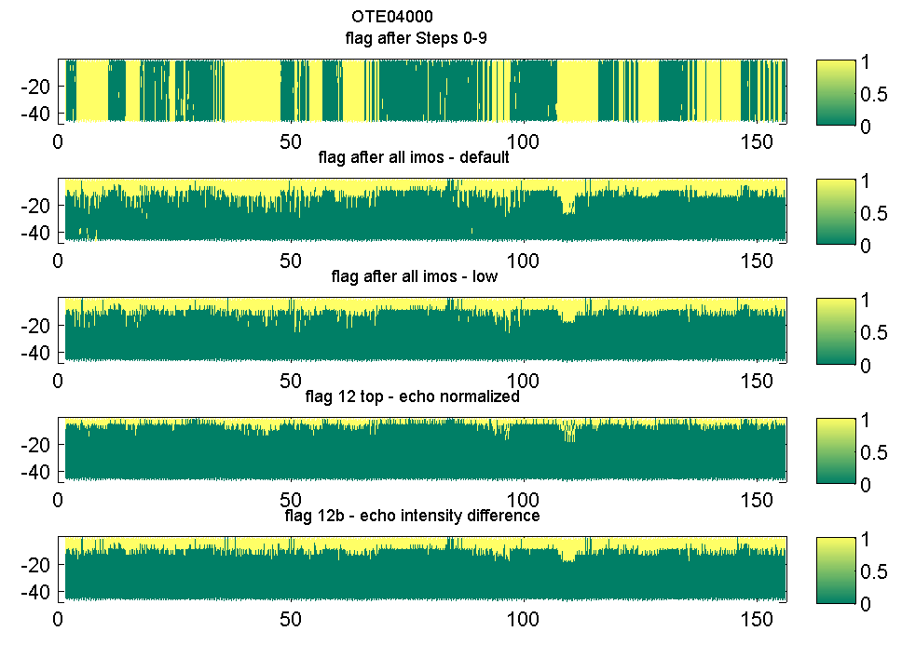 | 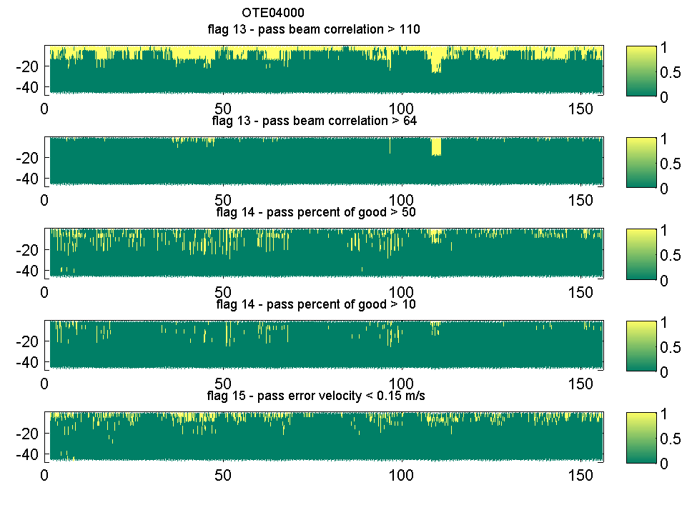
Figure B9: QC flags for the OTE03 deployment (14/03/2011 to 16/08/2011) along the water column (y-axis) and time (x-axis) with the rejected data points receiving flag = 1 (yellow) and accepted data points receiving flag = 0 (green); (left plots from top to bottom) – (i) Flags 0 to 9 together, (ii) all IMOS flag together using the default values, (iii) all IMOS flag together using the less strict cut-off limits, (iv) Flag 12 for the top half of the water column using the normalized echo intensity (cut-off = 15 dB), (vi) Flag 12b for the echo intensity difference (cut-off = 30 counts); (right plots from top to bottom) – (i) Flags 13a beam correlation (cut-off = 110), (ii) Flag 13b four beam correlation magnitude (cut-off = 64), (iii) Flag 14 the percent of good (cut-off = 50), (iv) Flag 14 the percent of good (cut-off = 10), Flag 15a for the error velocity (cut-off = 0.15 m s⁻¹).

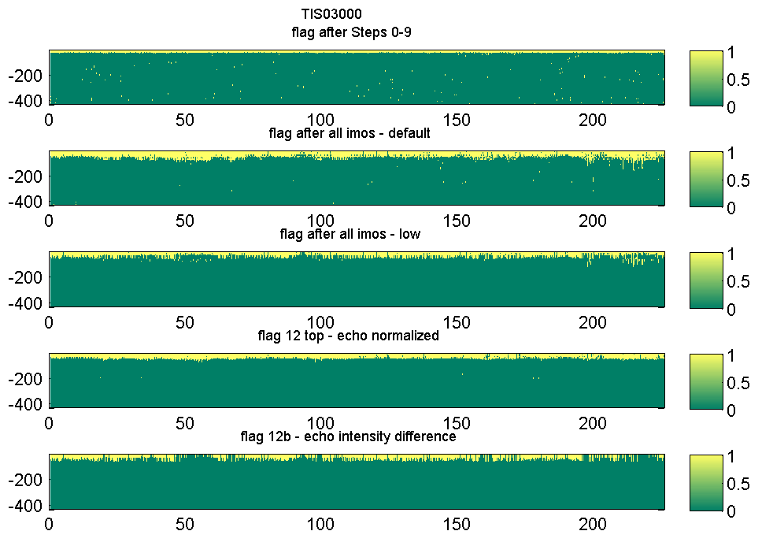 | 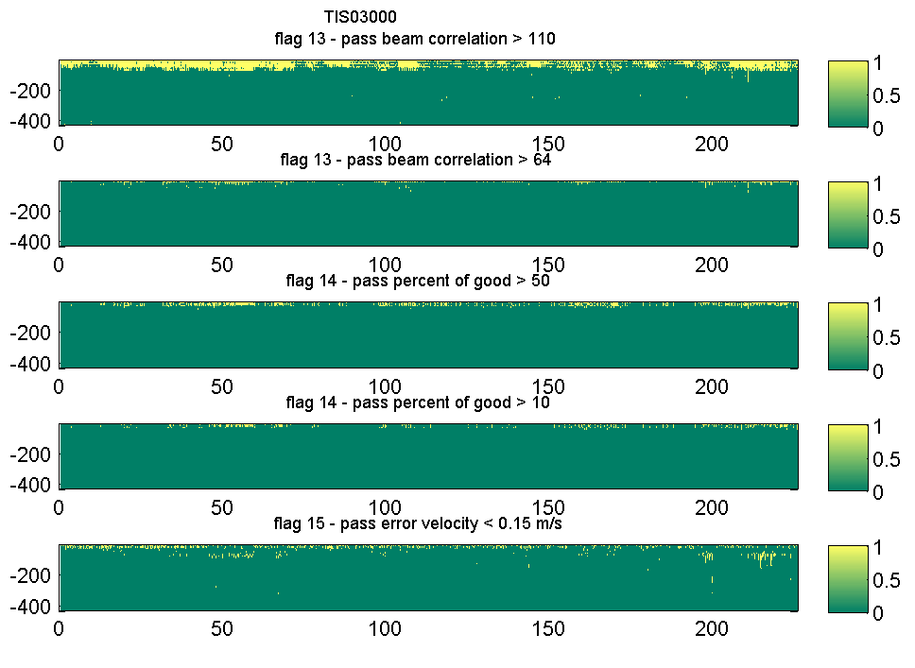
Figure B10: QC flags for the TIS01 deployment (30/05/2011 to 10/01/2012) along the water column (y-axis) and time (x-axis) with the rejected data points receiving flag = 1 (yellow) and accepted data points receiving flag = 0 (green); (left plots from top to bottom) – (i) Flags 0 to 9 together, (ii) all IMOS flag together using the default values, (iii) all IMOS flag together using the less strict cut-off limits, (iv) Flag 12 for the top half of the water column using the normalized echo intensity (15 dB), (vi) Flag 12b for the echo intensity difference (30 counts); (right plots from top to bottom) – (i) Flags 13a beam correlation (cut-off = 110), (ii) Flag 13b four beam correlation magnitude (cut-off = 64), (iii) Flag 14 the percent of good (cut-off = 50), (iv) Flag 14 the percent of good (cut-off = 10), Flag 15a for the error velocity (cut-off = 0.15 m s⁻¹).

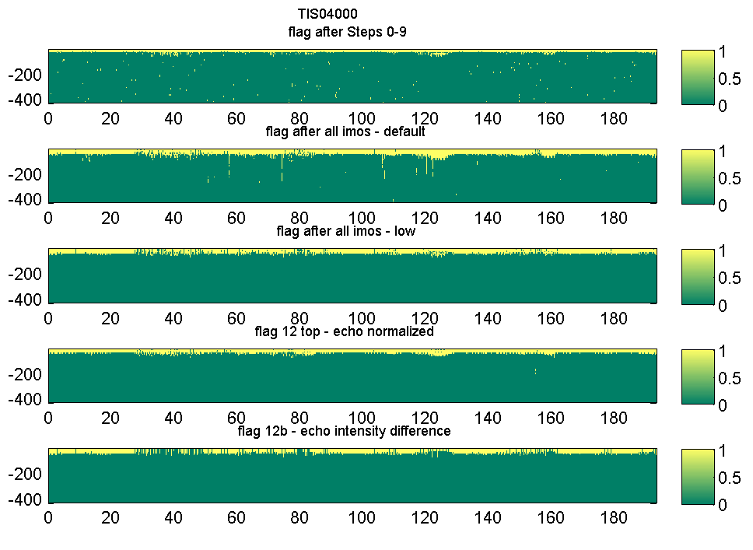 | 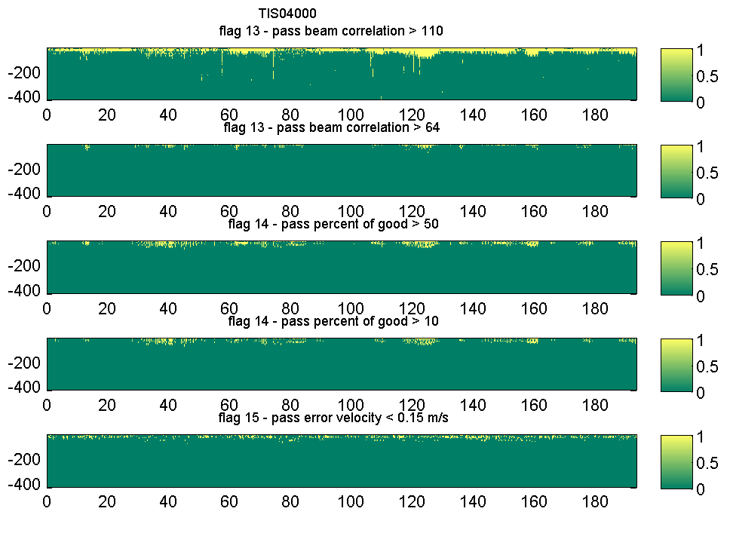
Figure B11: QC flags for the TIS02 deployment (11/01/2012 to 21/07/2012) along the water column (y-axis) and time (x-axis) with the rejected data points receiving flag = 1 (yellow) and accepted data points receiving flag = 0 (green); (left plots from top to bottom) – (i) Flags 0 to 9 together, (ii) all IMOS flag together using the default values, (iii) all IMOS flag together using the less strict cut-off limits, (iv) Flag 12 for the top half of the water column using the normalized echo intensity (cut-off = 15 dB), (vi) Flag 12b for the echo intensity difference (cut-off = 30 counts); (right plots from top to bottom) – (i) Flags 13a beam correlation (cut-off = 110), (ii) Flag 13b four beam correlation magnitude (cut-off = 64), (iii) Flag 14 the percent of good (cut-off = 50), (iv) Flag 14 the percent of good (cut-off = 10), Flag 15a for the error velocity (cut-off = 0.15 m s⁻¹).

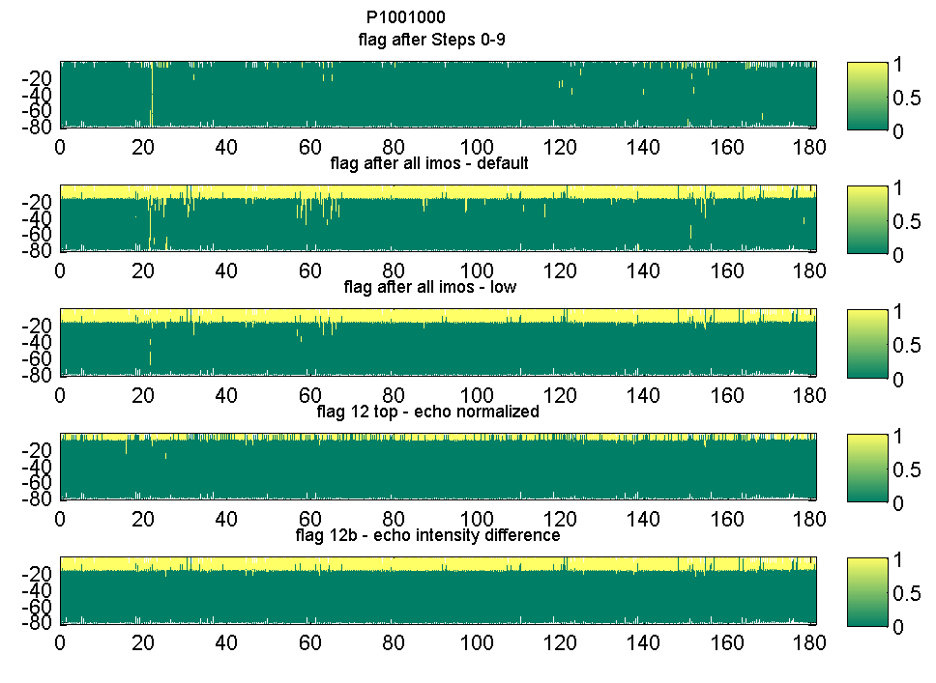 | 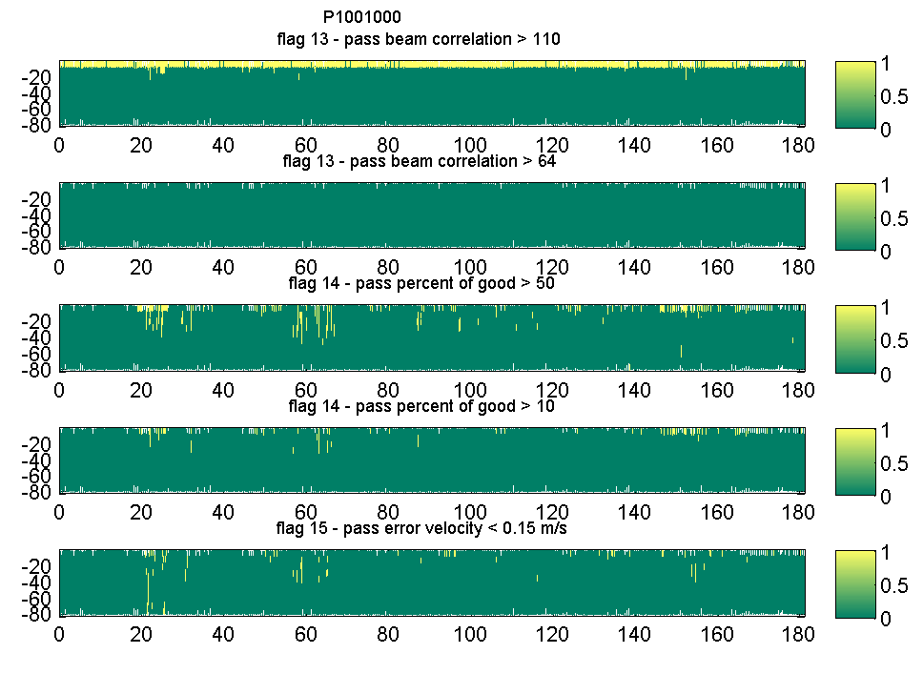
Figure B12: QC flags for the PIL deployment (20/02/2012 to 19/08/2012) along the water column (y-axis) and time (x-axis) with the rejected data points receiving flag = 1 (yellow) and accepted data points receiving flag = 0 (green); (left plots from top to bottom) – (i) Flags 0 to 9 together, (ii) all IMOS flag together using the default values, (iii) all IMOS flag together using the less strict cut-off limits, (iv) Flag 12 for the top half of the water column using the normalized echo intensity (cut-off = 15 dB), (vi) Flag 12b for the echo intensity difference (cut-off = 30 counts); (right plots from top to bottom) – (i) Flags 13a beam correlation (cut-off = 110), (ii) Flag 13b four beam correlation magnitude (cut-off = 64), (iii) Flag 14 the percent of good (cut-off = 50), (iv) Flag 14 the percent of good (cut-off = 10), Flag 15a for the error velocity (cut-off = 0.15 m s⁻¹).

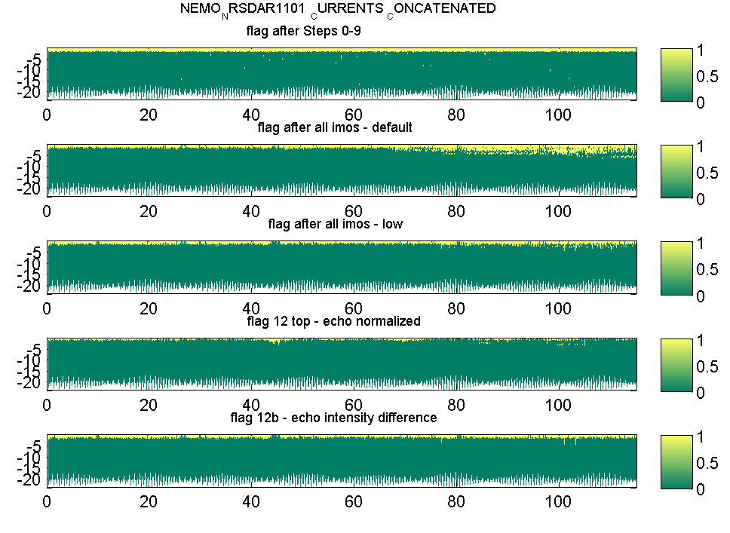 | 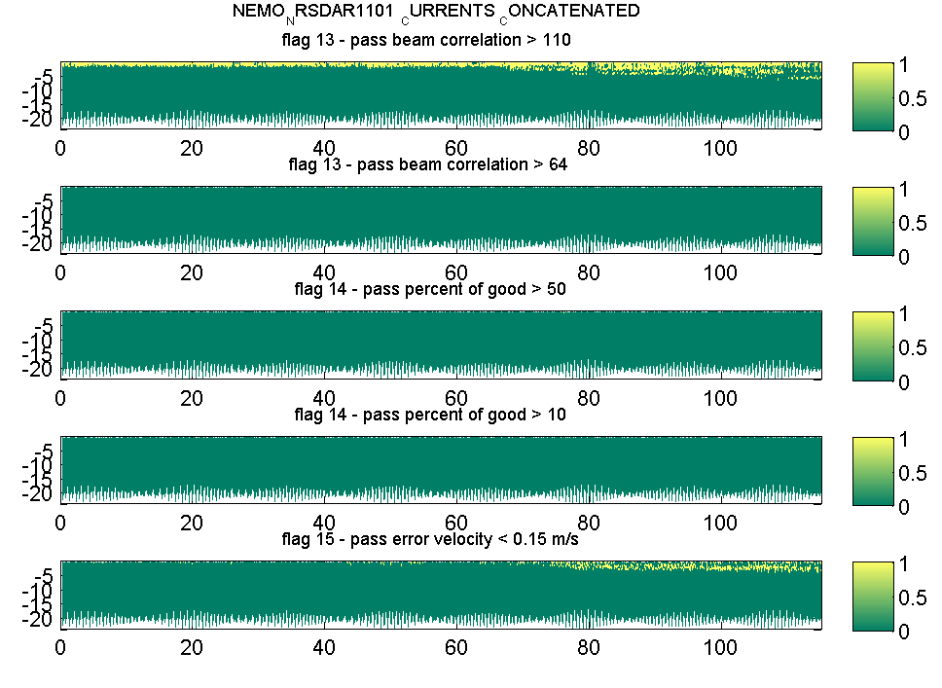
Figure B13: QC flags for the NRSDAR01 deployment (02/01/2011 to 25/06/2011) along the water column (y-axis) and time (x-axis) with the rejected data points receiving flag = 1 (yellow) and accepted data points receiving flag = 0 (green); (left plots from top to bottom) – (i) Flags 0 to 9 together, (ii) all IMOS flag together using the default values, (iii) all IMOS flag together using the less strict cut-off limits, (iv) Flag 12 for the top half of the water column using the normalized echo intensity (cut-off = 15 dB), (vi) Flag 12b for the echo intensity difference (cut-off = 30 counts); (right plots from top to bottom) – (i) Flags 13a beam correlation (cut-off = 110), (ii) Flag 13b four beam correlation magnitude (cut-off = 64), (iii) Flag 14 the percent of good (cut-off = 50), (iv) Flag 14 the percent of good (cut-off = 10), Flag 15a for the error velocity (cut-off = 0.15 m s⁻¹).

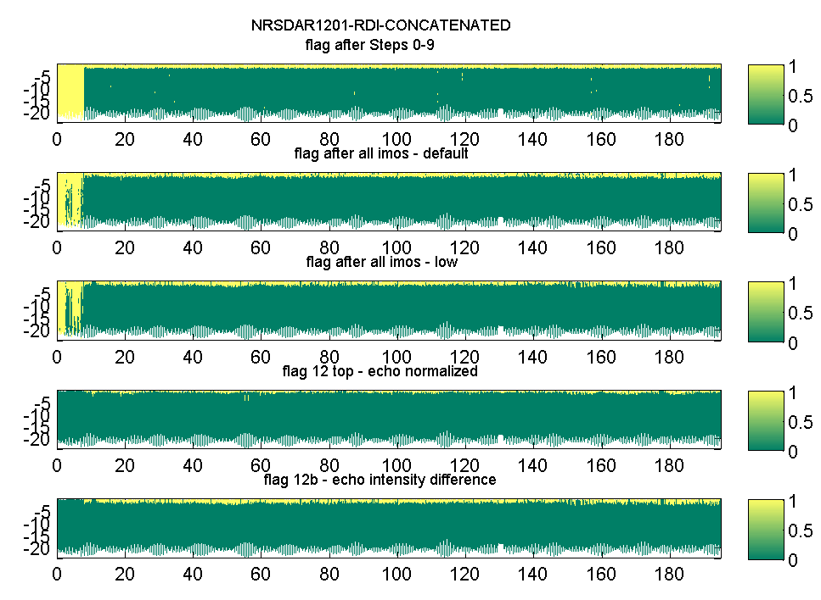 | 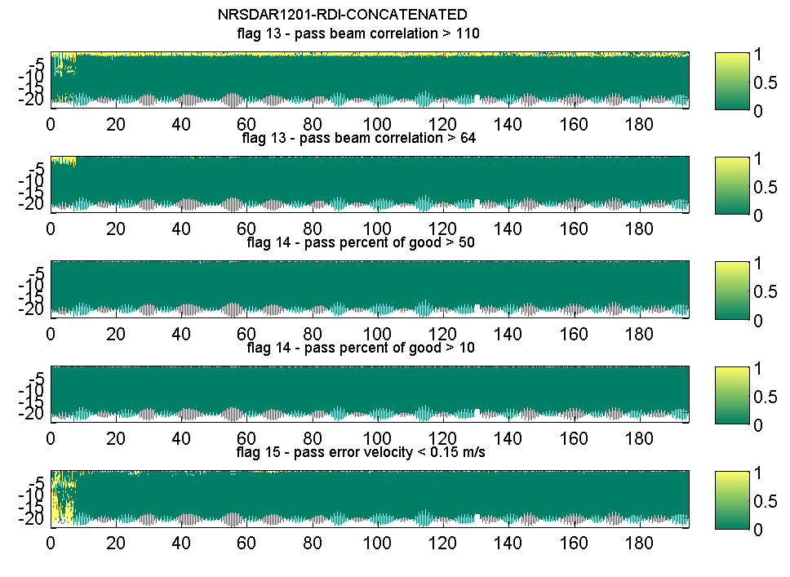
Figure B14: QC flags for the NRSDAR02 deployment (14/01/2012 to 26/07/2012) along the water column (y-axis) and time (x-axis) with the rejected data points receiving flag = 1 (yellow) and accepted data points receiving flag = 0 (green); (left plots from top to bottom) – (i) Flags 0 to 9 together, (ii) all IMOS flag together using the default values, (iii) all IMOS flag together using the less strict cut-off limits, (iv) Flag 12 for the top half of the water column using the normalized echo intensity (cut-off = 15 dB), (vi) Flag 12b for the echo intensity difference (cut-off = 30 counts); (right plots from top to bottom) – (i) Flags 13a beam correlation (cut-off = 110), (ii) Flag 13b four beam correlation magnitude (cut-off = 64), (iii) Flag 14 the percent of good (cut-off = 50), (iv) Flag 14 the percent of good (cut-off = 10), Flag 15a for the error velocity (cut-off = 0.15 m s⁻¹).

