GeoQ - Emergency Analysis and Response

Enterprise Crisis Management
GeoQ places open source geospatial technologies at first responders’ fingertips to assist relief organizations during crisis situations, leveraging a crowd-sourced workflow model as well as incorporating traditional and non-traditional map imagery and information. GeoQ allows users to rapidly examine areas affected by a crisis situation, input relevant details and disseminate this information to first responders in the field. This approach allows GeoQ to provide an impact assessment across a large geographical area within the first 24 hours of an event, providing information when timing is most critical.

Rapid Situation Awareness
GeoQ integrates numerous sources of information into a single operational picture. Analysts can selectively choose the information they see, enabling an operational view that best meets their needs and creates a richer picture of an affected area that can be obtained in a much shorter timeframe.

GeoQ Features
The GeoQ system features include:
- Crisis workflow management and distribution of work across geographically disparate locations.
- HTML5-based application that allows any analyst with a compliant web browser to participate in relief activities and provide near real-time information.
- Geospatial tools that allow analysts to quickly produce map features and details that can be widely shared.
- The ability to ingest and disseminate information into different applications, such as Google Earth and ESRI ARC products as well as other Open Geospatial Consortium-compliant applications.
- Connectivity to handheld and mobile devices to provide current situation status and alerts to areas or situations of high importance for first responders.
- Business analytics allowing managers to better estimate response timelines and manpower requirements
- Accessibility as an Open Source application on github.com for customization and participation in the development community

Efficiently Disseminate Information to Federal, State and Local Authorities
Because GeoQ presents a low barrier of entry into the geospatial analysis environment, organizations from across the spectrum can quickly adapt GeoQ into their current operating procedures. Information generated within the application can be exported and adapted to many other geospatial tools, allowing organizations to quickly determine areas most impacted by a crisis event. By allowing organizations with limited resources to focus on locations most in need in a timely manner, effective resource planning and utilization occurs, and lives can be saved.
NGA on GitHub

Sharing Tools and Techniques
The National Geospatial-Intelligence Agency’s GitHub repository is a ground-breaking initiative to share tools and techniques with the Geographic Information Systems community as well as other organizations across the country. NGA’s GitHub site at https://github.com/ngageoint was created in April 2014 and is a collection of more than 15 projects that enable access to cutting-edge geospatial tools.

Leadership in the Open Source Community
NGA’s GitHub site, a first within the IC community, opens a portal to any organization interested in collaborating. By building a community of like-minded individuals from across government industry, and academia, this collaboration streamlines the requirements and development phases of a software project, offering the ability to provide innovative solutions in a much shorter timeframe.

Sample Projects

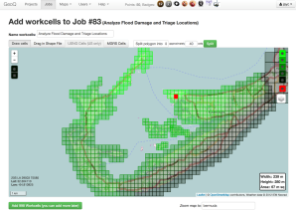
GeoQ: Geographic tasking system that allows teams to collect geographic structured observations across a large area, while also managing the work in smaller geographic regions.

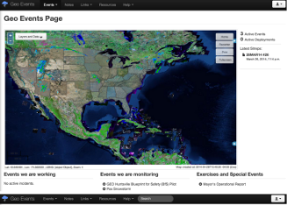
GeoEvents: A dynamic web presence that provides a common operational picture to consolidate activities, manage content, and provides a single point of discovery.

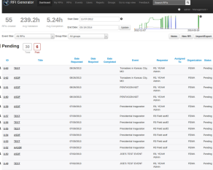

RFI Generator: The RFI (Request for Information) Generator encapsulates the RFI creation and management process.

